

Undergraduate assignment feedback form
(to be completed by marker)

Student Name: Elizabeth Bosworth

Module Code: HUSK6004  Module title: Roderic Bowen Centre: Archives and Research | Student number: 1500872
For completion by marker:
Comments:

Marker’s signature: |  | Date:
Provisional mark:
NB. All marks are provisional until confirmed by the final examination board.

Finding aids

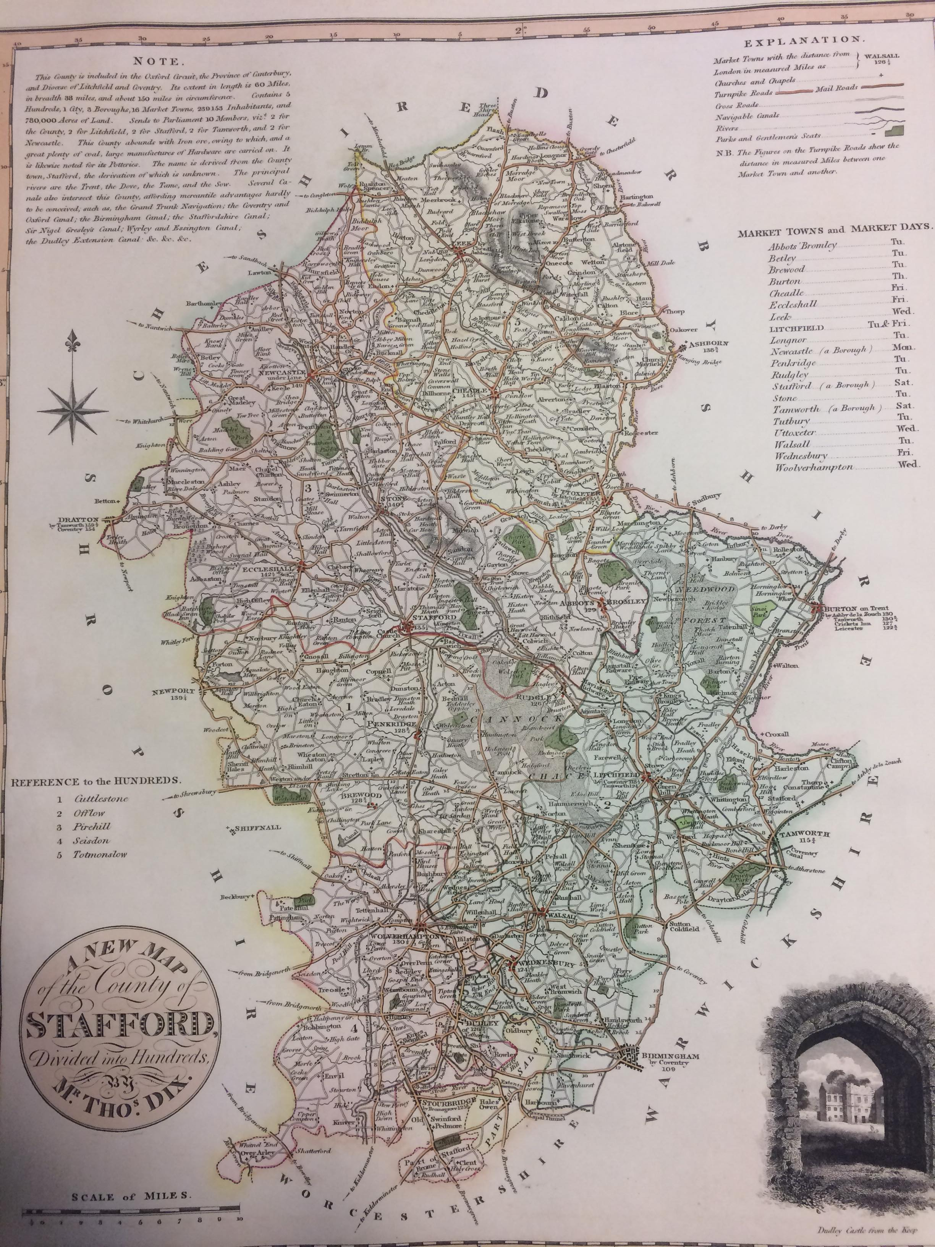

Description
Map no. 32 by Thomas Dix, ‘A new map of the County of Stafford Divided into Hundreds’, with an additional copperplate of ‘Dudley Castle as seen from the Keep’. A full-page copperplate map with colour and a key explaining aspects of the illustration.

Call Number
ODS 00001

Inscriptions
Place names throughout the map
Key explaining the illustrations
Key of the historic ‘hundred’ boundaries
Note describing the county’s attributes
List of market days throughout the county
Elaborate title badge
Scale of the map size

Production
Cartographer and artist – Thomas Dix. Printed in 1822 by William Darton, London.

Comments
The map was first produced via a copperplate engraving, with the watercolour boundaries and red ink dots marking larger settlements added later on. The compilation, an atlas of all the English counties (accurate for the time), also contains maps of North and South Wales. The maps include ‘towns, villages, parks, churches, chapels, navigable canals and rivers’, as detailed on the title page.

Subjects
Map
Staffordshire
England
Tourism
Cartography

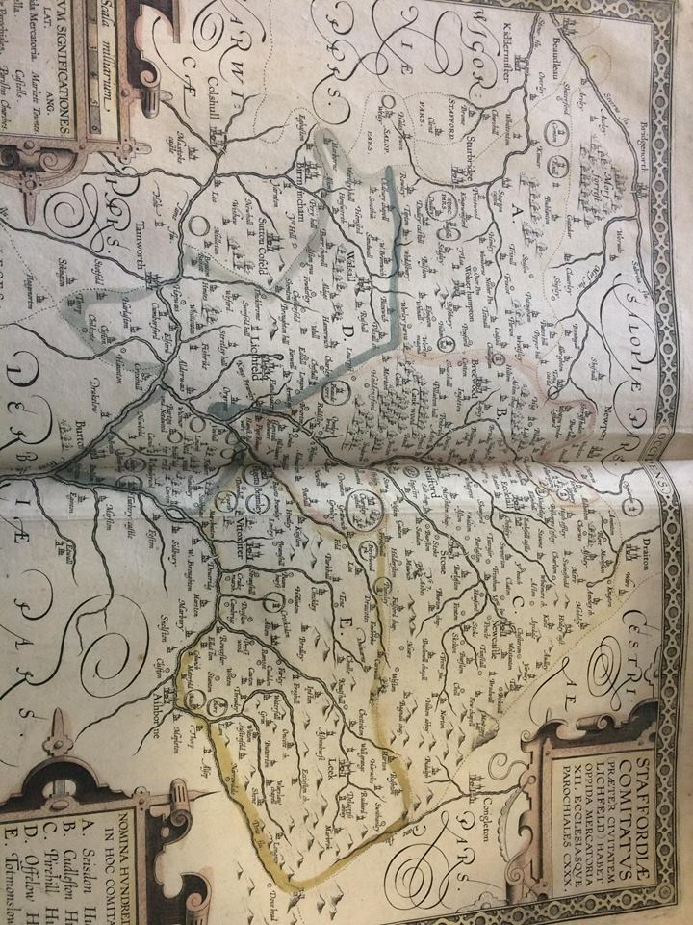

Description
Map no. 38 by John Speed, the titular Latin inscription reads ‘Stafford county (besides the city of Lichfield), has twelve market towns and 130 parish churches.’ It is a two-page plate of Staffordshire, with the titular inscription and two additional keys explaining the markings on the map. There are various watercolour markings outlining the county boundaries.

Call Number
PHI 00234

Inscriptions
Place names throughout the map
Title of the map in Latin
Key explaining the building illustrations in Latin and English
Key explaining the five ‘hundreds’ in Staffordshire in Latin and English

Production
Cartographer and artist – John Speed, between 1600-1612. Engraver – Jodocus Hondius, Amsterdam. Printed and sold by P. Stent, London.

Comments
The full title of Speed’s book is ‘The Theatre of The Empire of Great Britaine, Presenting an exact geography of England, Scotland, and Ireland’. The Gardener copy of this book provided detailed information about the county, richer colours and more illustrations of various items; coats of arms, separate maps of Stafford and Lichfield, and an image of a battle.

Subjects
Map
Staffordshire
England
Cartography

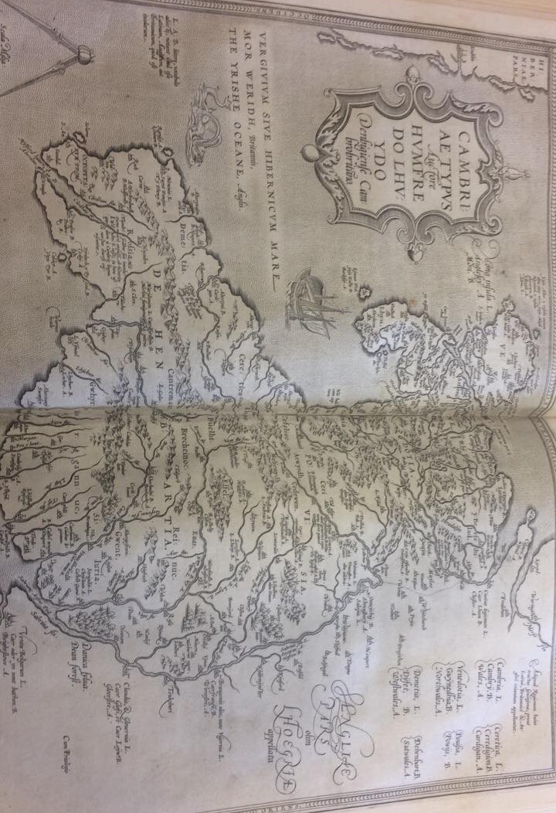

Description
Map no. 13 by Abraham Ortelius of Wales. Features names of the counties in Latin, Welsh and English. Shows place names, places of worship, mountainous regions and rivers.

Call Number
PHI 00231

Inscriptions
Place names throughout the map
Key in three languages of the Welsh county names
Elaborate titular badge for the map, all in Latin with a detailed decorative border

Production
Cartographer and artist – Abraham Ortelius of Antwerp. Entitled ‘Theatrum orbus terrarum’. Printed in 1606 by John Norton, London.

Comments
The map features no colour unlike the Speed map produced in the same few years. It does however, feature imaginative illustrations of a large sailing ship and a mythical sea creature as embellishment. The map of England was not present within the book for unexplained reasons, so I chose to use the Welsh map instead. The Latin inscription says ‘Humfredo Lhuydo’, otherwise Humphrey Llywd, who created the maps of England and Wales in 1573.

Subjects
Map
Wales
Cartography
Welsh language

Presentation script

The common theme of my illustrations for this presentation is cartography, which is the study and creation of maps. Two of these maps are of the historic county of Staffordshire (i.e. how it used to look compared to how it looks now). It is a subject I know well since I am from the county and I have a keen interest in the various histories from the area.

The first illustration that I chose to present is a map of the county of Staffordshire, printed in 1822. The full page features a large county map labelled ‘A new map of the County of Stafford Divided into Hundreds’ which was made from a copper template. It is the thirty-second plate featured in the compilation.

The map compilation was printed by William Darton in 1822. What is interesting to note is that Dix died before the date of the publication. Darton was a cartographer and artist himself so he continued to work under their joint names – it isn’t clear whether the map of Staffordshire in particular was created by Dix or Darton.

As well as the main illustration of the county map, there are additional illustrations on the same page. These are; the place names throughout the map, a copperplate view of Dudley Castle as seen from the Keep, a key explaining the illustrations, a note describing the county’s attributes and history, a list of market days throughout the county, a decorative title badge with Dix’s name on it and a scale of the map size.

The watercolour boundaries and red ink dots marking larger settlements added later. The five colours you can see on the map denote the historic boundaries of the five ‘hundreds’ of Staffordshire, which have served as boundaries since the eight hundreds. The map includes ‘towns, villages, parks, churches, chapels, navigable canals and rivers’, as detailed on the title page.

This is the illustration of a view of Dudley Castle, which I found quite sweet as it is like a tourist guide, promoting a historical and cultural heritage site. It also strikes me as going to extra mile, as by no means did an extra illustration need to be included.

The second map illustration I will inspect is the thirty-eighth map in an atlas created by John Speed. The full title of the compilation is ‘The Theatre of The Empire of Great Britaine, Presenting an exact geography of England, Scotland, and Ireland’. Speed was the cartographer for this set of maps, but the copperplate engraver was actually a man named Jodocus Hondius who lived in Amsterdam. The book was then printed and sold by P. Stent from London. The maps were created between 1600 and 1612.

The Latin inscription serving as the title reads ‘Stafford county (besides the city of Lichfield), has twelve market towns and 130 parish churches.’ It is a large plate of Staffordshire, with watercolour markings in five colours outlining the ‘hundreds’ county boundaries.

Inscriptions on the illustration are place names throughout the map, the title of the map in Latin, a key explaining the building illustrations in Latin and English, and a key explaining the five ‘hundreds’ in Latin and English. There is also a small scale above the key of buildings, and you can see that there is a patterned decorative border around the map.

The Gardener copy of this book (which is uploaded onto Cambridge University’s online archives) provided detailed information about the county, richer colours and more illustrations of various items; coats of arms, separate maps of Stafford and Lichfield, and an image of a battle. Different printers and producers of the same compilation of maps have placed different colours onto the maps.

There are comparisons to be made between the maps made by Dix and by Speed; the stricter presentation as time passes and the spelling of place names. The map by Speed does not face north, but west, so for example, Birmingham appears to the west of Walsall when in reality it is south of Walsall. Two examples of place names evolving over time are Birmingham from ‘Birmincham’ and Sutton Coldfield from ‘Sutton Cofeld’.

The final map from which I have taken an illustration is a collection called ‘Theatrum orbus terrarum’ by Abraham Ortelius. The Latin title translates into ‘theatre of the world’ Ortelius was from Antwerp, but this copy was printed in 1606 by John Norton in London. However, Ortelius collaborated with a Welsh cartographer names Humphrey Llwyd, who is responsible for creating this map of Wales. His copperplate template was created in 1573, which points towards his templates being used for a distinct period of time since this book was printed in 1606. I wanted to find three maps of Staffordshire for more direct comparisons, but while I was looking through the collection, there were only individual maps of countries in the British Isles, but the England map was missing. As a result I have picked the map of Wales instead, which is the thirteenth plate in the collection. It is a good resource for the history of cartography as well as the development of the Welsh and English languages as you can see how the spellings on the map are different from the ones we use and recognise today.

The key provided by Ortelius denotes place names, places of worship, mountainous regions, and rivers. The other inscriptions on the map are a key of Welsh county names in the three languages, and an elaborate title badge which is in Latin with a detailed decorative border.

Like the Speed map, it is a shame that this particular copy in the archive doesn’t have bright colours, but I enjoy that the map is still eye-catching without colour, as it has decorative borders and illustrations of ships and sea creatures.

Bibliography
Dix, T., A complete atlas of the English counties (London: William Darton, 1822).
Ortelius, A., Theatrum orbus terrarium (London: John Norton, 1606).
Speed, J., The Theatre of The Empire of Great Britaine, Presenting an exact geography of England, Scotland, and Ireland (London: P. Stent, 1612).
-

Cambridge University Library Special Collections, ‘Speed maps now in the Cambridge Digital Library’, (2015) [online] Available: https://specialcollections-blog.lib.cam.ac.uk/?p=9784. (Accessed 14/05/2018).

Depuydt, J., ‘Ortelius, Abraham (1527–1598)’, Oxford Dictionary of National Biography, (Oxford: Oxford University Press, 2004).

University of Cambridge Digital Library, ‘The theatre of the empire of Great Britaine : presenting an exact geography of the kingdomes of England, Scotland, Ireland,... (Atlas.2.61.1)’, (2018) [online] Available: https://cudl.lib.cam.ac.uk/view/PR-ATLAS-00002-00061-00001/55. (Accessed 14/05/2018).

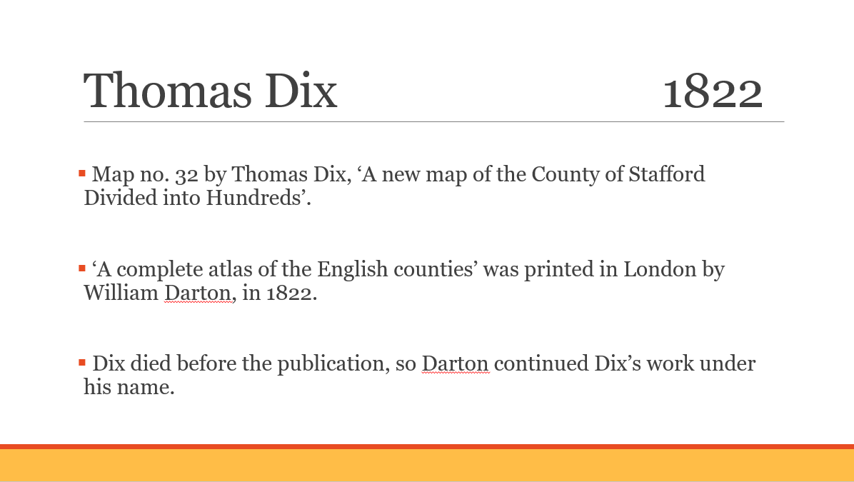
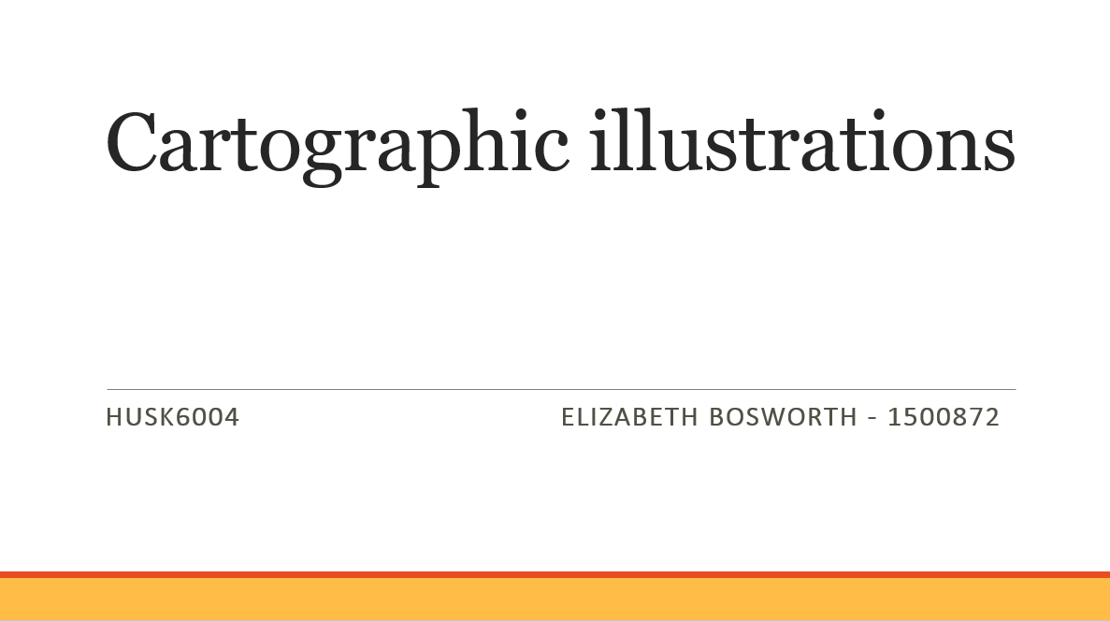

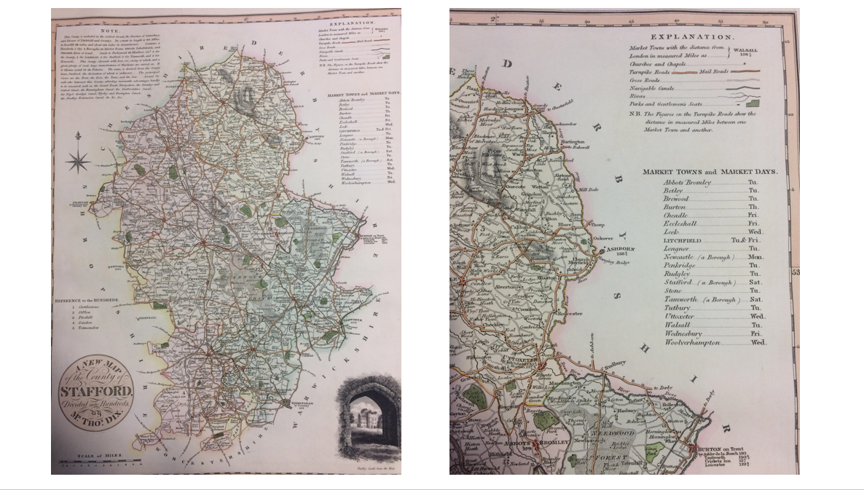

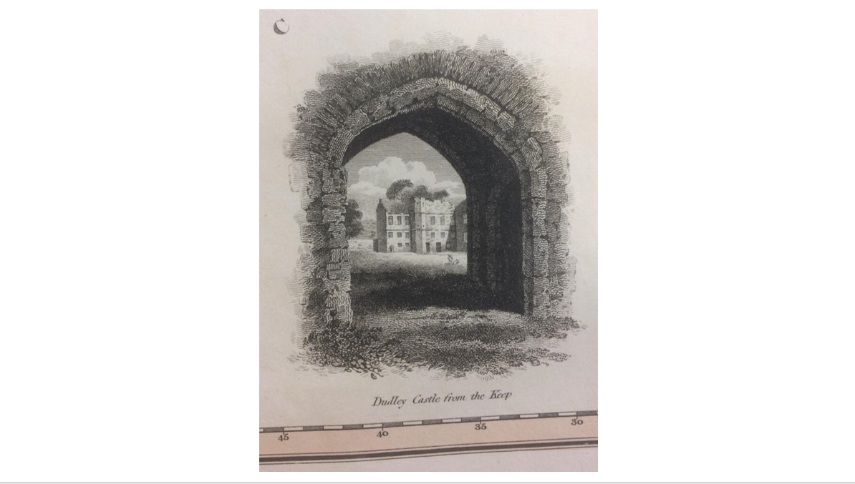

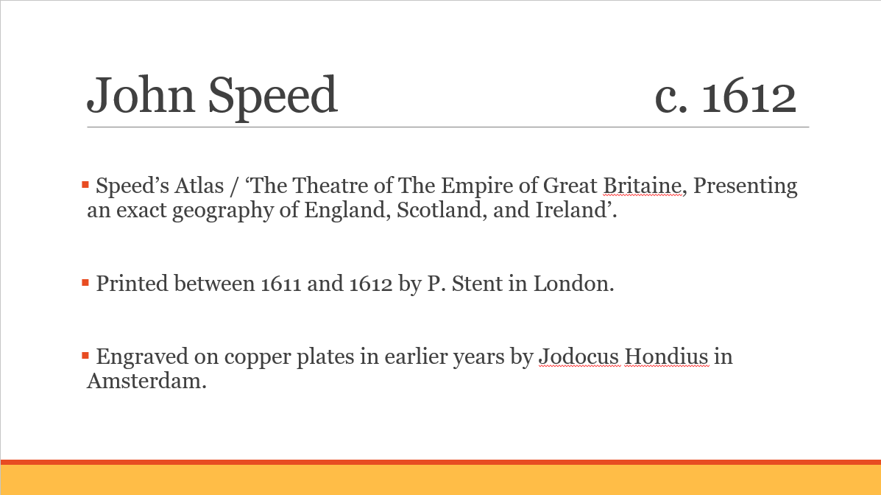
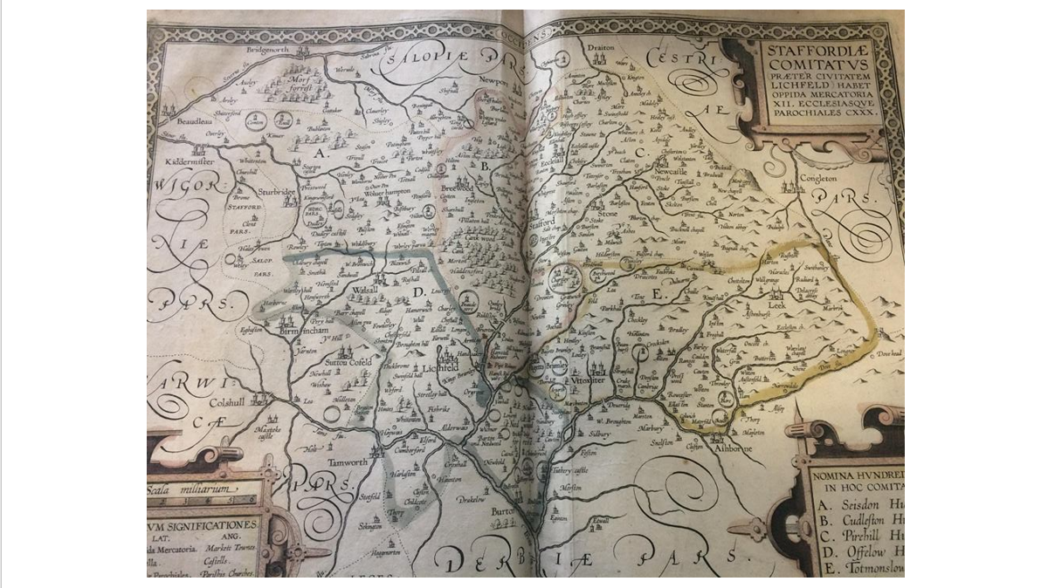
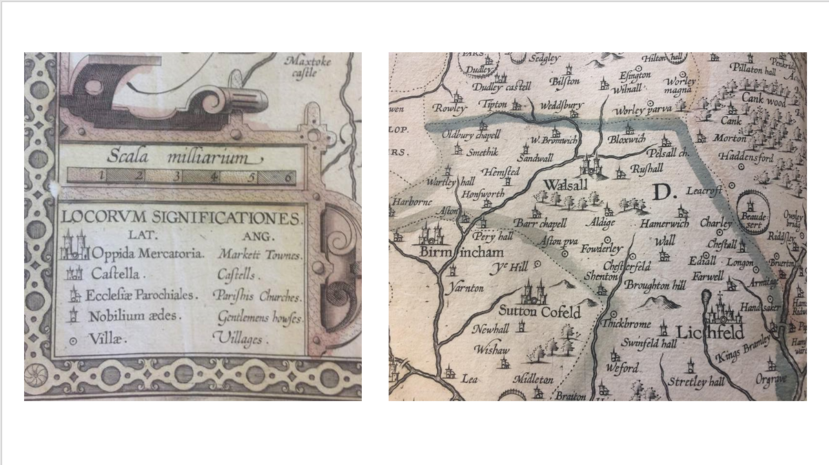

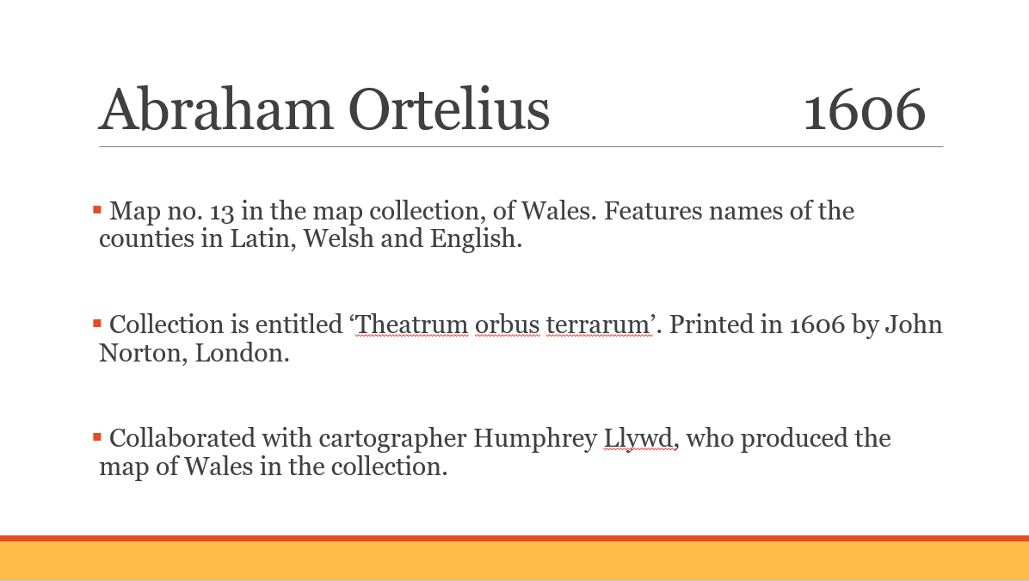
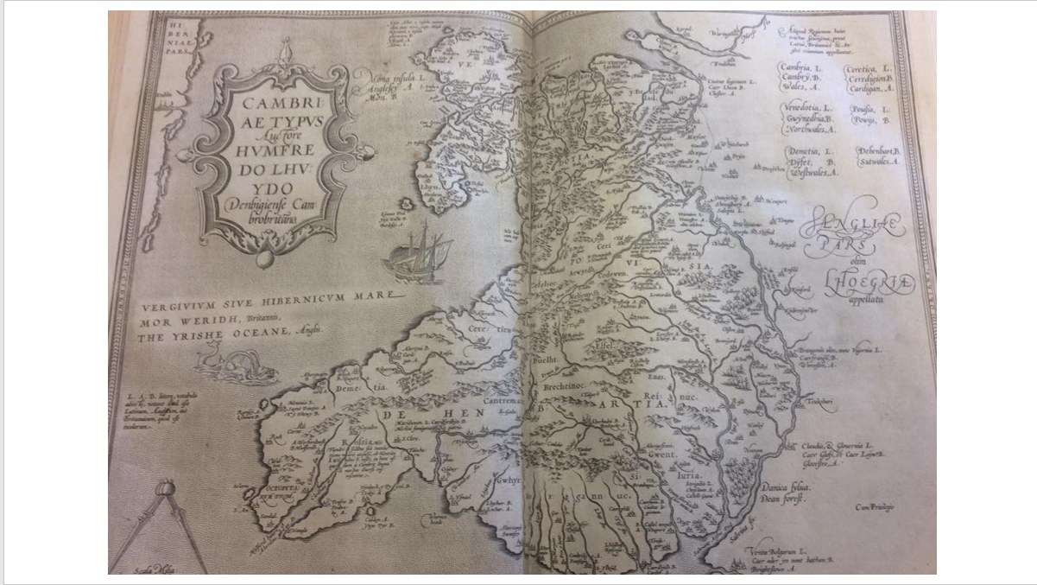
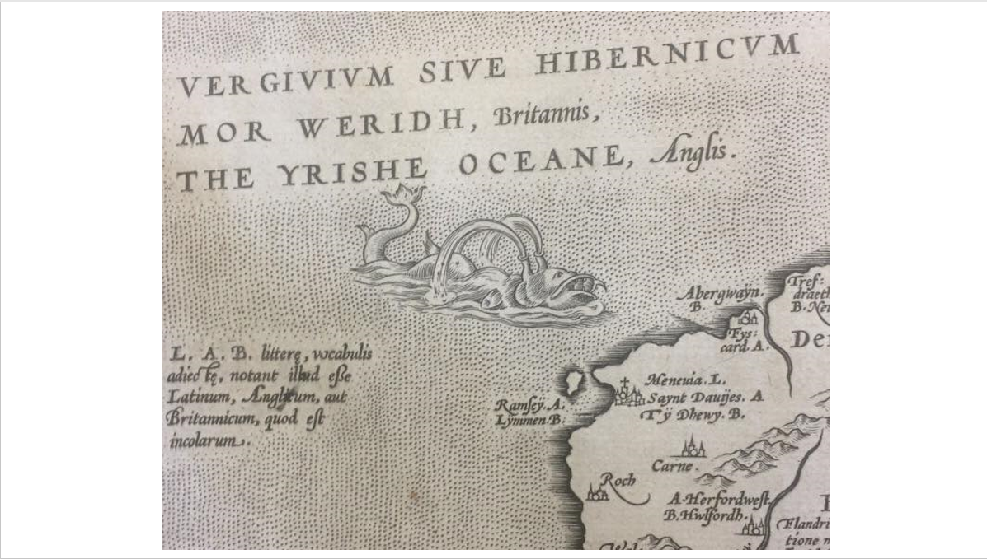

University of Cambridge Digital Library, The theatre of the empire of Great Britaine : presenting an exact geography of the kingdomes of England, Scotland, Ireland,... (Atlas.2.61.1), (2018) [online] Available: https://cudl.lib.cam.ac.uk/view/PR-ATLAS-00002-00061-00001/55.
Cambridge University Library Special Collections, Speed maps now in the Cambridge Digital Library (2015) [online] Available: https://specialcollections-blog.lib.cam.ac.uk/?p=9784.
Joost Depuydt, ‘Ortelius, Abraham (1527–1598)’, Oxford Dictionary of National Biography, (Oxford: Oxford University Press, 2004).
Cambridge University Library Special Collections, Speed maps now in the Cambridge Digital Library (2015) [online] Available: https://specialcollections-blog.lib.cam.ac.uk/?p=9784.

