Molly Thomas (2502132)

database concepts – ACCA4023

Design and Implementation of a Relational Database System

Contents

Introduction 2
Implementation 2
Scenario Analysis 2
Entity-Relationship Diagram (ERD) 2
Data structure Development 4
Normalization Compliance 9
Sample Data Population 10
Query Development / Validation & Testing 13
References 16

Introduction
This report presents the design and implementation of a relational database system for an electric bike rental company called EcoRide. This scheme is a green transport initiative that aims to provide electric bike rentals at multiple locations while contributing to environmental sustainability and promoting public health. A database management system should always provide users with the ability to update, store, and retrieve data, along with transaction, recovery, and authorisation support throughout. [1]
This report will showcase entity relationship modelling, normalisation to third normal form (3NF), validation rules and constraints, along with the use of primary, composite, and foreign keys. Microsoft Access has been used as the database management system to implement these design choices.

Implementation

Scenario Analysis
The local authority is currently relying on paper forms and basic data storage to run this scheme. This can result in double bookings, unreturned bikes, bike availability issues, and out-of-date maintenance records. These factors make it difficult for management to analyse service usage or produce accurate reports. Multiple entities with attributes and relationships have been chosen for this database management system to ensure the EcoRide database is normalised, organised, and logical. These entities are:
- Riders – To store name, ID number, date registered, email
- Riders Phones – To store multiple phone numbers for riders
- Staff – To store name, ID number, contact details, job role
- Stations – To store location, ID number, capacity
- Bikes – To store ID number, condition, bike type, status, date purchased
- Bike Types (lookup table) – To store different bike categories with descriptions
- Maintenance – To store all maintenance logs with dates, status, cost
- Rentals – To record rental activity including dates, duration, cost

Entity-Relationship Diagram (ERD)
Conceptual modelling is the process of creating a model of the entities, attributes, relationships, and restraints to assist an organisation in the production of a database management system. [1] Within the entity relationship diagram shown in Fig. 1, each rectangular entity has been labelled with its oval attributes branching from it. The primary keys for each table have been underlined to clearly indicate their role within the table.
The null attributes, such as “Current Location” and “Rental End”, are shown in brackets to represent that the data field can be null within the database if needed. Rental duration is presented as a derived attribute because it can be calculated from existing attributes, which are “Rental Start” and “Rental End”.
The Riders entity includes an attribute called “Phone”, which is a multi-valued attribute due to a rider possibly requiring more than one contact number to be saved on their account. Therefore, a weak entity was added to the ERD to create a separate table that solely stores contact details for each customer in a more organised format, reducing data redundancy.
The relationships in the diagram are presented as green rhombuses between each entity and labelled with their cardinality. For example, the relationship between the Bikes entity and the Maintenance entity is one-to-many (1:M), meaning that a bike can have multiple maintenance records within the business. Another example is the relationship between the Riders entity and the Rentals entity, which is one-to-one (1:1), showing that a rider can only rent one bike at a time.
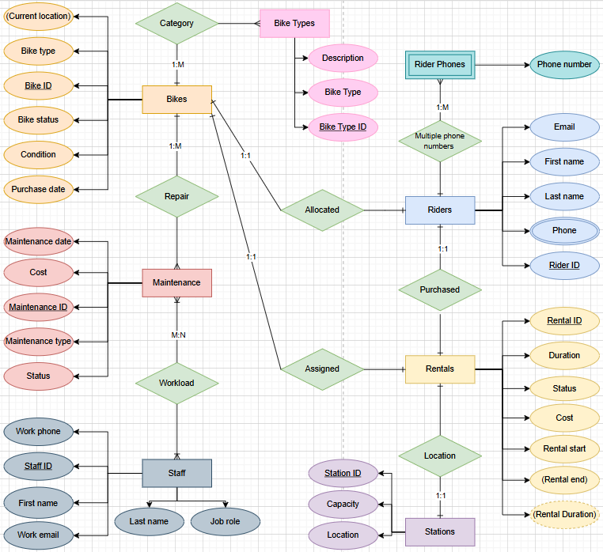
Fig 1. Entity relationship diagram

Data structure Development
The entity relationship diagram (ERD) was used to design each table within the database in the design view function as shown in Fig. 2. The attributes were listed and given a data type such as number, short text, currency, etc. Each attribute also has been giving a brief description of what it should be displaying; this prompts the end user of what is expected in that field.
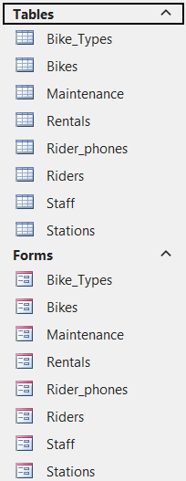
Fig 2. Tables that have been created within the database

The validity of data relies on business rules being implemented to create restrictions that shape a database. [3] At this stage, the primary, composite, and foreign keys are determined along with other business rules such as validation and look up tables. To maintain data accuracy and integrity validation is used to specify rules that the data in the database must comply with. [4]
As shown in Fig. 3, A validation rule has been applied to the Date Registered attribute to prevent the entry of future dates. This rule allows the data entry to be logical as a rider cannot be registered on a date that is in the future. Implementing this constraint improves data accuracy and reduces user input errors by a text box appearing if the data that has been entered is invalid.
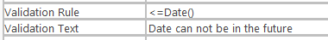
Fig 3. Validation rule set in the Riders table for the Date Registered attribute

Referring to Fig. 4, a validation rule has been applied to the Job Role attribute to make sure only 3 individual job roles can be entered into this field which are Technician, Administrator, and Supervisor. This makes sure that the data that is gathered is consistent; It ensures compliance with organisational business rules and improves usability as the user would get a pop-up stating, “Job role not recognised”, if the information inputted is incorrect.

Fig 4. Validation rule set in the Staff table for the Job Role attribute

Another validation rule is shown in Fig. 5; this rule highlights that the Bike Type attribute in the Bikes table cannot be null. Every bike within the company needs to be assigned a bike type from the look-up table that was created in the database called Bike Types. Without this constraint, incomplete or meaningless bike records could exist within the system.
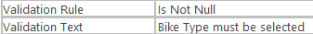
Fig 5. Validation rule in the Bikes table for the Bike Type attribute

Fig. 6 refers to the “Cost” attribute with a data type as currency in the Rentals table. This rule has been applied to make sure no negative cost value is entered. Enforcing this constraint allows the business to accurately track their revenue.
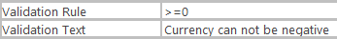
Fig 6. Validation rule in the Rentals table for the Cost attribute

A validation rule was also applied to the Rentals table to ensure that the rental end date and time is after the rental start date and time. This ensures data integrity and prevents calculation errors when the derived data is calculated by the Duration attribute. This is shown by: [Rental_End]>=[Rental_Start].

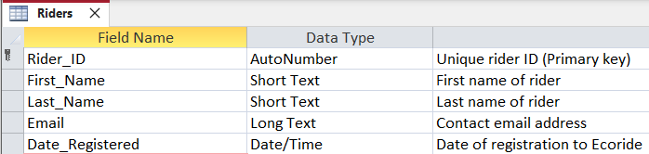Fig 7. Riders table in design view
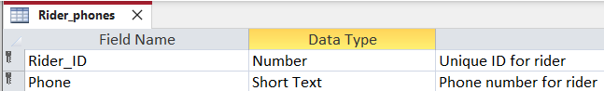Fig 8. Rider Phones table in design view
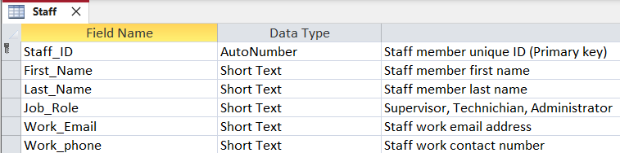Fig 9. Staff table in design view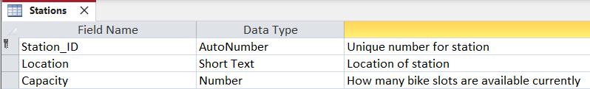Fig 10. Stations table in design view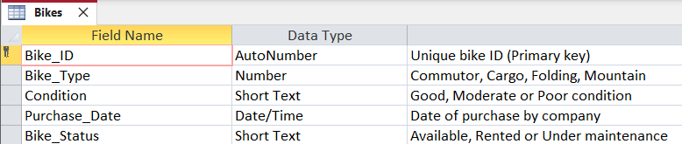Fig 11. Bikes table in design view
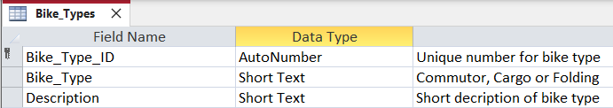Fig 12. Bike Types look up table in design view
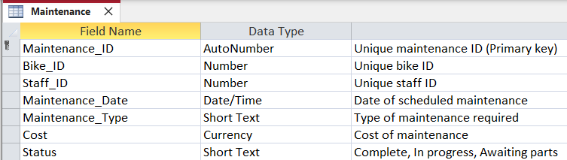Fig 13. Maintenance table in design view
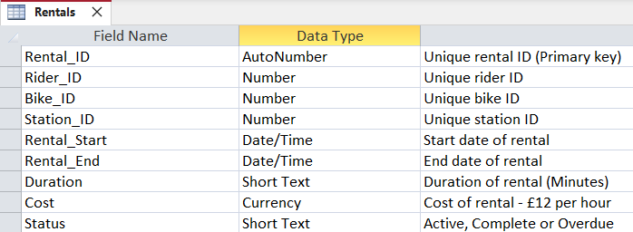
Fig 14. Rentals table in design view

After the validation process, relationships are created within the Relationships Design section in MS Access. A strong understanding of primary and foreign keys is fundamental to many database activities, including data cleansing, reverse engineering, optimising queries, and data integration. [5]
The primary keys are presented as short-length values with a key icon next to them; primary keys are normally identifiers for a particular table with no semantic meaning. [5] The tables have been linked together using foreign keys. Foreign keys are attributes that reference the primary key of a related table. For example, as shown in Fig. 15, the Rentals table records the transactions within the business and references multiple entities through foreign keys. This allows each rental entry to be linked to a specific rider, bike, and station.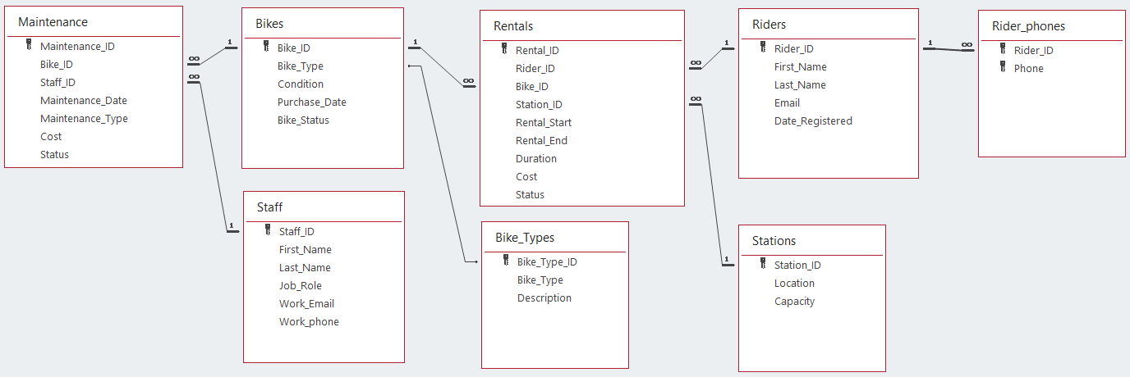Fig 15. Relationship design of the EcoRide database

Normalization Compliance

The EcoRide database has been normalised to Third Normal Form. Normalisation to third normal form helps prevent redundant data and supports the enforcement of data integrity constraints, improving the overall reliability of the database [2]. All tables within the database have been assigned unique primary keys, ensuring compliance with First Normal Form. All transitive dependencies have been removed by separating bike type details, phone numbers, and maintenance information into separate entities. As a result, the final data model minimises redundancy, prevents update anomalies, and complies with 3NF.

Look Up Table
The attributes within the Bikes table called “Bike_Type” and “Description” were moved into a separate look-up table named “Bike_Types”. This made it easier to select a bike type within the Bikes table, as there is now a drop-down function with four bike types to choose from. This prevents repeating data and removes transitive dependency, so each attribute depends only on the primary key. This overall satisfies Second Normal Form.

Composite Primary Key
Within the Riders table, there was a Phone attribute that could store multiple phone numbers for one rider, which would violate First Normal Form and make querying the data more difficult. After considering that riders may have more than one contact number, another table was added to the database called Rider_Phones. This table stores multiple contact numbers for a single rider by creating a composite primary key using the Rider_ID and Phone attributes. Adding this composite primary key ensures a rider can have multiple contact numbers stored within their account, prevents duplicated contact details, and removes the need for an additional ID attribute, which would be unnecessary. This ensures there are no transitive dependencies and complies with Third Normal Form.

Sample Data Population
Now that each table has been designed and saved with all the correct attributes, data types, and constraints, data was then entered into the tables by creating forms for each table within MS Access. This feature allows easy data entry and customisation, making it user-friendly for non-technical users. Navigation buttons such as Add Record, Delete Record, and Save Record were also created to speed up this process and give the database a professional appearance.

The forms also allow a user to display derived attributes efficiently, while allowing users to enter correct data and maintain database integrity. For example, the “Duration” attribute in the Rentals table is derived from the attributes “Rental_Start” and “Rental_End.” To calculate this automatically, a control has been set in the form’s control source using the DateDiff function: DateDiff("n", [Rental_Start], [Rental_End])

This function generates the rental duration in minutes, ensuring consistency and accuracy across all records, as shown in Fig. 16.

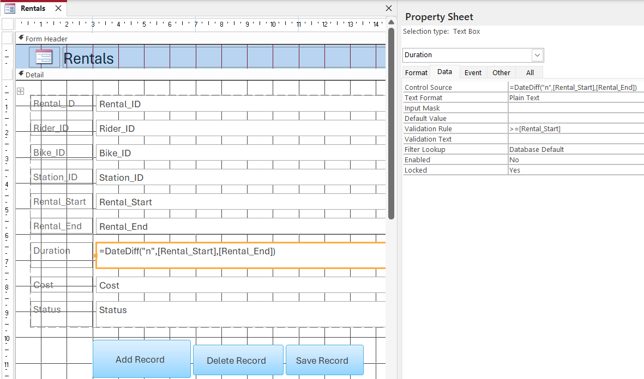Fig 16. Rentals form highlighting the derived attribute “Duration"

Fig 17. Forms that have been created in the database
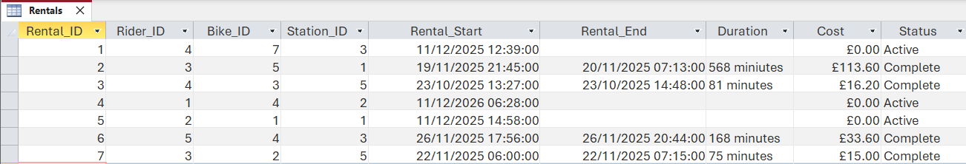Fig 18. Rentals table with sample data
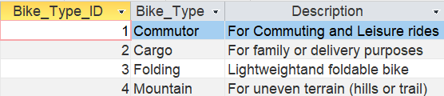
Fig 19. Bike Type table with sample data
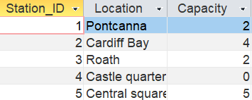
Fig 20. Stations table with sample data
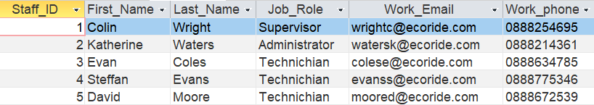Fig 21. Staff table with sample data
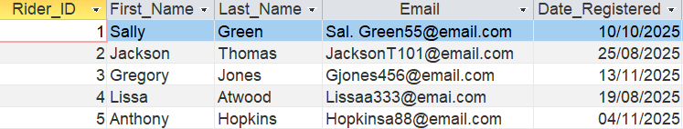Fig 22. Rider table with sample data
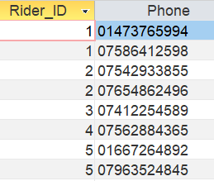
Fig 23. Rider Phones table with sample data
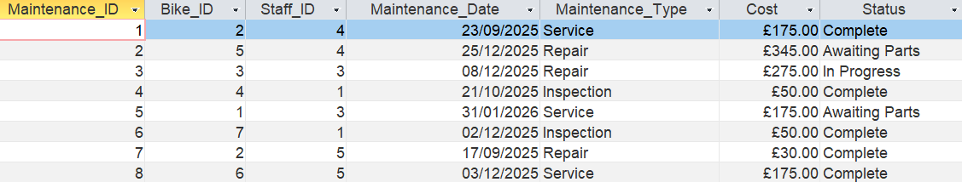Fig 24. Maintenance table with sample data
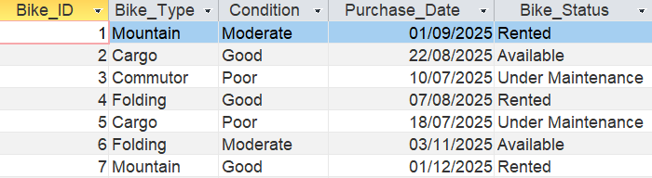Fig 25. Bike table with sample data

Query Development / Validation & Testing
Database Testing is a vital step in the creation of this project; it will verify the reliability, performance, and functionality of the database system. [6] Seven queries were ran to test various aspects, including the accuracy of data retrieval, the calculation of derived attributes such as rental cost, and the enforcement of data integrity constraints. The results demonstrated that the database returns correct outputs, handles different input scenarios effectively, and maintains consistency across related tables. Conducting these tests ensures that the system is robust and reliable, capable of supporting the operational needs of the EcoRide bike rental service without errors or unexpected behavior.

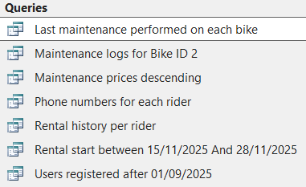
Fig 26. Queries that have been ran in the database

The query shown in Fig. 27 displays the phone numbers belonging to each rider. This demonstrates how the look-up table handles the one-to-many relationship (1:M) by allowing riders to have multiple contact numbers. This design adheres to Third Normal Form by splitting the data into two tables, avoiding redundancy.
Fig. 28 shows the rental start query between 15/11/2025 and 28/11/2025. This highlights that the database can filter data by date, as the values have been created using the correct format. This function will help the business understand trends in their services and capitalise on busy periods.
Fig. 29 displays specific maintenance logs for Bike ID 2. This query confirms that foreign keys are correctly linked between the Bikes and Maintenance tables. It demonstrates referential integrity and validates that the database can retrieve accurate results.
The last maintenance date for each bike query is shown in Fig. 30. The MAX function is used to identify the most recent maintenance date for each bike, helping to ensure that maintenance records are stored and retrieved correctly. It also supports data integrity, as each maintenance record must be linked to a valid bike through a foreign key. Any bike without a maintenance date indicates missing or incorrect data.
Fig. 31 shows the rental history per rider. The database meets its functional requirements by correctly using primary and foreign keys. This validates that rental records are appropriately linked to the relevant riders, allowing the business to monitor user activity effectively.

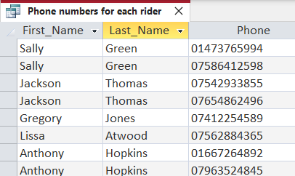
Fig 27. Phone numbers for each rider query
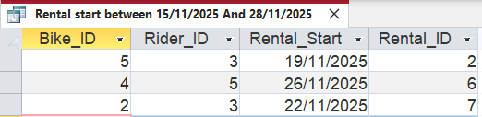
Fig 28. Rental start between 15/11/2025 and 28/11/2025 query
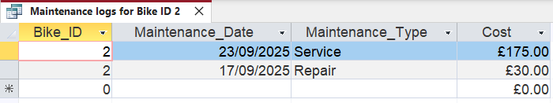
Fig 29. Maintenance logs for Bike ID 2 query
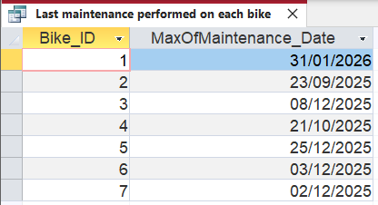
Fig 30. Last maintenance date performed on each bike
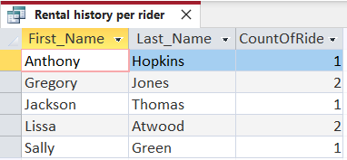
Fig 31. Rental history per rider

Improvements
Upon reviewing my database implementation, there are several areas of the design and creation process that could be improved. Within my database, I have a table called “Stations” that holds information on the location of a bike pick-up station, along with its current capacity for administration purposes. The Location attribute currently only states an area in Cardiff, such as Pontcanna or Roath. This could be improved by adding the full address to the table; however, it would need to be stored as multiple attributes, such as Street and Postcode, because storing a full address in a single attribute would violate First Normal Form.
Another potential improvement is to change the Cost attribute in the Rentals table to a derived attribute, as keeping it in the table violates normalisation. Deriving calculated attributes like Cost reduces the risk of errors and simplifies updates. This value can theoretically be calculated from the rental duration and hourly rate when querying the data. These improvements would make the database more robust and better suited to meet the operational needs of EcoRide as the service grows.

References
[1] T. M. Connolly and C. E. Begg, Database Systems: A Practical Approach to Design, Implementation, and Management, 6th ed. Harlow, UK: Pearson Education, 2015.

[2] A. Silberschatz, H. F. Korth, and S. Sudarshan, Database System Concepts, 7th ed. New York, NY, USA: McGraw-Hill, 2020.

[3] M. J. Hernandez, Database Design for Mere Mortals, 3rd ed. Boston, MA, USA: Addison-Wesley, 2013.

[4] R. Elmasri and S. B. Navathe, Fundamentals of Database Systems, 7th ed. Boston, MA, USA: Pearson, 2016.

[5] L. Jiang and F. Naumann, "Holistic primary key and foreign key detection," J Intell Inform Syst, vol. 54, (3), pp. 439-461, 2020. Available: https://www.proquest.com/scholarly-journals/holistic-primary-key-foreign-detection/docview/2237714229/se-2. DOI: https://doi.org/10.1007/s10844-019-00562-z

[6] SQE Labs Inc., “Why Do You Need to Perform Database Testing?”, LinkedIn, Jan. 16, 2024. [Online]. Available: https://www.linkedin.com/pulse/why-do-you-need-perform-database-testing-sqe-labs-inc--izpwc/.

