

ADAD7014
Module: Approaches to Art and Design Research and Academic Communication
ID number: 2106525

PART ONE – What is Knowledge?

The Gazes in Chinese Feminist Film Spring in a Small Town

The main theme of part one is to explain the question of what is knowledge? Western philosophy and thus, western philosophers have been engaged with attempting to answer this troublesome question from its inception. Whether it was seen through Plato’s ideas of the real world, Descartes’ idea of whether we can know for sure if we are awake or just a dream in someone else’s head, to Derrida’s belief that knowledge is it be found only within flawed language, humans have searched for the answer of ultimate knowledge. I am drawn to Albert Einstein’s assertion that: ‘Any fool can know; the point is to understand.’ (Goodreads, 2021) As with Einstein, as for me, knowledge is best understood as understanding. When we try to gather knowledge, it only becomes meaningful if we are able to understand it and test it through our actions and experiences. If we can understand events that have impacted on us, it might allow us to come to see how these experiences creates our subjective world view, phenomenologically speaking, and from that, we might begin to create a holistic perspective of what constitutes truth in our experiences. As I hope to create film practice in relationship to understanding the female experience within film (outlined in section 3), this section aims to explore how the male gaze, impacts on creating meaning in the film Spring in a Small Town (1948) This film reveals how me might find understanding in the Chinese introverted and implicit film aesthetic, and how the concept of scopophilia within psychology, help as understand how we perceive the lived experiences of the female character.

The very first female image on the Chinese silver screen is Die for Marriage (Nan Fu Nan Qi). It was shot and released in 1913 and is the first silent short black and white film in history with merely 40 minutes. Even though the female character was acted by a man, but it opened the beginning of female images in Chinese films. Almost has been shooting at the same time with Die for Marriage, Chuang Tsu Tests His Wife (Zhuang Zhou Shi Qi) was shown in the next year that the first actress has appeared in the film. And after eight year’s development, a female image of Romance of a Fruit Peddler (Lao Gong Zhi Ai Qing) once broke the constraint of the Chinese feudal marriage system and realised the freedom of love which was pioneering and progressive at that time. The waken of Chinese feminist films came to an important turning point when sound films have emerged in the 1930s (Zheng, 2021). Spring in a Small Town is a black and white film with loads of female voiceovers that was released in 1948. Fei Mu, the director, is the first one to detailly portray a female character’s psychology in a beautifully poetic way. As in the mind of Fei Mu that ‘he wanted instead to engage them by putting the focus on psychological description, which would be more likely to produce a self-reflexive, thoughtful response in the audience’ (Daruvala, 2007: 178). Hence, this 93-minutes masterpiece was rated as the best Chinese film that has been made in history at the Hong Kong Film Awards in 2005.

There are only five characters in the film: Squire Dai Liyan and his family – his wife Zhou Yuwen, his 16 years old sister Dai Xiu, his servant Lao Huang, and his friend (also the lover of Yuwen in the past) Zhang Zhichen. The story takes place in a small southern city after World War II. As spring arrives, Liyan has lost his property in the war and has become seriously ill for six years. Facing the situation of curtilage dilapidated, he is depressed all day long and has no faith in life. Yuwen always knows she doesn’t love his husband in their eight years marriage, but she has been kept taking care of him conscientiously. They have slept separately for two years, and they have no words when they get together. However, Xiu is different in this lifeless family. She is still a middle school student with an outgoing and lively personality who looks forward to the future. The dull life is interrupted by Zhichen, a successful doctor who comes to visit Liyan from outside of the town. He never knows that Yuwen marries his friend, but he does know he still loves her. Zhichen and Yuwen broke up because of Yuwen’s mother but now Yuwen has a husband which means they cannot be together again. Zhichen was invited to stay at the house, and he helps to take care of Liyan. Zhichen and Yuwen are still in love with each other and date secretly. What makes them struggle is their emotions are bound by propriety and loyalty of friendship and marriage. Xiu falls in love with this wise and handsome man but both Zhichen and Yuwen refuse. It was Xiu’s birthday that Liyan found a special relationship between his wife and the friend. In order to fulfil them to live a better life, Liyan attempts to commit suicide by swallowing a bottle of sleeping pills. After Zhichen’s rescue, Liyan comes back to life. Through the twists and turns, Yuwen realizes her love for her husband and chooses to live with him, and Zhichen decides to leave the town. Spring is coming, everyone is embracing a new life in this film.

I would like to use the first night that Zhichen visits Liyan’s house as the case study to analyse how do these four characters convey their motivations by gazing at each other.

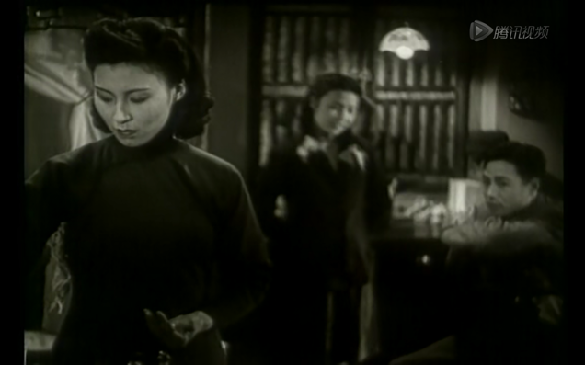

Yuwen is preparing the medicine for Liyan as usual. Xiu is singing a cheerful song to Zhichen, but Zhichen’s focus is always on Yuwen even though his body is facing Xiu.

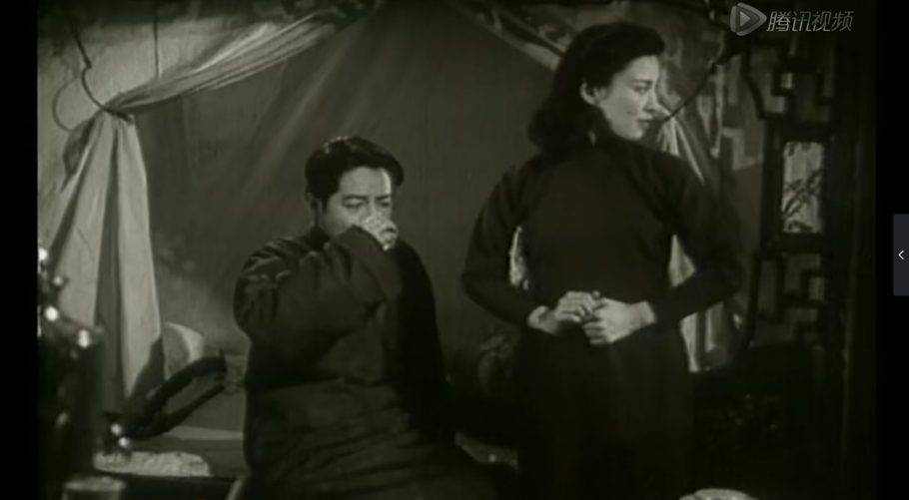

Liyan is sitting on the bed and takes the medicine and Yunwen turns to look at Xiu.

It is the only time that the audience can see Yuwen directly looking at Xiu (or including Zhichen). Yuwen wants to know what is happening in the other part of the room as the room is separated into quiet and delightful scenes.

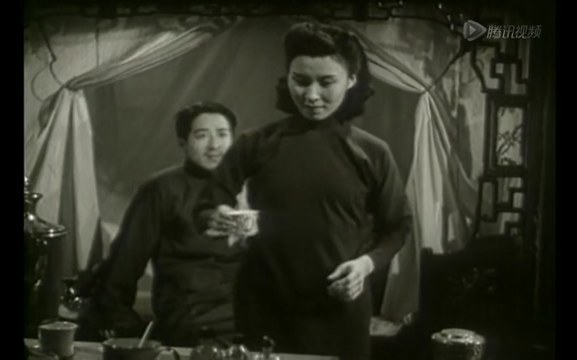

Yuwen is going to put the cup on the table and make the bottles of the medicine in order. Liyan is gazing at her, but Yuwen focuses on what she is doing as it is her responsibility to look after Liyan.

The footage on the top shows the gazes from three people, Yuwen, Zhichen and Xiu, and their positions construct a triangle in the scene which suggests a love triangle between them and foreshadows that Xiu has a crush on Zhichen in the later plots. It is interesting that the audience doesn’t know in the next scene (footage on the bottom), Liyan also has his gaze on Yuwen.

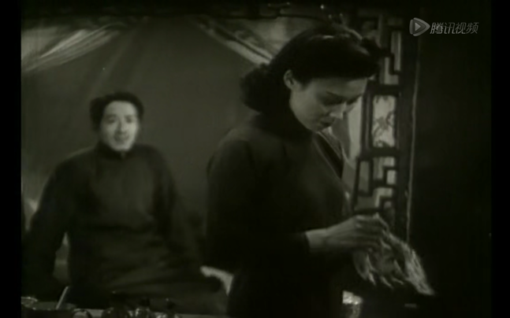

Yuwen is turning her back and trying to sit down. Liyan’s eyes still keep looking at his wife. But Yuwen doesn’t even look back to his husband.

This short performance represents the relationship between the couple. Liyan loves his wife and relies on her to take care of him. Yuwen doesn’t love him but just follows what she is supposed to do as a wife. At the same time, their actions present the situation of Chinese women in the old days as they had to do everything for their husbands, including the simple thing like preparing the medicine. From Liyan’s gaze, the image of Yuwen doesn’t relate to the aspect of sexuality but more approach to his guilty to the wife as he has been ill for a couple of years and his wife goes out to buy the medicine for him every day. Nevertheless, it is conflicting that he takes for granted the care of Yuwen. Thus, the more regretful emotions do Liyan feel toward Yuwen, the sadder marriage they have.

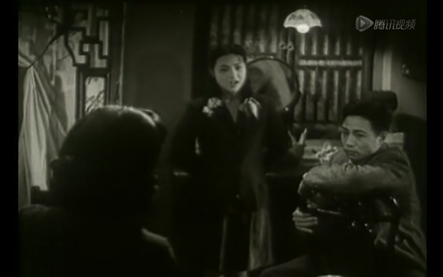

Yuwen turns her back to the audience, and now she is facing Xiu and Zhichen. I think she is looking at Xiu, so that’s why Xiu looks back. Now, Zhichen’s body is facing Yuwen.

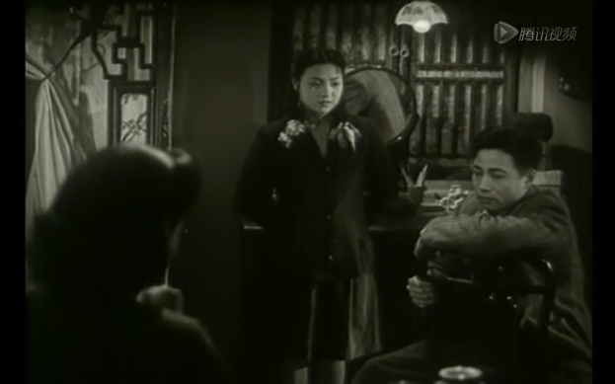

Yuwen’s head slightly turns right, I think she is looking at Zhichen at this moment. Xiu notices Zhichen’s attention is on Yuwen.

The audience has no idea whether Yuwen is looking at Xiu or Zhichen or both in this scene. So, the reactions of Xiu are important as her expressions drive the plot forward. At this point, Zhichen’s absorbed gaze on Yuwen is sexualised. He was watching what Yuwen did for her husband and guessing that is the life she has been living in. At the same time, he wishes he is the one as a husband that is taken care of by Yuwen. Even, he might think of the old days they had been through as a couple. Thus, even though his strong gaze is still in the footage, but his psychological process is active and intricate. In this thinking, Liyan and Zhichens’ gazes show their love to Yuwen in different ways – the husband is introspective and ashamed, while on the other hand, Zhichen is fanatic and transgressive.

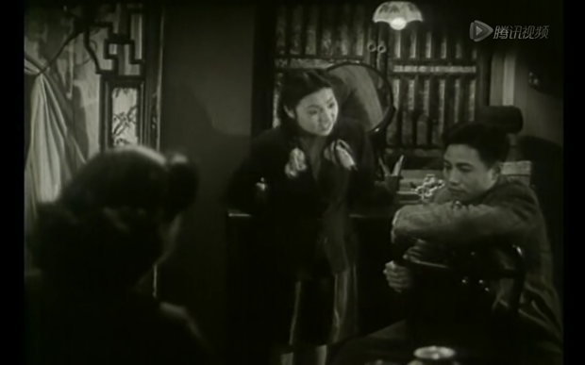

Xiu leans forward to Zhichen and tries to sing loudly to attract his attention.

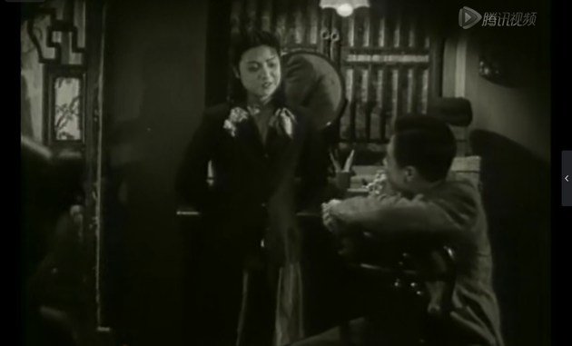

Xiu is satisfied because her actions work, Zhichen looks back at her immediately.

This scene tells the audience that Zhichen’s gazes are always on Yuwen and only stop because of Xiu’s interruption (the external factor). At the same time, it shows Zhichen has no feelings for Xiu.
Zhichen’s gaze is inappropriate because Yuwen is the wife of his friend. But the camera doesn’t give Liyan’s reaction as Zhichen’s gaze is so obvious that everyone in the room should notice. I think this is because Liyan is paying attention to his sister and senses her feelings to Zhichen. Besides, it also suggests Liyan is not a sensitive person who is good at observing others except his family.

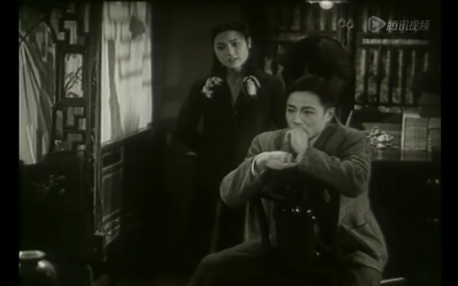

Zhichen’s two arms are on the chair, and he is biting his fingers. He turns his back to Xiu. Xiu looks at Yuwen again.

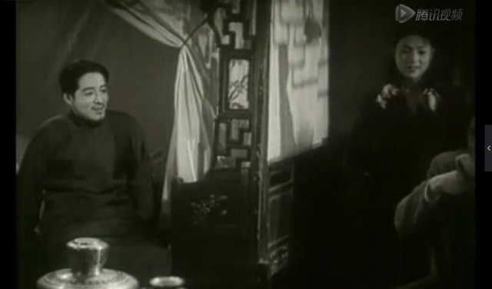

Liyan’s attention is on Xiu and Zhichen matches my previous hypothesis.

It is apparent to see that the gaze that Xiu gives to Yuwen is different from the last one. It contains jealous feeling in this time with a frown. The camera approaches Xiu and Zhichen on the top footage and moves slowly to the left to include Liyan in the scene. The position of Liyan is changed from sitting in the middle of the bed to approaching Xiu and Zhichen in a happy mood.
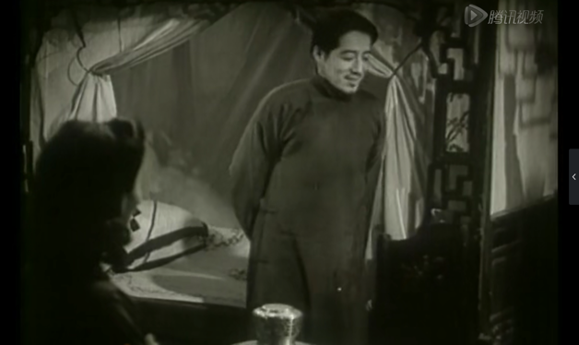

Liyan stands up smiling and walks toward Xiu and Zhichen. Liyan doesn’t stand up when his wife gives him the medicine.

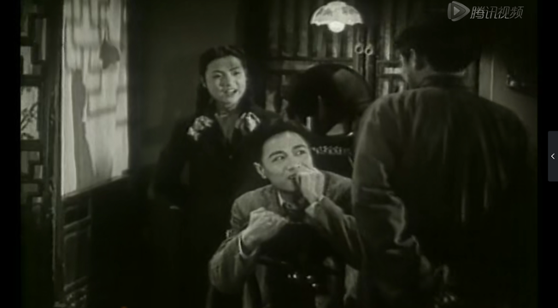

Liyan comes to Xiu and Zhichen with hands on his back. Liyan’s move attracts Xiu and Zhichen.

Liyan notices that his young sister’s emotions, as the master of the house, he should do something to help his sister pursue her love. Here, Yuwen’s gaze is on Liyan because he makes a change in his actions. In addition, it means Yuwen’s attention can be interrupted by her husband even she thinks she doesn’t love him, but her unconsciousness makes a different choice. The positions of those three people are interesting in the bottom footage. Liyan turns his back to the audience and looks down at his friend that portraying him as a patriarchal image (in Chinese old traditions, patriarchy decides the marriage of the women).

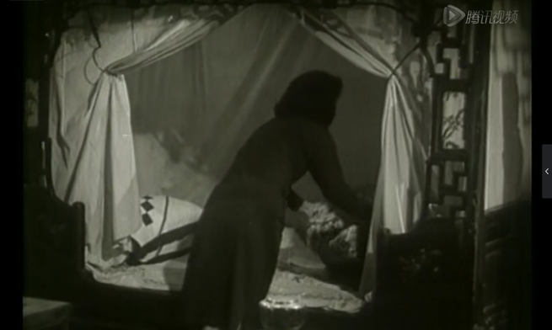

Yuwen stands up to tidy the bed. Seems like the joy in another part of the room is irrelevant to her.

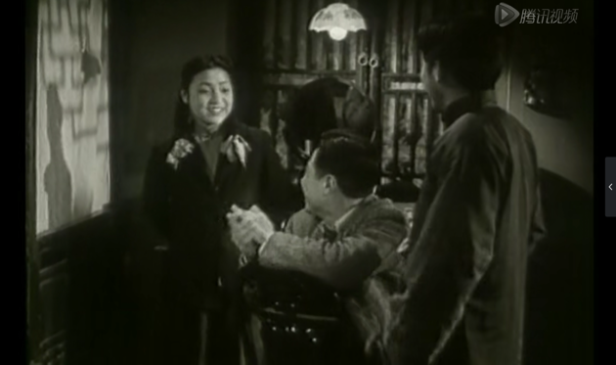

Xiu finishes her singing and Zhichen gives her a round of applause. Two men’s attention is on Xiu.

This singing plot is finished by a long shot with approximate one minute and thirty seconds which shows the complicated and obscure relationship between these four characters by presenting the flexible changes of their gazes and actions. In general, Liyan, Zhichen and Xiu all have their gazes on Yuwen as she is the centre of the room. There are no Yuwen’s voiceovers in this plot to tell the audience how she thinks and feels, but her movements are the clues that drive the gazes of the characters and let the audience follow them and interpret their psychological activities. In addition, there is no dialogue during the whole process of the singing that provides more imagery space for the audience to analyse the narrative.

Back to the male gazes in this plot, as I analysed above, Zhichen’s gaze is more voyeuristic than Liyan’s. The image of Yuwen in Zhichen’s eyes is elegant, tender, and attractive that ignites his possessive desire for her. However, the film didn’t make this desire too obvious to be seen as it will against the propriety of Confucianism. And the reason why the ending is putting Yuwen and Liyan back together is fitting with Confucianism because the passion between Yuwen and Zhiwen is still within the traditional thinking of ‘begin with love but end in propriety (Fa Fu Qing, Zhi Yu Li)’ (Daruvala, 2007). And that is why Spring in a Small Town is a realistic film that is in line with the Chinese view toward marriage.

The feminist film theory has emerged because of the second wave of feminism in the late 1960s. And the problem of patriarchal ideology had motived feminists to consider ‘the hegemony of the male gaze and the view that female characters were invariably represented as passive objects of male desire’ in feminist film in the 1980s (Creed, 487). In her well-known writing of ‘Visual Pleasure and Narrative Cinema’, psychoanalysis was applied by Mulvey to come up with the concept of scopophilia that can explain the gazes that male characters give to female characters are sexual desires (Mulvey, 1975). However, before John Berger has first used the term ‘the gaze’ and Mulvey’s ‘the male gaze’, there are no apparent definitions or notions to describe and clarify the meaning of ‘looking’ between two genders in Chinese feminist film history, even though the Chinese films themselves have already encountered this narrative for a couple of decades. Therefore, if I would not have read the feminist film theory, then I would not analyse the male gaze of Zhichen from the aspect of scopophilia-related psychology. This means the knowledge has provided me with a new way to understand and evaluate the film from a different angle. Hence, the process of understanding a thing is also the process of acquiring knowledge. Gadamer (1976: 101-102) says: ‘We cannot understand without wanting to understand, that is, without want to let something be said […] understanding does not occur when we try to interpret what someone wants to say to us by claiming we already know it.’ Therefore, being open-minded and embracing new knowledge can help us know the world differently and deeply, and also continue to explore what knowledge is in the future.

Reference list
Creed, Barbara. ‘Feminism and Film Since the 1990s’. 487-491. in Pam Cook edits., The Cinema Book (London: Bloomsbury, 2007).

Daruvala, Susan. (2007). ‘The Aesthetics and Moral Politics of Fei Mu’s Spring in a Small Town’. Journal of Chinese Cinemas. Vol. 1, No. 3, 171-187.

Gadamer, Hans-Georg. (1964). ‘Aesthetics and Hermeneutics’. In David E. Linge, edits and translates., Philosophical Hermeneutics (California: University of California Press, 1976).

Goodreads. (2021). Albert Einstein’s Quotes. [online]. Goodreads. Available at: https://www.goodreads.com/author/quotes/9810.Albert_Einstein accessed on 07/12/2021.

Mulvey, Laura. (1975). ‘Visual Pleasure and Narrative Cinema’, Screen. Vol. 6, Issue. 3, 01/10/1975, 6-18.

Zheng, Yuqing. (2021). ‘The Awakening and Dilemma of Feminist Consciousness in Early Chinese Films (1905-1949)’. Zhi Wang Journal, 15/09/2021.

PART TWO – Reflective Writing
New Abbie Manifesto
Me, Abbie, want to be an artist!
Do not let other people judge if I'm talented or not.
Do not be afraid of showing your true self to the world.
Do not follow the rules that have been set for ordinary people.
Do the thing that interests me.
Explore the truth that makes me curious.
See the world in different minds.
Follow my heart and live for myself.
YES, YES!
I want to be an artist, I want to paint, I want to make installations, sculptures, films…I want to perform, I want to dance, I want to make artworks on any day of the future. That’s the life that I should live in.

This is a piece of self-reflection writing which will use dialogue between the different me in my mind as a way to rethink my previous life and discuss my feelings. I agree with the thinking that reflection is something ‘quiet and personal’ (Kemmis, 1985: 139). Thus, showing my complicated emotions and inner struggling can let me understand myself better and deeper.

Confucius used to say that: ‘By three methods we may learn wisdom: First, by reflection, which is noblest; Second, by imitation, which is easiest; and third by experience, which is the bitterest’ (Hinnett, 2002). Yes, unfortunately, I am one of the third kind of people who use the bitterest way to equip myself with wisdom step by step. Nevertheless, at bottom of my deep heart, I am still a person who feels insecure, lonely and cares about others’ opinions. That is not wisdom. I might look happy and outgoing, kind and adorable, but I know myself, and the other Abbies know myself. Then, just let this reflection as a ‘mental process’, seeking for ‘an outcome’ of my traumas, and ‘a purpose’ of and my future (Moon, 1999: 10).

On November 20, 2021, it was a day with grey and fluffy clouds and a gust of singing wind. I was sitting on the beach alone, wondering if there will be a mermaid coming to shake my hand. Raising my head and could not stop feeling small in the universe. After a while, she appeared, and I had a conversation with her as usual. She is another Abbie, another me who is sharing my body. Actually, there are more than one in my head. I have known her for a long time that I even couldn’t tell the date or the year. I suppose she is the one who loves this world the most, or more accurately, she loves this world more than I do. But these are not important, all I care about is whether she loves me the most as well, and so the others do.

Me: There you are.
She: You look tired.
Me: No, I’m good.
She: You know, you’re a bad liar.
Me: Who told you this? I’m a performer. I play, I play all the time.
She: Are you sure?
Me: Yes, I am.
She: Then, Name one of the works you have done so far.
Me: Hmmm…I have no works.
She: Why? Everybody has.
Me: I don’t know if they can be seen as ‘works’.
She: What are you worrying about?
Me: People said I’m not a professional artist.
She: Then let them define what is ‘a professional artist’? What you have done are all ‘works’.
Me: Really?
She: 100% sure.
Me: But…they made me feel like I don’t have any valuable experiences.
She: Tell them to shut the fuck up! Right, let’s start it all over again. Name one of the works you have done in your life.
Me: Dream Pain.

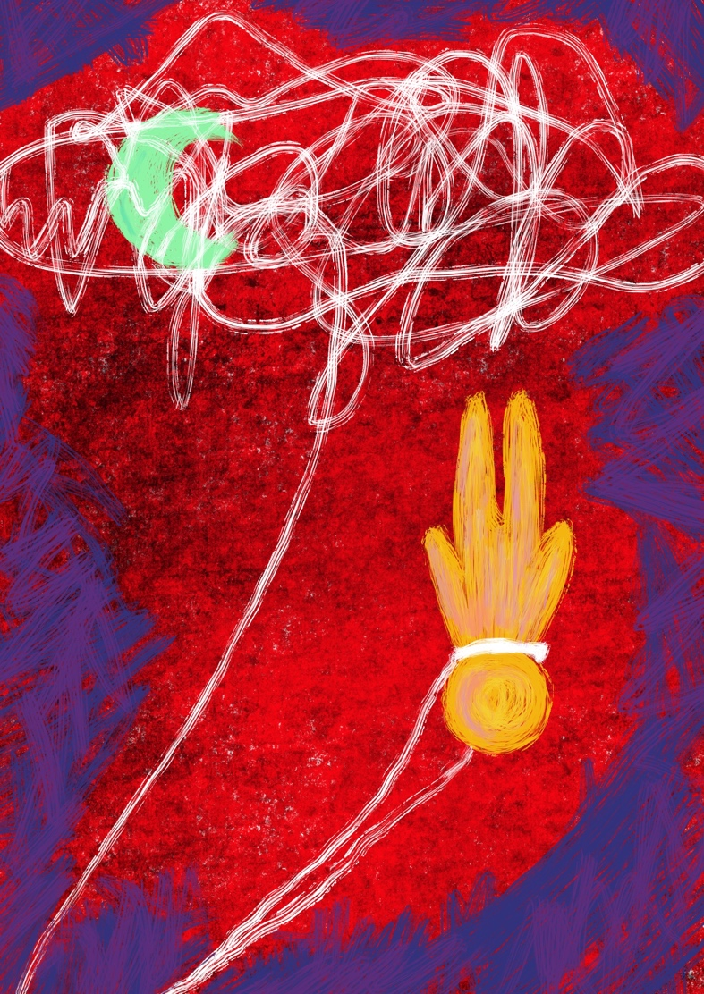
Dream Pain, 2020, Digital Painting, 297cm x 210cm.

She: You see? You do have a piece of work. Then tell me your experiences.
Me: Anything could do?
She: Perhaps, all.
Me: I had studied Journalism for four years. I was trained to be an art journalist who has abilities to report and comment on art exhibitions and events and write features and news for artists.
She: Ahh, I remember you had learned magazine production, right?
Me: Yes, I quite like that course. It lasted for two years, and it was the first time I tried to design something.
She: I thought you would hate it! You only got 42 in the personal project, the lowest mark in your uni’s life!
Me: I did cry at that time haha. I should be grateful, actually. It taught me a lesson that I should listen to the sayings of ‘less is more’, but not just create various formats for each story in the magazine.
She: Well, if you like it, why didn’t you join the magazine industry?
Me: Magazine is not my thing, and I don’t wanna work for journalism or media.
She: That’s weird! One of you once told me that she pretty liked it.
Me: Yes, she did. I even applied for my first postgraduate in journalism because of her.
She: Why’s that? You should stop her!!!
Me: She wanted to voice for the innocent and vulnerable people in the Syrian civil war, so I let her extend the research from the undergraduate to the master dissertation.
She: I remember it’s about sexual violence and the deaths of war journalists.
Me: Indeed.
She: But you were in pain. She must know you didn’t like it.
Me: Honestly, we had arguments many times.
She: She’s so selfish. That’s not your dream.
Me: So, when I was having a dream about being an art teacher and teaching a couple of kids to paint, I was so happy that woke up smiling, but I didn’t tell her though.
She: I wonder if it would have been different if you’d told her.
Me: If there was a chance to do it all over again, I would still let her do it.
She: Why?
Me: She was braver than me because she pursued what she wanted so firmly. She thought it’s necessary to do it as no one has done it before. That’s the journalistic ethics she had always kept in mind: observing the world wisely with a warm heart.
She: What about now? Has she appeared in these years?
Me: No, she is gone. Probably forever.
She: Do you miss her?
Me: No, it’s my turn now.

On November 21, 2021, a sunny day. I don’t like a rainy day like yesterday, that is because it will make me overthink a lot. I’m lying on the soft bed and letting the sunlight dance dramatically on my face. She was pretty naughty in the afternoon. I suppose that she wanted me to give her a confirmed answer, so she kept asking me different questions about my dream.

She: What are you thinking right now?
Me: Nothing.
She: Let me guess, it’s your dream, right?
Me: Haha, yes.
She: I knew it! I saw you were smiling. What does it like?
Me: Shh, give me a moment, it’s going to be eternal.

On November 22, 2021, still a sunny day. But I had a nightmare last night and I cried out loud that woke me up. It’s the same weather as yesterday but my mood is down to hell. I usually |don’t need her when I encounter this situation, even though I know she just worries about me and tries to be a good listener. But most of the time, we fight. That is why I didn’t want to start our conversation today.

She: Ab…
Me: I don’t wanna talk.
She: I know you’re exhausted.
Me: Leave me alone, please.
She: Why are you so upset?
Me: Because I’m enough with people.
She: Who are they?
Me: Really? Are you sure you should ask me this question?
She: I assume you have been overthinking.
Me: Me? Overthinking! Seriously?
She: You have been over protecting yourself, it’s not that necessary.
Me: You wouldn’t say these crucial words unless you have been hurt before.
She: But who has hurt you, huh? Do you mean the people in primary school? And middle School? That’s a long time ago!
Me: They were bullying me!!!!!!
She: Well, yes, but maybe you had done something wrong!
Me: How dare you say that!
She: Right, I’m sorry. Yes! they did it for no reason. But have you ever tried to forget it?
Me: Memories are long!
She: I want you to know you shouldn’t live in the past. You don’t need to forgive them, but you should set yourself free!
Me: Perhaps you should know there’s a word in English that is trauma.
She: Trauma? I suppose everyone has traumas, not just you.
Me: But each one is different. I wanna know my inner world.
She: Is this the reason you are interested in psychoanalysis and art?
Me: Yes. Traumas leave a trace in my unconsciousness and the dreams wake me up.
She: How long have you been noticing your dreams?
Me: After the pandemic, I drew my very first dream’s interpretation – Dream Pain. I was suffering from long term nightmares during that period because I saw people were dying every single day, but I could do nothing and just watched. Compassionate feelings had hurt me. And those pains did remind me of the old and buried traumas in my deep memories.
She: So, drawing dreams is somehow a self-therapy for you.
Me: Yes.
She: Have you drawn one today? Guessing it can make you calm down.
Me: Yes, and I made two. I felt much better and peaceful when I finished the first one, so I drew another one.

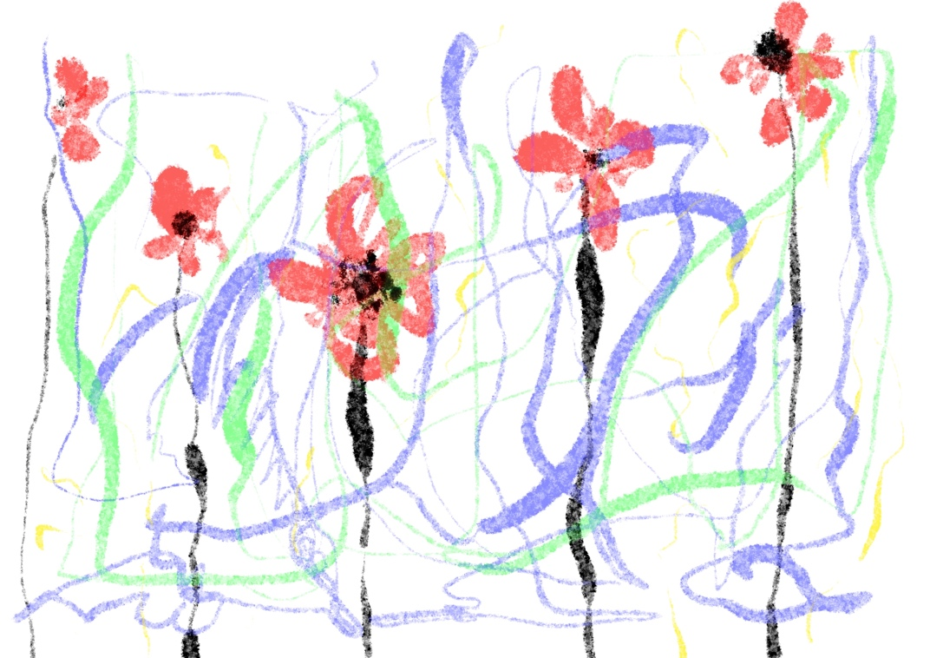
Untitled, 2021, Digital Painting, 297cm x 210cm.

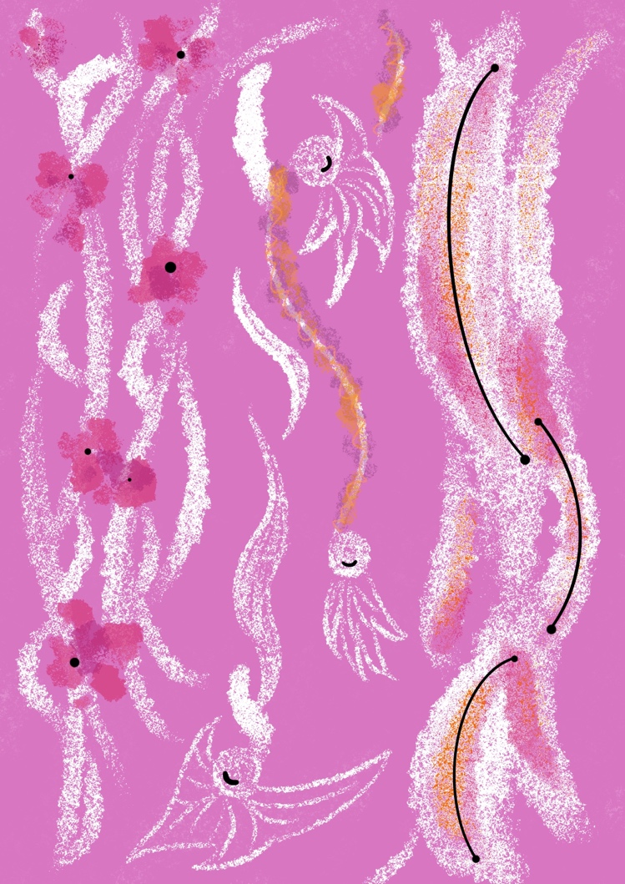
Untitled, 2021, Digital Painting, 297cm x 210cm.

She: That’s good.
Me: Sorry I shouldn’t shout at you.
She: Never say sorry, and, I love you.

It was sunny in the afternoon of November 27, 2021. There was pouring rain yesterday, cold, and windy. But people still love Black Friday that bad weather couldn’t stop them from shopping! I’m part of them.

She: How’s your day? Bought a lot?
Me: Yeahhh! I got a new ruffled shirt today for the graduation ceremony!
She: Excellent! Remember to wear flowery stockings. The red rose one.
Me: Hahaha, then I’ll be the prettiest in our art school!
She: You will! But…Abbie, since you’ve well prepared for the ceremony, do you wanna read some books tonight cuz you have stopped learning in a few days…
She 2: So what?
She: Why are you here? You’re not welcome.
Me: Hmmm…
She: Don’t listen to her Abbie, you got so many things to do.
Me: Actually…
She 2: Yes, go on, I know what you’re thinking!
She: Get out!
She 3: Maybe 2 is right, why are you keep controlling Abbie?
She: Excuse me? All I have been doing is to help her to be a better person.
She 2: Obviously she just wanna be happy every day.
She: Don’t disturb her, I’m warning you.
She 3: Come on 1, you are so arrogant. You have made every decision for her but never asked if she like it or not.
She 2: She doesn’t like it hahaha! I can tell.
Me: Stop arguing.
She 2: Abbie, giving it up, ok? You are just a daydreamer! You’ll never be an artist. Opening your laptop and watching South Korean TV shows.
Me: No.
She: No!!!! Abbie, Abbie! Keep focus!
She 3: No, Abbie, if being an escapist can make you happy, then just do it. It’s doesn’t matter at all.
She: She won’t do it!!!
She 2: You should know who you are. Don’t pretend you’re a hard-working student, that really makes me laugh.
She 3: Choose the one that makes you happy.
She: Learning can make her happy!
She 2: Happy? Then why does she still read the same book for two weeks? She has absorbed nothing haha! Do you know your fellows stay up late for studying until 2 or 3 am! But Look at her!!! How lazy she is!!!!! Going to bed early and watching funny cats and dogs’ videos!
She: Stop talking you idiots!!!!
Me: Enough!
She 2: Facing the truth.
She 3: 2, I think she is talented but needs more time. It always takes time to become a genius.
She: Abbie, open your laptop and write your essay, NOW!!!
Me: I don’t need you to tell me what I should do! And you, and you!
She 4: Time to call your friends.

On November 28, 2021. A day with a big storm and heavy snow. I was going to Edinburgh to attend my second master’s graduation ceremony. I have spent more than 12 hours on the train but that was fine, the next day will be one of the biggest days of my life. I know nothing precious comes easy, so it must be tough before I gain happiness. It is worth doing, always.

I was observing the people on the trains and platforms quietly and wondering what lives they have and where will they go. We might never meet again but we were breathing in the same place once in our lifetime. It really makes me feel strange and also marvel if I am standing in a crowd of people. I don’t know them, and they don’t know me. Every one of us is given birth by our mothers, and we were just zygotes at the very beginning and grow up to a human day by day. But we have no ideas about life before coming to this world, even some of us have been living for dozens of years still be confused and lost in time, in fates.

Obviously, I had messy thoughts during the trip, guessing that was the reason why I was so exhausted. But I was glad that Abbies were quiet. They always argue which does upset me.

It was snowing outside the window; I wrote my first poem in English on the train: “It’s a pale place. Lives are buried under the snow, but we all know their roots still be strong. I am a creature walks through the snowy world. Alone, and alone.”

On November 29, 2021. I was crying so hard in the ceremony. We gave the first round of applause to ourselves, the graduands. The second round of applause was for the university’s staff. And the last round was given to our loved ones. It was hard for all of us studying and living during the pandemic. But thankfully, we did it, well done! I was so touched by what the uni’s president said: “Never stop learning, be kind, and help to make a better world.” At that moment, I knew I will keep these words in my mind and try my best to do it for the rest of my life. I really hope I can become the kind of person who can contribute to the world in one day, I do not mind if no one will ever remember me.

I came back to Swansea in the early morning the next day, it was still a long long journey, but I was a bit different compared with me two days ago. Guessing my dear Abbies will still fight with each other, but it will be all right, I have known what I should do. Just as Keith Haring said: ‘Art should be something that liberates your soul.’ It is a new me sitting in front of the laptop right now, with more confidence for the future and more gratitude to the past.

Reference list
Kemmis, Stephen. ‘Action Research and the Politics of Reflection’ in David Boud, Rosemary Keogh and David Walker, edits., Reflection: Turning Experience into Learning (New York: Kogan Page Ltd., 1985).

Hinnett, Karen. Developing Reflective Practice in Legal Education, cited from Confucius (Warwick: Warwick Printing Press: 2002).

Moon, Jennifer A. Reflection in Learning and Professional Development: Theory and Practice (London: Routledge, 1999).

