BSCHSC BMHP5014_BIRM

Creativity and Value Creation

Student: 2014405 Laura Callan
Lecturer: Dr Azora Hurd.

CONTENTS PAGE
Page Three................Introduction
Page Four..................Front page Flyer.
Page Five...................Back Page Flyer.
Page Six.....................Front page Flyer Description.
Page Seven................Back page Flyer Description.
Page Eight..................Elevated Pitch.
Page Nine...................Elevated Pitch Cont.
Page Ten……………. References.
Page Eleven………….References Cont.

INTRODUCTION.
I have developed my e-portfolio as a new project for a Mindful café as there is a lack of places for people with mental health issues or concerns to feel, to seek advice, or to engage with likewise people, make friends and connections. I have chosen artifact 3 the elevated pitch and artifact 4 the flyer to promote my plan.

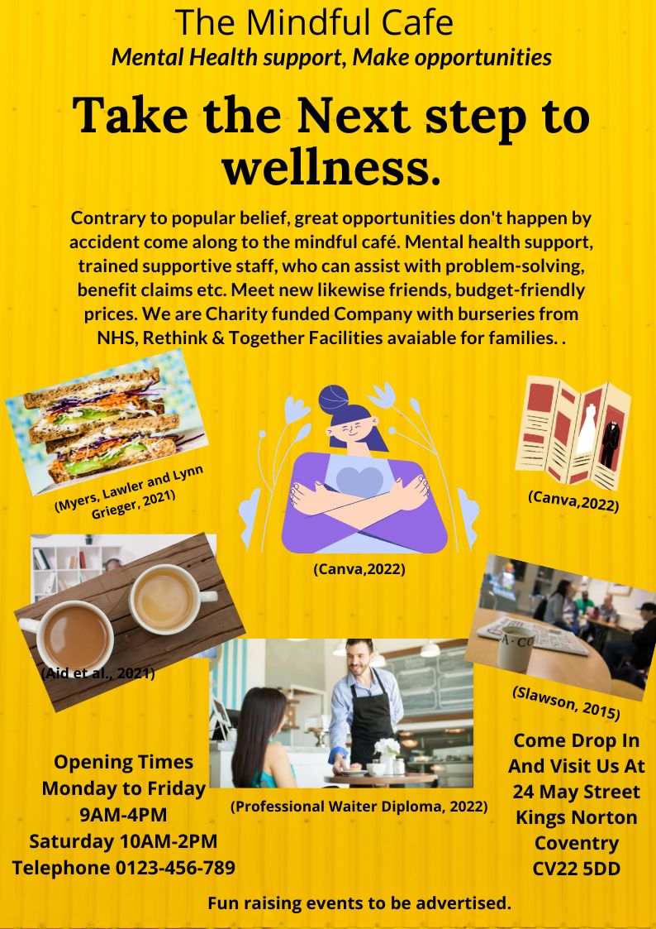

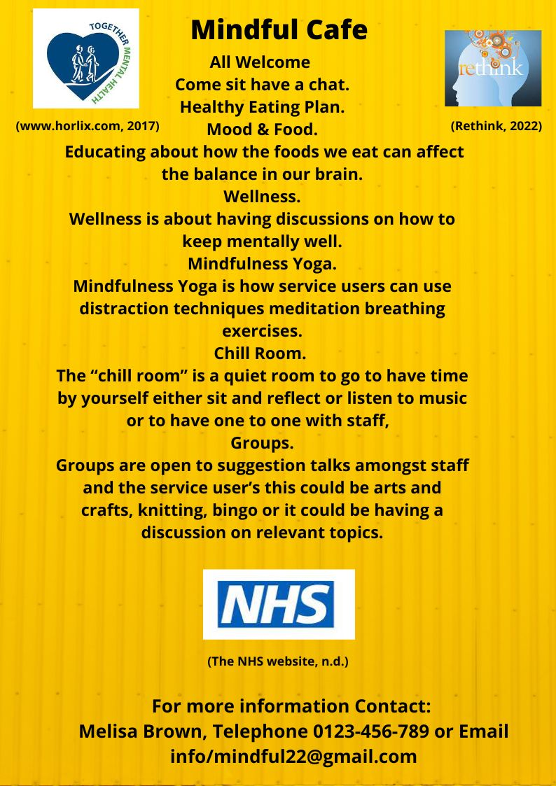

FRONT PAGE FLYER DESCRIPTION
I have produced my flyer using a website called Canva which was useful as it had icons and pictures, and text boxes that I could facilitate and needed to complete my flyer. Canva has an array of backgrounds that are vibrant and bold to grasp the audiences to the information I am portraying. I have also referenced by using charity websites and the NHS website.
The first page is introducing what the café is about that we provide a safe and friendly environment pacifically for mental health, as mental health has increased especially during the pandemic a place to meet likewise people and feel welcomed and no stigma to their illness
The flyer also explains we have trained dedicated staff who they can seek advice, from, this could be struggling with their mental health, or assistance with benefits. In the flyer, the public can also see that we are a charity-run company and gather funding from charity events, also funding from other mental health organisations and the NHS working in conjunction with talking therapies that service users can access themselves or via a GP. This funding is to assist in the running of the café to signpost to the café. (NHS talking therapies, 2021)
My flyer has a bright yellow background to capture the public's interest. The diagrams I chose are to what a café would entail a waiter, beverages, and food. I also used an image of people chatting to portray friendliness for the public to get the feeling that they will feel welcomed and at ease.
There is also an NHS logo, rethink and together so it shows our sponsors. While using Canva I used the text boxes to enter my dialogue describing the café's features, the title Mindful Café was in bold black lettering using size thirty-two font, the sub-title is also in bold black lettering Lato font size twenty-one point five, this subheading is to highlight that mental health is the focus of the café. The third heading is an indication of the journey within mental health, this font was Lora forty-five point six.
Around the flyer, I have placed bright pictures image one is of a sandwich, image two is a picture of a hug, image three is of a flyer image four is of beverages, image five is of customers in a café setting, and image six is of staff.

SECOND PAGE FLYER DESCRIPTION.
The second page is an introduction to what I want the public to know, which is information about a new mental health café specialising in advising on healthy eating planning. Food and Mood are educating about how the foods we eat can affect the balances in our brain. Wellness is about having discussions on how to keep mentally well. Mindfulness Yoga is a form of meditation getting as one with your body. are how service users can use distraction techniques meditation breathing exercises. The “chill room” is a quiet room to go to have time by yourself sit and reflect or listen to music or to have one to one with staff, and the groups are open to suggestion talks amongst staff and the service user’s this could be arts and crafts, knitting, bingo or it could be having a discussion on relevant topics.

Elevated Pitch
Good morning its lovely to see so many people here today to discuss with me the need for more services within the community for Mental Health to be able to access without feeling the stigma that can go along with Mental health.
This café will enable people to gain insight into food and mood how certain foods can affect the mind and body, also to develop skills, distraction techniques for coping mechanisms to take forward to progress in daily living.
My passion came from having a niece who has Bi-Polar, and when she feels like she is going into a crisis there is nothing available other than an admission to respite or hospital, and sometimes all we need is a reassurance that we can go somewhere and just talk to people other than professionals, which is something my niece has often said to me as she is a single mum and she gets concerned if the medical team become involved this will affect her family dynamics or fear her children will be taken into care.
This is the seed that grew the concept for Mindful Café as where she lives there is nothing of this nature somewhere to build on living skills encouragement to seek assistance without the fear of judgment, or repercussions
Every year, one out of every four people in the UK suffers from mental illness Mental illness affects approximately 792 million individuals globally One in every six working-age adults has issues associated with mental ill-health. Mental health diseases are now more widespread, endure longer, and have a significant impact than other health conditions They amount to 72 million lost hours at work each year and cost £34.9 billion (Mental health statistics, 2020).
Different research or studies will have similar costs but not always the same. There was an estimate of 6,154 suicides in the United Kingdom in 2018, this translates to about 16 people every day taking their own lives. It is approximated that ten to twenty-five people make attempts on their life (Mental health statistics, 2020).

ELEVATED PITCH CONT.
This is also where the concept for Mindful café has come from with these statistics in mind, I feel that having a haven for people that are struggling with mental health or stresses of everyday life can come to get support from staff or meet up with others to take time out of their thinking or just not to be or feel alone.
The mindful cafe is a charity we gain most of our funding from planned events, and donations, we also have funding from NHS, “simple steps you can take to look after your mental health.” (NHS talking therapies, 2021). Rethink: - providers of services for people living with mental illness (Our vision and impact, 2021).
Together: - Individuals have the rights, opportunity to live self-sufficient lives. (Together: A leading UK mental health charity, 2022) This way we can work in collaboration with each, for example, a person may have accessed services at NHS and might just need an outreach they could be guided to the café, hence supporting the NHS workload, and supporting the café.
I would like to thank you all for the opportunity to speak today I hope you gained some knowledge of Mindful café. I welcome any feedback or questions you have.

REFERENCES

Agarwal, P., (2021). Your Love for Coffee or Tea is all Genetic – Vaya News. [online] Vaya News. Available at: <https://vaya.in/news/love-coffee-tea-genetic/> (Accessed 23 February 2022).
Aid, T., Learning, O., Sciences, C., Management, D., Degrees, E., Hygiene, M. and Administration, O., (2021). Understanding Mental Health as a Public Health Issue. [online] Publichealth.tulane.edu. Available at: <https://publichealth.tulane.edu/blog/mental-health-public-health/> (Accessed 23 February 2022).
Canva., (2022). (online) Available at: <https://www.canva.com/design/DAE4o1zXzl8/1ULHVQNLG3TYOjgLWzfiaQ/edit#> (Accessed 21 February 2022).
Canva., (2022). (online) Available at: <https://www.canva.com/design/DAE4o1zXzl8/1ULHVQNLG3TYOjgLWzfiaQ/edit#> (Accessed 22 February 2022).
International Open Academy.(2022). Professional Waiter Diploma. (online) Available at: <https://internationalopenacademy.com/products/professional-waiter-training-diploma-online-course> (Accessed 22 February 2022).
MHFA Portal. (2020). Mental health statistics. (online) Available at: <https://mhfaengland.org/mhfa-centre/research-and-evaluation/mental-health-statistics/> (Accessed 23 February 2022).
Myers, W., Lawler, M. and Lynn Grieger, C., (2021). 10 Healthy Sandwich Dos and Don'ts. (online) EverydayHealth.com. Available at: <https://www.everydayhealth.com/healthy-recipes/healthy-sandwich-dos-and-donts.aspx> (Accessed 23 February 2022).
nhs.uk. (2021). NHS talking therapies. (online) Available at: <https://www.nhs.uk/mental-health/talking-therapies-medicine-treatments/talking-therapies-and-counselling/nhs-talking-therapies/> (Accessed 25 February 2022).
nhs.uk. n.d. The NHS website. (online) Available at: <https://www.nhs.uk/> (Accessed 22 February 2022).
Ons.gov.uk. (2019). Home - Office for National Statistics. (online) Available at: <https://www.ons.gov.uk/> (Accessed 23 February 2022).

REFERENCES

Rethinkbehavioralhealth.com. (2022). Rethink. (online) Available at: <https://www.rethinkbehavioralhealth.com/Home> (Accessed 21 February 2022).
Slawson, N., 2015. Late-night cafe can keep people with mental health problems out of A&E | Nicola Slawson. (online) the Guardian. Available at: <https://www.theguardian.com/society/2015/dec/01/mental-health-problems-late-night-cafe-not-a-and-e> (Accessed 23 February 2022).
www.horlix.com, J., (2017). Together : Annual Review 2016 - 17. (online) Together : Annual Review 2016 - 17. Available at: <https://www.together-uk.org/ouryear/16-17/support.php> (Accessed 22 February 2022).
Together: A leading UK mental health charity. 2022. Together: A leading UK mental health charity. (online) Available at: <https://www.together-uk.org/> (Accessed 2 March 2022).

