

RESULT

ASSIGNMENT DETAILS AND FEEDBACK
SOUTH WEST WALES CENTRE FOR TEACHER EDUCATION

Student Name: | Cameron Paul Avo | Student P Number: | 1706414
Programme: | Secondary Post Graduate Certificate in Education
Module: | Curriculum Development and Enhancement | Module Level (6 or 7): | Level 7
Module Code: | ECSP7002 | Contribution to Overall  Module Assessment (%): | 100
Module Lead: | Jan Barnes
Assignment Title: | Reflections on Teaching and Learning | Assignment Number: | 1
Start Date: | Not Specified | Submission Deadline: | 14th May 2018 - Full Submission
Return Date of Provisional Marks & Written Feedback: | 11th June 2018

Referencing: | In the main body of your submission you must give credit to authors on whose research your work is based. Append to your submission a reference list that indicates the books, articles, etc. that you have read or quoted in order to complete this assignment (e.g. for books: surname of author and initials, year of publication, title of book, edition, publisher: place of publication).
Submission: | All assignments must be submitted to Turnitin unless otherwise instructed by the Lecturer.  Note: the Turnitin version is the primary submission and acts as a receipt for the student. Late submission of the electronic version of the assignment will result in a late penalty. Penalties for late submission: Up to one week late, maximum grade D. Over one week late, Refer. Only the Extenuating Circumstances Panel may grant an extension. | Date: | 13/05/18

Module lead to tick to indicate if a hard copy version of the assignment must be submitted. | YES
 | NO | ✔

Secondary Post Graduate Certificate in Education
ECSP7002: Curriculum Development and Enhancement

Will scaffolding a PISA-style QER question with an inference grid lead to an improvement in pupils’ performance?

Cameron Paul Avo
1706414

Contents

Introduction Pg 4
Literature Review Pg 5
School Policy and Practice Pg 11
Methodology and Ethics Pg 12
Evaluation Pg 14
Conclusions Pg 19
Limitations and Future Development Pg 22
References Pg 23
APPENDIX A: QER/PISA-Style Questions A and B Pg 28
APPENDIX B: Exemplar Letter to Participants and Consent Form Pg 29
APPENDIX C: Exemplar Inference Grid Pg 31
APPENDIX D: Mark Schemes for Questions A and B Pg 32
APPENDIX E: Raw Data from Study Pg 33
APPENDIX F: PowerPoint for Intervention Training Pg 34

Introduction
Across the world, societies are recognising the link between scientific literacy and economic growth, as it becomes ever more important to solve social and environmental problems using science and technology (OECD, 2018a). The concept of scientific literacy encompasses an understanding of science and science-based technology (OECD, 2017). The focus of the 2015 Programme for International Student Assessment (PISA), run by the Organisation for Economic Co-operation and Development (OECD), was to test pupils’ ability to communicate their scientific understanding in the context of global problems (OECD, 2018a). Of the 75 countries that took part (OECD 2018b), Wales’ average score for the science section was 8 points below the 2015 OECD average and 20 points below its 2006 performance (Jerrim and Shure, 2016a).
The Welsh Government recognises the growing need for well-educated scientists to support Wales’ future growth and prosperity (Learning Wales, 2016a). In response to the falling standards of scientific literacy in Wales (Jerrim and Shure, 2016a), the WJEC has introduced questions into its GCSE Science examinations that specifically assess pupils’ scientific literacy skills. These questions are labelled ‘quality of extended response (QER)’ (previously ‘quality of written communication / QWC’), and marks are awarded for the content in pupils’ answers, the clarity with which they express themselves, their spelling, punctuation and grammar (WJEC, 2018a). These questions are similar in format to those asked in PISA. It is regularly emphasised in the Examiners’ Reports how poorly candidates answer these types of questions (WJEC, 2018b). As a result, I decided to base my research on trialling an intervention designed to assist pupils in answering PISA/QER-type questions. The aim of this research was to determine whether scaffolding a QER question with an inference grid (to be discussed later) would lead to an improvement in pupils’ performance.

Literature Review
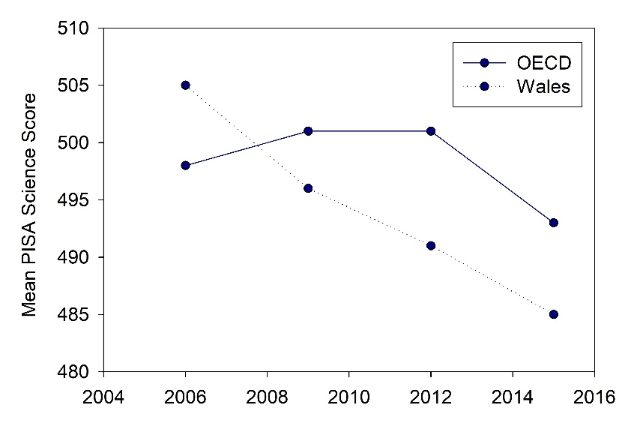
An education in scientific literacy involves pupils comprehending the falsifiability of scientific theories, appreciating the value and limitations of experimentation, and recognising the problem-solving nature that is inherent in scientific enquiry (Zen, 1990). In Wales, the National Curriculum aims to develop pupils’ scientific literacy through a combination of content-based and enquiry-led teaching (Welsh Assembly Government, 2008). Estyn (2017) conducted a report into the quality of science education in Wales, which highlighted several interesting points. Notably, there has been a general increase in the number of pupils achieving a level 2 qualification (GCSE or equivalent) in science between 2012 and 2015. Though this number declined in 2016, pupils in Wales perform better in science than the other core subjects (mathematics and English/Welsh).
While the level 2 attainment in science amongst Welsh students is increasing, there is a disparity with the findings of PISA 2015. PISA is conducted every three years, and, as evident in Figure 1, the performance of Welsh pupils in the science section has been continually declining since 2006. The results showed that pupils in Wales perform better when required to explain scientific phenomena than when asked to critique or design a scientific enquiry (Jerrim and Shure, 2016a). This contrasts with the performance of pupils in England and many of the top-scoring countries, which show equal strength in explaining scientific phenomena and critiquing/designing scientific enquiries (Jerrim and Shure, 2016b).
Figure 1: Performance of Welsh pupils in the science section of the OECD’s Programme for International Student Assessment vs OECD average across all participating countries.
Adapted from Jerrim and Shure (2016a).
It is difficult to isolate factors which could be contributing to the discrepancy between English and Welsh pupils’ abilities in scientific literacy. PISA is conducted amongst 15-year-olds; consequently, the majority of candidates will be in key stage 4 (KS4). The curricula for science subjects at GCSE do not differ significantly between England and Wales, as these courses are regulated by Ofqual, the Welsh Government and Qualifications Wales (WJEC, 2018c). Differences in educational experiences in science are more likely to arise in key stage 3 (KS3), where the National Curricula, though generally similar in topics, differ in the detail with which they specify the content that must be delivered (Welsh Assembly Government, 2008; Department for Education, 2013). A recent report in Wales outlined that pupils make good progress in their understanding in only about half of KS3 science lessons, and that teachers’ expectations of pupils’ attainment are often too low (Estyn, 2017). Interestingly, one of the main reasons for the decline in Wales’ PISA performance is a reduction in the number of top-scoring candidates (Jerrim and Shure, 2016a). This may suggest that pupils in Wales with the potential to perform well academically are not being challenged appropriately. Conversely, an Ofsted (2011) report in England highlighted the excellence of teaching in science across a wide range of schools. It was noted that the quality of science curricula was either ‘good’ or ‘outstanding’ in practically all schools assessed, and that pupils are appropriately supported and/or challenged, depending on their needs. It will be necessary to readdress this issue after the implementation of the new KS3 curriculum for Wales in 2022 (Welsh Government, 2018), and assess whether this leads to an improvement in the quality of science teaching in KS3.
Another factor affecting the overall attainment of Welsh pupils in scientific literacy may be poverty. The number of people living in poverty has remained higher in Wales than England, Scotland and Northern Ireland for over 20 years (Barnard, 2018). It is well-established that pupils who receive free school meals (FSM), often taken as an indicator of poverty, perform significantly poorer than their peers who do not (Estyn, 2013; Estyn 2017). In particular, there is a significant disparity between the literacy and numeracy skills of FSM and non-FSM pupils (Andrews 2011a; Andrews 2011b). Competency in scientific literacy demands an array of skills, and as a result, any detriment to literacy and numeracy skills experienced by FSM pupils will undoubtedly hinder the development of their scientific literacy. The Welsh Government recommends targeting FSM pupils who struggle with literacy with increased interventions (e.g. extra lessons specifically aimed at improving pupils’ literacy skills) as one approach to tackling disadvantage (Learning Wales, 2016b). While beneficial to pupils’ overall attainment, occasionally an issue arises with such interventions, where pupils receiving withdrawal support do not take this teaching on board when working independently in other subjects (Webster, 2014).
This hints at a more fundamental drawback of subject-based teaching: the risk that pupils compartmentalise the learning from different subjects and resist approaching problems with a cross-curricular mindset. This is alluded to in ‘Successful Futures’, which encourages the development of ‘Areas of Learning and Experience’, rather than traditional subjects, in an effort to promote cross-curricular thinking amongst pupils (Donaldson, 2015). In this report, literacy and numeracy are described as the “foundations of education”, and should therefore be embedded into the delivery of all lessons by all teachers. The Welsh Government has tried to address this issue by implementing the National Literacy and Numeracy frameworks, which aim to encourage a whole-school approach to developing literacy and numeracy across the curriculum (Learning Wales, 2014). Scientific literacy demands sufficient literacy skills to coherently express and comprehend scientific phenomena, as well as sufficient numeracy skills to apply mathematical reasoning to solve numerical problems (Zen, 1990). The findings of PISA 2015, as well as previous PISA tests, indicate that Welsh pupils perform below the OECD average across all three of the main areas tested (reading, mathematics and science) (see Table 1). This suggests that pupils’ poor performance in scientific literacy stems from a more general weakness in both literacy and numeracy.
Table 1: Average scores of Welsh pupils in three sections of the 2015 Programme for International Student Assessment vs OECD average of all participating countries.

Adapted from Jerrim and Shure (2016a).

 | Reading | Mathematics | Science
Wales | 477 | 478 | 485
OECD | 493 | 490 | 493

The notion that all teachers should embed the teaching of literacy and language into their practice has been prominent since the mid-70s (Department of Education and Science, 1975). Since then, it has been recognised that, for pupils to acquire an understanding of science, they must be able to comprehend its specialist vocabulary, decipher the meaning of scientific theories, and use the language of science to communicate their own ideas (Wellington and Osborne, 2001). An emerging problem, as reported by Estyn (2017), is that many KS3 lessons are not delivered in such a way that suits the needs of all learners. Too often, it seems that teachers set low expectations for their classes, thus encouraging a larger proportion of pupils to feel that the lesson is easily accessible, rather than tackle with the complex issue of differentiation. One of the highlights of the Ofsted (2011) report on science education in England was that teachers set high expectations for their pupils and differentiate work well in the majority of KS3 lessons. While certainly not the sole reason behind the higher PISA performance of English pupils compared to their Welsh peers (Jerrim and Shure, 2016a; Jerrim and Shure 2016b), there is little doubt that high expectations and more thorough scaffolding has only worked to improve the standards of science education in England.
It is explicitly stated in the National Curriculum for KS3 Science in England that pupils should develop the ability to use specialist vocabulary to explain scientific phenomena (Department for Education, 2013). Similarly, the National Curriculum for KS3 Science in Wales states that learners should have regular opportunities to develop their oracy, writing and reading skills, and over time this should lead to progression in their use of scientific terminology (Welsh Assembly Government, 2008). Moving into KS4, the new GCSE specifications developed by the WJEC have placed an emphasis on assessing pupils’ scientific literacy by testing their ability to communicate relevant information in a coherent fashion (WJEC, 2016). These questions are labelled ‘QER (quality of extended response)’. Candidates’ answers to these questions are categorised into three Bands dependent on the quality of their response, their underlying logic and their coverage of the question, while their final mark is determined by the accuracy of their spelling, punctuation and grammar. The aim of introducing QER questions was to encourage teachers to dedicate more time to teaching broader scientific literacy-related skills, rather than solely delivering the specified content; however, this has so far failed to translate into an improvement in Welsh pupils’ PISA performance (Jerrim and Shure, 2016a).
It is important to look more closely at the aspects of scientific literacy that are assessed by PISA, and why this is important in the context of Welsh education. The framework used in the development of PISA 2015 defined a scientifically literate individual as one who can engage intelligently with science-related issues (OECD, 2013). It identified three distinct competencies which form the foundation of scientific literacy: content knowledge, procedural knowledge and epistemic knowledge. The delivery of content knowledge (i.e. factual information related to a subject) has always formed an integral part of teaching (Ball et al., 2008). It was noted that, relative to performance in other areas, Welsh pupils were good at describing and explaining scientific phenomena (Jerrim and Shure, 2016a), which suggests that the current National Curriculum for Wales is succeeding in giving pupils a concrete understanding in science. Welsh pupils are much weaker in their ability to make evaluations of scientific enquiries and to design their own enquiries when presented with a science-related problem. This ties into the concept of procedural knowledge – i.e. an appreciation of the processes used by scientists to establish content knowledge (Millar et al., 1994). In Wales, pupils are educated in procedural knowledge by undertaking various enquiries in KS3 (Welsh Assembly Government, 2008) and completing specified practical experiments in KS4 (WJEC, 2016). Additionally, a scientifically literate individual should be able to make judgements on whether conclusions drawn from an enquiry are justifiable, which feeds into epistemic knowledge (Duschl, 2008).
The latter competencies, procedural and epistemic knowledge, require more than simple fact recall; they require pupils to engage with higher order thinking skills such as inference (Bedell, 1934). The ability to infer involves the application of known knowledge to solve problems in unfamiliar situations (Hayakawa, 1939). Judging by the poor performance of Welsh pupils in this area of the PISA test (Jerrim and Shure, 2016a), these are skills which have not been developed sufficiently by the current curriculum. A review by Kispal (2008) summarised the requirements for a pupil to have good inference skills as: an ability to read actively (i.e. reading with the intent to make sense of the text), an ability to evaluate their own comprehension and misunderstandings, a rich vocabulary and a competent working memory. It was also noted that good inference skills are largely dependent on having a decent background understanding of the text’s subject. By appreciating the foundations on which inference skills can be developed, it may be possible to devise scaffolding strategies to aid pupils in answering questions which demand these higher order skills.
Martin (2002) proposed that one of the many strategies for promoting active reading is encouraging pupils to make notes on a text while they read. Naturally, pupils must engage more closely with a text when required to summarise the information it provides. By stimulating active reading in this way, it increases the likelihood that pupils will make links between their prior knowledge and the content of the text. This notion works well with the ideas of Graesser et al. (1994), who devised a constructivist theory of inference which states that some, though not all, of the information extracted from a source is assembled in the context of prior knowledge. Researchers argue that pupils will not develop inference skills independently, and that simply dedicating more teaching time to reading is not sufficient (Byrnes, 2000). Without specific training, pupils have a tendency to simply re-word information from a text to answer a related question, and only then will they understand its meaning (Dewitz et al., 1987). Baker (2002) concluded that, in order for pupils to develop the higher order thinking skills required for inference, they require instructional scaffolding. A landmark publication in the study of inference training was the work of McGee and Johnson (2003), who found that training pupils to infer meaning from sources drastically improves their ability to answer questions related to a text. However, this research focused on improving pupils’ ability to decipher the meanings of literature-type texts; research into whether inference training of this kind has a similar benefit on scientific literacy skills is limited. When given comprehension exercises, all pupils tested by McGee and Johnson (2003) showed improvement, whether they received inference training or not, as a result of having an opportunity to practise this skill, but the observed improvement was accelerated by inference training. This links more closely to the types of questions asked in the scientific literacy section of PISA, where pupils must comprehend information given to them, and use their own knowledge to answer related questions. This raises the possibility that utilising scaffolding strategies to encourage inference will better pupils’ ability to answer PISA-style questions testing scientific literacy skills.
It important to emphasise that inference training cannot take precedence over content delivery, as understanding the vocabulary used in a question is vitally important in successfully answering it (Cain, 1996). Research has found that the success with which pupils can use inference to answer a question is dependent on their vocabulary (Calvo, 2004); i.e. those who do not possess the vocabulary to comprehend a question cannot compensate for this by employing inferencing skills. Rather, inference-based scaffolding strategies may promote success in comprehension by refocussing pupils’ aims. It may be that pupils who struggle with reading concentrate more on doing so accurately, while skilled readers will spend more time deciphering the meaning of a text than simply reading it (Cain and Oakhill, 1999). Lewis and Wray (2000) proposed numerous ways in which teachers can utilise inference-based scaffolding, including the use of an ‘inference grid’. This is a grid which encourages pupils to draw specific information from a question, rather than passively read it. An example of an inference grid is shown in Figure 2.
What do you know? | What can you see?
What can you infer? | What further questions should you ask?
Figure 2: Exemplar inference grid. Pupils must populate the grid using information from the question, information inferred from the question and their own knowledge.
While research into inference training and scientific literacy is limited, the benefits in comprehension-type questions are well-documented (Kispal, 2008). Building on this, it is possible that pupils attempting PISA-style questions testing scientific literacy may benefit from using a scaffolding tool such as an inference grid. Potentially, this may encourage them to be more active in their reading, utilise their prior knowledge, and more fully decipher the intended outcome of the question. This leads to the purpose of this research, which is to scaffold a scientific literacy question with an inference grid to see if it leads to an improvement in pupils’ performance.

School Policy and Practice
To maintain anonymity, the school in question will be referred to as ‘School X’. None of the schemes of work in School X include lessons specifically devoted to preparing pupils for PISA, nor do they explicitly mention developing scientific literacy skills. There has, however, been widespread integration of the National Literacy and Numeracy frameworks across the KS3 curriculum, including within the Science Department. For example, in the Year 8 scheme of work, a number of tasks provide pupils with extended pieces of writing from which they must infer information. The primary focus of School X’s scheme of work is still on delivering the scientific content, which agrees with research suggesting that pupils must first develop subject-specific vocabulary, allowing them to access the content of a text. Only then can they begin using sources to make inferences (Calvo, 2004). In KS4, the focus shifts even more towards content delivery with significantly less emphasis on literacy and numeracy skills. To prepare pupils for the WJEC GCSE examinations in science, pupils regularly practise questions from past papers, including QER (‘quality of extended response’) questions. These are scientific literacy-based questions which are similar to the types of questions posed in PISA. They require pupils to write longer answers based on their knowledge and any inferences they can make from the question. As marks are awarded mainly for content rather than spelling, punctuation and grammar, pupils are often told to focus on getting down as many relevant points as they can, rather than spend excessive time forming a lengthy “essay”.
From personal experience, it is evident that QER questions are a notable weakness amongst GCSE pupils. This is unsurprising given that GCSE candidates frequently perform poorly in these types of questions, and this is regularly highlighted in the WJEC Examiners’ Reports (WJEC, 2018b). There is no guidance or targeted strategy for teaching pupils how to answer QER questions; it is assumed that their scientific literacy will develop sufficiently through learning the content and by utilising skills developed across the curriculum. When pupils are given QER questions to practise, their answers are marked in accordance with the WJEC mark schemes; however, markers are advised to be lenient in judging what constitutes “sufficient indicative content”, as repeatedly scoring low marks may discourage pupils from attempting these questions in their examinations (Stan, 2012).

Methodology and Ethics
This project will be centred around a form of ‘action research’. Action research involves identifying an issue, conducting background research and trialling targeted strategies in the classroom (McAteer, 2013). The issue identified in this study is the poor performance of Welsh pupils in questions that assess their scientific literacy skills, as evidenced by their weakness in QER questions (from WJEC GCSE examinations) (WJEC, 2018b) and PISA (Jerrim and Shure, 2016a). While previous research has pointed to the benefits of inference training in improving pupils’ performance in comprehension-type questions (Kispal, 2008), it is difficult to know whether interventions will work in the highly unique context of different classes, different ages and for different subjects. Naturally, undertaking action research in a classroom will provide a more tailored indication of the success of an intervention than further reading. The structure of the research aspect is as follows:
- Pupils are given 10 minutes to answer a sample QER/PISA-style question which will be marked in accordance with WJEC QER guidelines;
- Pupils are then introduced to the concept of an inference grid, and receive instruction in how to use it (explained with visual help of the PowerPoint presentation in Appendix F);
- Finally, pupils are re-tested on a different QER/PISA-style question, but have 3 minutes to populate the inference grid with information they can infer from the question and their relevant prior knowledge, with the remaining 7 minutes to write their extended answer. Answers will again be marked in accordance with WJEC QER guidelines.
The exact questions used for the purposes of this study are shown in Appendix A. Participants were selected from a GCSE class, as it was agreed that they would benefit most directly from practising QER-style questions (on which they will be tested when they sit their final examinations). Participants’ consent was gained by distributing a consent form (attached in Appendix B); those who did not consent to have their data included in this research were still required to complete the task as part of their scheme of work, but their data was not stored. On the consent form, participants were assigned a randomly-generated identification number, which they were advised to note down. A list of participants’ names and identification numbers was kept securely on a password-protected USB stick, and only accessible to the researcher should a participant express a wish to withdraw their data from the research. Participants were required to note their identification number on their answers to both questions and the inference grid provided. An example of the inference grid used is shown in Appendix C.
The structure of the research was designed to maximise fairness and minimise the impact of mitigating factors on the results; consequently, the baseline assessment, intervention (i.e. introduction to the inference gird) and post-intervention testing were all conducted consecutively within a 30-minute timeframe. During the baseline assessment, a list of the participants’ identification numbers was used to give half of the class Question A (on global warming) and the other half Question B (on reactivity of Group I elements) (see Appendix A for exact questions). Question A was based on a similar question from a sample of exemplar PISA-style questions (OECD, 2009), while Question B was based on a past question from a WJEC GCSE Chemistry paper (WJEC, 2018d). Both sources included mark schemes which were very similar in format, so formed the basis of the mark schemes used in the study, which are shown in Appendix D. Pupils were required to complete the baseline assessment silently and seated apart from each other. Once the 10-minute time limit had passed, their papers were collected and they continued to sit silently while they listened to an explanation of the inference grid, including an example question and how they would go about filling it in. Finally, pupils received a blank inference grid, and those who answered Question A in the baseline assessment were given Question B to complete as the post-intervention assessment, and vice versa.
There are several benefits to this structure of testing. Firstly, having different pupils complete each question as both a baseline and post-intervention assessment means that any difference in post-intervention performance accounts for variability in the difficulty of the questions, as well as the time elapsed since the relevant topics were studied. Secondly, having pupils complete the baseline and post-intervention assessments in the same session ensures that no significant improvement in post-intervention testing is due to increased study time or from pupils sharing the questions with each other. Thirdly, basing the assessment on QER-style questions (including a variation on a past WJEC GCSE question) ensures that pupils are motivated to try and complete the task to the best of their abilities, as it is presented as a revision opportunity that falls naturally into the scheme of work.
This research structure also has several limitations. Using a GCSE class meant that the time allocated to this research was very limited, so as not to disrupt the delivery of the course. Had time not been an issue, then pupils could have completed more questions to increase reliability of the results, and/or more time could have been spent on the inference training. Pupils only received instruction in using an inference grid for approximately 10 minutes, which included a worked example of how to populate the grid using information from an exemplar question and prior knowledge. Engagement and completion of the inference grid may have been improved if pupils had received more in-depth training in its use. It should also be noted that the exemplar question used during the intervention demonstration was about acid rain – i.e. it was unrelated to the questions asked in the baseline and post-intervention assessments – so this would not have significantly impacted pupils’ post-intervention performance. Another limitation is the lack of measurement of pupils’ prior experience of inference training, meaning there is no way of correlating pupils’ existing inference skills with any change in their post-intervention performance; though, this should be mitigated by a better performance (relative to peers) in their baseline assessment.

Evaluation
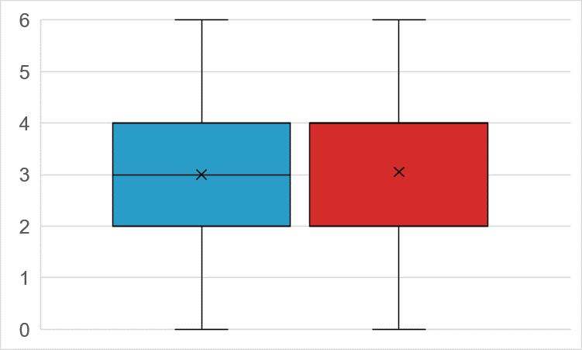
The final n-value for this study is 19, after removing the data of participants who did not give consent to be included in the study, as well as those absent on the testing day. This is a very small sample size, and indicates a high level of unreliability in the results of this research. Raw data are shown in Appendix E. Conclusions will be drawn in the context of this sample, but it should be noted that further repeats using a larger sample is needed to confirm or refute these findings. All statistical analyses were performed on R (statistical analysis software). A Shapiro-Wilk test suggests that neither the results for the baseline assessment [W = 0.89, p = 0.03] nor the post-intervention assessment [W = 0.84, p = 0.004] are normally distributed. This is further evidenced by a two-sample Kolmogorov-Smirnov test [D = 0.16, p = 0.97]. The mean score of the baseline assessment was 3; the mean score of the post-intervention assessment was 3.05 (see Figure 3). The result of a Wilcoxon signed-rank test indicates that this difference is statistically non-significant [T = 36.5, p = 0.79]. Therefore, the statistical analyses suggest that utilising an inference grid did not significantly improve pupils’ performance in the QER question.
Baseline
Post-Intervention
Score in QER Question (Max: 6 Marks)

Figure 3: Boxplot showing the distribution of GCSE pupils’ scores for a baseline assessment and post-intervention assessment of their ability to answer a QER/PISA-style question. Intervention entailed using an inference grid to summarise known and inferred information before attempting answer. Mean values were 3 for baseline and 3.05 for post-intervention, with both showing a range from 0 to 6 marks. Wilcoxon signed-rank test indicates non-significance of this difference [T = 36.5, p = 0.79].

An initial observation of the research aspect of the study was that the engagement of pupils was very mixed. Research has established a clear link between relevance and motivation (Albrecht and Karabenick, 2017); it is likely that pupils who realised the benefit of engaging with the task as a revision tool were more inclined to put effort into their answers, while those who saw it as irrelevant did not. Comparing baseline and post-intervention scores, it is apparent that 6 participants improved post-intervention, 5 worsened and 8 saw no difference. To test the relationship between engagement with the intervention and change in score, each participant was given an ‘engagement score’ (see Appendix E). The inference grid consisted of 4 boxes, which pupils completed to differing degrees. Pupils were given +0.25 on their engagement score for each of the 4 sections of the inference grid that was completed correctly (i.e. 0 indicates nothing completed; 1 indicates all 4 completed). These scores were then tested against pupils’ change in performance between their baseline and post-intervention test to observe any correlation. Shapiro-Wilk test indicates low normality for changes in score [W = 0.92, p = 0.12] and non-normal distribution of engagement scores [W = 0.78, p = 0.0005]. Spearman’s rank correlation test indicated weak correlation between the post-intervention change in pupils’ scores and their engagement score [r_{s} = 0.30, p = 0.22] (see Figure 4). This gives a slight indication that the more pupils engaged with the inference grid, the better their chance of achieving a higher score in a QER/PISA-style question. Some might argue that pupils who engage more with the inference grid are the ‘well-behaved high attainers’, who are more likely to follow the instruction to complete the grid and more likely to score highly (Department for Education, 2012). However, this has been considered by correlating engagement with the change in score rather than the raw mark.
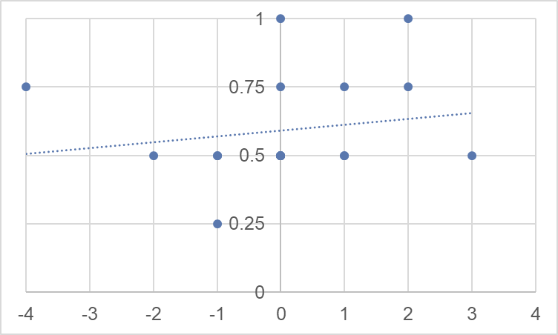
Change in Score between Baseline and Post-Intervention Testing
Engagement Score

Figure 4: Scatterplot to show the weak correlation between the change in GCSE pupils’ baseline and post-intervention scores on a QER/PISA-style question and their engagement with the intervention strategy [Spearman’s rank correlation, r_{s} = 0.30, p = 0.22]. Intervention consisted of populating an inference grid with information from prior knowledge and information inferred from question. Grid consisted of 4 boxes; engagement score indicates a percentage (as a decimal) of the grid completed correctly.

It was also necessary to test whether the question that pupils started on affected their change in score post-intervention. For pupils who completed Question A as their baseline assessment (BA-A) and Question B as their post-intervention assessment (PI-B), the average change in score was +0.22; for pupils who completed Question B as their baseline assessment (BA-B) and Question A as their post-intervention assessment (PI-A), the average change in score was -0.1. The changes in scores for BA-A/PI-B and BA-B/PI-A pupils were then compared against each other. The data for both BA-A/PI-B [W = 0.94, p = 0.59] and BA-B/PI-A [W = 0.88, p = 0.13] pupils were normally distributed according to Shapiro-Wilk tests. Assuming equal variances [F-test, F = 2.38, d.f. = 9, p = 0.24], a two-sample unmatched t-test indicated that the difference between pupils who started on A and those who started on B was not statistically significant [t = -0.44, d.f. = 17, p = 0.66]. Overall, these analyses suggest that, while using the inference grid in itself did not significantly improve pupils’ performance, performance was improved by engaging with the inference grid (i.e. populating it more fully and correctly). In addition, changes in performance were not affected by the question on which pupils started (A or B), as neither was significantly easier or harder than the other. This is further evidenced by a general comparison of the scores for A and B, where the mean score for Question A was 2.95 and the mean for Question B was 3.11. Scores for neither A nor B were normally distributed [A: W = 0.81, p = 0.0019; B: W = 0.87, p = 0.013], so a Mann-Whitney U test was performed and found that the difference between the mean scores for A and B was not significant [U = 159.5, p = 0.53]. The main findings of this study are summarised here:
- Change in score post-intervention was not affected by the question on which pupils started (A or B), as participants did not score significantly higher or lower in either;
- Use of the inference grid did not significantly improve participants’ scores;
- Better engagement with the inference grid (i.e. completing more of it) showed a weak correlation with an improvement in participants’ performance post-intervention.
Question A (see Appendix A) asked pupils to evaluate the impact of carbon emissions and develop an argument for reducing human activities that contribute to this. It was based on an exemplar PISA question from the OECD (2009), and tested pupils’ ability to use evidence to communicate conclusions. The relevant content is covered in Topic 1.4 (‘The Ever-Changing Earth’) of the WJEC GCSE Chemistry specification (WJEC, 2016), which was only recently taught to the participating class. Many pupils were quick to begin listing ways in which humans could reduce their carbon footprint, but this did not address the question appropriately. It seems that pupils were reluctant to utilise the information provided in the figure, and relied on their prior knowledge to develop an answer rather than make inferences about the effects of carbon emissions on the atmosphere, which would have been more relevant the question. Jerrim and Shure (2016a) noted that from the results of PISA 2015, it is apparent that Welsh pupils are far more comfortable describing scientific phenomena than they are evaluating evidence, critiquing methods, and other skills which require higher order thinking. The performance of participants in this question of the study clearly supports this finding, and highlights a weakness that is evidently widespread amongst Welsh pupils.
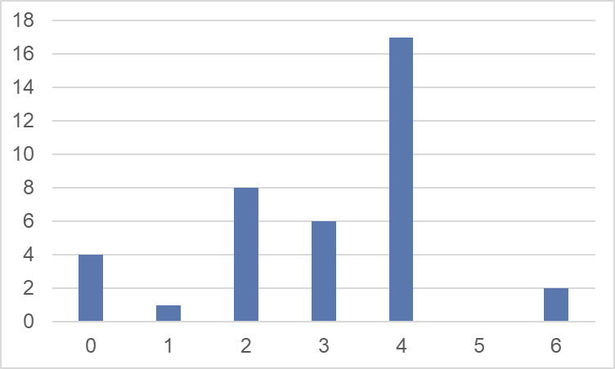
Question B (see Appendix A) asked pupils to infer from the figures the idea that, as you move down a group in the periodic table, the number of atomic shells increases, weakening the attraction between the positively-charged protons in the nucleus and the negatively-charged electron in the outermost shell. They then had to link this to the idea that, as the number of shells increases, the electron is lost more easily which makes an element more reactive. The relevant content is covered in Topic 1.2 (‘Atomic Structure and the Periodic Table’) of the WJEC GCSE Chemistry specification (WJEC, 2016), which was taught to the participating class several months ago. Furthermore, understanding the ease of ionisation requires far more abstract conceptualisation than cutting carbon emissions, and it has been highlighted how learners find such topics far more difficult than more concrete ones (Taber, 2001). It was anticipated that, due to difficulty of the content and the time elapsed since it was taught, the average marks for this question would be lower than those for Question A; however, the mean score for Question B was actually higher. This is likely because a large proportion of the mark scheme’s indicative content (see Appendix D) was related to describing the reactions of group 1 metals with water, rather than explaining the differences between them, which plays more on Welsh pupils’ relative strength in describing phenomena (Jerrim and Shure, 2016a). While not identical to the question used in this study, the WJEC GCSE question on which Question B was based was noted to be well-answered by candidates in the Examiners’ Report (WJEC, 2018b). Had the question dissuaded pupils from simply describing the reactions of group 1 metals with water, and instead encouraged them to infer information about the behaviour of electrons, the performance of pupils on this question may have been different.
Frequency
Score in QER Question (Max: 6 Marks)

Figure 5: Frequency distribution diagram of pupils’ marks on two QER/PISA-style questions.

A final note worth mentioning is the distribution of pupils’ marks across both Question A and B (see Figure 5). The mark schemes are outlined in Appendix D, and are based on the WJEC’s guidance for marking QER questions (WJEC, 2018d). Answers are categorised into Bands based on their coverage of the indicative content (specified in the mark scheme). An answer that covers all or most of the indicative content is placed into Band 1, answers that cover some of the content are placed into Band 2, and answers with only limited relevant points are placed into Band 3 (no relevant content incurs a mark of 0). Answers in Band 1 will then be given 6 marks for accurate spelling, punctuation and grammar (SPG), clarity of writing and correct use of terminology. A Band 1 answer with poor SPG, unclear writing or incorrectly-used terminology will receive a mark of 5 (though it would be difficult to produce a Band 1 answer if this was the case). A Band 2 answer will receive 3 or 4 marks, depending on the quality of writing, and a Band 3 answer will receive 1 or 2 marks. Looking at the distribution of marks (Figure 5), it is evident that more pupils received 2 marks than 1, more received 4 marks than 3, and more received 6 marks than 5. This suggests that the quality of pupils’ written communication (i.e. SPG / clarity of writing / correct use of terminology) is good, but marks are mainly lost due to unsatisfactory coverage of the indicative content. This further emphasises that pupils’ weakness lies in a poorer ability to infer what is needed to answer the question, rather than their ability to coherently communicate their ideas. Again, this agrees with the findings of Jerrim and Shure (2016a), who outlined that Welsh pupils struggle to infer information from a question, and the WJEC Examiners’ Report (WJEC, 2018b), which noted that pupils tend to include irrelevant content when answering QER questions.

Conclusions
The first finding of this study indicated that pupils’ average score for both QER questions (A and B) was approximately 3 out of 6 available marks. The WJEC (2018b) has repeatedly noted how poorly QER questions are answered in their examinations, and Jerrim and Shure (2016a) highlighted that inferring relevant information from a comprehension-type question is a weakness amongst Welsh pupils, indicating a need to improve their scientific literacy skills. Most of the pupils in this study lost marks from failing to filter out irrelevant information, which would have helped ensure their answers were coherent accounts that covered more of the necessary content. School X, possibly like many schools across Wales, devotes too much teaching time to content delivery, which is presented as a body of information to be memorised for the examination. While this does ensure Welsh pupils can describe a range of scientific phenomena (Jerrim and Shure, 2016a), it fails to contextualise the information; pupils see little relevance in the work, which results in a lack of motivation to explore it further (Albrecht and Karabenick, 2017). It also means that pupils fail to recognise the links between topics and develop their own ideas about them; consequently, in a question requiring pupils to infer information, they rely too heavily on prior knowledge and often miss the fundamental issue to be addressed. Effort must be made to ensure that pupils understand different topics from the syllabus in relation to one another, so that they can begin to apply higher order thinking skills (e.g. inference), rather than rely on the rote learning of the content.

Recommendation 1
A greater effort must be made to contextualise the content delivered from the GCSE Science syllabuses (i.e. trying wherever possible to give it ‘real-life relevance’), encourage pupils to further explore areas of interest, and ensure that pupils understand how different topics are interlinked. This should improve their understanding of how topics are connected, and make it easier for them to infer information when required to do so.

The second finding from this study was that the use of an inference grid did not significantly improve participants’ scores in the post-intervention test. The small sample size (n = 19) minimises the confidence with which conclusions can be drawn from the data; however, given such a high p-value (0.79), it is unlikely that repeated testing will show a different result. Considering the shortness of the inference training, it is probable that pupils did not fully understand how to engage with this intervention, and their performance may have improved if they had received further training in its use. The research into which specific strategies are most effective for inference training is limited (Kispal, 2008); however, some of those mentioned by Pressley (2000) include teaching decoding skills, developing vocabulary, extending word knowledge, implementing active comprehension strategies and comprehension monitoring. Another strategy, proposed by Israel and Massey (2005), is to model inference by thinking aloud – i.e. while reading to a class, talk pupils through the thought processes that occur at the time (e.g. activation of prior knowledge, linking to related topics, misconceptions, and information that is not immediately understood).
Recommendation 2
Teachers should employ a range of strategies aimed at developing pupils’ inference skills when addressing a literacy-based task (e.g. answering a QER question). In science lessons, teachers could model inference by reading a QER question aloud, then talking the pupils through their thinking in how they would answer the question (e.g. prior knowledge, inferences from figures, links to other topics etc.). This should hone pupils’ ability to be active when reading a question, and encourage them to focus on relevant information, rather than simply reeling off all prior knowledge that comes to mind.

The third finding of this study was a weak correlation between pupils’ engagement with the inference grid and their post-intervention improvement in performance. This may be due to the established link between engagement in lessons and educational attainment (Department for Education, 2012); however, this calculation utilised the change in score, rather than the raw mark. Therefore, the improvement in performance of ‘engaged high attainers’ and ‘disengaged low attainers’ is comparable as they are set relative to both groups’ baseline performance. Motivation is a prerequisite to pupil engagement (Saeed and Zyngier, 2012), so teachers must ensure that pupils are motivated to put effort into a task by explaining the relevance of their learning (Albrecht and Karabenick, 2017). When implementing new strategies to improve pupils’ inference skills, it is hugely importance to maximise pupils’ motivation to ensure that the greatest possible benefit is observed.
Recommendation 3
When trialling any new strategy focused on improving pupils’ inference skills, clearly outline the relevance to pupils’ learning, as this will motivate them to put more effort into the task. No strategy will lead to an improvement in pupils’ performance if they are not engaged with the task. Ensure that pupils see the potential benefit of the intervention.

Together, these recommendations utilise the findings of this study to present effective strategies for teaching inference skills. In summary, content delivery must be contextualised to promote deeper learning and a more integrated understanding of the subject, various strategies for targeting inference skills must be trialled to identify those which help in the unique context of a class, and the potential benefit and relevance to learning must be explained to pupils before any interventions are trialled in a class. By experimenting with strategies to develop higher order thinking skills (including inference), it is hoped that we will identify effective methods for improving the scientific literacy of Welsh pupils. This will become ever more important as the challenges of the future demand scientifically literate individuals with a solid understanding of science and technology, the creativity to design experiments to test hypotheses, and the ability to identify strengths and limitations of others’ work (OECD, 2018a).

Limitations and Future Development
It is worth re-emphasising that, due to the small sample size used in this study (n = 19) and large variance in the results (± 2.22 for mean baseline mark and ± 2.39 for mean post-intervention mark), the statistical analyses are underpowered; as a result, conclusions drawn from these results are not definitive, and require further testing to confirm or refute. The strict timeframe in which this experiment was conducted certainly did not allow for maximal pupil engagement with the intervention; it is possible that some pupils did not fully understand the use or relevance of the grid, and so did not put much effort into completing it. It would have also been beneficial for mitigating any effect of question difficulty to have a larger variety of questions, but only on a larger sample size (otherwise, test statistics for each question would be even more underpowered).
Another major limitation of this study is the fact that the sample of participants came from only one class: a GCSE Chemistry class (i.e. pupils who have taken the ‘Triple Science’ pathway, which is suggestive of high attainment in KS3). As the attainment level of the class was fairly homogenous, the impact of using inference grids with lower-attaining pupils is not clear. While this cannot be generalised to all schools, the pupils in lower sets for GCSE Science classes in School X tend to have lower attainment in literacy and numeracy. Poor attainment in these more general skills often translates into a lower level of scientific literacy. It would be interesting to test whether utilising an intervention targeted to improving scientific literacy (such as an inference grid) would prove more or less beneficial to lower-attaining pupils; it may, however, prove difficult to judge properly, as these pupils may struggle more in seeing the benefit of such an intervention, and thus may resist putting effort into using it (Albrecht and Karabenick, 2017).
Taking this work forward, there is a definite indication that utilising interventions such as inference grids provide benefits to those pupils that are willing (and motivated) to engage with them. It is unlikely that many pupils would discover these sorts of strategies independently, so as part of my future practice, I will ensure that pupils are informed about such tools and have a chance to practise using them. They can then decide for themselves whether they find them beneficial. Furthermore, there are numerous other strategies for encouraging pupils to develop inference skills, such as those listed by Pressley (2000) and Israel and Massey (2005). It will only enhance my future practice to try and implement a number of these, and judge whether they are helpful in the unique context of my own classes. Ultimately, this study has highlighted how undertaking action research can provide an informative insight into novel strategies for enhancing pupils’ skills; it is a powerful method for refining teaching practice, and definitely something I will take forward as I continue developing my skills as a teacher.

FINAL WORD COUNT: 7,602 – 301 (in figures, tables and legends) = 7,301

References

Albrecht, J. R. and Karabenick, S. A. (2017) Relevance for Learning and Motivation in Education. The Journal of Experimental Education. 86, (1), 1 – 10.
Andrews, L. (2011a) Teaching makes a difference. Cardiff: Welsh Government.
Andrews, L. (2011b) Raising school standards. Cardiff: Welsh Government.
Baker, L. (2002) “Metacognition in comprehension instruction” in Block, C. C. and Pressley, M. (eds.) Comprehension Instruction: Research-Based Best Practices. New York: Guilford Press.
Ball, D. L., Thames, M. H. and Phelps, G. (2008) Content Knowledge for Teaching: What Makes It Special? Journal of Teacher Education. 59, (5), 389 – 407.
Barnard, H. (2018) Poverty in Wales 2018 [www] https://www.jrf.org.uk/report/poverty-wales-2018 (date accessed: 06 / 05 / 2018).
Bedell, R. C. (1934) The Relationship Between the Ability to Recall and the Ability to Infer in Specific Learning Situations. Science Education. 18, (3), 158 – 162.
Byrnes, J. P. (2000) “Using instructional time effectively” in Baker, L., Dreher, M. J. and Guthrie, J. T. (eds.) Engaging Young Readers: Promoting Achievement and Motivation. New York: Guilford Press.
Cain, K. (1996) “Story knowledge and comprehension skill” in Cornoldi, C. and Oakhill, J. (eds.) Reading Comprehension Difficulties, Processes and Intervention. New Jersey: Lawrence Erlbaum.
Cain, K. and Oakhill, J. (1999) Inference making ability and its relation to comprehension failure in young children. Reading and Writing: An Interdisciplinary Journal. 11, (5-6), 489 – 503.
Calvo, M. G. (2004) Relative contribution of vocabulary knowledge and working memory span to elaborative inferences in reading. Learning and Individual Differences. 15, (1), 53 – 65.
Department for Education (2012) The Impact of Pupil Behaviour and Wellbeing on Educational Outcomes [www] https://assets.publishing.service.gov.uk/government/uploads/system/uploads/attachment_data/file/219638/DFE-RR253.pdf (date accessed: 13 / 05 / 2018).
Department for Education (2013) Science programmes of study: key stage 3 – National curriculum in England [www] https://assets.publishing.service.gov.uk/government/uploads/system/uploads/attachment_data/file/335174/SECONDARY_national_curriculum_-_Science_220714.pdf (date accessed: 05 / 05 / 2018).
Department of Education and Science (1975) A Language for Life. Report of the Committee of Inquiry Appointed by the Secretary of State for Education and Science [The Bullock Report]. London: HMSO.
Dewitz, P., Carr, E. and Patberg, J. (1987) Effects of inference training on comprehension and comprehension monitoring. Reading Research Quarterly. 22, 99 – 119.
Donaldson, G. (2015) Successful Futures: Independent Review of Curriculum and Assessment Arrangements in Wales. Cardiff: Welsh Government.
Duschl, R. (2008) Science Education in Three-Part Harmony: Balancing Conceptual, Epistemic, and Social Learning Goals. Review of Research in Education. 32, 268 – 291.
Estyn (2013) Working together to tackle the impact of poverty on educational achievement [www] https://www.estyn.gov.wales/sites/default/files/documents/Working%20together%20to%20tackle%20the%20impact%20of%20poverty%20on%20educational%20achievement%20-%20December%202013.pdf (date accessed: 06 / 05 / 2018).
Estyn (2017) Science at key stage 3 and key stage 4 [www] https://www.estyn.gov.wales/sites/default/files/documents/Science%20at%20key%20stage%203%20and%20key%20stage%204%20%28002%29.pdf (date accessed: 05 / 05 / 2018).
Graesser, A. C., Singer, M. and Trabasso, T. (1994) Constructing inferences during narrative text comprehension. Psychological Review. 101, (3), 371 – 395.
Hayakawa, S. I. (1939) Language and thought in action. New York: Harcourt Brace Jovanovich.
Israel, S. E. and Massey, D. (2005) “Metacognitive think-alouds: using a gradual release model with middle school students” in Israel, S. E., Block, C. C., Bausermann, K. L. and Kinnucan-Welsh, K. K. (eds.) Metacognition in Literacy Learning: Theory, Assessment, Instruction, and Professional Development. New Jersey: Lawrence Erlbaum.
Jerrim, J. and Shure, N. (2016a) Achievement of 15-Year-Olds in Wales: PISA 2015 National Report [www] http://dera.ioe.ac.uk/27969/1/161206-pisa-2015-en.pdf (date accessed: 30 / 04 / 2018).
Jerrim, J. and Shure, N. (2016b) Achievement of 15-Year-Olds in England: PISA 2015 National Report [www] https://assets.publishing.service.gov.uk/government/uploads/system/uploads/attachment_data/file/574925/PISA-2015_England_Report.pdf (date accessed: 05 / 05 / 2018).
Kispal, A. (2008) Effective Teaching of Inference Skills for Reading: Literature Review [www] https://www.nfer.ac.uk/publications/EDR01/EDR01.pdf (date accessed: 08 / 05 / 2018).
Learning Wales (2014) National Literacy and Numeracy Framework [www] http://learning.gov.wales/resources/browse-all/nlnf/?lang=en (date accessed: 06 / 05 / 2018).
Learning Wales (2016a) PISA Scientific Literacy: a short guide for Key Stage 4 teachers [www] http://www.wjec.co.uk/teachers/General%20principles%20underpinning%20the%20delivery%20of%20WJEC%20assessments.pdf (date accessed: 30 / 04 / 2018).
Learning Wales (2016b) Literacy intervention [www] http://learning.gov.wales/resources/learningpacks/mep/literacy/literacy-intervention/?lang=en (date accessed: 06 / 05 / 2018).
Lewis, M. and Wray, D. (2000) Literacy in the Secondary School. London: David Fulton.
Martin, G. T. (2002) Encouraging active reading in the science classroom [www] http://www.bcps.org/offices/lis/writing/secondary/docs/Reading,_Writing,_Comprehending_in_the_Science_Classroom%5B1%5D.pdf (date accessed: 08 / 05 / 2018).
McAteer, M. (2013) Action Research in Education. London: SAGE Publications.
McGee, A. and Johnson, H. (2003) The effect of inference training on skilled and less skilled comprehenders. Educational Psychology. 23, (1), 49 – 59.
Millar, R., Lubben, F., Got, R. and Duggan, S. (1994) Investigating in the school science laboratory: conceptual and procedural knowledge and their influence on performance. Research Papers in Education. 9, (2), 207 – 248.
OECD (2009) Take the Test – Sample Questions from OECD’s PISA Assessments [www] https://www.oecd.org/pisa/pisaproducts/Take%20the%20test%20e%20book.pdf (date accessed: 12 / 05 / 2018).
OECD (2013) PISA 2015: Draft Science Framework [www] https://www.oecd.org/pisa/pisaproducts/Draft%20PISA%202015%20Science%20Framework%20.pdf (date accessed: 07 / 05 / 2018).
OECD (2017) PISA 2015 Assessment and Analytical Framework: Science, Reading, Mathematic, Financial Literacy and Collaborative Problem Solving. Paris: OECD Publishing.
OECD (2018a) PISA 2015 Results in Focus [www] https://www.oecd.org/pisa/pisa-2015-results-in-focus.pdf (date accessed: 23 / 04 / 2018).
OECD (2018b) PISA 2015 participants [www] http://www.oecd.org/pisa/aboutpisa/pisa-2015-participants.htm (date accessed: 30 / 04 / 2018).
Ofsted (2011) Successful science: An evaluation of science education in England 2007 – 2010 [www] https://assets.publishing.service.gov.uk/government/uploads/system/uploads/attachment_data/file/413802/Successful_science.pdf (date accessed: 06 / 05 / 2018).
Pressley, M. (2000) “What should comprehension instruction be the instruction of?” in Kamil, M. L., Mosenthal, P. B., Pearson, P. D. and Barr, R. (eds.) Handbook of Reading Research: Volume III. New York: Lawrence Erlbaum.
Saeed, S. and Zyngier, D. (2012) How Motivation Influences Student Engagement: A Qualitative Case Study. Journal of Education and Learning. 1, (2), 252 – 267.
Stan, E. (2012) The Role of Grades in Motivating Students to Learn. Procedia – Social and Behavioural Sciences. 69, 1998 – 2003.
Taber, K. S. (2001) Building the Structural Concepts of Chemistry: Some Considerations from Educational Research. Chemistry Education: Research and Practice in Europe. 2, (2), 123 – 158.
Webster, R. (2014) Why making the most of TA-led curriculum interventions means pulling out all the stops [www] http://excellenceinliteracy.co.uk/articles/curriculum-interventions/ (date accessed: 06 / 05 / 2018).
Wellington, J. and Osborne, J. (2001) Language and Literacy in Science Education. Buckingham: Open University Press.
Welsh Assembly Government (2008) Science in the National Curriculum for Wales. Cardiff: Welsh Assembly Government – Department for Children, Education, Lifelong Learning and Skills.
Welsh Government (2018) New school curriculum [www] https://gov.wales/topics/educationandskills/schoolshome/curriculuminwales/curriculum-for-wales-curriculum-for-life/?lang=en (date accessed: 06 / 05 / 2018).
WJEC (2016) WJEC GCSE in Chemistry – Specification: Teaching from 2016, For award from 2018 [www] http://www.wjec.co.uk/qualifications/science/gcse/chemistry-gcse-2016/wjec-gcse-chemistry-spec-from-2016.pdf?language_id=1 (date accessed: 07 / 05 / 2018).
WJEC (2018a) General principles underpinning the delivery of WJEC assessments [www] http://www.wjec.co.uk/teachers/General%20principles%20underpinning%20the%20delivery%20of%20WJEC%20assessments.pdf (date accessed: 30 / 04 / 2018).
WJEC (2018b) GCSE Chemistry Examiners’ Report January 2018 [www] http://www.wjec.co.uk/examiner-reports/2018/gcse/wjec-gcse-science-chemistry-report-january-2018-e.pdf?language_id=1 (date accessed: 30 / 04 / 2018).
WJEC (2018c) About Us [www] http://www.wjec.co.uk/about-us/ (date accessed: 05 / 05 / 2018).
WJEC (2018d) Chemistry (GCSE) – Higher Tier | Winter 2015 | Question 3 (4472/02) [www] http://www.wjec.co.uk/question-bank/view-question.html?question=8edb35ac-0b24-47d6-9fca-31ad990e3d59 (date accessed: 12 / 05 / 2018).
Zen, E-an (1990) Scientific Literacy and Why it is Important. Journal of Geological Education. 38, 463 – 464.

APPENDIX A: QER/PISA-Style Questions A and B

A | Global Warming
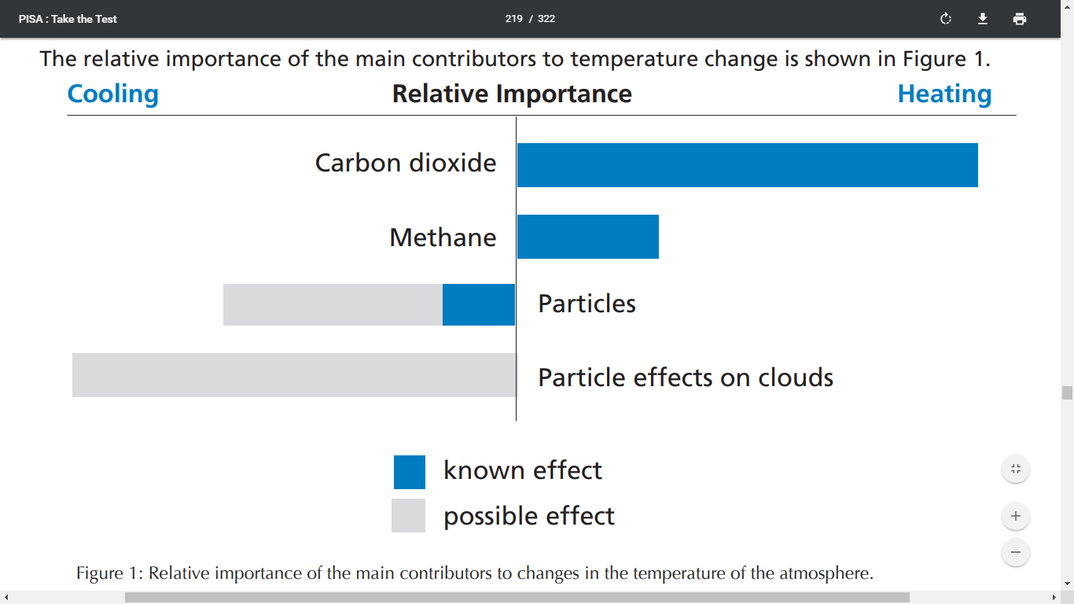
Figure 1: Relative importance of factors which contribute to changes in the atmosphere’s temperature.

Adapted from OECD (2009).

Burning fossil fuels releases gases and particles into the atmosphere. Figure 1 shows the relative known and possible effects of some factors on the temperature of the atmosphere. Use the information from the figure, as well as your own knowledge, to develop an argument for reducing carbon emissions. QER [6]

B | Reactivity of Group I Metals
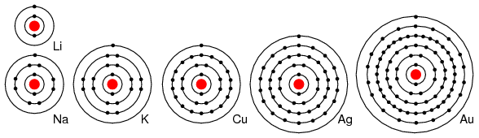
Figure 2: Group I elements in the periodic table.
7
Li
3
23
Na
11
39
K
19
Group I
2
3
4
Figure 3: Electronic configuration of lithium, sodium and potassium (Group I metals).
Period

Electrons are bound to atoms by the attraction between electrons and protons. Lithium, sodium and potassium are Group I metals. They react by losing the lone electron from their outermost shell. Using your knowledge, as well as the information in Figure 2 / Figure 3, explain how the reactions of Group I elements with water are similar and how they are different. QER [6]

APPENDIX B: Exemplar Letter to Participants and Consent Form


25th April 2018

Dear Participant,

I am a student studying at the University of Wales, Trinity St David and would like to invite you to participate in my research project.

This project will test whether scaffolding a PISA-style problem with an inference grid will improve pupils’ ability to answer questions demanding good scientific literacy skills.

The results collected from participants will inform my research project. All results will be kept strictly confidential to the researchers involved and will not be released to the general public. After careful and precise analysis of the data obtained from the baseline assessment and post-intervention test, I will be happy to provide you with a copy of the findings at your request. The results of this research will hopefully enhance my teaching practice in preparing students for their exams in the future.

Where students are not willing to participate in the research, they will be expected to undertake the classroom activities and the test; however, their data will not be collected or used within the research project.

I thank you in advance for your time and participation. If any questions do arise, please do not hesitate to contact me at your convenience.

C. Avo, BSc (Hons)
PGCE Student

Rhif Adnabod Cyfranogwr:
Participant Identification Number:
FFURFLEN GANIATÂD CYFRANOGIAD | PARTICIPATION CONSENT FORM
Teitl Y Prosiect: / Project Title:
Will scaffolding the answering of a PISA-style QER question with an inference grid lead to an improvement in pupils’ performance?
Enw'r Ymchwilydd / Name of Researcher:
C. Avo

Blwch Cychwynnol / Please initial box
1 | Cadarnhaf fy mod wedi darllen a deall y daflen wybodaeth dyddiedig 25/04/18 ar gyfer yr astudiaeth uchod. Rwyf wedi cael y cyfle i ystyried y wybodaeth, gofyn cwestiynau, ac rwyf wedi cael ateb boddhaol i’r rhain. |  | I confirm that I have read and understand the information sheet dated 25/04/18 for the above study. I have had the opportunity to consider the information, ask questions and have had these answered satisfactorily.
2 | Deallaf fy mod yn cymryd rhan o’m gwirfodd a bod croeso i mi dynnu’n ôl ar unrhyw adeg, heb roi rheswm. |  | I understand that my participation is voluntary and that I am free to withdraw at any time, without giving any reason.
3 | Deallaf y gellir defnyddio unrhyw wybodaeth a roddir gennyf mewn adroddiadau, erthyglau neu gyflwyniadau gan y tîm ymchwil. |  | I understand that any information given by me may be used in future reports, articles or presentations by the research team.
4 | Deallaf na fydd fy enw’n ymddangos mewn unrhyw adroddiadau, erthyglau neu gyflwyniadau. |  | I understand that my name will not appear in any reports, articles or presentations.
5 | Cytunaf i gymryd rhan yn yr astudiaeth uchod. |  | I agree to take part in the above study.
Enw’r Cyfranogwr Name of Participant |  |  |  | Llofnodwyd  Signature
Ymchwilydd  Researcher |  | C. Avo |  | Llofnodwyd  Signature

ENW A CHYFEIRIAD YR YMCHWILYDD  C. Avo  Prifysgol Cymru, Y Drindod Dewi Sant  Campws Abertawe, Mount Pleasant  Abertawe SA1 6ED | NAME & ADDRESS OF RESEARCHER  C. Avo  University of Wales, Trinity Saint David  Swansea Campus, Mount Pleasant  Swansea SA1 6ED

APPENDIX C: Exemplar Inference Grid
Participant Identification Number

What relevant information about this topic do you know already? | What can you see in the figure(s)?
What can you infer from the figure(s)? | What further questions would be useful to ask?

APPENDIX D: Mark Schemes for Questions A and B

A | Global Warming | MARK SCHEME

Indicative Content
- Carbon dioxide is main factor causing increased temperature of atmosphere
- Reducing carbon emissions will have greatest effect in reducing impact of global warming
- Reduction in carbon dioxide necessary as it considerably heats the earth
- Burning fossil fuels (coal / oil / gas) releases gases including carbon dioxide
- Carbon dioxide is a greenhouse gas / contributes to the greenhouse effect
- Increased greenhouse gases in atmosphere cause it to heat up / trap more heat
- Effect from other gases (e.g. methane) not as great as from carbon dioxide
- Effect from particles not yet confirmed / not yet proven / not yet known

 | Marks
Band 1 Well-structured account which intelligently links relevant points. Covers most or all of the indicative content. Question is fully addressed without significant omissions. Scientific terminology is used appropriately. Spelling, punctuation and grammar is accurate. | 5 / 6
Band 2 Structured account which links some relevant points. Evidence of indicative content in the reasoning of the answer. Question is addressed with some omissions. Scientific terminology is used appropriately. Spelling, punctuation and grammar is mostly accurate. | 3 / 4
Band 3 Account which links some relevant points, such as those listed in the indicative content. Limited coverage of the question with significant omissions. Limited use of scientific terminology with inaccuracies in spelling, punctuation and grammar. | 1 / 2
No content worthy of credit. | 0

B | Reactivity of Group I Metals | MARK SCHEME

Indicative Content
- All three metals float / move about on the surface of water / produce bubbles
- Lithium reacts slowly (without melting)
- Sodium reacts quickly (forming a sphere)
- Potassium reacts violently (forming a sphere) and burns with a lilac flame
- Reactivity increases down the group
- Atomic number increases so number of electrons increases
- Down the group, more shells / increased shielding / further from (positive) nucleus
- Electrons of larger atoms lost easier / take less energy to remove

 | Marks
Band 1 Well-structured account which intelligently links relevant points. Covers most or all of the indicative content. Question is fully addressed without significant omissions. Scientific terminology is used appropriately. Spelling, punctuation and grammar is accurate. | 5 / 6
Band 2 Structured account which links some relevant points. Evidence of indicative content in the reasoning of the answer. Question is addressed with some omissions. Scientific terminology is used appropriately. Spelling, punctuation and grammar is mostly accurate. | 3 / 4
Band 3 Account which links some relevant points, such as those listed in the indicative content. Limited coverage of the question with significant omissions. Limited use of scientific terminology with inaccuracies in spelling, punctuation and grammar. | 1 / 2
No content worthy of credit. | 0

APPENDIX E: Raw Data from Study
Table 2: Raw data collected from GCSE pupils’ scores in a baseline assessment and post-intervention assessment of their ability to answer a QER/PISA-style question. Participants had two possible questions, A and B. Half began the baseline assessment (BA) on Question A, then completed Question B for the post-intervention (PI) test; half began the baseline assessment on Question B, then completed Question A for the post-intervention (PI) test. Intervention employed using an inference grid to summarise known and inferred information before attempting answer. Mean values were 3 for baseline and 3.05 for post-intervention, with both showing a range from 0 to 6 marks. Wilcoxon signed-rank test indicates non-significance of this difference [T = 36.5, p = 0.79]. Green rows indicate where pupil’s score increased post-intervention (6); red indicates where score decreased post-intervention (5); white indicates where there was no change post-intervention (8). Engagement score indicates what percentage (shown as a decimal) of the inference grid was completed correctly. Average engagement score was 0.67 for pupils whose score improved, 0.5 for pupils whose score decreased, and 0.59 for pupils who showed no change.

Participant ID Number | BA | PI | Baseline Assessment Score | Post-Intervention Score | Change in Score | Engagement Score
194 | A | B | 4 | 4 | 0 | 0.5
869 | B | A | 0 | 2 | + 2 | 0.75
222 | B | A | 3 | 2 | - 1 | 0.25
278 | A | B | 3 | 4 | + 1 | 0.5
135 | B | A | 0 | 0 | 0 | 0.75
269 | A | B | 4 | 4 | 0 | 0.5
210 | B | A | 1 | 4 | + 3 | 0.5
980 | B | A | 4 | 4 | 0 | 1
249 | B | A | 6 | 2 | - 4 | 0.75
648 | B | A | 4 | 4 | 0 | 0.5
793 | A | B | 3 | 2 | - 1 | 0.5
902 | B | A | 3 | 2 | - 1 | 0.5
427 | A | B | 3 | 4 | + 1 | 0.5
132 | A | B | 4 | 6 | + 2 | 1
229 | B | A | 2 | 2 | 0 | 0.5
597 | A | B | 4 | 4 | 0 | 0.5
681 | B | A | 4 | 4 | 0 | 0.5
388 | A | B | 3 | 4 | + 1 | 0.75
569 | A | B | 2 | 0 | - 2 | 0.5
Average: | N/A | N/A | 3 | 3.05 | + 0.05 | 0.59

APPENDIX F: PowerPoint for Intervention Training
Figure 6: Slides from the PowerPoint used during research aspect of the study. This was displayed on an interactive whiteboard for the participating class to see. Red circles on ‘Baseline Assessment’ and ‘Post-Intervention Assessment’ slides are visual timers that pupils could see throughout both tests. Exemplar inference grid that was demonstrated as intervention training was based on a topic unrelated to those used in the testing.



