1. Introduction
Apple was founded in 1976 by Steve Jobs and Steve Wozniak in California, USA. Steve Jobs had a dream of manufacturing computers that can be used by the general public. The product gain huge popularity in a short time and Apple started to manufacture them commercially. The company went public in 1980 and became one of the most successful technology companies ever created (Richardson, 2021). Over time, the company has diversified its operations and started manufacturing mobile phones, tablets, laptops, and numerous other electronic devices.
The main vision of Apple is to create innovative hardware and software products that could provide the best user experience to its customers. After seeing the number of positive reviews and testimonies the company was able to garner for its products, we can say the company has been able to deliver on its vision. For instance, Apple has a Net Promoter Score (NPS) score of 72 in the latest, 2022, survey. The NPS measures customer satisfaction and loyalty. It is usually calculated by asking people (customers) how likely they will recommend a company’s products to others (Vishak, 2022). It is based on a scale of 0-10, with zero being the least likely and 10 being the most likely.
Over the course of this report, we will take a detailed look into the marketing strategies of Apple. We will also look at the external and internal factors that can influence customer buying behaviour. These factors are analysed using different marketing principles. For instance, we will conduct a PESTLE analysis to learn about the external factors that influence Apple and its customers. Then we will use Porter’s 5 Forces model to learn about the main competitive forces in the industry and how Apple addresses them. Similarly, we will use the SWOT analysis to learn about the internal factors influencing the company. Then we will look at the STP (Segmentation, Targeting and Positioning) strategies of Apple. Finally, we will take a detailed look at the marketing mix strategies of the company.
2. PESTLE Analysis of Apple
PESTLE analysis is a technique used to learn about the key external factors that could influence a company. It helps organizations to learn how they perform in several areas and identify any issues with them (CIPD, 2021). The analysis considers six key factors, which are as follows:
- Political: Political factors are factors that have political repercussions. Taxes and political stability are examples of political factors. There are a lot of such political factors affecting Apple. For instance, the Russian Member of Parliament Dmitry Gorotsov has accused Apple of colluding with the American government and providing surveillance data on Russian politicians (Dudovskiy, 2021). This could create a negative outlook for Apple products across Russia and reduce its sales in the Russian market. The trade war between US and China could also affect the company. Apple manufactures most of its devices in China. If the US decides to put sanctions on imports from China, it could drive up the prices of its devices (Dudovskiy, 2021).
- Economical: Economic factors are factors that affect the economic aspects of a company. Interest rates, wages, inflation, and foreign exchange rates are examples of economic factors. A major factor affecting Apple is the cost of labour. Apple outsources almost all its manufacturing to China, due to its low cost of labour. However, recent studies have shown that labour costs are gradually increasing in all major developing countries, especially China (Dudovskiy, 2021). The following bar chart gives a brief idea of this by comparing wages across developing economies like China, Mexico, and Vietnam, from 2016-2020.

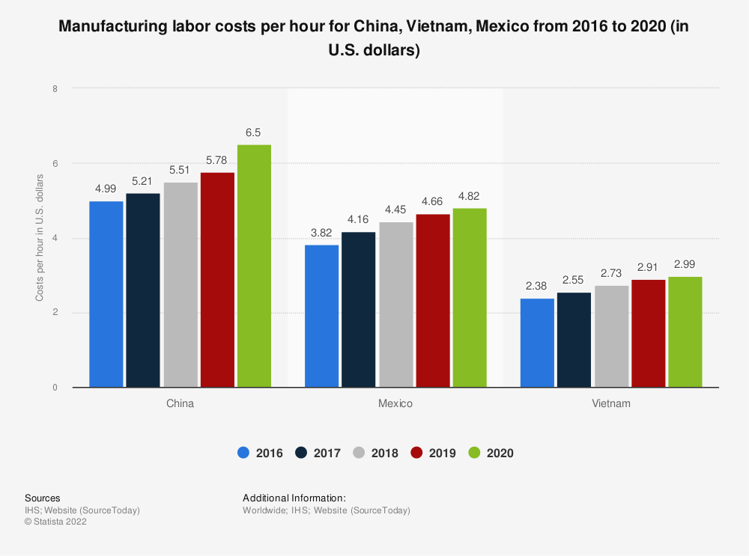
Source: https://www.statista.com/statistics/744071/manufacturing-labor-costs-per-hour-china-vietnam-mexico/

The rising wages could cause a decline in the profit margins of Apple in future. Another such factor is the rate of inflation. The pandemic of Covid-19 and the Russian invasion of Ukraine have caused increased inflation levels in almost all countries. For instance, the United Kingdom has recorded inflation of 10% (Office for National Statistics, 2022). This could make people spend less which will directly influence the sale of Apple devices.
- Sociological: These are factors connected directly to society. Cultural and societal expectations, health, and demographics are examples of social factors. As we have learned earlier, Apple manufactures its devices in China due to the low labour costs (Dudovskiy, 2021). This has created a backlash towards the company, accusing it of exploiting underpaid workers (Bilton, 2014). Another factor is the economic growth rate of countries. Studies have shown that in the next few decades, African countries are expected to grow at a much larger scale (World Bank, 2022). However, Apple has very little presence in these countries and most people are unaware of its products. Hence, Apple will not be able to take full advantage of these economic growths.
- Technological: Technological factors discuss the emergence of new technologies in business such as artificial intelligence and robotics. The main industry rivals of Apple such as Google and Samsung are catching up with it rapidly. For instance, Google took less than a year to develop Google Pay, an alternative to Apple Pay (9) (PESTLE analysis, 2015; Khan et al., 2015). Similarly, some people consider Apple software such as iOS to be very restrictive (Olson, 2022). For instance, iOS prohibits its users to download applications from third-party sources. This might make some of its customers switch to a product made by its competitors.
- Legal: Legal factors consider the legal aspects of the business. New laws and regulations, taxation, trade agreements and quotas are examples of legal factors. Apple has been influenced by numerous legal factors. For instance, the European Union has passed a new law forcing smartphone manufacturers to use type C charging ports on their devices (Hern, 2022). Apple has been using lightning charging ports on iPhones for years. However, as per the new law, they have no choice but to switch to type C ports. This will reduce the revenue Apple used to earn by selling lightning chargers and cables. Also, a significant portion of Apple’s revenue is earned by selling products that are covered by Intellectual Property Rights (IPR) and similar copyright laws (PESTLE analysis, 2015). Piracy and litigations challenging the IPRs could seriously affect this stream of income.
- Environmental: These are factors that have environmental connotations. Climate change and pandemics are examples of environmental factors. Climate change, for instance, has forced companies including Apple to employ greener production techniques. Apple uses recycled aluminium to manufacture its products. The company also use paper-based packaging for their products to reduce plastic waste (Apple, 2022). Additionally, the company is planning to decarbonize its entire global supply chain by 2030 (Apple, 2022).
As we had a detailed look at the PESTLE factors affecting Apple, we can now move to analyse the market of Apple, by using Porter’s Five forces model.
3. Porter’s Five Forces Model for Apple
Porter’s Five Forces is a framework to understand the competitive factors present in an industry. It will help us to learn how the industry is divided across different organizations. Analysing the five forces is pivotal for any industry as it will provide a detailed picture of an industry, including its competition, as well as its strengths and weaknesses (Investopedia, 2022). This will help companies to position themselves better. A diagram of the model is given below for reference.
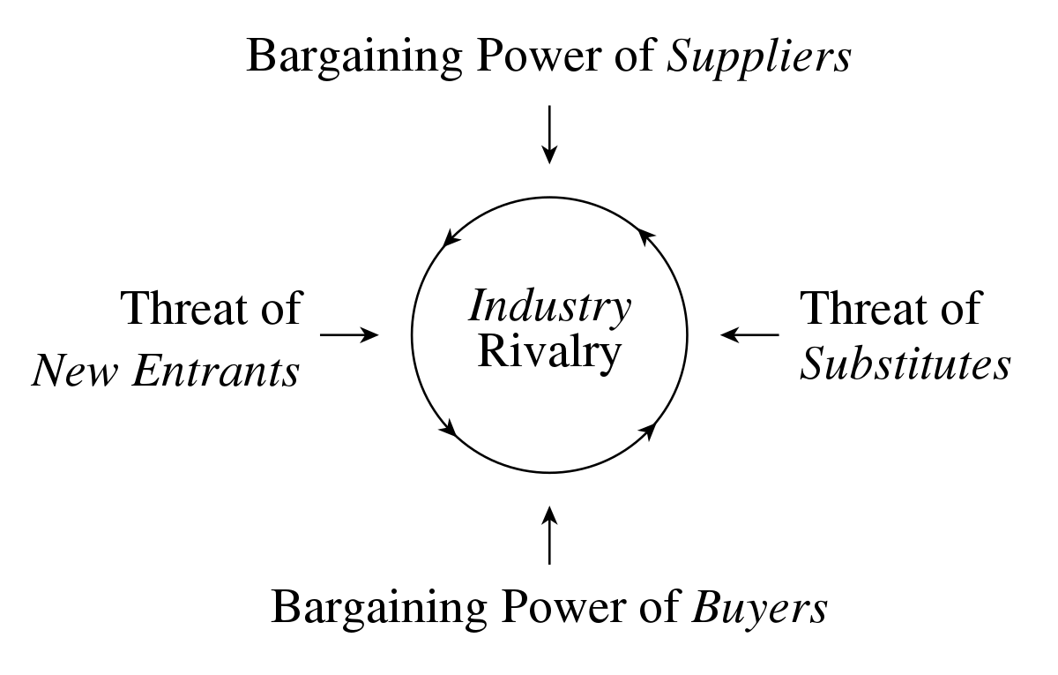
Source: https://en.wikipedia.org/wiki/Porter%27s_five_forces_analysis
As we can observe from the diagram, there are five different forces in the model. So, we need to address each of them individually, to successfully access the industry for Apple.
- Industry Rivalry: Apple has based its operations on the highly sought-after industry of technology. The company is directly competing with competitors like Google and Samsung, who spend almost the same amounts on research and development, marketing as well as branding (Maverick, 2022). Hence, we can conclude that the factor of industry rivalry is high for Apple. The company tries to alleviate this by creating innovative and unique products.
- Bargaining Power of Suppliers: Apple sources its resources from numerous suppliers across the world. The high number of suppliers means that Apple can easily switch from one to another. Additionally, Apple is one of the largest technology companies in the world. Hence, most of its suppliers are reluctant to leave it (Maverick, 2022). Both these factors keep the bargaining power of Apple suppliers low.
- Bargaining Power of Buyers: Apple has millions of customers across the world. As we learned in the industry rivalry section, switching to Apple’s competitors is relatively easy. Hence, the buyers have a strong power over Apple (Maverick, 2022). In other words, the bargaining power of buyers is high for Apple. Apple tries to retain its customers by providing quality products and exceptional customer service.
- Threat of Substitutes: Apple devices can be substituted with numerous other similar devices. For instance, a customer can purchase a landline phone instead of iPhone to make calls. Similarly, to take pictures, they can purchase a camera instead of an iPhone. However, both substitutes have very limited features compared to the iPhone (Maverick, 2022). For instance, iPhones are portable while landlines are not. iPhones can be used to browse the internet while cameras cannot. Hence, we can say that the threat of substitutes is low for Apple.
- Threat of New Entrants: Apple has been in the technology industry for decades. It has helped Apple to create economies of scale, driving its production costs very low. Apple has also created a good brand name by delivering quality products. It has helped Apple to create brand-loyal customers who are willing to pay a premium price for its products (Maverick, 2022). A new entrant to the field will not have access to any of these factors. They either have to keep their prices very low or invest a lot to create industries of scale. Hence the threat of new entrants is low for Apple.
From analysing the above factors, we can see that Apple has positioned itself quite well in its industry. Even in factors where they face difficulties such as the buying power of buyers and industry rivalry, Apple has created strategies to counter them. For instance, Apple produces products of high quality, which impresses and retains its customers. As we had a detailed look at the five external forces, we can now learn about the internal forces in Apple, by employing SWOT analysis.
4. SWOT Analysis of Apple
The SWOT or Strengths Weakness Opportunities Threats analysis gives a detailed insight into the performance of different internal factors in a company. In order to conduct the analysis on Apple, we will have to look at each of them individually.
- Strengths: Apple has numerous strengths. For instance, Apple has created economies of scale. This helped them to keep production costs low. The company is also known to create innovative and high-quality products (Gupta, 2022). This helped them to create brand-loyal customers, who are willing to pay a higher price for its products.
- Weakness: The company also has a few weaknesses. For instance, Apple has a very limited distribution network. The company is very selective while employing distributors. This has reduced its market reach in comparison with its competitors. Similarly, Apple products are relatively more expensive than its competitors (Gupta, 2022). It has drastically reduced the number of people who can purchase them.
- Opportunity: Apple can take advantage of a lot of opportunities. For instance, the company has an impressive customer satisfaction rate. This ensures that they stay brand loyal and become brand advocates. Similarly, Apple has diversified into electronic chip manufacturing. Apple has been using third-party processors in their devices. Now they have started to manufacture their own indigenous chipset called M1 (Gupta, 2022). It has helped them to become more independent and create chips that are fine-tuned for their devices. Additionally, Apple has also entered the electric vehicle industry. The company is planning to release its first electric car in 2025. The brand-loyal customers of Apple’s other products will be excited to try and purchase them.
- Threats: Alongside the opportunities, Apple also has to face a few threats. Apple manufactures most of its products in China. The pandemic of Covid-19 has caused significant disruptions to this. Lockdowns and travel restrictions in other countries have also significantly reduced the sales of Apple devices (Gupta, 2022). Another threat faced by Apple is the misuse of its products. Take the case of AirTags for instance. They were created to help people find misplaced devices. However, people are also using it for stalking and other similar criminal activities. Another major threat for Apple is the increase in competition. Apple’s competitors like Samsung and Google too are developing innovative and quality products. Hence, Apple has to create unique devices to keep its market share.
As we had a detailed look at the strengths and weaknesses of Apple, we can move to another important aspect of marketing; segmentation, targeting and positioning.
5. Segmentation, Targeting and Positioning (STP) of Apple
STP is a marketing concept used to provide targeted marketing messages to consumers. Without using STP, the marketing strategies will appear generic and would not be able to attract customers. As the name suggests the model is based on three key principles; segmentation, targeting and positioning. In order to learn how Apple uses them for attracting customers, we have to take a detailed look into each one of them.
5.1 Segmentation
Segmentation is the division of customers into different groups or subsets. The division is based on certain characteristics and criteria. Generally, there are four different types of segmentation (Wright, 2020; Dudovskiy, 2021).
- Geographic Segmentation: Here the customers are divided into different geographic regions such as countries, states, regions, cities and provinces.
- Demographic Segmentation: In this segment, the customers are divided as per the demographics. Age, Gender, Profession and Racial divisions are examples of demographic segmentation.
- Behavioural Segmentation: Here the customers are segmented as per their buying behaviour. We look at how and what they buy, how often they buy, and so forth in this segmentation.
- Psychographic Segmentation: Here we segment the customers according to their shared psychological traits. Hobbies and lifestyle are examples of psychographic traits.
The following table gives a clearer picture of how Apple differentiates its customers as per the different segmentation types.
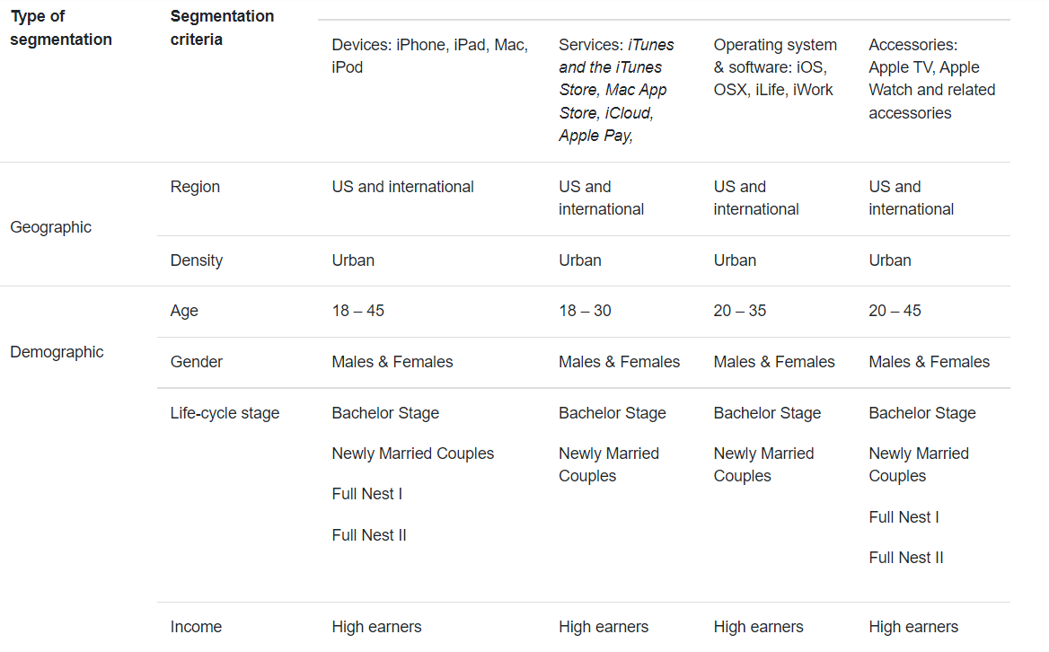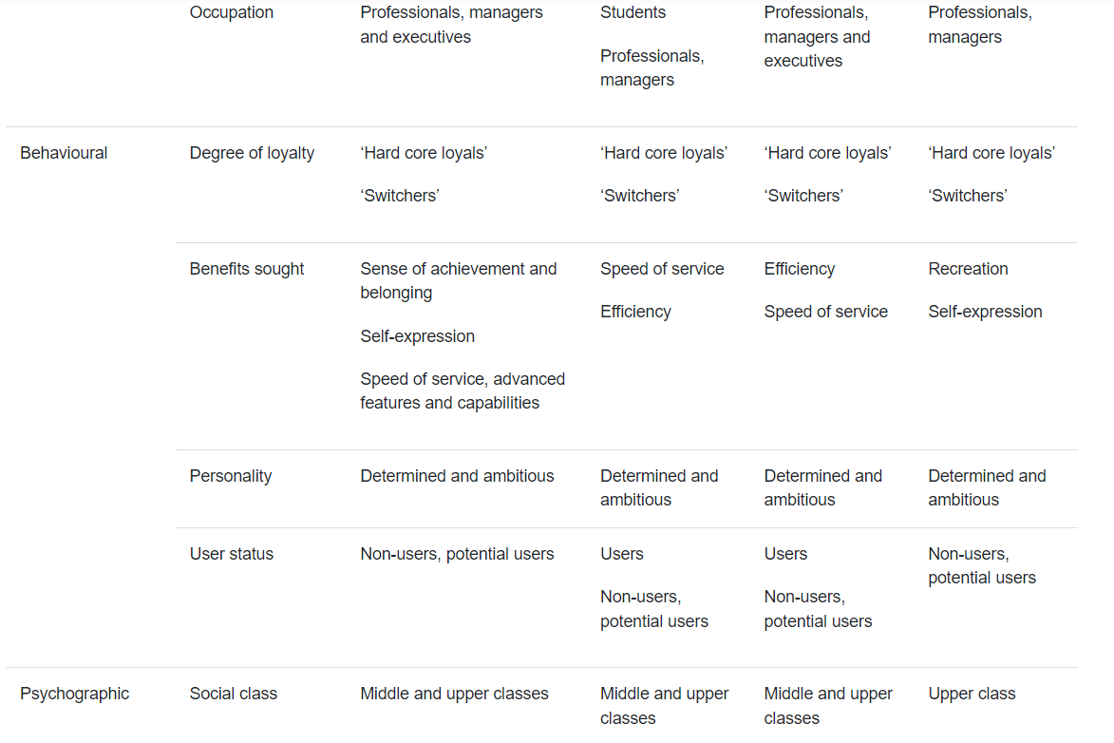
Source: https://research-methodology.net/apple-segmentation-targeting-and-positioning/
5.2 Targeting
Here we look at the different segments we created earlier and select the most suitable one for the product. An ideal segment is one that is growing, will return a higher profit and has a relatively low targeting cost. There are three different types of targeting techniques used by companies (Hofacker, 2022; Camilleri, 2018).
- Differentiated Marketing: In differentiated marketing, companies employ different marketing techniques to target different segments. It helps to create personalised strategies to target each segment, and could help create brand-loyal customers.
- Undifferentiated Marketing: In undifferentiated marketing, companies create a single targeting strategy for all the different segments. This will help companies to reduce the costs of advertising.
- Concentrated Marketing: Here the companies created strategies focusing on one particular segment. It is also called niche marketing as it helps to create and attract a small but highly profitable customer segment in the market.
Apple employs differentiated marketing techniques to target its customers. The company creates products with unique designs and features that will appeal to its target demographic of young and tech-savvy people.
5.3 Positioning
Positioning techniques are used to set your product apart from the competition to attract buyers. Apple uses the concept of emotional branding to position itself in the market. The company is known to produce innovative and quality products at a premium price. So Apple positions itself as a premium company that has a strong and brand-loyal customer base (Dudovskiy, 2021).
As we had a detailed look at the STP model we can now proceed to learn about the marketing mix strategies for Apple.
6. Marketing Mix Strategies for Apple
The marketing mix strategies help a company to position itself in a highly competitive market. Apple’s marketing mix strategy can be analysed with the help of the seven Ps in marketing, namely, product, price, place and promotion.
- Product Strategy: This strategy talks about the outputs/products of the company. Apple is a manufacturing company that creates technological products. iPhones, iPods, MacBooks and iWatches are some of the products manufactured by Apple (Greenspan, 2022). The company also provides some services such as iCloud, a platform for cloud storage and AppleTV, an online streaming platform.
- Price Strategy: Pricing strategies are used by companies to successfully price their products. Apple uses two major pricing strategies for their devices; premium and freemium pricing strategies (Greenspan, 2022). Apple has created millions of brand loyal customers who are willing to pay extra for its products. So Apple uses a premium or high price for its devices. The company also use a freemium pricing strategy for some of its products. In freemium pricing, companies provide a part of the service free of cost to their customers. However, in order to access the full service, customers have to pay extra. Apple for instance uses it for iCloud. Users are provided complimentary access upto 5 GB of cloud storage space. If they require more space, they have to pay a monthly subscription.
- Place Strategy: This strategy is about the selection of places of distribution for the products of a company. Distribution can be either company owned or through an external distributor. Apple employs four main channels of distribution (Greenspan, 2022).
  - Apple Stores: These are physical stores created by Apple to showcase and sell its products. The company has more than 500 such outlets across the world.
  - Apple Website: The company also sell its products through its official online website.
  - Authorized Resellers: Apple also makes use of resellers to sell its products. It has both online resellers like Amazon as well as offline resellers like Currys and Argos.
  - Telecommunication Companies: Apple has also partnered with telecommunication companies to sell its devices, For instance, Apple has collaborated with Vodafone to provide iPhones in contract, to its customers.
- Promotion strategy: Promotional strategies are the techniques used by companies to reach their customers. Apple uses four different types of promotional strategies (Greenspan, 2022).
  - Advertising: Apple broadcasts advertisements in both offline and online media. It posts regular ads on social media platforms like Twitter and Youtube as well as in newspapers and TV channels.
  - Personal Selling: The company also uses its employees for personal selling of its devices. They convince customers who visit physical stores of Apple to buy the devices.
  - Sales Promotion: The company also regularly uses sales promotion techniques. For instance, Apple UK provides special discounts and offers during occasions like Halloween and Christmas.
  - Public Relations: Apple also uses public relations to reach its customers. The company conducts events such as WWDC every year to showcase its new and upcoming products.
- People: The quality of Apple products has created millions of brand loyal customers. They regularly post reviews and videos on Apple devices gathering a positive image for the company. Also, Apple trains its employees to provide exceptional service (Frazer-Morris, 2018). Both these aspects help Apple to reach its customers more effectively.
- Process: This factor discusses the way customers communicate with the company. Apple has developed an excellent customer support team that can be reached through calls, texts, emails and social media. The process also denotes the way things are built (Frazer-Morris, 2018). Apple contributes millions to its research and development team to design innovative products.
- Physical Evidence: This factor denotes the tangible or physical aspect of the company. For Apple, these are the physical stores. They are built with a minimalistic nature, all while highlighting Apple products efficiently (Frazer-Morris, 2018). The following pictures show the internal view of an Apple store in Washington D.C.

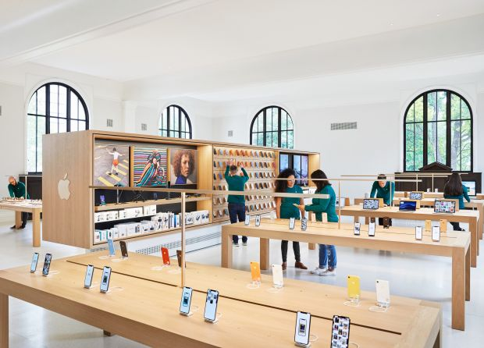
Source: https://www.the-spin-off.com/news/stories/Stores-Patented-places-14753

7. Conclusion
Marketing is not just about sales. It’s also about building long-lasting relationships between a company and its customers. Over the course of this report, we learned about marketing strategies of Apple. We started off by discussing the PESTLE factors that play a role in the functioning of Apple. Then we used Porter’s Five Forces model to learn about the competition in Apple’s business areas. We observed that some of the Five Forces such as the bargaining power of buyers and industry rivalry possess a higher threat to Apple. We also learned about the different strategies used by Apple to counter these threats. Then we had a detailed SWOT analysis of Apple. It helped us to identify the core strengths and weaknesses of Apple. Afterwards, we looked at the STP model of Apple to learn how the company positions itself in the market. Finally, we had a look at the marketing mix strategies employed by Apple. We used the seven Ps model as Apple manufactures both products as well as services. It helped us to get a clearer picture of various marketing strategies such as price and promotion and how Apple uses them to target customers.

