An Early Years Practitioners Handbook:
Transitions through early years


Table of Contents

Introduction
Proposed Outcomes
Interventions
Partnerships
The needs of the child
The role of the adult
Transitions
Introduction

The aim of the handbook

This handbook is aimed towards early years practitioners and to support them through children’s transitions and looking closely at the transition of moving throughout year groups in school Throughout this handbook, early years practitioners will collect information on the experiences and the considered outcomes for babies and young children whilst they enter their first encounters of childcare settings. Practitioners will gain information on enabling positive transitions for children by reading this handbook and outline the important roles of everybody involved.

Introduction

Throughout their lives, children will experience many transitions from birth to their school years and beyond into adulthood and although some children may look forward to transitioning throughout their school lives, for others it may be challenging but with support from parents and early years practitioners then it can be easier for children to move along. Early years matters (2018) believe that as children transition into key stage 1, they are working on a curriculum that is based on what they understand and what they have learnt through their time in reception and their knowledge will be developed further.

Early years practitioners play a vital role in children’s lives throughout their transition period at schools, and they must have a clear understanding of each child and ensure that the needs of children are met individually. Every child develops a range of skills at different rates and children should be given opportunities to put these skills into action as conveyed by Welsh Government (2018).
The NFER (2005) researched into a school group to find how children found the transition from reception class into year 1 and although many children enjoyed new challenges and expectations others found It difficult adjusting to a new environment. Children must move out of a familiar and safe environment into a new and unfamiliar setting and changes also include meeting new children and teaching and taking on a wider range of responsibilities whilst going through a transition.

This handbook also contains research conducted from theorists that support a child’s transition from their current environment into a new, unfamiliar setting and how early year practitioners are essential in making a child’s transition smooth and successful.

Transitions

A transition is a change in situations or environments that should be seen as positive journeys that involve not only children but early years practitioners and parents/carers, and according to Pacey (2016) as children develop, they will experiences a number of transitions such as:
Change in settings
- Breakdown of family relationships
- Moving from nursery to primary school
- Moving house
Transitions in day-to-day life
- Dropping off and picking up from school
- Going from play time back into lessons
Educational transitions
- Moving from home to Nursery/childcare setting
- Transition from reception class into key stage 1
- Key stage 1 to key stage 2

Early years practitioners must know the context of each child’s life and recognise how they are adapting to different transitions and the impact it is having on each child. It is also crucial that parents or carers are also heavily involved in a child’s transition period to ensure that children have support not only at school but at home also and that parents/carers can support and advise their children whilst transitioning, CWDC (2010).

Additional detail should be provided for children with special educational needs and disabilities (SEND) by practitioners to ensure that those children have equal opportunities as others to have a successful transition throughout school and these specified details can be used to plan the appropriate curriculum needed for each unique child,

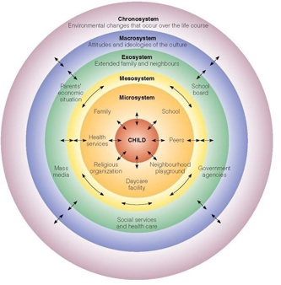
Source: SanDiegoCOE 2020.
Bronfenbrenner’s theory of human development represents a way of how practitioners should understand children’s experiences and development. This theory emphasises on the many different transitions that children could face on a day-to-day basis as they move between different environments and situations (Crowley, 2017). Bronfenbrenner’s model also highlights the importance of listening and understanding people’s perspectives to support children throughout their transitions. Individuals should see children as unique children who are at the very start of their journey in life and multi-agencies must come together in order to support and help a child’s transition.

The role of the adult

A positive approach should be given by key workers to children going through transition as it can be an unsettling experience for some children and key workers should build a relationship not only with children but with their parents or carers too which will have a positive effect on children whilst going through transition (Essex County Council, 2021).
Practitioners must have secure knowledge on the children they work with and understand the needs some children may have and knowing how to meet these needs and consider their interests and abilities also.

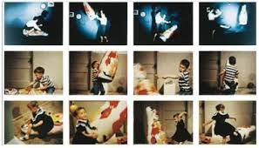
Bandura’s experiment of the ‘Bobo Doll’ was a theory that was made from a conclusion that shows that children learn their different behaviours from observing the behaviours of another individual around them. (Graham, & Arshad-Ayaz, A. 2016) This study shows that keyworkers should have a professional and positive attitude towards children during their time of transition as children will observe key workers’ attitudes and see them as role models.

Source: Mcleod, S (2014)

As shown in Bandura’s ‘Bobo Doll’ experiment, children observe the behaviour of those around them and keyworkers are seen as role models to children and must remember important aspects of their role such as:
- Giving children a welcoming environment and a high quality of care
- Ensuring that safeguarding measures are always in place and supporting each child and their families/carers.
- Meeting the social, physical, and emotional of each child and knowing what children need to work towards to better their progress.
- Support and reassurance are given and is known to both child and parent/carer.

Effective communication is essential between practitioners and a child’s parent/carer as by getting to know each child and their likes and dislikes, practitioners form a bond with each child individually and practitioners must be aware of the culture children come from and their family background and circumstances and by doing this both practitioners and parents/carers can discuss their child’s development and speak openly about what encouragement the child needs, (Professional Association for Children and Early Years, 2009).

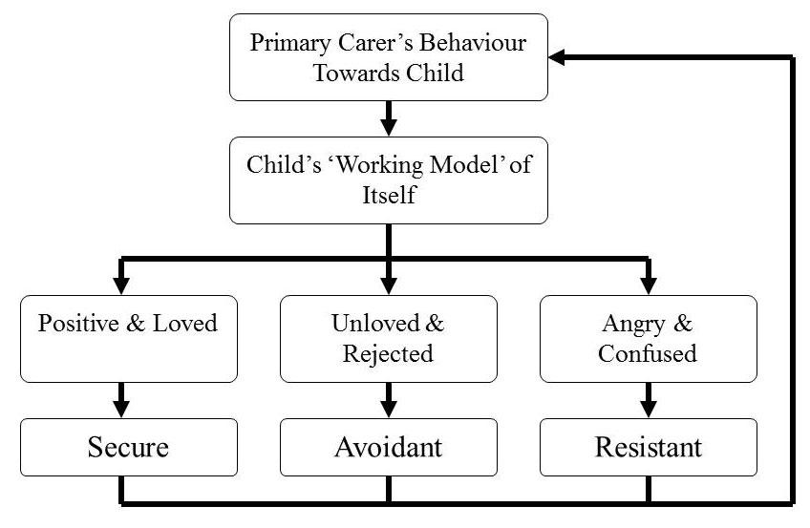
Bowlby’s attachment theory considers the importance of a child’s relationship with their primary carer, and this could be a parent, grandparent, older sibling, anyone that the child has developed a bond with that ensures their basic needs are met. Bowlby defines attachment as a ‘lasting psychological connectedness between human beings.’ (Bowlby J, 1969) Bowlby believed that children need to experience attachment and they also need a secure base which will enable children to develop socially.
However, Noddings (Attachment in the Classroom, 2009) states that practitioners must
Source: Counselling Buckinghamshire 2019.
care for children and school should concentrate
on the way children learn academically and children may become too attached to practitioners they work closely with, and some practitioners may favour some children and this may result in neglecting the needs of other children.

The needs of the child

The United Nations Convention of the Child is a safeguarding arrangement that is used worldwide that safeguards the rights of all children up to eighteen years of age, (UNCRC 2004). These rights are in place to ensure that children and young people are kept safe, have a say in things that may affect their lives, and have their right to a voice, (Welsh Government 2015). The Welsh Parliament (2020) state that the rights of children will have a positive effect on themselves, and their families and each child develop in their own unique way and therefore key workers should ensure that each child experiences an effective and comfortable transition. Transitional objects, such as a comfort blanket or a toy, or anything that children see as security objects can be used as support whilst children transition as it may reassure some children of the new environment they are going into and this will help children to make a smooth transition, (healthy children, 2019).

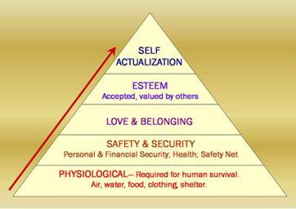
Maslow hierarchy of needs theory was developed as stages he believed children need and how to meet these stages in order to progress onto the next stage, as Maslow believed that each of these stages has an effect on the way children behave, (Thomas 2018). The needs at the bottom of the triangle must be met before the needs of higher up on the triangle and this is relevant to early years as children must feel safe and secure otherwise, they may refuse basic needs such as food and water and may not build strong relationships with those around them, (Pichere, P. et al. 2015).

This theory can be applied to the care that is given to children by early years practitioners as they must priorities what children truly need and what important needs must come before others not so important. Practitioners must consider the environmental issues that may be affecting children’s lives which enables them to reach their basic needs and fullest potential, and children must be treated with care and respect not only by practitioners within their classroom but also throughout their setting,

Effective communication plays an essential role between practitioners and children during their transitions as it encourages children to build a relationship built on trust and children are confident in speaking and listening to early year practitioners. Children find it difficult to communicate with people who are unfamiliar to them and may come across as anxious or overwhelmed and practitioners must be aware of this whilst children transition as children are getting familiar with a new environment and new people and practitioners must recognise when children are feeling scared or uncomfortable, (Thomas 2016).

The new curriculum for Wales states in the four main purposes that the schools aim is to ensure they are supporting children to develop into confident and ambitious learners and practitioners need to know each child’s development and individual needs and respond to them, (Welsh Government 2020). The importance of play is a very important part of a child’s transition process as article 31 of the UNCRC states that every child has a ‘right to play.’ Play can be initiated by both children and adults, and practitioners must recognise that play is a crucial part in the way children learn, therefore children must be given entry into opportunities that allows them to play, (Welsh Government 2002). The purpose of play is highlighted as it develops positive attitudes and communication skills for children, and it enables children to become active learners.

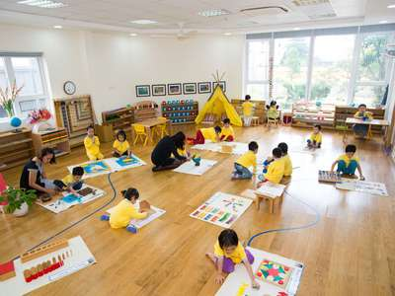

Montessori’s method is an educational approach which emphasises on children to learn and think independently and will also encourage self-learning which will then promote self-confidence, (Meinke, 2019). Children must make their own creative choices and given age-appropriate resources for activities which will result in them making progress and developing at their own pace and with resources that are suitable for them individually. However, it is the teacher/practitioners’ job to ensure that children are learning at the correct pace and learning
Cite: Britannica 2017
what they need to know at this particular age and this
may not be what a certain child wants to do but in order
to develop their core skills, they need to follow the correct curriculum.

Montessori also stated the importance of early year practitioners observing a classroom in order to acknowledge each child’s interests and what activities each child would choose and how many times would they engage in this activity. By observing the children closely, practitioners can gather information on each child and see in what areas of learning children need to develop and how they can do this in order to help them with their transition,
(Feez, 2010).

Partnerships

Working within a variety of different partnerships is an essential part of truly committing to a child’s development throughout their transition, and this can involve working with other agencies as well as a child’s parents or wider family. Whilst communicating with parents/carers, it is key for them to know who the key person of their child is, and that key person must inform parents/carers about the development of the child, (Pacey, 2018.) Pacey (2018) also state that parents/carers should be involved heavily within their child’s transition, along with sharing any resources that have been helpful within a child’s transitioning period and also about the way their child is settling. Building a trustworthy relationship with children’s’ parents/carers is beneficial in helping a child through their transition as parents must be involved in their child’s school life and having regular session between parents and key workers is an important opportunity.

The diagram on the right shows how the importance of the child being central to all communications between parents, practitioners, and multi-agency workers and how important the role of a key person plays in a child’s life.
Multi-agency workers
Early Year Practitioners

Child

Family

Effective partnerships between parents/carers and early years practitioners can result in parents/carers having a positive attitude between the school setting and this will result in children not seeing a big divide between home and school, (Parent Partnerships in the Early Years 2004). Parents will be able to have a wider understanding of the work that is being given to their child and how they are able to develop from this work, and these partnerships will benefit early years practitioners also as they will have a deeper knowledge of the background and culture of the children they are working closely with.

Having effective communication with a variety of different partnerships such as parents/carers and staff members can result in children having a smooth transition throughout school, and there are many things practitioners can do to help with this such as: (Thompson 2018)

Making handbooks for the child
- Handbooks should be provided for parents and staff which contains copies of all the relevant information and policies that are vital. Parents should have additional information in their handbook with things included such as information about absences and enrolment information.

Electronic Communication
- Electronic communication is an effective way of parents/carers to reach practitioners after school hours or for practitioners to reach parents at any time. Communication can be used as emails, and this can be an effective way of practitioners to keep up to date with any information that they are given, and emails can be checked routinely throughout the day.

School based programmes are available for children and families to improve the emotional and social skills of children. Schools are able to provide a range of support that is put together to meet a child’s individual needs and to deliver support to children and their families. Some resources might not be suitable for children of the same age as children develop in their own ways and at different times so schools must offer a range of different resources for children at all levels of development, (third space learning, NO DATE).
Schools offer intervention based on what area of learning a child needs to work on such as handwriting skills. Many children transition through school not knowing how to hold a pencil correctly and handwriting is an essential part of a child’s work and interventions can offer resources such as tracing letters, numbers, and words. This will allow children to work on their skill of holding a pencil correctly and bettering their handwriting and packs can be made for children to take home and work on these skills with their family.
Interventions

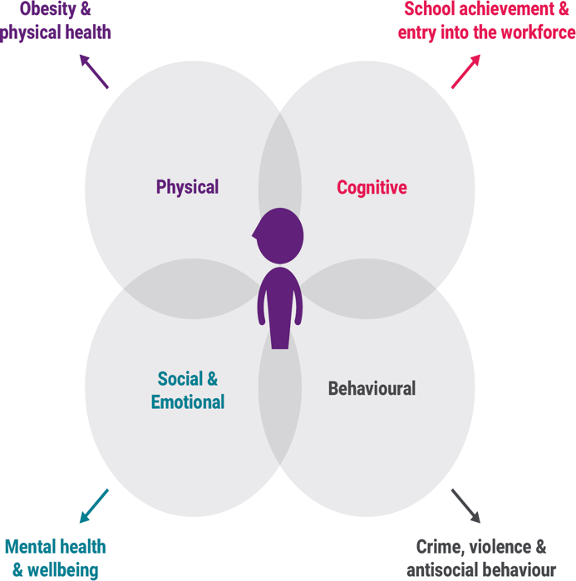

To maintain close relationships with parents and families, schools are able to provide families with information and packs to do with children at home to help with develop any skills they need to work on. Welcoming packs should be available for all families when their child starts a new transition period which consists of all the information, they need about their child’s new school year and the activities and information they will be learning.
Home visits are also beneficial for children who need intervention as practitioners are able to understand what environment children live in and what their life is like away from home and to see how they react at home.

The early intervention foundation believe that early interventions should support children on four key aspects of their developments that have the potential to make differences in children’s lives which they will benefit from, (EIF 2021).
-Physical development involves children’s health and whether they have a physical or hidden disability and intervention activities include reducing the risk of infectious diseases and reducing the risk of obesity within children.
-Cognitive development involves skills around many areas of learning such as reading, writing and problem solving. Interventions can help these skills by test at school to see the outcomes of children’s skills and if they need to develop further in certain areas of learning.
-Behavioural development looks at how children monitor their own behaviour as well as others around them and allows them to form positive and healthy relationships with people around them.
-Social and emotional development looks at children’s own emotional needs and those of others around them. These interventions can help to reduce mental health within children and to improve their self-esteem.

Source: Early Intervention Foundation 2021.

Not all children have the speech, language, and communication skills they need to reach their full potential in school, and these skills are that are crucial for children in school, (Royal College of Speech and Language Therapists 2020). Speech and language therapists are professionals in the health sector that come into schools to help children that are suffering with any additional needs by providing the care and support the children need whilst also working carefully with parents and practitioners. The UNCRC states that every child has the right to the highest standard of health and healthcare services that are available to them, and schools must ensure that professional healthcare workers are available for children if they are needed whilst under care of early year practitioners. Local education authorities can also work closely with the NHS to ensure that there is efficient provision in all schools in the area that supports the healthcare needs of all children, such as physiotherapists, doctors, and dieticians, (Scottish Government 2017)

Proposed Outcomes

The desired outcomes for children transitioning throughout school should be a child who is happy, confident, and engaged with the social and emotional skills they need in order to further their development and to support their needs. The transition of a child will be deemed successful when the child has appeared settled and independently doing their own tasks and playing with new children and not depending so much on practitioners for reassurance. Children will become familiar in their new settings/environments and begin to form new relationships with new practitioners and overall become comfortable in their new chapter of life. The Welsh Government state that children should feel engaged within their classrooms and within their wider school community and they should feel a sense of value and respect from practitioners and other children around them. (Welsh government, 2016).

Observation is a key part of a child’s outcomes as all children have their unique skills and abilities and some may not develop as quickly as other children, which is why observation should be taken place in multiple situations in order to see children in different environments to see where they need to develop and how they can do this, (Early years matters, 2021). Once early year practitioners know where each child need to develop on their core skills, plans can be put into place for the children to work on these and to have outcomes in place to see if they have developed over a certain amount of time.

Reference List

Anilkumar, A (No Date) Primary School Interventions – What works at key stage 1 & 2. Available at: https://thirdspacelearning.com/blog/primary-school-interventions/ (Accessed: 10th November 2021).

Bagula,F. (2020) Knowledge is Power:Equality considerations in the age of COVID. [image] Available at: https://www.sdcoe.net/lls/equity/Documents/2020-Webinar_Trauma-Human-Development.pdf (Accessed: 15th November 2021).

Bergin, & Bergin C. (2009) Attachment in the Classroom. Available at: https://edsource.org/wp-content/uploads/old/ClassroomAttachment.pdf (Accessed: 14th November 2021).

Bowlby, J. (1969). Attachment. Attachment and loss: Vol. 1. Loss. New York: Basic Books.

Children’s workforce development council (2010) The Common Core of Skills and Knowledge. Available at: https://dera.ioe.ac.uk/512/7/CWDC_CommonCore7_Redacted.pdf
(Accessed:15th November 2021).

Christle, C (2017) Montessori Schools [image]. Available at: https://www.britannica.com/topic/Montessori-schools (Accessed: 7th November 2021).

Counselling Buckinghamshire (2019) Internal working model [image] Available at: https://counsellingbuckinghamshire.co.uk/internal-working-model/ (Accessed: 14th November 2021).

Crowley, K. (2017) Child Development a practical introduction. 2nd Ed. London: SAGE
Early Intervention Foundation (2021) What is early intervention? Available at: https://www.eif.org.uk/why-it-matters/what-is-early-intervention (Accessed: 19th November 2021).

Early Years Matters (2021) Observation, Assessment, and Planning. Available at: https://www.earlyyearsmatters.co.uk/eyfs/a-unique-child/planning/ (Accessed:19th November 2021).

Essex County Council (2021) Role of the adult. Available at: https://eycp.essex.gov.uk/the-early-years-foundation-stage/how-do-i-become-an-outstanding-practitioner/role-of-the-adult/ (Accessed: 14th November 2021).

Every Child Matters (2018) Transitions.Available at: http://www.earlyyearsmatters.co.uk/eyfs/positive-relationships/transitions/(Accessed: 10th November 2021).

Feez, S. (2010) Montessori and early childhood a guide for students. Los Angeles: SAGE.

Fitzgerald, D. (2004) Parent Partnerships in the Early Years. London: Continuum.
Graham, P. and Arshad-Ayaz, A. (2016) ‘Learned Unsustainability: Bandura’s Bobo Doll Revisited’, Journal of Education for Sustainable Development, 10(2), pp. 262–273. Available at: https://journals-sagepub-com.ezproxy.uwtsd.ac.uk/doi/full/10.1177/0973408216650954

Healthy Children.org (2019) Transitional Objects. Available at: https://www.healthychildren.org/English/ages-stages/baby/Pages/Transitional-Objects.aspx 2019 (Accessed: 19th November 2021).

Mcleod, S (2014) Bobo Doll Experiment [image] Available at : https://www.simplypsychology.org/bobo-doll.html (Accessed: 16th November 2021).

Meinke, H (2019) Exploring the pros and cons of Montessori education. Available at: https://www.rasmussen.edu/degrees/education/blog/pros_cons_montessori_education/
(Accessed: 12th November 2021).

PACEY (2016) Transitions and Settling in. Available at: https://www.pacey.org.uk/Pacey/media/Website-files/PACEY%20member%20practice%20guides%20(PDFs)/PG10-transitions-and-settling-in.pdf (Accessed: 19th Nov 2020).

PACEY (2018) Working in partnership with parents. Available at: https://www.pacey.org.uk/working-in-childcare/spotlight-on/partnerships-with-parents/ (Accessed: 9th November 2021).

Pichère, P. et al. (2015) Maslow’s hierarchy of needs. Namur: Lemaitre Publishing.

Professional Association for Childcare and Early Years (2009) Helping your child settle in. Available at: https://www.pacey.org.uk/parents/working-with-your-childcarer/helping-your-child-settle-in/ (Accessed: 14th November 2021).

Royal College of Speech and Language Therapists (2020) Guidance for education settings on commissioning (buying in) speech and language therapy services and training. Available at: https://www.rcslt.org/wp-content/uploads/media/docs/Education-Guide_Final.pdf#page=6
(Accessed: 11th November 2021).
Sanders, D,. et al. (2005). A Study of the Transition from the Foundation Stage to key stage 1. DFES: London.
Scottish Government (2017) Supporting Children and young people with healthcare needs in schools: guidance. Available at: https://www.gov.scot/publications/supporting-children-young-people-healthcare-needs-schools/pages/3/ (Accessed: 10th November 2021).

Thomas, B (2016) The importance of communication. Available at: https://childcareeducationexpo.co.uk/importance-communication-beth-thomas/ (Accessed: 17th November 2021).

Thomas, S. (2018) Maslow’s Safety Needs: Examples and Definitions. Available at: https://study.com/academy/lesson/maslows-safety-needs-examples-definition-quiz.html (Accessed: 13th November 2021).

Thompson, M. (2018) Ways to communicate to Parents & Staff at a Day Care Centre. Available at: https://smallbusiness.chron.com/ways-communicate-parents-staff-day-care-center-41329.html (Accessed: 13th November 2021).

UNCRC (2004) The United Nations Convention on the Rights of the Child Available at: https://downloads.unicef.org.uk/wp-content/uploads/2016/08/unicef-convention-rights-child-uncrc.pdf?_adal_sd=www.unicef.org.uk.1637697757467&_adal_ca=so%3DGoogle%26me%3Dorganic%26ca%3D(not%2520set)%26co%3D(not%2520set)%26ke%3D(not%2520set).1637697757467&_adal_cw=1637697749444.1637697757467&_adal_id=92c3d720-a7fe-4559-8b51-3d03790e3771.1637697749.2.1637697749.1637697749.af7d40cc-5573-48fe-9c48-a02e0afa8974.1637697757467&_ga=2.134054670.1442436229.1637697749-1040648197.1637697749 (Accessed: November 16th 2021).

Welsh Government (2002) Welsh Assembly Government Play Policy Available at: https://www.playwales.org.uk/login/uploaded/documents/Play%20Policy/Wales%20play-policy-e.pdf (Accessed: 14th November 2021).

Welsh Government (2015) UNCRC An introduction to the United Nations Convention on the Rights of the Child. Available at: https://gov.wales/sites/default/files/inline-documents/2019-03/1_UNCRC%20Rights_En%20%281%29.pdf (Accessed: 14the November 2021).

Welsh Government (2016) Foundation Phase Action Plan. Available at: https://gov.wales/sites/default/files/publications/2018-03/foundation-phase-action-plan.pdf (Accessed: 16th November 2021).

Welsh Government (2018) Foundation Phase Framework revised 2015. Available at: https://gov.wales/sites/default/files/publications/2018-02/foundation-phase-framework-revised-2015.pdf (Accessed: 13th November 2021).

Welsh Government (2020) Introduction to curriculum for wales guidance. Available at: https://hwb.gov.wales/curriculum-for-wales/introduction/ (Accessed: 14th November 2021.)
Welsh Parliament (2020) Children’s rights in wales. Available at: https://senedd.wales/laid%20documents/cr-ld13405-r/cr-ld13405-r-e.pdf (Accessed: 7th November 2021).

