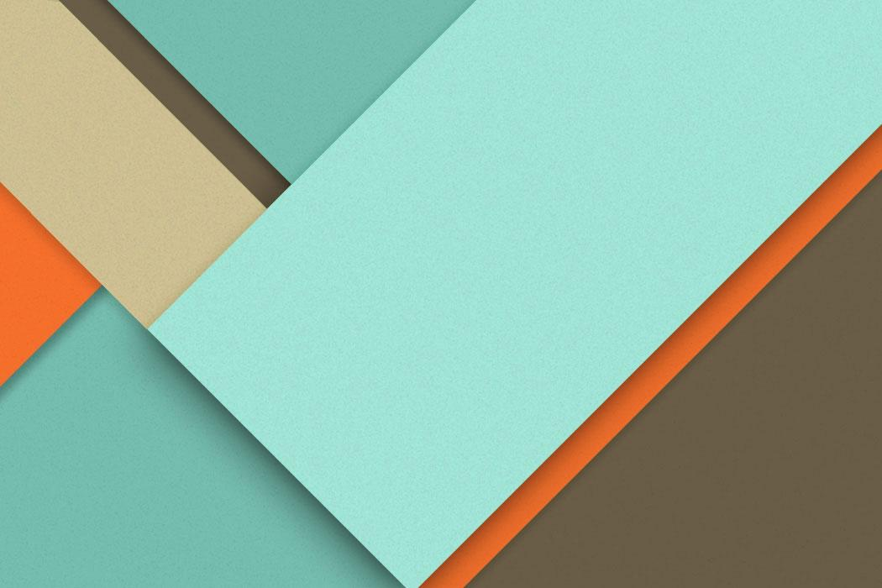

Digital era development diary

─
Jack Peterson
2305628

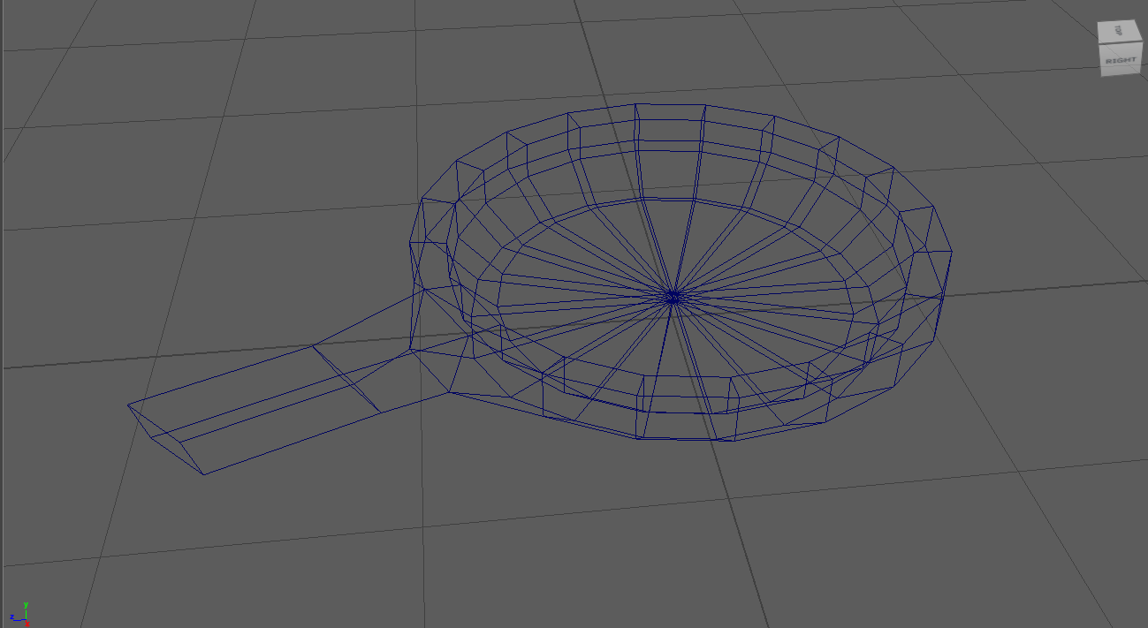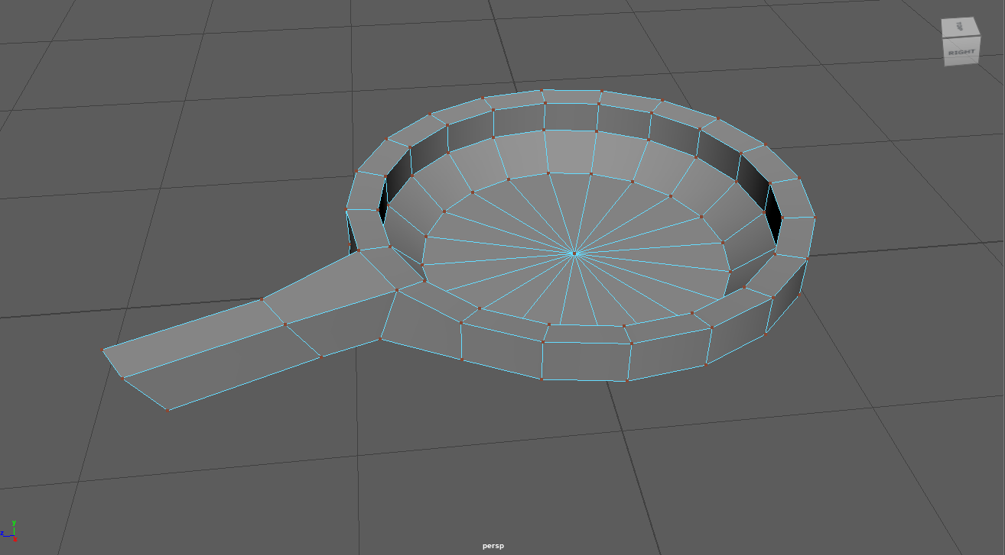 | Since I knew the main body would be round at the sides I started with a cylinder that I squished down, extruded it twice, made the top face smaller with the scale tool then moved that face back down to create a bowl shape. For the handle I simply extruded one of the faces on the side and pulled it out. I looked at a cast iron pan on pinterest for reference [1]  3/12/23
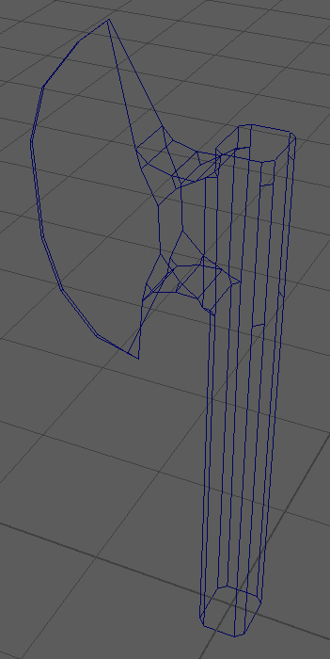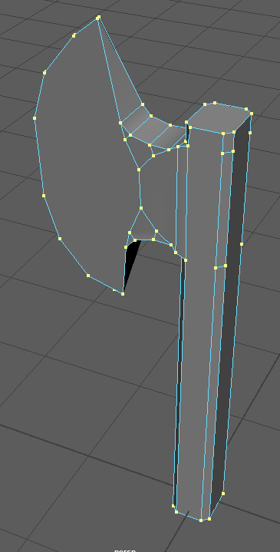 | For the ax I knew I could make the axehead out of extruded parts so I only focused on the stick body for my starter shape, I chose a square that I scaled on one side and selected the edges to bevel them. For the blade I wanted it to be only a single edge and not a face so I couldn't extrude it, instead I connected the two sides with the connect tool and scaled the edge between them larger and moved it forward, creating a rough blade, I then used the bevel tool on the perpendicular edges to make it curve and on the blade's edge to make it rounder. I like the overall rounded appearance of this piece, a result of the bevel tool, as it makes it look more true to the reference by turning normally rigid lines into curves. I looked up a simple ax for reference [2]  4/12/23
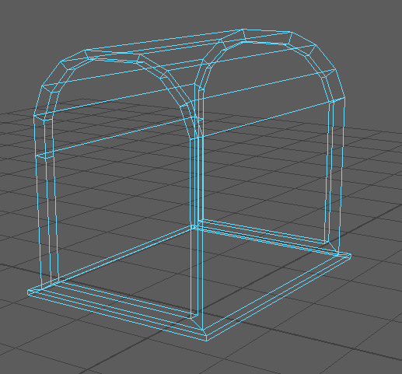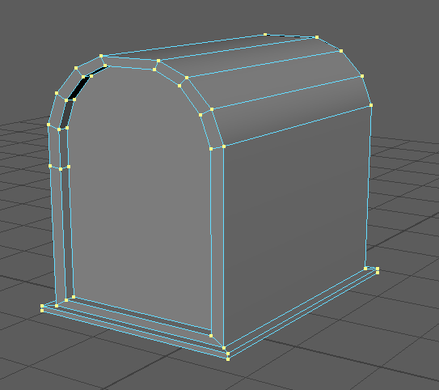 | The chest started as a cube, I beveled the top a few times to round it out then I selected the right and left side together and did the following: extruded them, scaled them down, extruded them again, then moved the face inward, I had both of them selected so the end result would be symmetrical. I used a prop treasure chest as reference [3]  6/12/23
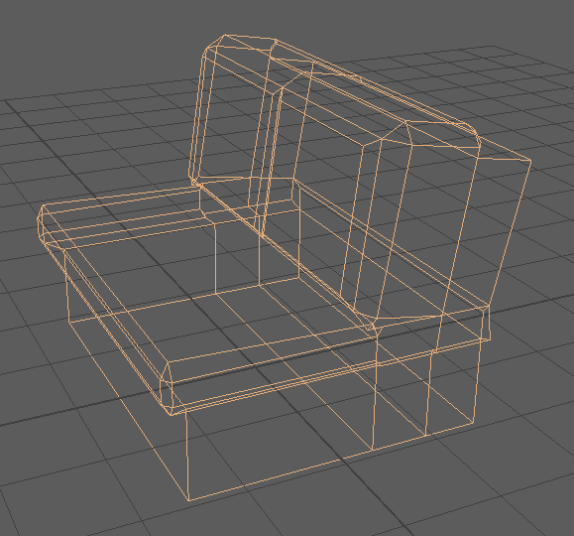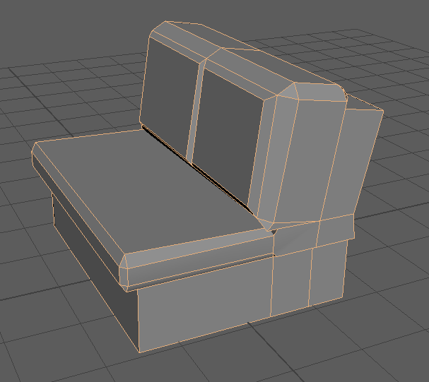 | The sofa was a cube I extruded and scaled into an L shape, I then tilted the back slightly so it reclined like a chair would, for the cushions I extruded every face on the front, brought them forward and scaled them larger, then extruded them again to give it volume, I then beveled all the edges to make them look plush. I used a portland sofa as reference [4]  6/12/23
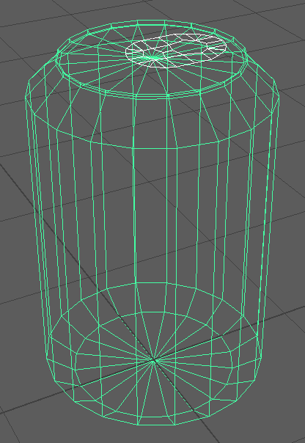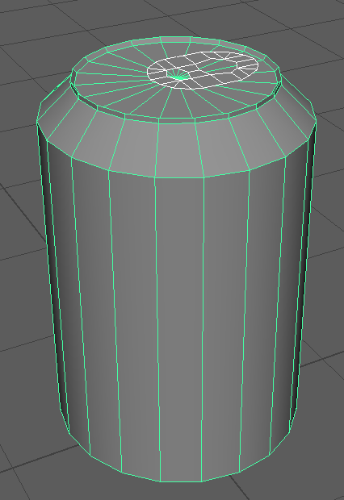 | For the soda can I created a cylinder and beveled the sides, then I moved the bottom more upwards to warp the bevel as the bevel only gives perfect 45° angle cuts but my reference has angles closer to 30° giving it a squashed look. For the can tab I created a separate plane and cut out squares to match the holes in a normal tab, it was looking too square so I beveled all the edges to make it round and placed it on top of the can at an angle. I used a pepsi can as reference [5]  13/12/23
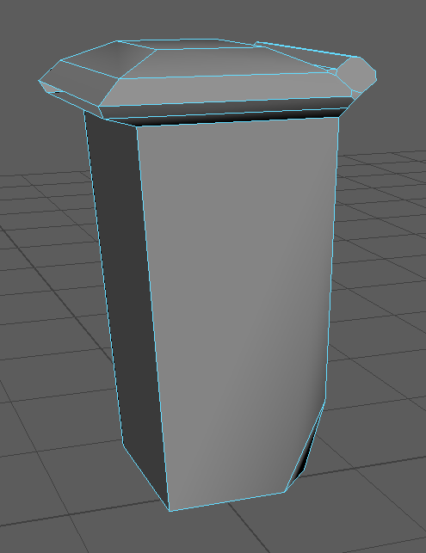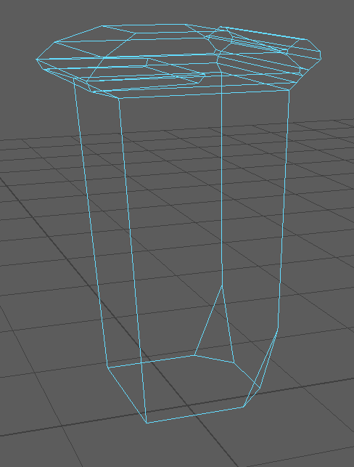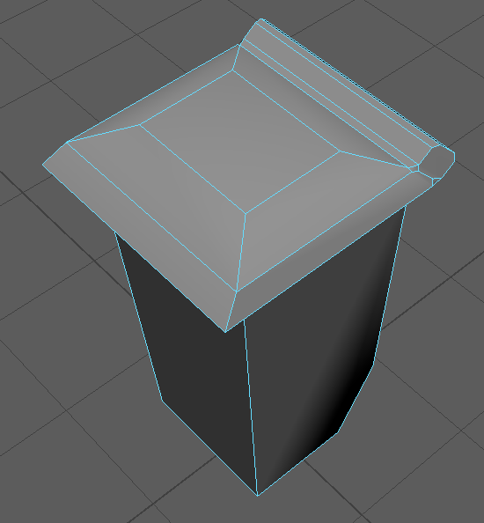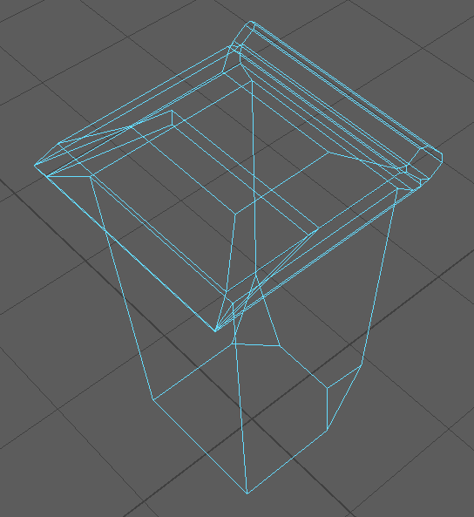 | The dumpster varies so I chose a singlet waste bin type. It started as a cube which I extended and extruded a few times to create a lid, for the mouth I extruded a face and moved that face inward. For the wheel holes I beveled the vertices creating a triangle-shaped divot and for the hinge extruded a face and pulled it out, then beveled the sides to make it more circular. I used a 2 wheeled waste bin as reference [6]
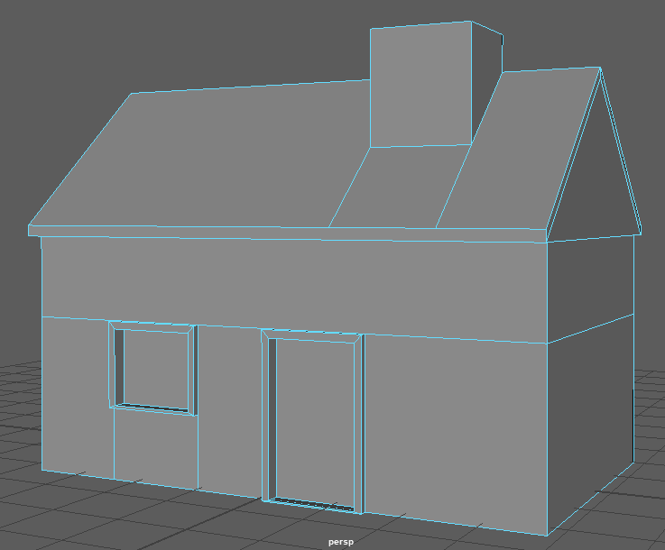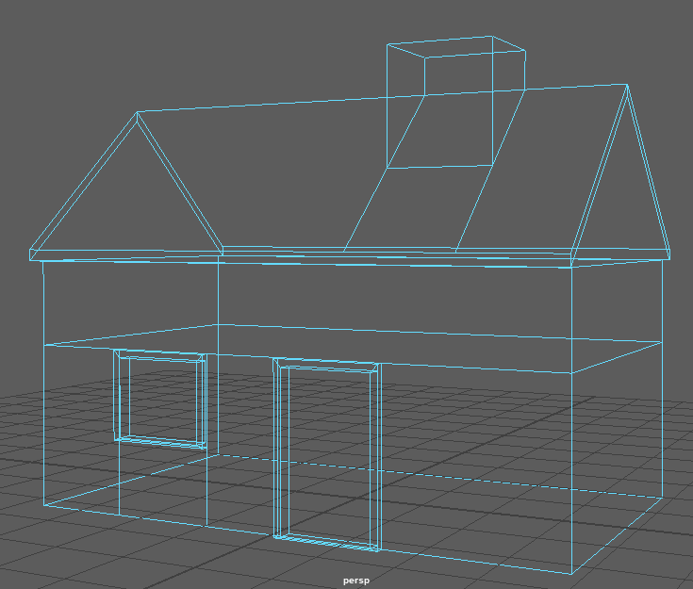 | To make the roof I beveled it and then connected both sides to make an edge. Then I lifted that edge up like a tent pole. For the door and window i made and edge loop and connected that loop to the floor to make edges that go down, for the window i also made one in the middle of it, then for both i extruded and moved them to make a visible ridge around them, and then extruded and pushed them back into the house. For the chimney i extruded a square and rotated it to match the horizon.
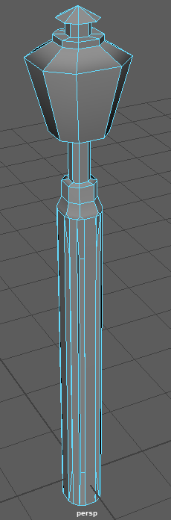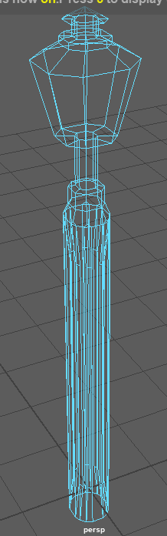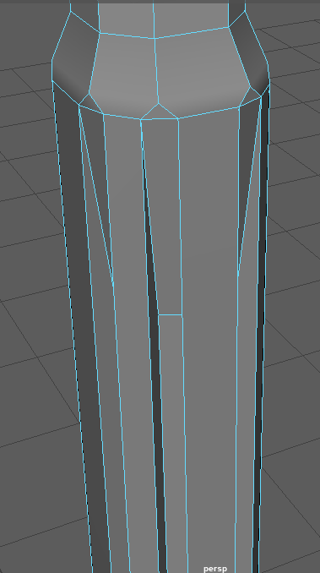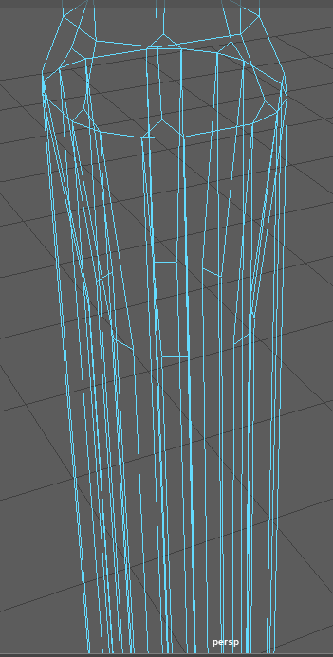 | For the lamppost I actually started with a cube so I could retain its octagonal shape in the lamp as the cylinder was actually too round for my tastes. I inserted an edge loop to separate the lamp from the pole and beveled the pole again, then used the edge loop to cut it into a few more sections and scaled them to different sizes, the last section I made into the lamp and sized the top face larger to match the ref. To make the ribbed effect I selected every second face on the beveled pole and scaled them down. Ref [7]
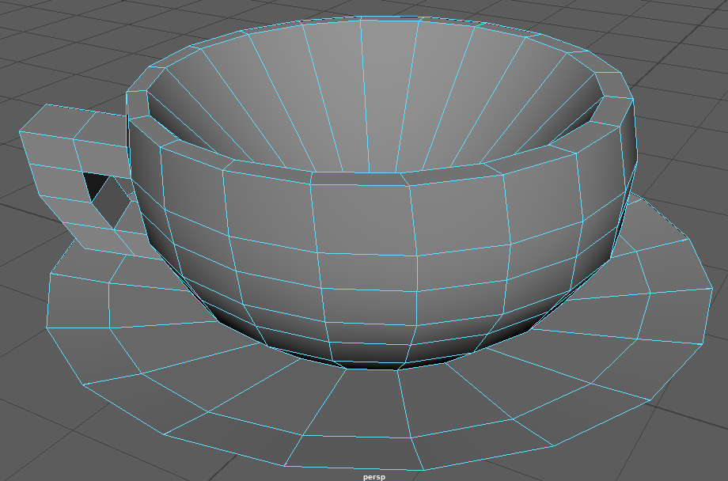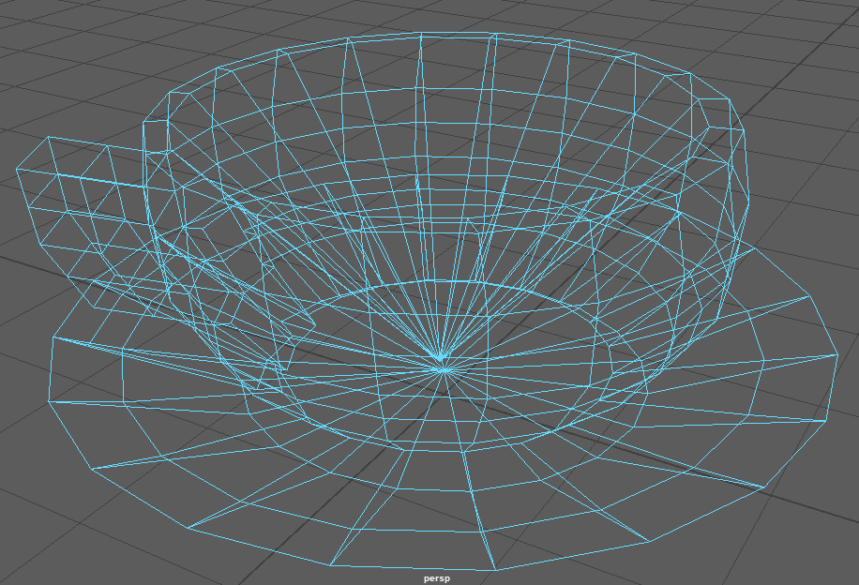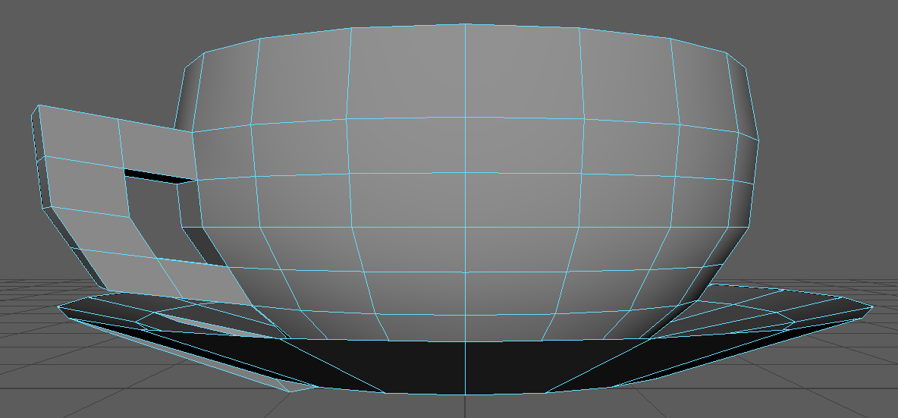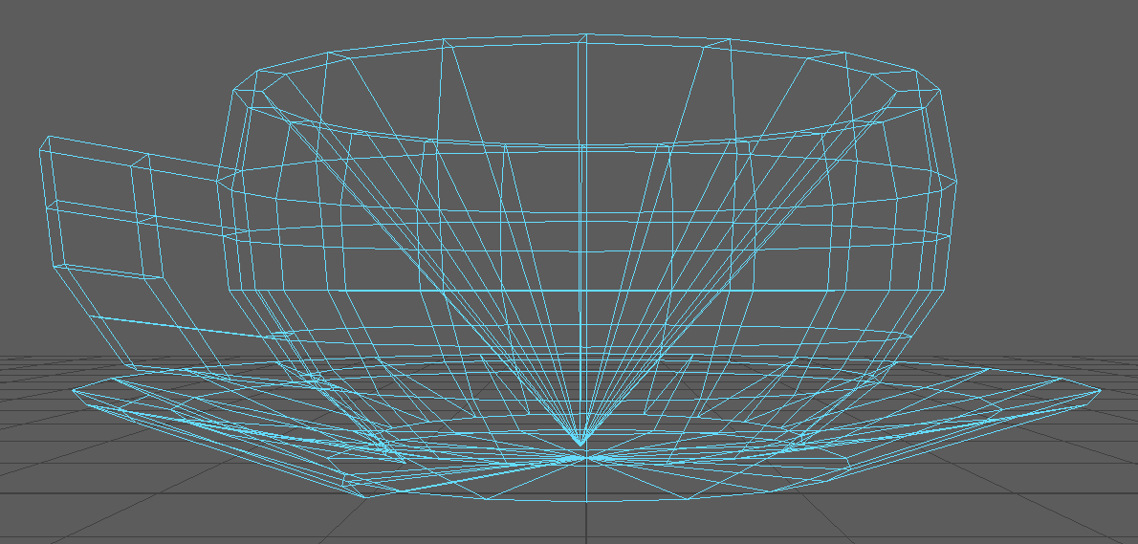 | I started with a cylinder and cut it with edge loops, then I scaled the sections and pushed the top face inward to make a bowl shape, then pushed the vertex a bit more to make the surface less flat. To smooth out the cup’s surface I ringed it and made each ring slightly smaller as it went down. For the hole I deleted the faces inside the teacup handle then used the bridge tool. Ref [8]

Bibliography

[1] YONGJUN (2018) Yongjun thick-bottomed frying pan, cast iron pan 7 inch -18cm vintage cast iron ear candle frying pan, non-stick cooker ga...: Cast iron pan, ear candling, cast iron, Pinterest. Available at: https://www.pinterest.co.uk/pin/642255596836888191/ (Accessed: 13 December 2023).

[2] Seller (2021) Damascus steel hatchet axe // VK5254, Touch of Modern. Available at: https://www.touchofmodern.com/sales/vky/damascus-steel-hatchet-axe-vk5254?wall=1 (Accessed: 13 December 2023).

[3] Platinum Prop House (2023) Medium treasure chest, Platinum Prop House, Inc. Available at: https://platinumprophouse.com/products/treasure-chest-2 (Accessed: 14 December 2023).

[4] Portland, “Portland 2 seater light grey modern sofa with hidden storage,” wilko, https://www.wilko.com/portland-2-seater-light-grey-modern-sofa-with-hidden-storage/p/0603677?msclkid=33e316bf600d14bc826b73c5a70fa102&amp;utm_source=bing&amp;utm_medium=cpc&amp;utm_campaign=PMax%3A+Furniture&amp;utm_term=4577541791563085&amp;utm_content=Furniture&amp;gclid=33e316bf600d14bc826b73c5a70fa102&amp;gclsrc=3p.ds (accessed Dec. 14, 2023).

[5] Tennille, “Pepsi can png, Transparent PNG - Kindpng,” KindPNG.com, https://www.kindpng.com/imgv/moTwJm_pepsi-can-png-transparent-png/ (accessed Dec. 14, 2023).

[6] Fosse Liquitrol, “360 litre 2-wheeled lockable clinical waste bin FL-143-360-CW,” Fosse Liquitrol, https://www.fosseliquitrol.com/product/360-litre-2-wheeled-lockable-clinical-waste-bin-fl-143-360-cw/ (accessed Dec. 14, 2023).
[7] Terra Lumi Außenleuchten, “Klassische Mastleuchte mit Schinkel-laterne sop1.71: Фонарные столбы, Уличные фонари, Фонарь,” Pinterest, https://www.pinterest.ph/pin/877216833641256609/ (accessed Dec. 14, 2023).
[8] “Tekopp & Fat Grön Jade,” Desina, https://desina.se/produkt/tekopp-fat-gron-jade/ (accessed Dec. 14, 2023).

Reflection

Something I improved on is visualizing objects better at their smaller components; to make something like a sofa I had to first imagine a square and reverse engineer what tools I would use to mold it into that shape, this tested my knowledge of 3d geometry and how to morph it.

I struggled with finding the right tool in maya, it has lots of very niche tools that I had difficulty sorting through, in particular I struggled to find a gap-filling tool which made my early attempts to cut holes in objects choppy and left unclean cuts until I found the bridge tool.

I used the website citethisforme.com which helped me gather and format my citations in IEEE, this was a huge relief because IEEE is a complicated format style that I don't usually use.

I also used the website stackoverflow.com for questions about maya because the people on that site know much more about the software than me, this helped me find the right tools for what I wanted and get more advice made for beginners

