ACTIVITY 1
INTRODUCTION
The aim of this report is to analyse the structure of different organisations, depending on its size, sector, and purpose. I will be comparing two companies to discuss not only how the type of business and, therefore, its purpose, affects the HR function, but also the impact that their organisational structure has on the HR function.
I will then explain what the HR professionals’ role is in formulating the business strategy and how this is translated into HR strategy and policies.
- Comparison of two types of organisations and their operational/business purpose

For this activity, I will be comparing Zara UK and Schoolhouse Daycare, both private sector organisations.

Zara UK is a multinational corporation (MNC), part of the INDITEX group, one of the world’s largest retailers in the world. It has over 7000 physical stores in 96 markets and it sells through its online platform in 202 markets. Worldwide, it employs over 176000 people, from 172 different nationalities and 73 different languages.

The company started in 1963 as a small family business making women’s clothes. Nearly 60 years after, the business still shares the original idea: ‘The customer is at the centre of everything we do’. Detailed information about the company’s history may be found at https://www.inditex.com/en/about-us/our-story.

Inditex covers the needs of its customers by bringing them the products at affordable prices. It focuses on the design, manufacturing, distribution, and retail of garments with flexibility, digital integration, and sustainability.

Zara is the group’s first brand, which was founded in Spain in 1975. Its core values are beauty, clarity, functionality, and sustainability. Its designers react to the customers changing needs received across their physical stores and online platforms.
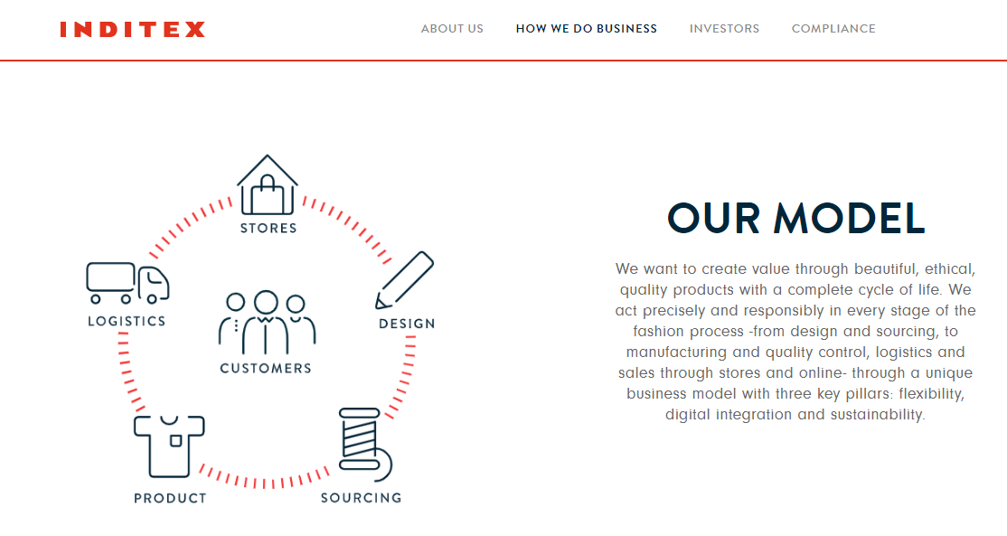
Inditex 2021

As the business is constantly evolving and growing, internal promotions have been the key to success, as most of the employees works or have worked in stores, the main component of the business, as they are nearest to the customers and identify their needs. Inditex promotes a working environment in which the employees expand their talent and skills. All the departments offer specialised, skilled or language training programmes, which depend on their requirements, but dealing with the main pillars of the business: product, process, and people management.
On the other hand, we have Schoolhouse Daycare, a group of nurseries which provide childcare from babies until 11 years old. It is considered a SME business and has three nurseries in Swansea and one in Bridgend. As we can read on its website, their commitment is to nurture all children in their care, encouraging confidence, inspiring creativity, and stimulating their curiosity, apart from making life easier to the families that benefit from them. Their vision and values are:
Schoolhouse Daycare 2021
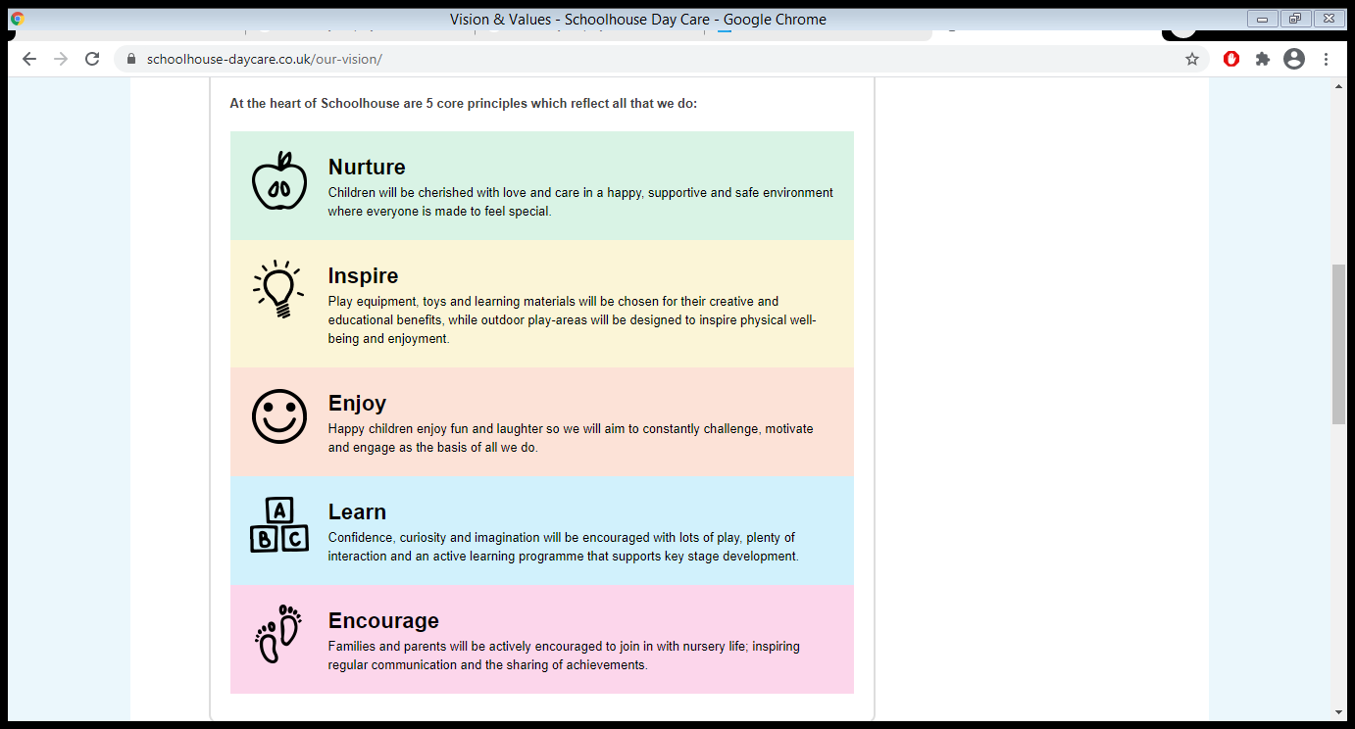

Schoolhouse Daycare was established in 1996 and are one of the largest day-care providers in Wales and, at the moment, they employ 85 staff.
Their dedication to excellence has been awarded by different authorities, such as the IIP Leadership and Management model in 2010, NLP Practitioner Programmes, NDNA Quality Counts and The Design to Smile Award Scheme.

- Assessment of how the business type and purpose affects the HR Function
As I have mentioned previously, Zara UK is a multinational corporation and it employs in the UK just over 3000 staff. One of the characteristics of how MNCs manage their workforces is linked to their country of origin (Taylor and Woodhams, 2016), but they must adapt their HR practices to the ones in the countries where they operate.
In terms of the HR delivery, Zara follows the Ulrich Model. The 60 stores that the company has in the country are divided in 4 groups or regions, depending on the size and performance of each. There is a Head of HR for the whole country, and every region has a Business Partner and a People Manager, and centres of excellence, with specialised teams on rewards, learning and development, training, among others. The shared service centre consists on HR advisors, payroll, and recruitment. The line managers have a very important role in HR as they deal with most of the administrative work in the stores, the recruitment, can take part in investigations and disciplinary processes and are key to train and develop the staff into more responsible positions in the company.
Alternatively, Schoolhouse Daycare, even if it is a large childcare provider in Wales and employs 85 members of staff, outsources its HR function to Effective HRM (https://www.effective-hrm.co.uk/).
According to Edwards and Ram (2010), the smaller companies tend to be more informal in the way that staff is dealt with, in terms of performance appraisal, disciplinary procedures or policies on employment matters. The positive aspects from this is a family environment that produces high levels of job satisfaction, effective teamworking and flexible working. On the other hand, the informality can result in demotivation as there is a sense of unfairness and favouritism.

- How different organisational structures and management roles can impact on the HR function
According to Kew and Stredwick (2016), there are six different models of organisational structure:
- Bureaucracy
- Divisionalisation
- Matrix organisations
- Networks
- Virtual organisations
- Strategic Alliances
Carrying on with the organisations we have been talking about, Schoolhouse Daycare would fall into the bureaucratic structure, with the distinction of a functional structure, described by Wagner and Hollenbeck (2014) as the most basic structure, and by Connor et al (2012), as the most logical and common. It shows hierarchy, specialisation and behaviour based on logical principles. While Schoolhouse Daycare focuses on purely childcare with its Operations, Health and Safety, Play and Development, and Accounts departments, they outsource their HR function to an external company.
Regarding Zara’s organisational structure, we can state that it is a divisionalisation, which is similar to bureaucracy but delegating some of the decision making to specific business areas, in this case it would be the UK market. Whereas company image, allocation of capital and target setting will be still a decision made in the headquarters in Spain, commercial, health and safety, and HR strategies will be specific to the UK team, following mainly legislation, trends and other external factors in the country, such as Covid-19. In terms of HR, and speaking specifically of the stores, the line manager has the main responsibilities of administration and recruitment, being this last one always overseen by the Business Partner in terms of vacancies authorisation. The line managers will also oversee training their staff and spotting the talent for future management vacancies in the country, with the support of the People Manager, Training, and Learning and Development departments.
Other internal factors that can affect the organisations are:
- Social components, such as structure and policies.
- Communication.
- Culture.
- Location and layout of workspace.
- Technological innovation.
- Financial Health, like funding.
- Sources of power, ways of easing conflict and control the resources
With this in mind, HR should encourage an effective culture and try to amend unsuitable ones. Any social processes like interaction, group behaviour, conflict or communication must be contemplated if we want to achieve the organisation’s goals by making successful use of available resources. HR needs to observe, measure and act upon any employee perceptions too.

- The role of HR function in formulating organisational strategy

Strategy, as defined by Quinn (1980), is the plan or pattern that incorporates a company’s goals, policies, and actions into a logical entity.

When formulating a business strategy, we can differentiate between three approaches:

- Rational/classical: Senior managers carry out a constant evaluation of external and internal environments with tools like SWOT or PESTLE, to formulate the objectives for the organisation. After getting together all the required assets, such as materials, people, or funds, they assess different procedures and then choose the most suitable one.

- Emergent/logical incrementalism: With this approach, originated with Quinn (1980), the originally formulated strategy would be amended depending on external or internal factors. An example could be the strategies that have had to be amended due to Covid-19.

- Symbolic/radical: It consists on implementing a strategy to check that it works and formulating it after.
HR’s involvement as a board member is growing significantly, as corporate directors seek more data and analysis from the HR professionals, to gain information about strategic HR issues like talent management or executive compensation.
But firstly, HR practitioners need to understand the business they work in, its market and the organisation’s goals. The HR professionals use the company’s insights to make decisions (strategic, team, individual) in the business. They also develop HR ideas with the intention of covering the organisation’s needs, as well as supporting the line managers on the implementation and delivery of HR plans or change initiatives.
Also, a very important field the HR practitioners need to develop their skills on is the People Analytics, as data and evidence is a key part of the CIPD’s strategy for the development of the HR profession, mainly to become more evidence-based and to build trust and engagement.
The HR professionals need to analyse constantly the external and internal factors that may have an influence on the business performance, with tools such as SWOT or PESTLE.
They also work together with internal and external specialists, embracing developing HR trends and identifying the external HR market. HR is required to comply with company policies and ensure they have skilled people in the right place.
In addition, the HR practitioners must have the legal knowledge on aspects like contracts of employment, employment protection, discrimination and health and safety at work.

- How organisational strategy is translated into HR strategy
Tyson (1995) defines HR strategy as ‘a set of ideas, policies and practices which managers adopt to achieve a people objective’.
There are a few models of HR strategy that support the belief that the HR policies must support the business goals. The HR strategies must be vertically integrated with the business strategies, linking the last ones with the external contexts and HR practices and policies (Fobrum et al 1984, Guest 1987, Pfeffer 1998).
But also, there has to be an internal fit, where the aspects of the HR strategy must be horizontally aligned so they are consistent and support each other.
According to Boxall and Purcell (2011), the HR strategy within an organisation is more effective when there is a greater degree of vertical and horizontal integration.
This takes us to the Contingency thinking model, where Porter (1985) recognises three alternative strategies that organisations follow: cost leadership, differentiation, and focus, this last one using either cost leadership or differentiation in a specific market.
According to Porter, the company may choose one of the strategies in order to achieve a more effective result (cheaper services, higher quality services, and more expensive, or more pioneering products). The HR policies to support effectively each one of these sources will have to be different (Schuler and Jackson, 1987).
Another approach to the formation of HR strategies is the Resource-based thinking, supported by Barney (1991). It starts analysing the strengths of the organisation’s existing resources. The formulated strategy should protect, enhance, and reinforce these assets to develop a competitive strength in the future. It must focus on the resources that are most rare, valuable, non-substitutable and difficult to imitate.
And last, we have the Best Practice model, which consists on whatever the organisation’s strategy is, HR must adopt the same practices to increase the chances of success (Pfeffer, 1994, Huselid, 1995 and Purcell et al, 2003).
Kew and Stredwick (2016) distinguish Ten Best Practices linked to high levels of employee commitment and are the following:
- Internal promotion
- Employee voice
- Performance related reward
- Employment security
- Employee ownership
- Employee involvement
- Commitment to learning
- Sophisticated selection
- Team working
- Harmonisation of terms and conditions

CONCLUSION
After analysing two different organisations, with different business purpose and size, we find that the HR function is affected in different ways. Although Zara and Schoolhouse Daycare are both private sector companies, their purpose and size could be considered as the main factors that affect the HR function on organisations, as one of the reasons why some small companies outsource HR could be to ensure the professionality when dealing with HR issues and avoid favouritism on unfairness.
In terms of organisational strategy, we find three different approaches in strategy formulation. We have discussed why HR plays an important part in the business strategy as the HR professionals have the knowledge and tools to analyse not only business KPIs, but also the internal and external factors that have a direct impact on the organisation’s performance.
Regarding HR strategy, I have analysed the different models that support the idea that the HR policies and practices must support the organisation’s goals.

ACTIVITY 2
INTRODUCTION
In this activity I will be conducting a PESTLE and a SWOT analysis on Zara in order to establish the effects that external and internal factors have on the HR function.
PESTLE
 | Factors affected within my industry | Importance to the organisation
Political | Lockdown enforced three times in less than a year, due to Covid-19, which has forced to close shops temporarily.  Brexit has negatively affected the business’ revenue as the pound is now weaker and the possibility of trade restrictions with Europe. | High  High
Economic | Low cost of labour, as Zara’s production is located mainly in Spain, close to the HQ, where the unemployment rate is quite high, so it minimises costs.  Affordable product in comparison to other high street retailers, so the profit is greater. | Low  Medium
Social | Clothing range caters all ages and sizes of people, both male and female. In addition, the company has recently launched the pet collection, with coats and accessories for pets.  The latest clothing trends are reflected in the product, which offers good quality for not a lot of money.  Online shopping has been hugely developed to allow the customer a pleasant experience and an easy procedure to return unsuitable items. | Medium  High  High
Technological | RFID system has been deployed in stores since 2013. This system allows the identification of each item by radiofrequency waves. Its main benefits are accurate store replenishment, efficient inventory counts, higher security control and higher customer service standards.  iPod’s available in the stores to offer customers the possibility of ordering product that is not available is the store.  Zara website and app are both very easy to use and offer different delivery options, some of them free of charge.  Data storage confidentiality and consumer rights. Compliance with GDPR regulations (May 2018). | Medium  Medium  Medium  Low
Legal | Compliance with Wage rates and National Minimum Wage, as they increase every year.  Compliance with furlough legislation.  As Zara designs are inspired by the catwalk product created by known designers, it has to ensure it complies with Copyright law in the UK.  Health and Safety regulations, including anything to do with protection against Covid-19. Requires constant review and risk assessments.  Compliance with regulation regarding short-term contracts to cover peak periods, like sales.  Codes of conduct for manufacturers, suppliers, and stakeholders. | Low  Medium  High  Medium  Low  Low
Environmental | Fast fashion is related to wastefulness, so Zara has developed a program in stores to collect used clothes and footwear, and then donate it to local charities to sort it for repair, resale or recycle.  Use of sustainable and recycled materials.  Commitment to protecting the planet through managing natural resources responsibly.  All new Zara stores are 100% eco-efficient since 2019.  Covid-19: Supplying the staff with reusable face masks since the reopening of the stores in June 2020. | High  Medium  Medium  High: needs to invest on older stores  Medium

SWOT
STRENGTHS | WEAKNESSES
Very high success on staff development programs. Two thirds of the management positions in the stores are filled through internal promotion.  Employee benefits program: 25% discount, uniform, long service awards (extra holidays).  Code of conduct.  Fast response to customer demand. 4-6 weeks to design, produce and deliver the product to the stores.  In-house production, close to HQ.  Large distribution network (7000 stores around the world)  Strategic locations of the stores (owning most of the business units).  RFID technology.  Affordable prices. | High employee turnover on big stores.  Imitator of products, not creator (ideas from catwalk’s well-known designers).  No advertisement, although some celebrities, like Kate Middleton, act as ambassadors.
OPPORTUNITIES | THREATS
Global expansion, although it needs more expansion in Africa and Asia.  Collaboration with Jo Malone in a range of perfumes and candles.  Design and distribution of licensed product like Disney, on all the departments, or Everlast (fitness line).  Focus on online stores, due to Covid-19. | Loss of profits during the 2020 financial year, causing the closure of over 1000 stores around the world due to Covid-19.  Main competitors: H&M and Next.  Increase on prices due to Brexit.  Regulation changes (Brexit).

IMPACT OF EXTERNAL FACTORS ON THE HR FUNCTION
- New legislation regarding furlough.
- New Health and Safety legislation to comply with Covid-19 prevention.
- Change on recruitment methods to avoid face to face interviews (Zoom/Teams videocalls).
- Face to face training to be delivered now through videocalls.
- Due to the online shopping focus during lockdowns, more staff needs to be trained on the systems used.
- Creation of training videos to avoid close contact (H&S, online packing, etc.).

CONCLUSIONS
In this activity I have conducted two analysis of Zara, PESTLE and SWOT. The CIPD (2021) classes them as a part of the core knowledge on enabling change in the new Profession Map.
A SWOT analysis is a tool to understand main factors that are involved in an organisation’s project. It is the acronym for: Strengths, Weaknesses, Opportunities and Threats, being the first two internal factors and, the last two, external.
SWOT can be used for problem solving, product evaluation, personal development planning, competitor evaluation and decision making. But also, along with PESTLE, for strategic planning within the organisation.
A PESTLE analysis is an assessment of six external factors than influence an organisation. These are:
- Political
- Economic
- Sociological
- Technological
- Legal
- Environmental
HR and senior managers can assess any risks to their industry and make any business decisions with this information. By understanding these factors, the organisations may exploit their opportunities and decrease any threats.
PESTLE is used for strategic business planning, workforce planning, product development, marketing planning, organisational change, and to formulate people strategies, reports, and projects.
After assessing Zara’s internal and external factors using PESTLE and SWOT, we find that as a multinational corporation, some of the factors are more global, whereas others are specific to the United Kingdom.
As Zara is an organisation that was established over 45 years ago, and has been evolving with time, it has a high amount of strengths and not so many weaknesses. One of its values is the professional development of the staff, so the organisation has developed a very complete training program.
But this can also take us to one of the company’s weakness, the high turnover on its largest stores. The biggest the workplace is, the hardest to train and develop their staff. This is one of the reasons why the company had to invest more resources on people management in the big stores. To improve these high turnover figures, there has been a need of an individual HR advisor for each store with a size of over 100 employees.
Looking at some of the external factors that affect the company’s performance, and specific to the HR function, Brexit and Covid-19 have had a huge influence in the past year.
Covid-19 has caused the stores to close for nearly six months in the last twelve months. The pandemic has had a massive impact on the HR professionals, with new legislation to comply with in terms of furlough and Health and Safety. As the business has had a change of its shopping strategy, focused now on online more than in-store shopping, there has been a demand of training courses and a development of new training methods, such as creation of explanatory videos on how to select product, process it in the system and packing techniques to follow the company image standards. Also, to avoid any close contact, the company has developed training videos for the Health and Safety new starter’s induction.
Regarding Brexit, the company will be faced with a whole new legislation to comply with in terms of transport of goods, as the product is distributed from Spain. But also, HR will have to act in accordance to the legal framework for how EU nationals may work in the UK.

