Submitted by: Sana Ali
Student id :2030389
Lecturer: Terry Wallcot
Module: Digital skills And Research Method
Module code: BMSW4003
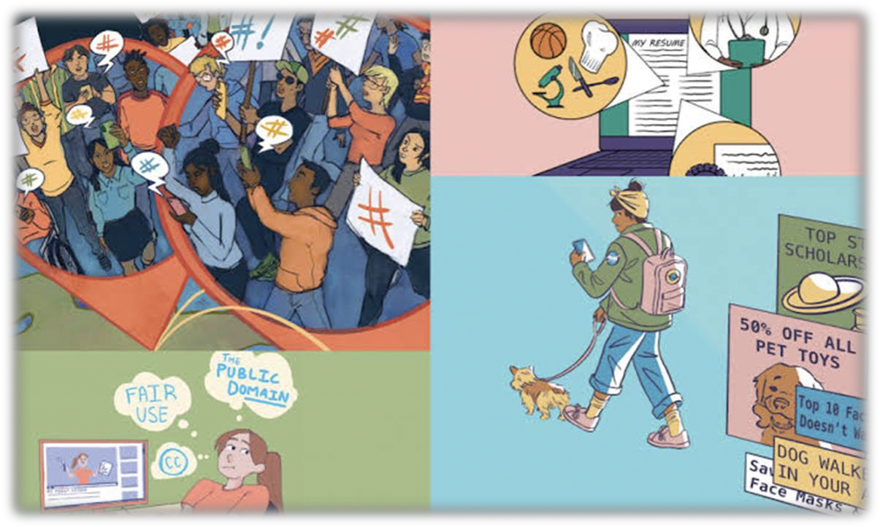

Introduction to digital skills:
Digital learning is necessary for you to become a digital citizen: people who are responsible for how they use technology to communicate with the world around them.
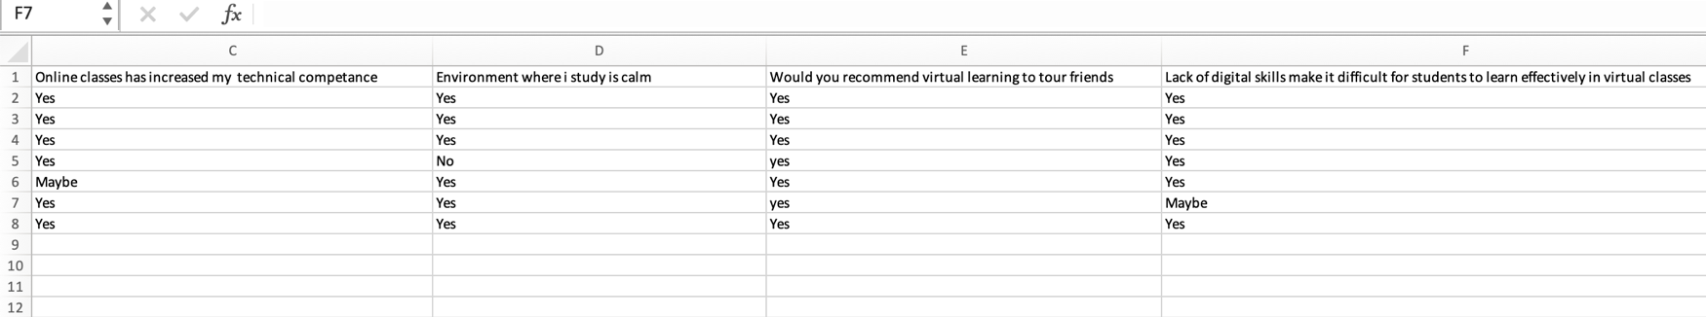
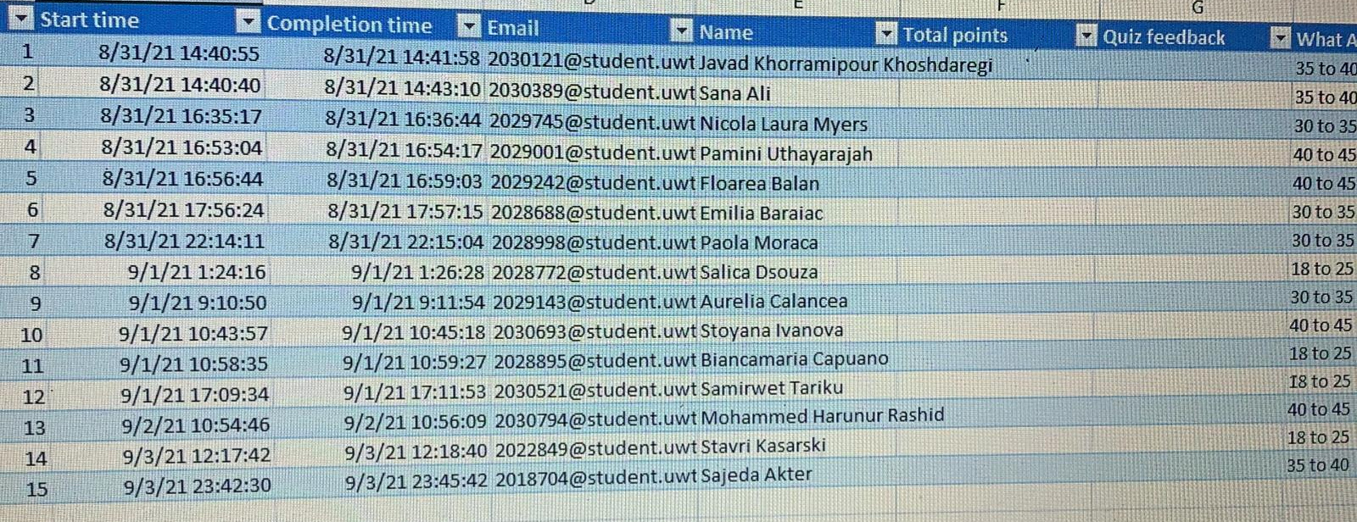
I did some psychological research. I asked 25 of my classmates about their experience with mental reading. Thirteen classmates answered me based on their experience visual learning has been very helpful. Most of them are learning digital skills for some time .Most people use pills to study online and live in London. .Tell me that visual learning has improved their technology skills. They highly recommend visual learning to their friends and family.
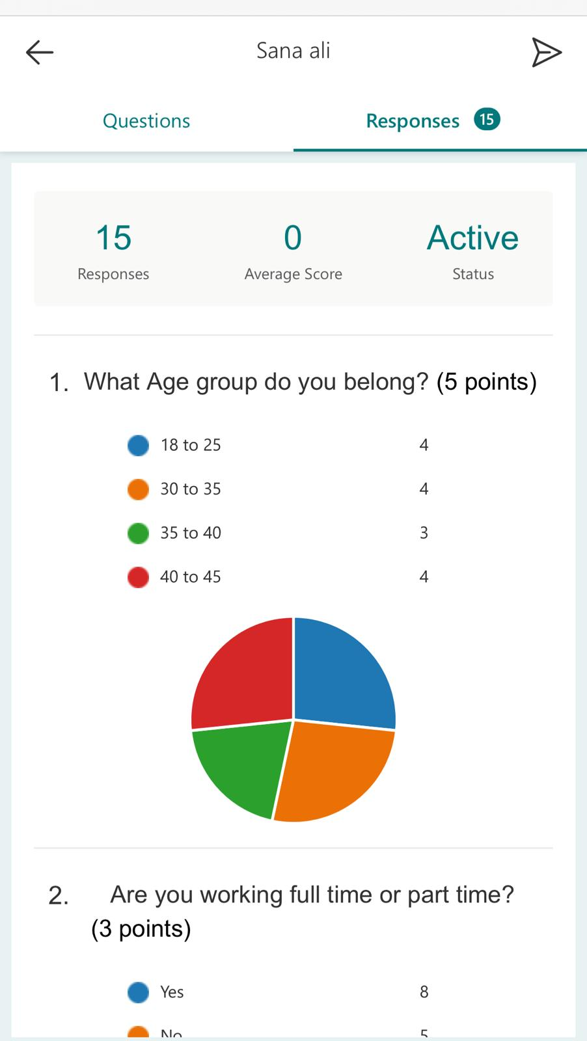

Digital reading should be the fourth pillar of a child's education alongside reading, writing and maths and benefit and be taught appropriately. ”House of Lords Report, 2017
10 Digital Skills That Can Get Students Hired Quickly
Over the past decade, companies in all industries have developed their own digital operations and processes. Even now, businesses are using artificial intelligence to streamline workflows and supply chains. For this reason, today's job seekers need special skills to help them stand out from the crowd.
In-depth reading and digital writing
The key to digital literacy when it comes to pedagogy is in-depth learning, with six basic skills: Interaction. Ability to work collaboratively with others, with strong interpersonal skills and team-related skills.
• Art. Being able to measure opportunities in a business way and ask the right questions to generate new ideas.
• Critical thinking. Ability to explore information and controversies, identify patterns and connections, and construct meaningful information and apply it in the real world.
• Nationality. Ability to look at issues and solve complex problems based on a deeper understanding of various values and worldviews.
- Morality. Factors such as grit, durability, tolerance, and durability; alongside the desire to make learning an integral part of life.
- Communication. Being able to communicate effectively through a variety of different audiences and methods.
In this article, we explore 10 key digital skills that they should offer in their portfolio to meet the needs of students and industry.
Digital learning and security
While it has the potential to bring in a lot of value, our online world also comes with natural hazards, especially for children. The fact is, while younger generations are being portrayed as digital citizens when it comes to security, they are often as educated as their parents.
Digital platforms put children at risk of crime and bullying, especially during periods of extreme imprisonment and isolation. They can cause students to compare their presence with the normal online lives of others, promote feelings of inadequacy, hostility, isolation, and the development of mental health problems. They can also leave students exposed to false information, deception, and false stories.
Here are some examples that can help you incorporate digital knowledge into your studies:
• Teach students about safety online
To educate students about staying safe online, as well as online threats, sexually explicit messages, cyber bullying and identity theft, the NSPCC has compiled a number of course programs and online guidance. This includes tips on the importance of protecting your personal information, including passwords and photo sharing. Students should also be taught never to give out their details as part of a security education.
• Introduce students to "false stories"
Fake news is not just for politicians; now it's class time. Teachers must therefore teach their students that not everything we see and read online is real. Here are some tips to help you deal with issues that are not in your classroom.
"More than a third of teachers now see false information available online - identified in students' conversations or in their classroom discussions."
Social Media
According to a recent study, 2.7 billion social media users are active worldwide. Of these, 2.5 billion are active users on mobile devices. These figures show a 30% increase in the number of mobile social users in just one year which is expected to increase year on year.
The ability to understand and use social media effectively is a fundamental skill that every professional should have. Social media marketing goes beyond tweeting or a Facebook update; it’s about understanding the dynamic relationships between brands, prosecutors and consumers. Simply put, businesses need to reach customers in ways that will drive traffic to their website - or product - in order to transform potential.
Social media has penetrated our society, and has become a major source of communication and flow of information between content creators and consumers. Educators who recognize the influence of communication should understand the complexity of certain platforms and the potential impact of increasing community engagement in order to provide graduates with relevant and practical skills.
Search Engine Advertising
Apart from communication, search engine marketing (SEM) is one of the most powerful ways marketers rely on. To put it bluntly, more than 6.5 billion SEM results are generated each day with Google accounting for 77% of that traffic.
Students with SEM experience will be able to increase the visibility of a company's website in a search engine (e.g., Google) primarily through paid advertising. By doing so, the business will attract relevant web traffic from the search engine results page.
Through SEM, students will be able to take part in the 6.5 billion search results results. That’s why marketers, content managers and webmasters spend a lot of time designing their websites and ad campaigns to ensure that conversion rates are very high.
Many companies are in the business of selling products or services. It is therefore important that their product is easily available online during their competition. Job seekers need to have a good knowledge of search marketing if they are not able to understand the larger context of their work.

Statistics
Peter Drucker, a leader in management education and often described as the founder of modern management, has this to say:
"If you can't measure it, you can't control it."
Data analytics actually allows students to make informed and data-driven decisions in their fields. The numbers indicate whether the campaign was successful, and what percentage. The key to analytics is knowing which data to collect and measure in order to improve your next campaign. Companies don’t want to waste important marketing dollars in terms of trends or natural guts. It's all about maximizing the effectiveness of each campaign and increasing profits in investing.
Statistics are generally compliant with SEM. These two complementary skills work together to ensure that the business understands consumer demands, and how best to attract and retain their attention.
Content Marketing
Content comes in many forms - blog posts, videos, podcasts, infographics, and even social media status updates.
Advertisers can spend their time using keywords and advertising campaigns, but content is still the master. After all, a website or social media page is driven by its content and without it, customers have no way of understanding the benefits of a product or service.
Content is important in driving brand awareness and can establish brands or promoters as thought leaders. New recruitment therefore requires an
understanding of the importance of creating not only content, but content that accompanies keyword research and strategic use.
Email
One of the best ways to find and keep track of a track record is email: email.
Email is one of the oldest forms of direct marketing and still packs a fist on customer acquisition and retention. From start-ups to multinational companies, email helps launch more effective campaigns.
But make no mistake, email marketing is a masterpiece. An experienced digital marketer knows that each of the appropriate categories must be carefully planned. From the registration page - including its placement on the website - to the initial welcome email, every step needs to be taken to attract and retain users and build engagement.
People can change their social media accounts or home addresses, but people rarely change their email addresses. This is why professionals who understand the power of email communicate directly with consumers are in great demand.
As those teachers should not make email not as an old tool, but instead challenge students to rethink ways to use email in their fields - current and future.
Mobile
According to a recent report by We Are Social and Hootsuite, mobile communication continues to grow by about two-thirds of the world's population using mobile phones, with 55% of all active communication coming from Smartphones. With smartphone traffic now surpassing desktop traffic, it is clear that mobile is the future.
To understand the impact of this change, we need to look at Google only. The world's largest search engine provider has created a mobile-friendly web app designed to test the usability and speed of mobile websites. Having an easy-to-use web page can increase your search results for consumers who do not have access to desktops.
Job seekers can use this information to their advantage by conducting campaigns using the latest advances in mobile search and user experience.
Strategy and Planning
Businesses that incorporate strategic planning into their marketing plans are more likely to see measurable results in the future. Instead of ad-hoc-based planning, digital marketers need to create and implement analytics-based campaigns with unparalleled SEO data.
For example, setting specific KPIs and targeting methods to measure each indicator can help a trader stay responsive. It is also important that they analyze past campaigns and determine which metrics are worth measuring.
Vision, strategy and planning are the leading skills gap in organizations - according to experts 58% in the USA, 55% in the UK and 42% in Ireland. By providing digital programming skills, graduates looking for new roles will have a clearer advantage than their peers with little or no knowledge.

Public Sales
To communicate with customer influences, marketing professionals need to be where their hopes are: online. As social marketing shows that it is important for the consumers who use it - the top 90% of consumers use social marketing tools effectively - it is becoming increasingly important for new employers to become proficient in using marketing technology.
In fact, according to LinkedIn, more than 70% of marketing professionals use social marketing tools like LinkedIn, Twitter and Facebook and see them as a major contributor to revenue.
Pay-Per-Click Marketing (PPC)
Thus, PPC is a popular way for products to get traffic faster. Companies with large budgets can easily find the results of their search on Google's homepage, thus ensuring maximum search engine optimization.
For someone looking for a competent digital career, understanding what emerges, accessibility, cost per click, and click-through costs will make them stand out from their peers during interviews.
Video
In terms of digital, the video has turned from being just a hobby to YouTube to a massive social media content driver. Snapchat is now a powerful and powerful platform while Facebook is now using video in its Instagram stories.
Easy to use video as content than standard blog posts. It's so exciting and lovely for a thousand years. By combining the emotional power of social video and access to the scope of digital advertising, markets can enter a growing market for engaged consumers.
8 out of 10 medium-skilled jobs are now digitally strong with 2.5-fold roles compared to non-digital jobs. The key to digital skills is that they can be used in any role; not only in the domain of merchants or sellers. Like graduates, job seekers and professionals should learn these essential skills to improve their grip.

References:
https://www.google.com/url?sa=t&source=web&rct=j&url=https://digitalm arketinginstitute.com/blog/10-digital-skills-that-can-make-students- instantly-employabl

