Radio Frequency Systems
By Alexander Gravatt

Context

Context 2
abstract 3
Introduction 3
Background research 3
System design 4
Simulations 5
Results 5
Discussion 5
Conclusion 6

Table of Figures
Figure 1: AM system diagram 7
Figure 2: DSBSC System Diagram 8
Figure 3: SSBSC System Diagram 8
Figure 4: DSBSC all signals 9
Figure 5: DSBSC no demod 10
Figure 6: DSBSC no demod no carrier 11
Figure 7: DSBSC no Sidebands 12
Figure 8: SSBSC all signals 13
Figure 9: SSBSC Scope 13
Figure 10: SSBSC No mesage no demod 14
Figure 11: SSBSC DSBSC SSBSC 14
Figure 12: SSBSC only 15
Figure 13: Modulation index scope 17
Figure 14: Modulation index scope 2 17
Figure 15: AM modulation index 0.3 18
Figure 16: AM modulation index 0.6 19
Figure 17: DSBSC SNR100 20
Figure 18: DSBSC Scope 100 21
Figure 19: DSBSC SNR 5 22
Figure 20: DSBSC Scope 5 23
Figure 21: DSBSC SNR -5 24
Figure 22: DSBSC Scope -5 25
Figure 23: DSBSC SNR -15 26
Figure 24: DSBSC Scope -15 27
Figure 25: DSBSC SNR -25 28
Figure 26: DSBSC Scope -25 29
Figure 27: SSBSC SNR 100 30
Figure 28: SSBSC Scope 100 30
Figure 29: SSBSC SNR 5 31
Figure 30: SSBSC Sope 5 31
Figure 31: SSBSC SNR -5 32
Figure 32: SSBSC Scope -5 32
Figure 33: SSBSC SNR -15 33
Figure 34: SSBSC Scope -15 33
Figure 35: SSBSC SNR -25 34
Figure 36: SSBSC Scope -25 34
Figure 37: AM SNR 100 35
Figure 38: AM Scope100 35
Figure 39: AM scope 5 36
Figure 40: AM SNR 5 36
Figure 41: AM Scope -5 37
Figure 42: AM SNR -5 37
Figure 43: AM Scope -15 38
Figure 44: AM SNR -15 38
Figure 45: AM Scope -25 39
Figure 46: AM SNR -25 39
Figure 47: AM Power density 40
Figure 48: DSBSC Power density 41
Figure 49: SSBSC Power density 42

Abstract
In this Report I will demonstrate three modulation techniques in simulink AM, DSBSC and SSBSC. I will demonstrate their noise tolerance power density and the spectrum usage to showcase what the the benefits and downsides of each modulation technique.

Introduction

This report will delve into the design of Simulink models for three modulation techniques: Amplitude Modulation (AM), Double Sideband Suppressed Carrier (DSB-SC), and Single Sideband Suppressed Carrier (SSBSC). A detailed description of each modulation method will be provided.
Robustness of the signal
To assess the noise robustness of DSB-SC, SSBSC systems and AM. Simulink simulations will be conducted for each model with the carrier and signals matched where they can be to make the modulation as close to each other as possible . By subjecting these systems to various noise levels, their performance degradation can be quantified and compared, In such a way that their benefits are made obvious to the reader.
Power density
I will compare the power density of each model will using the power density section in the spectrum analyser this will allow me to see the exact power of and where it lies on the transmission lines.
Frequency spectrum
I will look at the spectrum analyser and monitor the side bands of the signals to and where the power is placed to understand where other signals could possibly be placed in relation to the signal.

Background research
AM
Usage
AM was commonly used for radio stations and is currently used for point to point communication.

Fondation

It is the function of putting power on a single point and or small set of frequencies and changing the power level in relation to the data given this has been converted in more modern systems to a digital signal but it works with both analogue and digital data as its just multiplying the data onto a carrier signal.

Limitations of the system
As it is only looking at the power difference of a signal it is common for it to blend information on the same frequency depending on the strength this rarely happens with FM systems.

Dsbsc
Usage
Commonl;y used by amateur radio hobbyists as it can be used effectively in high frequency bands and is relatively cost effective to make.

Fondation
Is a modulation technique for analogue modulation. It means double sideband suppressed carrier. It is an alteration of double side band full carrier that has both the side bands and the carrier in the transmission. The Dsbsc only transmits the side bands without the carrier being transmitted or its transmitted at a low enough level that it's not relevant.

Limitations of the system
This system produces distortions in its demodulation unless specifically dealt with as such if this section is damaged or more commonly the distortion is more than it can deal with the user has to make do with what is likely garbage information

Ssbsc

Usage
Javapoint states “SSB is commonly used in the long-distance transmission of speech signals. The bandwidth of the speech signal lies in the range 300 Hz and 3400 Hz. The maximum space between the two channels in SSB can be 4000 Hz.”[6]

Fondation
Single sideband suppressed carrier is a modulation technique that suppresses the carrier and one of the side bands this reduces its presence in the frequency domain as its a third of the size of the side bands and the carrier.

Their are two demodulation systems possible “43000 Hz and 47000 Hz”[7] if the carrier is on the 45000 Hz point in real world terms this would vary by a few Hz as the crystals inside the device are only so precise 43000Hz is called lowside injection and 47000 Hz is called high side injection these side bands rely on the systems bandwidth some could be as small as 400Hz width but with high powers its easier to provide large gaps as it keeps the harmonics away and below the other sideband and carrier to avoid the receiver responding to the system.[7]

Limitations of the system
The limits of the system are related to its analogue nature as a copy of the signal is used to remove one of the side bands the system has a lower output than AM on its own.

System design
I designed an AM system in simulink this model multiples the message signal by the modulation index and then adds 1 to it producing an effective amplification of the message signal before it is put back onto the
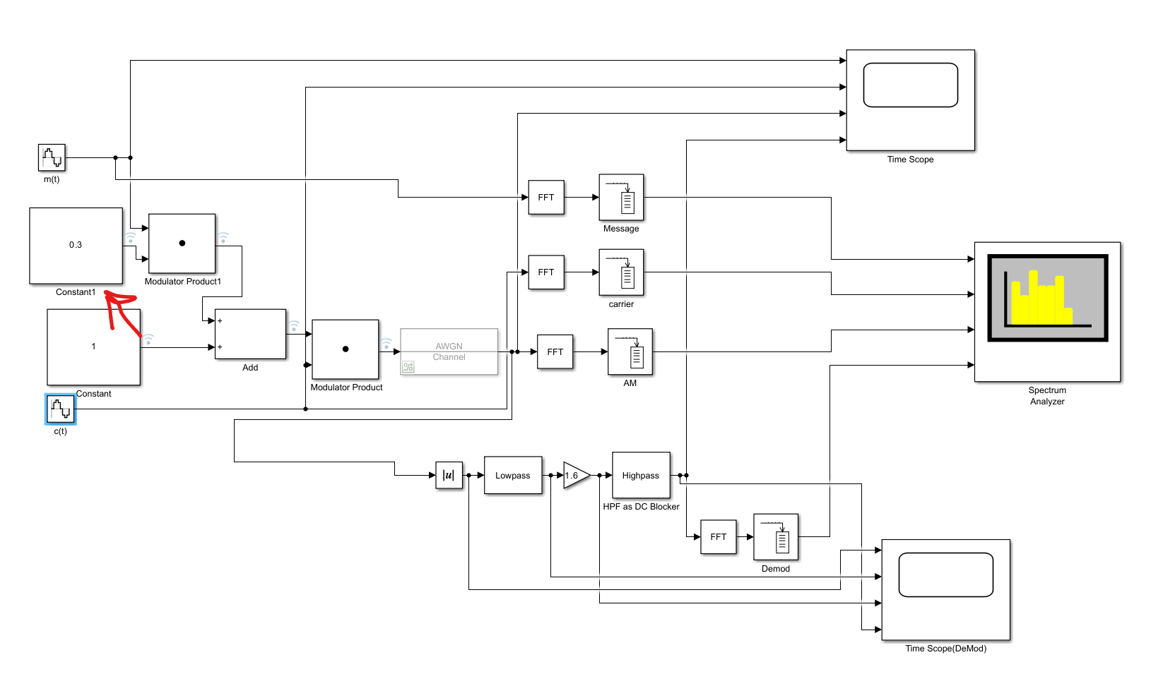Figure 1: AM system diagram
The red arrow points at the modulation index; this is important for later tests.

Mt is the message signal to be modulated

Ct is the carrier wave i will use these two names in the other system designs

DSBSC
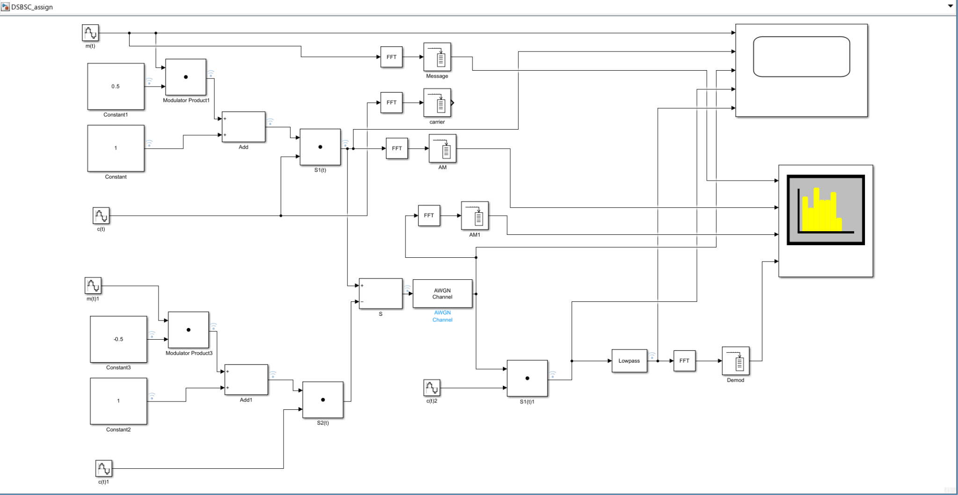Figure 2: DSBSC System Diagram
The modulation index is negative on the negative side of the signal to ensure that it removes the positive when their finally combined giving you the signal without modulation
SSBSC
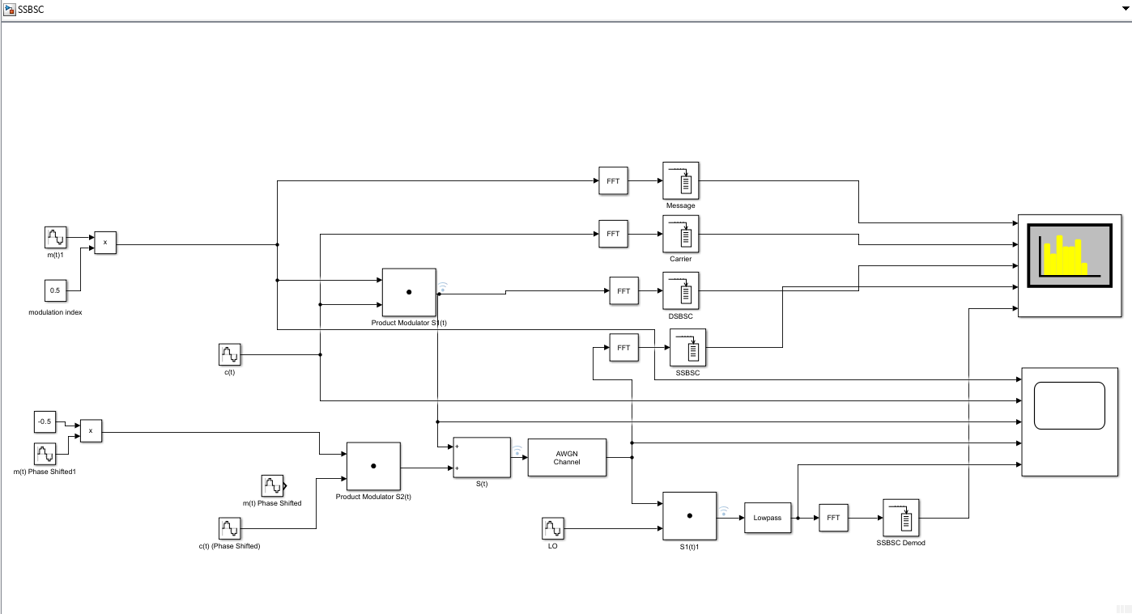Figure 3: SSBSC System Diagram
The modulation index is negative on the negative side of the signal to ensure that it removes the positive when their finally combined giving you the signal without modulation i will not be providing it further amplification as that would put it at an advantage over DSBSC and AM as such this is its limit.

No noise Tests

DSBSC
No noise
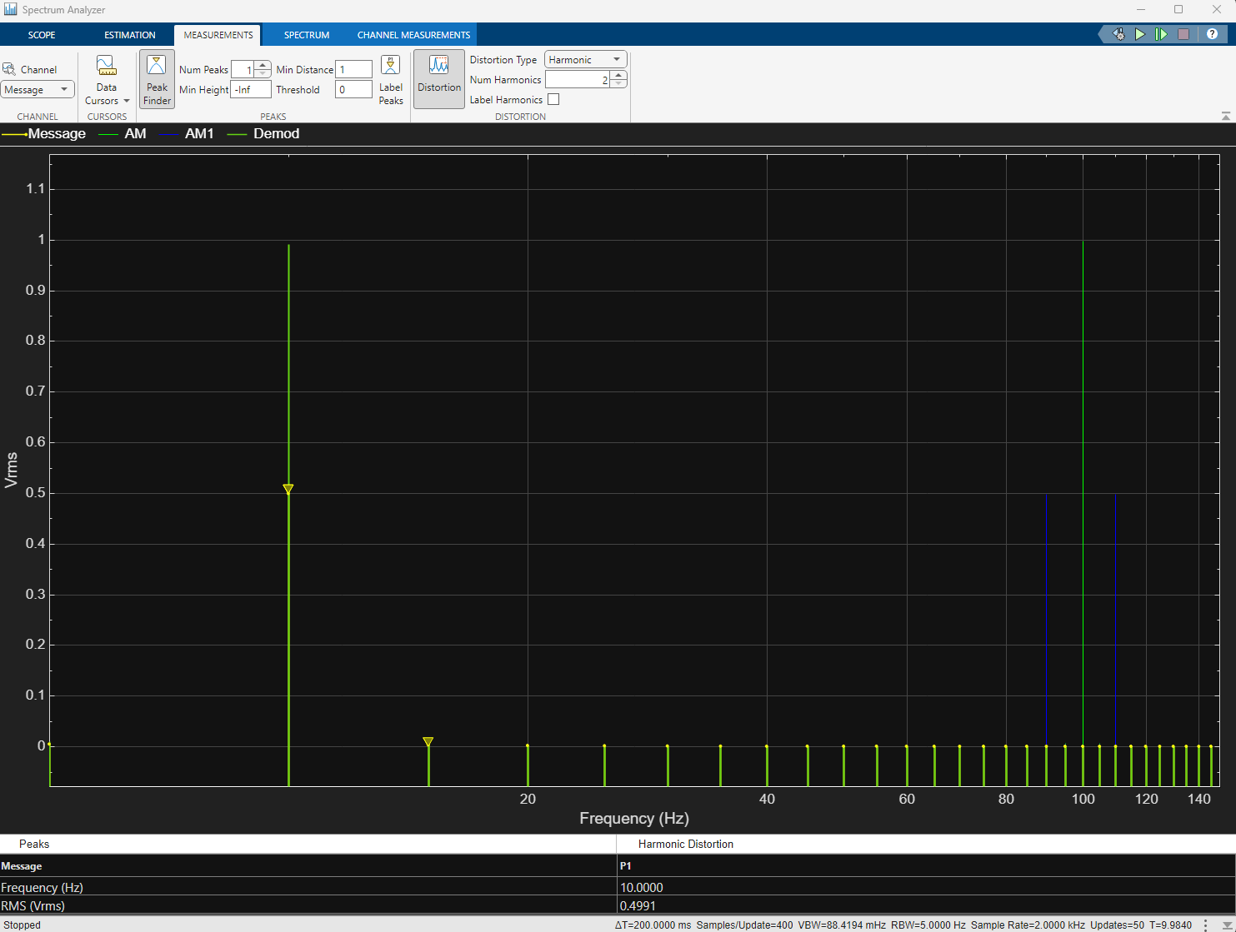Figure 4: DSBSC all signals
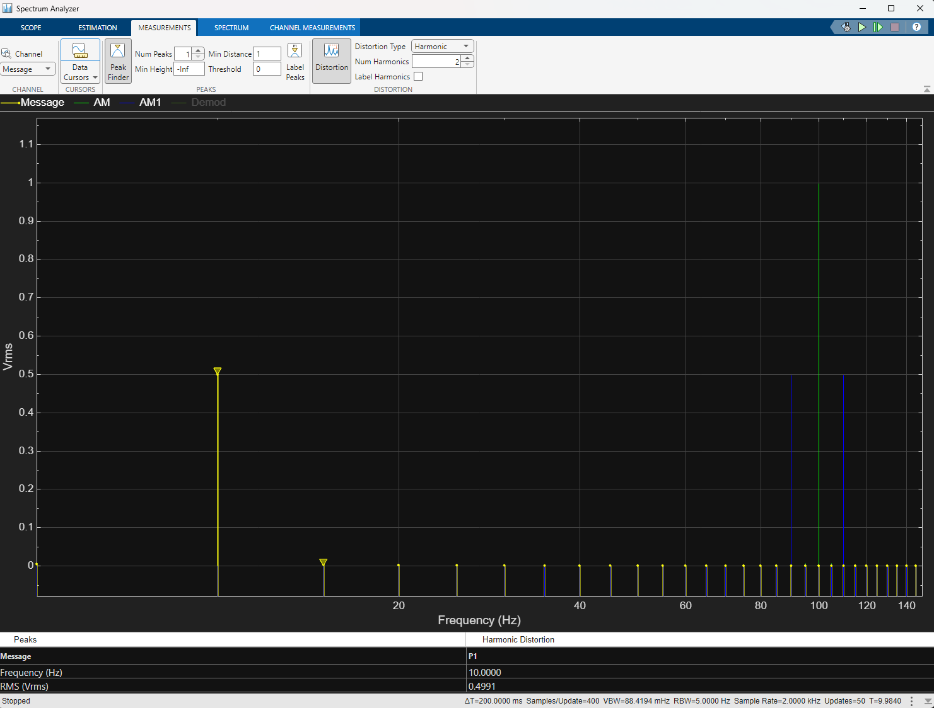Figure 5: DSBSC no demod
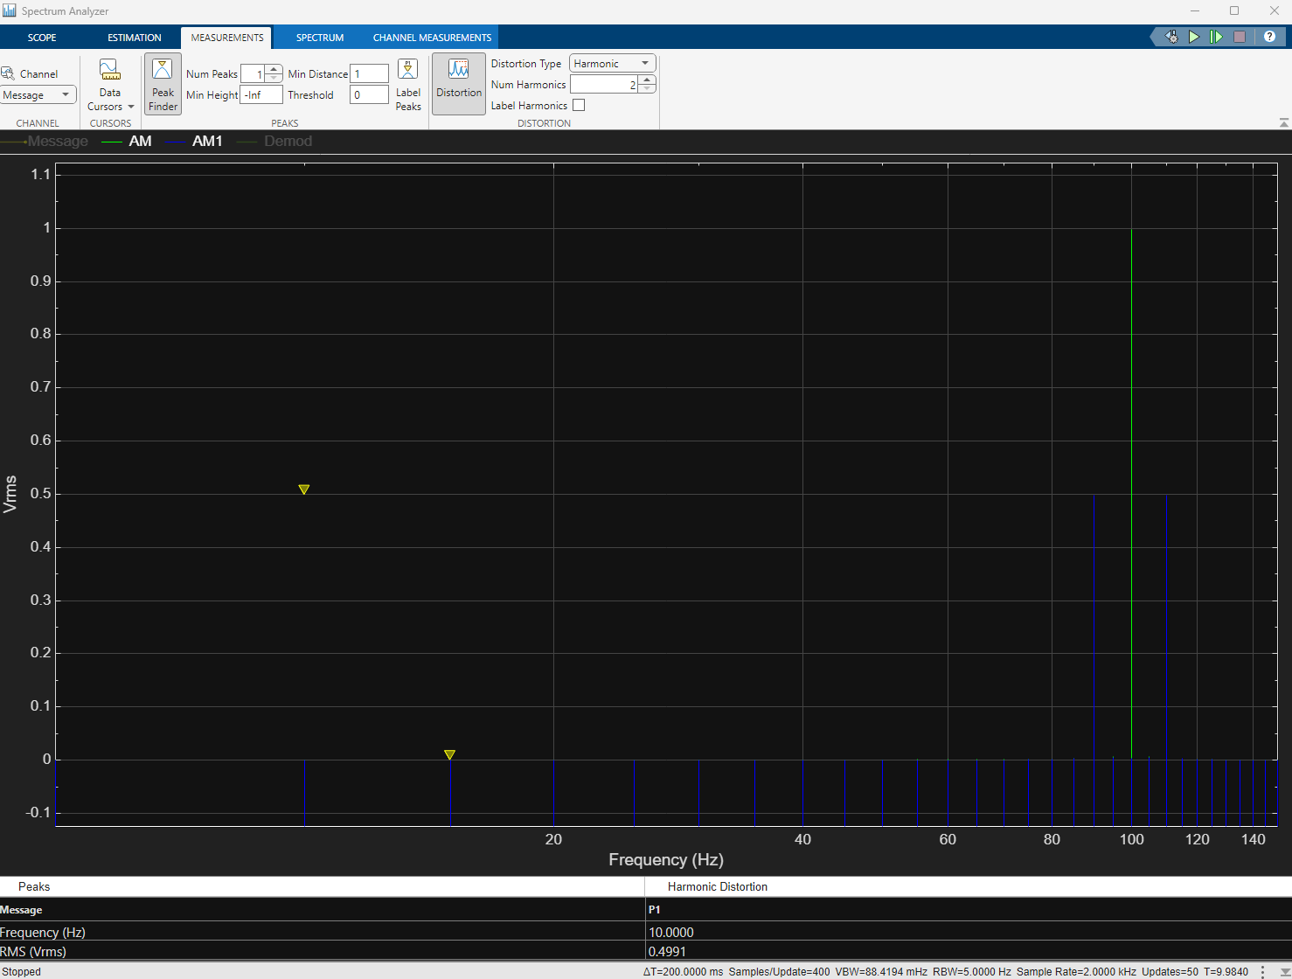Figure 6: DSBSC no demod no carrier
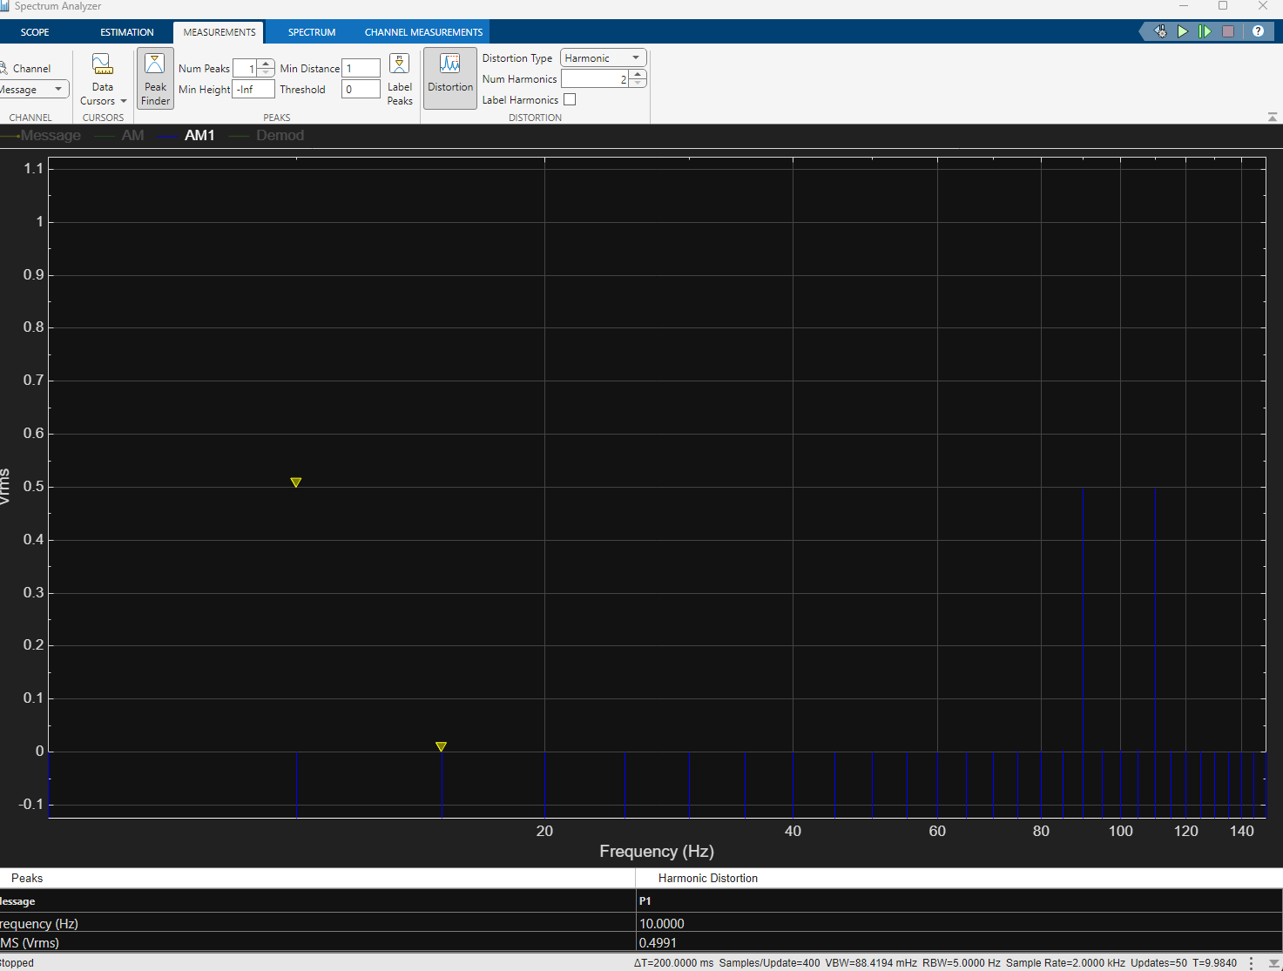Figure 7: DSBSC no Sidebands

SSBSC
No noise
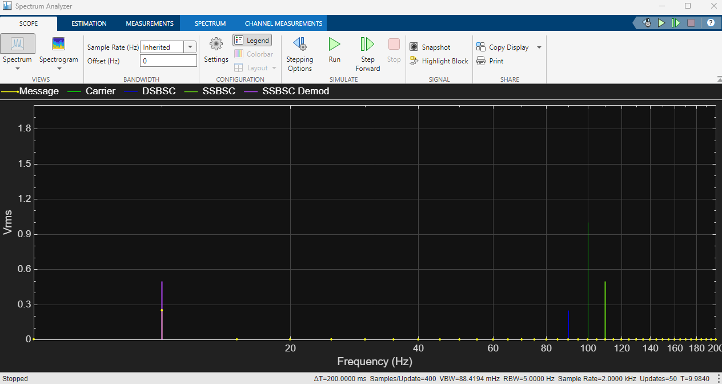Figure 8: SSBSC all signals
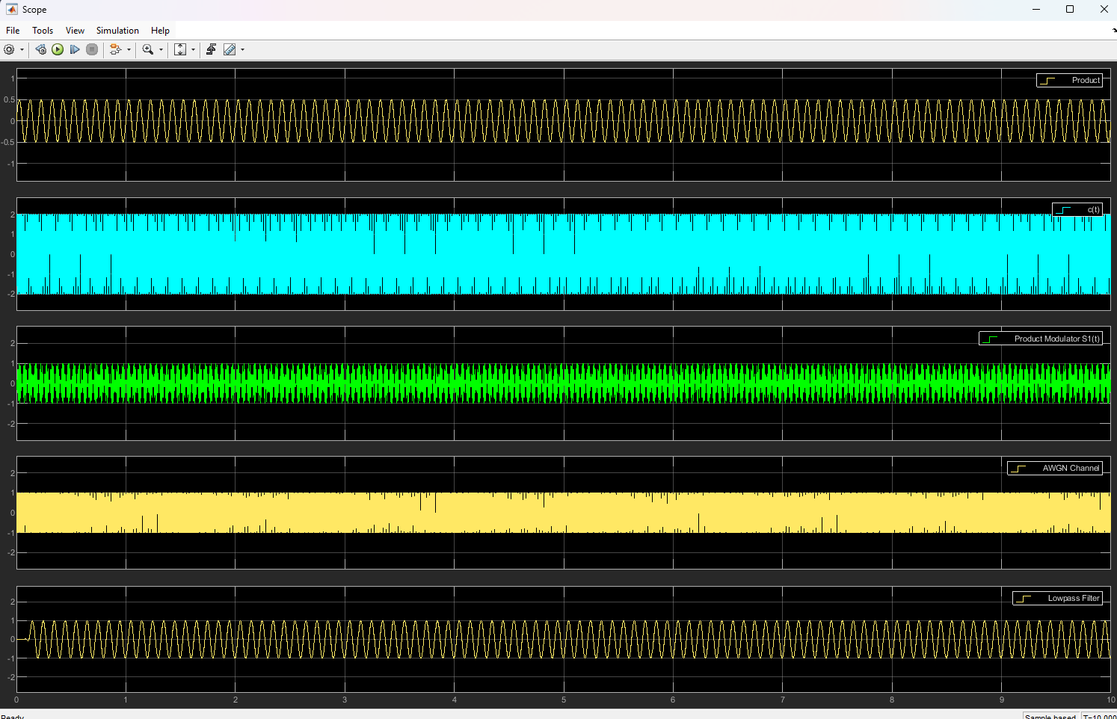Figure 9: SSBSC Scope
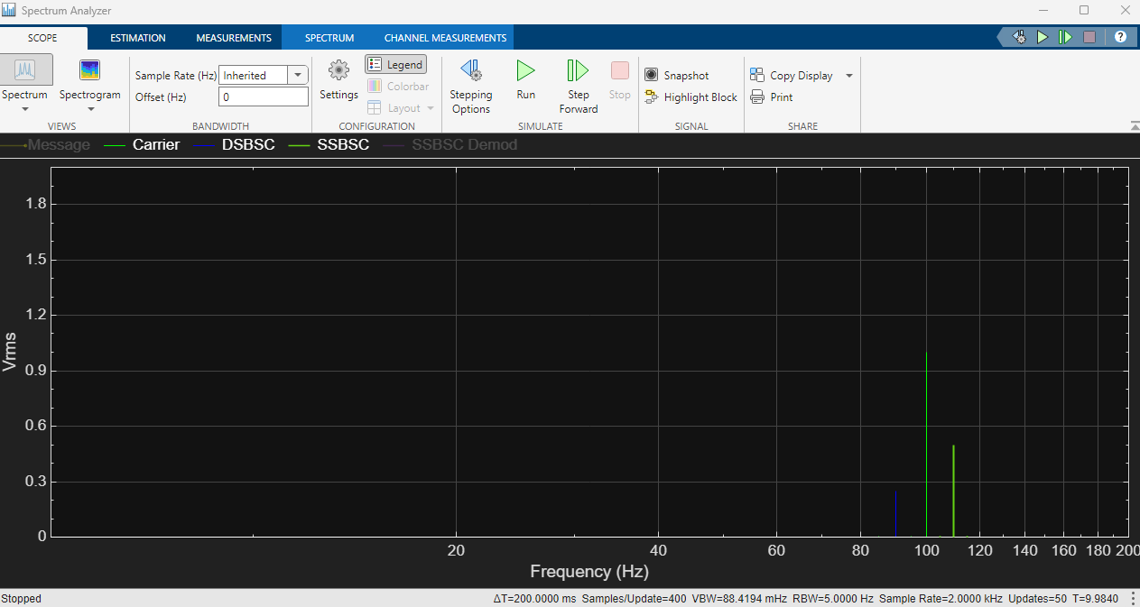Figure 10: SSBSC No mesage no demod

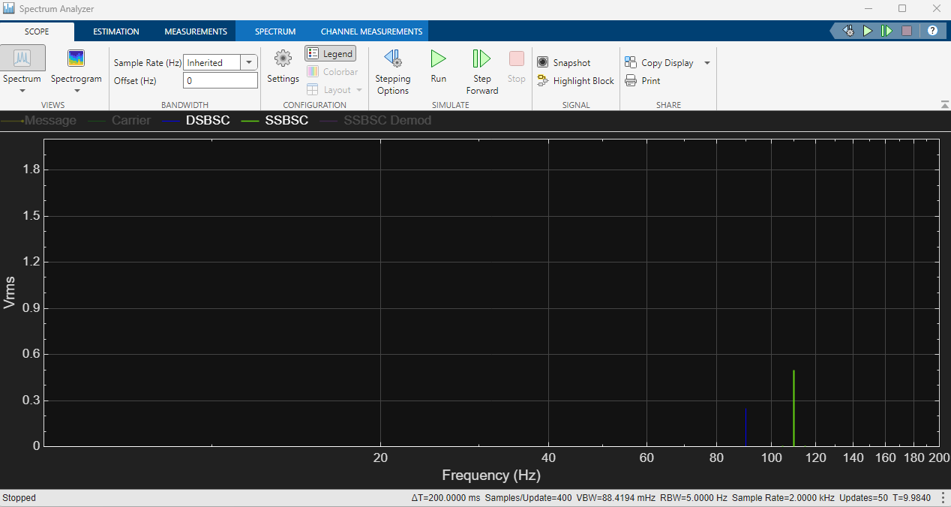Figure 11: SSBSC DSBSC SSBSC
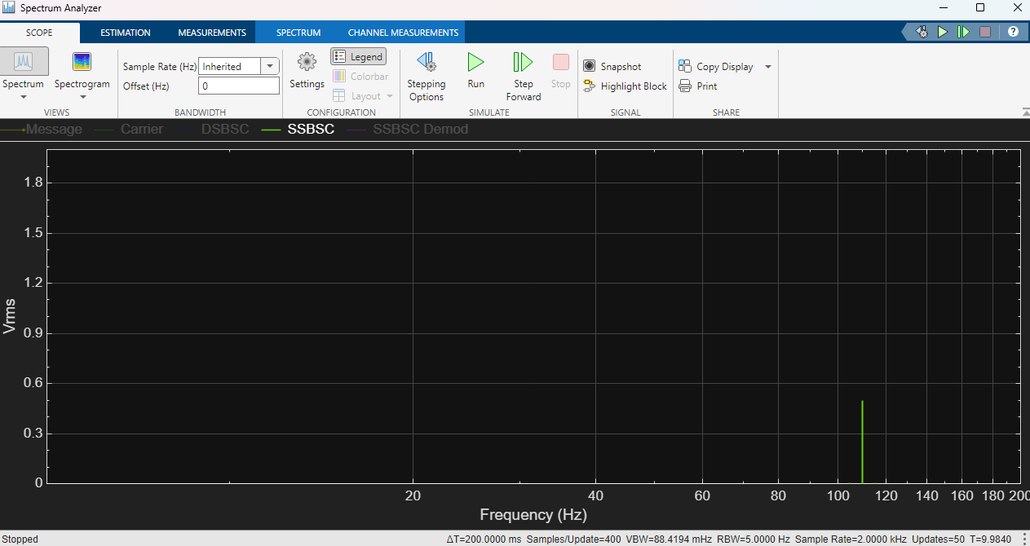Figure 12: SSBSC only

Results
DSBSC
DSBSC shows a similar power level to AM which is what I expected as its not subtracting part of its signal with a copy of itself. Its constituent parts are higher than it in power since its half their power.

The demodulated data in DSBSC over powers the carrier because the side bands are not half or less than half the carrier as such when added together they provide a very effective signal.

SSBSC
Shows a low power level when its on its own this demonstrates why it gets further amplification in most commonly used applications as such. And since you're adding an amplifier anyway the signal can be boosted to provide significant range compared to AM signals.

The carrier is higher in both SSBSC and DSBSC this is because they are products of the carrier not individual signals them selves.

AM modulation comparison of modulation index

Below is the settings used in the am modulator design

carrier
Modulating wave

or
W,c = 628.318531

or
W,m =62.83185307179586

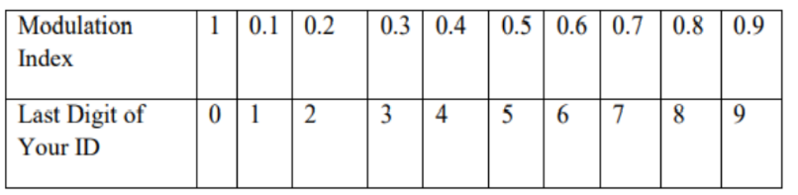

I will showcase the difference between 0.3 and 0.6
0.6 is chosen as my student number's final number is 6 and 0.3 is the corresponding half of my student number providing what I believe will be an easily visible difference in the modulation scheme.

AM in the time domain

AM in the time domain looks as follows.
0.3
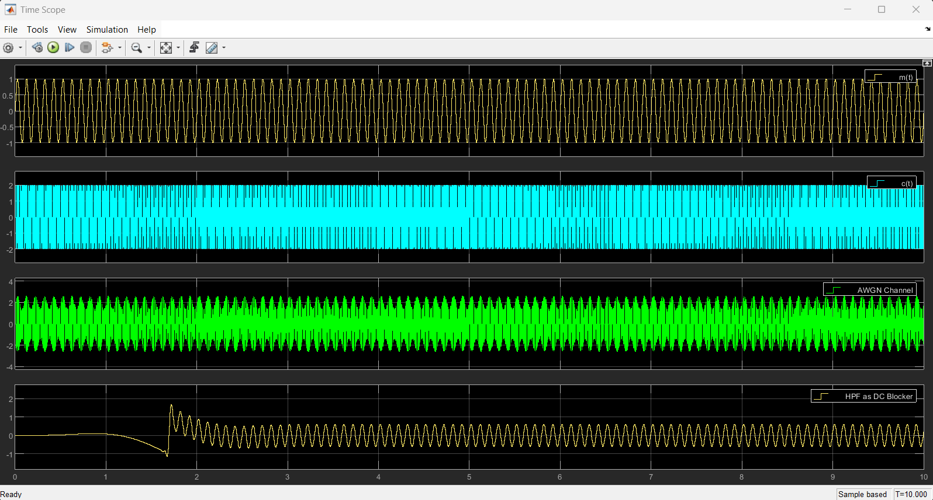Figure 13: Modulation index scope
0.6
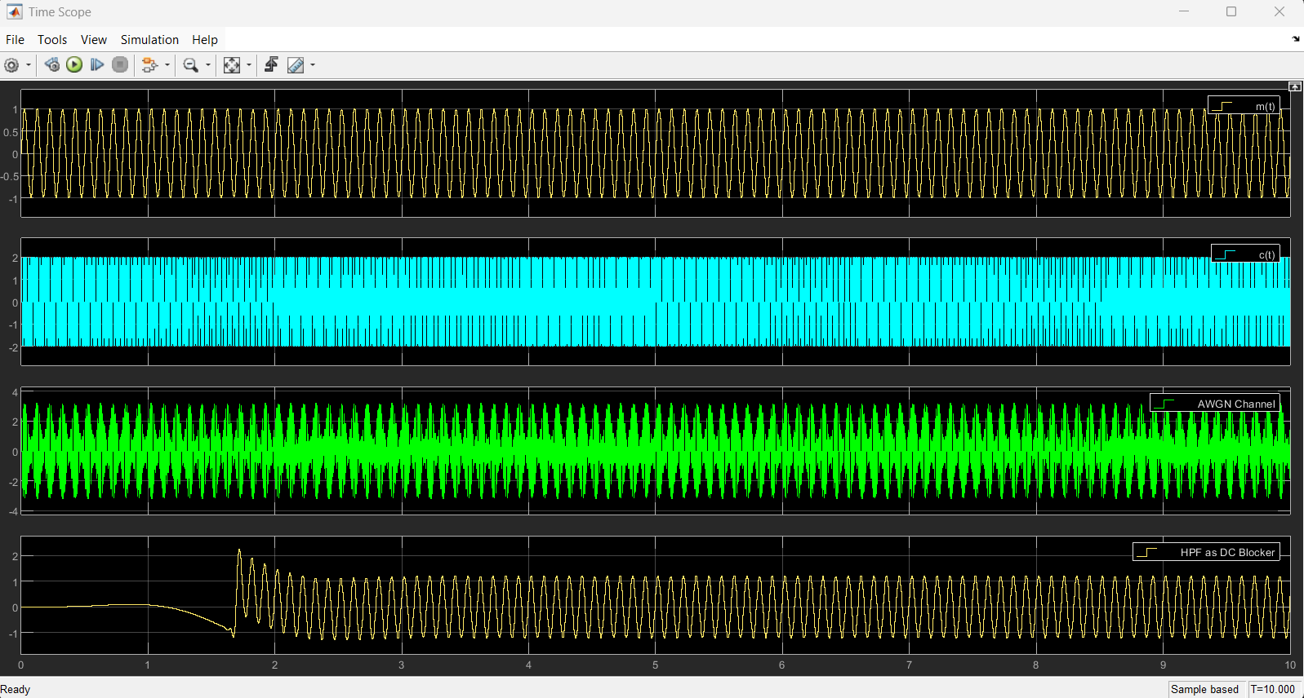Figure 14: Modulation index scope 2
This was obtained from a scope in simulink.

AM the in frequency domain

AM the in frequency domain looks as follows.
0.3 modulation index
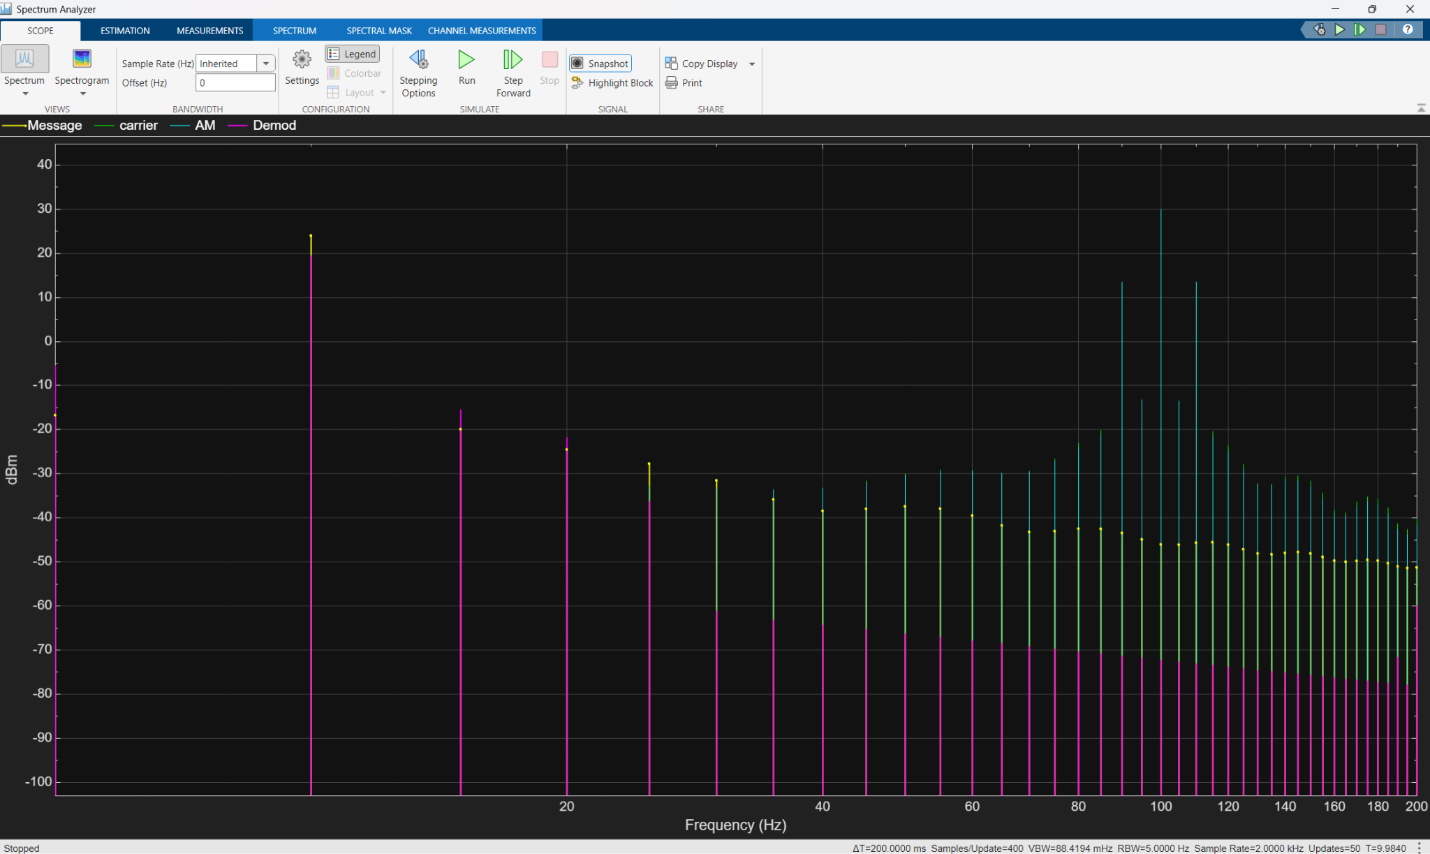Figure 15: AM modulation index 0.3
0.6 modulation index
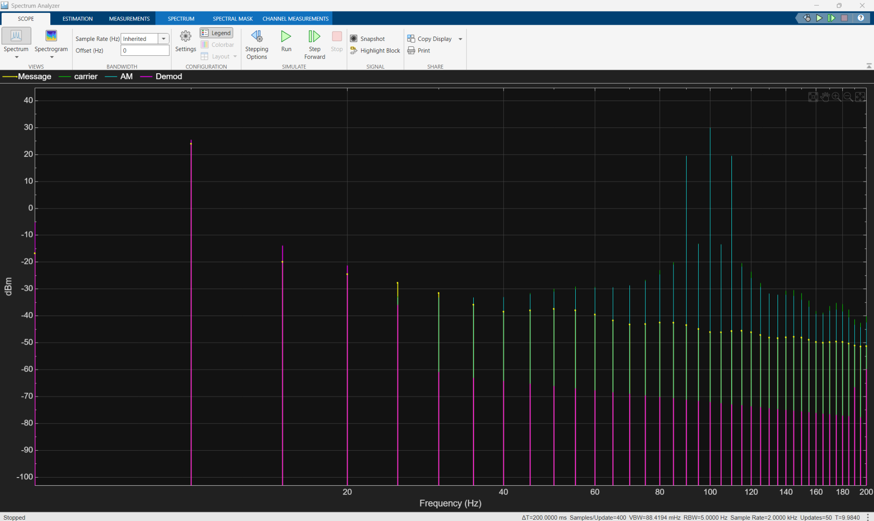Figure 16: AM modulation index 0.6
This was obtained from a spectrum analyser in simulink.

The modulation index relates to the how much power is in the message signal before being combined with the carrier signal this makes it easier to asses the amplification needed to produce a good demodulation

Simulations

Dsbsc
100
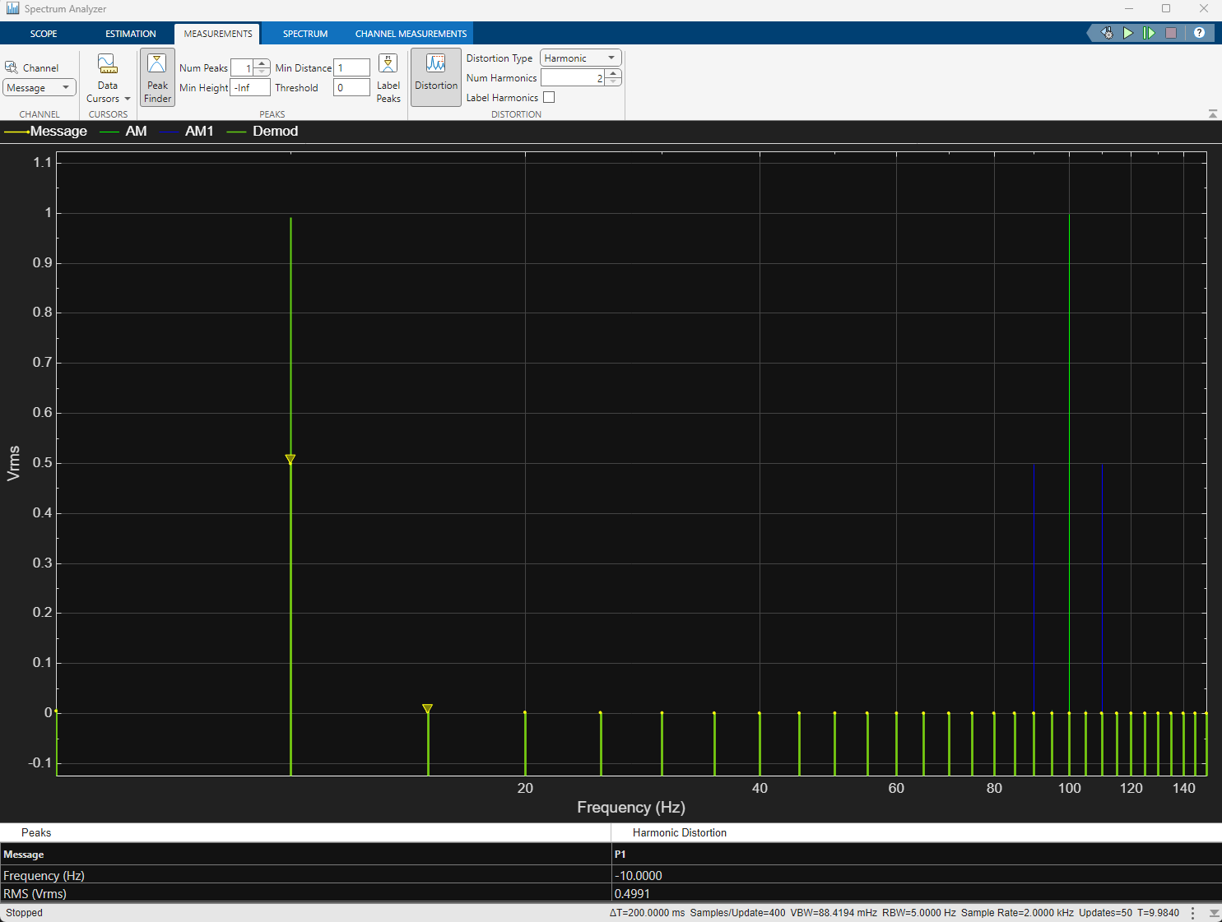Figure 17: DSBSC SNR100
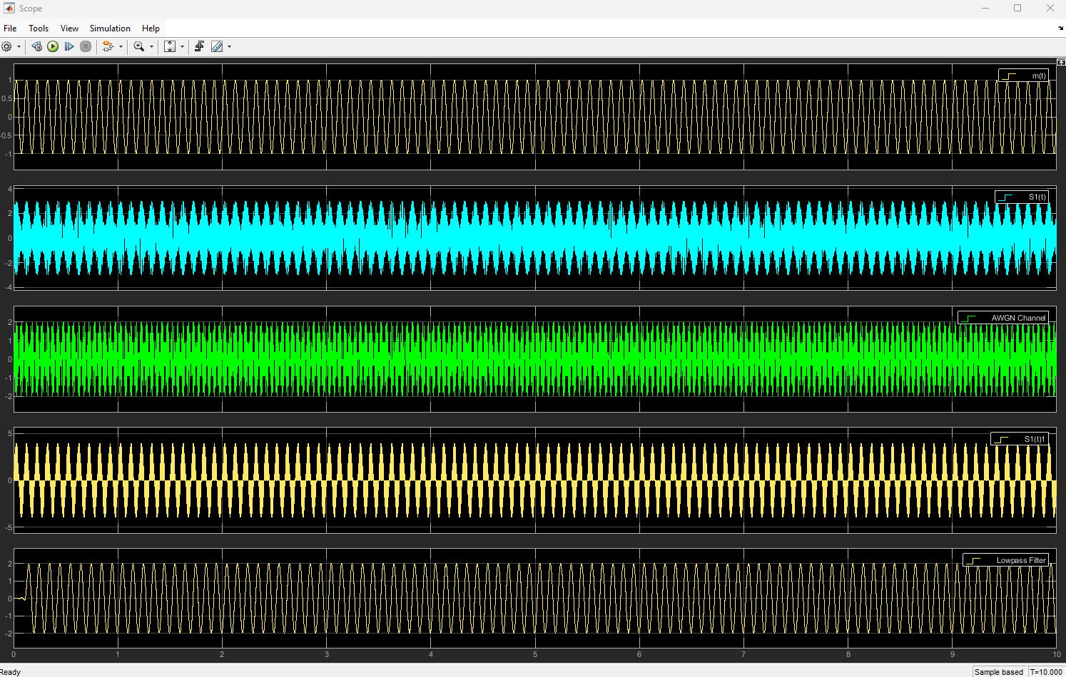Figure 18: DSBSC Scope 100
5
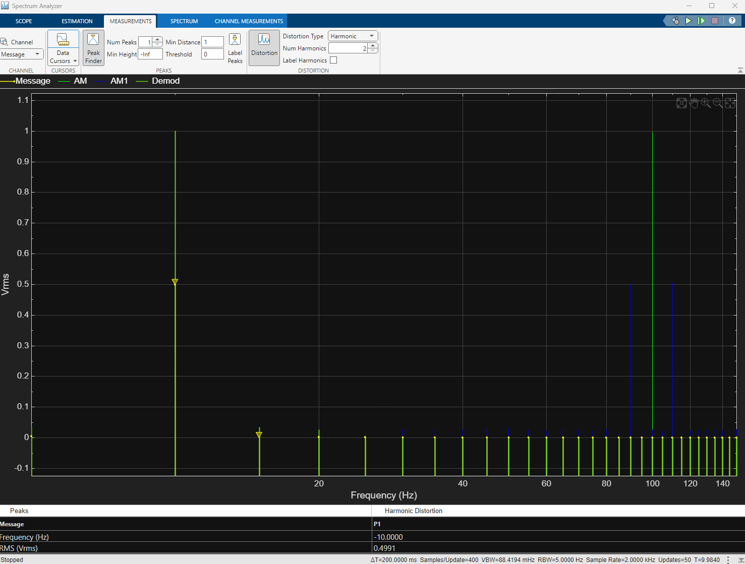Figure 19: DSBSC SNR 5
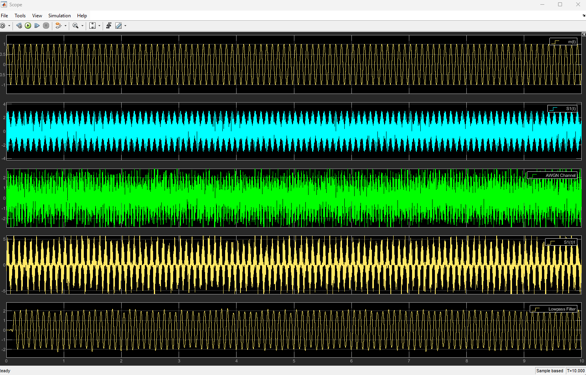Figure 20: DSBSC Scope 5

-5
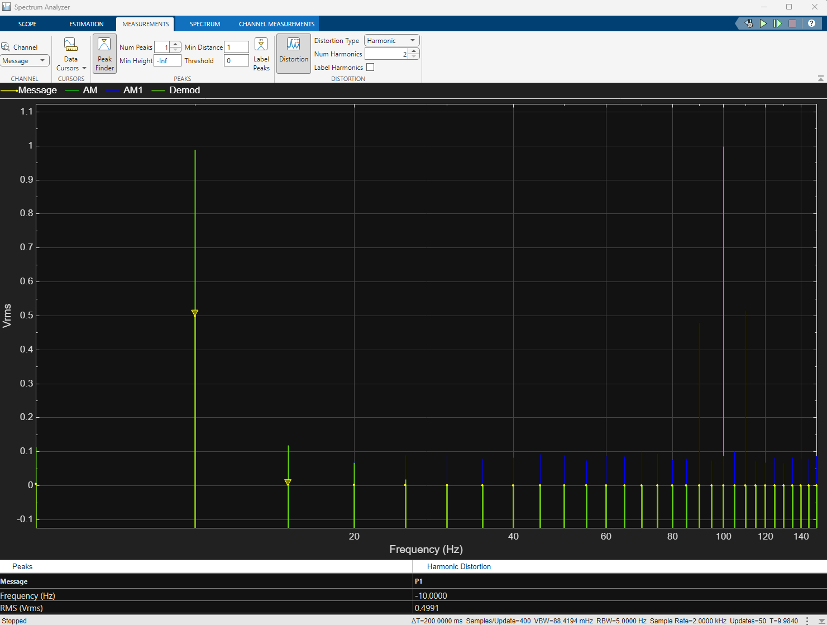Figure 21: DSBSC SNR -5
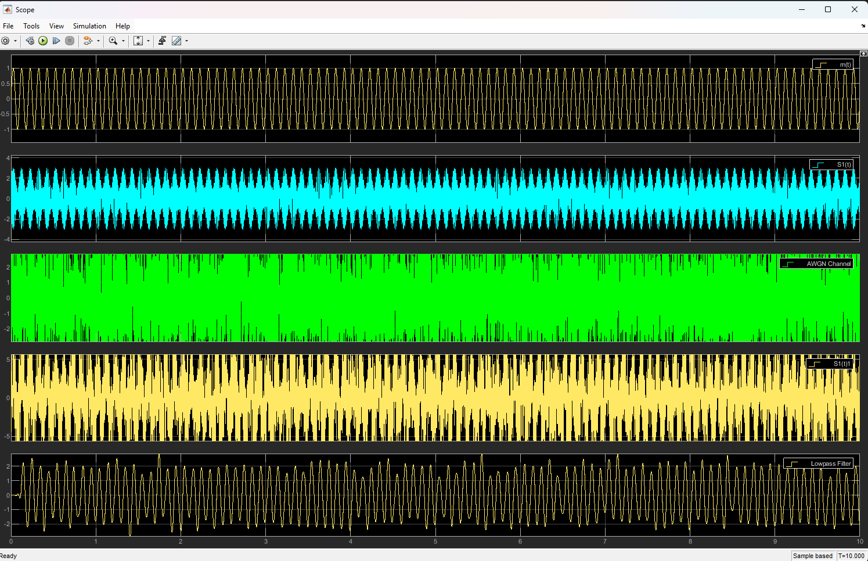Figure 22: DSBSC Scope -5

-15
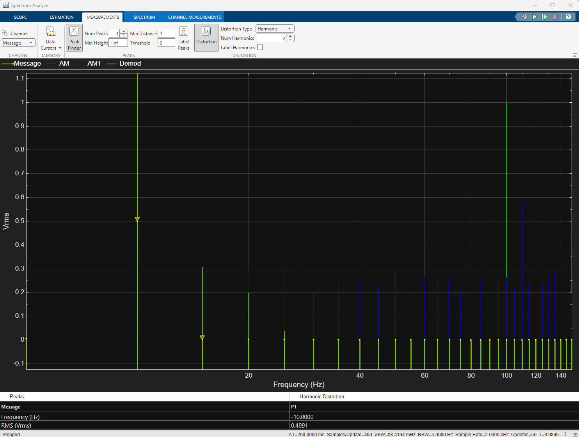Figure 23: DSBSC SNR -15
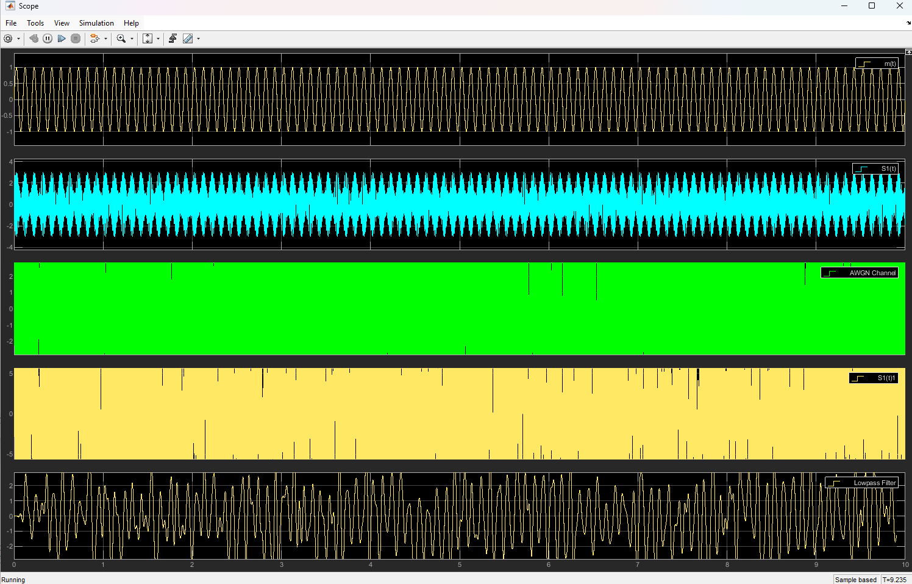Figure 24: DSBSC Scope -15

-25
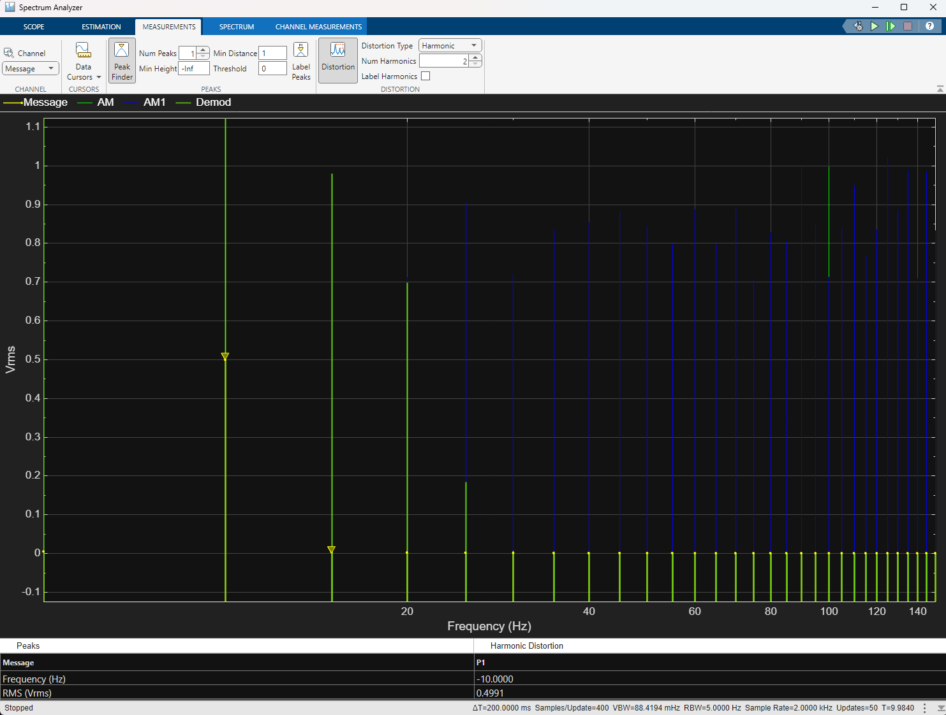Figure 25: DSBSC SNR -25
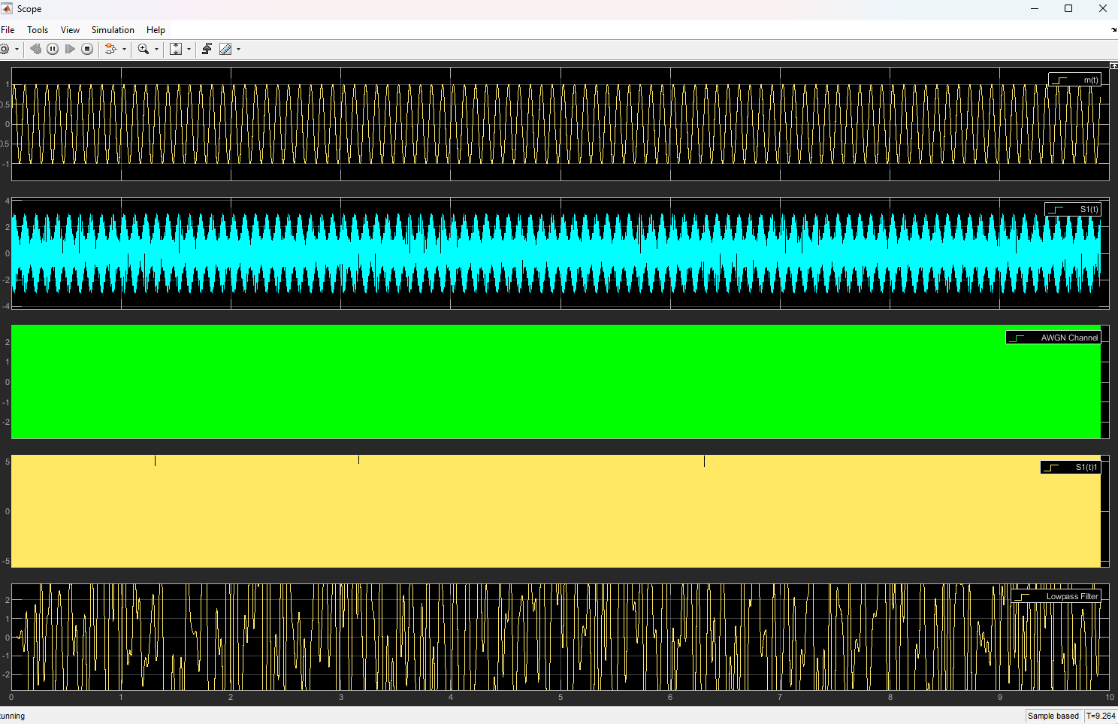Figure 26: DSBSC Scope -25
Ssbsc
100
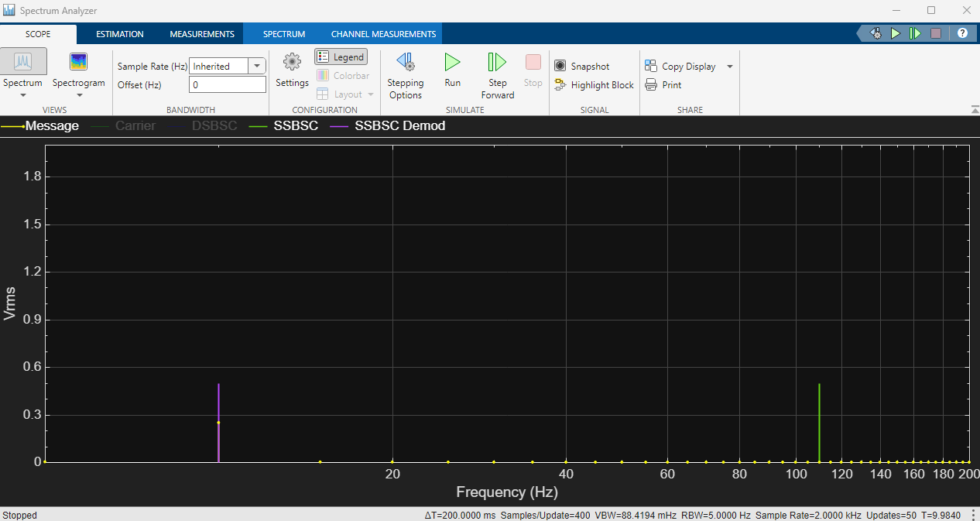Figure 27: SSBSC SNR 100
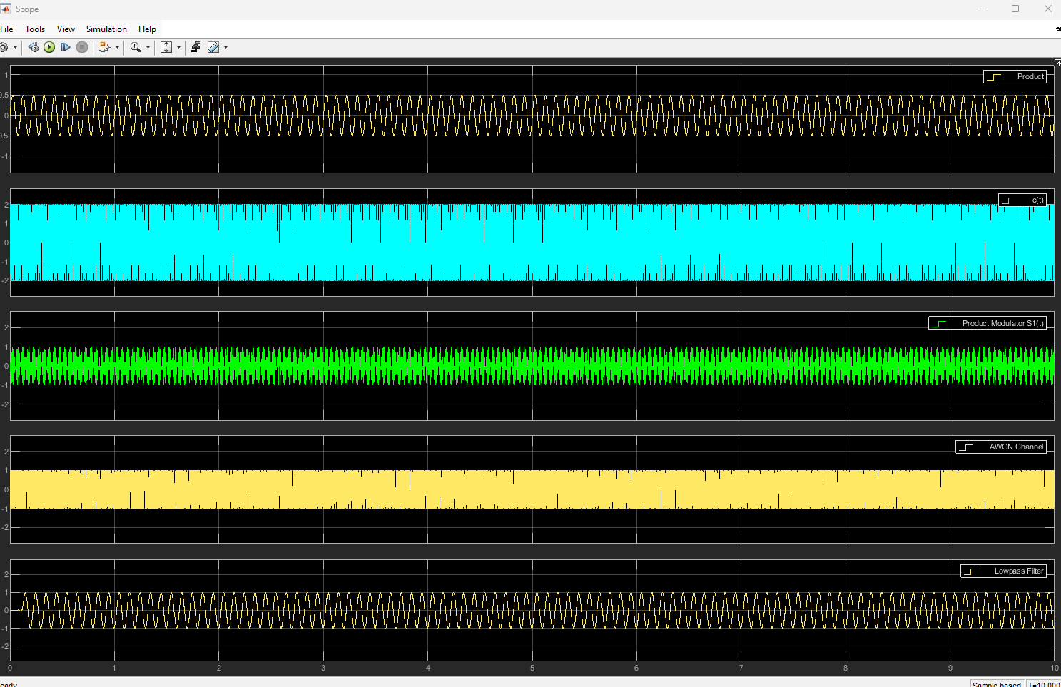Figure 28: SSBSC Scope 100

5
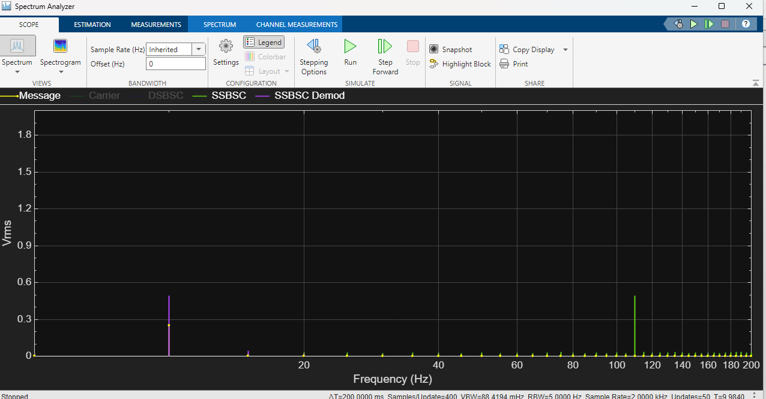Figure 29: SSBSC SNR 5
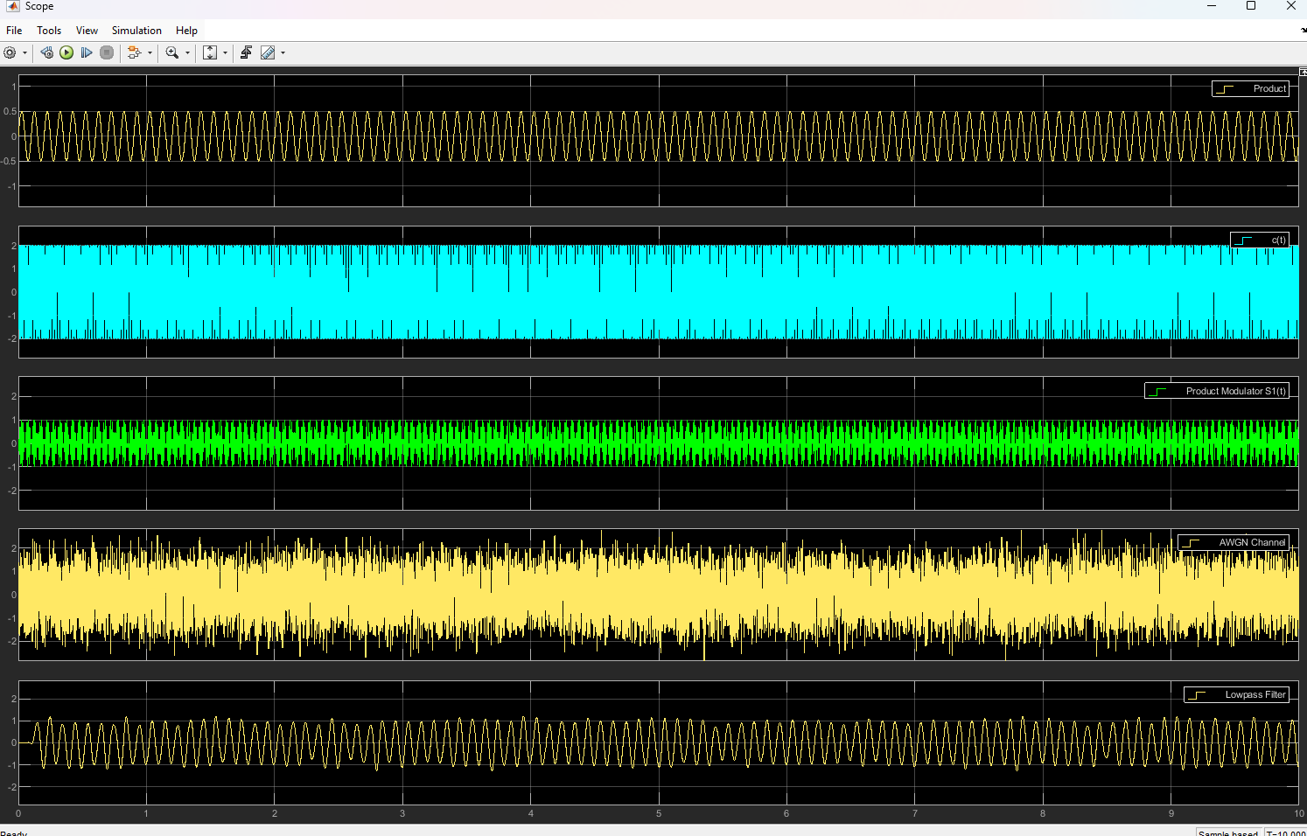Figure 30: SSBSC Sope 5
-5
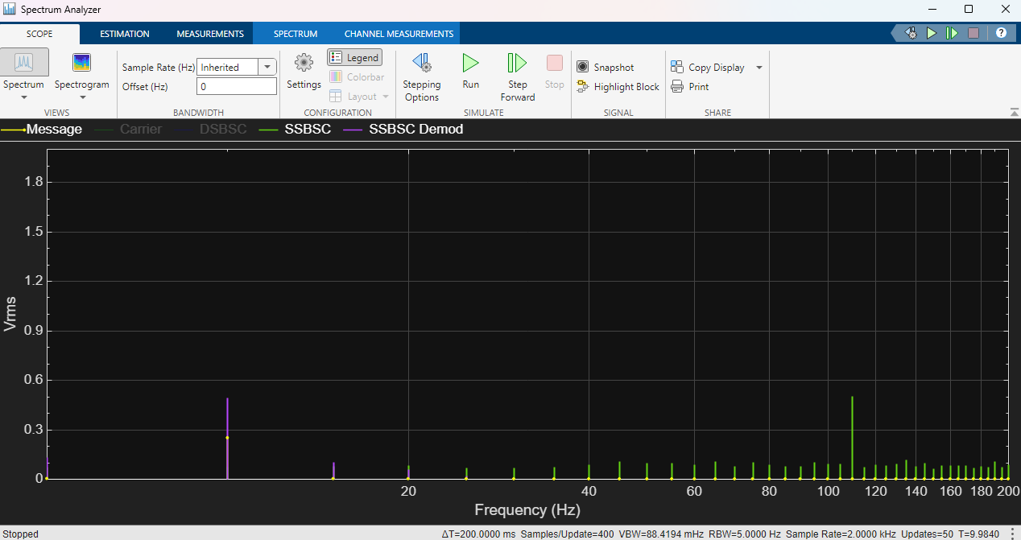Figure 31: SSBSC SNR -5
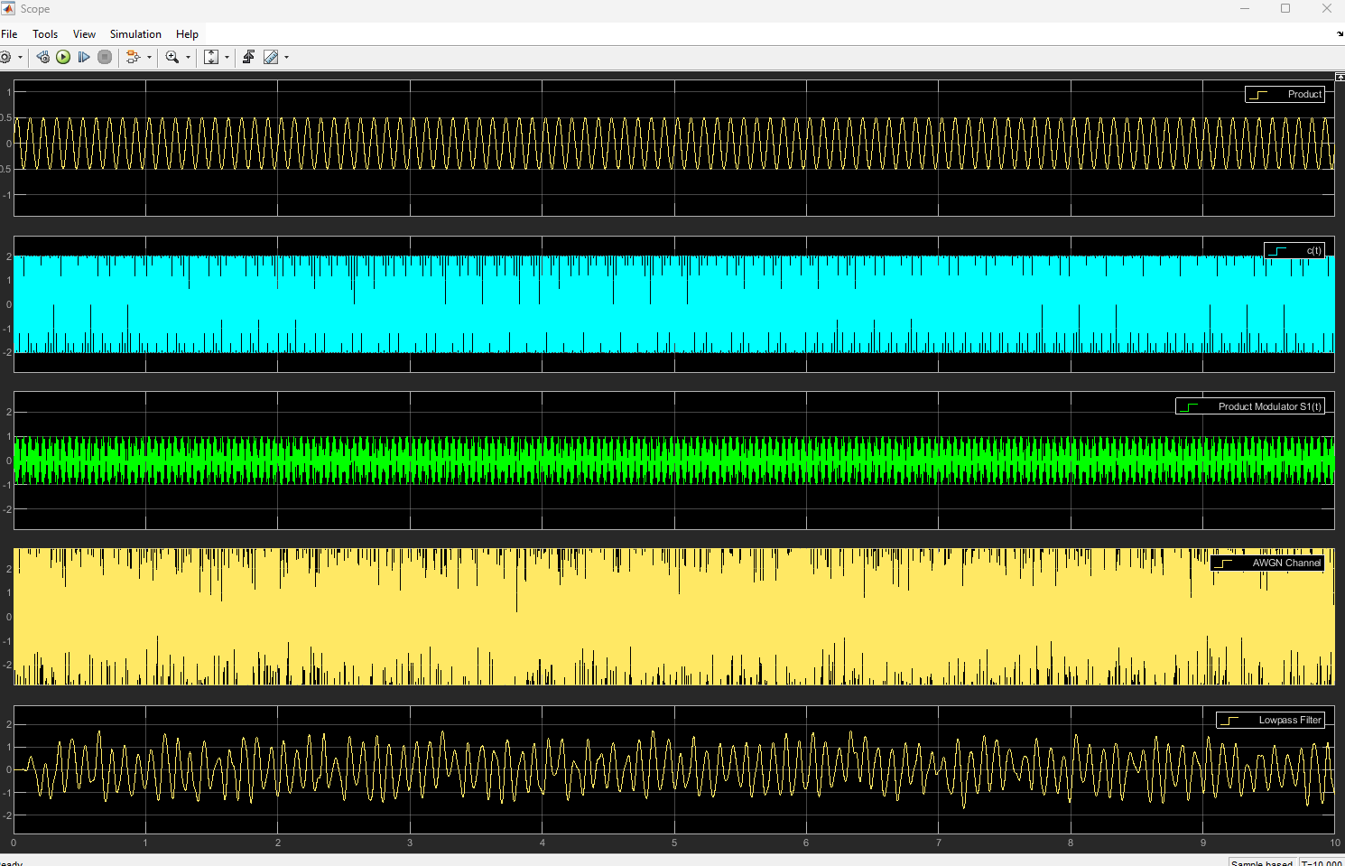Figure 32: SSBSC Scope -5
-15
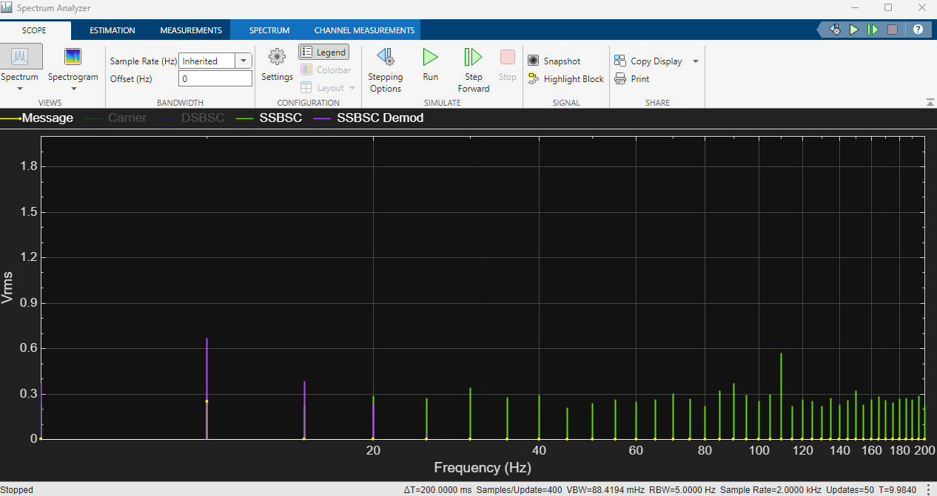Figure 33: SSBSC SNR -15
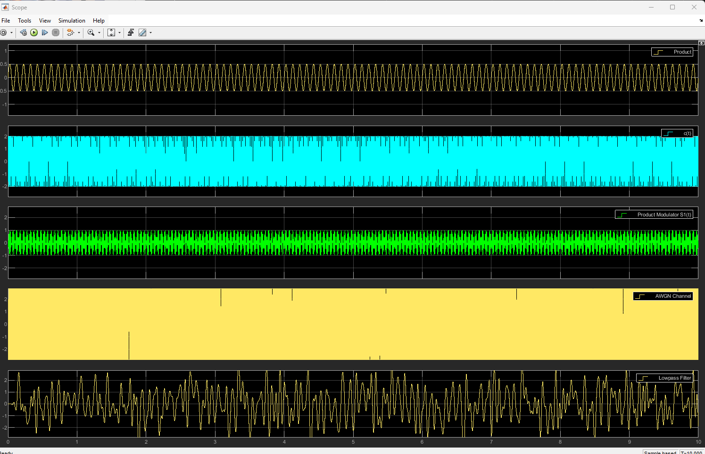Figure 34: SSBSC Scope -15
-25
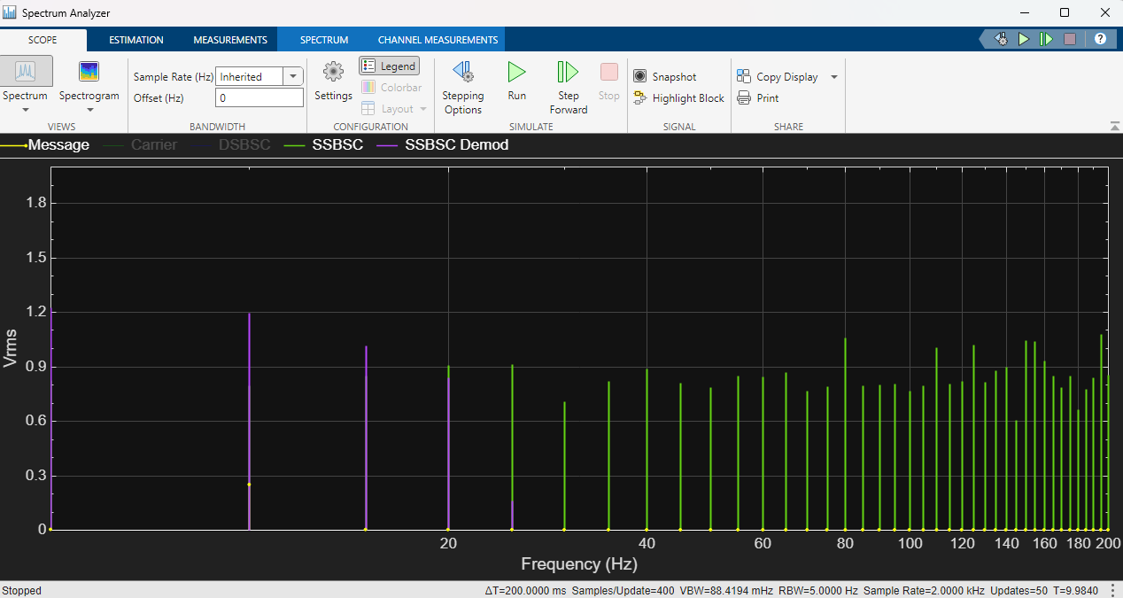Figure 35: SSBSC SNR -25
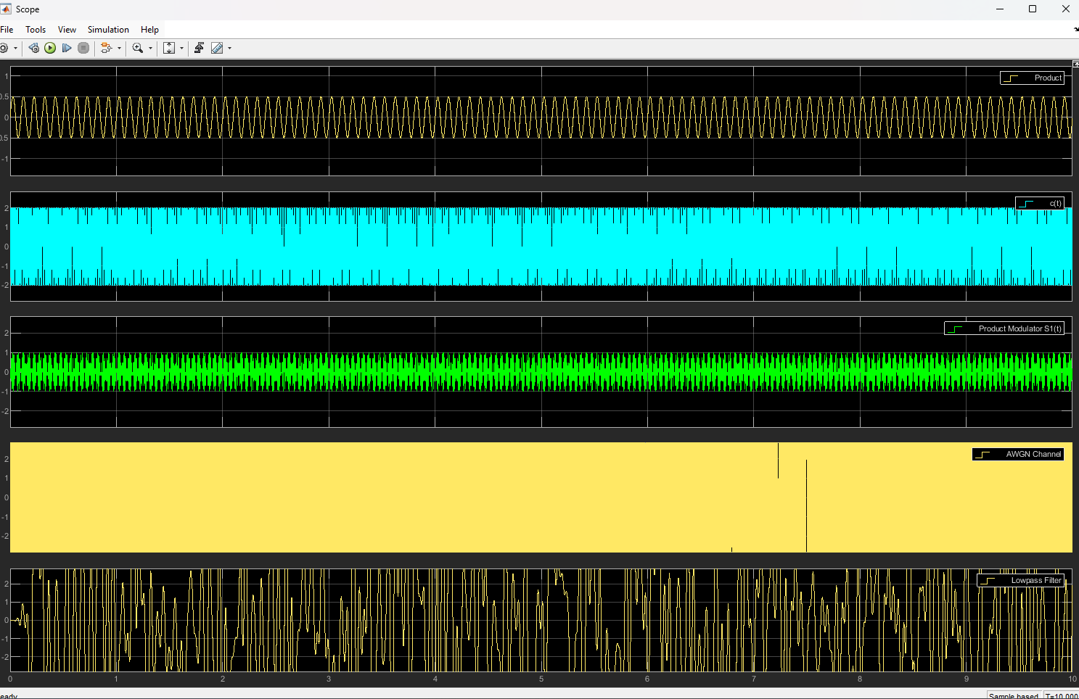Figure 36: SSBSC Scope -25

AM
100
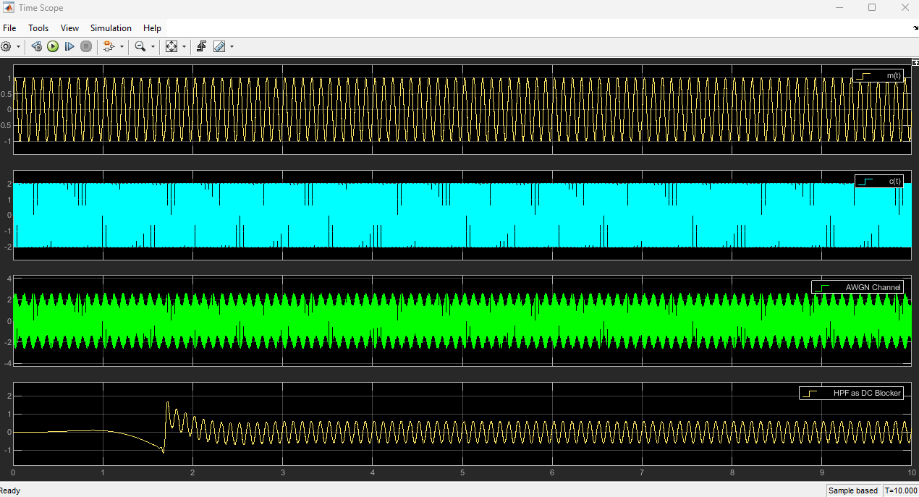Figure 37: AM SNR 100
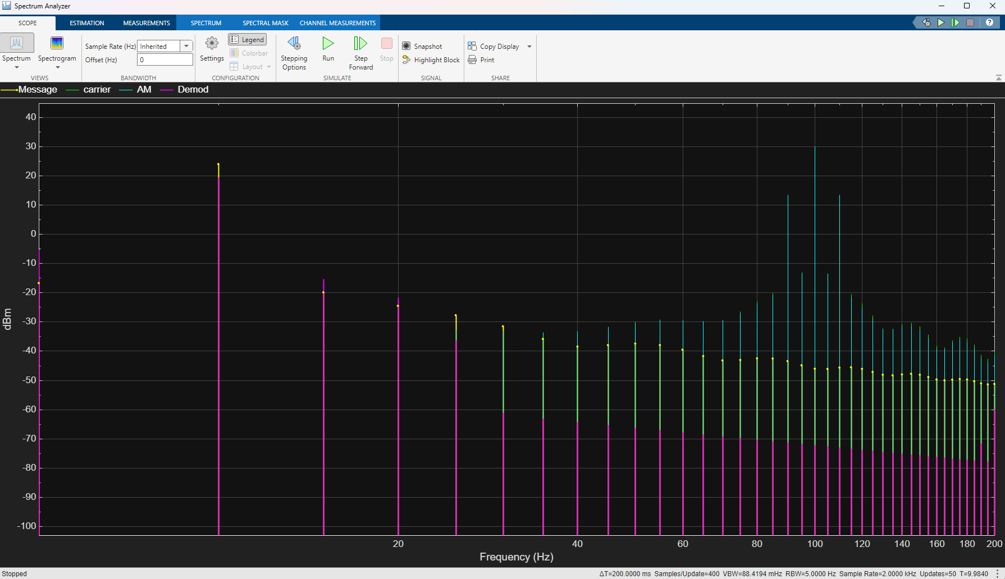Figure 38: AM Scope100
5
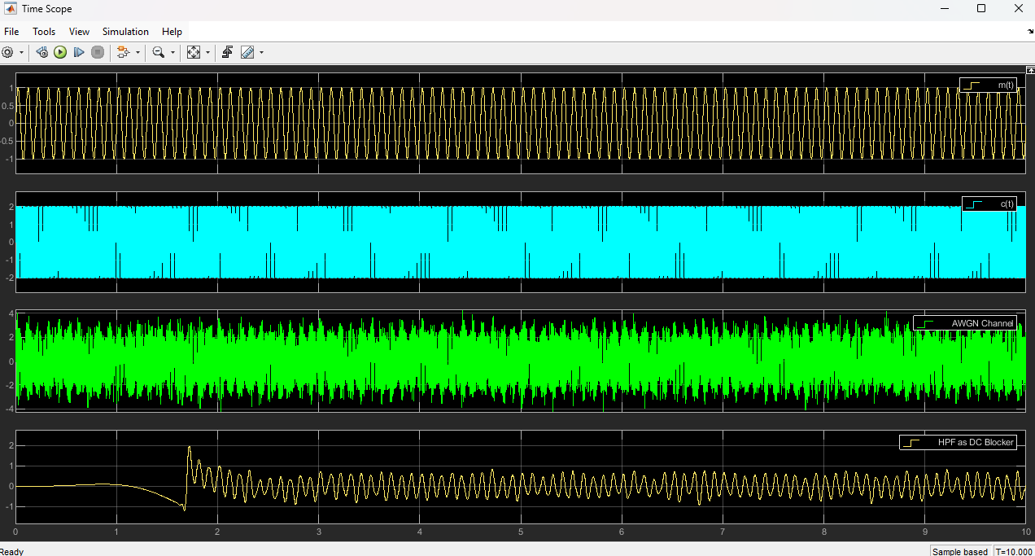Figure 39: AM scope 5
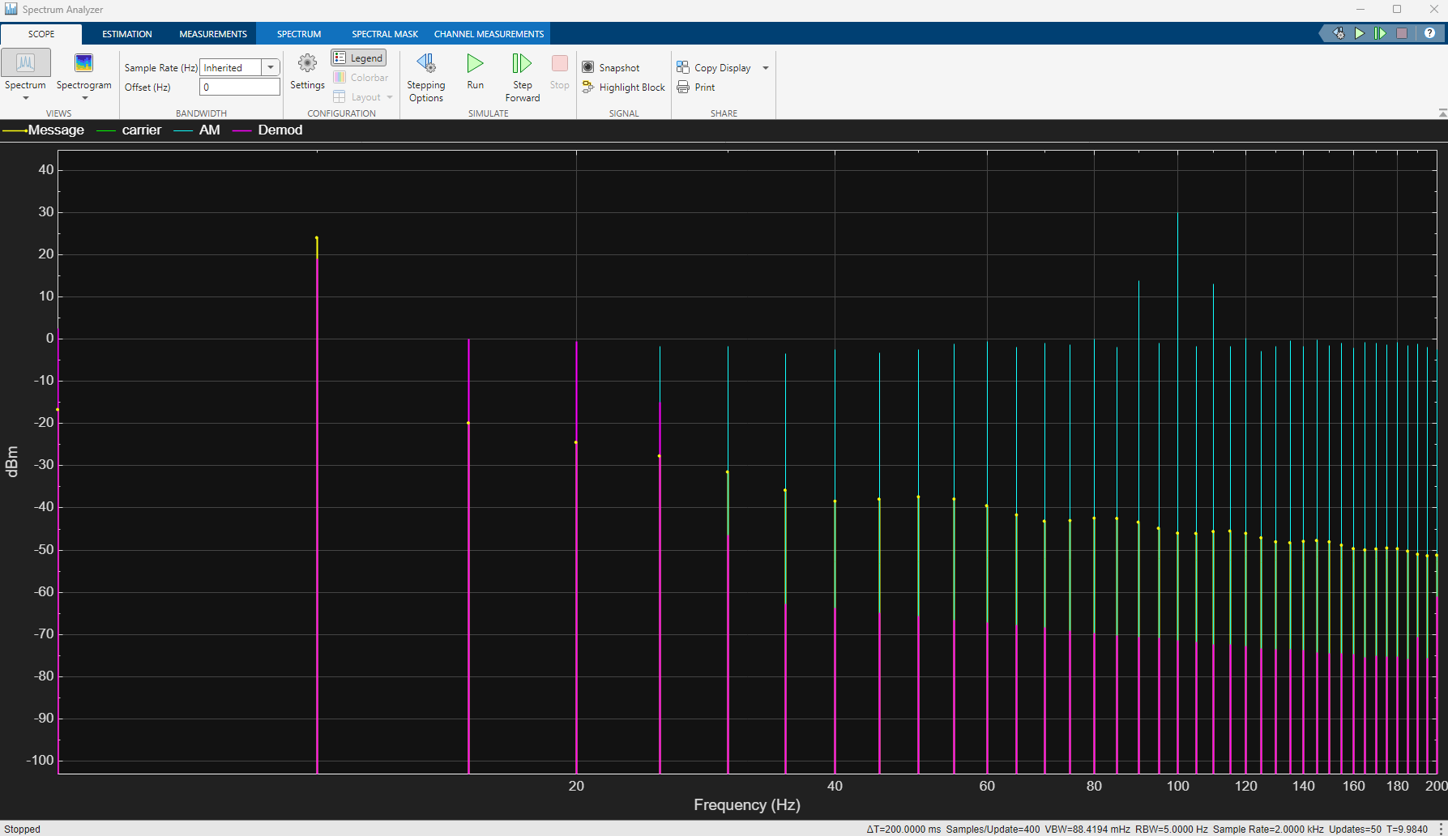Figure 40: AM SNR 5
-5
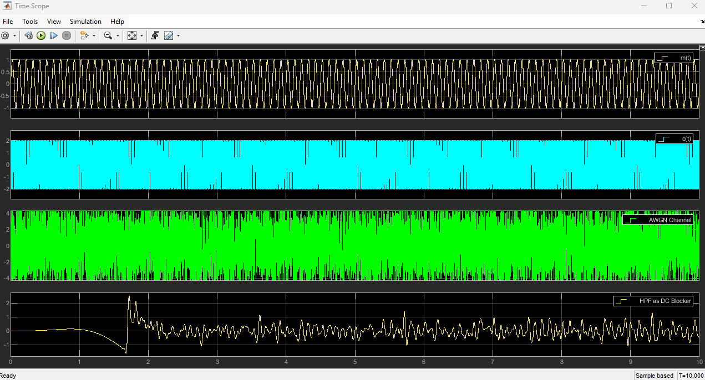Figure 41: AM Scope -5
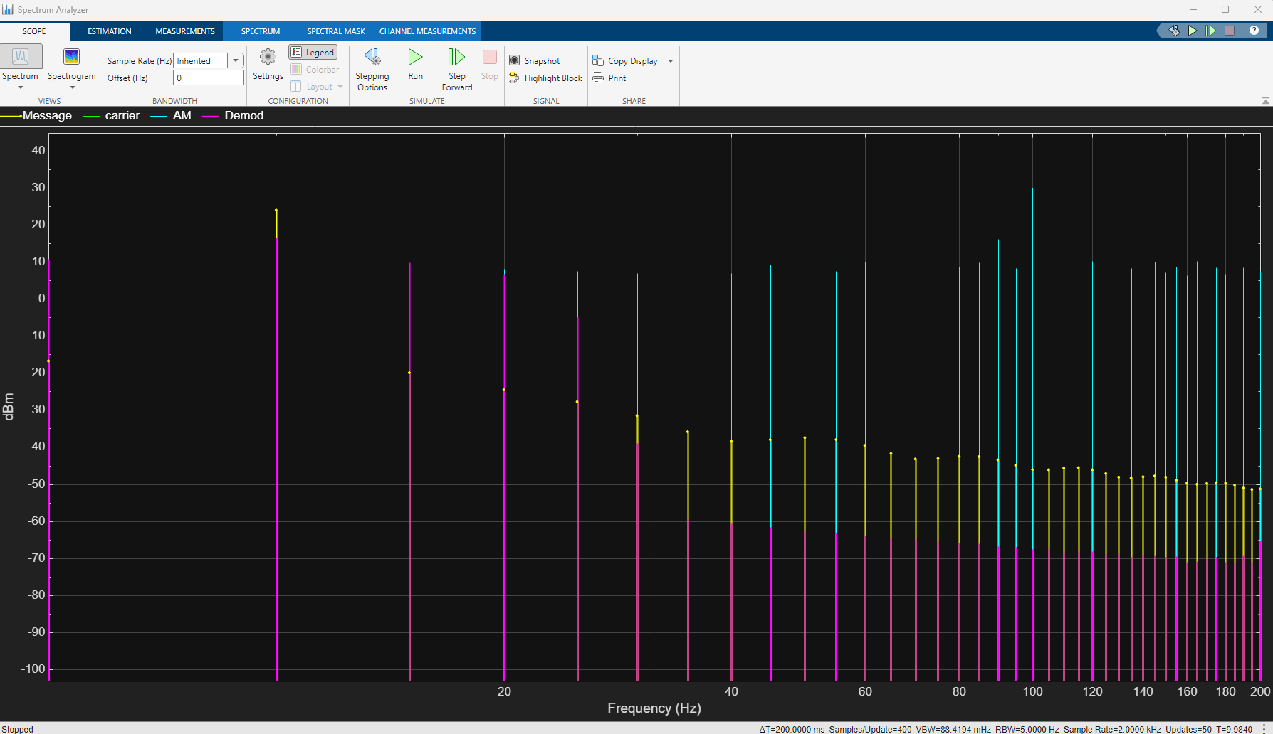Figure 42: AM SNR -5
-15
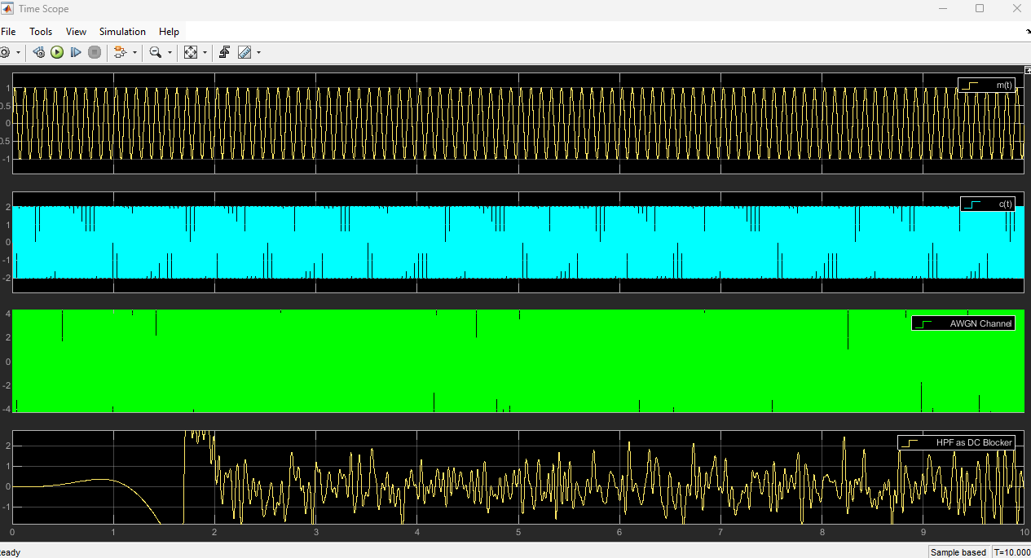Figure 43: AM Scope -15
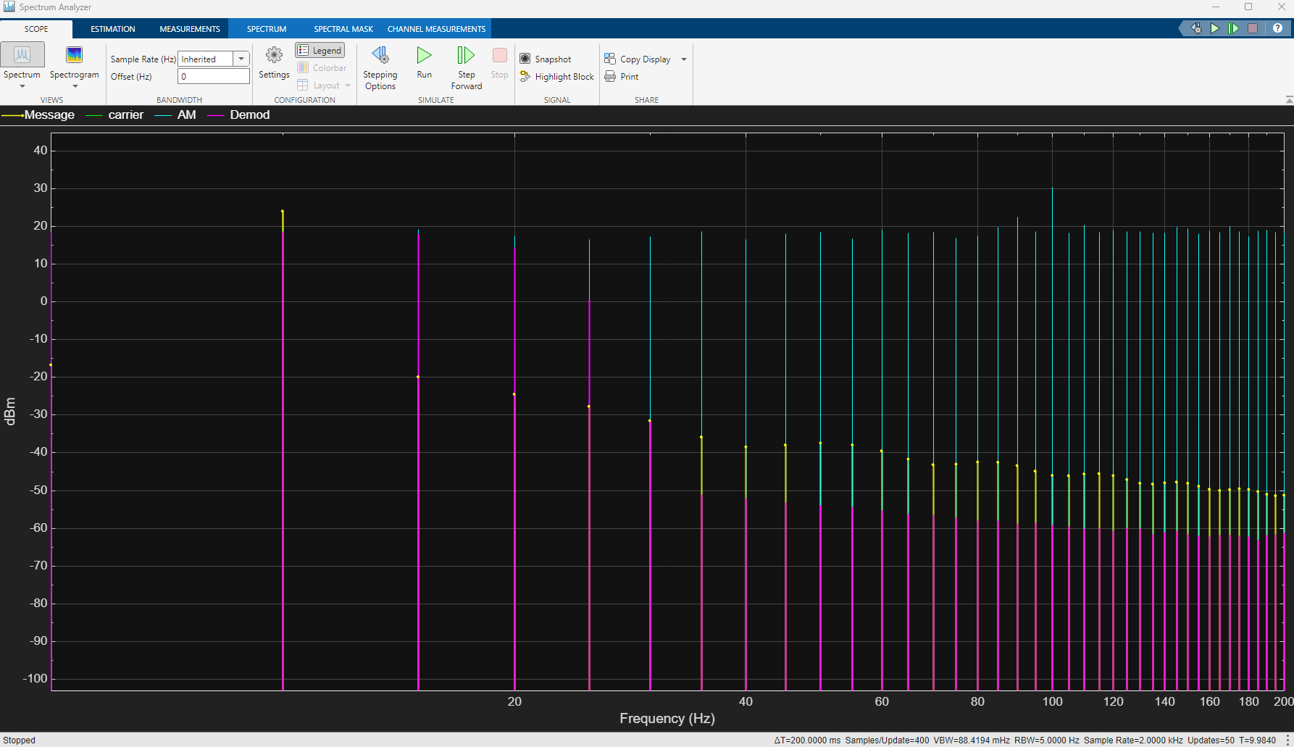Figure 44: AM SNR -15
-25
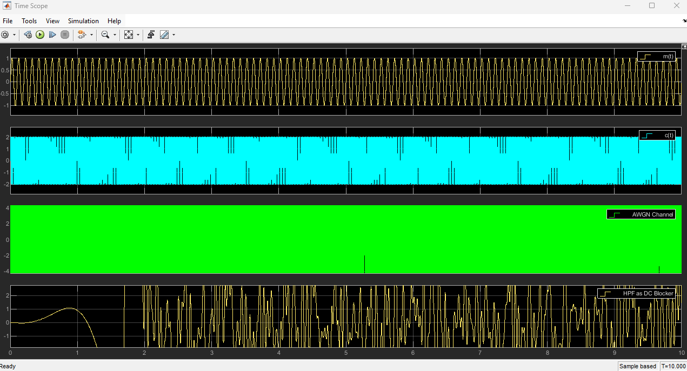Figure 45: AM Scope -25
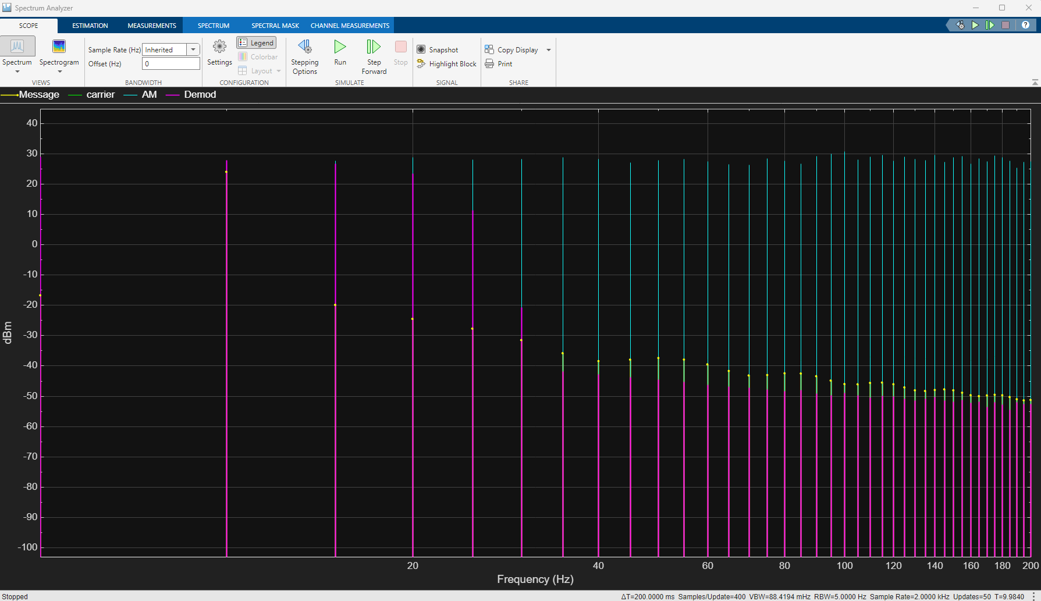Figure 46: AM SNR -25

Results
These results will be the average of the three tests I have run for each noise level.
I will perform tests at 5 different SNR values 100 to ensure that the modulator is working and give a baseline 5 to start the test -5 - 15 - 25.

AM modulator
Power density
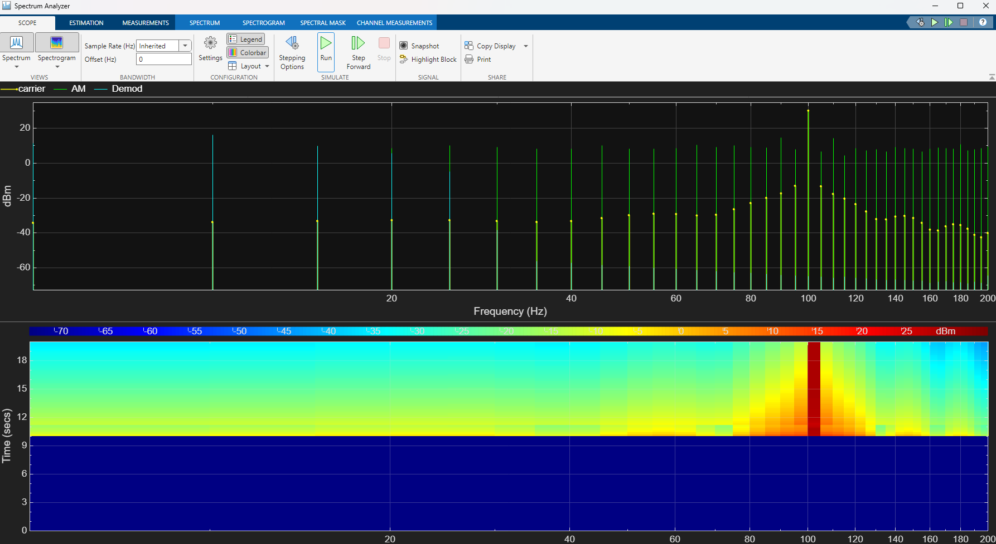Figure 47: AM Power density
The power is all placed on the carrier with power place around the carrier but much lower down

The max power outputted by this signal is 25dbm placed on the carrier with the area around it decreasing to 3 at the lowest before it enters the noise floor of this system

Noise tolerance
This is harder to measure but based on the simulations above the AM signal is unreadable at -15 and barely readable at -5 due to this i will place the noise tolerance of AM at -5 dbm as this is where the signal is last visible in my tests although this is likely not visible to a rf system

Spectrum usage
Am uses very little spectrum if its filtered correctly as it only transmits at one frequency this makes it able to have many channels in the spectrum area if filtered correctly. AM harmonics due to powers involved in AM transmission can be very large and could cover a weaker AM signal

Dsbsc
Power Density
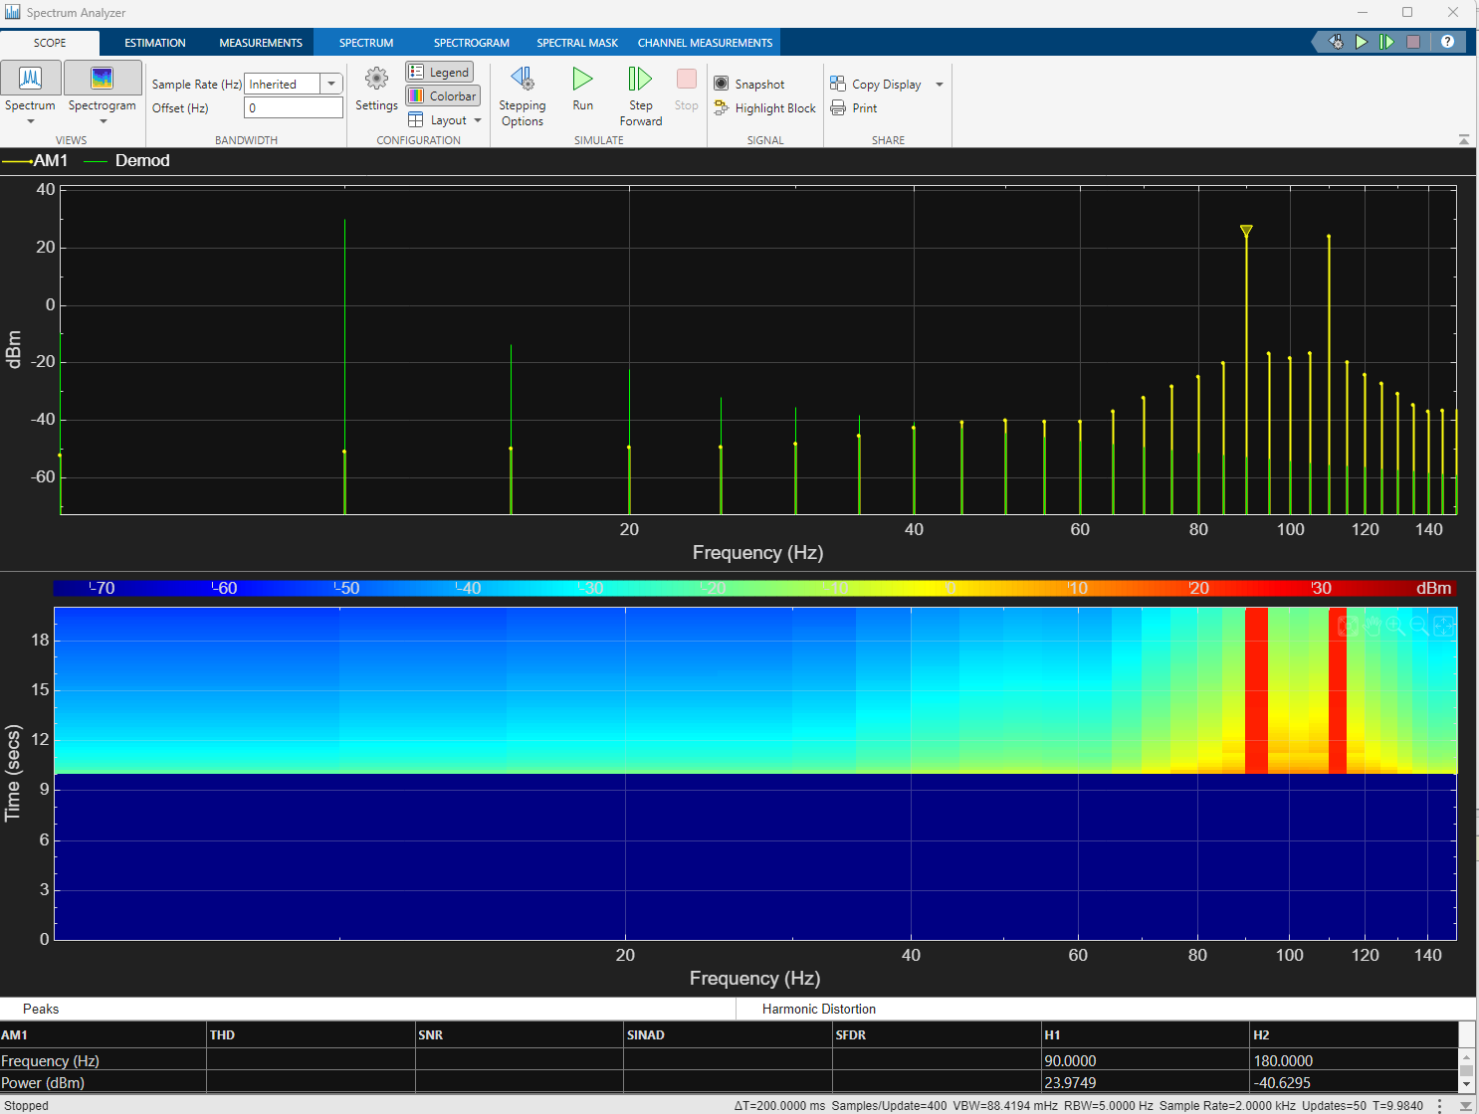Figure 48: DSBSC Power density
DSBSC places all the power around the two side bands of the am signal as shown above. I have removed the carrier to get a better understanding of power the max power of this signal is 24

Noise Tolerance
As shown in the above images the DSBSC signal has a very high noise tolerance considering its an analogue the last time i can discern the signal from the noise is -15.

Spectrum usage
This uses about 20 hz of spectrum usage as such its not the smallest but its still very small

Ssbsc

Power Density
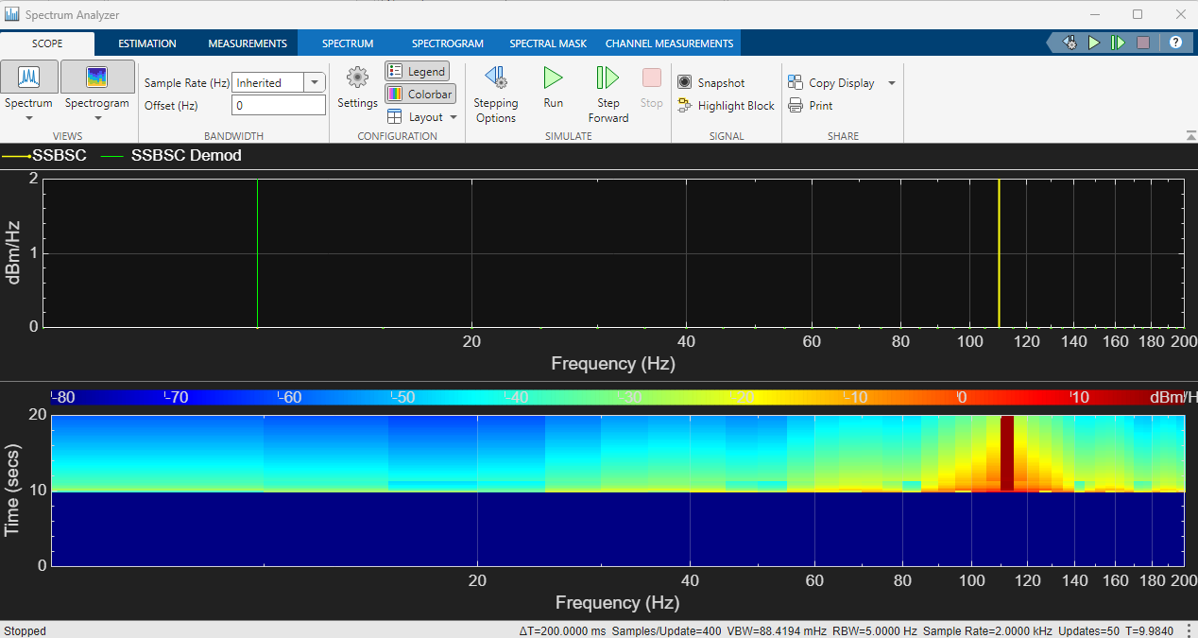Figure 49: SSBSC Power density
The power is all placed around the transmitted sideband and not anywhere else this makes it very power efficient and capable of

Noise Tolerance
Ssbsc is

Spectrum usage
Ssbsc uses around 1hz of spectrum up to 20 depending on what is required to find the signal. As the message is only transmitted on the side band the actual data only takes up to 2 hz in width.

Discussion

Positives and negatives of the modulation techniques

AM
Has the lowest noise rejection of all but its the most simple to implement and the smallest in frequency spectrum as such in an open rural area AM is likely a more effective standard as it will be cheaper to implement than DSBSC pr SSBSC and you can have more channels in the same area given good filters are present on the transmitters.

DSBSC
Has a higher Noise tolerance than both AM and SSBSC And a Higher power level than SSBSC due to not cancelling one of its side band signals this increases DSBSC signal strength significantly compared to SSBSC. Although it has a much larger Spectrum usage compared to AM or SSBSC.

SSBSC

Has Reduced spectrum usage compared to DSBSC and higher noise tolerance than AM make this effective in more applications than AM as it can be found in more noise. It has less noise tolerance than DSBSC And DSBSC can be more easily be seen at -15dbm than SSBSC but DSBSC takes up more frequency space than SSBSC as such their are less channels available in the spectrum for when using DSBSC.

SSBSC has a lower power output so its noise tolerance may increase within amplification but it also may make it take up more spectrum space as such their may be increases to come from a higher amplification.

Conclusion

In conclusion I believe SSBSC and DSBSC can be used for similar work depending on if the area has more noise or needs more channels. This is due to DSBSC having such a more capable noise rejection than SSBSC.

In a rural low noise environment AM is likely more effective as it should be cheaper to implement than SSBSC and DSBSC and the benefits of both are reduced compared to a urban environment as rural environments normally have less rf noise and would prefer the ability to have more device channels to communicate on separate channels.

Future

In future tests i would automate the data capture so that its more consistent and run more tests as this would enable me to get a more accurate representation of the system i would also increase the number of SNR values as the values chosen made it difficult to spot when the modulation types too noisy to see for a better setup i should go down in 5 dbm intervals and then when the noise becomes to much go back up in 1dbm increments to find when its truly lost.

REFERENCES

[1]
TutorialsPoint, “Analog Communication - DSBSC Modulation - Tutorialspoint,” Tutorialspoint.com, 2019. https://www.tutorialspoint.com/analog_communication/analog_communication_dsbsc_modulation.htm (accessed Jan. 06, 2025).
[2]
TutorialsPoint, “Analog Communication - SSBSC Modulation - Tutorialspoint,” Tutorialspoint.com, 2019. https://www.tutorialspoint.com/analog_communication/analog_communication_ssbsc_modulation.htm (accessed Jan. 06, 2025).
[3]
electronics notes, “Demodulation | Amplitude Modulation AM | Electronics Notes,” Electronics-notes.com, 2019. https://www.electronics-notes.com/articles/radio/modulation/amplitude-modulation-am-demodulation-detection.php
[4]
K. Leung, “Communications II Lecture 4: Effects of Noise on AM.” Accessed: Jan. 06, 2025. [Online]. Available: https://www.commsp.ee.ic.ac.uk/~kkleung/communications2_2009/Lecture4.pdf
[5]
“Double-sideband suppressed-carrier transmission,” Wikipedia, Oct. 24, 2020. https://en.wikipedia.org/wiki/Double-sideband_suppressed-carrier_transmission (accessed Jan. 06, 2025).
[6]
“SSBSC (Single Sideband Suppress Carrier) Transmission - javatpoint,” www.javatpoint.com. https://www.javatpoint.com/ssbsc-single-sideband-suppress-carrier-transmission (accessed Jan. 06, 2025).
[7]
“Single-sideband modulation,” Wikipedia, Jul. 11, 2022. https://en.wikipedia.org/wiki/Single-sideband_modulation (accessed Jan. 06, 2025).

