MANAGING ENTERPRISE IN THE 21ST CENTURY
Module code: BMSW4006
Lecturer: Afzal Munna
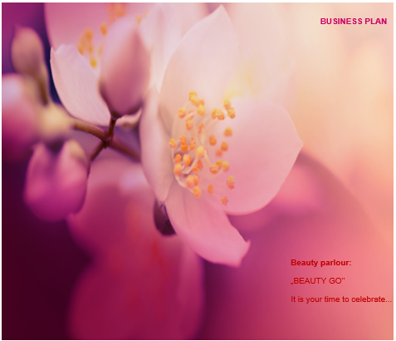

Iliana Hadzin /Group leader/ ID:2009467
Augusto Rivero ID:2008328
Amy Corbett ID:1908526
Fazlee Zahid ID:2012168
Enamul Ludhi ID:2008932
28/04/2021

BUSINESS PLAN COMPONENTS

Iliana Hadzin /Group leader/
- Cover letter
- Executive summary
- Table of contents
- Business description and history
- Business structure

Augusto Rivero
- Product or service description
- Market analysis and trends

Amy Corbett
- Operations

Fazlee Zahid
- Technology plan
- Management and organization
- Social responsibility and sustainability
- Development, milestones and exit plan

Enamul Ludhi
- Financial data

Iliana Hadzin /Group leader/
- Conclusion
- References
- Appendix

Iliana Hadzin /Group leader/
COVER LETTER
To
Mr. Afzal Munna,
18 Acre Ln, Brixton, London SW2 5SQ
Lloyds Bank

Dear Mr. Munna,
We are glad to address this cover letter as a proof of our application for a bank loan of business purpose, alongside with the business plan and the relevant documentation on our project.
As a group of individuals sharing the passion for beauty, we are planning to make a small beauty parlour in a lively area in London. We are conscious of the fact that such an enterprise can seem quite risky amidst pandemic, but we also strongly believe that once the pandemic is over, people will re-start their lives back to normal and the beauty will be again an important and integral part of it. We are skilled as managers in different levels of knowleage as administration, marketing, finance, development and procurement. So we have full range of skills to support each member of our team and likewise our four hairdressers, four beauticians and receptionist as self-employed. The skills that members of our team as self-employed have acquired include a variety of beauty hairstyles, haircuts and make-up techniques and also we all have practiced in various countries and regions across Europe and Asia, including in Portugal, Spain, Bulgaria, Greece, Poland, France, India, Ireland and the Emirates. Although no one of us as five still had the chance to manage an own business, we have the solid team as professionals in the beauty sector and the ideas on how to establish a parlour that can become a real hit at London market, gain fast popularity and offer exceptional quality to the clients inspired from the worldwide.
So we see in the eventual support of Lloyds Bank through a business loan the chance to start a business on our own. We are confident that the objectives we set are achievable and that your initial support through the loan of £7500 will be an investment that worth and repays well. We are looking to hear from you for an interview and to continue further on the assessment process.
Sincere regards:
The Beauty Go team

EXECUTIVE SUMMARY

The „BEAUTY GO” beauty parlour sets the ambitious goal to become a place where clients clould enjoy beauty hairdess styles, hairdess cuts and make-up from across the globe. The beauty parlour aims to offer both beauty services and natural beauty products - hair care shampoos, conditioners, masks and face skin masks and make-up .
The products and the services offered can be roughly divided in two main categories:
1. Only natural products – hair care shampoos, conditioners, masks and face skin masks and make-up by proven recipes and technology.
2. Services – hairdressing (men, women and children), make-up (daily, holiday, bridal, high definishion, airbrush, mineral, shimmer, smokey and professional), beauty hairdess styles (straight, wavy, curly, coily hair and using hair accessories).
The objectives of the beauty parlor „BEAUTY GO” are to offer exceptional quality make-up and hairdressing services, as well as hairdess styles. Apart from it, the brand sets the ambitious objective to introduce the local customers to a broad range of make-up and hairdressing services that use styles from across the globe.
The beauty parlours market in London is not saturated and it still exists the big potential for new entries. The market is mostly dominated by independant entrepreneurs and not the chains which leaves space for small businesses to operate on a very profitable base.

The viability of the project „BEAUTY GO” is based mostly upon its main competitive advantages:
• offering only natural beauty products, tested and proven;
• offering beauty hairdess styles inspired by worldwide techniques.

Competition of „Toni&Guy” hairdress salons and the „Huda Clinic” beauty salon could reveal as challenging for „BEAUTY GO”, but the fact that the „BEAUTY GO” beauty parlour can offer techniques from worldwide and only natural beauty products can appear as a strong competitive advantage, including in attracting not only the locals, but also foreigners living in London as customers.The growth potential expected in the first five years is shown in Table 1 below (graph on Fig. 1 in appendix):

Table 1. Number of customers between Year 1 and Year 5

Number of customers yearly: | Year 1 | Year 2 | Year 3 | Year 4 | Year 5
In visits: | 1 000 | 1 200 | 1 500 | 2 000 | 2 750
The overall funding necessary amounts to £50 000, and the loan of £7500 has to be fixed minimum to 2 year, providing that the interest rate does not exceed 3 percents annualy.

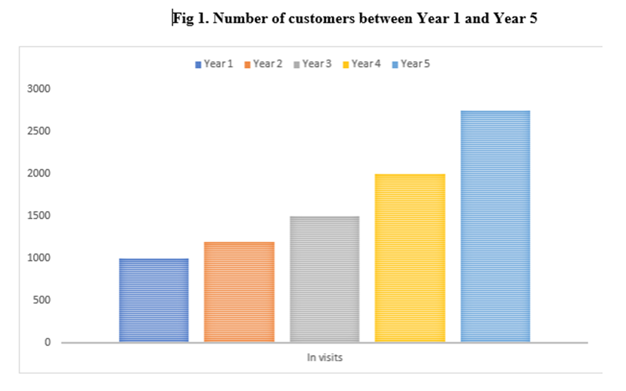

TABLE OF CONTENTS

1. MEMBERS DESCRIPTION
1.1. Iliana Hadzin ID:2009467 /Group leader/
1.2. Augusto Rivero ID:2008328
1.3. Amy Corbett ID:1908526
1.4. Fazlee Zahid ID:2012168
1.5. Enamul Ludhi ID:2008932
2. BUSINESS DESCRIPTION AND HISTORY
3. BUSINESS STRUCTURE
4. PRODUCT OR SERVICE DESCRIPTION
5. MARKET ANALYSIS AND TRENDS
6. OPERATIONS
7. TECHNOLOGY PLAN
8. MANAGEMENT AND ORGANISATION
9. SOCIAL RESPONSIBILITY AND SUSTAINABILITY
10. DEVELOPMENT, MILESTONES AND EXIT PLAN
11. FINANCIAL DATA
12. CONCLUSION
13. REFERENCES
14. APPENDIX

1. MEMBERS DESCRIPTION
1.1. Iliana Hadzin is a founding BEAUTY member of „BEAUTY GO” LTD and performs the position President and Administrative manager as possessing 25% stake. She is appointed within the team to be in charge with the overall process of the Private Limited Company.
Iliana is very self-driven person, always ready to learn more and to try new things. She is innovative and ready to reach new heights. Her approach towards the beauty business brings a great value added to the team through the precious knowledge she is always ready to share.
Currently, Iliana is striving to improve her practical skills in business management as a part of her ambition to be integral part of the ''BEAUTY GO” team.
1.2. Augusto Rivero is a methodical person who productively manages stressful situations, faces new challenges with motivation and seeks solutions and alternatives to unforeseen events.

1.3. Amy Corbett has previous work experience, combined with a short educational course in beauty and paved the way to the knowledge she possesses today of this thriving sector. Previous Business experience within a Local Authority whilst completing a Business & Administration course enabled her to acquire knowledge and understanding around different business departments that exist all within one business.
Her beauty knowledge comes from a short-studied course where she got to understand the importance of health and safety, legalisations, and technicalities surrounding the functioning of this kind of working environment. Her experience allows her to contribute best to the team by transmission of knowledge on Business and Administrative; Specifically, business.
1.4. Fazlee Zahid was responsible for the development, implementation and monitoring of company and organizational environmental strategies in Asian beauty salon chains.
1.5. Enamul Ludhi has previous work experience in large financial institutions, both in Europe and in Asia.

2. BUSINESS DESCRIPTION AND HISTORY
The business is planned to consist of a beauty parlour ‘’BEAUTY GO’’. The salon will offer the following range of services:
- Hairdressing – men, women, and children.
- Hairstyling – straight, wavy, curly, coily hair and using hair accessories.
- Make-up services – daily, holiday, bridal, high definishion, airbrush, mineral, shimmer, smokey and professional.
The haircuts, hairstyles and the styles offered for the make-up range of services will follow some of the hottest trends and techniques been used in Europe and Asia.
The products "BEAUTY GO" will offer will be only natural types of masks for hair and face skin in order to use make-up:
- natural face skin care masks – made only by herbs as chamomile, roses and aloe vera and then applied as a solution on the face.
- natural hair care masks – made only by herbs as chamomile, violets and calendula and then applied on washed hair and leave it for two to three minutes to absorb through the hair.
The main idea is to offer completely natural products that can bring instant regenerating and refreshing to the skin and the hair through the regenerating substances of the chamomile and the fresh aroma of roses and violets. Advertising is planned to be run mostly through social media sponsored ads, mostly in Facebook, LinkedIn, Twitter, and Instagram. The website of the salon ‘’BEAUTY GO’’ will be created through Wix, Oxxyor or Weebly.
The short-term objectives of the company – planned to be achieved by the end of the first year of operations – can be outlined as following:
1. The first step would be to use the advantage of social media in digital marketing by Instagram, Facebook and other media platforms.
2. Successful advertising campaign.
3. Develop own exclusive app in order to pertain its customers with the latest newswebsite.
The medium-term objectives of the company – planned to be achieved in the horizon of three consecutive years – can be outlined as following:
1. Launching successfully the "BEAUTY GO" beauty parlour with only natural products – hair care shampoos, conditioners, masks and face skin masks and make-up by proven recipes and technology and selling at least 5000 pieces yearly.
2. Achieving at least 1500 yearly visits or customers by the end of the third year.
The long-term objectives of the company – planned to be achieved in the horizon of five consecutive years – can be outlined as following:
1. Achieving a solid volume of sales of the masks for skin and hair on the market of at least 6000 pieces yearly.
2. Achieving at least 2000 visits or customers by the end of the fifth year of the company's existence or an accumulated value of at least 8450 customers or visits for the first five years of its existence.

3. BUSINESS STRUCTURE
The business entity is planned to operate as a private limited company which is actually the most popular form of business entities in the UK. The initial capital set is planned to be £50000. The owners of the company will be all the five members of the team, only four of them having equal share of the company /15% stake/ and been able to operate as authorized representatives of the company. Entirely the President and Administrative manager will have 25% stake due to the most important representative functions and responsibility for the development of the company. In the horizon of the first year, we do plan to employ staff: four hairdressers, four beauticants and one receptionist as self-employed.
The structure of the company is presented as below:
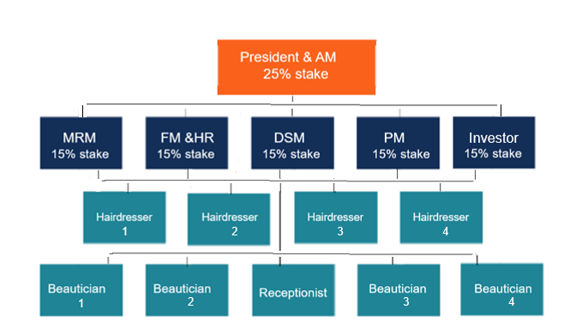
The five members of the team will be both owning and working for the beauty salon ’Beauty GO’’ as managers:
Iliana Hadzin will be main and driving wheel as a President and Administrative manager.
Augusto Rivero will really make us proud as our Marketing and Research manager.
Amy Corbett will work for our additional resources as our Procurement manager.
Fazzle Zahid will build strong relationships as our Development and Sustainability manager.
Enamul Ludhi will give us numbers and positive sales as our Finance Manager and Human Resources.
Augusto Rivero
4. PRODUCT OR SERVICE DESCRIPTION
In accordance with the new ecological trend, we have decided to offer treatments that are natural and cruelty-free products. Also, we have professional products from recognised brands to use for the customers in general. Our suppliers can provide us with a wide variety of products that are organic and cruelty-free, as also, the recognised brands that we can use for all our purposes. But we will focus on natural products for hair care, like shampoos, conditioners, hair masks or face skin masks and makeup. Then, we have:
- natural face skincare masks – made only with herbs like chamomile, roses and aloe vera and then applied as a solution on the face.
- natural hair care masks – made only with herbs like chamomile, violets and calendula and then applied on washed hair and leave it for two to three minutes to absorb through the hair.
The makeup, shampoos and conditioners are with similar natural ingredients. The results that can bring it using these products in an instant regenerating and refreshing to the skin and hair through the regenerating substances.
Hairdressing (men, women and children)
Make-up (daily, holiday, bridal, high definition, airbrush, mineral, shimmer, smokey and professional),
beauty hair dress styles (straight, wavy, curly, coyly hair and using hair accessories).
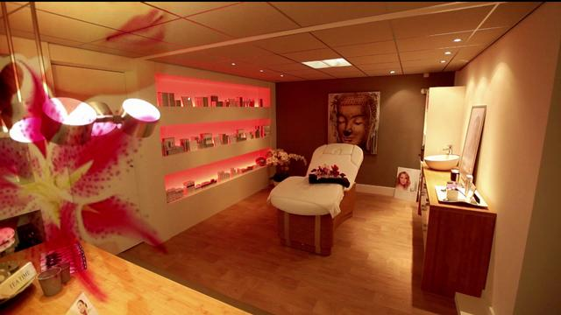
Our service starts from the customer make the appointment, we give to them the best attention focusing in them well-being and comfort.
Following the standards of security Covid-19, we provide different ways to do the appointment. We have a different social media where the customers can find us, a website and in addition our phone number where will be possibly make the reservation.

Advertising is planned to be run mostly through social media sponsored ads, mostly in Facebook, LinkedIn, Twitter, and Instagram. The website of the salon ‘’BEAUTY GO’’ will be created through Wix, Oxxyor or Weebly. Also we will create leaflets to give in special points like Universities or Gyms.
The customer a part of ask about what kind of main service will need, like hairstyle, make up or haircut, they can ask about some drink to consume, newspaper or magazine to read. The time space between each appointment is strategically distributed so that there is not an agglomeration of clients in the waiting room and thus be able to minimize risks regarding the constant threat of the Covid-19 virus. Cleaning and disinfection will be done regularly throughout the day, in addition to having the basic contagion prevention materials (masks, antibacterial gel and air purifying aerosol).

5. MARKET ANALYSIS AND TRENDS
- Target Customers
Population between 16 to 65 years old.
- Location
Area decided is Central London comparing population density
- Briefly description of the customers
- What customers will pay for this service and products
- Prices, offers and who will benefit of this.
Prices will be an average of different competitors. Also, there are discounts for students and one day in a week that will be best price, besides, there is a special discount for key workers and thus be able to contribute with our part to the great work and effort that they carry out every day.
- Market and competition: explain why I choose the area, what kind of customers and area.
Making a research firstly targeting that the Local we want to be in the centre of London. We finally decided that will be located in Lambeth Borough , specifically near of Vauxhall station, the address is Unit 4, St George Wharf, SW8 2LE.
The reason of this decision is based in a research made comparing three neighbourhoods that have areas in central London. I compared by population and by the group of clients that we aim to have. The age ranges from 16 years that are students, to 65 years people. Our offer covers the needs of both gender, men and women. We hope have clients with a standard of living from middle class onwards, obviously not discriminating against any social class, but the prices will not be the cheapest, without become the most expensive.
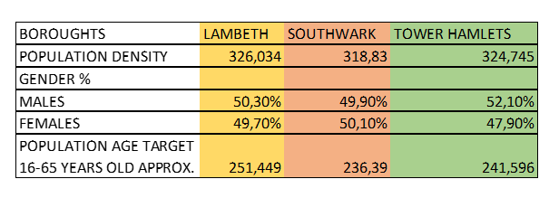

ANALYSIS OF CLOSER COMPETITORS

Live true London (Beauty Salon)
They are our most direct competitor and will be challenging to aim costumers that maybe are now costumer from this local. They offer good quality of services like haircut, hair dress and make up. We will have better options about our services because we will offer at our customers the best experience from de booking until the end of the service contracted.

Novel Hair Studio (Beauty Salon)
A brilliant company that offer them services seven days of the week, also friendly and wide range of services for women and men. They are a strong competitor, but we are sure that our customer service will be the best.
For another hand, we have as a strong point the natural products that are certified as organics and cruelty-free. Also, our good offers for key workers and students will attract the attention of our future customers.
SWOT ANALYSIS

Strengths: Our strongest point is the flexibility of our service, from which we can cover a wide age range. From 16-years-old students to elderly population at 65 as an approximation, it is not something strict, it is to get an idea. For that reason, we have a prepared professional to meet the expectations of our customers. Additionally, we have amazing discounts and offers that we can offer for certain age ranges and population group.
On the other hand, we are aware of the ecological impact that we can create as a business and we see ourselves with commitment to join the new trend the has been emerging for a few years ago, but currently with more force. For out part, we offer products that are organics, vegan and tested, also with no parabens and toxic chemicals for our organism. The people nowadays are conscious about his impact and more and more people decide to consume these products. For this reason, for us, this is as well a strong point that we can offer against our closest competence.
Without leaving behind and no less important, the quality and excellence of our service that we already see as a strong point in our favour, will make the satisfaction of our clients, a loyalty that we can maintain over time.
Weakness: The most complicated part, which we consider to be the greatest weakness, is entering the market being a new company. We are aware of the high competitiveness that we must face and that we have to win over our future clients. With all this, I want to say that although this is our weakest point, we are not going to feel intimidated and we are going with all the strength, strategy and preparation to be a successful company.
For other hand, our capital is provided from our savings, the risk of the current situation about the pandemic virus. It can generate an instability when predicting our next earnings if after the reopening of the businesses there are re-outbreaks that cause an indefinite closure of the businesses again.
Opportunity: As I mentioned before, the society is more conscious about be more ecological and eco-friendlier, as well that we are surrounded of many chemicals that in a long term are harmful to health. We take advantage of this market niche and we emphasize the quality, ingredients and provenance of our products. Our suppliers make easy for us to offer the best quality of products.
As part of our strategy to attract customers, we will design exclusive discounts for key workers who are helping so much to overcome this difficult stage of this last year for our society. On the one hand, we do it as a commitment and form of gratitude from our sector and at the same time it will be a way to achieve that range of clients that can also help carry our business forward. Like the student haircut discount which is another good strategy to attract this range of customers.
Threat: The main threat is our competitors, they are here long time ago and they were created a fidelity with them customers, the this is the most difficult challenge that our company has.
To point out another threat that we may have, it is the way in which we are going to promote ourselves as a company and make ourselves seen, since making ourselves known initially, this has a cost in money and time. We must carefully measure the investment that we are going to focus in this regard in order to transform this threat in opportunity.

PESTEL ANALYSIS

Political:Due to the current situation about the Covid-19, the Businesses in all sectors have been affected to a greater or lesser extent and the personal care sector where the beauty salon is located has not been an exception. Currently in the country we are in a de-escalation of restrictions which have kept Beauty Salon businesses closed due to the high risk of contagion posed by the virus. This has meant that the sector has been affected dramatically. As a new company, we have to take this situation into account and be prepared for future circumstances, as well as being updated with the new action policies that are taken in relation to the opening and use of the beauty salon facilities.
The decision of the United Kingdom to stop being part of the group of countries that make up the European Union and to follow its own path as a country belonging to the continent of Europe but having its own laws and conditions in international trade, will have an impact on the value of certain products that are imported, in addition to their availability. This is due to the fact that the United Kingdom is in a third country position with respect to the rest of Europe, creating a new protocol of measures and import controls that will be more exhaustive. We must constantly update the status of personal care products in order to prevent future stock outs or correct the sale value in time.
Economical:As I explained in Political factors, some products will have increased them price about the Brexit. This is like a chain that affect to different points in the business. We have to stay alert to recalculate the prices or services that we give to our customers.
Social:Society today is in constant change and evolution, there are many factors that influence us today to follow a trend about something or to start making a change. This also happens in the personal care sector and one of the most powerful factors that is including society today is the fact that we are more aware that products we consume and that they are eco-friendly, that they are also free of chemicals in general, in addition to being as natural as possible. Our company focuses on this new ecological trend and proposes a great variety of organic products.
Technological:In addition to social factors, technological ones are another important point that is constantly evolving. Due to the current Pandemic situation, the fact of having access to products has become easier to access and the supply and sale of products has been almost entirely centralized through online sales. It is faster, and free of contact between people.
In the technological field we give more relevance to the fact of receiving payments avoiding using cash. The payment method will be made, unless in special circumstances, in online transfer by contactless payment.
Legal:The national minimum wage will be increased, and this is another factor to take into account for update the salary of the workers. In addition, we are aware about all the requirements that the Government ask to have a safe and free Covid place.
Environmental:As I mentioned in different points of this task, we will be eco-friendly and not only for the part of the products that we offer but we will also consider our ecological footprint. As far as possible we will use recyclable packaging, in addition we will try to contribute to our community with projects that are related to the maintenance of green areas.
Amy Corbett
6. OPERATIONS
This Business document is based on the section within the business plan called ‘Operations’. This section is the overview of the businesses functioning process and what is necessary in which to keep the business operating at the maximum capability.
Our business ‘Beauty Go’ aims to provide a variety of Hair and Make-Up services to both male and female clients, with some of those services having an over 16 age requirements. Within our salon we intend to have a minimum of 9 employees to start off with, rotating on shifts to cover the shops booking demand. Open days include:

Monday - Wednesday: 9am till 9pm
Thursday: CLOSED
Friday - Sunday: 9am till 8pm

We are regulated and insured to offer our staff and clients protection, as well as ensuring necessary training is provided to our employees as well as a salon risk assessment undertaken to offer maximum safety, “A business owner who fails to plan, plans to fail” (Covello & Hazelgren, 1995, p.2).

LOCATION

The location of our Salon ‘’Beauty Go’’ is based in the heart of Vauxhall, known for its busy city life, tourist attractions and beautiful skyscrapers. Based only a minute walk away from Vauxhall underground station, this makes our shop easy to locate for our customers, we will fortunately be situated in a place that is passed by many of its local whilst commuting. This advantage will prove positive for us as a company when it comes to advertisement of our Salon. “Location, Location, Location.” It was reputedly first said by the former boss of Marks and Spencer (Lord Sieff) to describe location as the main success factor in his business. Wrong location can have a disastrous effect on the business. Retail unit in St George wharf, Vauxhall, SW8, approximately spread 519ft across ground floor level. Monthly rent cost is £1,500 pcm.


Based on Age population research analysed in the plan, our surrounding boroughs target audience is approximately 730,000 combined, with this area being situated inside all of these areas will enable us to expand our clients outside of Vauxhall.

DEVELOPMENT MILESTONES


Here is a demonstrated timeline that we have put together to estimate the length of time it would take from securing funding to opening the doors of our salon at beauty go. It is very important to have these kind milestones included in a business plan to ensure that the business is on track, when investors meet, they can look back at the development milestones put in place and compare it with the progress achieved to see whether the milestone is being met. Being too technical in the plan may present a problem (Lasher, 1994).

GROWTH MILESTONES
Like the development plan, a growth plan was also devised to follow the same steps to ensure the company is on track with goals set out. We do not want to limit our business to in house appointments, we aim within two years to develop our business to perform at a prestige level with quality work being completed by our Hairdressers/Stylists that grows our reputation beyond the salon doors. Anon said ‘Reviewing your milestones monthly gives you more opportunities to spot problems and identify opportunities. If you only check in on your progress once a quarter or potentially just once a year, you have fewer opportunities to adjust course and change direction. In virtually every business, there’s always new information to review and changes in what your customers want and need’ (Liveplan. 2020). Our business expansion includes taking on private work for special events such as celebrations, parties, weddings etc. We can achieve this goal by liaising with Event planners establishing a business relationship where they can offer our services to their clients as a first point of call, as well as spreading the word via our social media pages and website. To ensure this expansion does not interrupt with salon day to day bookings, we will use out of house freelance hairdressers and makeup artists to fulfil these events. We would ensure we had a list of people who we could potentially employ for the event duration to ensure our company values are held up as these individuals will be representing our company.
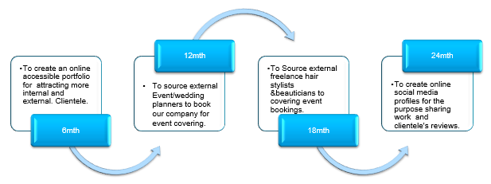
SUPPLIERS
The salons main supplier is Salon-Direct, they are a family run company which has been in the beauty products business since 1977, when they developed their e-commerce site in the early 2000’s which gave the company the exposure needed, since then the company took the title of leading supplier in the UK since 2009 holding a 4.6-star rating on feefo for its quality performance and outstanding customer service. This company also provides next day delivery as well as compatible product prices.
In case of any unforeseen circumstances the salon also has a backup, supplier which is an independent owned company called Capital Hair & Beauty operating since the early 1980’s. This supplier again offers a fantastic product range suitable to our needs, they also hold a 4.6-star rating for amazing products and customer service which makes us confident in engaging in business with them.

EMPLOYEES
Each potential candidate for the roles we are hiring for will need to be suitable to the job description with relevant qualifications for those positions.
We require a minimum LV3 NVQ or equivalent qualification for both the Hairdresser and Beauticians position as well as Receptionist, and for the Lead roles a minimum of LV4.

LV3 responsibilities for following position Hairdresser/Beautician as follows:
- To support meet and greet front of house responsibilities if reception is busy.
- To provide services booked in for your shift that day.
- To keep workstation tidy
- To be knowledgeable of health and safety hazards
- To be up to date on salons risk assessment
LV3 responsibilities for following position Receptionist as follows:
- To update our system with clients details where needed.
- To provide a meet and greet service, supplying our customers with a refreshment and magazine if any delays.
- To always keep work area presentable.
- To manage bookings and cancellations.
- To liaise with lead team members to be knowledgeable of inventory to ordering from suppliers when needed.
- To be up to date on salon risk assessment.
LV4 responsibilities for following position Lead Hairdresser/ Beautician as follows:
- To devise weekly rota for their team.
- To provide services booked in for shift that day.
- To keep workstation tidy.
- To be knowledgeable of health and safety hazards.
- To be aware and update the team on any changes on salon risk assessment.
HEALTH AND SAFETY
Our salon will comply with the relevant legislation set out by industry standards internationally which covers the following.
- Health and Safety at Work Act 1974.
- Control of Substances Hazardous to Health Regulations (COSHH) 2002.
- Cosmetic Products (Safety) Regulations 2004.
To ensure our staff are fully aware of hazards and prevention care we will provide a training manual which will show the effects of chemicals that can cause skin conditions such as contact dermatitis that in common in salon if appropriate PPI is not followed, to have a salon weekly staff meeting so the staff can communicate anything that is not understood or any issues that staff members have found.
We will complete a salon risk assessment prior to opening so we can identify any non-obvious hazards that exist within the shop like trailing wires, sufficient space between clients to offer personal space and accessibility to our staff whilst carrying out treatments, we will also provide adequate chairs or stools to ensure our staff members to prevent musculoskeletal problems from arising by providing support as mentioned above.
INSURANCE

The business has two different types of insurance policies, one which covers protection of the salon and one that provides protection for our employees and clients. Insurance is an essential when opening a business as at any time natural disasters and accidents can occur which can damage the businesses capital which effectively allows the business to keep operating. Such as many salons now are struggling with the recent pandemic, which is affecting the whole world, if you do not have appropriate cover for these kinds of disasters it can cause your business to close. The total cost for these insurances combined are £1,974.35 annually.
LICENCES

There are many permits/licences needed to protect ourselves against any lawsuit regarding copyright infringement. The company will take all necessary steps to ensure that the salon is covered fully to comply with nationally regulations set out.
Some of the licences we need would be PPL licence to allow us to play music recorded from radio, streaming platforms, or TV. Essentially music is very important in creating a suitable atmosphere that is light and bubbly. It has been proven music has this effect on its surroundings, so it is considered an essential for us.
If we intend to broadcast television then we would also need a PRS licence, not all our clients would best suit a music environment so at times music may be turned low so our clients can enjoy the comfort of television.
Extra licences and permits we have opted for are.
- Register with company house as a limited company.
- Register with the information commissioner’s office (ICO) based on GDPR regulations.
- Apply with local authority for a permit to place street sign outside the shop premises.
- To ensure we have a TV license valid for the premises.

Fazlee Zahid
7. TECHNOLOGY PLAN
Going through such a long period of lockdown through the country has led to digital breakthrough, after seeing what the outcomes were during the pandemic has shown us how organization structures have changed in such a short span of a year everything is done digitally. This change in business structure has affected service organizations the most. Due to increase fear of Covid-19 customers health and safety pressure has increased stress on the day-to-day operations. Of such type of businesses due to which increased cost and low employees are used in order to maintain the current sops used. This has paved way to a number of new methods that can help in running the business after adopting these new ways more efficiently and effectively under economy. "BEAUTY GO" beauty parlour needs to adopt such changes in order to run in the current circumstance’s the company cannot rely in the traditional methods used previously but have to operate in new methods. Due an increase in the competitive environment with similar businesses since being old to this line. Having being running these changes in their line of work already, shows that "BEAUTY GO" needs to put up with a lot of new advancements in order to cope up with this. The first step would be to used the advantage of social media in digital marketing by Instagram, Facebook and other media platforms. "BEAUTY GO" beauty parlour can even develop its own exclusive app in order to pertain its customers with the latest news. Using of a website can also help in increasing the customers by giving them a platform where they are updated regularly with latest packages and schedule feasibly for them. Giving information on the use of our organic products as our main catch could enhance the knowledge of the viewer giving us a competitive advance on our product use. The use of product on procedures can be shown by a short film which would be updated on website displaying the customers our work environment, and how we strive in keeping our customers happy by providing them with the almost comfort and reliance on our high prioritize product usage. "BEAUTY GO" beauty parlour can use the latest scheduling software to update our customer days and the number of customers we are having digitally with no fear of losing data can be directly updated by the website which would display a statistical report at the end of the month. Which would be used by the management in targeting customer requirements and to focus on where the business needs to improve. "BEAUTY GO" can also use AI technology in its beauty procedures showing how the output can be displayed on the customer. Along with this in order to handle health and safety issues which is a key drive factor for business is the use of thermal screens at the entrance showing the daily temperatures. With the additions of air purifying devices in the work place in order to cleanse the air form harmful bacteria (Bose,2018).
8. MANAGEMENT AND ORGANIZATION
"BEAUTY GO" beauty parlour is a privately owned business enterprise consisting of 5 individuals: Iliana, Augusto, Amy, Fazzle and Enamul, who are managers in "BEAUTY GO" beauty parlour that hold 85% of the total shareholding and the remaining 15% is owned by investor. The major shareholder of the company is Iliana who is the President and Administrative manager holding a shareholding of 25%. Augusto is the Marketing and Research manager holding 15% shareholding. Amy is the Procurement manager holding 15% shareholding. Fazzle is the Development and Sustainability manager holding 15% shareholding. Lastly, the Finance manager is Enamul who holds 15 % shareholding. "BEAUTY GO" is managed by individuals who were employees of salons and in the services sector. All of the managers were previously employed in Portugal, Spain, Bulgaria, Greece, Poland, France, India, Ireland and the Emirates in highly reputed salons and companies which gives them the expertise of salon business.
None of the managers have any previous experience in managing the salon but due to their previous work experience, they are well aware of what challenges could "BEAUTY GO" possibly face and how it could overcome them. "BEAUTY GO" beauty parlour having a vison of being an environmentally friendly organization with high concerns for customer health and safety have developed policies in its structure to ensure its vision is implemented. Its policies include a strict procurement policy that all products sourced must be natural and chemical free. "BEAUTY GO" is service industry which works in providing the best of services to its customers. This type of organization unlike other industries relies on its time and service quality and these factors are the most challenging part of the industry in order to maintain their standards the company must focus on the all of the characteristics which work in the industry. Once the service is done there is guarantee of it being repeated. The main focus of the managers is to maintain the standards of the organization in order to maintain a strong hold customer satisfaction to increase number of sales.

9. SOCIAL RESPONSIBILITY AND SUSTAINABILITY

The impact on the social environment would be immense due to the strict rules and regulations followed in preventing the spread of Covid-19. By basically starting with the work time and work force since being a service industry for staff work and hours employed are crucial for business success. Of both being reduced time and the number workers working in a particular place. Are to be reduced in order to maintain SOPS for the virus, another factor to look on to would be the reduce customer relation because of trying as best to keep distance and avoiding maximum engagement but being a service industry, the main key role is of public relation which drastically affected by the rapid growth of this. There will be an increase of government focus in order to maintain standards which will result in regular drills exhausting the working staff and increasing cost and paper work for the employees. One mistake in implementing could cause the business to close down plus also paying heavy fines as per law. Everything would likely be preferred to be digital this will be an extra cost for the business as it would need to train the staff in order to be up to date with the technology and methods. "BEAUTY GO" has maintain strict standards in order to create a very health cautious organization showing how much effort they are putting in order to maintain a good safe environment in their organization for the sake of their customers with increase loyalty among them. Even after the return to normal activities after the pandemic, "BEAUTY GO" will still continue to operate using standard SOPS decided by the national legislation. To ensure health and safety of our dear customers, "BEAUTY GO" will use the latest procedures such as thermal screening to detect customer temperatures and staff temperatures, automatic entry system of every staff member daily in order to give a statistical report at the end of the month ensuring that we have a Covid-19 free environment gaining customer trust. We will have modern humidifiers to keep the air clean from a dust free environment. Due to Covid19 the government has to implement many policies and health standards in order to maintain a healthy environment for the people. This had led to a number of heavy fines being charged on business who failed to obey the new laws and had put public safety at risk. "BEAUTY GO" being a service industry had to already work on the health and safety factors before and now has to work on the new standards in order to avoid heavy fines.
So that customers who abide by such rules (also the ones in support of this rule) remain their customers and understand the level of care given by the "BEAUTY GO" beauty salon. It is of immense importance for "BEAUTY GO" to keep customer care as the first thing that matters. The items that are reusable shall be thoroughly sterilized so that a certain standard is maintained. Of course, this is one of the things that is already in action by many other saloons, however they may not be as regular as the one and only "BEAUTY GO" and that to remain in the business of the leading beauty parlor with a name that people could trust. A name that people could rely on and a name like no other. This would also be promoted in marketing while portraying the right image of the company which is all about customer care and not just a beauty parlor. With people who can always rely on such a parlor, the business must go on, run smooth and be always competing with others who can not just reach the level such of "BEAUTY GO" (Vousden, n.d).
10. DEVELOPMENT, MILESTONES AND EXIT PLAN

In order for the business to keep up and running. The organization must focus on creating recognition in the market, by focusing on their mission statement. Since being a service industry, we must not forget the characteristics which make us "BEAUTY GO" stand out. To get a good start in obtaining initial profits enough to repay the loan taken for the business. The company must try to target customer requirements and do a short survey in order to obtain better knowledge the organization can focus on the areas where they need to work in order to create customer loyalty and a brand image. It must regularly be contact with its suppliers and beauticians in order to know information about the latest products and the best applicable methods in applying them. In order to reduce costs, since being a labor-intensive industry its main focus must be to see that there is less idle time and more work is being put out with a higher-grade output maintaining the quality of work at the same time as well. Once the company has created a reputable image, "BEAUTY GO" beauty salon can work on maintain the number and work on improving the numbers. The company managers can also investigate new technology uses in order to cut labor costs and improve standards by importing from other countries which have expertise in those processes. once all of these standards are set up the only thing left would be to control and implement those standards in the organization in order to create the greatest output. There are five milestones set for "BEAUTY GO" beauty salon. Mile stone 1 is that "BEAUTY GO" operates on a profitable business model that achieves the value which clients expect and deliver the value at a feasible cost. Milestone 2 is to focus on building repeat customers. Milestone 3 is to ensure the marketing costs are kept at an acceptable level that generate revenue and build goodwill. Milestone 4 is to hire the right employees who are responsible and trained to ensure no negative impact could be faced by the business and the customers are given a service of quality. Milestone 5 is to become a market leader that provides services which are unique and offer solutions which the competitors cannot. Milestone 6 is to achieve significant amount of sales that absorbs all the costs and leave enough profits for the shareholders and the business to continue as going concern.The exit strategy for "BEAUTY GO" will be when "BEAUTY GO" has a significant amount goodwill, market share, sales, achieved all its milestones and earned significant profits and is known as a market leader for its strong commitment to natural products with a large number of repeat clients. In order to decrease the competition from "BEAUTY GO", its competitors such as ‘’Tony and Guy’’ or ‘’Huda Clinic’’ could be interested to to expand their business, to become more diversified and improve their going concern status.
Enamul Ludhi
11. FINANCIAL DATA
"BEAUTY GO" salon will offer hair and beauty services for the local population in Central London. Our target market is broad. As it will be a service business, it will have minimal inventory. The business will have the principle of building customer loyalty to be self-sufficient and generate the required profit. The financial analysis of the business will be discussed mainly throughout this report.
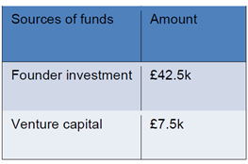
Source of Finance of the beauty salon

The business initially requires £50000 for launching its operation for the installation salon and the required furniture and settlement. It will use the balance for startup expense such as rent, fix up, legal, and marketing. As this will be a clean startup, the founder must invest a substantial amount and also have some attractive projection so that it can get the external necessary loan. With that response, the founder, five partners of the business will provide £42.5k. The rest of the amount will be collected through a bank loan or from outside investment.

Personal survival budget of the beauty salon

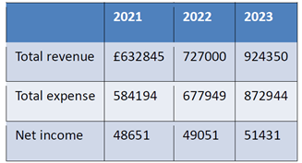
The basic of the personal survival budget is to measure whether the shop will generate more revenue than the expense for its survival. This indicates that the business must earn more than its expenditure to run the operation. For the business, it will average the monthly revenue minus all costs and expenditure of that following month. This personal survival budget is significantly important for the creditors as they can understand whether thebusiness will be able to meet the monthly startup loan. The lender will certainly expect that the business will afford the loan amount which is given to the business.
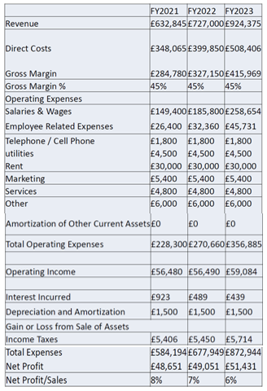
From the projected income statement it has been found that the business will achieve some net profit to pay the loan amount. This amount will be for the business after paying all sorts of expenses. Therefore, the survival budget indicates that the business will be realistic and will generate money.

This is a service business mainly it will have daily revenue and it will run the business based on cash basis. The income statement is prepared based on the projection for the next three year financial data.

Cash flow statement of the beauty salon

The cash flow statement shows the cash inflow and outflow of a business for a certain period. This statement is made at the end of the year to observe the cash flow within the time and the cash balance at the end of the year (Kausar & Lennox, 2017). It contains three parts such as cash flow from operating activities, cash flow from investing activities, and cash flow from financing activities. The project cash flow statement of the business is as follows.
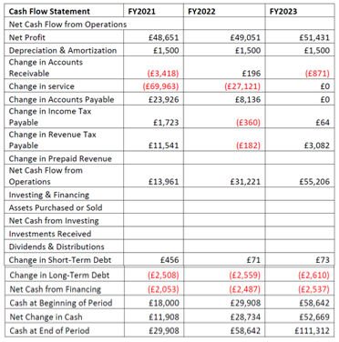

Cash flow from operation is found by considering the current cash inflow and current cash outflow. The cash flow from operation shows the net cash flow to the business by an operation such as making revenue and paying expenses. It starts with net income and then non-cash expenses are added, an increase in assets is deducted, decreases in current assets are added, an increase in current liability is added and a decrease in current assets is deducted, etc. As this is a service beauty salon, it doesn’t have any investment currently and thus this portion of the cash flow statement is blank.
Balance sheet of the beauty salon
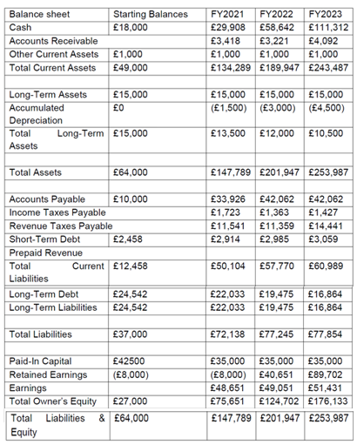
The balance sheet of the business will contain some current assets, inventory receivable in the parts of the asset, and current liability such as payable to the suppliers, rent payable, creditors, owners fund, etc. The projected balance sheet of the business has been presented above which shows the current assets and liabilities that are projected at the beginning of the business. This is an important financial statement for the lender of the business. For getting a startup loan, the balance sheet convinces the lender. Service forecast of the "BEAUTY GO" salon.
Measuring sales from services help the investor to decide whether to invest or not in that particular business. Practically, the services forecast will not be 100% accurate, but it should be close to reality as much as possible. However, the business must explain why the target of service is realistic. Beauty Go will consider some factors while making the service projections such as the period of forecast such as the number of customers to be served daily and monthly.

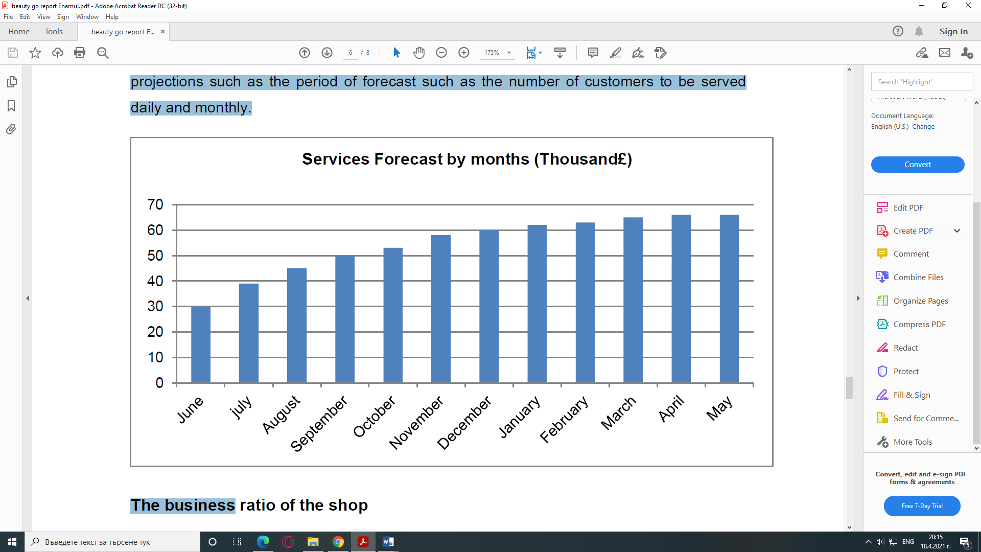
The business ratio of the "BEAUTY GO" salon
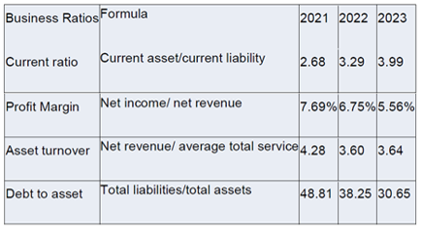
Business ratios are the indications of liquidity, profitability, solvency, efficiency, etc. of a certain business. The managers and investors can understand whether the business is achieving the target and the level of what the business is achieving by analyzing those ratios. The project ratios indicate that the business will be able to achieve the target successfully.

CONCLUSION
The beauty parlour „BEAUTY GO” is planned to become one of the competitors beauty salons in a lively area in London and to attract customers from all over the world, both locals and guests. The beauty is one of the businesses that have always been viable (Preis, 2000). This is mostly explained by the human desire and aspiration to achieve perfection and it makes the beauty sector one of the always good to work for or within (Hamermish and Biddle, 1994).
What aims the „BEAUTY GO” beauty parlour is to offer an exceptional quality hairdressing services and make-up, as well as hairdess styles of beauty on affordable quality and price to the customers. Beauty for the hair through the hairdressing services and for the face, through the make-up ones.
The project is viable and aims to offer a great experience to the ladies, gentlemen and kids once the pandemic is over. It will be a such of beauty that most of them have dreamt to during the long lockdowns. Apart from it, this is a project that will serve as a livelihood to at least fourteen people.
Finally, it can be said that the business will be able to maintain its survival and profitability as per the projected financial data. The business has to ensure quality service offering to maintain customer loyalty and satisfaction to maintain business growth (Palepu, Healy & Wright, 2014). It will have to do marketing research to know the customer demand and reduce cost as much as possible to get long-term profit maximization.

REFERENCES
- Anon (2020) Business-to-you. [Online] Available at: https://www.business-to-you.com/scanning-the-environment-pestel-analysis/ (Accessed:15 April 2021).
- Bose, T. (2018) What are the latest technologies redefining the beauty and cosmetics industry? [Online]. Available at: https://www.prescouter.com/2018/01/technologies-redefining-beauty-cosmetics-industry/ (Accessed: 8 April 2021).
- Citypopulation (2019) Citypopulation.de. [Online] Available at: https://www.citypopulation.de/en/uk/southeastengland/wards/tonbridge_and_malling/E05009588__vauxhall/ (Accessed: 12 April 2021).
- Covello, J., Hazelgren, B. (1995) Your first business plan. Naperville, IL: Sourcebooks.
- Hamermesh, D., Biddle, J. (1994) Beauty and the labor market, American Economic Review, vol.84, pp.1174- 1194, [Online]. Available at: https://www.nber.org/system/files/working_papers/w4518/w4518.pdf (Accessed: 12 March 2021).
- Lasher, W. (1994). The perfect business plan made simple. New York, NY: Doubleday Dell.
- Kausar, A., Lennox, C. (2017) Balance sheet conservatism and audit reporting conservatism. Journal of Business Finance & Accounting, 44(7-8), pp.897-924.
- Oppong, Thomas. (2018) ‘The importance of Location in Business’, [blog]. 15 March. Available at: https://www.alltopstartups.com/2018/03/15/the-importance-of-location-in-business/ (Accessed: 15 April 2021).
- Palepu, K., Healy, P., Wright, S. (2014) Business Analysis and Valuation. Melbourne: Cengage.
- Parsons, N. (2020) ‘How to use milestones to create a roadmap for your business’, [blog]. 11 June. Available at: https://www.liveplan.com/blog/milestones-as-business-roadmap/ (Accessed: 8 April 2021).
- Peiss, K. (2000) Introduction. On Beauty ... And the History of Business Enterprise & Society: The International Journal of Business History, Vol. 1, Issue 3, pp. 485-506, 2000, [Online]. Available at: https://ssrn.com/abstract=907178 (Accessed: 10 March 2021).
- Vousden, E. (n.d) What will salons and spas need to do to stay safe on reopening? [Online]. Available at:https://professionalbeauty.co.uk/site/newsdetails/beauty-salons-spas-reopening-advice (Accessed: 12 April 2021).

APPENDIX




