  Explosive Ordnance Disposal Assisstant Robot | Abstract  This report documents the research and development process that went into manufacturing a prototype EOD robot, the requirement changed during the late stages of the project, but a robot was still produced.  George Atkins (P144281)  BEng Test Range Engineering

Table of Contents
Chapter 1 – Introduction 2
Background of MOD Pendine 2
Purpose of EOD Robot 3
Aim of Project 3
Objectives 4
Chapter 2 – Research and Review of Literature 4
Existing Robot Systems 4
Dragon Runner Family 4
DR-10 5
DR-20 6
Mini 7
tEODor 7
Data Transmission Systems 9
RF control 9
Umbilical Cord 11
Control systems 12
Arduino 12
Raspberry Pi 14
PICs 14
Robot Chassis 15
Wheeled Chassis 15
Tracked Chassis 16
Cameras 18
Conclusion of Literature Review 18
Chapter 3 – Design and Implementation 19
Component Selection 19
Design 20
Requirement change 22
Brief description of gas operated weapons 23
Weapon malfunctions 24
Adaptations 25
Updated Design 25
Chapter 5 – Evaluation 26
Chassis 26
Control System 26
Camera system 28
Chapter 6 – Future Improvements & Conclusion 29
Future Improvements 29
Conclusion 29
References 29

Table 1: DR-10 Specifications (1; 2) 4
Table 2: DR-20 Specifications (1; 3) 5
Table 3: DR-Mini Specifications (4) 6
Table 4: tEODor specifications 8

Chapter 1 – Introduction

Background of MOD Pendine
MOD Pendine is a QinetiQ site operated under the Long Term Partnering Agreement (LTPA). The LTPA is a 25-year long contract between the MOD and QinetiQ to deliver test and evaluation (T&E) and training support services to the UK military. The LTPA runs until 2028, with an option of extending the contract a further 25 years. The contract is designed to be an innovative partnering arrangement, which will enable long-term planning to meet MOD’s current, evolving and future T&E needs.
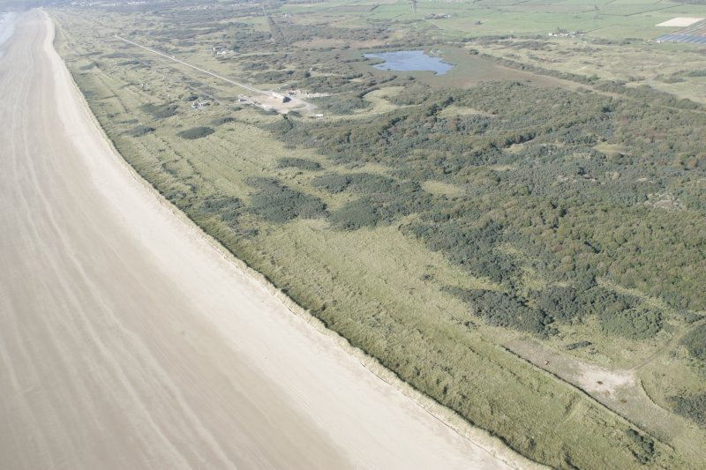
An aerial picture of MOD Pendine.
MOD Pendine is located in south west Wales. The whole site has a land area of 20.5km2 and 9km of shoreline, the site is split into three sections: west, central and east, with each section having numerous ranges on each with different capabilities. West 6 for example is a 1500m long shooting range suitable for firing a variety of calibres of weapons from 9mm pistols all the way up to .338 sniper rifles. Whereas Central 9 has the famous long test track, which is 1500m long and consists of two parallel, narrow gauge, lengths of precisely aligned railway track. Eastern Ranges are primarily used for conducting static trials on various explosive stores such as rocket motors, warheads, mines and other munitions. Eastern ranges would be the primary users of an EOD Assistant Robot as they are more likely than the other ranges to have unexploded ordnance (UXO) on the range that needs investigating.

Purpose of EOD Robot
Under current Pendine range standing orders if an explosive store fails to initiate, then a 30-minute waiting period is to be observed from the last sign of activity, smoke etc. If activity or smoke is observed, then the 30-minute wait is to recommence. After the wait has finished, the Trials Conducting Officer (TCO) alone proceeds to the explosive store and inspects it. Depending on what he finds he then determines a course of action to dispose of the explosive item, whether to attack it again with shaped charges or to use disposal by explosive demolition.

The purpose of the proposed EOD robot is to eliminate the risk to the TCO during the inspection phase of the store. There is a chance that, despite the 30-minute wait, the store could explode and wound or even kill the TCO while he’s inspecting it. Using a remote-controlled vehicle to inspect the explosive store removes the TCO from the danger entirely. If the store does detonate then it’s the robot that is at risk rather than the TCO.

Aim of Project
The overarching aim of the project is the construction and demonstration of a serviceable EOD robot that shows the capabilities to be utilised on QinetiQ Pendine ranges in the aforementioned situation. A report shall also be written which shall contain the following:

• Details of the research that has gone into the design of the robot.
• A step-by-step process of the construction of the prototype.
• Results of initial tests conducted on the prototype. (The tests shall consist of various things relevant to the job the robot will be doing, such as: speed; off road capability; camera control; etc.)
• A list of alterations made to the robot following the results of the initial tests. With reasons as to how and why the alterations have been made.
• A second phase of testing shall then be conducted. The results and alterations based on the results shall then be published. (This process of testing and then improving the robot shall be repeated until either: the robot fulfils the design criteria successfully; it is no longer cost effective to implement alterations; or there is not a suitable timeframe to bring the alterations in to effect)

Objectives
Listed below are the major objectives that must be achieved by the end of this project, in order for the project to be considered a total success:

1. To conduct research and critical analysis into existing EOD robot technologies.
2. To create reliable software for controlling the robot.
3. To design and build robust hardware for the software to operate.
4. To amalgamate the software and hardware to create a functioning EOD robot.
5. To compile a report showing the process of getting to the finished robot; from research to initial design to finished article.

Chapter 2 – Research and Review of Literature

Existing Robot Systems
This section of the report shall cover the research and review of the literature surrounding the EOD robot systems that already exist in the world, namely: the “Dragon Runner” family of robots and “tEODor”
Research shall also be conducted into various methods that exist to control the robots: RF, Umbilical cords and optical control are some examples of control methods. This section of the report shall also consider what chips/computers exist that could be mounted on the robot to perform the actual control of the robot. Potential systems include: Raspberry Pi; Aurdino Boards; and even simple PICs.

Dragon Runner Family
This section of the report conducts a literature review into the family of dragon runner robots that are manufactured by QinetiQ North-America (QNA). QNA is a technology company that conducts engineering research and development and delivers products to the defence, security and consumer markets. The research that this document focuses on is the unmanned systems that QNA has developed called “Dragon Runners”.
The family of Dragon Runner Robots are designed to provide support to military forces, the easily transportable robots enable the operators to carry them into some of the most hostile environments and hazardous terrain around the globe. The Dragon Runners were the first ever small robot to be deployed by the United States Marine Corps (USMC) in Iraq in 2003, and have since been deployed to the mountains of Afghanistan to locate, identify and attack enemy improvised explosive devices (IEDs). They are not solely used by the military though, as several security forces and counter-terrorism units around the world also use the robots to disrupt bombs and IEDs in urban areas. (1)
The fact that these Dragon runners are so popular with the USMC, other military forces and bomb squads, show that they are dependable, rugged robots that will provide an insight into what makes a successful EOD assistant robot. The three robots that shall be researched are the Dragon Runner 10 (DR-10), Dragon Runner 20 (DR-20) and the Dragon Runner Mini.

DR-10
The Dragon Runner 10 (DR-10) is a lightweight robot designed and manufactured by QinetiQ North America. The unmanned ground robot is designed to provide situational awareness to military fireteams by ‘scouting out’ an area whilst the operator remains at a safe distance. (2)
When ﬁtted with the Light Weight Modular Arm, the DR-10 has the ability to investigate and recover or neutralize a potential IED. This lightweight arm weighs only seven pounds and requires no tools to quickly install to the vehicle. (1)
Table 1: DR-10 Specifications (1; 2)
Size | 15 x 13 x 6 inches (38.1 x 33.02 x 15.24 centimetres) l x w x h
Weight | 10lbs (4.5kg)
Speed | 4mph (6.44kph)
Endurance | 2-3 hours, mission dependant
RF Range | 650+m (2100ft) Line of sight
Acoustics | On-board microphone
Environmental | IP 66 rated (hose down, drive through puddles)
Cameras | Front and rear (day and night capable)
Controller | Compatible with lightweight radio unit and Gen 2.5 hand controller
Payloads | Sensors, manipulator arms, cameras, etc.
Max arm lift | 4.4lbs (2kg)
Other | Throwable and invertible, climbs stairs, adding payloads eliminates throwability
Image of DR-10
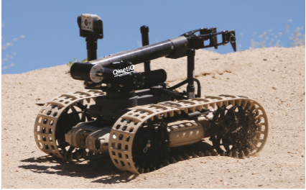
Whilst QinetiQ Pendine wouldn’t be using an EOD robot in a warzone, the DR-10 has many features which would be useful to incorporate into the EOD robot that I aim to build. The features that would be useful to emulate are: the easily installable arm; the two cameras; the good RF range and endurance. The weight of the robot is a secondary concern due to the fact that the robot isn’t going to be carried over great distances. There is no need for my design of robot to be able to climb stairs or any need for it to be thrown, these features are of no importance in the environment in which my robot shall be used.

DR-20
The Dragon Runner 20 (DR-20) is the DR-10’s big brother, whilst the applications of the DR-20 are similar to the DR-10, the DR-20 is capable of more. Both robots are used for providing situational awareness to dismounted military patrols and as EOD assistants, the DR-20 lends itself more towards the inspection and disposal of unexploded ordnance (UXO) and IEDs than the DR-10.
Dragon Runner 20 is small enough to be hand-carried yet capable of lifting up to 10 pounds. The robot features a robotic arm with a rotating shoulder, wrist and grippers for impressive dexterity. Reconnaissance and surveillance options for the robot include day night cameras, pan/tilt zoom cameras and a microphone for listening capability. (3)
The main feature of the DR-20 is its manipulator arm which is equipped with a rotating shoulder, wrist and grippers for dexterity and as previously mentioned, is capable of lifting up to 10lbs (4.5kg). This makes the DR-20 ideally suited for placing charges onto the surface of UXO.
Table 2: DR-20 Specifications (1; 3)
Size | 20 x 15 x 7 inches (50.8 x 38.1 x 17.78 centimetres) l x w x h
Weight | 20lbs (9.07kg)
Speed | 4mph (6.44kph)
Endurance | 3-4 hours, mission dependant
RF Range | 650+m (2100ft) Line of sight
Acoustics | Two way audio (as payload)
Environmental | IP 65 rated (hose down, drive through puddles)
Cameras | Front and rear (day and night capable); left and right (day only); quad video display
Controller | Compatible with all existing QinetiQ controllers
Payloads | Sensors, manipulator arms, cameras, two way audio, etc.
Max arm lift | 10lbs (4.5kg)
Other | Highly modular mobility options, climbs stairs
Image of DR-20
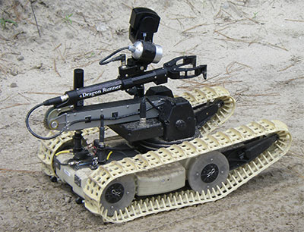
The manipulator arm which is capable of lifting 4.5kg for positioning charges on UXO whilst leaving the EOD operator at a safe distance is essential for my robot and I aim to create something equally as capable. The DR-20’s pan/tilt and zoom camera would be more useful than the fixed one that is on the DR-10 and having that capability on my robot would make the robot better at its job of providing the EOD operator with awareness of the state of any UXO.

Mini
The latest edition to QNA’s dragon runner range is the dragon runner mini (DR-Mini). It is the smallest and lightest unmanned ground robot weighing less than three pounds. Like the other systems, the DR-Mini is used for reconnaissance and security operations to assist military, first responders and law enforcement personnel with security and emergency operations. (4)
Table 3: DR-Mini Specifications (4)
Size | See Below
Weight | Less than 3lbs (1.36kg)
Speed | Unknown (presuming to be similar to DR-10)
Endurance | 1 hour continuous driving, 4 hour intermittent driving
RF Range | Through 4 interior walls or 200m line of sight
Acoustics | Integrated 2-way radio
Environmental | Unknown
Cameras | 1 hi-definition camera; IR video and lighting for stealth night vision with auto IR activation in low-light conditions; low latency
Controller | Android Tablet
Payloads | N/A
Max arm lift | N/A
Other | Excellent mobility through sand, gravel, grass, can climb 4” curbs  Throwable: 20 feet high through a 30 foot distance
Image of DR-Mini next to a mug for size comparison
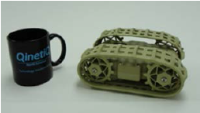
The Dr-Minis small size and ruggedness are good qualities for an observational tool, as it can navigate small spaces. The ability to control the robot through walls is also essential because on trial sites there are often blast walls and other obstacles that may prevent the user from having line of sight to the vehicle. The lack of an arm on the robot limits its usefulness as an EOD aid, but it would still be a useful tool in the operator’s arsenal to provide high definition images of a device prior to the operator approaching.

tEODor
tEODor is an EOD robot designed and manufactured by TELEROB, a German engineering firm based just outside of Stuttgart. Their company philosophy is “Whether the task at hand is disarming an improvised explosive device with a remote controlled robot, investigating NBC hazards with an unmanned sensor platform, or deploying mobile, fully networked measurement, monitoring and intervention systems to ensure the safety and security of critical infrastructure, our top priority is always the protection of people and their surroundings.” (5) The tEODor is the main robot that they ship to 45 countries, 20 of which are NATO members. But there are other, smaller robots that they sell, called the telemax family. All the robots manufactured by TELEROB shall be reviewed in this section of the report.
Image of tEODor
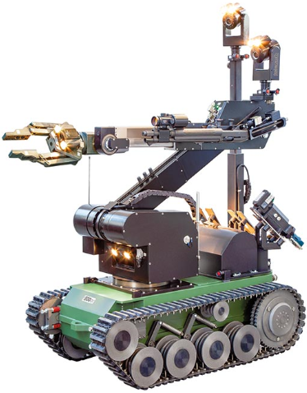
The telerob Explosive Ordnance Disposal and observation robot (tEODor) has the following ‘highlights’:
- Programmable 6-axis manipulator with linear axis
- Magazine for three additional EOD devices, with automatic and tool change
- Universal interfaces to connect to all current firing systems
- Built-in diagnostic system
- long list of accessories (more than 40 systems and devices)
- can be used under all ambient conditions from -20°C to + 60°C
- Strong manipulator arm lifts up to 100 kg
- CBRN sensors available (6)
Table 4: tEODor specifications
Size | The robot has a length of 1.3m, width of 0.65m and a height of 1.24m (7)
Weight | 375kg (7)
Speed | Unknown
Endurance | Unknown
RF Range | 200m fibre optic cable, unknown radio range (6)
Acoustics | Integrated 2-way radio
Environmental | Unknown
Cameras | The basic version the vision system consists of two drive cameras plus one overview camera and one gripper camera. Stereo, night vision or infrared cameras are available as options
Controller | Bespoke control centre
Payloads | N/A
Max arm lift | N/A
Other | Many optional accessories
Image of tEODor next to a man for size comparison
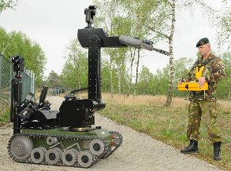
The strength of the manipulator arm is a bit excessive for what QinetiQ Pendine would need, as is the magazine for additional EOD devices, only one should be needed for each task. The amount of cameras mounted on tEODor to provide multiple views of a suspect item would be a trait to incorporate into the robot needed at Pendine, because the more views of a piece of UXO the operator can see, the better. The pan tilt and zoom capabilities of the cameras mounted on tEODor are obvious, something that the dragon runners don’t have is the height of the cameras on tEODor. This could be a double edged sword, because the extra height could enable a clearer, unobstructed view of UXO over something. But equally the extra height could mean that the operator couldn’t get a very close up image of something of interest. There are some concepts in the tEODor that wouldn’t be needed, the size of the tEODor for example, is much larger than anything that would be practical for QinetiQ Pendine.

Data Transmission Systems
Data transmission is the process of transferring data or information from one point to another, in this case this means from the controller of the EOD robot to the actual EOD robot. Getting the commands from the input device to the robot without compromising the quality of the transmission is paramount. It would not be good if the robot received incomplete or even wrong commands from the controller, the last thing you want is a haywire machine trundling about near explosives.

RF control
All the robots mentioned previously in this document are remotely controlled using radio controllers. Radio control operates on the principal of the transmitter sending a command signal on a certain frequency (x) to the receiver on the robot in the form of a radio wave. The receiver is constantly monitoring frequency x for a signal, when the signal is received it is passed through a filter which blocks out any frequencies other than frequency x. The signal that is left over is then converted into electrical pulses. These electrical pulses then go through the circuit on the device to be controlled, the chip on the circuit board is programmed to know what the electrical pulses mean and what it must do, for example there could be 12 pulses which the chip translates into powering a motor. In this way, different numbers of pulses can be used to make the device do different things, as long as the chip is programmed to know what different pulse combinations mean.
This system would be good to use for an EOD robot as the operator could remain well in cover whilst sending the robot out to inspect munitions. Another benefit would be that there is quite a long range on some RF controllers, again distancing the operator from any potential harm.
Unfortunately, an RF solution is not viable to be used at MOD Pendine due to governance from our resident expert on Ordnance Munitions and Explosives. A lot of work carried out at Pendine uses exposed Electro Explosive Devices (EED’s) such as detonators and electrically initiated rounds, these devices are extremely sensitive to radio waves, especially detonators. The problem is that the leads of a detonator can act as an antenna for radio waves, if this happens then a current may be induced in the wires which would result in the detonator initiating. The rules on site are very stringent, for example mobile phones must be looked away and turned off if detonators or electrically initiated rounds are being used on range; and the on-site radios must be kept a minimum of 15 metres away from any exposed EEDS’s in order to eliminate the risk of accidental initiation. Therefore, it would be unacceptable to use an RF controlled machine on the range as the signals from the transmitter may initiate the explosives that the robot must inspect. In time, it may be possible to get dispensation to use certain frequencies on site, but at the time of writing, an RF controlled robot is unviable.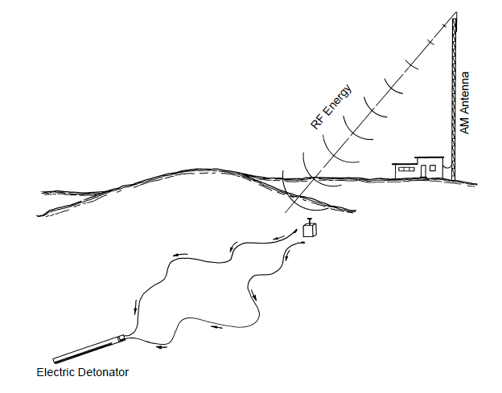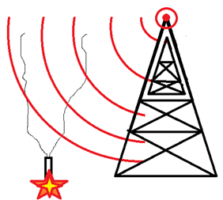
Optical Control
Optical control is another wireless method of control, but instead of radio waves, Infrared (IR) radiation is used to transmit data, it is known as ‘IR wireless’ in the workplace. IR wireless is the use of wireless technology in devices or systems that convey data through infrared (IR) radiation. (8) IR wireless can be used for short and medium range data transfer which should be sufficient for the EOD robots purpose. There are two types of IR wireless control, line-of-sight and diffuse or scatter. Line-of-sight means that there must be an unobstructed view between the transmitter and the receiver so that the IR light can pass from one to the other unimpeded. The other method called diffuse or scatter can operate even if there isn’t direct line-of-sight between transmitter and receiver.
Most IR wireless systems operate in a similar way, for ease of explanation a television remote shall be used as an example. When a button is pressed on the remote, the IR LED in the end of the remote flashes many times in a second, this is called pulse modulation. In the graph below, each spike represents the LED emitting IR light.
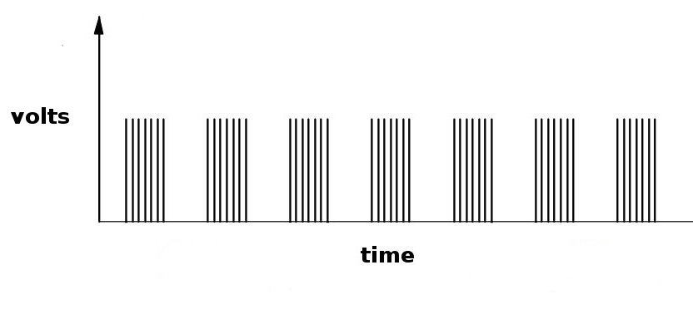
The receiver sees these pulses of IR light, demodulates, and then interprets them as a command, each different button would have a different, unique, pulse modulation. These pulse modulations would be different commands. The graph below shows how the receiver demodulates and then interprets the pulses.

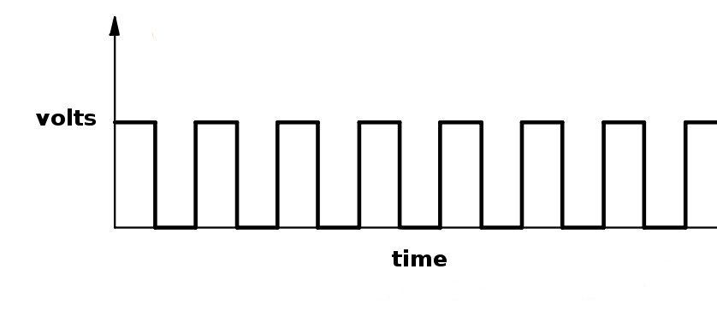 (9)
An advantage of IR wireless control is that it is harder to hijack and eavesdrop on IR control than it is for RF control. A disadvantage, is that IR wireless control, unlike RF wireless links, IR wireless cannot pass through walls. (10) This presents a problem, as walls are often built around munitions under test in order to mitigate blast effects.

Umbilical Cord
The umbilical cord method removes the need for transmitting signals via radio waves as all the command signals are sent down a length of cable directly into the robot. The transmitting still sends encoded command signals and the receiver still gets these signals, decodes them, and then acts upon them. A lot of children’s remote controlled toys use the umbilical cord system, such as a remote-control car attached to a simple controller by a short length of cable.
An EOD robot is slightly more complex than a children’s toy however, needing more inputs and outputs than forward/backward and left/right. The drawbacks that may come about because of having an umbilical cord are as follows: -
• The robot may end up running over its own cable and damaging it.
• The cable could twist whist unravelling.
• The weight of the cable may hamper the mobility and or speed of the robot.
There are several advantages though: -
• There is no chance of exposed EED initiation using an umbilical cord.
• If for whatever reason the robot gets stranded, it can be retrieved by pulling it back by using the umbilical cord as a rope.
• If the cable ever got damaged it would be simpler to repair/replace than an RF transmitter and receiver.
• The camera mounted on the robot can send images to a monitor back along the umbilical cord, giving a ‘live’ view of what the robot is seeing.
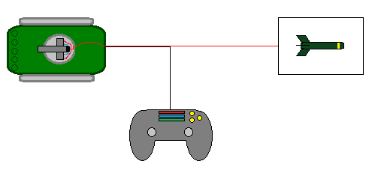

Control systems
The actual control system is an integral part of the project because, as the name implies, it controls everything that happens within the machine, bring all the components together so that they function as a whole, rather than several components bolted together. There are several options for controlling the machine. There are several existing platforms that can be purchased as a unit, which must then be programmed to carry out the desired function, this report focuses on just two of them; ‘Arduino’ boards and the ‘Raspberry Pi’. Another method of controlling the machine is to use a PIC, which are widely available in most electrical shops.

Arduino
According to the Arduino website “Arduino is an open-source electronics platform based on easy-to-use hardware and software. Arduino boards are able to read inputs - light on a sensor, a finger on a button, or a Twitter message - and turn it into an output - activating a motor, turning on an LED, publishing something online. You can tell your board what to do by sending a set of instructions to the microcontroller on the board. To do so you use the Arduino programming language (based on Wiring), and the Arduino Software (IDE), based on Processing.” (11)
As mentioned above, the Arduino uses its own language for programming it, which I would have to learn and become confident to use in order to create the code that would be required to make the EOD robot function in the desired fashion.
Arduino systems are relatively inexpensive in comparison to other microcontrollers on the market, the cheapest one available on the internet store was €20 or £16.74 (correct at the time of writing) which is the “Arduino UNO Rev 3”. This board also has the benefit of being “the most used and documented board of the whole Arduino family.” (12)
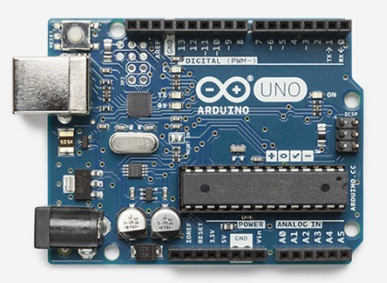
The specifications of this Arduino board are below:
Microcontroller | ATmega328P
Operating Voltage | 5V
Input Voltage (recommended) | 7-12V
Input Voltage (limit) | 6-20V
Digital I/O Pins | 14 (of which 6 provide PWM output)
PWM Digital I/O Pins | 6
Analog Input Pins | 6
DC Current per I/O Pin | 20 mA
DC Current for 3.3V Pin | 50 mA
Flash Memory | 32 KB (ATmega328P) of which 0.5 KB used by bootloader
SRAM | 2 KB (ATmega328P)
EEPROM | 1 KB (ATmega328P)
Clock Speed | 16 MHz
LED_BUILTIN | 13
Length | 68.6 mm
Width | 53.4 mm
Weight | 25 g

Raspberry Pi
The Raspberry Pi is a Credit card sized computer that costs around £25 (13)
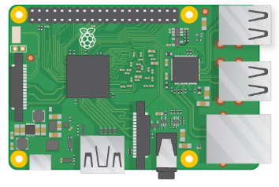
The Raspberry Pi 3 is the third generation Raspberry Pi. It replaced the Raspberry Pi 2 Model B in February 2016. Compared to the Raspberry Pi 2 it has:
- A 1.2GHz 64-bit quad-core ARMv8 CPU
- 802.11n Wireless LAN
- Bluetooth 4.1
- Bluetooth Low Energy (BLE)
Like the Pi 2, it also has:
- 4 USB ports
- 40 GPIO pins
- Full HDMI port
- Ethernet port
- Combined 3.5mm audio jack and composite video
- Camera interface (CSI)
- Display interface (DSI)
- Micro SD card slot (now push-pull rather than push-push)
- VideoCore IV 3D graphics core
- The Raspberry Pi 3 has an identical form factor to the previous Pi 2 (and Pi 1 Model B+) and has complete compatibility with Raspberry Pi 1 and 2. (14)

PICs
Tech target provides the following definition for a PIC
“PIC microcontrollers are a family of specialized microcontroller chips produced by Microchip Technology in Chandler, Arizona. The acronym PIC stands for "peripheral interface controller," although that term is rarely used nowadays. A microcontroller is a compact microcomputer designed to govern the operation of embedded systems in motor vehicles, robots, office machines, medical devices, mobile radios, vending machines, home appliances, and various other devices. A typical microcontroller includes a processor, memory, and peripherals.” (15)

Robot Chassis
These following chassis types shall be used as a source of inspiration for creating a bespoke chassis that is most suitable for an EOD robot. If constructing a bespoke chassis is unfeasible then one of these existing chassis could be purchased and used instead. All of these chassis were found on the robotshop’s website www.robotshop./uk.
Either a wheeled or tracked system shall be used on the robot. Choosing the best system depends on several factors including: the traction; ground pressure; suspension; and steering.
The traction is greater if tracks are used instead of wheels, but this depends on the terrain that the robot shall be traversing. Tracks have a lower ground pressure than wheels and are more suited to soft surfaces. Larger tires on wheels could be used to have the same effect but this has limitations and will not be suitable for all conditions – for example on snow.
Building suspension for a tracked robot is more complicated than for a wheeled robot. The suspension system has an important role related to traction as it is responsible for keeping the wheels/tracks in contact with the ground. The wheels have a significant advantage in steering compared to tracks. However, a tracked vehicle will be able to turn on the spot (one track backward and the other forward). (16) The advantages and disadvantages of each system shall be detailed in the respective sections.

Wheeled Chassis
Advantages | Disadvantages
Low production costs | Higher ground pressure than tracks
High speed compared to tracks | Less suitable for difficult terrain
Greater manoeuvrability than tracks
Lightweight
Simple to replace a wheel if it becomes damaged

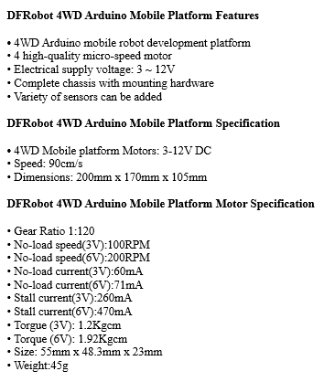
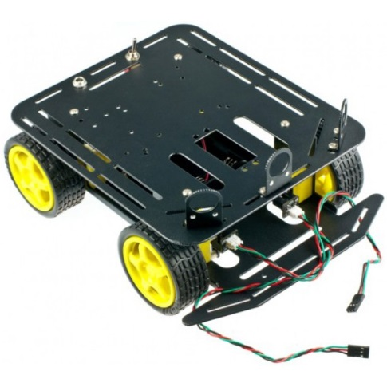
This is the ‘DFRobot 4WD Arduino-Compatible Platform’. It has a strong obstacle and climbing ability with high strength aluminium alloy body. It features thick acrylic material to eliminate the heavy, fragile thin acrylic material defects. It has powerful motor performance, flexible and rapid movement and is especially suitable for outdoor grass, gravel, sand, or slope pavement. It has a top speed of 68cm/s and only requires 4.5-6 volts to power. (17) (18)
These features make this chassis an attractive option, the Arduino compatibility is a big bonus as the chassis is designed to work off one of the control mechanisms previously discussed. Also the robot seems suitable for the test range environment, with its ability to traverse a wide range of terrain and even slopes.

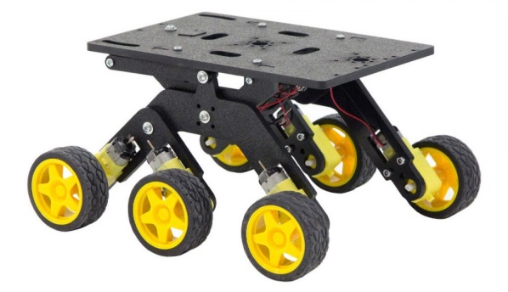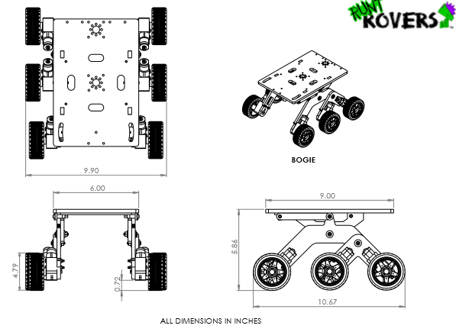
This 6-wheeled chassis is the ‘Bogie Runt Rover’ it is designed with rocker-bogie suspension making it great for climbing over tough obstacles. It has got nearly 5” of ground clearance and 5”. Powerful gearmotors driving six high-traction rubber tires gives the bogie amazing climbing capabilities. Modifying the Bogie is simple as any component in the actobotics product line can be effortlessly attached. This kit can be powered with either a 6.0 - 7.4V battery pack or re-chargeable batteries. (19)
The high ground clearance and ability to operate on rough terrain would be very useful, the ground clearance giving the camera a high vantage point and also enabling the robot to get over debris that may be in the trial site.

Tracked Chassis
Advantages | Disadvantages
High power efficiency | Complex to repair/replace a faulty track
High traction | Low manoeuvrability
Low ground pressure | Slower than a wheeled vehicle
Suitable for rough terrain
On-the-spot turning

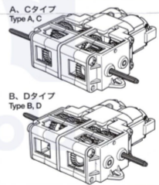
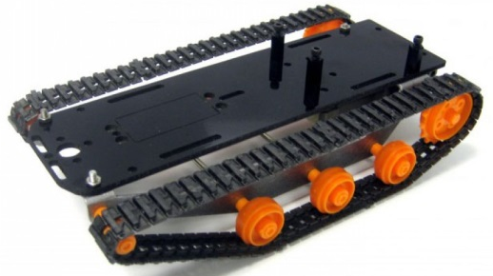
This tracked vehicle is the DFRobotShop Rover Chassis Kit is based on the popular DFRobotShop Rover but does not include any electronics. Instead of a fully-integrated PCB with Arduino, there is a durable black Lexan plate with mounting holes for an Arduino Uno, Arduino MEGA or Raspberry Pi. Hex standoffs and hardware to mount any of these three microcontrollers are included. There is an optional cut-out for a standard sized HItec servo motor (HS-322, HS-422 etc). The SES mounting pattern is retained at the front. A 4xAA battery pack can be mounted to the underside of the rover to provide power. (20) A gearbox is included in the kit to drive the tracks.
This tracked chassis dimensions are 202mm x 106mm x 50mm, this gives a lot of room for the mounting of various components such as the camera and associated ancillaries.
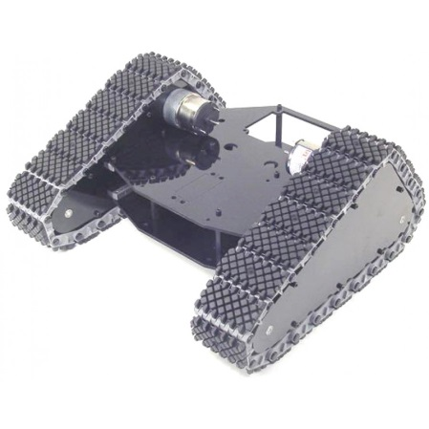
The above chassis is a Lynxmotion Tri-Track Chassis Kit and it is a robust Tracked Development Platform. The robot is designed for indoor or outdoor use and performs well on many different surfaces. With the addition of the optional Base Rotate a robot arm or large sensor array can be added. The chassis is designed to accept the Lynxmotion Mini Atom Bot Board V2 and/or the Lynxmotion SSC-32 Servo Controller. The robot is capable of carrying up to a 5lb payload. (21) The kit includes two 12VDC 120RPM 15oz-in GHM-02 Spur Gear Head Motors which are designed to propel the chassis.
Chassis Type | Cost | Motors Included? | Features
DFRobot 4WD Arduino-Compatible Platform | £46.42 | 4 x Micro gear motors | -Arduino compatible
Bogie Runt Rover | £65.10 | 6 x Pre wired motors | -5” ground clearance  -Simple to modify
DFRobotShop Rover Chassis Kit | £36.67 | Tamiya twin motor gear box kit | -Mountings for Arduino and Raspberry Pi  - Cut-out for a standard sized HItec servo motor to replace existing motor
Lynxmotion Tri-Track Chassis Kit | £205.52 | 2 x 12VDC 120RPM 15oz-in GHM-02 Spur Gear Head Motor | -Base rotate system easily added for sensor array  -Can carry a 5lb payload

Cameras
There are hundreds, if not, thousands of cameras that may be suitable for utilisation on this EOD robot, from full kits with built in pan, tilt and zoom functions (the kind of CCTV camera found on the ceilings of supermarkets) to little pen cameras that would need to have a system built to enable them to be operated remotely. One example of camera that may be used is the Lorex 720p HD Weatherproof Bullet CCTV Camera. It has the following features:
• 720p HD resolution camera with powerful night vision up to 40m
• Wide viewing angle of 55 degrees to monitor paths, entrances or gardens
• IP66 weather resistance for indoor and outdoor use
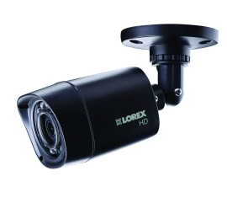

Conclusion of Literature Review
There are a lot of existing designs for EOD robots already out on the market, many of them built and sold by QinetiQ, which begs the question: “why hasn’t Pendine got one for free?” but that’s for a different time.
The features that this robot hopes to emulate from the existing ones are as follows
- To be able to traverse rugged terrain with ease
- To be able to operate remotely, keeping the operator from harm
- To provide video directly back to the operator
The robot does not need to have robotic arms, or be as large as some of the models shown. The author believes that the dragon runner 10 is a suitable size to aim for. All the existing robots that were researched are tracked vehicles, so that seems to be the best way forward for this robot too.
However, all of the researched robots are controlled by radio, which is unfeasible for use at Pendine due to on-site regulations limiting the use of radios around exposed EEDs. As such, the only two methods which are suitable are the optical control method and the umbilical method.

Chapter 3 – Design and Implementation

Component Selection
This section of the report covers which components from the list above would be first choice for use in the EOD robot.
For the chassis the ’DFRobotShop Rover Chassis Kit’ would be most suitable for the requirements as it is the cheapest suitable chassis at just £36.67. It is also capable of holding a variety of control systems, has a large amount of space on top of the vehicle for mounting both the circuitry and the camera system. It is a tracked vehicle, apparently capable of traversing rough terrain that may be encountered in the test range environment. Another bonus is that the kit comes complete with two motors that are designed to operate on the tracked chassis, the specifications of the motor is shown below:
• Gear Ratios: 58:1 207:1
• Motor: FA-130
• Motor RPM: 12300 (9710 Maximum Efficiency)
• Motor Voltage: 1.5-3V (1.5V Recommended)
• Motor Stall Current: 2.1A
• Free-run current: 150mA
• Motor Stall torque: 36 g-cm (22)
To control the machine a system of PICs shall be used. One PIC shall be used to encode and transmit information from the controller end and another PIC shall receive this information, decode it, then carry out the instruction. PICs shall be used over the other systems (Arduino and Raspberry Pi) due to the fact that the author is not familiar with the coding language needed to right programmes on either of the alternatives, but he has, however, had limited and basic training in the use of Proteus software to design circuitry and create code to programme the PIC to do what he wants. Another reason for the choice of PIC over the others is the cost and the simplicity, PICs cost pence for many of them, whereas an Arduino or Raspberry Pi can set you back up to £25. It will also be far quicker to replace a PIC with the same code than it would be to replace/recode the other systems. It is these factors that has meant that the author has chosen to utilize the PIC has in favour of the more sophisticated options of Arduino and Raspberry Pi.
The method of transferring data from the controller to the EOD robot shall be to use the umbilical cord method. This is because, as previously mentioned in this document, radio control is not a viable method of controlling a robot designed to approach UXO on a QinetiQ site. Robots in the field that use radio control have got lots of specialist electronic counter-measures which are kept secret (for obvious reasons) and as the author does not have access to these counter-measures, radio control is not suitable. Optical control would not be suitable either as it requires an uninterrupted line of site to the robot to be effective, and this is not always going to be obtainable in the case of range usage.

Design
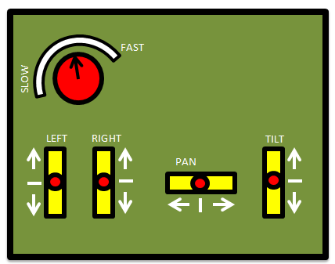
A bespoke built control system shall be utilised, a PIC programmed on Proteus (PIC16F616) shall provide both the transmitting and receiving control systems of the circuitry. Code shall be written in the Proteus software which tells the components what to do. The inputs to the transmitting circuits shall be four pots: one for forward and backwards movement of the vehicle; one for turning the vehicle left and right; one for panning the camera left and right and the last one shall be used for tilting the camera up and down. 4 buttons shall also be on the controller which shall be used to switch on various appliances like laser pointers and lights. There shall be a variable resistor in the controller to restrict the voltage which in turn shall alter the speed of the vehicle so that slow precise movements can be made to either the vehicle or the camera.

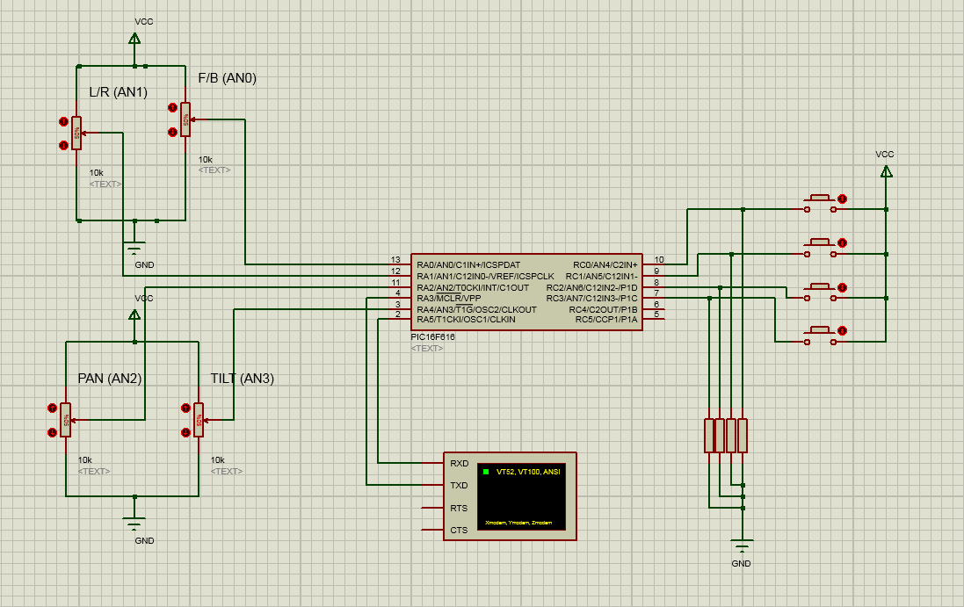
This circuit layout shows the transmitting circuit. The button inputs are highlighted in red, the PIC in blue and the POT inputs in yellow.

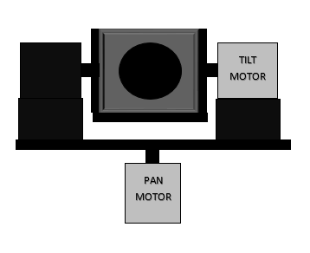
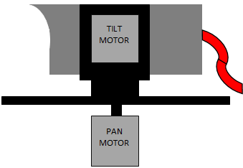
These images show how the camera shall be mounted onto the vehicle and how the camera shall be panned and tilted by a purpose-built rig of motors.
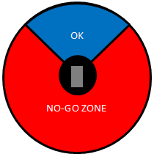
A method of preventing the pan motor from spinning all the way round and therefore tangling the cable shall have to be designed. A 90° range of movement should be sufficient, especially considering the cameras wide field of view.
The camera may also have to sit higher above the pan motor so that it can tilt further back, again a method of preventing the camera tilting too far back shall have to be designed.

Requirement change
After reaching this point in the project, an incident occurred at Pendine that meant that investigating UXO became a secondary concern, and investing weapon malfunctions of small arms and cannons became a top priority.
During a trial, a weapon suffered a misfire, a member of the visiting dignitaries went to the weapon to ascertain what had gone wrong. When attempting to determine the cause of the misfire the round was initiated resulting in a detonation of the round with a half open breech. Luckily the visitor was okay and only suffered a terrible fright! Following an investigation into the incident, it was deemed that if a means of checking weapons malfunctions without exposing people to the dangers just covered, then it should be exploited. Since misfires of small arms and cannons are comparatively more common than unexploded bombs on the site it was decided that a method of checking misfires is more important than the development of an EOD robot in the short term. As such this project is to be repurposed to check malfunctions of small arms and cannon weaponry.

Brief description of gas operated weapons
A brief description shall be given of the most common type of operation of rifles in use today, this is to help the reader better understand circumstances surrounding a misfire.
- Gas Port
- Piston Head
- Rod
- Bolt
- Bolt carrier
- Spring
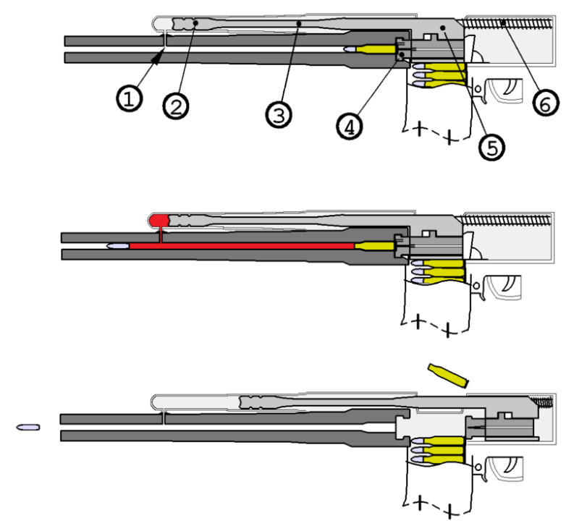
When the round is fired, the propellant in the cartridge case is ignited, producing high pressure gases which force the bullet along the barrel at high velocities. These gases follow the bullet up the barrel and when they reach the gas port (labelled 1) some of the gases are diverted into it. The gases push on the piston head (labelled 2) forcing the rod (labelled 3) rearwards. The rod is connected to the bolt carrier (labelled 5) which is also forced rearwards, the bolt carrier, as the name implies, catches on the bolt (labelled 4) and carries that rearwards. When the working parts are fully to the rear then the spent cartridge case is ejected from the breech and the gases have expended all of their energy. All while this has been going on the spring (labelled 6) has been compressed by the rearwards motion of the working parts, following case ejection the springs’ stored compression energy forces the bolt carrier, and therefore the bolt, forward. The bolt strips another round from the magazine on its way forward and locks into the chamber. Once all the working parts are forward the weapon is ready to fire and the cycle can be repeated until the trigger is released or ammunition is expended.
The above example was for a long-stroke piston method of operation, found in the now infamous AK-47 assault rifle but the principle remains the same for short-stroke piston and direct impingement operated weapon systems.
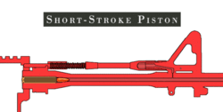
With a short-stroke system, the piston moves separately from the bolt group. It may directly push the bolt group parts as in the M1 carbine or operate through a connecting rod or assembly as in the Armalite AR-18. In either case, the energy is imparted in a short, abrupt push and the motion of the gas piston is then arrested allowing the bolt carrier assembly to continue through the operating cycle through kinetic energy. (23)

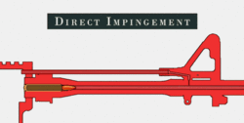
Unlike conventional gas-operated firearms, direct impingement does away with a separate gas cylinder, piston, and operating rod assembly. High-pressure gas acts directly upon the bolt and carrier. (24)

Most weapons that undergo testing at Pendine tend to use the short-stroke piston as the gas operation method, as this is the method often employed in the rifle of NATO affiliated countries. Only a handful of weapons use the other two methods and are quite rare on the test range.

Weapon malfunctions
A weapon malfunction is the failure of a firearm to operate as intended for causes other than user error. Malfunctions range from temporary and relatively safe situations, such as a casing that didn't eject, to potentially dangerous occurrences that may permanently damage the gun and cause injury or death. Improper handling of certain types of malfunctions can be very dangerous. (25)
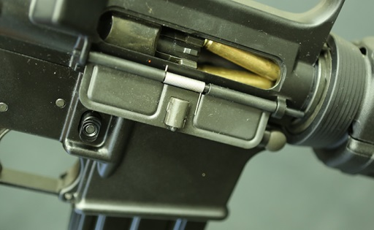
A double feed happens when a round is already in the chamber and the bolt strips another round from the magazine and attempts to feed that into the chamber as well, resulting in two rounds being mashed together in the chamber. The first round can be expended or live, the situation is more dangerous if the first round is live as the second round being forced into the chamber could cause the first round to initiate. If the first round is an empty case, then it’s less dangerous and is just a fiddly job to extract both the case and the live round.
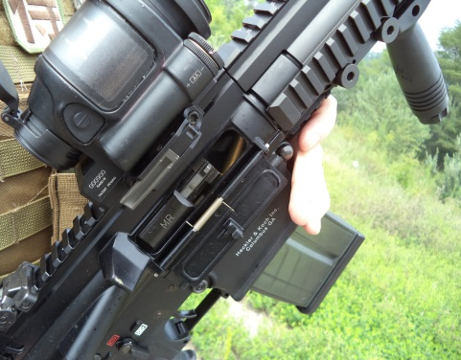
A failure to feed a round into the chamber usually occurs when the bolt doesn’t return fully to the rear during the cycle of operations, this can result in the nose of the round getting into the chamber whilst the rest of the round is in the magazine as it is pinned by the bolt that hasn’t gone all the way back (see picture). A failure to feed can be quite serious as attempts to either free the round or to make it sit in the chamber correctly can cause the working parts to slam forward and initiate the round unintentionally.
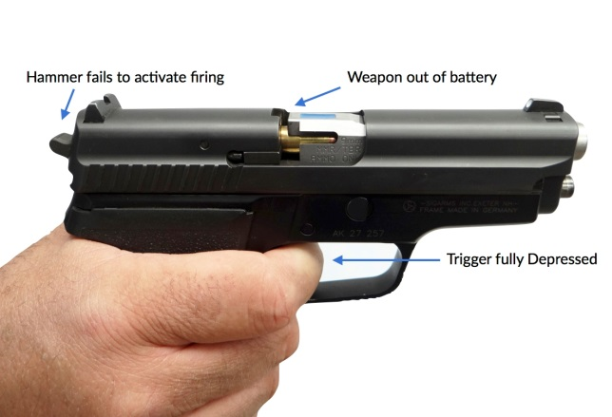
A firearm is in-battery when the slide/bolt is in the normal firing position. A firearm is out-of-battery when the slide/bolt is not fully seated in the normal firing position, typically because it did not cycle fully after firing. This is similar to a failure to feed in the sense that the weapon hasn’t cycled properly, but a round is seated in the chamber, but the working parts aren’t fully forwards.

Adaptations
As a result of the change in requirement, adaptations can be made to the operation of the robot. The major one is that the robot can now be radio controlled, as the majority of the ammunition fired at Pendine is percussion fired. This means that there is no danger of the radio waves inducing a voltage into the ammunition and inadvertently initiating it. On jobs where the rounds are electrically initiated then the robot shall not be fit for purpose, but these occasions are few and far between.
The rest of the robot can remain the same; the existing control system of two PICs can still be used, as can the chassis and the camera. The only difference will be that instead of the data being sent along an umbilical cable to the robot, information shall instead be transmitted via the use of radio waves.

Updated Design
The images below show the prototype vehicle that was constructed to show the thought process and very basic concept of the vehicle. This was built on an extremely limited budget hence the poor quality of products used to build said prototype.
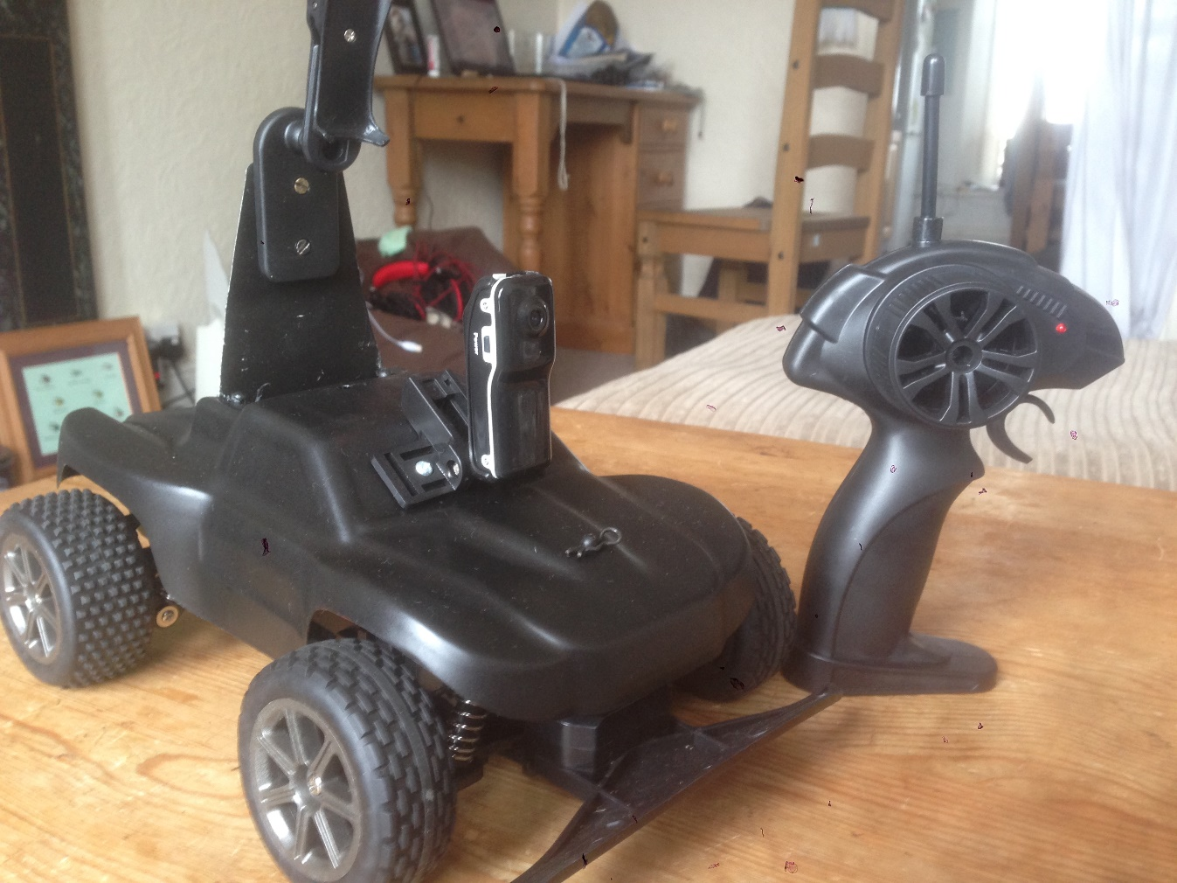
Camera Position 2
Camera Position 1
Chassis
Controller
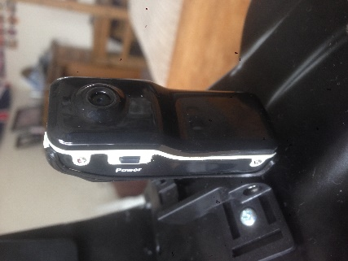
The chassis is a remote-controlled car from a toy shop with a 2.4GHz operating frequency for the radio which is a permissible frequency for use on MOD Pendine.
The camera is a miniature lightweight spy camera with an 8GB SD card built in.

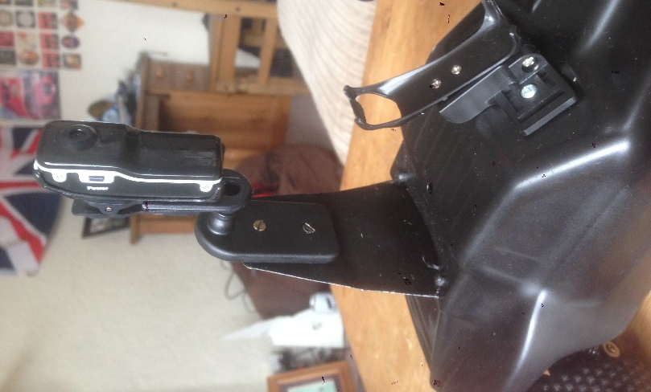
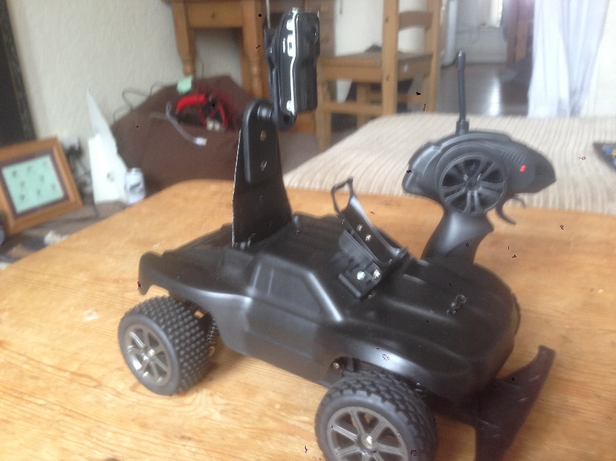
There are two mountings for the camera affixed to the casing of the chassis, one offering a high vantage point and the other being lower down.

Chapter 5 – Evaluation

Chassis
The chassis is ideal as it provides a relatively stable platform for the camera at position 2, the camera at position 1 is a little bit wobbly whilst the vehicle is moving, but is steady when the vehicle is at a stop, which is all that matters. The chassis can cover relatively rough ground and is also capable of driving through puddles that are 150mm deep which is very useful seeing as the site had 144 days of rain last year.

Control System
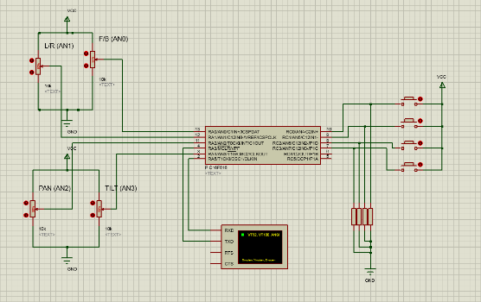
The control system for the vehicle is simple to use and as previously mentioned, operates with a frequency of 2.4GHz which is suitable for use at Pendine. The main thing missing from this prototype robot is that the control system is not utilising the PICs and the code written in Proteus. This is because although the author was comfortable with drawing and understood what was required from the circuit diagrams, he lacked the knowledge of programming to effectively compile code to carry out the tasks required. The code shown below is how far the author managed to get before his knowledge of coding ran out and he was forced to stop.

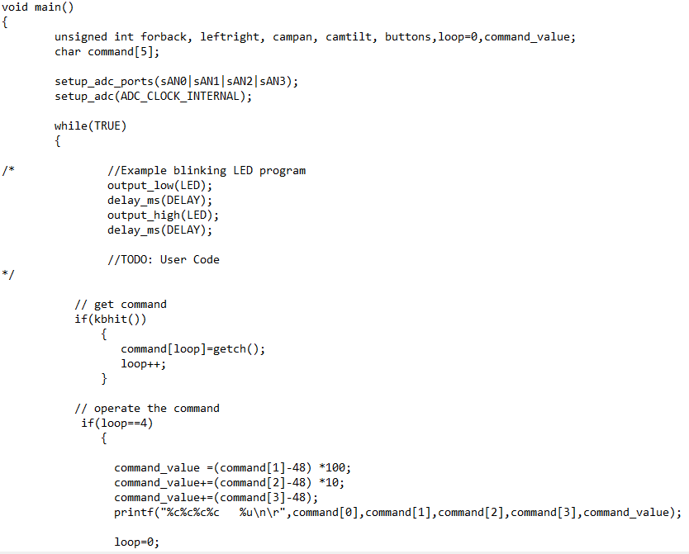
PIC test code
Operating on the command received from transmitting circuit
Receiving command from transmitting circuit
This is the code for the receiving circuit.

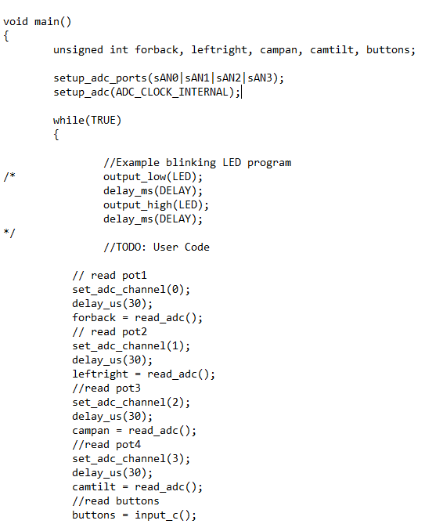
This section of code is defining the various inputs. Forwards, backwards, left, right, pan and tilt. The various inputs would be assigned a value which would be transmitted. The receiver would get these values and then carry out the desired function.
PIC test code
This is the code for the transmitting circuit.

Camera system
The camera on the prototype is an ideal size, however there is a major drawback. The camera does not provide a live view back to a monitor, it only records video and sound. The robot would have to go and investigate the malfunctioned weapon then return to the operator before plugging the camera into a computer and then the operator would review the film. This means that the operator can’t see what’s going on as he’s doing. The reason for this is because the camera that the author originally wanted to use (Lorex CCTV) required a separate CCTV kit to be able to have a live view, this kit cost £150 and then the camera cost on top resulting in an overall cost of £184.99. Money that the author does not have and that QinetiQ Pendine was not willing to pay.

Chapter 6 – Future Improvements & Conclusion

Future Improvements
To fully realise this project, several improvements are going to have to made in order to use the robot to its full potential, whether that be as originally designed as an EOD assistant robot, or as an inspector of malfunctioned weapons.
The feature that needs to be improved most urgently is the camera system, because at present on the prototype, the camera does not give a live view back to the operator. This feature would increase the usefulness of the robot many times over as the operator would be able to see where he’s driving and also make quicker decisions on how to approach a potentially hazardous situation. Also, the camera system need to be able to pan, tilt and perhaps even zoom; these extra functions would again improve the useful attributes that the robot has, allowing the operator to more easily make fine adjustments to the picture he is receiving to better make an informed decision on the correct course of action. These functions could be included with the use of the PIC method of control or even the Arduino and raspberry pi, but further learning on the part of the author would have to take place to fully understand these systems so that they may be put to use.
The chassis could also be updated to one of the researched ones, probably the ’DFRobotShop Rover Chassis Kit’ due to the large amount of space, and its tracked design which the author believes would be more robust than the current chassis. Of course, changing to this chassis would mean also updating the control system and data transmission system too. Whether umbilical method or radio control will be used depends on the situation that robot will be deployed into: EOD or weapons inspection.

Conclusion
This project has produced a working prototype of a weapons inspection robot that, with a little tweaking, could be converted to the initial purpose of being an EOD robot. The report has also identified several routes that one could go down to building said robot, depending on the budget of the creator. While the prototype could be improved, it does demonstrate the principles of what the actual product would have to do.

References
1. Document #15-09-DRb. www.QinetiQ-NA.com. [Online]
2. Document #16-2-DR10. www.QinetiQ-NA.com. [Online]
3. Document #16-3-DR20. www.QinetiQ-NA.com. [Online]
4. Document #16-9-DRMINI-D. www.QinetiQ-NA.com. [Online]
5. [Online] http://www.telerob.com/en/about-telerob/philosophy.
6. [Online] http://www.telerob.com/en/products/teodor.
7. [Online] http://www.army-technology.com/projects/teodor-explosive-ordnance-eod-robot/.
8. [Online] http://searchmobilecomputing.techtarget.com/definition/IR-wireless.
9. [Online] https://www.quora.com/How-do-an-IR-transmitter-and-receiver-work.
10. [Online] http://searchmobilecomputing.techtarget.com/definition/IR-wireless.
11. [Online] https://www.arduino.cc/en/Guide/Introduction.
12. [Online] https://store.arduino.cc/homepage/arduino-uno-rev3.
13. What is a Raspberry Pi?
14. [Online] https://www.raspberrypi.org/learning/hardware-guide/components/raspberry-pi/.
15. [Online] http://whatis.techtarget.com/definition/PIC-microcontrollers.
16. [Online] https://www.intorobotics.com/wheels-vs-continuous-tracks-advantages-disadvantages/.
17. [Online] http://www.robotshop.com/uk/dfrobot-4wd-arduino-platform-encoders.html.
18. ROBOT, DF. Baron - 4WD Mobile Platform Instruction Manual.
19. [Online] http://www.robotshop.com/uk/bogie-runt-rover.html.
20. [Online] http://www.robotshop.com/uk/dfrobotshop-rover-chassis-kit.html.
21. [Online] http://www.robotshop.com/uk/lynxmotion-tri-track-chassis-kit.html.
22. [Online] http://www.robotshop.com/uk/tamiya-twin-motor-gearbox.html.
23. [Online] https://en.wikipedia.org/wiki/Gas-operated_reloading.
24. [Online] https://en.wikipedia.org/wiki/Direct_impingement.
25. [Online] https://en.wikipedia.org/wiki/Firearm_malfunction.

