Why is it important that children need visual stimulation when reading and looking through books?

Introduction (500words)

The primary purpose of this thesis is to show the how illustrations in picture books have an impact on how young children learn. When a child reads a book they interact with the image as well as the story being read aloud to them, how do they correlate images with sound? When children are growing and learning, books are an important part of their education not just for learning to read, but also helping them communicate and learning morals in life. Reading with their parents or their carers is a way to start understanding words, but the images can help a child comprehend what a word means, this also associates with language, when someone cannot speak a language or understand the words written down, images help break down what is being said on paper.
There will be a thorough study to look at how words and image are connected and how images can sometimes tell a story better than the writing on the page, sometimes images and the text don’t go hand in hand with each other. How do the illustrators communicate with children through image? How do you keep a child stimulated with a book especially when it’s a story that has been told hundreds of times since it was written.
When a child is growing up, they are usually going through a fun but sometimes stressful time. Children need to learn and they do it through many ways, play, communication and reading are the primary sources for education. When children look through books their eyes are naturally drawn to the illustrations, and with their parents reading the book, the story captures the attention of the child, pulling them into a world of make belief bringing the story alive.
Before children learn to read words, they read pictures instead. “For many young children, their first reading experiences often involves the use of picture books” (Danko-Mcghee & Slutsky, 2011) Suggesting that the illustrator holds a big responsibility in helping that child learn to read by creating images that draw in the attention of the reader as well as the parent, because they need to buy the book first.
Illustrators work in tangent with authors to create a fun filled, adventurous experience for children to explore their imaginations and learn. “Certainly the prevalence of illustration in books for children in the past and in the present reflects an adult decision that pictures will attract and hold children’s interest or help them to learn about a subject” ( Nodelman, 1988, p.4) This backs up the statement of children learning to read through images rather than just learning straight from words because the author and illustrator have wished this . If they have pictures alongside their text they will be able to look at the image and understand a bit better as to what the words mean.

Chapter 1 (1700words)
Why are pictures important in books?

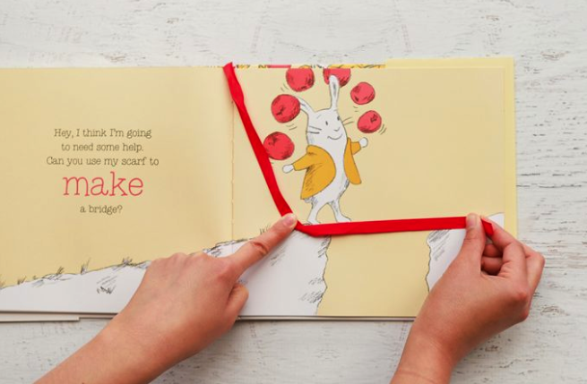
In a book called Hungry Bunny by Claudia Rueda, the story is about a bunny who comes across many challenges and has to face them in order to move forward, to do this the bunny has to use his scarf, which is a simple red ribbon attached to the book. One challenge is that the bunny has to cross a large gap between two rocks, the only way for the bunny to surpass this task is for the young reader to make a bridge with the rabbit’s little red scarf attached to the book.
The book is a very creative way of teaching children, it has a smart yet simple design to engage and capture the attention of the readers. Once the child has surpassed the challenge brought forward, they can then turn the page to find, that with their help the bunny has found his way across the bridge that they created, leaving the child feeling rewarded and giving them the motive to now move forward. This bit of interaction in a book helps a child learn, they are understanding that there are solutions to simple problems and they can learn how to combat them. The pictures in this book are very important because without the drawings there would just be a story, and challenges, but no visual representation, making the book incomprehensible and boring. The text works alongside the illustrations to produce an enjoyable pleasurable book for children to read with their parents.

Children are hard to keep stimulated when you don’t know what makes them excited, so authors and illustrators have a hard job in keeping their attention to the book rather than the outside world. Children often find their attention drifting if the book doesn’t keep them entertained. A book needs to have eye catching illustrations but also a wonderful story line that keeps them guessing to prevent boredom. That is why Rueda’s book works so well, as it presents a new challenge to accomplish every time a page is turned, the book is creating a world that entices the young reader to enter and explore with the protagonist bunny.

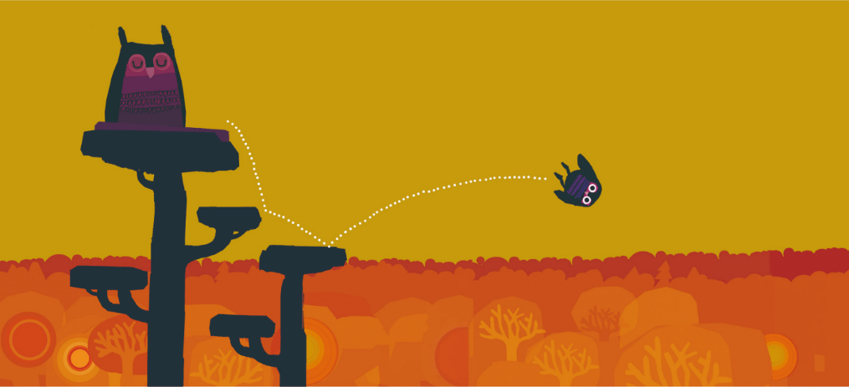
In a book called “A bit lost” created by Chris Haughton, he has managed to tell his story with very little words. In this page the reader can see a sleeping mommy owl and a baby owl bouncing from a tree branch, that he was once perched on.
This page doesn’t need words to tell the reader what is happening, they can see for themselves. The illustrations show that this baby bird is bouncing, and Chris Haughton has managed to create this illusion by simply using white dots in a repetitive “jumping” motion. The white line made of dots stands out on the page because of the contrast from the background colour. From looking at the page they can see that the bird hit two places before plummeting into the air, which a thumping sound can be imagined in the reader’s mind.
This page is so well thought out that words aren’t needed, thus proving that pictures are so important that they can sometimes tell the story better than words. Chris Haughton stated that when he was creating the book, he found himself trying hard to think of words to go on the page but then came to the realisation that he in fact did not need as many words or any in some cases to bring his story to life.

One item to pay attention to in children’s picture books are the illustrations and their detail. Children’s picture books often change with age. When a child is younger the words are basic if there any and frequently the illustrations tend to be simplified to suit the young reader. As a child gets older their level of reading develops meaning the sentences in books become longer, involving harder words rather than easy sounds that are present in baby books. The illustrations also grow up with the age group becoming more intricate and detailed, rather than using the block shapes, primary colours and simple designs, the pictures expand into something more beautiful and exciting allowing the reader to still be transported into a world other than their own.

Throughout the years children’s books have been progressing into amazing pieces to have and to share with your family. Over the years children’s books have progressed into pieces of art as opposed to the plain boring books they used to be in the past.

Throughout centuries images have been used as a way of communication. When a person doesn’t understand something they often turn to images for help, a good example of this is when a person is trying to follow instructions, but find that the words don’t quite make sense so the only solution is to look at the image and ninety percent of the time the picture works hand in hand with the words to help you understand what is happening and what is to be done.
Pictures play an important part in our every day lives whether we care to notice or not. An advert often has a picture or an illustration, cards, clothes, magazines are all things that involve pictures.

Sign language is a very impressive way of communication, it allows people who cannot hear to still communicate through image with their hands. They can speak with the shapes their hands and bodies make.

How does the same story differentiate for different ages?

When looking at a classic story, one we all know and have grown up with, how does this story change for different age groups?
The story that is the key focus for this study is the three little pigs. The best known version of this story made its first real appearance in 1898 by Joseph Jacobs and it was published in a book called English fairy tales, But he credited James Orchard Halliwell as his source who created the first print version of the story in 1849.(1)
This story is a loved one, but how has a story that’s over one hundred years old stayed interesting for readers? There are hundreds of variations of the three little pigs tale, with the story staying on track most of the time, but has known to have a few twists and turns. The story of the three little pigs is briefly about pigs who build houses and a wolf who’s ambition is to eat the pigs. Children have grown up reading about these notorious pigs and each child has seen the pigs and the wolf in different art styles, have heard about their tale in different ways.
The story varies on the age of the child, in a simple rendition of the three little pigs written by Ronne Randall “The little pig’s reedy, weedy straw house just fell to pieces” these are strong verbal adjectives that are very vocal and very easy for a child to learn, descriptive words are used to help children with their vocabulary.

Illustrations can sometimes tell a slightly different story or sometimes even contradict a storyline in a book. In the classic tale of the three little pigs, the story is known for the first two of the pigs to get eaten by a wolf whereas the third survives, sometimes this tale changes to the pigs running away to take shelter in the other houses and the wolf ends up deceased.
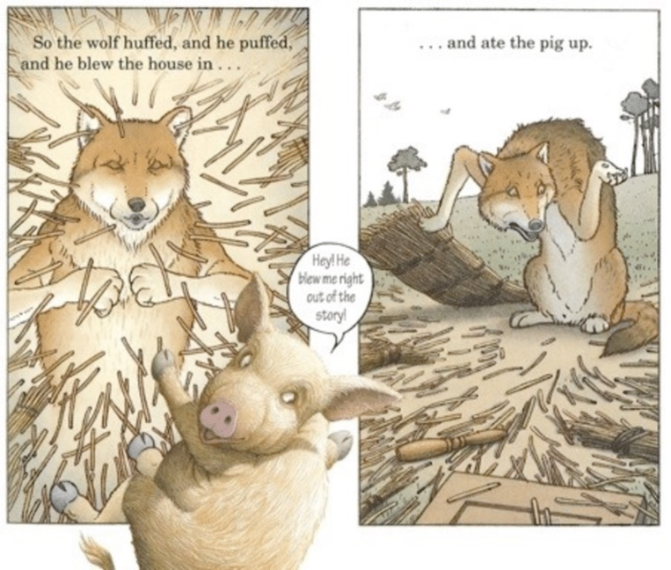
This however wasn’t the case for The Three Pigs created by David Wiesner. In his variation of the three little pigs, the story written on the paper tells the reader that the first two pigs are consumed by the wolf, as opposed to the illustrations which portray a rather confused wolf, who clearly hasn’t had his lunch, and a mischievous pig who has managed to escape the story he was in, because the wolf had blown him out, crossing the frame of the illustrations and onto the white space.
In doing so the pig’s art style changes from a simple, not to detailed illustrated character, to a very hairy pig that now is semi realistic. Every part of this book has been thoroughly thought about, the story isn’t supposed to match up with the illustrations, it’s a great way to engage the reader into a captivating book, the story may be one that isn’t unheard of but the illustrations make it into something more. It takes the pressure off it being the same as the other books before it.
This book is another extraordinary way of demonstrating how amazing picture books can be, a child can get lost in the adventure with the pigs whilst the parents read the story, embarking upon a few giggles when the child realises that the words written aren’t matching up to the story the pictures are telling. An author Cyndi Giorgis (2012) indicates, “A picture book is a unique art form, and every aspect of it is meaningful” (p. 4) This is a good statement to support what was said before, illustrations usually need to work hand in hand with the story to create something beautiful but Wiesner demonstrates that’s not always the case, he’s not the only person to have done this, in 1968 a book called Rosie’s walk was published by Pat Hutchins. In this beautifully presented book it shows a chicken named Rosie going for a walk, the text states that the hen, takes a peaceful stroll around the farm and gets back in time for dinner. However the illustrations tell a different story, the hen Rosie is being stalked by a rather sly fox, who is plotting to eat the poor chicken.

or even contradictory story than the text. For example in Rosie’s Walk
(Hutchins, 1968), the text says that Rosie, the hen, takes a peaceful stroll around the farm and
gets back in time for dinner (p. 134). However, the illustrations relate another tale; a menacing fox lurks behind Rosie, ready to make the hen its dinner (Fang, 1996).
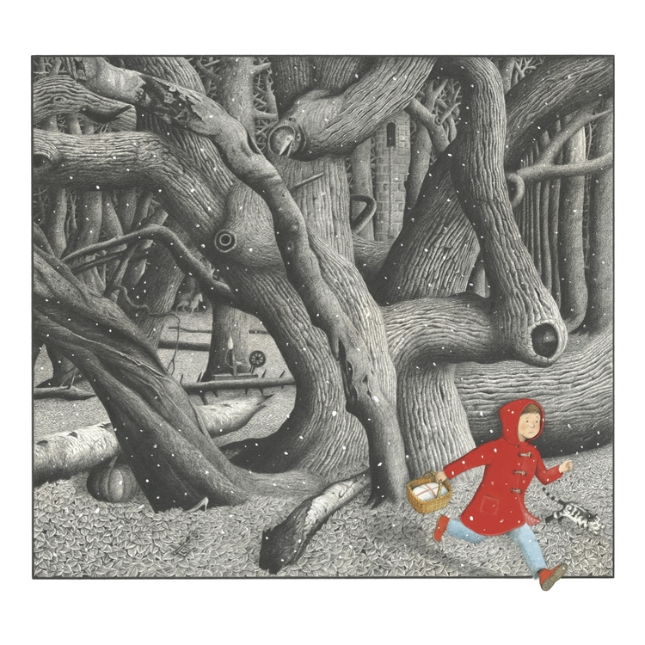
Illustrators don’t just help children learn to read, they help with other problems too. Authors and illustrators are passionate, creative people, and it is their passion that assist children and those that are different to move forward in the world and help them. Children often go through struggles in life and sometimes these struggles can be unfortunate events, such as bullying, the loss of a family member or pet, and it is illustrators and authors that can sit down together and help others from behind the scenes.
When an author writes a children’s book, they need to find and artist to work hand in hand with them, stating that already word and image are correlating together without being on paper, you cannot have one without the other. Because of this dynamic duo, the two or one, as some illustrators are the author, can come up with ways to communicate with children through either image or word. Illustrators are known to make a book fun, hiding easter eggs, hidden gems throughout the book, sometimes the book will be about a fairy tale like Snow White and in that book the reader will find references to other fairy tales, example a slipper can be seen in a book called ‘Into The Forest’ by Anthony Browne, it is a tale about a boy heading into the woods in search of his father who disappeared in the night during a terrible storm. In this book the reader can see references to other stories, on a page where the boy wears a red coat, to portray little red riding hood, there are hidden illustrations of pumpkins, slippers and other small items that are heavily known for other popular fairy tale stories.

When the book is aimed at children between the ages of three and four, the pigs are simple block colours and shapes

For many young children, their first reading experiences often involves the use of
picture books (Danko-McGee & Slutsky, 2011)

Beth Olshansky author of The Power of Pictures:
Creating Pathways to Literacy Through Art (2008), observes, “as a visual language, that runs
parallel to our own verbal language, it is possible to teach the very same literary elements
through the language of pictures as through the language of words” (p. xii)

Chapter 2(1700words)

Chapter 3 (1700words)

Conclusion (500 words)
Bibliography

Giorgis, C. (2012). The art of picture books. Book links, 22(2), 4-9

Fang, Z., (1996). Illustrations, text, and the child reader: What are pictures in children’s storybooks
for? Reading Horizons, 37(2), 130-142.

Nodelman.P (1988)Words about pictures. Georgia: University of Georgia Press

http://www.surlalunefairytales.com/threepigs/history.html (1)

