LCLM6002 – Design Thinking and Innovation

Title: Innovation & Customer Journey for HSBC Holdings Plc UK

Student: Dumitru Alexandru Dumitru
Student ID: 2309588

Contents

Introduction 3
Part 1: Analysis and Assessment 5
1.1. Innovation Ambition Matrix 5
1.2. Customer Journey Mapping 7
Part 2 – An analysis of HSBC Holdings Plc UK 9
2.1. Introduction to HSBC Holdings Plc UK 9
2.2. Key Consumer and Industry Trends and Data 9
2.3. Analysis of HSBC’s Approach to Innovation 10
2.4. Proposed Digital Transformation Initiative 12
Conclusion 17
References 18

Introduction

The report presents an analysis of HSBC Holdings Plc UK covering its innovation strategy, customer experience design, and digital transformation agenda in financial services. HSBC is among the largest banking and financial organizations worldwide. More than 39 million customers are engaged through operations that span over 60 countries and territories in its network coverage. In recent years, significant disruption to the UK banking industry has emanated from digitalization together with changes in regulation and evolving consumer expectations. Thus, increasing innovation inside a company like HSBC with improved customer experiences plus embracing technologies delivering added value eventually as efficiency and sustainability become pertinent (Kotler et al.,2019; Tidd and Bessant ,2021).
The main objective of this report is to assess HSBC’s existing innovation strategy and highlight recommendations for its enhancement based on the application of two principal analytical tools: the Innovation Ambition Matrix (Nagji and Tuff, 2018) and Customer Journey Mapping (Rawson et al., 2016). The study analyses HSBC’s innovation portfolio to find out how it mixes core, adjacent, and transformational initiatives within its business operations. This will show the bank’s current application of digital technologies that include artificial intelligence (AI), blockchain, analytics, and mobile platforms toward optimisation of service delivery functions, management of risk, and addressing customer engagement (Trott, 2020; Osterwalder and Pigneur, 2020). The report thus points out existing shortfalls and prospective areas for further innovations especially in enhancing personalisation, sustainability,
The second part uses Customer Journey Mapping to study the interaction of HSBC customers with the organisation at different touchpoints-from awareness till long-term relationship management. It, therefore, summarises critical pain points and gain points: lengthy onboarding cross-channel inconsistency and lack of personalisation as service pain points; strong brand trust and security and diversity as gain points (Baines et al., 2019). The customer journey is set out such that new areas for digital innovation can be found where it creates added value for the customer through improved experience as well as more efficient delivery of services (Hollensen, 2020).
Hence, based on the results in Part 1, this report is going to propose a new digital transformation initiative for HSBC named ONE Digital Ecosystem that would integrate AI-driven financial advisory, blockchain-based cross-border payments, sustainability tracking, and digital identity onboarding into one single unified platform to pursue seamless security and environmental responsibility in customer experience as per strategic priorities with long-term sustainability goals at HSBC (Varadarajan 2020). This initiative is accompanied by an improved and revised customer journey map to indicate how these innovations can solve present issues, improve customer involvement, and ensure a competitive advantage.
Also included in the report is a practical implementation plan that spells out requirements-technological, organisational and cultural-for the adoption of an improved journey map. KPIs and success metrics are proposed to register progress accompanied by risk management issues and mitigation actions., followed by strategic recommendations on innovation leadership, sustainable digitalisation, and constant upgrading.
Overall, this report provides both an academic and a strategic review of HSBC’s digital transformation, showing how practical innovation strategies and theoretical frameworks can be used to improve customer experience, drive operational efficiency, and frame HSBC as a leading proponent of sustainable banking through technology on a global scale (Grant, 2019; Tidd and Bessant, 2021).

Part 1: Analysis and Assessment

1.1. Innovation Ambition Matrix

HSBC Holdings Plc is among the world’s biggest banking and financial services organizations. More than 39 million customers in 62 countries and territories bank with HSBC, according to its website. The innovation strategy at HSBC can be mapped to what Bansi Nagji and Geoff Tuff (2012) describe as the Innovation Ambition Matrix-which breaks down three horizons of innovation: core, adjacent, and transformational-and this mapping helps articulate HSBC’s balancing acts between short-term efficiency measures and long-term transformation in increasingly digital financial environments (Tidd and Bessant, 2021; Trott, 2020).
Core innovations are enhancements and upgrades of better products and services in delivering values to customers while making the operations resilient. Mobile banking upgrades at HSBC-including both core and incremental innovation within the biometric login feature plus AI chatbots such as "Ask Amy" demonstrate that kind of innovation (Kotler et al., 2019). That development is based on convenience, security, and speed as retail-and business-banking-specific competitive differentiators (Grant, 2019). Core innovation continuously invests in cybersecurity, regtech, and advanced analytics supporting compliance with strengthening requirements.
HSBC’s adjacent innovations are new but closely related markets and customer segments. It has implemented blockchain-based trade finance solutions such as Contour, to digitize documentary credits and make cross-border payments efficient (Varadarajan, 2020). Wealth Compass HSBC integrates robo-advisory functionalities within its retail banking ecosystem thereby democratizing access to investment advice for the mass affluent market. Such innovations are in line with adjacent growth wherein existing financial expertise is leveraged while digital technologies are used to attract a younger tech-savvy clientele (Hollensen, 2020). Other adjacent moves comprise open banking partnerships and API ecosystems that facilitate smooth data sharing between third-party fintech collaborators.
Transformational innovations comprise HSBC’s most daring efforts aimed at changing its business model and role in society (Osterwalder & Pigneur, 2020). Some examples include AI-powered personalised banking-predictive financial insights based on transaction data-and carbon tracking tools enabling customers to estimate and offset their environmental footprint. Under its ‘Sustainable Finance and Net Zero Strategy’ policy, HSBC has announced a $1 trillion sustainable finance commitment by 2030 that would purportedly serve as a low-carbon innovation accelerator (Kotabe and Helsen, 2022). An emerging capability being tested is blockchain-enabled digital identity-for secure, decentralised customer onboarding-that has the potential to transform compliance and global KYC (Know Your Customer) frameworks (Baines et al., 2019).
HSBC innovation as described in the report lies about 70 percent within the core, 20 percent in the adjacent, and 10 percent in the transformational; HSBC is committed to maintaining stability while being disruptive (Nagji and Tuff, 2012). Most innovations at the bank are focused on improved digital customer journeys and integrated advanced analytics solutions of sustainable finance. However, this shall also be considered under a future transformation innovation fin Tech competitor like Revolut, Starling, and Monzo new enhancements of blockchain beyond trade finance into real-time remittance sustainability insight retail banking dashboard AI personalization across customer life cycle.
In conclusion, HSBC maintains a balanced approach toward innovation; however, the bank remains cautious on account of its size and regulations governing its operations as is common with other similar institutions (Tidd and Bessant 2021). The real challenge for HSBC lies in gradually recalibrating the matrix toward transformational initiatives that create new value ecosystems. A large share of the future success will depend on sustaining innovation culture agility experimentation and cross-sector partnership collaborations granting allowance to morph from a traditional financial intermediary into a digital ecosystem orchestrator (Grant 2019; Varadarajan 2020).

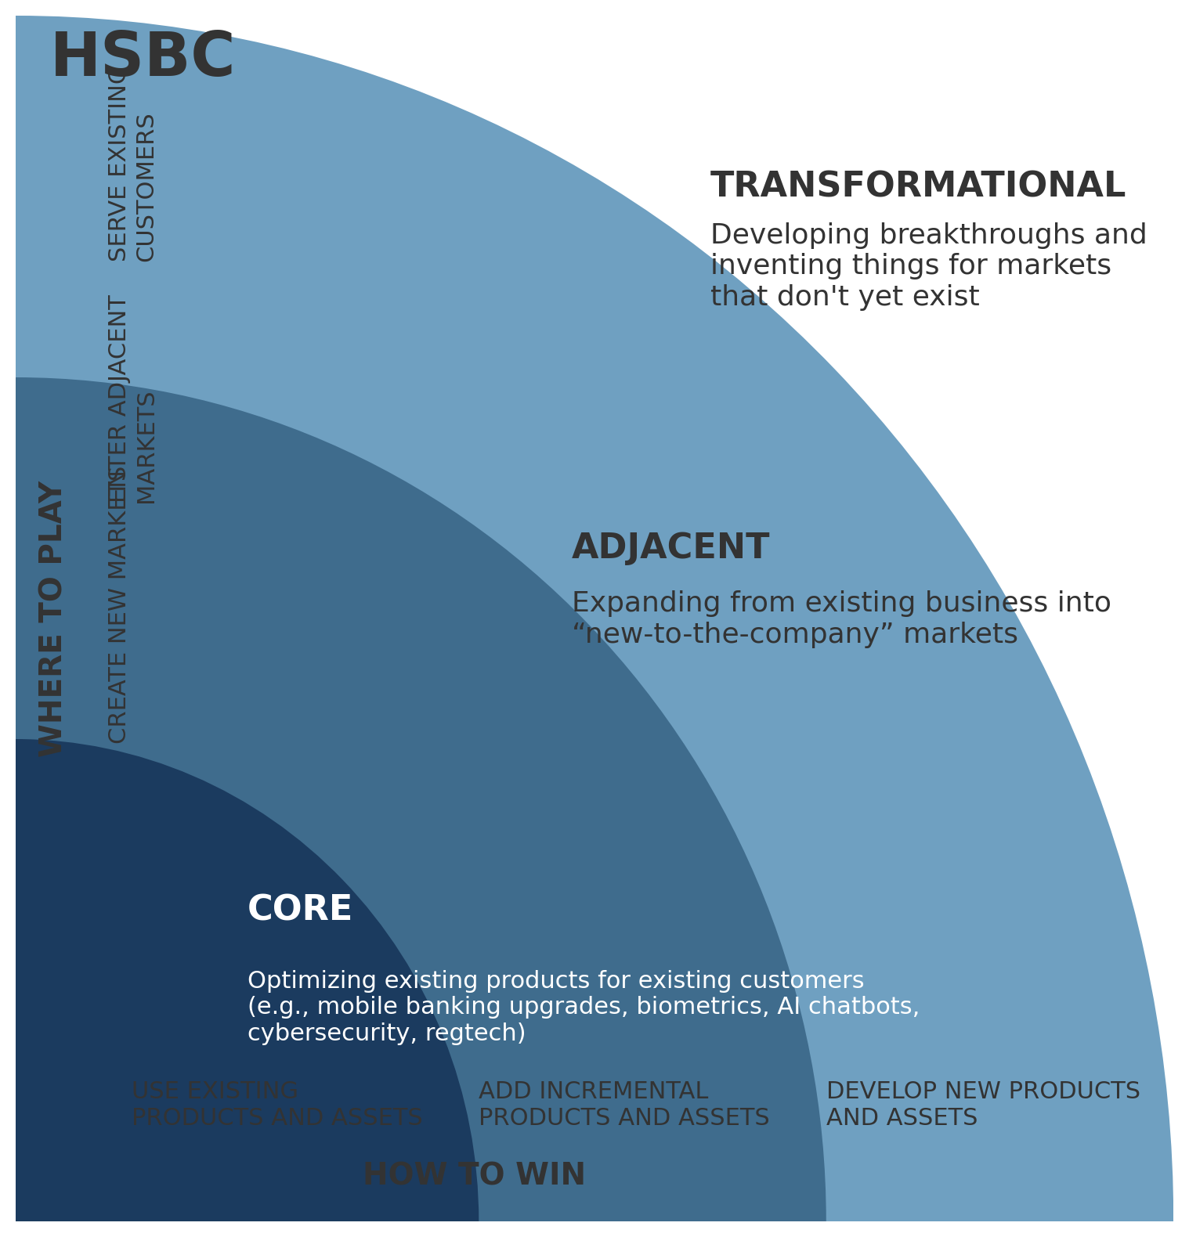

1.2. Customer Journey Mapping

HSBC’s present customer journey mapping illustrates the way the bank engages its principal customers, beginning from the stage of awareness up to long-term relationship management. This mapping is focused on retail banking customers through both digital and physical touchpoints (Kotler et al., 2019). It highlights major pain points, gain points, and opportunities for digital innovation (Rawson et al., 2016; Blythe, 2018).

Current Customer Journey Stages
Awareness and Research-This is the stage at which the customer first notices HSBC either through advertising or social media or by a recommendation. The digital channels contain information on products available include the HSBC UK website and mobile app. Pain points: cluttered information architecture, limited personalisation. Gain points: strong brand trust, sustainability messaging.
Consideration and Application – Customers apply for products (e.g., current accounts, mortgages, or credit cards) via online portals or in-branch. Pain points: lengthy onboarding processes requiring repetitive data entry. Gain points: competitive product range and human support during application.
Onboarding and Account Activation – Customers verify identity, receive account details, and access digital banking. Pain points: manual KYC, document uploads, and delays. Gain points: secure systems and multiple verification options.
Usage and Servicing - They do daily transactions through mobile or online banking, ATMs and contact centres. Pain points: inconsistent omnichannel experience and cross-channel continuity is limited. Gain points: intuitive mobile app, chatbot support 24/7 and branch network availability.
Relationship Growth and Retention - They get periodic product offers, credit reviews or investment advice. Pain points: generic marketing emails and recommendations not tailored enough. Gain points: access from anywhere in the world, loyalty programmes and financial advice availability.

Opportunities for Digital Innovation
AI Personalisation: Usage of predictive analytics to propose financial advice and adjust budgeting tools (Tidd and Bessant, 2021).
Blockchain Integration: Streamlining international remittances and trade finance in reducing time cost per transaction (Kotabe and Helsen, 2022).
Enhanced Mobile Banking: Adding voice navigation, simple dashboards plus biometric security to further build trust (Grant, 2019).
Sustainability Tracking: Embedding carbon calculators into banking apps so that financial decisions can be linked with environmental impact (Doole and Lowe, 2018).
Digital onboarding makes KYC easier using AI and blockchain for digital identity checks (Varadarajan, 2020).
HSBC’s customer journey is more of advanced multi-channel than true omnichannel. The bank has integrated advanced analytics but actual handoffs between digital and human channels and real-time personalisation remain as gaps to be addressed by an integrated digital ecosystem to increase customer satisfaction reducing churn while reinforcing HSBC as an innovation leader in UK financial services (Osterwalder and Pigneur, 2020; Baines et al., 2019).

Part 2 – An analysis of HSBC Holdings Plc UK

2.1. Introduction to HSBC Holdings Plc UK

HSBC Holdings Plc, based in London, is among the top banking and financial services holding companies with total assets at 2024 above US$3 trillion. The bank operates four global businesses—Retail Banking and Wealth Management, Commercial Banking, Global Banking and Markets, and Global Private Banking. Founded in 1865, today’s HSBC purpose of ‘Opening up a world of opportunity’ reflects a long-standing role it has played in enabling trade and investment flows and international connectivity. In the UK, HSBC serves millions of personal and business customers through a hybrid physical-digital network comprising branches and ATMs together with highly developed online and mobile banking channels (Kotler et al., 2019).
HSBC’s strategic vision is directed toward achieving sustainable growth through digital transformation and innovation. Confronted with challenges from fintech competitors, changing customer expectations, and regulatory pressures, the bank has sped up its digital investments aimed at improving user experience and operational agility (Grant, 2019; Hollensen, 2020). At the core of this transformation is the application of artificial intelligence (AI), blockchain, and data analytics toward better decision-making and customer value creation (Tidd & Bessant, 2021). HSBC’s approach to sustainable finance underpins its “Net Zero by 2050” target articulates good corporate positioning as a responsible institution driven by innovation (Varadarajan, 2020).

2.2. Key Consumer and Industry Trends and Data

Technological innovation comprising regulatory reforms and market competition is massively redefining the UK financial services digital landscape (Baines et al., 2019; Kotabe and Helsen, 2022). Financial Conduct Authority (FCA) statistics reveal that more than 87% of adults in the UK use online banking as their primary interface with finances. Therefore, definitely, a mobile-first trend has set in which firms like Revolut, Monzo, and Starling are placing yet another nail in the coffin of traditional banking by offering frictionless fully digital low-fee experiences competing head-on with incumbent banks (Doole and Lowe, 2018).
Consumer expectations are very much driven toward speed, transparency, and personalisation. Strategically, HSBC has no choice but to ensure a perfectly integrated omnichannel experience between mobile, online, and physical channels. Millennials and Gen Z are mostly into self-service, instant support, and sustainability; hence chatbots and predictive analytics and ESG-linked products for banks (Kotler et al., 2019). The AI-powered personal finance tools and credit risk models—those insights have already become a standard competitive practice (Grant, 2019).
Meanwhile, the UK’s Open Banking Initiative (OBI) has made the environment very competitive while also leaving room for innovation. HSBC uses APIs with fintech firms such as data analysis companies to enhance both internal and customer-facing personal financial management applications (Varadarajan, 2020). In addition to this change brought about by blockchain redefining payments and trade finance through cost savings accompanied by transparency improvements (Hollensen, 2020), HSBC is a first mover on platforms like Contour in distributed ledger solutions for cross-border transactions hence it remains committed to such solutions (Osterwalder and Pigneur, 2020).
There is sustainability involved as well. A big change. Clients are now demanding options for responsible banking of the environment. Green Deposits at HSBC, ESG linked loans, and a carbon tracking pilot-all very well aligned (Johnson et al., 2020). Meanwhile in another area rules regard investment automation continue to press accounting capital Basel III KYC/AML on RegTech.
To conclude, the financial ecosystem is heading toward platform-based digital ecosystems that integrate financial, lifestyle, and sustainability services. For HSBC bank, success lies in embedding innovation at every customer touchpoint through Artificial intelligence, blockchain, mobile interfaces, and sustainability-driven financial products (Tidd and Bessant, 2021; Trott, 2020).

2.3. Analysis of HSBC’s Approach to Innovation

HSBC frames its innovation ambition around incremental change and radical experimentation across its digital estate. The Innovation Ambition Matrix, as applied earlier, highlights the bank’s focus on balancing core efficiency with disruptive potential.
Core Innovation: HSBC constantly upgrades digital banking capabilities to directly eradicate functional frictions. The HSBC UK Mobile App enables a fingerprint and facial recognition login, AI-driven chatbot support (“Ask Amy”), and real-time fraud alerting. This lowers the cost to serve and makes it more accessible to younger users (Kotler et al., 2019). In addition, using Robotic Process Automation (RPA) in back-office loan processing and compliance operations which traditionally relied on human labour not only eliminates errors but also significantly accelerates the process (Tidd and Bessant, 2021).
Adjacent Innovation: The bank integrates adjacent innovations through a combination of blockchain, open banking, and robo-advisory. It is therefore a participant in the Contour network that exemplifies how trade finance can be enhanced on the blockchain by digitizing letters of credit and reducing settlement cycles to run Wealth Compass democratises investment provides personalised portfolio guidance delivered through AI-driven insights (Grant, 2019). Accelerator Programme HSBC has also partnered with fintech start-ups to innovate through collaboration (Doole and Lowe, 2018).
Transformational Innovation: HSBC’s transformational agenda aligns with its Sustainable Finance Strategy. The bank announced a US$1 trillion sustainable finance commitment by 2030, embedding climate targets within its corporate lending and retail products. Its AI-driven sustainability dashboards enable customers to monitor carbon emissions associated with spending patterns (Kotabe and Helsen, 2022). HSBC is piloting digital identity solutions based on blockchain technology aimed at the simplification of global KYC that would enhance customer onboarding efficiency while maintaining compliance robustness (Osterwalder and Pigneur, 2020).

Innovation Strengths
Long-established international brand with massive cash reserves to channel into research and development.
Government policies on foreign bank entry are based mostly on reciprocity-the treatment its own banks receive from a potential host country.
First-mover advantage in blockchain-based trade finance.
Sustainability integrated as a core innovation pillar.

Innovation Gaps
Agility and scalability constrained by legacy IT infrastructure.
Fragmented customer data does not allow full AI personalisation.
Slow internal innovation due to a culture of regulatory caution.
Inconsistent omnichannel experience across regions.

Figure 1 - Current Customer Journey Insights
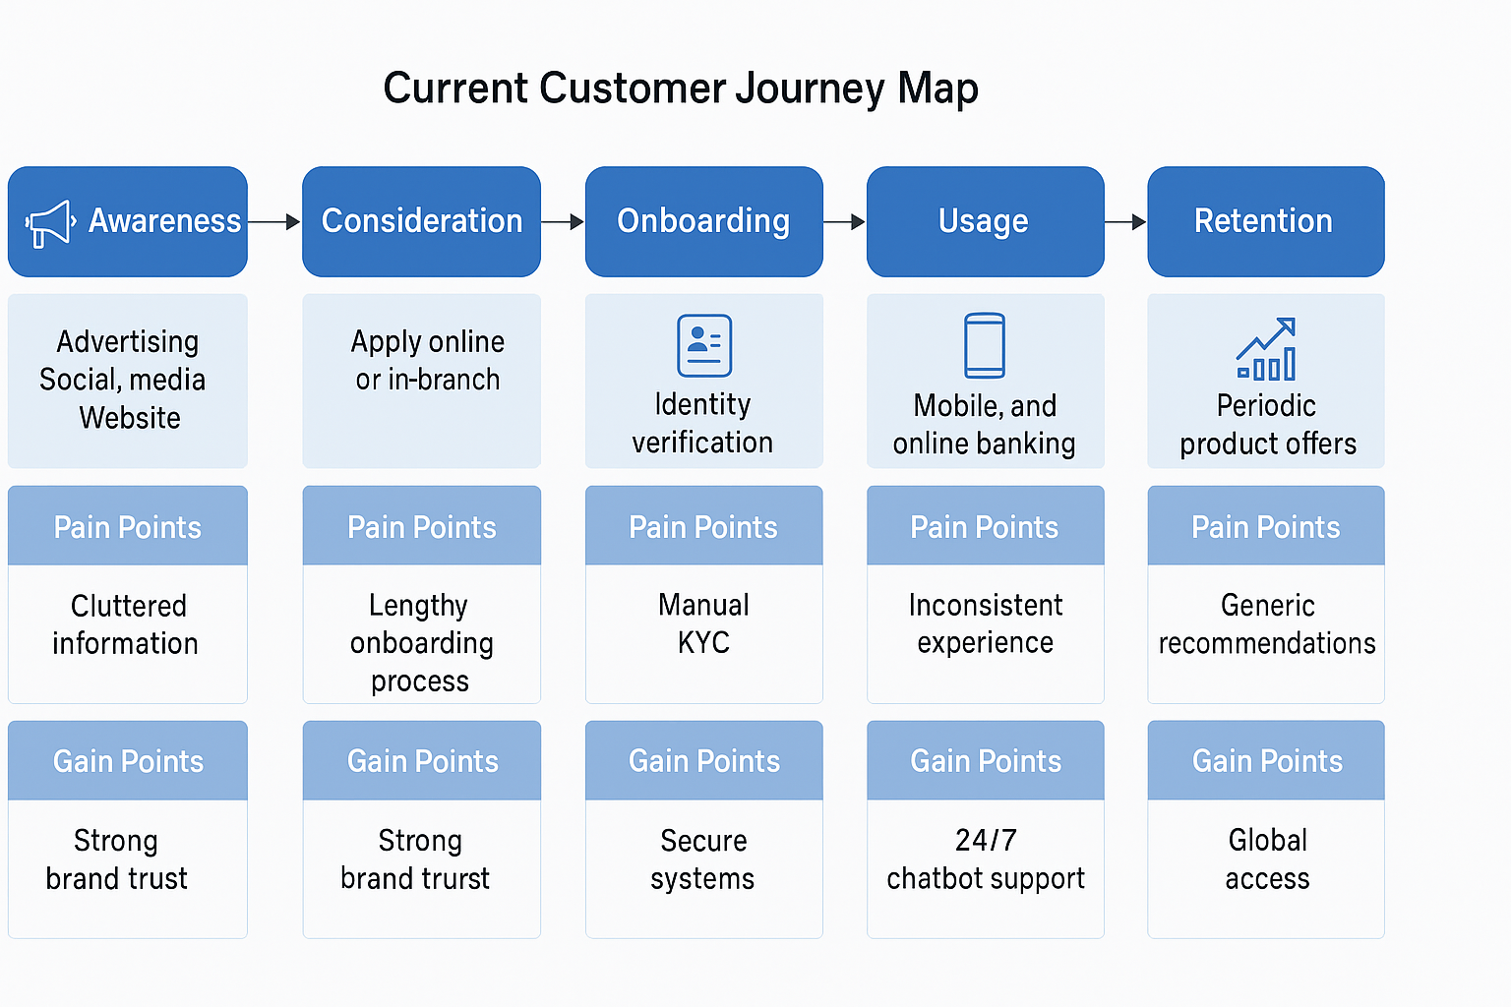
As analysed earlier, the present journey from awareness to retention proves HSBC’s brand trust and global accessibility as core strengths. However, pain points still score high around manual onboarding processes, lack of cross-channel personalisation, and a disjointed mobile-to-branch experience. These are gaps which offer large opportunities for digital transformation.

Emerging Innovation Opportunities
AI Personal Financial Assistant: Real-time budgeting and predictive analytics.
Blockchain-based Global Payment Network: Instant, low-cost cross-border transactions.
Digital Onboarding Hub: End-to-end automated KYC using AI and biometrics.
Integrated Sustainability Platform: Carbon tracking and eco-investment tools.
Enhanced Mobile Banking Ecosystem: Voice interface, augmented security, and gamified financial education.

2.4. Proposed Digital Transformation Initiative

HSBC’s proposal—HSBC One Digital Ecosystem (HSBC ONE)—integrates artificial intelligence, blockchain, mobile innovation, sustainability tracking and digital onboarding within one single platform. The ecosystem connects retail, business and wealth customers under one digital infrastructure designed for personalisation, transparency and sustainability.
AI-Powered Personalisation: HSBC ONE will feature an AI financial advisor providing real-time insights into spending analysis with predictive budgets. Machine learning optimises the personalisation of credit offers and investment recommendations to drive engagement and customer loyalty (Tidd and Bessant, 2021).
Blockchain-Enabled Payments: A global payment gateway on the blockchain path permits real-time low-priced remittance with gradually reduced reliance on intermediary banks. Such a move would place HSBC in a better standing competition against fintech disruptors like Wise, formerly Transferwise, and Revolut (Grant, 2019).
Digital Onboarding & Identity: The customer proves identity over a secure blockchain ledger that integrates biometrics and digital ID validation. The innovation reduces onboarding time from days to minutes, which had long been a significant pain point in acquiring customers (Osterwalder and Pigneur, 2020).
Mobile Experience Enhancement: A single mobile application contains all the functions-in banking, investment, and payments plus account aggregation and sustainability tools. Other features to be added comprise voice interactions with gamified savings supported by real-human hybrid support 24/7 (Kotler et al., 2019).
Sustainability and Carbon Tracking: The customer receives information on his/her purchases' carbon footprint in-app as an option for offsetting and ESG investments opportunities strengthening brand loyalty among eco-conscious consumers (Varadarajan, 2020).

Impact and value creation
Customer experience: Speed, transparency, and trust through a seamless data-driven engagement.
Operational Efficiency: Cost savings include automation, blockchain settlement, and reduction of compliance overheads.
Sustainability Leadership: In that it continues to build on HSBC's existing standing and credentials in sustainable finance and ESG innovation.
Market Differentiation: Carves out an exclusive, purpose-driven digital identity for HSBC within the UK banking arena.

Measurement of Success
Reduction of onboarding time by 30%
20% uplift in digital engagement (mobile logins and active users)
15% reduction of operational costs through automation
Positive customer satisfaction (NPS) improvement +10 points
People are picking up 25% more ESG-linked products over the last couple of years.

Figure 2 – New Enhanced Customer Journey Map

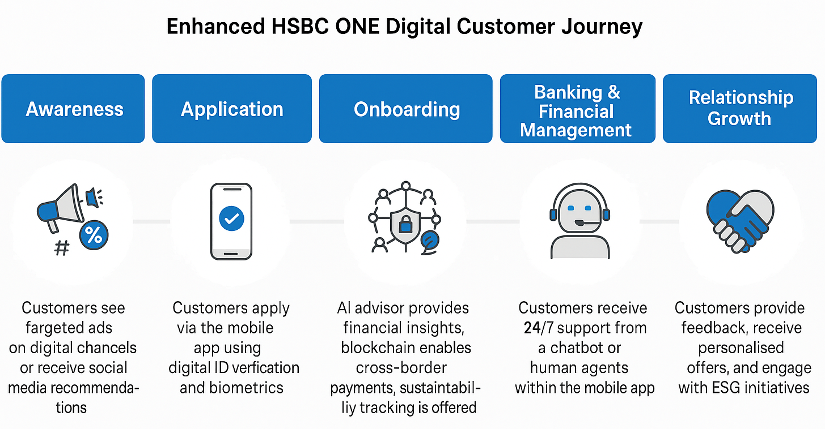

Implementation of this Enhanced Digital Customer Journey Map for HSBC ONE has to be through a structured cross-functional approach between technology innovation, organizational transformation, and customer-centric design. Transformation success factors include the alignment of digital technologies-artificial intelligence, blockchain, sustainability tracker, and mobile integration-with the strategic intentions of the bank and objectives toward customer experiences (Tidd and Bessant, 2021; Trott, 2020).
Vision Integration and Strategic Alignment: The journey mapping technique should ensure a strategic alignment between the innovation roadmap and HSBC’s vision of “Opening up a world of opportunity”. Customer-centric innovation should be strongly emphasized by senior leaders in embedding it into the core strategy where technological enhancements support engagements with customers as well as sustainability and profitability (Grant 2019). This is according to the Innovation Ambition Matrix, which advises HSBC to keep its portfolios equally balanced at 70% core innovations or incremental improvements; 20% adjacencies involving new markets brought about by emerging technologies; and 10% transformation through governance frameworks that are clearly defined for investment decision coordination thus reducing risk besides ensuring regulatory compliance (Johnson et al., 2020).
Technological Implementation and Infrastructure Development: In actual delivery of the proposed improved customer journey, HSBC has to upgrade its old systems with new digital infrastructure capable of supporting instant analytics, blockchain transactions, and artificial intelligence personalisation. Implementation shall be on a cloud-based scalable platform integrated with KYC using blockchain for safe digital onboarding plus amalgamation of machine learning models which predict customer engagements (Osterwalder and Pigneur 2020). The IT function should engage top fintechs in a partnership model facilitated by open banking APIs that accelerate implementation while sharing innovations (Doole and Lowe 2018).
Also, an integrated Customer Data Platform (CDP) should unify disparate data sources to offer a holistic view of customer interactions (Kotabe and Helsen, 2022). The same makes HSBC capable of cross-selling and up-selling its marketing, credit, and investment services to personal needs in real time. Cybersecurity and data privacy enhancements shall also be implemented to ensure regulatory compliance and consumer trust (Hollensen, 2020).
Organisational Culture and Employee Training: The bank must, therefore, allow a culture of innovation-oriented employee empowerment to permeate the entire organisation. It should train all its employees in design thinking and data literacy and digital tools for effective human-AI collaboration (Kane, 2023; Drucker, 2015). In this regard, frontline employees have to be provided with digitally interfaced tools through which real-time insights into customers shall be available so as to ensure them consistent service across various touchpoints accompanied by personalised attention. In this case, change management frameworks like Kotter’s 8-Step Model will drive buy-in among employees while lowering resistance towards technological changes due largely or partly because of lack/inadequacy thereof training.
Customer Experience Management and Omnichannel Integration: Consistency of the omnichannel is a top component in ensuring channels are properly linked both physically and digitally. In its implementation, HSBC should monitor AI-powered journey analytics to check real-time customer point frictions. Chatbots and other mobile tools should offer personalized recommendations responding faster to enhance historical issues of slow responses on inquiries together with sustainability tracking features that will help the bank attain its ESG goals. Develop an adaptive self-learning system ecosystem that constantly changes with customer requirements as well as market dynamics.
Measurement and Continuous Improvement: The KPIs should include time to onboard, rate of digital adoption, customer satisfaction NPS, cost-to-income ratio, and ESG-linked engagement metrics (Kotler et al., 2019). They shall help measure the degree of success for a target state definition with continuous feedback optimization between innovation teams-in-service design-and-customer data. New features can be tested using A/B testing as well as customer feedback surveys before going live with all users (Osterwalder & Pigneur 2020). There must always be regular checks on compliance within financial regulations/data regulations together transparent reporting on digital ethics/sustainability.
Partnerships and Ecosystem Expansion: Strategic partnerships with fintechs, AI developers, and sustainability platforms will accelerate HSBC’s innovation. Partnerships like a blockchain consortium (e.g. Contour) and green finance startups can increase the capability of service provision without diluting the brand (Grant 2019). Through an open innovation ecosystem, HSBC can develop solutions with its customers that respond to market changes and customer changes dynamically (Tidd and Bessant 2021).
Recommendation: HSBC should phase the implementation of the enhanced customer journey over three years, starting with areas of high customer impact and feasible operations. The first phase will include digital onboarding and blockchain verification because these are among the major pain points and quick efficiency wins. The second phase will roll out AI-driven personalisation and sustainability tracking features that enhance customer engagement and brand differentiation. Cross-channel integration will be consolidated in the final phase to ensure a digital experience that is in line with in-branch and global operations.
To sustain innovation, a Digital Transformation Office (DTO) should be installed with HSBC. The DTO will keep track of KPIs, monitor partnership deals and oversee upgrades in technology. Continuous training programs for employees on AI tools and customer empathy as an innovation component into the service culture must also be implemented (Kane, 2023). A techno-human balance oriented towards future-readiness, ethical core-values based approach to transformation that firmly establishes competitive strength through customer focus amid increasing digitization banking landscape is achievable by HSBC (Kotler et al., 2019; Tidd and Bessant ,2021).

Conclusion

This report has applied the Innovation Ambition Matrix and Customer Journey Mapping frameworks to critically analyse HSBC Holdings Plc UK’s innovation strategy and customer experience. HSBC integrates innovations of core, adjacent, and transformational changes to stay competitive in a swiftly changing financial environment. The bank adds strength to its already trusted brand with incremental innovations through AI, mobile banking, and cyber security-including digital resilience and sustainability agendas. As much as these initiatives-applications for blockchain-enabled payments, digital onboarding, and artificial intelligence-based personalisation-highlight HSBC’s developing capacity to match technological innovation with customer-centric value creation-they also show the fruit of adjacency and transformation.
HSBC ONE Digital Ecosystem integrates different digital transformation initiatives into one customer experience platform connecting AI, blockchain, sustainability tracking, and biometrics. In the long run, this transformation makes HSBC operations efficient while building HSBC differentiation on transparency, speed, and sustainability integration. The enhanced customer journey map proves how digital innovation can remove friction create personalized interaction and measurable improvement in service quality and engagement.
With design thinking, data-driven decision-making, and sustainability-based innovation embedded in the HSBC culture, banking as a service ecosystem delivering commercial as well as societal value can be redefined. Success, however, will still depend on compliance with regulations and managing data ethics together with an agile mindset at all levels for innovation. This report hence finds that HSBC has placed digitally transforming itself strategically to continue leading financial services in the UK sustainably while growing by focusing on customer experience accompanied by responsible innovation.

References

Baines, P., Fill, C. and Page, K. (2019) Essentials of Marketing. Oxford: Oxford University Press.
Blythe, J. (2018) Consumer Behaviour. London: Cengage Learning.
Brown, T. (2019) Change by Design: How Design Thinking Transforms Organizations and Inspires Innovation. New York: HarperCollins.
Cavusgil, S.T., Knight, G. and Riesenberger, J.R. (2014) International Business: The New Realities. Harlow: Pearson Education.
Christensen, C.M. (2016) The Innovator’s Dilemma. Boston: Harvard Business Review Press.
Doole, I. and Lowe, R. (2018) International Marketing Strategy. Andover: Cengage Learning.
Drucker, P.F. (2015) Innovation and Entrepreneurship. Abingdon: Routledge.
Grant, R.M. (2019) Contemporary Strategy Analysis. Chichester: Wiley.
Hofstede, G., Hofstede, G.J. and Minkov, M. (2015) Cultures and Organizations: Software of the Mind. London: McGraw-Hill.
Hollensen, S. (2020) Global Marketing. Harlow: Pearson Education.
Johnson, G., Whittington, R., Scholes, K., Angwin, D. and Regnér, P. (2020) Exploring Strategy. Harlow: Pearson Education.
Kane, G.C. (2023) The Technology Fallacy: How People Are the Real Key to Digital Transformation. Boston: MIT Press.
Keller, K.L. and Kotler, P. (2022) Marketing Management. Harlow: Pearson Education.
Kim, W.C. and Mauborgne, R. (2017) Blue Ocean Shift: Beyond Competing. New York: Hachette.
Kotabe, M. and Helsen, K. (2022) Global Marketing Management. Hoboken: Wiley.
Kotler, P., Kartajaya, H. and Setiawan, I. (2019) Marketing 5.0: Technology for Humanity. Hoboken: Wiley.
Magretta, J. (2019) Understanding Michael Porter: The Essential Guide to Competition and Strategy. Boston: Harvard Business Review Press.
Nagji, B. and Tuff, G. (2012, reprinted 2018) Managing Your Innovation Portfolio: The Innovation Ambition Matrix. Boston: Harvard Business Review Press.
Osterwalder, A. and Pigneur, Y. (2020) Business Model Generation: A Handbook for Visionaries, Game Changers, and Challengers. Hoboken: Wiley.
Porter, M.E. (2019) Competitive Advantage: Creating and Sustaining Superior Performance. New York: Free Press.
Prahalad, C.K. and Krishnan, M.S. (2017) The New Age of Innovation: Driving Co-Created Value Through Global Networks. New York: McGraw-Hill.
Rawson, A., Duncan, E. and Jones, C. (2016) The Customer Experience Edge. New York: McGraw-Hill.
Tidd, J. and Bessant, J. (2021) Managing Innovation: Integrating Technological, Market and Organizational Change. Hoboken: Wiley.
Trott, P. (2020) Innovation Management and New Product Development. Harlow: Pearson Education.
Varadarajan, R. (2020) Strategic Marketing in the Global Economy. London: Routledge.
Wirtz, J. and Lovelock, C. (2023) Services Marketing: People, Technology, Strategy. London: Pearson Education.
Wood, V.R. (2017) Marketing and International Expansion. New York: Routledge.

