understanding and engaging in the customer experience

EXECUTIVE SUMMARY Asda is one of Britain’s leading retailers founded in the 1960’s by two families known as The Asquith family and the Stockdale family. Competition within the supermarket industry is high due to there being such fierce strategies from leading organisations such as Tesco, Morrisons and Sainsbury’s. Retailers such as these are using CRM Systems in order to implement strategies that can help improve the customer experience. Ethical and sustainability policies also play a large part in the competitiveness within the market.

  - REHANA KHATUN

  - REHANA KHATUN
Lecturer: Dr Olu Adegbite

Contents Page
Introduction………..……………………………………………………………………..…….Page 2
Task One………………...……………………………………………………………………..Page 2
Ethics……………………………………………………………………………………………Page 2
Sustainability………………………………………………………………………..………….Page 3
How ethical and sustainable is Asda…………………………………………..……………Page 3
How ethical and sustainable are competitors………………………………………………Page 3
Customer Relationship Management……………………………………………..…………Page 4
Demmings 14 Key Principles…………………………………………………………………Page 5
Jurans Theory of quality…………………………………………………………...………….Page 9
McKinsey’s 7s Framework…………………………………………………………….……Page 10
Conclusion………………………………………………………………………………...…Page 12
Recommendations………………………………………………………………………….Page 12
References……………………………………………………………………………………Page 14

Introduction
This report will provide the marketing and operations director of Asda on the customer experience based on ethical and sustainable policies. This report will discuss customer relationship management, alongside quality models and theories, such as McKinseys 7s framework and Demmings theory. CRM is the management of the relationship between buyer and seller. It is through the exploitation of this relationship that some form of customer loyalty can be established and repeat business can be achieved. In the supermarket industry customer loyalty is detrimental to success and CRM is one of the key factors to success.

Task one
Unethical behaviours have become a rising concern within business organisation and one of the reasons behind this is due to increasing scandals and corrupt behaviours that have been recently exposed within the media; Arulrajah (2015). Therefore, creating ethical and sustainable workplaces are pivotal to business organisations. Ethical and sustainability policies are very important in being able to guide employees on how to achieve organisational objectives and goals. Such policies can help prevent a number of negative factors, such as discrimination, inequality, favouritism, detrimental impacts on the environment. There are a number of benefits that good ethical and sustainable behaviour can bring, these include having a positive impact and image within society, in addition to helping create a successful organisation. Operating in an ethical and sustainable manner can facilitate in protecting the reputation of the business, which also enables it to thrive in the long-term. Taking into consideration ethical and sustainable factors can help provide an organisation with competitive edge. According to Arulrajah (2015), human resource management (HRM) can help influence ethical behaviour. Another strategy that can facilitate in improving ethics and sustainability within an organisation is customer relationship management (CRM).
Ethics
CFI (2020) describes ethics as the moral principles that provide a business with guidelines on how they should interact and conduct themselves. Basic standards are available which educate a business on what is deemed as ethical and unethical and these standards should be complied with. However, with the business industry being so competitive, it is important for organisations to demonstrate how they are going above and beyond in order to fulfil and supersede their ethical responsibilities. There are a number of ways in which organisations can show how they are fulfilling their ethical requirements, for instance keeping workers safe and being honest and fair during business transactions. According to Stanwick (2013); senior managers have the ability to utilise mechanisms in order to communicate their values to others as well as lead by example. They also have accountability to demonstrate what behaviours are acceptable and desirable. Stanwick (2013) also states that these managers have two core responsibilities; one of which is to verify all the decisions that are made by the managers within the organisation and the second is to create an organisational culture that can help support the ethical decision-making process.
Sustainability
The integration of sustainability policies within a business strategy has become increasingly popular for a number of reasons. Spiliakos (2018) states sustainability within a business aims to have a positive impact on the environment or/and on society. Sustainability within a business can help provide a number of important benefits, such as environmental preservation, social justice and equality. Spiliakos (2018) suggests that sustainability can help increase the success of a business as well as attract investors, external stakeholders and customers. One of the first issues that first came to public attention on the issue of sustainability was fish and namely tuna. This in turn began to highlight other issues that we have with the oceans. According to ethicalconsumer.org, Lidl currently supplies the most sustainable brand of tuna on the shelves. But Asda too has brought about awareness by supplying pole and line caught tuna in their own brand and only shelving ethically sourced brands such as john west and princess as their brand of choice.
How ethical and sustainable is Asda?
Asda have incorporated a number of strategies in order to demonstrate their ethical and sustainable practices. Asda have stated on their website that they protect and conserve the world around us through sustainable practices and initiatives; Asda (2020). Some of the strategies include working with suppliers that treat their employees fairly as well as operate their factories in a safe manner. Asda have claimed they operate on a zero-waste policy and they have reduced their energy bills by twenty percent in stores. Further initiatives include ensuring operational waste is recycled. In addition to this they have reduce the number of plastic items and packaging as well as work with farmers to look after nature, biodiversity, soils and water. Asda have reduced their carbon footprint by thirty-eight percent and they are also using thirty percent of recycled packaging in their own branding; Asda (2020). Asda have also set themselves a number of sustainable and ethical goals by the year 2025, these involves ensuring they are using one-hundred percent recycled packaging by this year and to ensure they sustainably source their top twenty commodities by this year. Cooper (2009) has reported that the parent company Walmart wanted to get eighteen thousand shoppers involved in the decisions on purchasing for the company. This decision was made by the CEO; Andy Bond, whom stated that he wanted to have customers involved significantly into every aspect of the business. The purpose of this strategy was to build trust with the customers and also show them transparency.

How ethical and sustainable are competitors
Asda have several competitors, some of these include; Tesco, Morrisons, Sainsbury’s, Waitrose & Partners, Iceland and Ocado. Kantar (2020) states Asda has a 14.8% market share and is known to be the third biggest retailer within the United Kingdom as of December 2019. The other two retailers leading the market are Tesco in first place and Sainsbury’s in second place. Sodry (2020) describes Asda as an organisation that has expanded very well and is famously known for their strong management in place.
As with every aspect of the supermarket business, all the major supermarkets practically mirror each other’s behaviour. Just as they have a personalised logo’s, slogan’s and store layout’s that is consistently used throughout all their stores, so is the medium of ethical and sustainable marketing. The big supermarkets have not always just competed over price, as they are well aware that customers are willing to spend extra money on sustainable and ethical products. For example, the price of free-range chicken and eggs is substantially higher than that of caged chicken and eggs. The price of organic and GM free fruit and produce is also higher than that of non-GM and organic fruit and produce. All though these might be considered as “fads” and people will go back to buying cheaper products when times are hard, one thing that consumers have always felt strongly about is “fair trade”. Fair trade is the gold standard of ethical trading. It has caused consumers to abandon certain products such clothes and coffee when the media revealed that child labour was being used or farmers were not being paid proportionately. Asda has always been keen and competitive when it comes to such issues. Asda is capitalising on the fact that they are one of the UK’s largest clothes retailer and combining that with the current awareness of ocean pollution. According to the vice president Nick Jones “By 2025, we’re committing that any George fashion or George Home products using polyester fibres will be made from fully recycled plastic. So that means that your drinks bottles, rather than ending up in the ocean or in landfill, will be reused and made into clothes and other fabric products. Our first products – featuring a range of George Home cushions and throws made from recycled plastic bottles and blouses and dresses made from recycled polyester clothing – will launch in our Spring/Summer collection later this year.” (Asda 2020).
However, Asda’s competitors, such as Tesco have taken a different spin in order to enhance their customer relationship management. One of the strategies that Tesco uses for this is by providing customer with a Club Card on which they are able to earn loyalty points. The Tesco Clubcard is known to be the first loyalty card within the supermarket industry and is also known to have revolutionised loyalty from customers. The strategy works very well and has given Tesco competitive advantage against Asda.

Task two
Customer Relationship Management
Muller (2014) describes customer relationship management as a comprehensive strategy, one that is used to attract, retain and cooperate with customers. Customer relationship management is all about the strategies, procedures and technologies that are used to help enhance the relationship with the customer as well as undertake an analysis of the interactions that take place throughout the customer lifecycle; Rouse (2020). Customer relationship management systems are utilised to manage, consolidate and compile data on the customers. These data systems provide employees with valuable data on the customers, which can facilitate them in their job significantly. However, Rouse (2020) suggests that these systems must be managed effectively in order for them be useful and not used just for data storage. Consumers are showing a greater interest in sustainability and ethics and these policies can be utilised to help enhance the customer relationship management.
Figure 1 - Deming’s 14 key principles
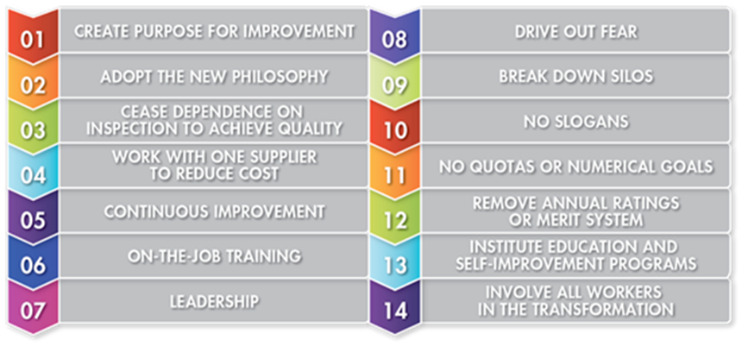
Deming’s 14 key principle was away to transform business effectiveness and improving efficiency. It highlights total quality management and concentrated on the team’s effectiveness, rather than the individuals. The model is based on the principles of total quality management where the whole organisation is required to work as one body. This is/was a revolutionary model which is still given great emphasis even by todays managers and CEO’s. it has excellent team motivational work qualities and highlights that quality of work is better than quantity.

- Create purpose for improvement - Constantly improving the product or service with the aim of increasing market share and staying in business, so that the organisation can provide jobs in the community.
Asda is consistently expanding and constantly opening new stores around the country. The majority of their staff are sourced from the local area so they can provide local knowledge. Local knowledge enables them to be sensitive to the needs of the community. For example, they have taken advantage of the Islamic month of Ramadhan by offering low prices on Asian foods in their “world foods section” and marketing it to Muslims.

- Adopting to new philosophy in the new economic age. The current new economic “philosophy” is online shopping which is a large portion of today’s economy and will play a bigger role in the future.
Asda has kept in line with its competitors when it comes to online shopping. They offer website and mobile app shopping which can then be delivered for a small fee.
- Ceasing dependence on the need for constantly inspecting quality. By producing a good quality product in the first place, there will not be a need to constantly change and improve on it.
Asda provides leading brand products and its own brand is also of a reasonable quality. Their clothes and homewares brand “George” have been nominated for multiple awards. The strongest competition they face is here is from Aldi and Lidl who provide good quality food products that are cheaper than the Asda home brand.
- Sticking to one supplier and building a long-term relationship of loyalty and trust outweighs the importance of buying it at the cheapest price.
Asda stocks all the leading brands that its competitors do and has maintained a good relationship with them. This has helped to promote the brand and enabled Asda to stay competitive by giving special offers on these leading brands.
- Improving constantly on the production of service, quality and productivity can decrease costs.
Asda should always be looking to improve efficiency and effectiveness to reduce costs which does through its training programmes and quality surveying of its goods.
- On the job training.
Asda is routinely training and retaining their staff to improve every aspect of the business. This includes customer service, the handling of inventory and health and safety at work.
- The role of leadership is one being to supervise, rather than penalise. Managers and supervisors should be there to help staff do a better job and constantly noting on how they can improve on making the task easier and more efficient. This includes the use of machinery and technology.
Asda has a tall functional structure in the shape of a pyramid, where the CEO is at the top and everyone reports either directly to the CEO or the executive of the department. The executives of departments should constantly stay in touch with branch and area managers, maintaining a good relationship and provide persistent training in line with the company’s ethos.
- Driving out fear, so that all the workers can work effectively and to the best of their abilities. By providing a safe work environment, productivity of the workers will always be on the increase.
Asda has a diverse working force and policy which is in line with government legislation. This also helps them to make the most of their employees by encouraging them to work effectively. Asda is a very sought-after company to work for and is always looking to employ new talent to help them stay ahead of their competition.
- By breaking down silos – everyone involved in the research, design, production and sale of the product must work together as a team to ensure that there are as few problems as possible. It is important that they all have the same knowledge and understanding of the of the product or service, even though they have different responsibilities in the delivery or sale of the product.
All of the Asda employees need to work as one entity, everyone involved in the organisation has an important job or role to deliver. This stems from the responsibility of the warehouse workers, right up to the CEO’s. everyone needs to do their job effectively and have a shared vision of what the organisational goals are.
- No slogans – by eliminating policies that can cause conflicts between the employees or asking for too much perfection in certain tasks. It is important to ask for what is only humanly possible otherwise this can also counterproductive.
Asda currently has an employee of the month scheme which does have its benefits as it can encourage healthy competition amongst the employees. It encourages them to come to work on time and be well presented. Schemes like this help to identify the employees that take their job seriously and who could possibly be promoted up when the need arises.
- No quotas or numerical goals – asking employees to work or race against each other can lead to poor productivity and quality. Managers should encourage a better quality of product or service and ensure that the job is done right the first time.
Workers at Asda are constantly being trained to work effectively and efficiently. It does not ask them to race against each other at tasks as that could cause poor performance at the task. For example, if there was to be a race to stack shelves, this could cause the job to be done poorly and the end result being unsatisfactory and unsightly.
- Remove annual rating systems – this is to remove barriers that affect hourly workers that might encourage them to churn out lesser quality goods because of pressure from management.

Asda has a monthly employee review scheme policy in which employees can sit with their team leader and discuss their progress at the company. This is better than having a yearly review based on achievements.

- Education and self-improvement – this can be achieved through training programmes and team building exercises. In the current climate, companies and organisations are always sending their managers on training courses to help them improve their managerial techniques.

- Involve all workers in the transformation – involving all the members of the organisation to work as one body from the top of the organisation to the bottom.

Juran’s Theory on Quality
Doctor Joseph Juran provided a framework on quality management in which he provided a number of contributions on the subject of managing quality, Bigsaard (2007). McGowan (2010) states that his theory had an impact on the Japanese economy after World War Two. The three key components that are part of his theory are; quality planning, quality control and quality management. The process is described as identifying customers and their needs, identify how to meet the needs, measures of quality needed to be produced and these also need to be met consistently; McGowan (2010). In addition to this, McGowan (2010) states Juran’s theory proposes that senior or top-level management must ensure they are sincere in their efforts with dedicating to quality, otherwise the effort that it put in is potentially a waste. Asda’s higher management are responsible for the quality of their planning, management and control and it is also their responsibility as to oversee how these factors are implemented down the line. Because it is a bureaucracy the lower level worker do not have any say as to how the company is run, what products are sold and what policies are implemented.
Figure 2 – Juran’s Trilogy
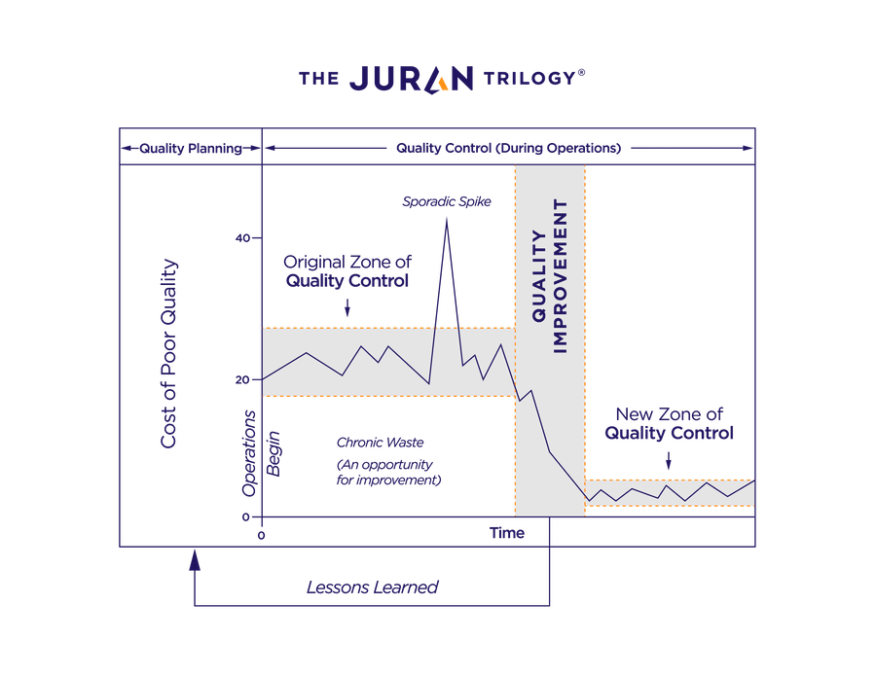
Source: De Feo (2019)
McKinsey’s 7s Framework
McKinseys 7s framework was introduced in the 1970s and its purpose is to improve organisational effectiveness. The tool is important as it can help to understand the complexity of organisations and the model is still widely used today; Mckinsey et al (2008). Jurevicius (2013) states the tool focuses on human resource as a way to help improve the organisational effectiveness and higher organisational performance. Jurevicius (2013) also describes the seven key elements of an organisation that are critically examined, these are known as hard S’s; structure, strategy, systems and soft S’s; shared values, skills, style and staff.

Figure 3 – McKinseys 7s Framework
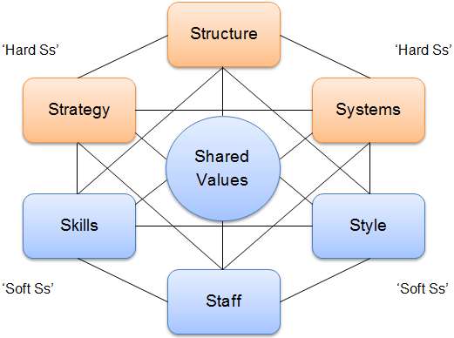

Source: Jurevicius (2013)
According to Jurevicius (2013), the shape of the model represents the interconnectedness of the seven key factors. Egner (2009) states the tool can help organisations overcome challenges such as evolving markets, increased competition and the increased expectations from shareholders and stakeholders. Egner (2009) also advises that it is essential for all factors to align as well as avoid any conflict between any of the factors so that there is maximum output achieved.
Structure
The structure entails the way the business is organised and this includes the levels of management as well as whom reports into whom. Asda is a functional structure and is centralised by design. It has the characteristics of a bureaucracy and has many different departments.
Strategy
Jurevicius (2013) describes the strategy as the plan that has been created by the business in order to achieve competitive advantage. It is important for the strategy to be well-aligned and it must also be clearly articulated. The strategy of an efficient business is usually backed up a strong mission, vision, values and goals. Asda maintains a good strategy designed and created by its higher management and is implemented throughout all of its stores.

Systems
Systems are the procedures and processes that employees use to undertake their work. Asda is a bureaucracy so it has standardised procedures that need to be followed. The disadvantage to this, is that there is a lot of red tape involved and employees must always seek permission of upper management before they can make any decisions.
Shared Values
The shared values are the goals for the company and these are demonstrated through the work ethic and culture. Asda uses training programmes to try and help all members of the organisation work together. All new employees must go through a rigorous training programme and health and safety course before they can commence work in the store or warehouse.
Skills
The skills are what employees within the organisation hold. There are many skilled people working within the Asda organisation and are trained rigorously in their jobs to avoid any mishaps or incidents.

Style
The style is related to the type of leadership that is used within the business. The styles of leadership used in Asda are democratic and autocratic. The upper management would be allowed to be democratic in the way they work, this allows them flexibility to solve problems on the spot. whilst the lower grade employees, such warehouse operatives and store workers will be working under the autocratic principle.

Staff
The staff are their general capabilities are defined for this factor. Staff are very important to the success of any business and their ability to do their job well will determine how well the company performs. Asda needs to keep good experienced hard-working staff and workers, so they can remain competitive. Large organisations like Asda, Tesco and Morrisons are always on recruitment drives and are head hunting the best talent.
Conclusion
Ethics and sustainability are fundamental to the success of a business as they can have a significant impact on the reputation of an organisation as well as their relationship with the customer. It is obvious that strong ethical and sustainable values and processes can enhance the value and image of a brand, which is why organisations must take and action these matters seriously. It is the job of the CRM department to make sure that the relationship between its customers is solid and not fluid. The CRM needs to make use of all resources available to them, to build on this relationship and the use of ethical and sustainable marketing is an excellent opportunity. This report has investigated the strategies that Asda have implemented in order to fulfil their ethical and sustainable responsibilities. However, recommendations have been provided below in order to provide Asda strategies on how they can further enhance their policies and procedures.
Recommendations
One of the recommendations for Asda is to enhance their corporate communications and reports on how they are addressing ethics and sustainability. This will help enhance their brand further and make their customer relationships stronger. It is crucial for Asda to provide hard evidence on how their strategies align with sustainability and ethics in order to make customers aware of the positive contributions they are making to the society and the positive impacts they are having on the environment.
Ethical and sustainable products are a main driver, when it comes to consumer choice. Customers are willing to pay a little extra if they know that their products have been ethically sourced or that their products have come from sustainable sources. Green policies are now key to marketing and will help improve the sale and advertising of a product. The current focus is on the state of the world’s oceans and the effect that plastic is having on them. Government legislation is also helping to bring down the carbon footprint and needs to be adhered too or they could face consequences in the courts and backlashes from the public. Public scandals can be very dangerous especially to large organisations that would see immediate drops in profits and share prices.
Another recommendation for Asda is ensure on-going investment into their website and mobile App as the future of shopping is predicted to be digital. Asda is currently in line with the other leading supermarket brands and offers the same services as Tesco’s, Sainsbury’s and Morrison, who also offer services such as click and collect and online delivery, but with the development of internet and broadband, it is likely that online shopping can only increase. The use of social media platforms like Facebook, twitter and Instagram need to be constantly up dated as they are cheap and reliable sources of advertising.
Although some people feel that Brexit is yesterday’s news, there is still time for Asda to take advantage of the situation, before it is fully implemented. In the future it seems very highly likely that taxes on products coming in from Europe might substantially rise and even the possibility of them becoming less available. Asda should take full advantage by stock piling as much non-perishable products from Europe as is possible. Brexit could also cause staffing issues that need to be addressed immediately.
At the time of writing this report, the world is facing a global pandemic COVID-19 or also known as Corona virus. So far it has sent at least two European countries in to total quarantine. The virus at the moment is still picking up momentum and although panic buying has started, it is still limited to certain products like hand sanitiser, toilet paper, pasta and canned goods. Panic buying has already seen some supermarket shelves being stripped bare of these products and could see other items disappearing as well if people start stock piling. Asda needs to prepare itself for such eventualities firstly by making sure it has lots of stock available for the large consumer demand. They need to be aware of the customer’s needs and have items like basic medications and sanitary products well stocked and their availability well publicised. At the moment, it would not be un-ethical to say that Asda should take advantage of the situation and use it to gain the competitive edge over its rivals. If the virus continues to spread the situation could get a lot worse especially if it was to mutate and affect live stock as well as humans. They also need to prepare for the worst and put emergency contingency measures in place to protect themselves from disasters like looting and total quarantine and risk assessments should be carried out to stop the spread of the infection to its employees.

References

De Feo. (2019). The Juran Trilogy: Quality Planning. Juran. 1
McKinsey & Company. (2020). Enduring Ideas: The 7-S Framework. McKinsey & Company.
Rouse M. (2019). CRM (customer relationship management). Tech Target
CFI. (2020). What are Business Ethics? Business Ethics.
Muller A. (2014). Sustainability and customer relationship management: current state of research and future research opportunities. Research Gate.
McGowan G. (2010). Management Theory of Joseph Juran. Business.
Bisgaard S. (2007). Quality management and Juran's legacy. Online Library.
Kantar. (2019). Grocery Market Share. Available: https://www.kantarworldpanel.com/en/grocery-market-share/great-britain. Last accessed 02/03/2020
Sodrey S. (2019). SWOT analysis of ASDA. How and What.
Alurajah S. (2015). Contribution of Human Resource Management in Creating and Sustaining Ethical Climate in the Organisations. Sri Lankan Journal of Human Resource Management. 5 (1)
Stanwick P (2014). Understanding Business Ethics. London: Sage.
Cooper B. (2009). Asda and sustainability – Better things in store? Ethical Corporation.

