Research Proposal: Analyse the impacts of socio-economic force on employees’ performance management and monitoring in different work modes: Hospitality HR’s perspective.

Module title: Personnel Resourcing and Development
Module code: BMIH5005
Lecturer’s name: Scott James, Jemma Smith
Name: Mircea Nicolae Tilica
Student ID: 2246572

Table of Contents
1. Introduction 3
1.1. Background 3
2. Literature Review 4
2.1. Hospitality Industry Trends 4
2.2. Different Work Modes and its Impact on Employee Monitoring 5
2.3. Radisson Employee Monitoring Management and Possible Solutions 6
3. Evaluation and Conclusion 7
3.1. Conclusion 7
3.2. Recommendations 8
References 9

1. Introduction
Radisson Hotel is a world-renowned hotel that has received numerous recommendations for accommodation and exceptional services; it has over 1,320 hotels in 120 countries (Radisson, 2023). The chosen hotel chain is well-known for its exceptional performance, as it has received numerous positive reviews from guests and industry awards. Nevertheless, more contemporary issues involving Radisson are in workforce management, particularly the problem of how to address more flexible work modes.

1.1. Background
The hospitality industry has been impacted by economic fluctuations especially when experiencing volatility as evidenced by the COVID-19 pandemic (Liu et al., 2023). According to Statista (2024), COVID-19 led to a global hotel market revenue drop of more than 50% in 2020 shown in figure a,b, necessitating cost and economies of scale relooking. From an economic point of view, this pressure is seen to exert pressure on Radisson to seek ways and means of practicing lean and efficient work models that include hybrid and flexibility to remain relevant and profitable (Statista, 2024). The concept of work culture has become dynamic mainly due to technological innovation that has transformed the regular workplace setting which can either be remote or hybrid (Raj et al., 2023). According to Aleem et al. (2023), the Pandemic fast-forwarded the evolution of digital technology by several years and remote working became the norm in many sectors. Here, the highlighted technologies are key to implementing technological solutions for employee monitoring and management in a hybrid work environment for Radisson. The changes in cultural values regarding work-life balance serve to intensify the argument for flexible work schedules (Shagvaliyeva & Yazdanifard, 2014). Now a new survey by FlexJobs, in June 2021 found that 58 percent of employees said they would seek another job if they couldnot work remotely after the pandemic (Pelta, 2021). This trend demonstrates the shift of the workforce to fluidity, which puts pressure on Radisson to adopt modern work policies that meet the expectations of their workers while continuously providing exemplary customer service. The aim of this proposal is to examine how Radisson Hotel can adopt different work modes; especially on addressing management of employee performance issues. With the help of the proposal, the elaboration of hybrid, office, and flexible work models in the context of the specific work of Radisson will be investigated.
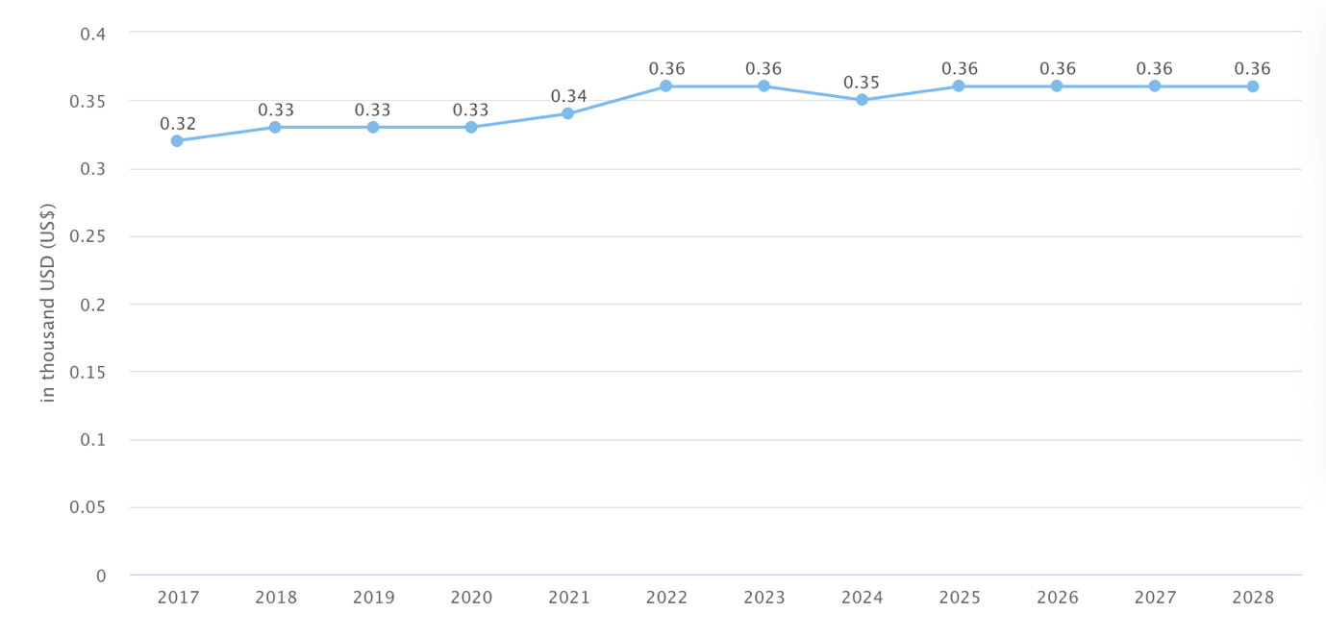
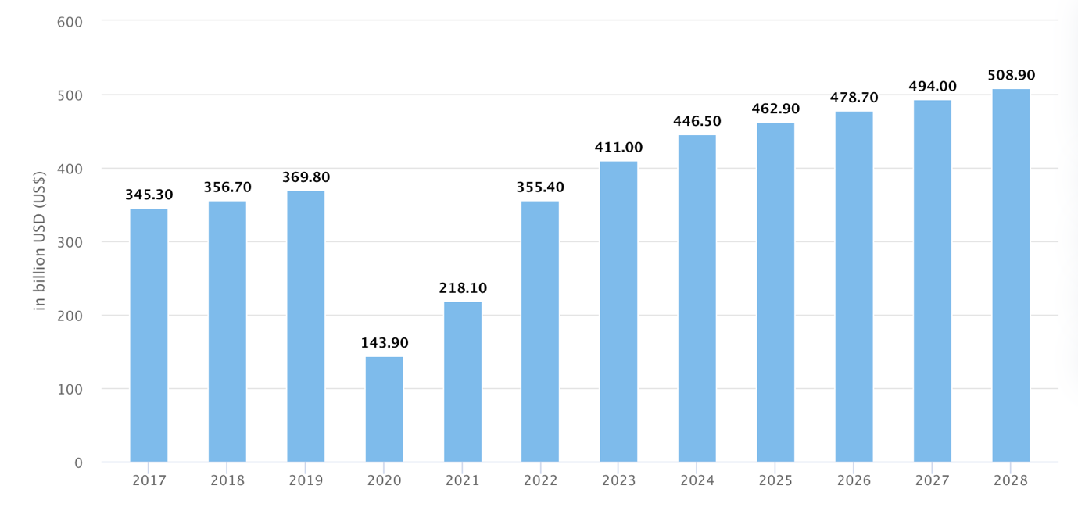
Figure 1 (a,b): Hotel Industry Trend (Statista, 2024)

2. Literature Review

2.1. Hospitality Industry Trends
Before the COVID-19 outbreak, the work formats in hospitality organizations were traditional with most employees working under fixed on-site environments owing to the nature of the business. But as the case has shown, early signs of change had started appearing owing to the advancements in technology that affected the industry. The use of digital platforms in taking orders, responding to customers, and managerial operations began to show some flexibility (Khan et al., 2021). Employees started experimenting with flexible work arrangements for some clerical and technical positions (Thompson et al., 2014). For example, through widespread computerization, Radisson Hotel established a central reservation system that enabled reservation operators to operate independently. This sort of early attempt was aimed at increasing performance and cutting costs of general expenses (Brussels, 2023).

2.2. Different Work Modes and its Impact on Employee Monitoring
The pandemic also proved remote work for most tasks and positions within a hospitality company including marketing, human resources, and financial departments. Some of these tasks could be executed effectively from home, with the advancement of technology in communication and collaboration tools (Urbaniec et al., 2022). For instance, Radisson reassigned several organizational workers to work remotely to sustain business operations in the face of strict health measures. Remote work together with taken as whole working days provides a high level of flexibility and even can save money on rented working space (Silvermann, 2024). Some studies showed that working in the hybrid model may enhance several aspects and lead to higher workplace effectiveness; for instance, according to García-Salirrosas et al. (2023) the performance of remote workers escalated by 13% in 2015. For Radisson, the option to shift to a more flexible model of work implied potential benefits in the form of increased job satisfaction and reduced turnover rate. However, there are some drawbacks i.e., for instance, guaranteeing a constant level of service in the team, and team unity. Implementation would need enhanced technology in working and communicating, recording performance, where most of its workers would be working away from the physical workplace (Grønholdt & Martensen, 2019). Standard working spaces allow for close monitoring of employees, as well as providing easy access to tools and equipment that are beneficial in delivering quality services, particularly in the service sector (Zhenjing et al., 2022). Many of these experiences are a significant part of Radisson’s core operational model, which involves a focus on face-to-face communications with guests. However, conventional workplace settings provide few working options, implicitness of which can negatively impact productivity and motivation. However, a study by Davis et al. (2012) shows, that only about one in three employees can be considered engaged at work, leading to question the lack of movement at workplaces. Also, most industries have high fixed costs due to the costs of renting physical office space, and that is why the sustainability of this structure needs to be examined. Flexible working patterns, which enable people to choose their working hours and locations, can be of great value when it comes to increasing job satisfaction and improving personnel acquisition (Yildizhan et al., 2023). In an article by Wingard (2020), it was seen that 94 percent of employers said that productivity was either the same or higher when flexible work arrangements were adopted. In the case of Radisson, integrating a flexible working model might mean more employees’ self-governance and performance. However, this approach brings some challenges in terms of scheduling and guaranteeing the constant quality of the provided services. Adopting a flexible work model at Radisson would require installing comprehensive performance tracking systems to check on the workers’ productivity; this would help check on other employees working remotely to maintain an excellent standard of service delivery (Mamatha & Thoti, 2023). According to Ferrara et al. (2022), employees who work remotely are 22% happier with their jobs than those forced to come to the office, and this could decrease the turnover rate. Nevertheless, monitoring the performance of employees in the form of remote employees has its challenges. Accordingly, Radisson would have to make investments in productivity-related applications that would enable efficient performance monitoring and the use of project management tools and the like for collaboration. It is miles easier to monitor the employees and provide them with feedback, especially if the organization requires following a traditional corporate work model that suits Radisson. However, such a fixed model restricts the freedom of employees which in one way or another can affect morale, motivation, and thereby, productivity. According to the Gallup employee engagement survey conducted in 2024, only 34% of employee staff felt engaged at the workplace which insinuates that the conventional office structures may not wholly address the current age employees' requirements (HARTER, 2024).

2.3. Radisson Employee Monitoring Management and Possible Solutions
Radisson Hotel Group has implemented flexible work structures which include a hybrid and remote working model especially given that some positions do not necessitate the physical presence of an employee all the time. In terms of performance management, the company has applied integrated communication as well as cloud-support systems to allow Radisson to have access to and be supported through the necessary resources and tools while working remotely. The conformity of periodic check-ins and progress reports with managers also ensures that the employees remain accountable for their tasks and are on track toward accomplishing the laid down goals and objectives (Radisson, 2024). Occupational relations at Radisson likewise stress employee involvement achieved through organizational schemes such as online team building, as well as support for improving the employees’ quality of work-life balance. Such measures when combined with other staff training and development programs put Radisson in a position to guarantee that its employees offer an acceptable level of productivity (Hoffman, 2019). To further improve on this monitoring of the hybrid workers, Radisson should consider acquiring more advanced performance management systems which would help track all the activities of the employees. There is a variety of solutions on the market, such as Workday or SAP SuccessFactors, that provide functional tracking, goal setting, feedback processes, and more. Also, the application of analytic tools based on AI technology can find regularities in employees’ work experience, which can be important for further optimization and professional assistance (Murugesan et al., 2023). Ad hoc training sessions also can be conducted by offering frequently used software for work or digital working tools training sessions for the employees and precautions related to working from home can also be taken so that employees are always prepared for the Hybrid ways of working (Kozlowski & Ilgen, 2006). For even better remote work monitoring, Radisson could invest in applications like Time Doctor or Hubstaff or systems that would offer additional data on employee performance and the way they use their time at work. Moreover, specialized technologies with incorporated performance tracking panels assist managers in monitoring the results of distant workers without controlling their tasks avidly. It also shows that strengthening cybersecurity and educating people regarding protecting data can guarantee that working from home is safe and does not violate any rules and protocols (Borkovich, 2020).

3. Evaluation and Conclusion

3.1. Conclusion
The hospitality company known as Radisson Hotel Group has established a reputation for providing the highest quality of service and operates internationally. However, employing modes like traditional work patterns may not be very effective or applicable in implementing more efficient strategies since there are modern-day issues like economic instability and technological innovation. This has been most evident in the COVID-19 experiences where systemic, hybrid, remote, and flexible working modes have become pertinent for organizations to keep working effectively and for employees’ content. It is quite logical that Radisson Hotel Group has already begun some steps towards a change in working models toward hybrid and full remote work where it is possible and applicable not for all positions but for those who do not necessarily have to attend meetings all the time. These changes are prompted by socio-economic factors that include stability in the economy, new technologies, culture towards working and family, and market structures that favor labor. These flexible work models create potential advantages such as high job contentment rates, low turnover, and operating costs, but also service standards and the enhancement of employee supervision.

3.2. Recommendations
Performance Management Systems: For supervising and controlling employees in the new context of activities, including working from home and in the mixed model, Radisson should integrate more effective software, for example, Workday or SAP SuccessFactors. Such systems provide broad features for the evaluation of the performance and setting of the objectives and appraisal. The application of these tools will assist in maintaining a high motivation of the workers while keeping them on track with the Radisson standards (Murugesan et al., 2023).
Remote work monitoring tools: To enhance their remote workers’ oversight, Radisson can utilize tools such as Time Doctor or Hubstaff. These applications give details about productivity and time to be utilized by the employees, giving the managers a chance to check on the workers without having to constantly monitor them. At the same time, the use of these tools can help to get an idea of how the employees spend their time, and this can be very valuable for further steps (Borkovich, 2020).
Work-life balance and employee engagement: There is also a need for Radisson to maintain employee well-being through the flexibility to provide options that make employees’ schedules manageable and the availability of mental health assistance and wellness programs. Ensuring a good work-life balance remains practicable for all employees is crucial for retaining maximum productivity and morale. Creating online team-building events and maintaining the links between participants will assist in managing the social cohesion issues among the teleworkers and the other employees who work on an unpredictable schedule (García-Salirrosas et al., 2023).

References
Aleem, M., Sufyan, M., Ameer, I., & Mustak, M. (2023). Remote work and the COVID-19 pandemic: An artificial intelligence-based topic modeling and a future agenda. Journal of Business Research, 154, pp. 113303.
Borkovich, D. J. (2020). Working From Home: Cybersecurity in the Age of Covid-19. Issues in Information Systems, 21(4), pp. 234-236.
Brussels. (2023). Radisson Hotel Group expands its real-time instant online booking platform for meetings and events in EMEA portfolio. Available at: https://www.radissonhotels.com/en-us/corporate/media/press-releases/radisson-hotel-group-expands-real-time-instant-booking-platform-for-meetings-and-events
Davis, M. C., Leach, D. J., & Clegg, C. W. (2012). The Physical Environment of the Office: Contemporary and Emerging Issues. In John Wiley & Sons, Ltd eBooks (pp. 193–237).
Ferrara, B., Pansini, M., De De Vincenzi, C., Buonomo, I., & Benevene, P. (2022). Investigating the Role of Remote Working on Employees’ Performance and Well-Being: An Evidence-Based Systematic Review. International Journal of Environmental Research and Public Health/International Journal of Environmental Research and Public Health, 19(19), pp. 12373.
García-Salirrosas, E. E., Rondon-Eusebio, R. F., Geraldo-Campos, L. A., & Acevedo-Duque, N. (2023). Job Satisfaction in Remote Work: The Role of Positive Spillover from Work to Family and Work–Life Balance. Behavioral Sciences, 13(11), pp. 916.
Grønholdt, L., & Martensen, A. (2019). Linking employee, customer, and business results: a study in the hotel industry. Total Quality Management and Business Excellence/Total Quality Management & Business Excellence, 30(sup1), S74–S82.
HARTER, J. (2024). In New Workplace, U.S. Employee Engagement Stagnates . Available at: https://www.gallup.com/workplace/608675/new-workplace-employee-engagement-stagnates.aspx
Hoffman, J. (2019). Employee Feedback: Radisson Hotel Group’s New Way of Working . Available at: https://www.linkedin.com/pulse/employee-feedback-radisson-hotel-groups-new-way-working-hoffman
Khan, K. I., Niazi, A., Nasir, A., Hussain, M., & Khan, M. I. (2021). The Effect of COVID-19 on the Hospitality Industry: The Implication for Open Innovation. Journal of Open Innovation, 7(1), pp. 30.
Kozlowski, S. W., & Ilgen, D. R. (2006). Enhancing the Effectiveness of Work Groups and Teams. Psychological Science in the Public Interest, 7(3), pp. 77–124.
Liu, Y., Cheng, X., Liao, S. S., & Yang, F. (2023). The impact of COVID-19 on the tourism and hospitality Industry: Evidence from international stock markets. ˜the œNorth American Journal of Economics and Finance, 64, pp. 101875.
Mamatha, N. K., & Thoti, N. K. K. (2023). The Effects of Working Remotely on Employee Productivity and Work-Life Balance. Journal of Advanced Zoology, 44(S6), pp. 1304–1313.
Murugesan, U., Subramanian, P., Srivastava, S., & Dwivedi, A. (2023). A study of Artificial Intelligence impacts on Human Resource Digitalization in Industry 4.0. Decision Analytics Journal, 7, pp. 100249.
Pelta, R. (2021). FlexJobs Survey Finds Employees Want Remote Work Post-Pandemic . Available at: https://www.flexjobs.com/blog/post/flexjobs-survey-finds-employees-want-remote-work-post-pandemic/
Radisson. (2023). Our global presence . Available at: https://www.radissonhotels.com/en-us/corporate/about-us/our-presence
Radisson. (2024). Radisson Hotel Group launches new career development proposition with Career Month . Available at: https://www.radissonhotels.com/en-us/corporate/media/press-releases/RHG-launches-new-carrer-development-proposition-with-Career-Month
Raj, R., Kumar, V., Sharma, N. K., Singh, S., Mahlawat, S., & Verma, P. (2023). The study of remote working outcome and its influence on firm performance. Social Sciences & Humanities Open, 8(1), pp. 100528.
Shagvaliyeva, S., & Yazdanifard, R. (2014). Impact of Flexible Working Hours on Work-Life Balance. American Journal of Industrial and Business Management, 04(01), pp. 20–23.
Statista. (2024). Hotels - Worldwide. Available at: https://www.statista.com/outlook/mmo/travel-tourism/hotels/worldwide
Silvermann, B. (2024). Does Working From Home Save Companies Money? Available at: https://www.business.com/articles/working-from-home-save-money/
Thompson, R. J., Payne, S. C., & Taylor, A. B. (2014). Applicant attraction to flexible work arrangements: Separating the influence of flextime and flexplace. Journal of Occupational and Organizational Psychology, 88(4), pp. 726–749.
Urbaniec, M., Małkowska, A., & Włodarkiewicz-Klimek, H. (2022). The Impact of Technological Developments on Remote Working: Insights from the Polish Managers’ Perspective. Sustainability, 14(1), pp. 552.
Wingard, J. (2020). 94% Of Workers Want This Benefit (And Most Leaders Are Screwing It Up). Available at: https://www.forbes.com/sites/jasonwingard/2020/03/06/94-of-workers-want-this-benefit-and-most-leaders-are-screwing-it-up/?sh=3c5f0fd4451f
Yildizhan, H., Hosouli, S., Yılmaz, S. E., Gomes, J., Pandey, C., & Alkharusi, T. (2023). Alternative work arrangements: Individual, organizational and environmental outcomes. Heliyon, 9(11), e21899.
Zhenjing, G., Chupradit, S., Ku, K. Y., Nassani, A. A., & Haffar, M. (2022). Impact of Employees’ Workplace Environment on Employees’ Performance: A Multi-Mediation Model. Frontiers in Public Health, 10.

