

Task 1 – Reading Task Template
Upload your photo of your A3 in-class notes here:
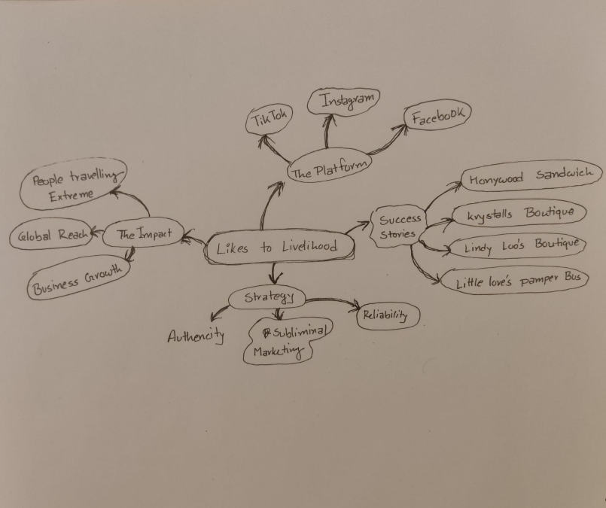

1. Answer these questions using the sentence starters below
a. What is the main idea of the text?
The main idea is that many small businesses are using social media platforms such as, TikTok and Instagram to go viral which is helping them bring in a huge number of new customers and change their livelihood.
b. What are two key points?
One key point is that viral videos are making people travel for hours just to visit these places to have a sandwich or to get a prom dress.
Another key point is simple and funny posts draw more attention than traditional advertisements as people prefer buying from relatable people.
c. What part of the text did you find most important? Why?
The most important part is the quote from the marketing expert, “people know what is an ad and they don’t want to be sold to. People buy from people.” For me it means, people want authentic content and don't want to feel like they're being deceived.
d. Was anything unclear or difficult to understand?
I was not sure about the part where the marketing expert talks about subliminal marketing and little skits. Other than that, the text was pretty clear.

e. How did your group help you understand the text better?
My group helped me by explaining the marketing quotes which made the expert's advice a lot easier for me to understand.
3. One sentence reflection
Question: What did you find challenging about this task?
The hardest part was narrowing down the article to just two key points since there are so many different shops and examples that were mentioned in the article.

