
Title of report: Assessment 1

Course: BA Business Management

Module name: International Business Communications

Module Code: LCBB6002

Lecturer name: Dr Charles Nwaogwugwu

Student name: Krasimir Iliev

Student ID: 2123464

Submission Date: 27/04/2024

Table of Contents
Introduction 3
Company Overview (Iceland) 3
Evaluation of Two EU Countries Identify Cultural Differences between Greece and Austria 4
Hofstede’s Culture Dimension Model 5
Analysis of the Communication Barrier the British Business 7
Recommendations on Greece Should the British Business Expand 9
Conclusion 11
References 12

Introduction
International business communication is the simplest way to improve communication in global business is to hire employees to speak multiple languages (Kossowska and Rosiński, 2024). The essay has demonstrated that Iceland is a leading and fastest-growing retailer in the marketplace. It has explained two countries to analyze country differences. The essay has discussed Hofstede’s model to understand cultural differences within the workforce and possible risks faced by organizations in the United Kingdom. It has demonstrated two different countries of the EU and identified communication barriers the British could experience for organizational growth. Moreover, the Global management consultant of Iceland suggests choosing two EU Countries to improve customer experience. The essay provided suitable suggestions to British businesses and strategies to overcome challenges to succeed in a positive environment for everyone. International business communication helps to better understand cultural sensitivity, the background of the workforce, and the labor outlook in the current marketplace.

Company Overview (Iceland)
Iceland is the fastest-growing and most innovative retailer in the UK. The Company has managed around 900 stores in the UK and 40 owned as franchise stores. In 1970, Iceland opened its first shop selling frozen food in the market. The Company has around 22,000 employees around the world to manage the operation effectively (Iceland, 2024). Iceland mainly focuses on innovation, convenience, and value for organizational development. In COVID-19, Iceland created 3,500 new jobs to meet the online shopping demand. Iceland Foods Limited provides frozen food products or services to satisfy customer needs. Iceland begins trial of new swift convenience of store format for organizational growth. Iceland seeks to develop a growing, profitable, and answerable business that does the precise things for colleagues and clients for organizational success.
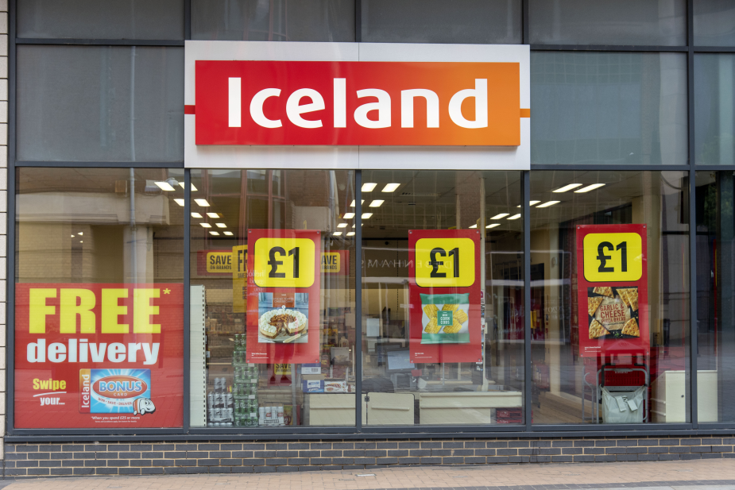.
Source: (Iceland, 2024)

Evaluation of Two EU Countries Identify Cultural Differences between Greece and Austria
To deal with everyday cultural differences, the global management consultant of Iceland identifies the cultures of Greece and Austria for future expansion (Kossowska and Rosiński, 2024). On the other hand, the Manager of Iceland in Greece has a dry sense of humor at every point direct and indirect. Greek people mainly focus on clear and quiet communication channels to deal with challenges in the market situation. Apart from this, Austrians have been talking about their home regions and their sense of belongingness to their region of birth for many years (Escandon et al., 2022). In Austria, people distinctly classy atmosphere for late growth and experience some authentic culture for Austrian fare.
- Social Context: Austria does not depend on shared language, and culture to achieve long-shared history. The Greece Nation is encompassed by both Austria and Greece to accomplish the desired outcome (Dyson and Humphreys, 2023). Apart from this, Iceland mainly focuses on tourist destinations in Greece, while traditional methods to improve organizational performance. Greece's culture and academic exchange with Austria is probably forceful and wide-ranging with other nations. Austria and Greece offer the best cooperation between team members to improve customer experience (Rehman, 2022).
- Possible Risks: The managing consultant of Iceland mainly focuses on identifying hurdles to improve organizational effectiveness. The Company provides good shipping support to improve ethical ratings to maintain its brand image among customer mindset (Sharma et al., 2020). Therefore, Iceland focuses on Greece, and Austria to manage flatted curbs to accomplish the desired outcome. The Company mainly deals with unpredicted alliances with conservation and Greens in 2020. Due to high risk, Iceland has closed its supermarket branches temporarily while focusing on strategies to overcome these challenges (Lovari and Bowen, 2020).
- Labor: Iceland mainly focuses on understanding the shortage of workers is the biggest risk to growth in Greece and Austria. The government also expects the financial system to grow 0.2% this year, far less than a previous estimate of 1.3% due to weak global demand. Moreover, the job market in Austria is limited, and it has the 10th lowest unemployment rate. Simply, the unemployment rate to the share of the labor force that is without work while available in the marketplace (Escandon et al., 2022). Moreover, Iceland considered laborers who work longer for future growth. Greek people mainly focus on planned increases in welfare payments to improve labor practices.
- Background of Workforce: To deal with the changing situation, Iceland supermarket job employees in Austria are in charge of assisting grocery items and operations to keep for organizational growth (Gerlach and Eriksson, 2021). After being employed, the Company will be charged with acting as the client of contact and supporting them with grocery shipping. To work at a supermarket, Iceland mainly focuses on distinct kinds of customers, patients, and others for organizational growth. Generally, the Greece management team of Iceland focuses on work background and culture to improve performance with new employees.

Hofstede’s Culture Dimension Model
This model stated that the values of those groups of different cultures may generally based on classification, and broad patterns of difference for organizational growth (Rehman, 2022). To deal with the changing situation, Iceland needs to understand the cultural dimension developed by Greet Hofstede. For further study, this model used and gain access to detailed cultural data including regional and demographic segments.
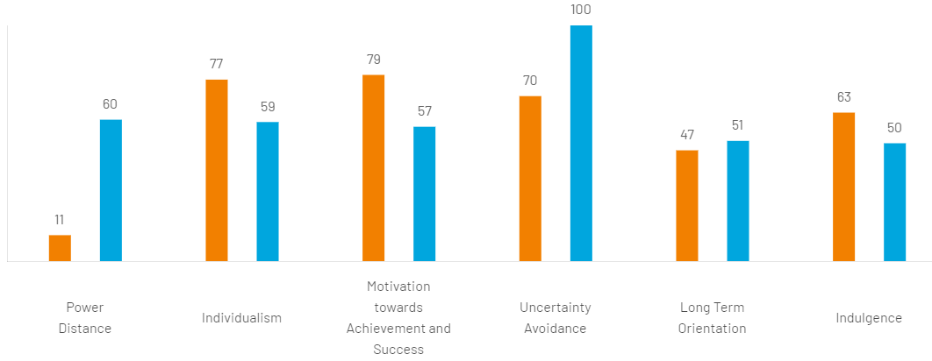
Source: (Kossowska and Rosiński, 2024)

- Power Distance: This dimension shows score of Austria is low which features the style of Austrians and superior access for organizational growth (Rehman, 2022). Moreover, the highly decentralized and supported middle-class people among lower distance countries. Leadership is challenged to improve participative communication and meeting style to improve organizational success in the marketplace. On the other hand, at 60 Greece deals intermediate score while indicating a slight tendency to the higher side. It shows the distribution of power and justifies the facts of the power holder. It shows differences among values bigger than other countries.
- Individualism: Iceland mainly focuses on Greece's society is truly individualist (59 scores) and small families focus on parent and children relationships rather than most common people (Sharma et al., 2020). Apart from this, Austria with a score of 77 shows a high favorite for a loosely-knit social structure in that people are expected to take care of people. Iceland supermarket mainly focuses on customer loyalty based on individual preference for people as well as responsibility and blame.
- Motivation: In this dimension, Iceland studied Austria 79 a high score of motivation toward achievement and success in the marketplace. The Company mainly emphasizes equity, competition, and performance (Escandon et al., 2022). Therefore, a 57 score in Greece denotes decisive society-driven competition in the marketplace. Managers in Iceland are expected to be decisive and assertive to augment organizational performance (Lovari and Bowen, 2020).
- Uncertainty Avoidance: Austria is the best nation to deal with complex times and avoid uncertainty in the marketplace. The Company decided to avoid maintaining of rigid code of behalf and behavior for organizational success (Dyson and Humphreys, 2023). To deal with the challenging situation, Iceland also focused on Greece scoring 100 higher than Austria's 70 but it gave slight preference to improving organizational value. In the supermarket, the Company mainly focuses on countries with high uncertainty avoidance ability to survive in the market in the long run (Lehe et al., 2022).
- Long-Term Orientation: Austria's score of 47 does not show a physically powerful preference for their direction. Apart from this, the Company believes the truth is dependent on the situation, content, and time to deal with changing surroundings (Gerlach and Eriksson, 2021). Greece scored 57 which shows a practical nation. The Company mainly focuses on the ability to adopt tradition and change conditions to achieve better results.

Analysis of the Communication Barrier the British Business
The Global Management Consultant of Iceland needs to be aware of the potential cultural barrier toward communication that may exist within the organization (Iceland, 2024). The Company mainly focuses on proper communication channels to achieve success in the competitive marketplace. It is a procedure relying on every one of the same pace and understanding content even more vital growth in the marketplace. Cultural communication is often more challenging than meetings and negotiating to interrupt someone who is speaking. Moreover, this way it shows the rudeness of a person for organizational growth (Sharma et al., 2020). Iceland mainly focuses on understanding how communication barriers affect organizational performance.
- Language Skills: It shows the crucial barrier to effective communication in the global marketplace. Employees do not understand the language of their counterparts, different cultures, and formality while communicating effectively (Kossowska and Rosiński, 2024). There are always risks that show at different levels of procedure. For instance, the word "du" is used for associates and relations while the word “Sie” is used for commerce associates. Global management consultant of Iceland understands language-related issues create problems. These expressions that do not translate often have different meanings in distinct cultures (Lovari and Bowen, 2020).
- Belief and Behavior: To survive in the market, the Managing Consultant of Iceland mainly focuses on cultural norms and values that lead to communication problems in business. The Company found different cultural ideas in context such as polite behavior, treatment position, and suitable way of meeting to share valuable information with the team (Escandon et al., 2022). Supplier of Iceland always tries to avoid misunderstandings among people and make sure negotiation is handled suitably across distinct cultures.
- Culture Shock: On the other hand, Iceland needs to understand business for a certain level of culture shock in global projects or services (Rehman, 2022). It is a feeling of disorientation of people may experience while exposed to new and unfamiliar changes in the marketplace. The Company knows that the culture shock of distinct EU nations creates problems as people may find to adjust new ways of doing things in the marketplace. Iceland does not easily adjust in Greece as well as Austria due to culture shock affecting performance. To deal with the changing situation, Iceland needs to develop a new strategy to overcome the challenges of the current market (Lehe et al., 2022).
- Non-verbal Communication: This is another barrier to communication that affects personal as well as organizational performance. On the other hand, Greece and Austria consider it rude to make direct contact with people to achieve something new for organizational success (Dyson and Humphreys, 2023). Due to misinterpretation, body language is left to resolve the problem of communication. To survive in the market, the Company is looking toward survival depending on employees and resolving organizational problems (Lovari and Bowen, 2020).
- Semantic Barriers: The latter involves the usage of technical terms that the receiver is unaware of. Iceland has different departments in the company that perform their roles and responsibilities with each of them having their way of communication. Thus, it could impact interdepartmental communication (Gerlach and Eriksson, 2021). Global management consultants of Iceland are concerned with issues in the process of encoding and decoding messages to deal with challenging situations. The Company's main purpose is to transmit accurate reception of each sign symbol in the context of meanings.

Recommendations on Greece Should the British Business Expand
Iceland's fastest-growing e-commerce channel is established in the United Kingdom and performs its operations virtually (Sharma et al., 2020). To enhance their communication within the firm, it is recommended for them to establish a specific channel of communication that aligns with the organizational culture. Also, it is required for the employees to listen and understand the opinions of other staff so they can communicate without any misunderstandings (Chen et al., 2020). Also, the employees and employers should focus on the consistency of the message. To improve the Greek economy, Iceland is looking toward expanding revenue and profit margin for organizational success. With this single keyword, Iceland focuses on their growing industry, and own business overseas for better success in the marketplace (Escandon et al., 2022). Iceland Supermarket mainly focuses on effective communication to hold employees in Greece as well as in Austria to improve professional growth.
- Common Language: Being a retail industry, the company should hire employees who are comfortable speaking and understanding various languages (Kossowska and Rosiński, 2024). Also, they should possess a common method of communication that would help them understand each other (Iceland, 2024). Being multilingual is common in modern times also it will enhance the productivity of employees. Also, the employees could use simple terminologies for sharing their thoughts and messages in the company. The Company mainly focuses on Greek languages to maintain close connections with people for organizational success (Jadil et al., 2023). Greece people commonly use distinct languages English, German, French, and Italian. To deal with challenges, Iceland clear understanding of the message with the right way of opinions and ideas for organizational success.
- Cultural Awareness: Iceland should promote awareness among their employees of various cultures that are attached to the company (Dyson and Humphreys, 2023). For this task, it could arrange campaigns and provide sessions to the employees enhancing their exposure. Iceland mainly focuses on understanding the reasons that influence the entire society. Moreover, the Company needs to be aware of the local culture, society, and norms of Greek culture for organizational growth (Chen et al., 2020). Being able to communicate with people from diverse cultures us to respect growth effectively.
- Leverage Right Tools and Technology: The manager of Iceland focuses on remote work, smartphones, and other advanced technology to improve work quality for organizational success (Lehe et al., 2022). The Company focuses on modern technology and employee engagement tools to make it easy to connect with people and customers across the world for the right action and decision. Employees may share documents with employees and live chat with each other to resolve organizational problems. With effective communication, Iceland mainly focuses on sharing information with the right tools for effective growth in the marketplace.
- Train Staff on Effective Communication: With live chats, the Managing Consultant of Iceland focuses on good chunks of live communication with others for organizational success. Employees of Iceland carried away feelings and missed key details to fill gaps leading to conflicts, and workplace politics (Jadil et al., 2023). Effective communication is the best way to teach and proactively train people to improve organizational value for future success. Through effective training, Iceland focuses on organizing training and development programs to improve organizational performance. The Company mainly focuses on training sessions in distinct locations in Greece to present their idea in the right manner.
- Nurture Two-Way Communication: The global management consultant of Iceland focuses on a two-way street to reach a desired outcome. Moreover, the Company mainly focuses on discussing the information conveyed and then does not communicate with each other. Iceland focuses on directives and approaches to improve the skills of talented employees who derive an environment of autonomy (Gerlach and Eriksson, 2021). Apart from this, the Company mainly focuses on the right communication strategy to share the respective space of employees and clear communication to understand valuable information. Iceland offers two-way communication in organizations that come on social media for the right growth and success in the distinct market of EU nations.

Conclusion
In conclusion, global management consultants of British multinational supermarkets improve organizational performance. The essay has examined the EU countries and factors to understand the cultural differences between Austria and Greece. Therefore, Iceland uses Hofstede's model to know the cultural background of workers and people for organizational success. To deal with the changing situation, the Manager of Iceland focuses on identifying communication barriers that create challenges to managing business activities. The essay has provided suggestions to improve organizational performance and strategies to overcome communication barriers. To improve communication channels, the Global management consultant of Iceland chose a selection channel to share valuable information with employees for the right decision.

References

About Us (no date a) Iceland. Available at: https://about.iceland.co.uk/ (Accessed: 29 February 2024)
Chen, Y., Singletary, A. and Ames, A.D., 2020. Guaranteed obstacle avoidance for multi-robot operations with limited actuation: A control barrier function approach. IEEE Control Systems Letters, 5(1), pp.127-132.
Dyson, K. and Humphreys, P. eds., 2023. The Political economy of communications: international and European dimensions. Taylor & Francis.
Escandon-Barbosa, D., Ramirez, A. and Salas-Paramo, J., 2022. The effect of cultural orientations on country innovation performance: Hofstede cultural dimensions revisited?. Sustainability, 14(10), p.5851.
Gerlach, P. and Eriksson, K., 2021. Measuring cultural dimensions: external validity and internal consistency of Hofstede's VSM 2013 Scales. Frontiers in Psychology, 12, p.662604.
Jadil, Y., Jeyaraj, A., Dwivedi, Y.K., Rana, N.P. and Sarker, P., 2023. A meta-analysis of the factors associated with s-commerce intention: Hofstede's cultural dimensions as moderators. Internet Research, 33(6), pp.2013-2057.
Kossowska, M. and Rosiński, J., 2024. Global Mindset and International Business: Driving Process Outsourcing Organizations (p. 232). Taylor & Francis.
Lehe, F.G., Tabrizi, N. and Sharepour, M., 2022. Effect of Hofstede cultural dimensions on citizens' satisfaction with tourism activities (Case study: Babolsar city). Tourism Management, 17(58), pp.9-38.
Lovari, A. and Bowen, S.A., 2020. Social media in disaster communication: A case study of strategies, barriers, and ethical implications. Journal of Public Affairs, 20(1), p.e1967.
Rehman, A.U., 2022. Consumers' perceived value of luxury goods through the lens of Hofstede cultural dimensions: A cross‐cultural study. Journal of Public Affairs, 22(4), p.e2660.
Sharma, P., Leung, T.Y., Kingshott, R.P., Davcik, N.S. and Cardinali, S., 2020. Managing uncertainty during a global pandemic: An international business perspective. Journal of business research, 116, pp.188-192.

