STUDENT NAME: YASMIN CHOHID
STUDENT ID: 1814774
DATE: 7-02-2020

PROFESSIONAL AND CAREER DEVELOPMENT
MODULE CODE: BMSW 4005
LECTURER: BUDDHI PATHAK

REFELECTIVE PORTFOLIO

Table of Contents:

A. Discursive report
What is self-awareness.……………………………………………………………………..……….3
Johari Window.…………………………………………………………………..……………………4
B. Reflective report
Importance of the job advert.…….……………………………………………………………….....5
Importance of the application documents.………………………………………………..……….6
The relevance of the job advert in preparation of several documents...………….……………6
The role of preparatory steps before the interviews on performance.…………..……………..7
Lessons drawn from mock interviews and the ways it will influence career
development ……………………………………………………………………………………..…..7
Conclusion…………………………………………………………………………..………….…….8
References……………………………………………………………………….………….……….9
Appendix……………………………….…………………………………………………….……...12

A. Discursive Report
What is self-awareness test?
Self-awareness test is the process of finding out about what qualities you hold and what you’re lacking in. It helps us to understand our personalities, values, habits, emotions and lastly our behaviour. Having a better understanding of both our positive traits and negative traits helps us expand on our many of our own abilities. This forces us to widen our mind-sets in order to further develop and strive to achieve greater goals. Research suggests that critical feedback from oneself promotes learning and increases motivation (Andrade and Boulay, 2003). Therefore, utilising the self-awareness test is a good start to self-improvement. However, the conditions required for self-assessment to occur are difficult to have present at once and therefore, many people do not do this as much as they should (Deakin-Crick et al, 2005). Thus, the self-assessment test was created to get an overall view of oneself in one questionnaire.
Myers Briggs type indicator (MBTI) personality test is a self-assessment test that identifies people’s personality type, strengths and preferences. The test that was done in class for assessing career progression in future was the Myers Briggs type indicator (MBTI) test. The benefit of the test is that you learn about your strengths and blind spots, different ways to gain energy, process information, make decisions, organise and improve work place communication by building better relationship with colleagues (Romo, 2012).
The Myers Briggs type indicator (MBTI) is a typology composed of four pairs of opposite preferences called dichotomies (Potgieter and Coetzee, 2013).
- Extraversion (E) or Introversion (I)
Where people prefer to focus on their attention and get energy.
- Sensing (S) or Intuition (N)
It’s the way people prefer to take in information.
- Thinking (T) or Feeling (F)
The way people prefer to make decisions using logic.
- Judging (J) or Perceiving (P)
It’s how people deal with the outer world.
There are 16 different types of combination (ESTP, ESTJ, ESFP, ESFJ, ENTP, ENTJ, ENFP, ENFJ, ISTP, ISTJ, ISFP, ISFJ, INTP, INTJ, INFP, INFJ) (Romo, 2012). The test gives people four letter designation like (ISTJ) or (INFP) to indicate their preferences and therefore their personality type. The test undertaken in class for assessing career progression the result indicated that I am an ISFJ. A person with the trait ISFJ generally shows how caring, compassionate, practical and how motivated they are to protect and provide for others. There is no best type as all types are equal its only goal is to make you understand and appreciate your personality and the differences between people. The visionary feature of this trait can show a person what impact they will have in the future in accordance to that and understanding of the success they can achieve. The Myers Briggs has given me the understanding to organise my career options, if any of my answers were to be given incorrectly then the result may not be valid and will not benefit me. However the test result has been helpful for me to understand how to progress in my career for the future.

Johari Window
Johari Window is a tool that was first developed by Joseph Luft and Harry Ingham in 1955, to show and explain the model of self-awareness and communication about behaviour, (Esposito, Mcadoo and Scher (1978). Name Johari itself has been named after merging the first names of the two psychologists Joseph Luft and Harry Ingham and was initially called Johari Window.
 | Known to self | Unknown to self
Known to others | OPEN  Known to self and others | BLIND  Not known to self but known to others
Not known to others | HIDDEN  Known to self but not to others | UNKNOWN  Not known to self and others

(Luft, J. and Ingham, H., 1961)
By conducting a class group activity everyone was able to know each other especially themselves. Open is what you know and what others know about you, hidden self is the things we know about ourselves that others do not know, blind self is the things others about us that we do not know, and finally the unknown self is the things neither we or others know about us. The Johari window actually represents information like feelings, views, attitudes, skills, motivation and intentions that a person holds in relation to their group, and its all described in the four grid diagram shown above.

B. Reflective Report
Importance of the job advert
Applying for a job it is important to have the knowledge about the job recruitment process and know the rules and regulations to apply for the post. Preparing documents to apply for the job has to be accordance with the job advertisement and be prepared in a way with the knowledge and skills that will need to be carried within the job (Todd, McKeen and Gallupe, 1995). According to Feldman, Bearden and Hardesty, (2006) it states that many firms emphasis on well- rounded individuals with business knowledge and strong skills, as where the job advertising only focuses on the process of recruiting on hard skills only. Most companies frequently wish to have large amount of applicants to apply for the position so it can give them better chance to find the potential candidate, whereas not realising that by doing so it is increasing the time and money spent on making the decision on selecting the best candidate.
Mahboob and Golden (2013) have investigated how job advertisement for certain job rolls can also discriminate against candidates with particular backgrounds, key requirements in these advertisements were such as age, gender, nationality, nativeness and race. Results from the research have shown how more than half of the advertisement that was gathered had discriminatory element to it.
When I am looking to apply for a job in any company the first thing I look for in a job advert is the qualification and experience that require an applicant to have. Bee and Hie, (2015) stated that most of the job advertisements mentions the requirements of qualifications and some working experience, in another word the employer expects the applicant to have the necessary skills for the position they are applying for. However according to Walker et al, (2008) advertisement of jobs by companies are not so simple as they need to work for whom the job advert is being published for before creating the advertisement. In my opinion before an applicant is recruited for a certain position it is important that they must know the job description and the experience the company requires of them for the position.

Importance of the application documents
McDowell (1987) stated that the cover letter and resume or curriculum vitae is an important document in a form of communication with the employer to accept you and invite for an interview. It also stated that the cover letter should be short in details of their interests, how they have learnt about the job and why the applicant is interested in the position. As the curriculum vitae should include all previous employers’ detail, previous job descriptions, reasons leaving the previous jobs and all qualifications.
I have prepared a curriculum vitae that contains all the information from education details, experiences at work place where I have worked before to all my personal information. I have learnt that a cover letter is necessary to be written correctly and presented effectively, any mistakes such as typos, misspellings and poor sentence structure can result in rejection. Cover letter should always indicate how you can benefit the company to reach its goals rather than stating your requirements for example salary (Korkki, 2009).

The relevance of the job advert in preparation of several documents
Job advert is the description of the job that clearly specifies the responsibility and skill requirements that are needed for the candidate to be able to perform the responsibilities. (Parker and Brown, 2018). The job description that are provided in a job advertisement works as a form of rules for the applicant to prepare their documents that are required to apply for the job. To apply for jobs each time I would have to write separate cover letters each time to apply for the jobs, instead of sending off the same cover letter to all companies. This might result in not being selected for an interview due to the fact that the cover letter might not be relevant for the post and not describe the skills which are required for the job. In fact I have always prepared my cover letter after fully going through the job advert and include all the relevant information in the cover letter that will give the recruiter to be interested with my application.

The role of preparatory steps before the interviews on performance
Job application with all the necessary documents will ensure that the company will be calling you for an interview (Hancock, 2002). Preparation for the interview is very crucial as it might give other candidates the opportunity to get the job if you’re lacking in anything. For this reason I always ensure that I have some knowledge through research about the company and job related questions. I make sure that I am prepared to answer all questions related to the job for instance, my skills, qualifications, experience and any specific qualities that I might have that would be relevant to the post.
Dressing up smartly and being punctual demonstrates an important role in the interview, because being late at an interview shows how irresponsible you are and will reduce the chance to get the job. Presenting yourself well at the interview by dressing up smartly is important as it gives the first impression of yourself to the interviewer of what kind of person you are. Not only dressing up smartly is important it is also important keep up with a positive body language techniques, make sure to smile, maintain eye contact and stand tall or if sitting down do not slouch (To, D.G., 2006. Interviewing.)
Interviews are taken place to judge your knowledge and to check whether you are a suitable person for the job. If you have been selected for an interview it means that the company is already thinking that you might be one of the most suitable candidate for the job (Corfield, 2009). Most likely the interviewer would be the person that you have never met before, in my case I would prefer to be interviewed by someone that I do not know, as it will be easier for me to answer or ask any questions related to the job.

Lessons drawn from mock interviews and the ways it will influence career development.
I have taken part in a mock interview test so that I can improve on any of my shortcomings that I may have. In having a mock interview it has allowed me to practice on how to make preparations for any job interviews successfully and it has also increased my confidence level. There were two main criteria at the mock interview that I have attended and those were the first impression and verbal behaviour. As a result of my first impression almost everything went well apart from shaking hands with the interviewers, as I was very nervous and did not shake their hands in fear of sweaty palms. Apart from the shaking of hands to my knowledge I have kept a positive body language, smiled, maintained eye contact and did not slouch while sitting down which I am a person who always likes to sit up and not slouch whether at home or in public.
There was some verbal issues at the mock interview as I was getting very nervous, I could have spoken more about my strength and the qualities that I have rather than talking about my weaknesses. I was able to answer almost all the questions that I was asked at the mock interview, and if there was any question which I could not answer I have been honest and denied to not knowing the answers to the questions.
Due to this mock interview I have been able to identify my fears and will be able to prepare well in advance for any job interviews that I may have in the future.

Conclusion
This assignment has been helpful to me in analysing the self-assessment tool in developing my career options that I might have for the future. Analysing results from all the test that I have taken in the class has helped to learn about skills and it can contribute towards my job sector. Knowing the importance of the job advert, cover letter and the curriculum vitae has been really helpful for me. Most important role for me was the mock interview as I am aware what to expect at a job interview and how I can improve my answers for the future interviews. It has been a learning experience and helped me to improve my current skills and confidence about my future career direction.

Reference

Andrade, H. and Valtcheva, A., 2009. Promoting learning and achievement through self-assessment. Theory into practice, 48(1), pp.12-19.

Bee, O.K. and Hie, T.S., 2015. Employers' emphasis on technical skills and soft skills in job advertisements. The English Teacher, 44(1), p.1.

Corfield, R., 2009. Successful interview skills: How to prepare, answer tough questions and get your ideal job. Kogan Page Publishers.

Esposito, R. P., Mcadoo, H., & Scher, L. (1978). The Johari Window Test: a Research Note. Journal of Humanistic Psychology, 18(1), 79–81.

Feldman, D.C., Bearden, W.O. and Hardesty, D.M., 2006. Varying the content of job advertisements: The effects of message specificity. Journal of Advertising, 35(1), pp.123-141.

Furnham, A. (1990). Can people accurately estimate their own personality test scores? European Journal of Personality, 4(4), pp319–327.

Hancock, C., 2002. Effective Recruitment and Selection: The Pre-interview Process. Legal Information Management, 2(2), pp.23-25.

Korkki, P., 2009. A cover letter is not expendable. The New York Times, pp.1-3.

Luft, J. and Ingham, H., 1961. The johari window. Human relations training news, 5(1), pp.6-7.
Mahboob, A. and Golden, R., 2013. Looking for native speakers of English: Discrimination in English language teaching job advertisements. Age, 3(18), p.21.

McDowell, E.E., 1987. Perceptions of the ideal cover letter and ideal resume. Journal of Technical Writing and Communication, 17(2), pp.179-191.

Oliver, S., & Duncan, S. (2019). Editorial: Looking through the Johari window. Research for All, 3(1), pp1–6.

Parker, A. and Brown, I., 2018, August. Skills Requirements for Cyber Security Professionals: A Content Analysis of Job Descriptions in South Africa. In International Information Security Conference (pp. 176-192). Springer, Cham.

Potgieter, I. and Coetzee, M., 2013. Employability attributes and personality preferences of postgraduate business management students. SA Journal of Industrial Psychology, 39(1), pp.01-10.

Romo, E., 2012. THE MYERS-BRIGGS TYPE INDICATOR (MBTI).

Silvia, P.J. and Duval, T.S., 2001. Objective self-awareness theory: Recent progress and enduring problems. Personality and Social Psychology Review, 5(3), pp.230-241.

South, B. (2007). Combining mandala and the Johari Window: An exercise in self-awareness. Teaching and Learning in Nursing, 2(1), pp8–11.

Todd, P.A., McKeen, J.D. and Gallupe, R.B., 1995. The evolution of IS job skills: a content analysis of IS job advertisements from 1970 to 1990. MIS quarterly, pp.1-27.

Walker, H.J., Feild, H.S., Giles, W.F. and Bernerth, J.B., 2008. The interactive effects of job advertisement characteristics and applicant experience on reactions to recruitment messages. Journal of Occupational and organizational psychology, 81(4), pp.619-638.

Parker, A. and Brown, I., 2018, August. Skills Requirements for Cyber Security Professionals: A Content Analysis of Job Descriptions in South Africa. In International Information Security Conference (pp. 176-192). Springer, Cham.

To, D.G., 2006. Interviewing.
APPENDIX

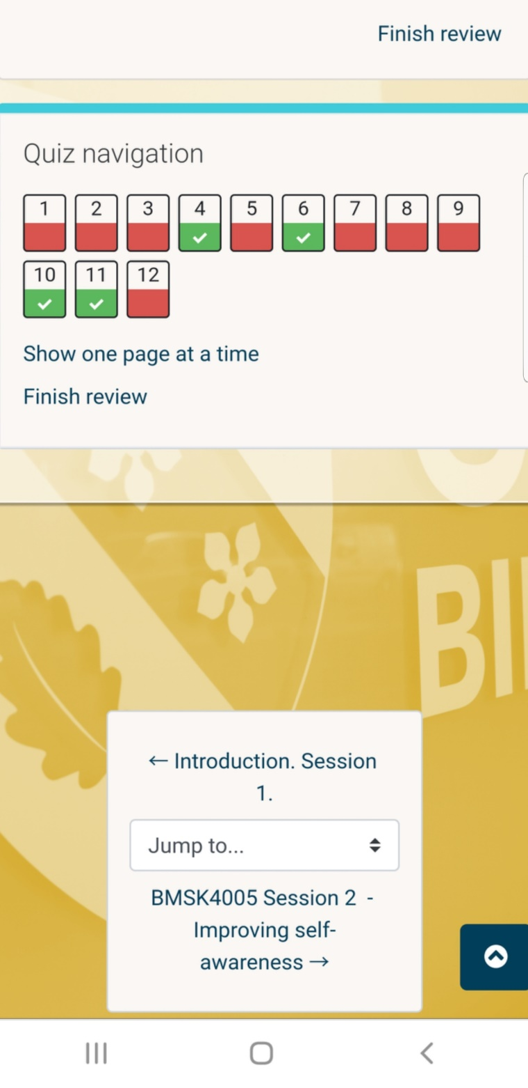

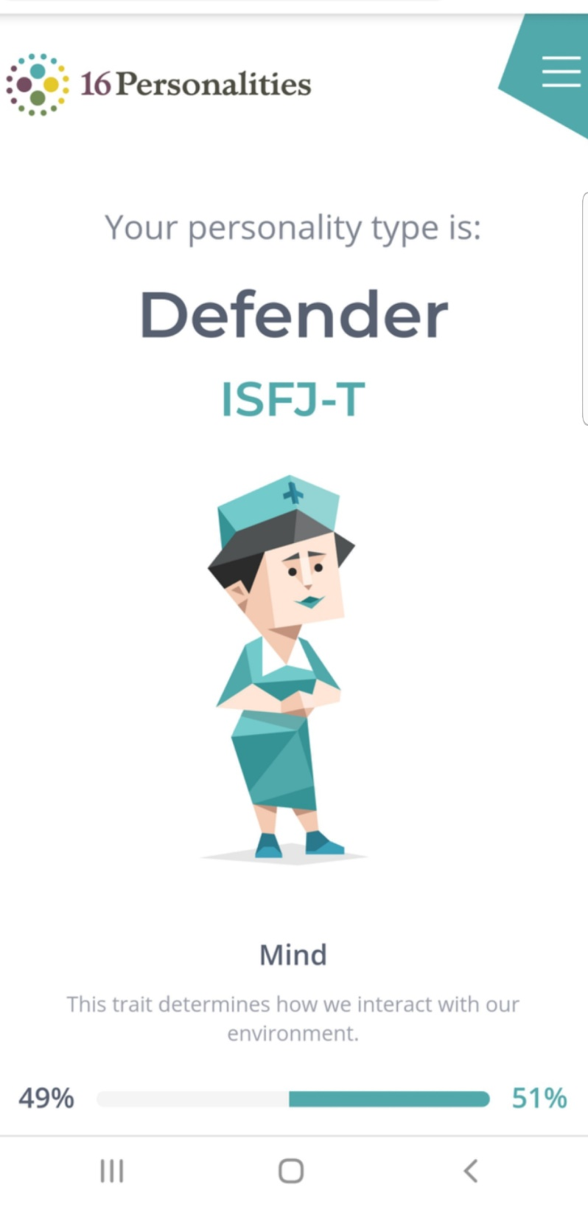

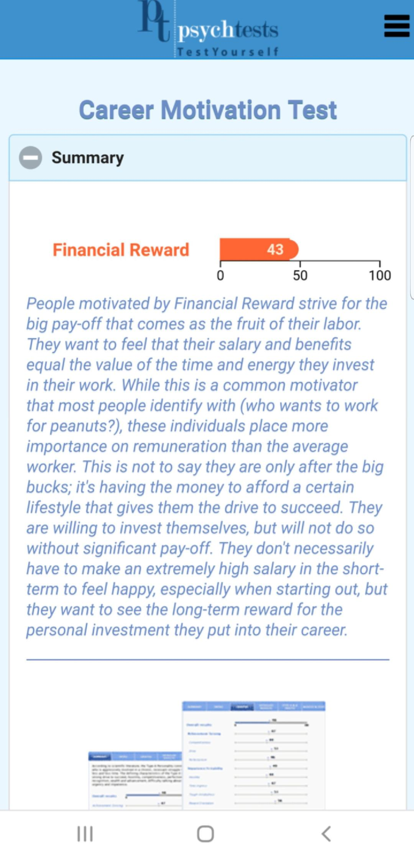

Skills
Teamwork, organisation, communication skills.
IT Skills- Word, Excel, PowerPoint
Languages – English, Bengali and Urdu, currently learning Arabic.

Hobbies and Interests
I enjoy sports such as netball, badminton, swimming, solving puzzles, sewing and socialising with friends and family. I also love to cook especially Indian food hence I have chosen to work at a Indian Restaurant.

References
References available upon request


Office Administrator
Time etc Limited - Birmingham
Responded to 51%-74% of applications in the past 30 days, typically within 2 days.
Apply with Indeed
Birmingham
Full-time, Part-time
£21,000 a year
- Do you love ticking things off your to-do list?
- Would you love a role filled with variety where no two days are the same?
- Does working within a passionate team who really cares about what they do sound like it’s for you?
*
About Time etc
Started in 2007 we are an award-winning company who helps entrepreneurs to achieve more by pairing them with their own experienced remote executive assistant, at a fraction of the cost of hiring. By doing this, we help our clients achieve life-changing goals and we put food on the table in the homes of our 700+ Virtual Assistants.
We’re based in newly refurbished landmark offices (complete with gym) just a few minutes walk away from Five Ways station in Birmingham (postcode: B16).
We’re proud to be officially recognised by Gallup as one of the top 1% of all companies worldwide for employee engagement. We enjoy a 4.9 score on Glassdoor and we've recently been voted in the Top 25 of Cultural Leaders based on our values, approach, vision and impact.
We hire incredible people who enjoy working within a fast-paced environment and thrive as part of the family-based culture. Our approach is to hire amazing people and then help them achieve their best through empowerment, career progression and strengths-based personal development.
Note: This position is not a Virtual Assistant/Personal Assistant role - this role involves working from our head office on a daily basis.
Read more here: https://web.timeetc.com/careers/
Top Tip: A cover letter is essential and if you want to stand out, tell us something funny or interesting.
About the role:
As our Office Administrator, you’ll play a vital in our business - keeping our office, working environment and team working efficiently and comfortably. At Time etc we love to stay organised and look after our team, and you’ll be doing this important work every day.
The Office Administrator will be working directly with Kirsten, our Chief Operating Officer, on a range of different tasks including:
- Keeping our office running smoothly, including stocking our free food and drink
- Being an administrator, which may include HR administration (like holiday requests), employee benefits admin, sorting expenses and screening CVs
- Gathering company statistics for key meetings.
- Helping organise team incentives, perks, fun and food
- Helping us to stay compliant with things like GDPR and health and safety
About you:
- You thrive in a busy environment and love ticking things off your to-do list.
- You enjoy a full and varied role where you’re constantly being asked to take on new challenges.
- You’re self-motivated and never leave a task half done.
- You love prioritising tasks and working to deadlines and goals.
- You have good computer and communication skills.
- You have a desire to learn and improve.
What we can offer you:
- Starting salary of £17-21K depending on experience.
- The opportunity to work from home 3 days a month.
- Very regular pay reviews.
- Performance coaching to help you be the best.
- Fantastic progression and learning opportunities.
- Birthdays are important. That's why we give you a special day off on your birthday to spend time with family or just relaxing - it's up to you.
- Airport lounge access whenever you go on holiday.
- Starbucks coffee from our delicious coffee to bean machine.
- Casual dress code.
- Free Netflix or Spotify Account.
- Macbook Air to call your own.
- Free Business Book Allowance.
- Matched Charity Donations.
- Your own Virtual Assistant to take care of your personal tasks.
APPLY NOW!
Don't miss out on your dream role, our recruitment process is really quick and you'll hear back from us within 1-2 days! The position is available for an immediate start however we are more than happy to work around notice periods. We can't wait to talk to you!
Further reading about this opportunity: http://web.timeetc.com/careers/
Don't forget, a cover letter is essential and if you want to stand out, tell us something funny or interesting about you!
*
Job Types: Full-time, Part-time
Salary: £21,000.00 /year
Experience:
- administrative assistant: 1 year (Preferred)
Education:
- GCSE or equivalent (Preferred)
Location:
- Birmingham, West Midlands (Preferred)
Just posted
report job

