IMPORTANCE OF EFFICIENT INFORMATION AND KNOWLEDGE MANAGEMENT SYSTEM

NAME: RODICA VIORICA CUC
STUDENT ID: 1906092
LECTURER: GLADIUS DAVID KULOTHUNGAN

Executive summary
The current report has focused on the knowledge management system of Amazon. Critical evaluation of the KM system of the company has been done by implementation KM theories. The report highlights the challenges in the knowledge management system within the organization “Amazon”. The study also sheds light on the effective measures to improve the information as well as knowledge management system in the significant US Company.
Table of Contents
1. Introduction 4
2. Company profile 4
3. Description of the “key knowledge management theories” 4
4. Importance of necessary properties of good knowledge management practices (effective creation, application, storing, integration of knowledge and sharing) 7
5. Description of the particular scenario in the organization “Amazon” 8
6. Identification of significant theories regarding the effectiveness of good knowledge management procedures in the tech giant “Amazon” along with the importance of maintaining a healthy relationship with the customers 10
6.1 Theories supporting knowledge management system 10
6.2 Discussion of implemented information systems by “Amazon” 11
6.3 Evaluation on the importance of efficient information system for “Amazon” 12
7. Potential challenges regarding knowledge management system faced by the significant organization 13
8. Recommendations to encounter as well as to strengthen the knowledge management challenges from the perspectives of “acquisition-retention-transfer” knowledge 300 14
Recommendation 1: Incentivizing the staff members 14
Recommendation 2: Implementation of effective measures and innovative technical strategies 15
9. Conclusion 15
Reference list 16

1. Introduction
Knowledge management has been the most important part of an organisation from the early '90s for the globalisation of business. The sustainability of an organisation has been managed by an effective "Knowledge management cycle (KMC)”. The current report has covered the knowledge management perspectives in the context of Amazon. Discussion of the knowledge management theories and the importance of knowledge management practices have been further covered in the study together with the challenges faced by Amazon to manage an effective knowledge management system. A set of recommendations have been further included in the studies for the mitigation of the challenges in context to acquisition, transfer and retention of Amazon.

2. Company profile
Amazon has beena US-based MNC established in 1994 by Jeff Bezos. The key focus of the company has been e-commerce. The current revenue of the organisation has been 38,606.4 crores USD (Amazon.com, 2021). Customer relationship has been a crucial aspect of the company to sustain in the competition in the era of globalisation. As stated in the provided case study, the IT infrastructure of the company has been strengthened by implementing Linux which has been the key technological background. The company has been dealing with online retail as well as cloud computing and online streaming services. “Customer relationship management (CRM)” has been another essential part of the business of Amazon.

3. Description of the “key knowledge management theories”
The major KM theories have been “Organisational KM theory”, “Ecological KM theory”, and “Techno-centric theory”.
“Organisational KM theory”
According to the “Organisational KM theory”, the structure of an organisation has been the key determinant of its culture. Acquisition of knowledge has been done by the implementation of effective management of the organisation. It can be effectively done by the management system of the organisation (Kane, 2017). Decision making of an organisation has been the other important aspect of the management of value from the organisational perspective.
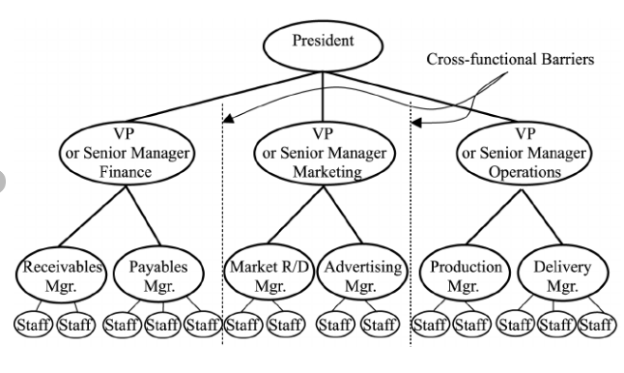
Figure 1: KM structure of an organisation
(Source: Barão et al.2017)
In the current business scenario, artificial intelligence has been implemented by companies to sustain in the market by retaining the skilled workforce for competitive advantages. The marketing strategies of Amazon have been decided by the existing knowledge management system of the company which has reflected in the behaviour with the customers. Retention of existing customers has been an important part of the business operation.
“Ecological KM theory”
“Ecological knowledge management theory” has been focused on the individual perspectives of the customers in the process of analysing the interactions of the customers. Scalability of the knowledge has been important to understand the behaviour of each customer in the process of delivering effective service and product (Peng et al. 2018). The performance of an organisation has been important for sustainability in the competition.
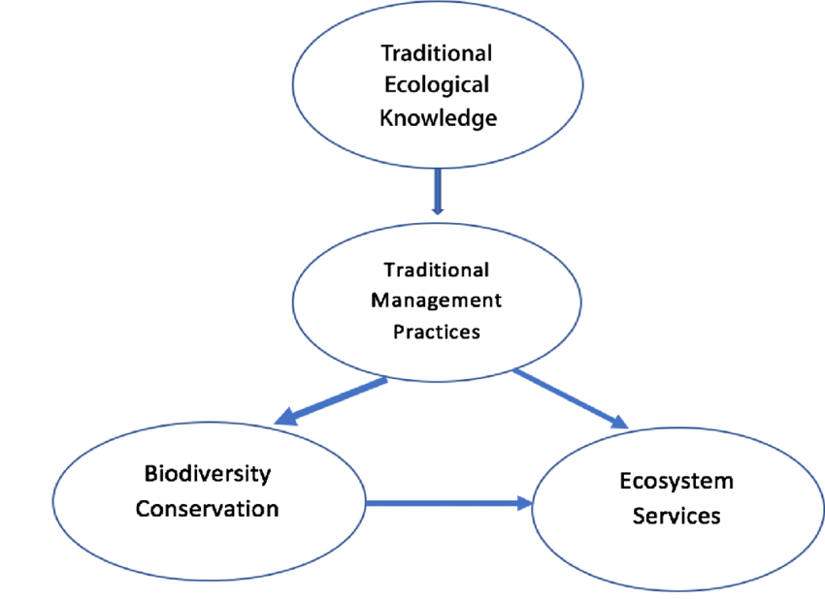
Figure 2: Ecological knowledge management
(Source: Kane, 2017)
Internal factors of an organisation have been crucial for deciding the offerings for the existing customers as well as the potential customers. As per the view of Kane, (2017), sharing of knowledge has been a fundamental aspect of the ecological knowledge management process. Knowledge of the customers about the existing products and services of Amazon has been crucial to maintaining healthy relationships. Interaction in the different online platforms has been important for the company to analyse the progress in the product and service market.
“Techno-centric theory”
The "Techno-centric theory" of KM has been a crucial aspect for an organisation to manage the flow of information through the process of business operation. The impact of customers on the products and services has been analysed by the implementation of technology. Understanding the behaviour of the customers has been the key aspect to gaining a competitive advantage in the market (Servaes and Hoyng, 2017). The employees of an organisation have been the other part of the knowledge management system.
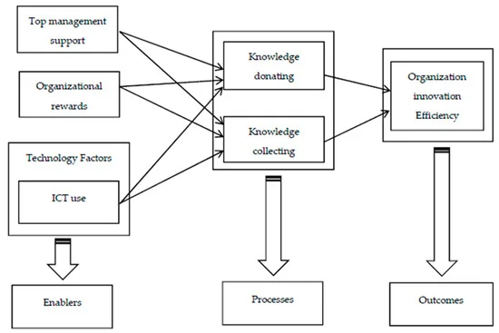
Figure 3: Techno-centric KM model
(Source: Kaoud, 2017)
The service provided by Amazon has been oriented to the technology which has been crucial to maintaining the privacy of each customer related to the process. Acquisition of knowledge has been a key element to provide relevant knowledge about the customers and the existing workforce.

4. Importance of necessary properties of good knowledge management practices (effective creation, application, storing, integration of knowledge and sharing)
Knowledge management has been important for an organisation to retain customers as well as talents to provide products to the company operation. The key importance of KM practices has been the access of the company to the information gathering (Martins et al. 2019). It has been useful for the determination of the models and structures to gain sustainability in the competition. An effective work environment has been created by the implementation of effective knowledge management concepts to integrate with the existing customer relationship management system.
The Decision-making processes of an organisation have been crucial to retain customers and create effective relationships with them. Improvements in the productivity of the employees have been crucial to collaborate with the tools of knowledge management. The experience of different people has been important in the decision-making process (Santoro et al. 2018). The choices that an organisation has made have been effective for sustainability in the competition.
Innovation has been the other important facet of an organisation that can be achieved by the implementation of effective knowledge management. The culture of an organisation has been decided by the organisational KM which has been decided by the leadership. Evolving needs of the business have been analysed by the management to make decisions that have been effective to manage the changes (Kianto et al. 2017). Improvement of the satisfaction level of the customers has been done by effective knowledge management. Retention of the customers has been done by the company by analysing their needs.
It has been the fundamental stage of customer retention. Faster interaction with the customers has been important to solve the queries and that develops a healthy relationship with the existing and new customers. It can be said that the application of effective knowledge management has been important to create effective customer relationships, knowledge integration and storing of the information gathered from the market. Effective decision making has been important to gain a competitive advantage in the market from a global perspective.

5. Description of the particular scenario in the organization “Amazon”
Organizations faced a lot of ups and downs due to the adverse outbreak of life taking disease. . According to He et al. (2020), businesses had to find alternative ways to provide organizational services and products to their customers in a hassle-free manner. Instead of taking many precautions to protect their businesses from getting affected by the “COVID-19” or coronavirus epidemic, organizations still faced negative consequences. Current evidence indicates that some issues have been faced by the tech giant “Amazon” due to the impact of “COVID-19”. Around “70% of” organizational products, “Amazon” purchases “from China” (Lauren, 2020). In the context of the impact of the current health pandemic, the nationwide lockdown has cost “Amazon” a lot in terms of importing the services and products. Based on this disruption, the tech giant has faced negative consequences such as delay in delivering, customer dissatisfaction and decreasing the profit margin of the significant organization. Along with that, the customer satisfaction rates have also decreased and other competitors have taken advantage of this situation. In addition to that, the "COVID-19 pandemic" has affected the tech giant's sales profit also. The net income of “Amazon” has decreased to around “$2.49 billion” from around “$3.59 billion” due to the impact of this infectious pathogen-associated disease (Forbes.com, 2020). Along with that, the famous organization has faced losses in operating income also, decreasing from around “$4.39 billion” to almost “$3.9 billion” (Forbes.com, 2020). Based on this factor, the brand reputation of the organization “Amazon” has been damaged in the international market. As a result of this, it has faced odds in achieving its desired goal. The significant organization has also faced a lot of customer dissatisfaction cases associated with delayed delivery of products, faulty goods and services. The customer satisfaction graph of the company “Amazon US” has decreased year by year resulting in disruptions in accelerating their growth in the business. Based on the views of Haial et al. (2021), customer dissatisfaction and supply chain disruption can affect an organization's reputation and restrain a company from achieving its desired goal. “Amazon” has also been accused of undermining the customer's privacy protection. A recent study says that the renowned tech company has opposed “major privacy-protection bills”. Consequently, leaking of sensitive as well as private information of the consumers increased the dissatisfaction cases against ‘Amazon”. Along with that, an organization can face revenue losses and consequences like damage to brand image (Liu et al. 2017). “AMAZON” has encountered many losses due to the issues of privacy data theft as well as the outbreak of coronavirus disease.
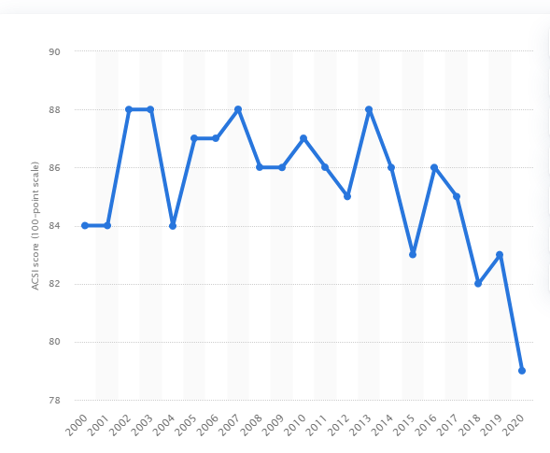
Figure 4: Customer satisfaction cases in AMAZON U.S. (FY 2000 to FY 2020)
(Source: Statista.com, 2020)

6. Identification of significant theories regarding the effectiveness of good knowledge management procedures in the tech giant “Amazon” along with the importance of maintaining a healthy relationship with the customers

6.1 Theories supporting knowledge management system
“Organizational KM theory”
“Organizational KM theory” assists an organization to gather knowledge about company insights. In addition to that, this significant theory aligns the information appropriately in order to improve the management process in an organization (Efstathiou et al. 2019). Based on these factors, an organization can identify the business structure issues as well as the required consistency process. In order to develop the process of “knowledge management”, the employees of a company can focus on developing their employability skills in the context of accelerating the growth of the company. Gathering knowledge from the “Organizational KM theory”, the tech giant “Amazon” can be able to identify the issues within the workspace area as well as determine the requirements in the market. Thus, the significant US Company can achieve its desired goal and ensure its long term sustainability by gathering knowledge regarding the management system.
“Ecological KM theory”
“Ecological KM theory” provides information regarding the required disciplines to manage in order to mitigate the interdisciplinary workspace environment. In addition to that, this significant theory helps an organization to develop its management system in order to encounter customer dissatisfaction cases (Zinzou et al. 2020). Along with that, an organization can gather knowledge regarding the economic environment resulting in helping to handle the consumer needs. The renowned organization “Amazon” can gain information about effective ways to develop its knowledge management in order to know the cause behind the sale rates and deliver their products accordingly in the market. The significant US Company can also develop their knowledge by following the current trend in order to strengthen business financial infrastructure.
“Techno-centric theory”
“Techno-centric theory” assists an organization to focus on implementing technical innovations in order to facilitate the knowledge management system. According to OYAKHIRE (2021), this significant theory also provides information related to business management processes as well as effective IT strategy. The US Company“Amazon” can gather knowledge from this significant theory in order to develop its IT technologies in order to innovate the business area. In addition to that, the tech giant can also avoid customer dissatisfaction cases along with supply disruption by identifying reasons behind the unpleasant issues. “Amazon” can also expand its business in the international market with innovative technological advantages and attain a high position in the high-competitive market. The significant US Company can ensure its long term sustainability by developing the technological design with the help of gathered information from the “Techno-centric theory”.

6.2 Discussion of implemented information systems by “Amazon”
The success of the tech giant “Amazon” lies in its efficient technology management system. “Web service”, “middleware”, “networking” technologies have helped the significant US organization to accelerate its growth and attain a high position in the international market. The integrated MIS system “middleware'' has assisted “Amazon” in gathering information related to market trends and delivering the organizational products as well as services to meet the consumer needs. In the views of Chen et al. (2017), the middleware MIS system helps an organization to gain knowledge about the market requirements in order to follow the demands for earning more profits.
“Web service” system helps an organization to gather information by connecting two developed networks. Developed networking systems are omnipotent for any organization to collect data regarding business profit sale rates. “Amazon” has achieved its desired goal by attaining an unbeatable position in the international market with the help of the "Web service” MIS system. According to Cheng and Meng (2019), the web service management system provides valuable information by smoothening the process of programming. The US organization “Amazon” progresses efficiently with the help of this significant MIS system as “Web service” works as a developed technological asset masking apps run faster.
The “AWS networking system” helps “Amazon” to bring innovations in technologies in order to make their application customer-convenience. The “AWS networking system” helps to make an application work faster in order to avoid delaying processing resulting in decreasing customer affection rate towards the app. This significant networking system provides the "highest network availability" along with the fast content delivery process to anywhere in the world. In addition to this factor, “Amazon” also has its own “cloud front” networking device in delivering fast app content such as video, pictures and many more. On the basis of an integrated information system, “Amazon” focuses on customer needs and makes it able to meet the demands with the help of innovative technologies.
Innovation and implementation of these MIS systems allow “Amazon” to know all detailed information related to productivity, availability and market requirements. In addition to that, the significant US Company is also able to increase their productivity and avoid customer dissatisfaction. Adopting and developing the MIS systems also help “Amazon” to gather information related to customer reviews and their feedback. Based on critically analyzing that information, the particular company is capable of building indirect as well as direct relationships with the consumers.


Figure 5: Networking as well as content delivery system of “Amazon”
(Source: Jin et al. 2019)

6.3 Evaluation on the importance of efficient information system for “Amazon”
An efficient information system is necessary for an organization in order to operate appropriately. Based on the views of Kim and Hong (2018), information system management helps an organization to provide every information related to business starting from business inputs to the process of generating useful management operations. “Amazon” can develop their information management process by adopting effective management theories. Based on the context of “Organizational KM theory”, the significant US Company can gather knowledge regarding organizational structure and can be able to identify issues related to business. “Amazon” can also able to recognize the obstacles in the consistent progress and develop their strategy in order to mitigate the problems. “Organizational KM theory” can help the company by providing effective information that can boost the management process. The collected information from the theory can help to identify the technique of making the right decisions in order to benefit the significant company. “Amazon” can improve the knowledge management strategy by adopting knowledge from “Ecological KM theory”. In the views of Elshareef (2020), this theory helps to strengthen the customer relationships within an organization by providing information related to increasing their productivity. The world-famous organization “Amazon” can intensify the financial stability in order to increase their sale rate by building healthy relationships with the customers. This theory can help the US company to avoid facing negative consequences related to customer dissatisfaction cases. “Amazon” can be able to handle difficulties such as COVID-19 impact and customer complaints in a disciplined and strategic manner. Based on this information, “Amazon” can operate their business proceeds by increasing its product availability in order to meet the demands in the market. In this way, the famous organization can develop its information management system in order to maintain its high position in the international market.
The tech giant “Amazon” needs to focus on the issues of supply chain disruption as well as develop their technical skills in order to avoid the cases of consumer data theft. “Techno-centric theory” can help an organization to give information about the ways to improve their technical systems in order to ensure the privacy of the consumers. Based on this data, “Amazon” can ensure avoiding the privacy concern issues resulting in building healthy relations with the customers. Along with that, the intervention of innovative and efficient technology can make their apps website-traffic free to maintain the customer affection rate.

7. Potential challenges regarding knowledge management system faced by the significant organization
In the financial year of 2020, “Amazon” has achieved high-profit sales and broke the record. The annual revenue increased by around 37.9% with around “$386 billion” (Forbes.com, 2021). Instead of achieving this success, the world-famous tech giant has faced many issues resulting in customer dissatisfaction. Due to the lack of efficient and effective technical management, “Amazon” has neglected the importance of making the consumer's personal information secure. There have been cases regarding customer data theft resulting in customer dissatisfaction. Poor knowledge management systems did not allow the significant company to know the environment in the workspace area. “Amazon” has been accused of not treating their employees well resulting in job dissatisfaction amongst the organizational employees. The recent study refers to a complaint by a staff member against the tech giant “Amazon”. The staff member pointed out the immense workload like over shift and mistreating behaviour of the significant US Company. Along with that, serious work environment issues have emerged in the world-famous organization “Amazon”. The COVID-19 impact has led the organization to increase its profit margin resulting in compelling the employees to work overtime (Bbc.com, 2021). The renowned organization “Amazon” was attacked by many strikes due to employee dissatisfaction.
Based on these challenges faced by the significant company “Amazon”, lack of efficiency in knowledge management has been recognized as the reason for the mishaps. Incapable MIS of an organization has pushed them to face negative consequences such as customer as well as employee dissatisfaction. Effective measures and innovative technological intervention can help to improve the information knowledge management system of the organization “Amazon”. In addition to that, the company's reputation has been damaged in the global market as well as assisting in decreasing the customer affection rate towards the organizational products and services. According to Asiimwe (2017), poor management skills in gathering information can decrease the profit sale of an organization. In the context of the effect of the insufficient knowledge management system, “Amazon” has ruined its reputation in the global market.

8. Recommendations to encounter as well as to strengthen the knowledge management challenges from the perspectives of “acquisition-retention-transfer” knowledge
Efficient knowledge, as well as information management systems, plays a vital role in the progress of an organization globally. In addition to that, the systematic information management system can assist a company to expand its business in a proficient and significant manner (Piccarozzi et al. 2018). The significant knowledge perspective of “acquisition-retention-transfer” can help the tech giant “Amazon” to bring improvement in their knowledge and information management system. The principles of “acquisition-retention-transfer” talk about accepting reality within an organization such as “acquisition” of the condition and also provide knowledge about upcoming risks or damages referred to as “retention”. Along with making changes in the business strategies in order to mitigate the problems to ensure long term sustainability in the global market suggested as “transfer”.

Recommendation 1: Incentivizing the staff members
Employee dissatisfaction decreases the brand image of organizations. In addition to that, the dissatisfaction amongst the staff members of a company is the main reason behind the reducing organizational productivity (Al Mamun et al. 2017). “Amazon” needs to focus on their information and management system in order to boost the morale of the employees as human force is the key asset behind the progress of any business. The significant US Company can maintain a healthy environment in the workspace area by gathering knowledge from “acquisition-retention-transfer” perspectives. In order to increase the satisfaction amongst the staff members, the US Company“Amazon” needs to adopt a new strategy by incentivizing the organizational employees.

Recommendation 2: Implementation of effective measures and innovative technical strategies
Poor knowledge, as well as information management systems, costs an organization adversely. According to Souza et al. (2018), an organization needs to improve its management system in order to expand its business in the most proficient manner. Adopting the strategy of “ acquisition-retention-transfer”, the world-famous tech giant “Amazon” can bring development in the strategy of knowledge management. Innovative technological methods, as well as equipment, need to be impregnated by “Amazon” in order to know the business progress along with maintaining relationships with the consumers. The intervention of new technical support can help the significant company to know all the information related to market trends and requirements. According to the perspectives of “acquisition-retention-transfer”, the company “Amazon” needs to accept new technology in order to mitigate the upcoming risks. In addition to that, the tech giant needs to transform the workspace area with the intervention of innovative technology strategies.

9. Conclusion
Thus, it can be concluded that the renowned organization “Amazon” can encounter the potential challenges related to “knowledge and information management” with the help of significant theories. In addition to that, the theories, strategies as well as perspectives of “acquisition-retention-transfer” can help the significant US company to have detailed information regarding the business. Based on this factor, “Amazon” can operate its business in a strategic manner and according to the requirements of the market. “Amazon” can have a new direction in the progress by achieving a high customer satisfaction rate by meeting the demands in an appropriate manner.

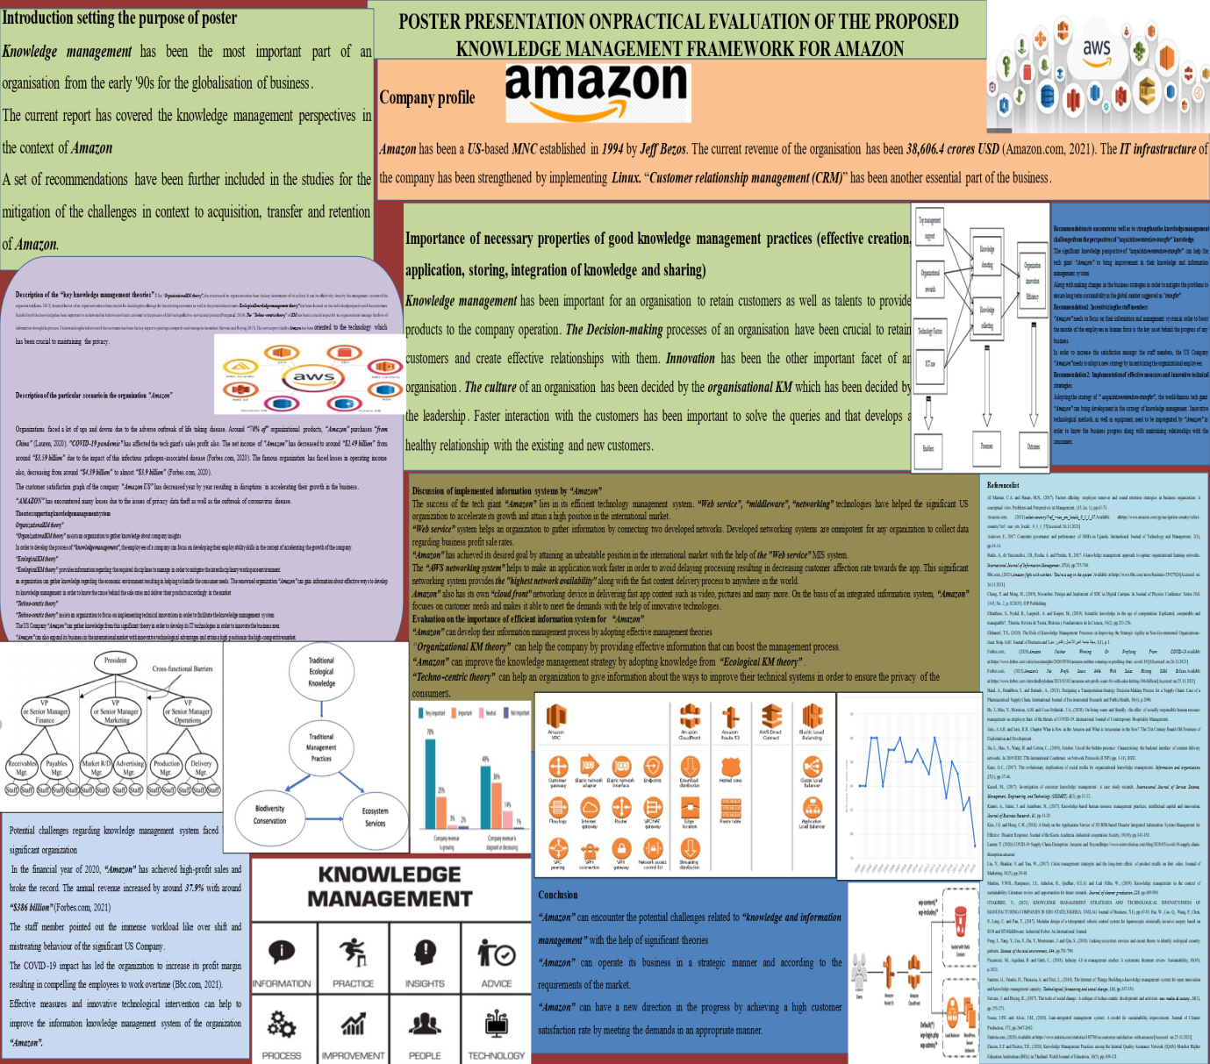

Reference list
Al Mamun, C.A. and Hasan, M.N., (2017). Factors affecting employee turnover and sound retention strategies in business organization: A conceptual view. Problems and Perspectives in Management, (15, Iss. 1), pp.63-71.
Amazon.com, (2021).select-country/?ref_=nav_em_locale_0_1_1_37.Available athttps://www.amazon.com/gp/navigation-country/select-country/?ref_=nav_em_locale_0_1_1_37[Accessed:26.11.2021]
Asiimwe, F., 2017. Corporate governance and performance of SMEs in Uganda. International Journal of Technology and Management, 2(1), pp.14-14.
Barão, A., de Vasconcelos, J.B., Rocha, Á. and Pereira, R., 2017. A knowledge management approach to capture organizational learning networks. International Journal of Information Management, 37(6), pp.735-740.
Bbc.com, (2021).Amazon fight with workers: 'You're a cog in the system'.Available at:https://www.bbc.com/news/business-55927024[Accessed on: 26.11.2021]
Cheng, Y. and Meng, H., (2019), November. Design and Implement of SDC in Digital Campus. In Journal of Physics: Conference Series (Vol. 1345, No. 2, p. 022035). IOP Publishing.
Efstathiou, S., Nydal, R., Laegreid, A. and Kuiper, M., (2019). Scientific knowledge in the age of computation: Explicated, computable and manageable?. Theoria. Revista de Teoría, Historia y Fundamentos de la Ciencia, 34(2), pp.213-236.
Elshareef, T.S., (2020). The Role of Knowledge Management Processes in Improving the Strategic Agility in Non-Governmental Organizations-Gaza Strip. AAU Journal of Business and Law مجلة جامعة العين للأعمال والقانون, 3(1), p.1.
Forbes.com, (2020).Amazon Neither Winning Or Profiting From COVID-19.available at:https://www.forbes.com/sites/moorinsights/2020/05/04/amazon-neither-winning-or-profiting-from-covid-19/[ASccessed on:26.11.2021]
Forbes.com, (2021).Amazon’s Net Profit Soars 84% With Sales Hitting $386 Billion.Available at:https://www.forbes.com/sites/shelleykohan/2021/02/02/amazons-net-profit-soars-84-with-sales-hitting-386-billion/[Accessed on:25.11.2021]
Haial, A., Benabbou, L. and Berrado, A., (2021). Designing a Transportation-Strategy Decision-Making Process for a Supply Chain: Case of a Pharmaceutical Supply Chain. International Journal of Environmental Research and Public Health, 18(4), p.2096.
He, J., Mao, Y., Morrison, A.M. and Coca-Stefaniak, J.A., (2020). On being warm and friendly: the effect of socially responsible human resource management on employee fears of the threats of COVID-19. International Journal of Contemporary Hospitality Management.
Ioris, A.A.R. and Ioris, R.R., Chapter What is New in the Amazon and What is Amazonian in the New? The 21st Century Brand-Old Frontiers of Exploitation and Development.
Jin, L., Hao, S., Wang, H. and Cotton, C., (2019), October. Unveil the hidden presence: Characterizing the backend interface of content delivery networks. In 2019 IEEE 27th International Conference on Network Protocols (ICNP) (pp. 1-11). IEEE.
Kane, G.C., (2017). The evolutionary implications of social media for organizational knowledge management. Information and organization, 27(1), pp.37-46.
Kaoud, M., (2017). Investigation of customer knowledge management: A case study research. International Journal of Service Science, Management, Engineering, and Technology (IJSSMET), 8(2), pp.12-22..
Kianto, A., Sáenz, J. and Aramburu, N., (2017). Knowledge-based human resource management practices, intellectual capital and innovation. Journal of Business Research, 81, pp.11-20
Kim, J.E. and Hong, C.H., (2018). A Study on the Application Service of 3D BIM-based Disaster Integrated Information System Management for Effective Disaster Response. Journal of the Korea Academia-Industrial cooperation Society, 19(10), pp.143-150.
Lauren T. (2020).COVID-19 Supply Chain Disruption: Amazon and Beyondhttps://www.roirevolution.com/blog/2020/05/covid-19-supply-chain-disruption-amazon/
Liu, Y., Shankar, V. and Yun, W., (2017). Crisis management strategies and the long-term effects of product recalls on firm value. Journal of Marketing, 81(5), pp.30-48.
Martins, V.W.B., Rampasso, I.S., Anholon, R., Quelhas, O.L.G. and Leal Filho, W., (2019). Knowledge management in the context of sustainability: Literature review and opportunities for future research. Journal of cleaner production, 229, pp.489-500.
OYAKHIRE, V., (2021). KNOWLEDGE MANAGEMENT STRATEGIES AND TECHNOLOGICAL INNOVATIVENESS OF MANUFACTURING COMPANIES IN EDO STATE, NIGERIA. UNILAG Journal of Business, 7(1), pp.67-83. Bai, W., Cao, Q., Wang, P., Chen, P., Leng, C. and Pan, T., (2017). Modular design of a teleoperated robotic control system for laparoscopic minimally invasive surgery based on ROS and RT-Middleware. Industrial Robot: An International Journal.
Peng, J., Yang, Y., Liu, Y., Du, Y., Meersmans, J. and Qiu, S., (2018). Linking ecosystem services and circuit theory to identify ecological security patterns. Science of the total environment, 644, pp.781-790.
Piccarozzi, M., Aquilani, B. and Gatti, C., (2018). Industry 4.0 in management studies: A systematic literature review. Sustainability, 10(10), p.3821.
Santoro, G., Vrontis, D., Thrassou, A. and Dezi, L., (2018). The Internet of Things: Building a knowledge management system for open innovation and knowledge management capacity. Technological forecasting and social change, 136, pp.347-354.
Servaes, J. and Hoyng, R., (2017). The tools of social change: A critique of techno-centric development and activism. new media & society, 19(2), pp.255-271.
Souza, J.P.E. and Alves, J.M., (2018). Lean-integrated management system: A model for sustainability improvement. Journal of Cleaner Production, 172, pp.2667-2682.
Statista.com, (2020).Available at:https://www.statista.com/statistics/185788/us-customer-satisfaction-with-amazon/[Accessed on:25.11.2021]
Zinzou, E.F. and Doctor, T.R., (2020). Knowledge Management Practices among the Internal Quality Assurance Network (IQAN)-Member Higher Education Institutions (HEIs) in Thailand. World Journal of Education, 10(5), pp.108-121.

