

LEVEL: 4
MODULE CODE BMSK4005
Module Name: Professional Career Development
Student Name: Mehdi Hasan
Student Number: 1706299
Lecturer: Sylvia Hoffmann

Table of Content

Contents
1.1 Introduction 3
2.1 Identify Self Awareness and Self development 4
3.1 Importance of Self development 4
4.1 Learning Style 4
4.1.1 Kolb Model 5
4.1.2 Honey and Mumford Learning Style Model 6
4.1.3 Visual-Auditory-Kinesthetic Model 8
5.1 Analysis of personal strength and weakness 10
6.1 Ideas with the concept of personal confidence, studying and think independently 13
7.1 Strategies for exploring employment option 14
8.1 Clear, coherent ad logical presentation 15
9.1 Effectiveness of health and safety regulations and good conduct procedures 16
10.1 Strategies for Career Advancement 16
11.1 Development of students confident 19
12.1 Relevant Procedures and employment legislation 19
13.1 Conclusion 20
Reference 21

1.1 Introduction
We all want to be successful in our own way. Everyone has their own vision of what ‘success’ mean for themselves and others (Stella Cottrell, 2010) Career development is an important task to make individual skilled and more experienced. Different training and development program can be practiced to enhance the career development. Professional career development process helps the individual to perform the right job more effectively. This is the key process to develop more and more in the personal life as well as professional life. Professional career development process increases the individual’s potential and ability to perform the job. Not only that, this kind of process helps to minimize the mistakes and complexities. As early said, an individual can perform various training and development process according to their abilities and capabilities to develop the career. Besides, there are several leaning processes that an individual can adopt for better career development. Honey and Mumford (1992) Learning Style’ and ‘Visual-Auditory-Kinesthetic Model provides the effective direction of right and proper learning style. These different models have different dimensions to perform and choose the right learning style for the individual. On the other hand, SWOT analysis helps to find the strength, weakness, opportunities and threat for the developing plan of the career. An individual can easily find out the most effective strength and weakness of them and choose the opportunity to develop more avoiding the threats. Moreover, SMART rules and regulations help to choose the more defined personal development plan. It is the core job of an individual to choose the right developmental plan more precisely for them because any kind of mistakes can de motivate the individuals for developing the career plan I am 43 years old and in this section I have evaluated my professional career development plan.

2.1 Identify Self Awareness and Self development
According to Bridget (2000), develop the personal career development it is very much important to acknowledge the self-awareness process. Self-awareness is the core process to get more knowledgeable from the past experiences. Past experiences provide the best idea and knowledge to go forward. It also motivates the individual to develop the skills and abilities in the challenging time.
Besides self-awareness, self-development is a process to develop the personal career. Self-development helps to increase the potential of the individuals by having more task and job. An individual can develop them by various learning process.
Both the self-awareness and self-development makes the individual to be more skilled and experienced to perform the appointed task more precisely and more effectively. There are various learning styles an individual can adopt for the betterment and development of their professional career development.

3.1 Importance of Self development
Self-development is performed according to the abilities of the individuals. It helps to develop the potential of the person. There are so many ways to develop self. An individual can choose the right path of self-development and career development process. It is very important for both the academic and professional task. Self-development process also increases the confident level of the individual. The person who adopts the self-development activities can keen to take challenging jobs to perform. Moreover, they are likely to develop themselves as well as the organization whenever they are working with them. Self-development works like as motivational asset.

4.1 Learning Style
Self-awareness and self-development are the vital activities for the development process of career. Both of those have different impacts on an individual’s life. Self-development process needs to adopt several learning styles. An individual can adopt the effective learning style according to his/ her abilities and capabilities. The learning style of one person can be very different than other person. On the other hand, in some cases, learning style can be same. So first of all it is very much important to choose the perfect learning style for the individuals.

4.1.1 Kolb Model
Kolb Model is very much effective to choose the right learning styles for the right person. Different person may have different ability to learning. Kolb model illustrated the whole thing.
Kolb Model is so well-known for this circumstance and here some discussion can be made in flowing ways-
Figure 01: Kolb Model

Source: (Denison, 1990)
Concrete Experience Learning: This kind of learning is the way to choose the individual’s ability for learning reading and writing. Persons are more likely to adopt the reading and writing styles to learn more.
Reflective Observation Learning: The individuals are more prefer to learn by group or team activities. This type of learning process helps to develop individual’s career as well as team performance.
Abstract Conceptualization Learning: Abstract conceptualization learning process is defined whenever the individual becomes active to learn from the theories. More knowledge can be adopted by the theoretical lessons and models.
Active Experimentation Learning: The individual are more preferable to learn from the personal experiences. As it is said, past experiences can drive an individual faster than anything towards future.

4.1.2 Honey and Mumford Learning Style Model
According to Bridget (2000), Honey and Mumford took the Kolb model as an ideal one and analyzed to develop more efficient learning styles for the individuals.
Figure 02: Honey and Mumford Learning Style
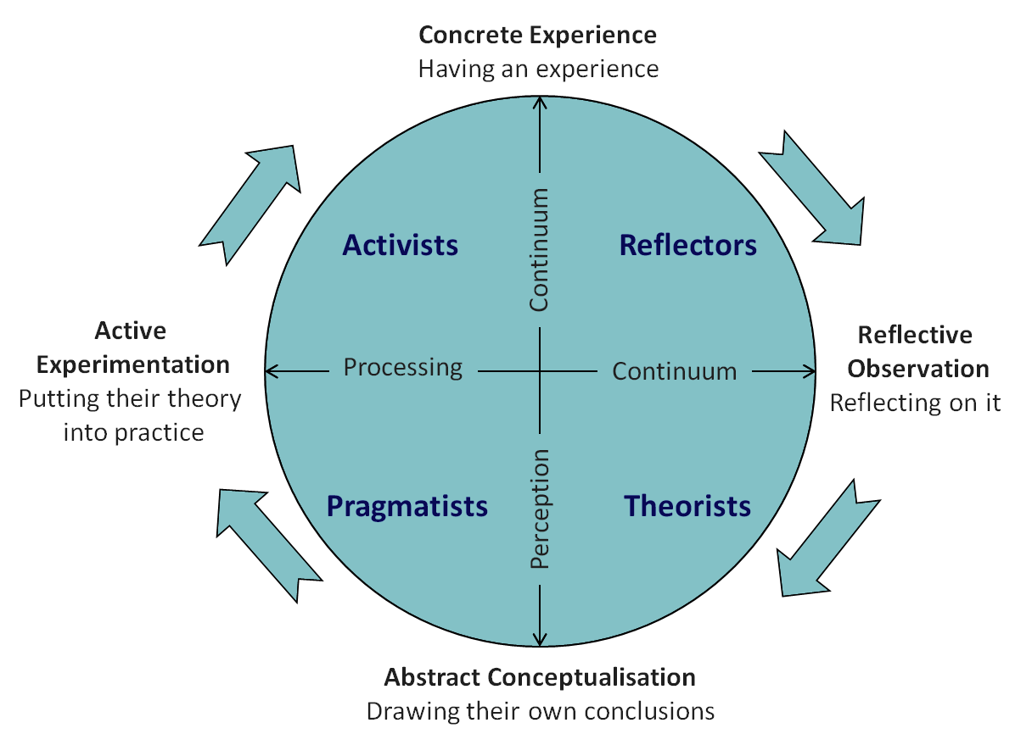
Source: (Ton, 2014)

Activists, Reflectors, Theorists, Pragmatist are the identities of the individuals who are having different learning styles. Honey and Mumford has provided their identities according to their activities for learning.
‘Activists’ are the individuals who like to learn more by team participation. They like to do the job in team basis and get the result to learn more and more. The ‘Reflectors’ check out the whole situation to make any decision. This helps to develop the experiences both any positive and negative aspects. They prefer to take the perfect learning from the present situation. ‘Theorists” are the people who are more active to gather the knowledge from the theoretical lessons. Several theories and models help them to take perfect decision in every situation.On the very last, “Pragmatists” are the individuals who like to evaluate the situation and learn from the real world in practical rather than studying the Theoretical lessons only.
Honey and Mumford arranged eighty (80) questionnaires to choose the perfect learning styles for an individual. Those questions are different but relevant to each other. After analyzing the questionnaires a table can be developed.
Table 01: Obtain result in Honey and Mumford questionnaires
1 | 3 | 5 | 7
4 | 6 | 12 | 8
9 | 11 | 13 | 10
14 | 17 | 16 | 15
18 | 19 | 20 | 21
22 | 24 | 26 | 23
25 | 27 | 28 | 29
33 | 32 | 31 | 30
35 | 34 | 36 | 37
41 | 38 | 39 | 40
43 | 42 | 44 | 45
49 | 48 | 47 | 46
50 | 52 | 53 | 51
54 | 55 | 57 | 56
58 | 59 | 61 | 60
62 | 64 | 65 | 63
66 | 67 | 69 | 70
73 | 68 | 72 | 71
74 | 75 | 73 | 76
77 | 78 | 79 | 80
Total Circled- 14 | Total Circled- 10 | Total Circled- 09 | Total Circled- 11
Activist | Reflector | Theorist | Pragmatic

By attending the eighty (80) questions I finally found myself as “Activist” who like to gather knowledge by performing as team. These questionnaires are well arranged to find out the perfect someone and his/ her learning styles.

4.1.3 Visual-Auditory-Kinesthetic Model
According to Bridget (2000), there are so many ways that an individual can learn more and more. Kolb model provides the different learning styles and Honey & Mumford has named the individuals according to their learning styles. In this case, a new model has developed named ‘Visual-Auditory-Kinesthetic Model’ to identify the learning styles according to the sensory elements.

Figure 03: Visual-Auditory-Kinesthetic Model
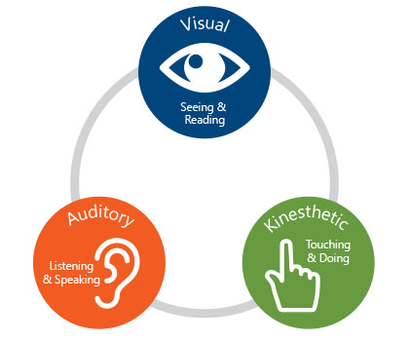
Source: (Ton, 2014)

Visual Learning Styles: This kind of learning process has developed through vision by his/ her eyes when an individual sees the theories, pictures and learn from them.
Auditory Learning Styles: The learners like to gather more knowledge lectures and group discussion process when the voice gets highly used. This is more useful and effective for any learners to gather the proper knowledge.
Kinesthetic Learning Styles: Kinesthetic learning style influences the learners to gather knowledge by physical touch.
Like Honey and Mumford, a set of thirty questions has developed to select the appropriate learning styles for an individual. A question-answer session has developed for me to select mine style. (Here A= Visual, B= Auditory and C= Kinesthetic)

Table 02: Obtain result of ‘Visual-Auditory-Kinesthetic Model’
Questions | Answers |  | Questions | Answers
1 | B |  | 16 | B
2 | A |  | 17 | A
3 | B |  | 18 | B
4 | B |  | 19 | A
5 | B |  | 20 | C
6 | A |  | 21 | C
7 | C |  | 22 | B
8 | B |  | 23 | A
9 | C |  | 24 | C
10 | B |  | 25 | A
11 | A |  | 26 | B
12 | B |  | 27 | A
13 | A |  | 28 | B
14 | C |  | 29 | C
15 | B |  | 30 | B

From the question-answer session we can found that A=9, B=14, C=7. That means I prefer to learn by Auditory learning styles and I like to get knowledge from lecture and group discussion process.

5.1 Analysis of personal strength and weakness
According to Sindell (2001), SWOT analysis helps to identify someone’s strength, weakness. Moreover, someone get to know about his/ her opportunity to further and develop themselves. This analysis also helps to identify the possible threat and recover those. Here a table can be made for justifying mine.

Strength | Weakness
- More efficient and focused on destination.  - Keen to gather more knowledge and more precise to do the job.  - Self-confident.  - Patience and Hard working.  - Quick learners.  - Developing the career planning through various training and development program.  - Able to match up with the challenging time.  - Team performance helps to develop myself. | - More depend on others because I always prefer to perform in group.  - High tempered.  - Can’t deal with everyone.  - So much hesitation flows through my mind when some unknown person talks to me.  - Like to gather knowledge from personal experiences, so theoretical lessons goes beyond my limit.  - Flexible.
Opportunity | Threat
- So much opportunity in my sector.  - High experience provides me confident.  - Proper communication with the higher management helps to develop the teamwork.  - Friendly environment motivates everyone.  - New business sector has always developed.  - Company reputation works much to feel relax and perform the actual job. | - There are huge uncertain issues and challenging task to perform in my sector.  - Lack of training and development program can suffer most.  - I am so much emotional and I need much opportunity to work.  - Competition is going wild in every sector.

According to Sindell (2001), There are lots of things and characteristics that make a person different from other persons. Every person may not have the same strength as well as weakness. Different business fields may have different and unique opportunities to develop. Not only that, some threats can be chosen as barriers in those sectors too. I always prefer to perform in a team basis. That is more effective because everyone can share their knowledge, views, and experiences to perform a single job. It provides vast opportunity to gather knowledge from the skilled and experienced one. Despite of so many strengths, I also have some weakness that makes me limited than others. I can’t deal with every person because I can’t trust everyone easily.
In my business sector, there are so many opportunity to develop myself by performing the appointed job perfectly. The communication process and working environment is so friendly that someone can easily match up with the working employees. Not only that, the organization has a great reputation in UK and every person is loyal to perform. Besides, some threat is also seen for me and my business sectors. Lots of challenging task has grown and more competitors are coming in the business sector. Well career development process should be developed to enhance myself and so on.
To reduce the threat and the weakness some learning styles can be adopted. Here a list can be made that can be done in a time period to develop myself to be better and skilled.

Name |  | Membership Number
Covering the period form | August 2018 | To | August 2020

What I need to learn? | What I need to do to achieve this | What resource I need? | What will be my success criteria? | Target date, review
Develop my learning skills  Development of the time managing  Develop my professional training.  Enhance the Academic record.  Increase of the patience | By reading the theoretical lessons, academic and outer books  By performing every task timely, attending the seminar & courses.  By attending various training and development program.  By performing in the educational institution.  By becoming partner of long duration task. | Magazine, text book, internet.  Monitoring and helping from the management.  Permission and financial support from the management.  Financial support.  Meditation | Can be able to learn more.  Will be able to perform task timely.  To be more skilled and knowledgeable.  Will be more able to gather and use the academic lessons.  Can be patient more. | Within December 2018  Within August 2019.  Within December 2019  Within August 2020  Within December 2018

6.1 Ideas with the concept of personal confidence, studying and think independently
According to Sindell (2001), Personal confidence is an important factor of an individual to develop the professional career. Self-development program is very much effective to increase the confidence level. To develop the personal confidence an individual can perform various tasks. Also an individual can follow some policies and those will be sufficient to enhance the personal confidence and think independently.
Positive attitude: Positive physical and mental attitude mostly helps to be confident. An individual should be always positive in every task. If the person can do the job perfectly then it will be more sufficient to be confident on them.
Believe on them: The individuals should have more belief on themselves. The individual only can justify themselves about what they can do or what they can’t. So the person should have trust on them that they can do everything.
Communicate: According to Sindell (2001), Communication with the other person can enlarge the confidence level of an individual. If the individuals can listen something positive from others about him/ her then it will be more effective to grow up the self-confidence.
An individual should always be focus on themselves. Self-development process can be developed to increase the confidence level as well. The person who has lower confidence can perform team work because several peoples working at that job. Any success will help the individual to develop the self-confidence. Whenever the individual can be able to grow up the self-confidence and overcome the dependency then it will be more helpful for his/ her to perform by their own. There are so other ways to develop the self-confidence and work independently.
Jahari Window is a common but useful tool to develop the career and confidence. This window helps to choose the tactics what a person should do to the known and unknown person.
Table 04: Application of Jahari Window for self-development
 | Known to self | Unknown to self
Known to others | Open area or Arena | Blind spot
Known by others | Hidden area or façade | Unknown

Independent think is more effective for the individuals as it helps to think by person to person basis. Self-confidence helps to increase the independent think.

7.1 Strategies for exploring employment option
For an individual professional career development process is very much important so it is essential to explore the employment option. The individual should choose the right employment for themselves because only right employment can be helpful to develop the professional career. In that case, an individual should be aware of the process to explore the employment.
At first, the individual should search the possible employment from internet and then choose the right job for them.
Secondly, the individual should be self-confident regarding what career he/ she should need. Lack of self-confidence can reduce the career opportunity.
Thirdly, Individual should be more self-awareness. The individual should be known about the present and business of the business sector.
Fourthly, the individual have to idea about the possible task of the employment. The person should be confident if he/ she are capable to perform the job or not.
Finally, the person needs to think more and more to fix the decision. A proper decision can be more effective for the development of the career. Otherwise, the decision can be the big reason to get frustrated later.

8.1 Clear, coherent ad logical presentation
According to Denison (1990), After selecting the employment, the individual should be conscious regarding the clear, coherent and logical presentation of their information to submit for the post. Some information should be kept in mind while an individual prepares him/ her to provide the information.
- What is the career development process should be elaborated
- The academic record should be providing in a systematic manner.
- Work experiences must be there.
- The other skills relevant of the post can be attached.
- Personal information can be written.
- Two references

9.1 Effectiveness of health and safety regulations and good conduct procedures
According to Denison (1990), an individual should be more conscious while they are joining for an organization. There are so many issues to think and consider before joining. The individual should be aware of the health and safety regulations given by the organization. Most of the cases, the organization takes possible health and safety steps for every working employees.
On the other hand, conduct procedures are the formal activities to perform. An individual should be more aware of the conduct before signing. Conduct refers than the recruitment is done in proper ways and there was no unethical activity.
From selection to joining an organization maintain various tasks. The individual should be more careful about them personally. A lot of knowledge about joining in an organization or signing in a conduct can damage the career. To develop the successful professional career, everyone should be aware and conscious about what happening.

10.1 Strategies for Career Advancement
According to Denison (1990), an individual should always focus on the career development process. On the other hand, organization maintains various processes to make it facilitate. There are some strategies an individual can be adopted for the career advancement. These are follows:
Staff Recruitment
Staff recruitment is an important task for an organization. Mainly an organization can recruit employees by two different ways and they are (a) Internal recruitment and (b) External recruitment process.
Internal Recruitment: According to Thomas (1990), whenever the recruitment process is completed within the organization. Succession plan can be practiced throughout the whole organization. The junior employers can get promoted and become senior staff to fulfill the recruited post.
External Recruitment: The outer applicants are asked to apply for the post and right candidate is selected by the management with a whole recruitment process. There is a large process to complete the external recruitment.
Job Evaluation
Job evaluation is an arrangement for an individual to select the perfect job for him/ her comparing with the other jobs. Job evaluation process has two kinds- (a) Analytical and (b) Non-Analytical. Both of these kinds have several specifications and more kinds.

Figure 05: Job Evaluation Process
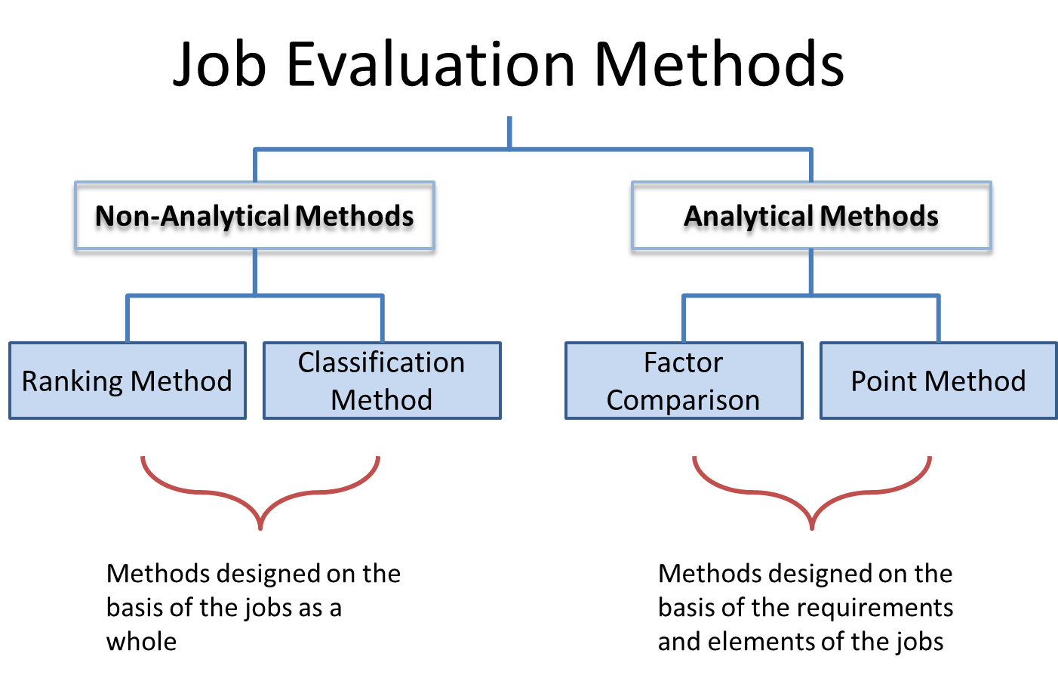
Source: (Bridget, 2000)

Persons Specification
According to Thomas (1990), every individual has are recruited for a job are responsible to perform the job task. The management is the responsible to select the right persons who are knowledgeable and skilled to perform the job. On the other hand, the management is also responsible to select those who are not capable to do the appointed job. They can be eliminated afterwards.
Job Specification
According to Paul (1991), Job specification is the overall discussion of the job, job position, roles and responsibilities thus an applicant can justify he/ she is capable or not. The management can select the right person for the right job after comparing the job specification.
Interviewing
Interview is the process to justify the candidate either the applicant is suitable for the prost or not. The interviewer and interviewee can get the chance to exchange their views and the interview can easily choose the right person for the right job. Interviewing is a long process. According to Paul (1991), there have two or more interview sections. After proper interviewing process a candidate is selected by the management for the post. The management can practice psychometric test if they wish. There are some tests that management can use to justify the right person. The whole process should be completed before final selection of candidate.
Figure 06: Types of psychometric test
No | Test | Process
1 | Cognitive Ability | Justifying the knowledge, skills, ability
2 | Personality Test | Evaluating the emotions and thoughts
3 | Physical Ability Test | Experimenting the Muscular strength
4 | Integrity Test | Evaluation whether any individual engaged with an illegal task.
5 | Drug Test | Justifying if an illegal drugs are pushed or not.
6 | Work Sample Test | Experimenting with providing some sample of the work and justify

Source: (Bridget, 2000)
Induction
Induction is a well management process that is performed by the management and existing employees thus the new comer can be familiar with the job and environment. It is very tough for a new employee to match up with the new culture and working condition of the organization. Induction process is performed to habituate the new employee with the new working rules and regulations.
Mentoring
According to Bridget (2000), Mentoring is a kind of supporting activities. Senior staffs are appointed to mentoring the new employee/ employees in the organization. The new working employee/ employees are monitored by the appointed staffs about what to do or what not to do.
Appraisal
The management should be friendly with the new appointed employee/ employees. There should have a performance appraisal process to appraise the performance of them. Thus they can fell motivated and make the correction if they have any wrong in activities.

11.1 Development of students confident
Students are the future generation for every organization. It will be very much helpful if any development process can be practiced to increase the student’s confident level. They will be more skilled and experienced in the organization.
Responsibility and accountability: Everyone must be responsible about their job and responsibility. It is very much effective if anyone has the sense of responsibility and accountability.
Interpersonal relationship: Whenever two or more persons interact about their daily needs or working responsibilities then they should be cooperative and friendly.
Effective means of communication: Proper communication process can easily develop the relationship with everyone. It works as a motivational element.

12.1 Relevant Procedures and employment legislation
An organization may have part time and full time employees who are working for the respective organization. The authority can practice various rules and regulations throughout the whole organizational process. There may have several legislations too.
Equality Act 2010
This act helps to reduce the discrimination among the working employees. Every employee is equal according to the equity act.(GOV.UK, 2018).
Employment Act 2002
Employment act helps to provide the friendly working environment throughout the whole organizational process (GOV.UK, 2018).
Health & Safety at Work Act 1974
This is major legislation of an organization. The authority is highly responsible to provide every health, social and political safety for the whole working employees.

13.1 Conclusion
Career development is an important task for an individual. The individual is highly responsible to maintain the perfect way to develop the career. Before that, the individual should improve the self-awareness and self-confident. Self-confident helps the person to increase the confidence level. SWOT analysis is a kind of analysis process to justify the strength, weakness. It also helps to identify the opportunities as well as possible threat. To develop the career, the person should select the proper learning styles among different options. Lack of proper justification can reduce the development process. There are several models like Kolb model, Honey and Mumford model to select the proper learning styles. From job selection to interviewing an individual have to maintain various tasks. Most importantly, they should be aware before applying any post either the post is suitable for him/ her or not. Skilled, experienced and knowledgeable candidates are highly selected by the management. Overall career development is a long process and everyone should select the right way to develop the Career.

Reference

- Bridget D.,(2000) "Name your career development intervention", Journal of Workplace Learning, Vol. 12 Issue: 5, pp.205-217,
- Cottrell, S., 2010. Skills For Success The Personal Development Planning Handbook. 2nd ed. London: Macmillan Publishers Ltd.
- Cameron, S. 2009. The Business Student's Handbook Skills for Study and Employment. 5th ed. Essex: Pearson.
- S. Gayle B., Sherry E. (2005) "Mentoring and career development", Career Development International, Vol. 10 Issue: 6/7, pp.425-428,
- Paul I.,(1991) "Customer‐focused career development", Executive Development,
- Paul S., Career Development assistance Strategies: International Journal of Career Management, Vol. 5
- (2000) "Career Development", Journal of European Industrial Training, Vol. 24 Issue: 8, https://doi.org/10.1108/jeit.2000.00324hae.001
- Thomas N. (1990) "Promoting Strategic Career Development Activates: Some Irish Experience", Industrial and Commercial Training, Vol. 22 Issue: 6,
- Denison, D.R. (1990). Corporate Culture and Organizational Effectiveness. New York: Wiley.
- Sindell, M., Hoang, T., (2001). Leadership Development: Management Development: American Society for Training and Development
- Ton, Z., (2014). The Good Jobs Strategy: How the Smartest Companies Invest in Employees to Lower Costs and Boost Profits: Houghton Mifflin Harcourt

