University of Wales Trinity Saint David

Automotive Engine Design
Module Code: M6X00410

Calculation on Piston, Rod, Crankshaft Assemblies

Author; Supervisor;
Joshua Bass, P146018 Malcolm McDonald

February 17th, 2020

Contents
1 Contents 2
2 Table of Figures 4
3 Table of Equations 7
4 Introduction 10
5 Masses and Dimensions 11
5.1 Constants relative to the forces and stresses acting on the gudgeon pin 11
5.1.1 CAD model of the conrod and gudgeon pin, with values recorded for the constants table 12
5.2 Constants relative to the compressive and tensile forces at the three critical rod-sections 14
5.2.1 CAD model of the cross-sectional areas calculated for each point in the three critical rod-sections 15
5.3 Constants relative to the standard conrod; bolt and cap 17
5.3.1 CAD model of the standard conrod bolt 18
5.3.2 Constants relative to the modified bolt 19
5.4 Constants relative to the Ford 1.6 GDI crankshaft 20
6 Calculations and Results 21
6.1 Results of forces and stresses acting on the gudgeon pin 21
6.1.1 Methodology of the forces and stresses acting on the gudgeon pin 21
6.1.2 Results of the forces and stresses acting down on the gudgeon pin 25
6.1.3 Results of the forces and stresses acting up around TDC on the gudgeon pin 28
6.2 Results of forces and stresses acting on the three critical rod-sections 29
6.2.1 Methodology of the forces and stresses acting on the three critical rod-sections 29
6.2.2 Results of the forces and stresses acting on the three critical rod-sections 32
6.3 Results of forces, torques and stresses acting on the standard Ford 1.6 GDI eco-boost bolt 35
6.3.1 Methodology of the forces, torques and stresses acting on the standard Ford 1.6 GDI eco-boost bolt 35
6.3.2 Literature review on conrod bolts 40
6.3.3 Results of the forces, torques and stresses acting on the standard Ford 1.6 GDI eco-boost bolt 41
6.3.4 Results of the forces, torques and stresses acting on the modified bolt 45
6.4 Results of forces and stresses acting on the crankshaft 46
6.4.1 Methodology of the forces and stresses acting on the crankshaft 46
6.4.2 Literature review on crankshaft 49
6.4.3 Results of the forces and stresses acting on the crankshaft 50
7 Conclusion 52
8 References 53
9 Appendix 55
9.1 CAD model of the conrod and gudgeon pin with values recorded 55
9.2 Forces and stresses acting on the gudgeon pin 56
9.3 Three critical rod-sections 59
9.3.1 Forces acting on each point on the three critical rod-sections 59

Table of Figures
Figure 1: Constants table relative to the forces (N) and stresses (N/mm²) acting on the gudgeon pin 11
Figure 2: Accurate measurements recorded for the conrod CAD model 12
Figure 3: Length sticking out and the force acting on the gudgeon pin 12
Figure 4: Centre of Mass, L₂, of the gudgeon pin 13
Figure 5: Side measurements recorded from the CAD model 13
Figure 6: Constants relative to the three critical rod-sections 14
Figure 7: Mass constants used for each point in the three critical rod-sections 14
Figure 8: Cross-sectional area at point 'A' 15
Figure 9: Cross-sectional area at point 'B' 15
Figure 10: Cross-sectional area at point 'C' 16
Figure 11: Constants table relative to the conrod bolt and cap 17
Figure 12: Standard 1.6 GDI Ford eco-boost conrod bolts 18
Figure 13: Standard 1.6 GDI Ford eco-boost conrod bolt design 18
Figure 14: Constants table relative to the modified conrod bolt 19
Figure 15: Constants table relative to the Ford 1.6 GDI crankshaft 20
Figure 16: Peak compressive and tensile forces (N) acting on the gudgeon pin 25
Figure 17: Maximum compressive force (N) representing the stresses (N/mm²) acting on the gudgeon pin 25
Figure 18: Maximum tensile force (N) representing the stresses (N/mm²) acting on the gudgeon pin 25
Figure 19: Goodman diagram of the mean stress (N/mm²) acting on the gudgeon pin 26
Figure 20: Mean and range of stresses for the gudgeon pin (N/mm²) 27
Figure 21: Maximum compressive and tensile force (N) and stresses (N/mm²) acting on the gudgeon pin around TDC exhaust 28
Figure 22: Stress concentration at each point acting on the three critical rod-sections 31
Figure 23: Results of the forces (N) and stresses (N/mm²) acting on the three critical rod-sections 32
Figure 24: Goodman diagram representing point 'A' (N/mm²) in the three critical rod-sections 33
Figure 25: Goodman diagram representing point 'B' (N/mm²) in the three critical rod-sections 33
Figure 26: Goodman diagram representing point 'C' (N/mm²) in the three critical rod-sections 34
Figure 27: Results of the forces (N), torques (N/mm) and stresses (N/mm²) acting on the standard Ford 1.6 GDI conrod bolts @6000rpm 41
Figure 28: Results of the forces (N), torques (N/mm) and stresses (N/mm2) acting on the standard Ford 1.6 GDI conrod bolts @9000rpm 42
Figure 29: Modified 1.6 GDI Ford eco-boost conrod bolt design 43
Figure 30: Results of the forces (N), torques (N/mm) and stresses (N/mm²) acting on the modified bolt 45
Figure 31:Gas pressure and inertial forces acting on the crankshaft (N), (Bosch, 1978) 49
Figure 32: Results of the forces (N) and stresses (N/mm²) acting on the crankshaft 50
Figure 33: Goodman diagram representing point 'B' (N/mm2) on the critical fillet-section on the crankshaft 51
Figure 34: CAD model of the conrod 55
Figure 35: Cross-sectional Area of the CAD model gudgeon pin (mm²) 55
Figure 36: Inertia force without the mass of the gudgeon pin (N) vs Crank angle (°) 56
Figure 37: Properties of steel grades (Bell, 2019) 56
Figure 38: Variable entities acting on the gudgeon pin at 5700rpm 57
Figure 39: Variable entities acting on the gudgeon pin at 6000rpm 57
Figure 40: Polytropic equation used for peak gas forces acting on the gudgeon pin (N) 58
Figure 41: Polytropic equation used for tensile force acting on the gudgeon pin (N) 58
Figure 42: Three critical rod-sections diagram 59
Figure 43: Applied forces acting on point 'A' (N) 59
Figure 44: Applied forces acting on point 'B' (N) 60
Figure 45: Applied forces acting on point 'C' (N) 60

Table of Equations
Equation 1: Inertia force without the mass of the gudgeon pin (N) 21
Equation 2: Net force without the mass of the gudgeon pin (N) 21
Equation 3: Bending moment acting on the gudgeon pin (N/mm) 22
Equation 4: Inertia force of the gudgeon pin (N) 22
Equation 5: Mass of the gudgeon pin sticking out (kg) 22
Equation 6: Bending Stress (N/mm²) 23
Equation 7: Shear Stress (N/mm²) 23
Equation 8: Combined Stress (N/mm²) 23
Equation 9: Mean Stress (N/mm²) 23
Equation 10: Range of combined compressive and tensile stress (N/mm²) 23
Equation 11: Allowable Range (N/mm²) 24
Equation 12: Fatigue Safety Factor 24
Equation 13: Reciprocating Mass (kg) 29
Equation 14: Mass of lower conrod (kg) 29
Equation 15: Inertia force for each point acting on the three critical rod-sections (N) 29
Equation 16: Net Force (N) 29
Equation 17: Maximum nominal stress (N/mm²) 30
Equation 18: Minimum nominal stress (N/mm²) 30
Equation 19: Mean nominal stress (N/mm²) 30
Equation 20: Range of nominal stress (N/mm²) 30
Equation 21: Approximated Stiffness Ratio 35
Equation 22: Standard bolt stiffness (N/mm²) 35
Equation 23: Standard cap stiffness (N/mm²) 35
Equation 24: Actual Stiffness ratio 35
Equation 25: Highest inertia force acting on the standard bolt (N) 36
Equation 26: Extra force on the standard bolt variant 1 (N) 36
Equation 27: Extra force on the standard bolt variant 2 (N) 36
Equation 28: Additional bolt stretch (mm) 36
Equation 29: Extra force on the standard bolt variant 3 (N) 36
Equation 30: Extra nominal stress at root thread (N/mm²) 37
Equation 31: Tightening to 90% Yield (N/mm²) 37
Equation 32: Clamping force when built (N) 37
Equation 33: Circumferential friction force acting on 2nd engaged thread (N) 37
Equation 34: Circumferential friction force acting on the head (N) 37
Equation 35: Resisting torque at threads (N/mm) 38
Equation 36: Torque needed to overcome head friction (N/mm) 38
Equation 37: Total torque needed when tightened (N/mm) 38
Equation 38: Sigma minimum (σ_{Min}), of 90% yield (N/mm²) 38
Equation 39: Sigma maximum (σ_{Max}), of 90% yield (N/mm²) 38
Equation 40: Mean stress (N/mm²) 39
Equation 41: Final endurance limit (Mpa) 39
Equation 42: Area for each section of the new bolt (mm²) 44
Equation 43: Stiffness at a certain section on the bolt (N/mm²) 44
Equation 44: Total bolt stiffness (K) 44
Equation 45: Horizontal projected bearing area (mm²) 46
Equation 46: Nominal bearing pressure (N/mm²) 46
Equation 47: Second moment of area (mm⁴) 46
Equation 48: Bending moment at point 'A' on the crankshaft (N/mm) 46
Equation 49: Bending moment at point 'B' on the crankshaft (N/mm) 47
Equation 50: Bending Stress (N/mm²) 47
Equation 51: Shear stress acting on the critical fillet section (N/mm²) 47
Equation 52: Upwards inertia force acting on the crankpin (N) 47
Equation 53: Maximum resultant stress @B (N/mm²) 48
Equation 54: Minimum resultant stress @B (N/mm²) 48
Equation 55: Range of stress @B (N/mm²) 48
Equation 56: Mean stress @B (N/mm²) 48

Introduction
The aim for this project is to use the standard Ford 1.6 eco-boost GDI turbo engine, previously used to calculate acceleration, forces and displacements of the piston and con-rod assembly. Previous data can be transferred initially to calculate stresses acting upon the gudgeon pin, conrod, bolt, cap and crankshaft.
The objective is to analyse the calculations recorded for the fatigue safety factors and provide a numerical guideline for the modified engines and their race duty cycles.

Masses and Dimensions

Constants relative to the forces and stresses acting on the gudgeon pin
Represented in the following; Figure 1, are the masses of the conrod, gudgeon pin, and piston components which entail the overall mass of the components used to calculate the forces and stresses acted over in the heading; 5.1.1 and 5.1.2. These masses were taken from the previous assignment; Con-rod accelerations, forces, displacements. However, in this study the lengths of the conrod and gudgeon pin were recorded using a Vernier provided by the University, where it states the following measurements in columns K, L and M. In addition, some of these measurements were conducted on Solidworks after a CAD model was created of the conrod and gudgeon pin, in order to find the values for L₁, represented in Figure 3 and L₂, represented in Figure 4. Due to insufficient research material available for the gudgeon pin, two materials were used, tool steel and alloy steel, and an average of UTS was taken. The values for the UTS were recorded from (Bell, 2019) where an assumption was presumed as an average of the two UTS values giving a total of 699Mpa shown in column L, row 16, shown in Figure 1.
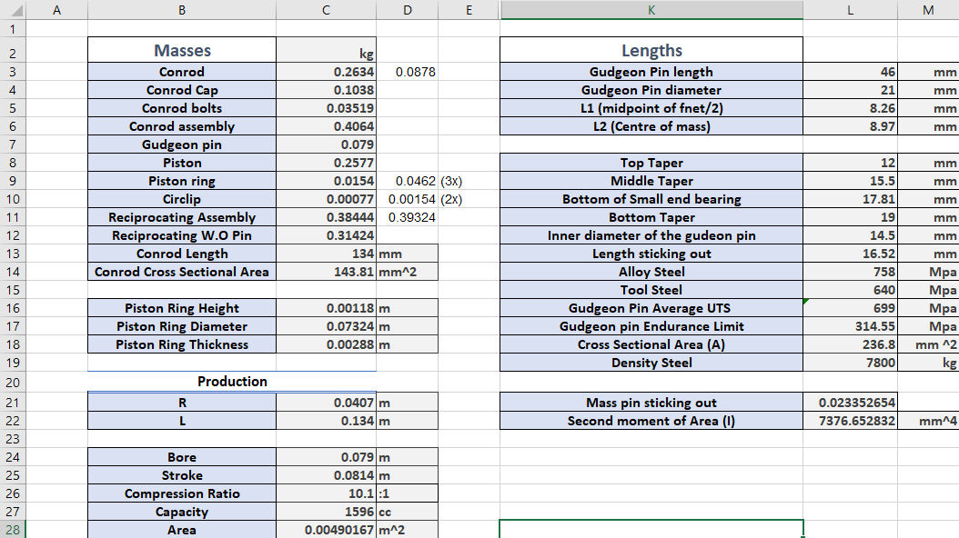

Figure 1: Constants table relative to the forces (N) and stresses (N/mm²) acting on the gudgeon pin

CAD model of the conrod and gudgeon pin, with values recorded for the constants table
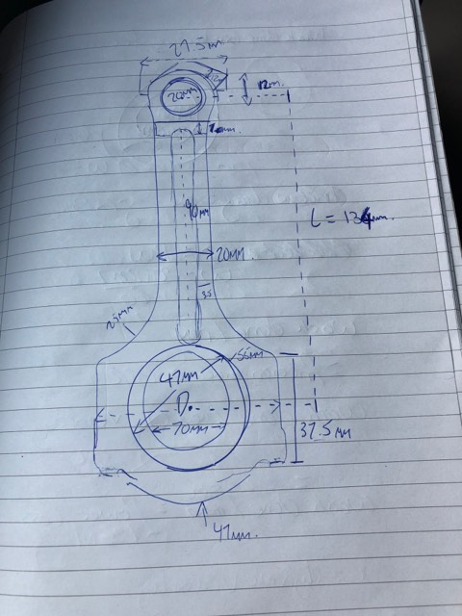
In the process of designing the CAD model of the conrod, Figure 2, represents the measurements recorded from the conrod and each aspect of the conrod needed in order to design in Solidworks. These measurements were a brief understanding to get the conrod extruded. However, when creating the CAD model more measurements were conducted but not recorded. The final design of the conrod is shown in Figure 34, were this includes the tapers recorded in MS Excel; Figure 1.

Figure 2: Accurate measurements recorded for the conrod CAD model
Referring to Figure 3, in order to find L₁, the gudgeon pin was mated in the assembly so the forces acting on point ‘A’, represented as the green circle to the edge of the gudgeon pin, which is represented as the length of the gudgeon pin sticking out. However, the net compressive force acting on the gudgeon pin is half of the length sticking out from point ‘A’, as recorded in the constants table, Figure 1.
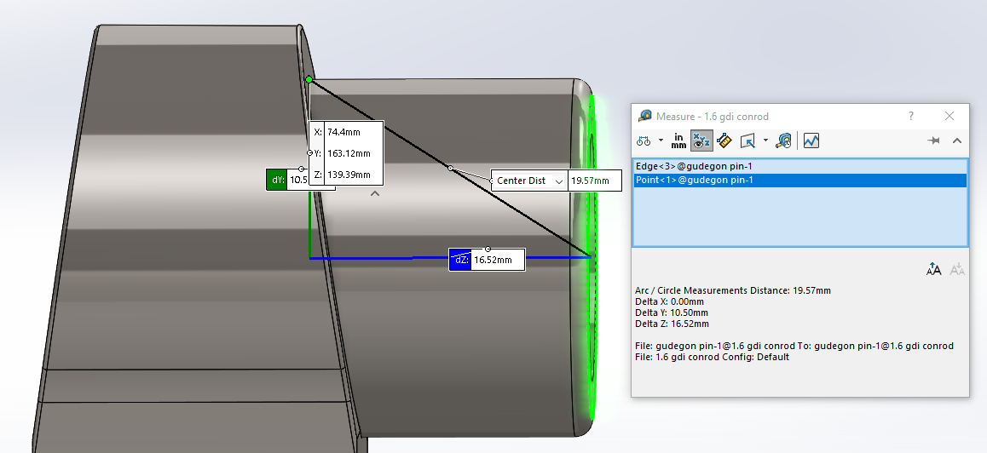

Figure 3: Length sticking out and the force acting on the gudgeon pin

Furthermore, referring to Figure 4, in order to find the distance from point ‘A’, represented as the green circle to the centre of mass of the gudgeon, the gudgeon pin was evaluated for the taper and the length the gudgeon pin was sticking out in order to find the centre of mass; this was presented in the mass properties entailed in Solidworks.
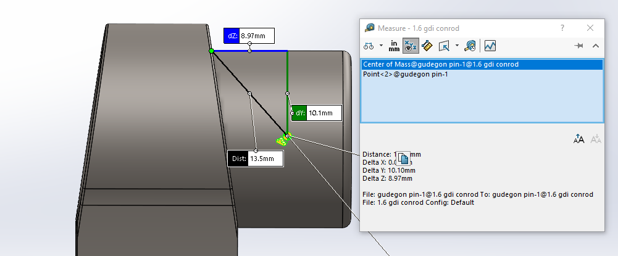

Figure 4: Centre of Mass, L₂, of the gudgeon pin
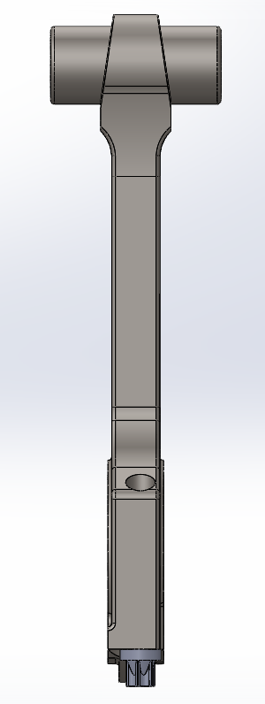
- Top Taper – 12mm
- Middle Taper – 15.5mm
- Bottom of small end bearing – 17.81mm
- Bottom Taper – 19mm
Referring to Figure 5, the top of the conrod has a taper, as shown above, the measurements recorded with the Vernier and transposed into Solidworks.
In addition, the value for the cross-sectional area was recorded from Solidworks represented in heading; 8.1, Figure 35.

Figure 5: Side measurements recorded from the CAD model

Constants relative to the compressive and tensile forces at the three critical rod-sections
Figure 6 shows the stress concentrations calculated for each point in the three critical rod-sections in order to recall the allowable range for the fatigue safety factor results.
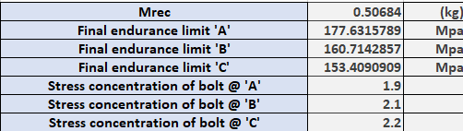

Figure 6: Constants relative to the three critical rod-sections
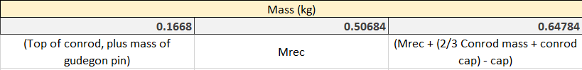
In addition, the masses are calculated for the three critical rod-sections, where point ‘B’ and ‘C’, apply the reciprocating mass entailed in Equation 13.
Figure 7: Mass constants used for each point in the three critical rod-sections

CAD model of the cross-sectional areas calculated for each point in the three critical rod-sections
Applying the section property tool in Solidworks, the cross-sectional area can be located, shown in Figure 8. A value of 67.33mm² is represented, however, the cross-sectional area has only applied for one side of the conrod. Due to only one side selected, the value can be multiplied by 2 to calculate the actual cross-sectional area.
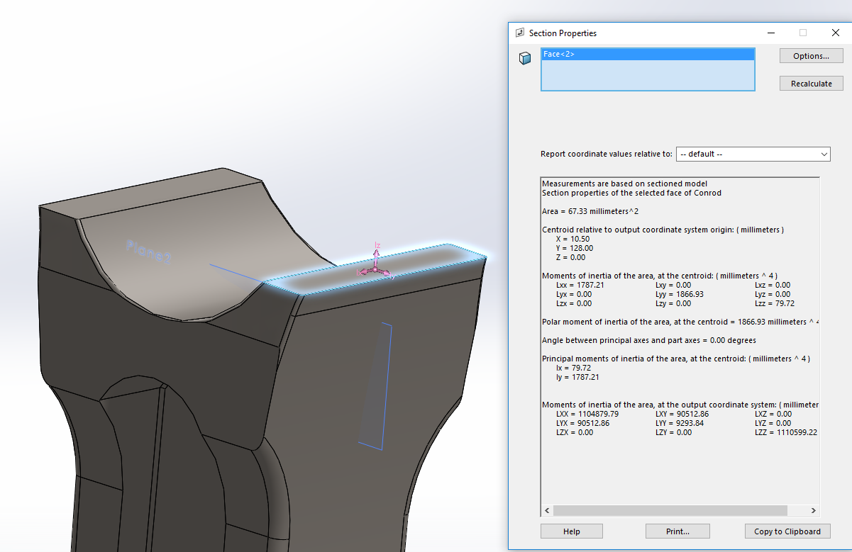

Figure 8: Cross-sectional area at point 'A'
Secondly, the cross-sectional area for point ‘B’ was located giving a value of 259.77mm².
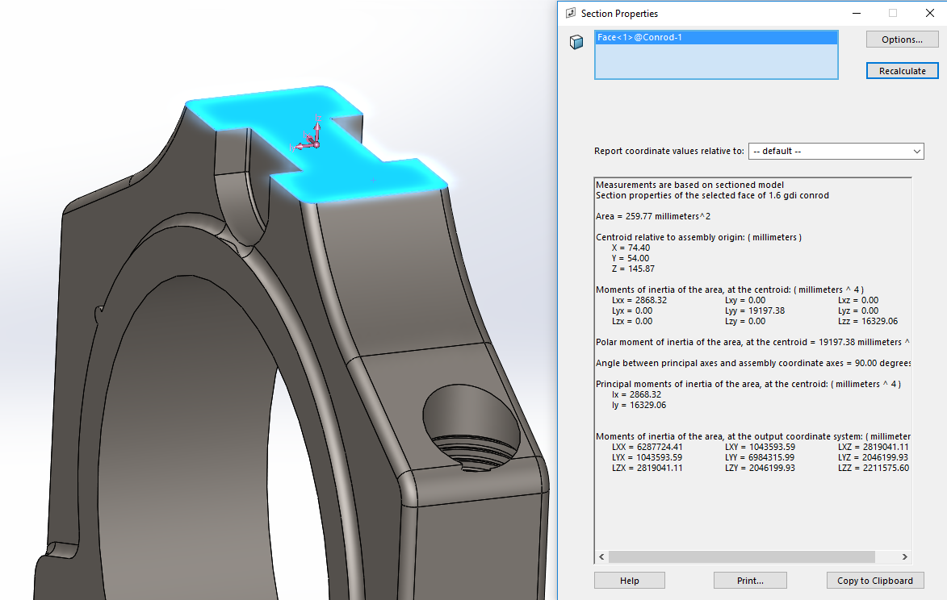

Figure 9: Cross-sectional area at point 'B'
Finally, the last cross-sectional area located at point ‘C’, represents a value of 143.62mm².
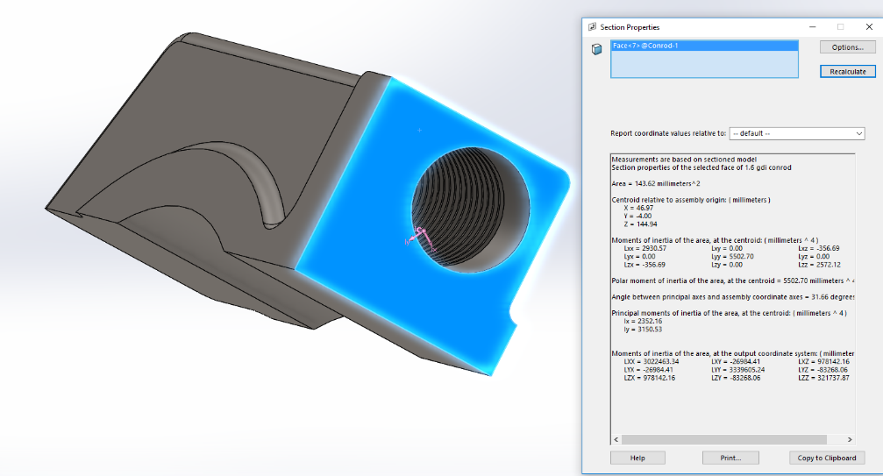

Figure 10: Cross-sectional area at point 'C'
All these values for the cross-sectional area can be found in the results table, Figure 23.

Constants relative to the standard conrod; bolt and cap
Represented in the following; Figure 11, are the measurements carried out with a Vernier in the University where a CAD model was created using Solidworks, shown in Figure 13. Referring to the UTS of the bolt, a value of 1100 Mpa was conducted, where shown on the top of the conrod bolt states the UTS.
In addition, these values for the Young’s modulus were assumed from the materials data table (Cambridge University Engineering Department , 2003), where the bolts material relates to the value for a ‘mild’ stainless steel, however the rod-cap is applied as AISI 4130 low ‘alloy’ steel.
Furthermore, values assumed such as mthread and mhead coef, also the stress concentration at thread root, according to (Mcdonald, 2020).
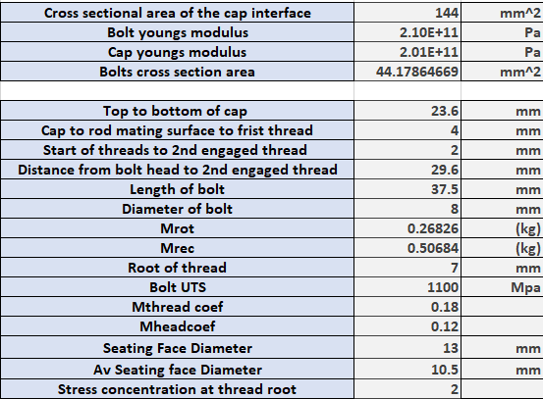

Figure 11: Constants table relative to the conrod bolt and cap

CAD model of the standard conrod bolt
Figure 12, shows the bolts sitting in place on the conrod, and Figure 13, of the entire bolt design; these were modelled using the measurements carried out in the University using the Vernier, where they could be applied in Solidworks to find the constant values above in Figure 11.
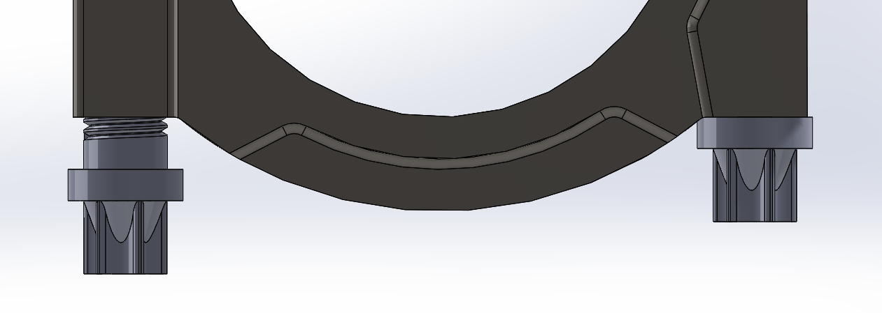

Figure 12: Standard 1.6 GDI Ford eco-boost conrod bolts
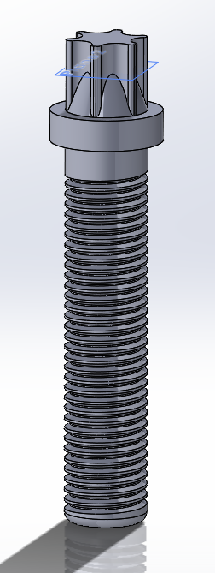

Figure 13: Standard 1.6 GDI Ford eco-boost conrod bolt design

Constants relative to the modified bolt
Figure 14 shows the measurements created for the modified bolt, where the shank diameter is reduced to ‘6mm’; however, using the same design and concept as the standard bolt. In order to calculate the new fatigue safety factor at each rpm the bolt stiffness has changed. Figure 14 shows three different areas and lengths for the bolt, which will equate as the total bolt stiffness (K) and a new UTS of 1516.8466, which represents the new material, ARP2000 (ARP automotive racing products, 2020).
The length stated in ‘L2’ does not include the length of the chamfers, however, for further work they could be applied for a more accurate result.
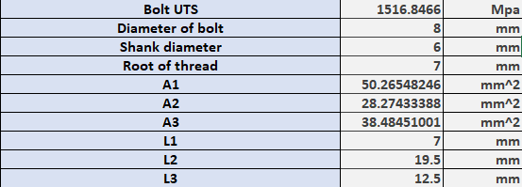

Figure 14: Constants table relative to the modified conrod bolt

Constants relative to the Ford 1.6 GDI crankshaft
Referring to Figure 15, these measurements of the crankshaft were recorded using a Vernier for the most accurate results. The crankshaft ultimate tensile strength (UTS) was recorded from a website (Matmatch, 2020), which states the value of the crankshaft to be ‘620 Mpa’ acting as a medium carbon steel; AISI1040, applicated to: crankshafts, railway tracks, train wheels, gears and machinery parts because of their high strength, resistance to wear and toughness (Matmatch, 2020).
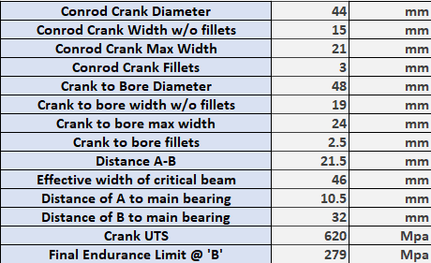

Figure 15: Constants table relative to the Ford 1.6 GDI crankshaft

Calculations and Results

Results of forces and stresses acting on the gudgeon pin

Methodology of the forces and stresses acting on the gudgeon pin
Referring to the previous data, such as cylinder pressures, masses and dimensions obtained on the Ford 1.6 eco-boost GDI turbo engine, the gas forces need to be recalculated in order to find the force acting upon the gudgeon pin. This is acquired by using the previous equation for inertia force, however, removing the mass of the gudgeon pin, shown in Equation 1.
$Piston Acceleration \left(m/s^{2}\right)*\left(\left(1/3 * Conrod Mass\right)\left(kg\right) * Mass of Piston \left(kg\right)*\left(3 * Piston ring mass\right)\left(kg\right) * \left(2 * Circlips mass\right)\left(kg\right)\right)$
Equation 1: Inertia force without the mass of the gudgeon pin (N)
Equation 1, represents previous data calculated, such as the first and second order piston acceleration. This equation will only apply to the top third of the conrod, this is where the gudgeon pin actuates in the small end bearing.
In order to find the maximum net compressive and tensile force on the gudgeon pin, refer to the previous data obtained in the previous study, where the gas force is acquired to find the updated net force using the following equation, Equation 2.
$Gas Force \left(N\right) - Inertia force \left(N\right)$
Equation 2: Net force without the mass of the gudgeon pin (N)
Furthermore, following Equation 2, the maximum compressive force is applied in 5700 rpm, however, the maximum tensile force is attained in 6000 rpm. This means, at point ‘A’, at 5700 rpm the compressive force will be in tension, this force acts at point ‘A’, which is applied on the corner edge on the top plane where the gas force is fired on the piston acting in the same direction; however, the tensile force will be applied as compression, where the force acting at point ‘B’ will be applied to the opposing direction on the bottom plane of the gudgeon pin, when gas force is acting on the piston.

As a result, the bending moment on the gudgeon pin will increase as rpm increments; this is because the greater the gas force applied to the gudgeon pin, the more the gudgeon pin will bend. In addition, using Equation 3, the bending moment can be calculated for the tension acting at point ‘A’ using the maximum compressive force.
$\left(\frac{Maximum Net Force \left(N\right)}{2}* Midpoint Length of Gudgeon pin \left(mm\right)\right) - \left(Gudegon pin Inertia Force \left(N\right) * Centre of mass length of Gudgeon pin \left(mm\right)\right)$
Equation 3: Bending moment acting on the gudgeon pin (N/mm)
Furthermore, represented in Equation 3, the inertia force of the gudgeon pin is calculated from the following, Equation 4.
$$Maximum piston acceleration \left(m/s^{2}\right) * Mass of gudgeon pin sticking out \left(kg\right)$$
Equation 4: Inertia force of the gudgeon pin (N)
However, the mass of the gudgeon pin can be calculated from the following, Equation 5.
$Length sticking out \left(m\right)*\left({\frac{3.14 * Gudgeon pin diameter \left(m\right)}{2}}^{2}\right)-\left({\frac{Inner diameter of gudgeon pin \left(m\right)}{2}}^{2}\right)*Density of Steel \left(7800kg\right)$
Equation 5: Mass of the gudgeon pin sticking out (kg)
A CAD model was applied to calculate measurements of the Ford 1.6 eco-boost GDI conrod and gudgeon pin, where referring to Equation 3, it states the midpoint length of the gudgeon pin; this represents the distance from point ‘A’ where the force acts upon the gudgeon pin to the centre of the piston pin bore. In addition, the centre of mass was calculated in Solidworks, where the gudgeon pin was recreated when all the components of the conrod was mated together, allowing a section of the conrod to be applied to the mass properties giving the distance of centre of gravity from the edge of the conrod.

Furthermore, after calculating the bending moment for the maximum compressive and tensile forces, the bending stress acting upon each point of the gudgeon pin can be calculated using the following; Equation 6.
$$\frac{\left(Bending Moment \left(N/mm\right) * \frac{Diameter of Gudgeon Pin \left(mm\right)}{2}\right)}{Second moment of Area\left({mm}^{4}\right)}$$
Equation 6: Bending Stress (N/mm²)
In addition, to calculate the shear stress which acts at each point of the gudgeon pin using compressive and tensile forces, using the following, Equation 7.
$$\left[\frac{\left(\frac{Maximum net force\left(N\right)}{2}\right)}{\left[\left(\frac{3.14 * \left({(Gudgeon diameter}^{2}\left(mm\right)\right) - \left({Inner diameter of the gudgeon pin}^{2}\left(mm\right)\right)}{4}\right)\right]}\right]$$
Equation 7: Shear Stress (N/mm²)
Moreover, using Equation 6, in order to calculate the bending stress and Equation 7, to work out the shear stress, the combined overall stress between the two stresses can be calculated using the following, Equation 8.
$$\sqrt{\left({Bending stress}^{2}\right)\left({N/mm}^{2}\right)}+\left(2 * {Shear stress}^{2}(N/{mm}^{2}\right)$$
Equation 8: Combined Stress (N/mm²)
As a result, the combined stress for compressive and tensile forces have been calculated; this can be represented now as the mean stress using the following, Equation 9.
$$\frac{Combined Compressive Stress \left(N/{mm}^{2}\right)+Combined Tensile Stress \left(N/{mm}^{2}\right)}{2}$$
Equation 9: Mean Stress (N/mm²)
Also, the range of stress can be applied from the combined compressive and tensile stress using the following, Equation 10.
$$Combined Compressive Stress \left(N/{mm}^{2}\right) - Combined Tensile Stress \left(N/{mm}^{2}\right)$$
Equation 10: Range of combined compressive and tensile stress (N/mm²)
Furthermore, the allowable range can be applied using the mean stress calculated using, Equation 9, using the following, Equation 11.
$$\left(2 * Endurance Limit\right) * \left(\frac{1 - \left(Mean Stress (N/{mm}^{2}\right)}{UTS}\right)$$
Equation 11: Allowable Range (N/mm²)
However, referring to Equation 11, the UTS of the gudgeon pin was unknown as study refers to their material as either Tool steel or Alloy steel, so an assumption presumed of the average UTS between the two materials shown in the properties table in the heading, 8.2, Figure 37. In addition, shown in constants table; Figure 1.
Furthermore, knowing the values for the range of stress and the allowable stress, the fatigue safety factor can be evaluated using the following, Equation 12.
$$\frac{Allowable Range \left(N/{mm}^{2}\right)}{Range of compressive and tensile stress \left(N/{mm}^{2}\right)}$$
Equation 12: Fatigue Safety Factor

Results of the forces and stresses acting down on the gudgeon pin
Using the methodology provided in the heading 5.1.1, in order to find the maximum compressive and tensile forces for each rpm the following equations were used: Equation 1 and Equation 2, represented in Figure 38 and Figure 39. These equations were conducted for each rpm, where 5700 rpm proved the greater compressive force acting upon the gudgeon pin and at 6000 rpm the greater tensile force acting upon the gudgeon pin represented in Figure 16 .
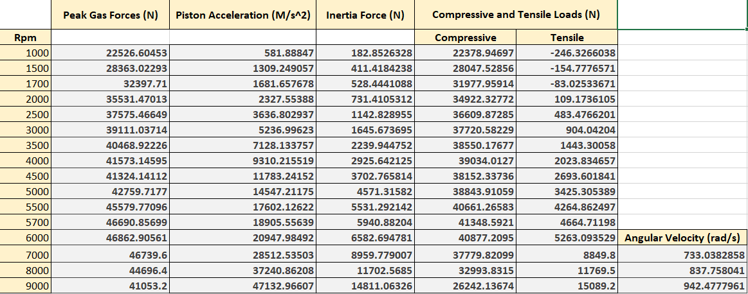

Figure 16: Peak compressive and tensile forces (N) acting on the gudgeon pin

Compressive force results at point ‘A’ acting in tension
Furthermore, the stresses carried out for the maximum compressive force as follows; represented in Figure 17 recorded from 5700 rpm.
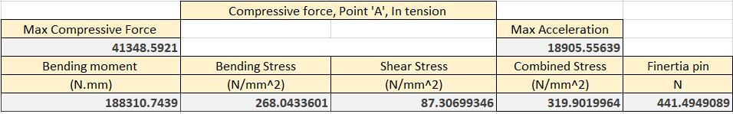

Figure 17: Maximum compressive force (N) representing the stresses (N/mm²) acting on the gudgeon pin

Tensile force results at point ‘A’ acting in compression
In addition, the stresses carried out for the maximum tensile force as follows; represented in Figure 18 recorded from 6000 rpm.
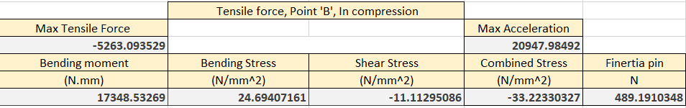

Figure 18: Maximum tensile force (N) representing the stresses (N/mm²) acting on the gudgeon pin

Goodman diagram representing the mean stress acting on the gudgeon pin
Represented below, Figure 19, is the Goodman diagram for the gudgeon pin where the average UTS of the two materials; alloy steel and tool steel were assumed at a value of ‘699’. In addition, the Goodman diagram’s states to keep within the endurance limi where the endurance limit is a precise stress level for a material, where stress cycles under a specific amplitude and mean will not accumulate fatigue damage, (Siemens, 2019), and can last forever. The mean stress is applied at point ‘XY’, which allows a value for the allowable range to be calculated shown in, Figure 20, using Equation 11.
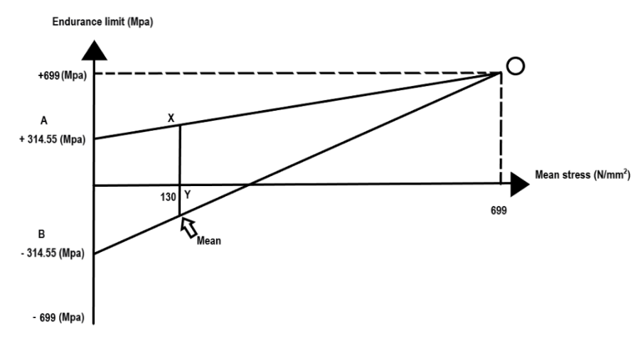

Figure 19: Goodman diagram of the mean stress (N/mm²) acting on the gudgeon pin

Mean and range of stresses for the gudgeon pin
Furthermore, the results calculated referred to the compressive and tensile forces combined the mean and range of stresses can be calculated, allowing the result of the fatigue safety factor which acts on the gudgeon pin, as represented in Figure 20.

Figure 20: Mean and range of stresses for the gudgeon pin (N/mm²)
Referring to Figure 20, the fatigue safety factor, ‘FSF’, is represented at a value of 1.56_{(2dp)}, which represents that the gudgeon pin will last forever under the maximum compressive force acting upon at 5700rpm and tensile force at 6000rpm reaching over the material, steels fatigue of 10⁷ cycles. At 5700rpm, the gudgeon pin will complete 47.5 complete cycles/sec and the number of hours, ‘N’ to get 10⁷ cycles is equal to 58 hours. In addition, at 6000rpm, the gudgeon pin will complete 50 complete cycles/sec and the number of hours, ‘N’ to get 10⁷ cycles is equal to 55 hours.

Results of the forces and stresses acting up around TDC on the gudgeon pin
Referring to the fatigue safety factor recorded for the compressive and tensile forces acting at 5700 rpm and 6000 rpm, the same process following the same equations used in the heading; 5.1.1, were calculated for compressive and tensile forces acting around TDC exhaust where at 7000 rpm produced the maximum compressive force and 9000 rpm which produced the maximum tensile force.
In addition, the compressive force was calculated taking the polynomial equation recorded from the polytropic trendline for peak gas forces across each rpm shown in the Appendix; 8.2, Figure 40. Moreover, the piston acceleration was calculated in respect to each rpm referring to their angular velocity, in order to find the inertia force using Equation 1. Finally, referring to the maximum compressive force acting around TDC exhaust on the gudgeon pin; 7000 and 9000 rpm, take the inertia force (N) away from the peak gas force (N). However, the values for tensile forces were taken from an equation represented in the polytropic trendline shown in the Appendix; 8.2, Figure 41, where this formulas was applied to each rpm incrementing each thousand.
Referring to Figure 21, when increasing the rpm of the engine, the fatigue safety factor of the gudgeon pin slightly decreases under the forces and stresses applied compared to Figure 20. However, the standard 1.6 gudgeon pin can apply the higher loads and stresses acting tensile without breaking according to the assumptions made for the higher forces and piston accelerations using the polytropic trendline.
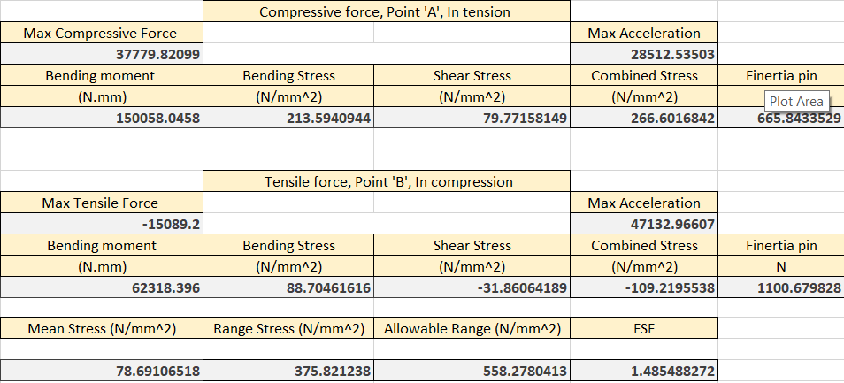

Figure 21: Maximum compressive and tensile force (N) and stresses (N/mm²) acting on the gudgeon pin around TDC exhaust

Results of forces and stresses acting on the three critical rod-sections

Methodology of the forces and stresses acting on the three critical rod-sections
Firstly, calculate the mass for each critical rod-sections in the diagram, Figure 42, where, point ‘A’ the mass is 1/3 of the conrod plus the mass of the gudgeon pin, point ‘B’, is represented in Equation 13 and point ‘C’, is represented in Equation 14.
$$\left(\frac{1}{3}*\left(Conrod mass+Conrod cap\right)\right) + Piston mass+\left(3 * Piston rings\right)+\left(2 * Circlips\right)+Gudgeon pin$$
Equation 13: Reciprocating Mass (kg)
$$Reciprocating Mass + \left(\left(\frac{2}{3} * Conrod mass+Conrod Cap\right)- Cap mass\right)$$
Equation 14: Mass of lower conrod (kg)
In addition, using these masses, shown in the constants table, Figure 7, the inertia force for each point presented in the three critical rod-sections can be calculated using the following, Equation 15. Where the maximum compressive force applies in 5700rpm and the maximum tensile force applies in 6000rpm, hence the piston acceleration value changing for compressive and tensile.
$$\left(Mass of Point,'A ,B or C^{'} \left(kg\right)+Mass of gudgeon pin \left(kg\right)\right)*Piston acceleration \left(m/s^{2}\right) (@5700 or 6000 rpm)$$
Equation 15: Inertia force for each point acting on the three critical rod-sections (N)
Furthermore, the net force is applied in order to find the maximum compressive and tensile forces, using Equation 16.
$$Inertia force (N) - (Inertia force on the gudgeon pin (N)+ Inertia force without gudgeon pin (N)+ Gas force (N))$$
Equation 16: Net Force (N)
These equations for inertia force and net force are represented in the heading 8.3.1; Figure 43, Figure 44 and Figure 45.

Furthermore, calculating the stresses and fatigue safety factors at each point according to the diagram, Figure 42, using the following equations;
$$\frac{Maximum Tensile Force \left(N\right)}{Cross-sectional area \left({mm}^{2}\right)}$$
Equation 17: Maximum nominal stress (N/mm²)
$$\frac{Maximum Compressive Force \left(N\right)}{Cross-sectional area \left({mm}^{2}\right)} * -1$$
Equation 18: Minimum nominal stress (N/mm²)
$$\frac{\frac{Maximum nominal stress \left(N/{mm}^{2}\right)}{Minimum nominal stress (N/{mm}^{2})}}{2}$$
Equation 19: Mean nominal stress (N/mm²)
$$Maximum nominal stress \left(N/{mm}^{2}\right) - Minimum nominal stress \left(N/{mm}^{2}\right)$$
Equation 20: Range of nominal stress (N/mm²)
The allowable range and fatigue safety can be applied using Equation 11 and Equation 12, in order to find at each point of the rod-sections.

Stress concentration literature review
A change in the geometric form of a component gives an increase to further stress over and above the calculated stress which is known as stress concentration. Within the component, the internal stress gets redistributed from miniscule to greater values at the region where the cross-sectional area changes. For example, in the diagram represented of the three critical rod-sections represented in Figure 42, at point ‘A’, the redistribution arises at the area of the fillet radius combining the two geometric shapes. If a greater fillet radius is provided amongst the two segments, the cross-sectional area is altered more steadily, then the internal stresses gets adequate space to get redistributed evenly. However, if the fillet radius is minuscule, the change in form is more sudden, then the internal stresses do not get adequate space to get redistributed evenly (Sengupta , 2019).
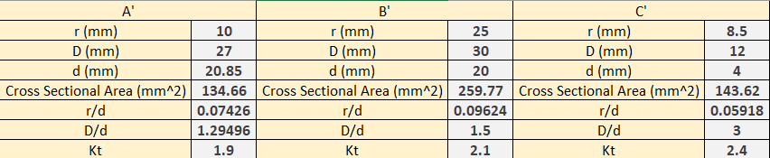
The values of stress concentrations were taken from the radius at each point acting on the three critical rod-sections; ‘A’ = 10mm, ‘B’ = 25mm and ‘C’ = 8.5mm, as shown in Figure 22; the radius’ are then divided by ‘d’, which is a value for the cross sectional areas recorded in the results table, Figure 23. This gives a value for r/d, which allows the aspect line to reach the curve ‘D/d’, which is applied using the larger distance across that cross sectional area divided by the smallest distance. In this instance, the constants carried out for the three critical rod-sections are as stated in Figure 22.
Figure 22: Stress concentration at each point acting on the three critical rod-sections
The values for stress concentration ‘K_{t}’, were constructed from the Bosch automotive handbook (Bosch, 1978; Pilkey, 1997).
According to (Sengupta , 2019), the value of the stress concentration ‘K_{t}’ differs from 1 to about 3 in most senarios. When ‘K_{t}’ = 1, this means there is no stress concentration, that is, considered the value of stress = actual value of stress. When ‘K_{t}’ = 3, the genuine stress is three times the intended value.

Results of the forces and stresses acting on the three critical rod-sections
Using the equations, provided in the heading; 5.2.1, the following results can be calculated as shown in Figure 23.
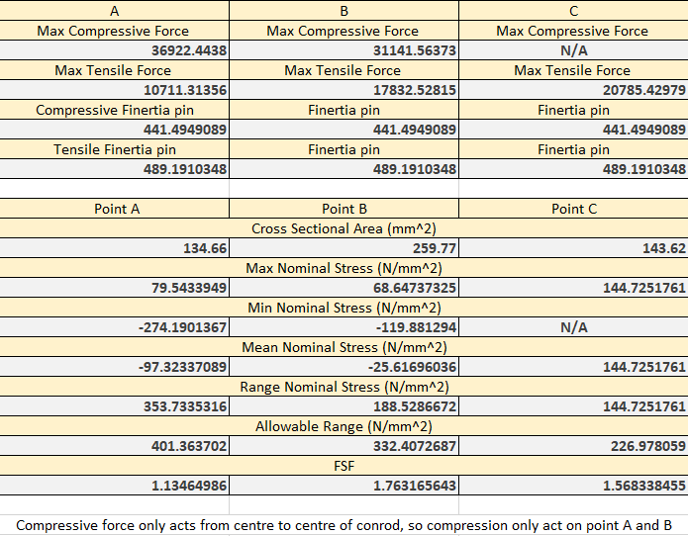

Figure 23: Results of the forces (N) and stresses (N/mm²) acting on the three critical rod-sections
As previously stated above, in Figure 22, the stress concentrations were applied at each sector, which affected the final endurance limit values shown in Figure 6. These stress concentrations varied the value for the fatigue safety factor (FSF), where at point ‘A’ and ‘B’, the stress concentration was carried from the Figure A-15-5, recorded from (Bosch, 1978), where it states the rectangular filleted bar is in tension or simple compression. However, at point ‘C’, Figure A-15-6, was recorded from (Bosch, 1978), as at point ‘C’ the rectangular filleted bar was in bending.

Goodman diagrams representing each point in the three critical rod-sections
Referring to Figure 24, represents a Goodman diagram of the mean stress acting at point ‘A’ on the three critical rod-sections shown in Figure 42.
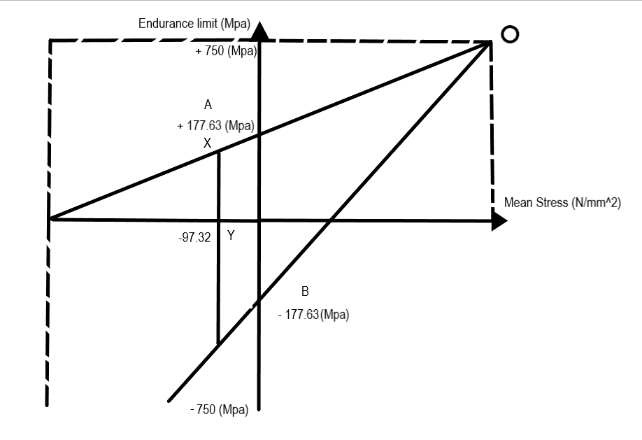

Figure 24: Goodman diagram representing point 'A' (N/mm²) in the three critical rod-sections
Furthermore, Figure 25, represents the mean stress acting at point ‘B’ against the UTS and endurance limits.
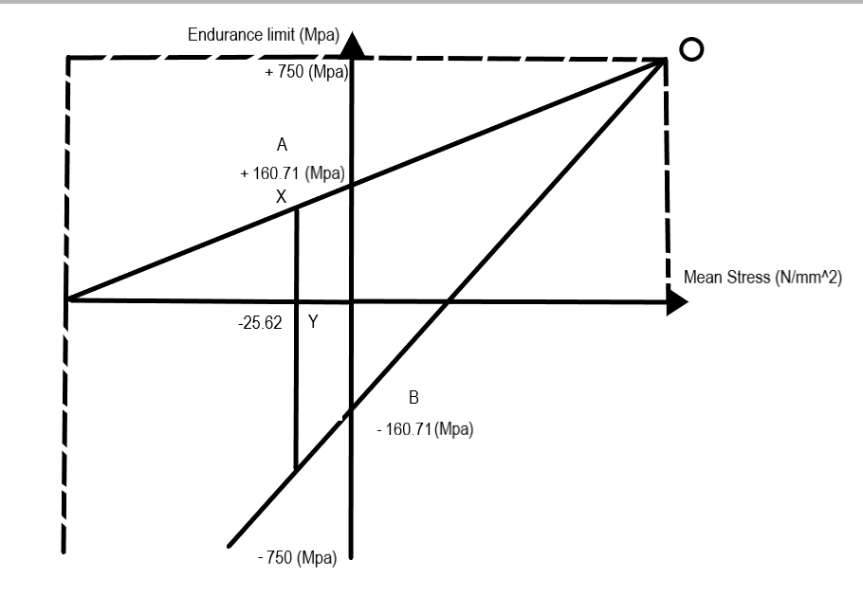

Figure 25: Goodman diagram representing point 'B' (N/mm²) in the three critical rod-sections

Finally, Figure 26 represents the mean stress acting at point ‘C’ against the UTS and endurance limits.
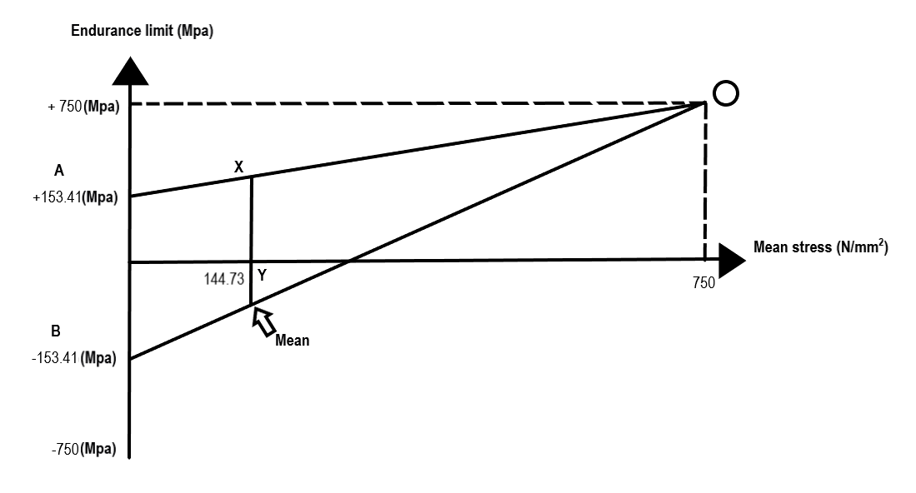

Figure 26: Goodman diagram representing point 'C' (N/mm²) in the three critical rod-sections

Results of forces, torques and stresses acting on the standard Ford 1.6 GDI eco-boost bolt

Methodology of the forces, torques and stresses acting on the standard Ford 1.6 GDI eco-boost bolt
Firstly, in order to find the stiffness ratio of the bolt and cap combined, find the cross-sectional area for each bolt and cap interface and Youngs modulus, apply these constants into Equation 21. This will determine the approximate ratio of the bolt stiffness (K_{B}) to the cap-rod stiffness (K_{Rod}).
$$\frac{\left(Caps Youngs modulus (Pa) * Cross-sectional area of the cap interface ({mm}^{2}\right) }{\left(Bolts Young modulus (Pa) * Cross-sectional area of the bolt ({mm}^{2}\right)}$$
Equation 21: Approximated Stiffness Ratio
Secondly, in order to find the stiffness of the standard bolt (K_{B}), use Equation 22.
$$\frac{\frac{Bolts Youngs modulus \left(Pa\right)}{1000000} * Cross-sectional area of the bolt \left({mm}^{2}\right)}{Distance from bolt head to 2nd engaged thread (mm)}$$
Equation 22: Standard bolt stiffness (N/mm²)
In addition, following the same route, find the cap interface stiffness (K_{Rod}), using Equation 23.
$$\frac{\frac{Caps Youngs modulus \left(Pa\right)}{1000000} * Cross-sectional area of the cap \left({mm}^{2}\right)}{Distance from bolt head to 2nd engaged thread (mm)}$$
Equation 23: Standard cap stiffness (N/mm²)
Using the following equations, Equation 22 and Equation 23, the actual stiffness ratio can be calculated using Equation 24.
$$\frac{Standard cap stiffness (N/{mm}^{2})}{Standard bolt stiffness (N/{mm}^{2})}$$
Equation 24: Actual Stiffness ratio

Moreover, to find the highest inertia force acting on the standard bolt, use Equation 25.
$$Reciprocating mass (kg) * Crank throw (m) * (Angular velocity (rad/s) @ '6000Rpm') * \left(1+\frac{Crank throw \left(m\right)}{Conrod length \left(m\right)}\right) + \left(\frac{2}{3} * Conrod mass\left(kg\right)-Conrod cap mass \left(kg\right)\right) * Crank throw (m) * Angular velocity (rad/s) @ '6000Rpm')$$
Equation 25: Highest inertia force acting on the standard bolt (N)
Referring to Equation 25, this will entail the final value for the extra force on the bolt, where three variations of equations can be used to validate the result of the extra force on the bolt.
$$\left( \frac{1}{\left(1+Actual stiffness ratio\right)}\right) * \left(\frac{Highest inertia force \left(N\right)}{2}\right)$$
Equation 26: Extra force on the standard bolt variant 1 (N)
$$\left( \frac{1}{\left(1+\left(\frac{Cap stiffness \left(N/{mm}^{2}\right)}{Bolt stiffness \left(N/{mm}^{2}\right)}\right)\right)}\right) * \left(\frac{Highest inertia force \left(N\right)}{2}\right)$$
Equation 27: Extra force on the standard bolt variant 2 (N)
$$\frac{\left(\frac{Highest inertia force\left(N\right)}{2} \right)}{Cap stiffness \left(N/{mm}^{2}\right) + Bolt stiffness \left(N/{mm}^{2}\right)}$$
Equation 28: Additional bolt stretch (mm)
$$Bolt stiffness \left(N/{mm}^{2}\right)*Additional bolt stretch \left(mm\right)$$
Equation 29: Extra force on the standard bolt variant 3 (N)

In addition, finding the extra force acting upon the standard bolt using the equations above, means the extra nominal stress at root thread can be calculated using Equation 30.
$$\frac{Extra force on the standard bolt \left(N\right)}{\left(3.14 * \frac{{Root of thread \left(mm\right)}^{2}}{4}\right)}$$
Equation 30: Extra nominal stress at root thread (N/mm²)
Furthermore, from the static bolt force when tightened to 90% yield, the required tightening torque needs to be calculated. Firstly, calculate the clamping force when built using Equation 32.
$$60\%*\left(90\%* Bolt UTS \left(Mpa\right)\right)$$
Equation 31: Tightening to 90% Yield (N/mm²)
$$\left({\frac{3.14 * \left(Diameter of bolt \left(mm\right)+\left(Root of thread \left(mm\right)\right)\right)}{4}}^{2}\right)*Tightened to 90\% Yield \left(N/{mm}^{2}\right)$$
Equation 32: Clamping force when built (N)
There are two areas of friction applied when calculating the required bolt tightening torque; one coefficient of friction acting on the 2nd engaged thread with a value of ‘0.18’ and friction between the head with a value of ‘0.12’, both represented in the constants table, Figure 11 and apply both frictional areas to the clamping force as shown below;
$$0.18*Clamping force\left(N\right)$$
Equation 33: Circumferential friction force acting on 2nd engaged thread (N)
$$0.12*Clamping force\left(N\right)$$
Equation 34: Circumferential friction force acting on the head (N)

Using the equations above to find the circumferential friction force, this can be applied to finding the resisting torque at threads taking Equation 33, and applying it to Equation 35.
$$\left(\frac{\left(\frac{Diameter of the bolt \left(mm\right)+Thread root \left(mm\right)}{2}\right)}{2}\right)*Circumferential friction force acting on 2nd engaged thread \left(N\right)$$
Equation 35: Resisting torque at threads (N/mm)
In addition, using the circumferential force acting on the head, the torque needed to overcome head friction can be applied using Equation 36.
$$Circumferential friction force acting on the head \left(N\right)*\left(\frac{Average seating diameter \left(mm\right)}{2}\right)$$
Equation 36: Torque needed to overcome head friction (N/mm)
This means, the total torque acquired when tightened can be calculated using Equation 37.
$$Resisting torque at threads \left(N/mm\right)+Torque needed to overcome head friction \left(N/mm\right)$$
Equation 37: Total torque needed when tightened (N/mm)
Furthermore, the range of stress is equivalent to the extra nominal stress at thread root shown in Equation 30, this value can be equated as the range of stress. In order to find sigma max (σ_{max}), the value of the minimum can be applied as 90% of the tightened yield strength as shown in Equation 38.
$$90\% * ( Bolt UTS (Mpa) * 90\%)$$
Equation 38: Sigma minimum (σ_{Min}), of 90% yield (N/mm²)
This result can be applied to find sigma max (σ_{max}) using Equation 39.
$$Range of stress \left(N/{mm}^{2}\right)+Sigma minimum \left(N/{mm}^{2}\right)$$
Equation 39: Sigma maximum (σ_{Max}), of 90% yield (N/mm²)
In addition, the mean stress can be calculated by applying the minimum and maximum values for sigma (σ), using
$$\frac{Sigma max + Sigma min}{2}$$
Equation 40: Mean stress (N/mm²)
Furthermore, in order to find the final endurance limit, calculate the polished endurance limit which represents 45% of the rod-bolt UTS, which is applied to Equation 41.
$$\frac{\left(45\%*Bolt UTS \left(Mpa\right)\right)}{Stress concentration factor}$$
Equation 41: Final endurance limit (Mpa)
Finally, taking into account the final endurance limit, the allowable range can be calculated using Equation 11, in order to find the fatigue safety factor for the bolt using Equation 12.

Literature review on conrod bolts
Furthermore, there are two tightening methods on how the preload is generated; such as, rotational tightening which is torque, angle and yield controlled; where the tensioner is rotated to directly produce the preload and Tensioning, where the bolt is stretched without rotating the tensioner (Nord-Lock Group, 2014). In this case, Figure 27, the study results in rotational tightening where the bolt is tightened to 90% yield. A conrod bolt is torque tightened, torque gradient, angle rotating, stretch measurement and various other methods. The torque process is commonly used due to its ease and convenience (Misumi, 2020). According to research findings; various references such as, ((Norbar, 2020); (Gedore, 2020)), state the load will be 90% of the bolt yield strength and a coefficient of 0.14. However, in the results table the coefficient of friction used at the threads was 0.18 (Mcdonald, 2020).
According to, (Boltscience, 2018), when the rod-bolt is tightened the shank tolerates a direct stress because of the elongation strain, along with a torsional stress because of the torque that acts upon the threads. A majority of bolt tightening torque tables ignore the torsional stress and assume the threads impact a direct stress of some percentage of bolt yield stress, such as 75%. With high frictional conditions, the magnitude of torsional stress depends when combined with direct and an equivalent stress over a yield, leading to failure. A more accurate representation to determine the magnitude of direct stress, when shared with torsional, will equal the stress of some percentage of yield. This percentage is commonly applied at 90%.

Results of the forces, torques and stresses acting on the standard Ford 1.6 GDI eco-boost bolt
As previously stated in the heading; 5.3.1, the methodology studies each aspect shown in the results table below; Figure 27.
This study looks at the forces, torques and stresses acting on the standard 1.6 bolt and cap at 6000rpm, where the bolt is being stretched and the cap is being compressed.
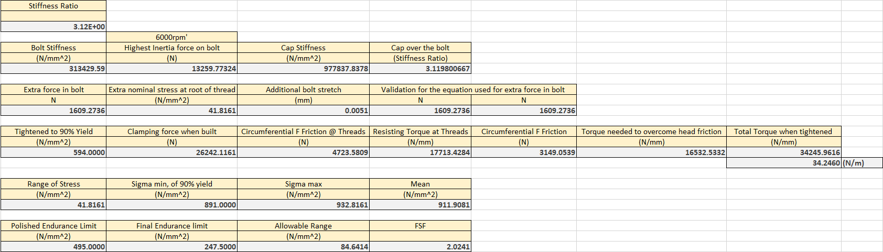

Figure 27: Results of the forces (N), torques (N/mm) and stresses (N/mm²) acting on the standard Ford 1.6 GDI conrod bolts @6000rpm

Using the previous equations in the heading; 5.3.1, Figure 28 shows the fatigue safety factor of the standard bolt acting at 9000rpm.
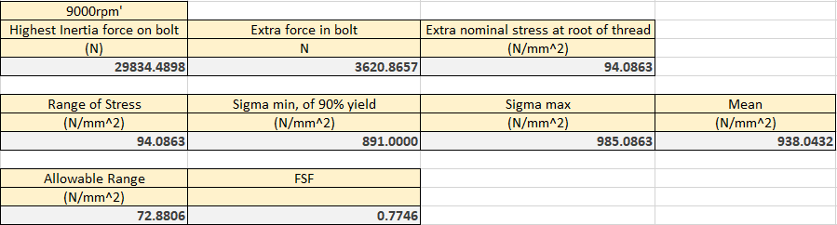

Figure 28: Results of the forces (N), torques (N/mm) and stresses (N/mm2) acting on the standard Ford 1.6 GDI conrod bolts @9000rpm
Comparing the fatigue safety factors at the two rpms chosen; 6000rpm and 9000rpm, Figure 27 shows the standard 1.6 bolt is within the fatigue safety factor allowing the bolt to act under the force and stresses applied. However, Figure 28 shows when the rpm increases; the inertia force, extra force acting on the bolt and extra nominal stress at root of thread significantly increases which applies a lower allowable range the bolt can apply; this causes the bolt to fail at 9000 rpm with a fatigue safety factor of ‘0.77’ causing the bolt to break. This is where a modified bolt design has been redesigned shown in Figure 29, where the shank diameter has been reduced in order to reduce bolt stiffness which will reduce the extra force in the threads. In addition, a new material has been applied to the modified bolt; this will enlarge the bolts ultimate tensile strength, for the bolt not to break under high loads at higher rpms.
The new material applied is an alloy steel ‘ARP2000’ which can be carefully heat treated to an advanced level, which can produce a greater strength material than the standard 1.6 bolt. ARP2000 is commonly used in short track and drag racing as an upgrade from standard bolts, so theoretically these bolts should not break under high rpms (ARP automotive racing products, 2020).

CAD model of the modified conrod bolt
Figure 29 represents the modified CAD model compared to the standard 1.6 GDI Ford eco-boost conrod bolt. As shown in Figure 29, the rod has a reduced diameter shank and full engagement for the remaining threads. The reason for this design comes from (ARP, Automotive racing products, 2011), where the reduced diameter shank is helpful in an alternative way. It decreases the bending stiffness of the rod-bolt. Hence, when the rod-bolt bends because of deformation in the conrod, the bending stresses are condensed below compared to the stresses acting before. In addition, this additionally increases the fatigue resistance of the rod-bolt (ARP, Automotive racing products, 2011).
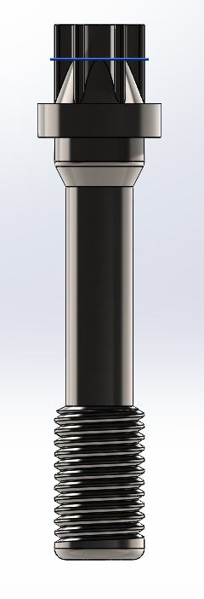

Figure 29: Modified 1.6 GDI Ford eco-boost conrod bolt design

Methodology used in order to calculate the new total bolt stiffness (K)
In order to calculate the new areas for each section of the new bolt design, use Equation 42.
$$\frac{3.14 * 'Length (mm)'}{4}$$
Equation 42: Area for each section of the new bolt (mm²)
In addition, to calculate the stiffness at each section of the bolt, which represents as K₁, K₂ and K₃, use Equation 43.
$$\frac{\left(\frac{Youngs modulus \left(Pa\right)}{1000000}*Area ({mm}^{2})\right)}{Length (mm)}$$
Equation 43: Stiffness at a certain section on the bolt (N/mm²)
Finally, in order to calculate the total stiffness of the bolt after working out each stiffness at each section of the bolt, use Equation 44.
$$\frac{1}{\left(\frac{1}{K^{1} (N/{mm}^{2})} + \frac{1}{K^{2} (N/{mm}^{2})} + \frac{1}{K^{3} (N/{mm}^{2})}\right)}$$
Equation 44: Total bolt stiffness (K)

Results of the forces, torques and stresses acting on the modified bolt
As previously stated, a new rod-bolt was designed for the Ford 1.6 eco-boost GDI to improve the fatigue safety factor at higher rpms compared to the standard rod-bolt. Figure 30 shows the modified bolt has a significant improvement acting at 6000 and 9000 rpm, where a fatigue safety factor of ‘1.8’ is represented at 9000rpm, which implies the bolt is strong enough under higher inertia loads and stress.
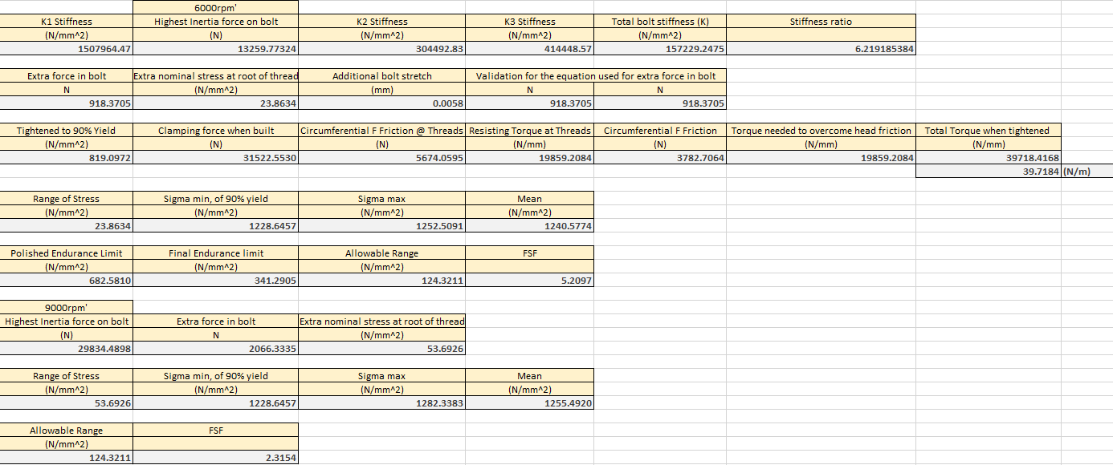

Figure 30: Results of the forces (N), torques (N/mm) and stresses (N/mm²) acting on the modified bolt

Results of forces and stresses acting on the crankshaft

Methodology of the forces and stresses acting on the crankshaft
Firstly, calculate the inertia force acting upon the crankshaft, however, because of a rotational angular velocity; this equation will apply to Equation 25 previously applied for calculating the fatigue safety factor in heading; 5.3.3 and 5.3.4.
Furthermore, the net force is applied in order to find the maximum compressive forces, using Equation 16.
Once the maximum compressive force has been calculated, the horizontal projected bearing area can be considered using
$$Crankshaft diameter \left(conrod\right)\left(mm\right)*Crankshaft max width \left(conrod\right)\left(mm\right)$$
Equation 45: Horizontal projected bearing area (mm²)
Following this, as the values for the maximum compressive force and horizontal project bearing area are known, these can be used to find the nominal bearing pressure, using
$$\frac{\left(\frac{Maximum compressive force \left(N\right)}{2}\right)}{Horizontal projected bearing area \left({mm}^{2}\right)}$$
Equation 46: Nominal bearing pressure (N/mm²)
In order to calculate the stresses acting on the crankshaft, the second moment of area needs to be known, using Equation 47; this can be achieved.
$$\frac{Effective width of critical beam \left(mm\right)*\left({Crankshaft max width \left(conrod\right)}^{3}\left(mm\right)\right)}{12}$$
Equation 47: Second moment of area (mm⁴)
In addition, the bending moment and stresses can be calculated for point ‘A’ and ‘B’ on the crankshaft. Firstly, looking at the bending moment;
$$\frac{Maximum compressive force \left(N\right)}{2} * \frac{Crankshaft max width \left(conrod\right) (mm)}{2}$$
Equation 48: Bending moment at point 'A' on the crankshaft (N/mm)

$$\frac{Maximum compressive force \left(N\right)}{2}*Distance to B to main bearing \left(mm\right)$$
Equation 49: Bending moment at point 'B' on the crankshaft (N/mm)
These equations used the maximum compressive force which correlates back to the inertia force and net force at 6000 rpm.
Moreover, the second moment of area is known, along with the bending moment just calculated, the bending stresses at each point can be calculated using Equation 50.
$$\frac{\left(Bending moment \left(N/mm\right)*\frac{Distance A - B (mm)}{2}\right)}{Second moment of area \left({mm}^{4}\right)}$$
Equation 50: Bending Stress (N/mm²)
Furthermore, the shear stress can be considered at point ‘B’, which is acting in tension acting on the critical fillet section using Equation 51.
$$\frac{\left(\frac{Max compressive force \left(N\right)}{2}\right) }{{\left(\frac{3.14*Crank diameter \left(conrod\right)\left(mm\right)}{2}\right)}^{2}}$$
Equation 51: Shear stress acting on the critical fillet section (N/mm²)
In order to calculate the maximum and minimum resultant stress acting on the critical fillet section at point ‘B’ at TDC exhaust. The upwards inertia force on the crankpin needs to be known, where Equation 52 shows;
$$\left(Reciprocating mass \left(kg\right)*Crank throw \left(m\right)*{Angular velocity \left(rad/s\right) @7000rpm}^{2}\right)*\left(1 * \frac{Crank throw \left(m\right)}{Conrod length \left(m\right)}\right)+Rotational mass \left(kg\right)*Crank throw \left(m\right)*\left({Angular velocity \left(rad/s\right) @7000rpm}^{2}\right)$$
Equation 52: Upwards inertia force acting on the crankpin (N)

Considering the upwards inertia force along with the bending and shear stress acting on the critical fillet section, point ‘B’, the maximum and minimum resultant stress can be considered at point ‘B’, where;
$$\sqrt{{Bending stress \left(N/{mm}^{2}\right) @B}^{2}}+{\left(2*Shear stress \left(N/{mm}^{2}\right) @B\right)}^{2}$$
Equation 53: Maximum resultant stress @B (N/mm²)
$$\frac{Upwards inertia force on the crankpin \left(N\right)*Bending stress \left(N/{mm}^{2}\right)}{Maximum compressive force \left(N\right)} * -1$$
Equation 54: Minimum resultant stress @B (N/mm²)
Finally, the final procedures to find the fatigue safety factor, consider the range and mean stress using the following;
$$Maximum resultant stress \left(N/{mm}^{2}\right) @B - Minimum resultant stress \left(N/{mm}^{2}\right) @B$$
Equation 55: Range of stress @B (N/mm²)
$$\frac{Maximum resultant stress \left(N/{mm}^{2}\right) @B + Minimum resultant stress \left(N/{mm}^{2}\right) @B}{2}$$
Equation 56: Mean stress @B (N/mm²)
In addition, the allowable range acting at point ‘B’ shown in Equation 11, where the fatigue safety factor can be considered using Equation 12.

Literature review on crankshaft
During the process of the crankshaft throw, the primary stresses and deformations defines from the gas pressure and inertial forces as represented in Figure 31, (Bosch, 1978).
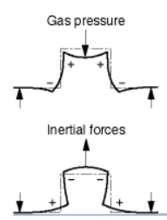

Figure 31:Gas pressure and inertial forces acting on the crankshaft (N), (Bosch, 1978)
During the material and manufacturing processes, stress and load factors are primary considerations during selection. High stressed crankshafts are commonly drop forged, however, in smaller stressed engines, cast crankshafts, unite two main advantages; such as lower weight and less expensive, which are predominately becoming popular within the manufactures (Bosch, 1978). There are two types of loads applied on a crankshaft, these being; bending force and a twisting force. Referring to the results shown below, Figure 32, the calculations are for the bending moments and stress acting on the crankshaft. These results can represent the bending fatigue failures from the bending of the crankshaft which takes place over once per revolution (General Motors Corp, 1972).

Results of the forces and stresses acting on the crankshaft
Using the equations previously stated in the heading; 5.4.1, the results are as shown in Figure 32. Furthermore, the results show a greater upwards inertia force on the crankpin compared to half the maximum compressive force; this could be down to an error in the methodology. However, looking further into the results at point ‘B’ in the critical fillet selection, shows a greater bending moment and stress value than point ‘A’, where this implies a greater amount of tension on the crankshaft. In addition, the crankshaft is capable of handling the forces and stresses giving a value for its fatigue safety factor of ‘2.01’, which evaluates to double the expected.
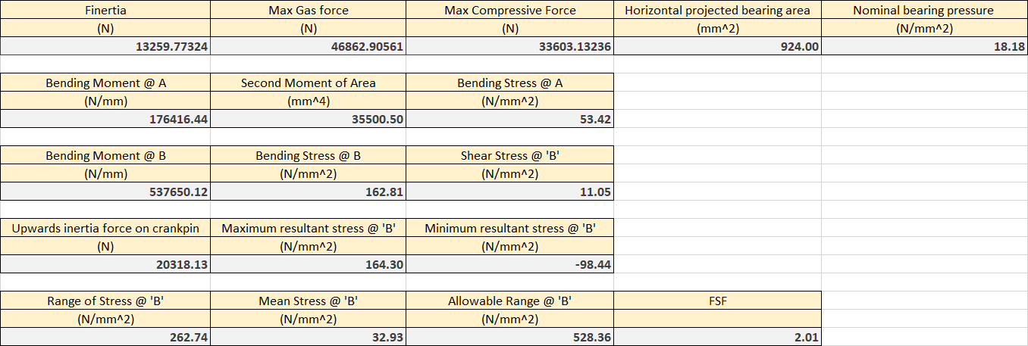

Figure 32: Results of the forces (N) and stresses (N/mm²) acting on the crankshaft

Goodman diagrams representing the critical fillet section at point ‘B’ on the crankshaft
Referring to Figure 33, represents a Goodman diagram of the mean stress acting at point ‘B’ on the critical fillet sections acting on the crankshaft.
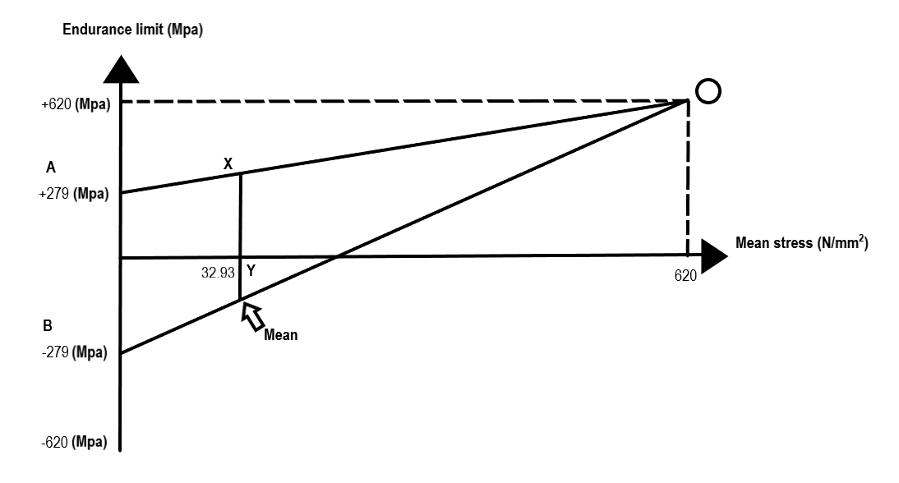

Figure 33: Goodman diagram representing point 'B' (N/mm2) on the critical fillet-section on the crankshaft

Conclusion
To conclude, during this study of calculating the working safety factors for infinite fatigue life for the duty cycle of the standard Ford 1.6 GDI eco-boost engine includes the piston, conrod and crankshaft assemblies, shows if the engine was to increase their rpm, Ford would need to produce a new conrod and rod bolts in order to apply the higher loads and stresses which act from the engine. However, the piston and crankshaft proved to seem reliable if given forces and stresses were to act on the components proofing a beneficial working safety factor.

References
ARP automotive racing products, 2020. Material Specifications; ARP automotive racing products. [Online]
Available at: https://arp-bolts.com/p/technical.php
[Accessed 11 02 2020].
ARP, Automotive racing products, 2011. The world leader in fastener technology. s.l.:Automotive Racing Products, Inc..
Bass, J., 2019. Con-rod accelerations, forces, displacements, Swansea: s.n.
Bell, T., 2019. What Are the Different Types of Steel?. [Online]
Available at: https://www.thoughtco.com/steel-grades-2340174
[Accessed 08 02 2020].
Boltscience, 2018. Methods of tightening threaded fasteners; Bolt science. [Online]
Available at: https://www.boltscience.com/pages/tighten.htm
[Accessed 10 02 2020].
Bosch, R., 1978. Automotive Handbook. s.l.:Wiley.
Cambridge University Engineering Department , 2003. Materials Data Book. Cambridge: Granta Design Ltd.
Gedore, 2020. Tightening/Test Torque; Gedore. [Online]
Available at: https://de.gedore.com/fileadmin/Service/Tabellen_Downloads/410-421_Technik_UK.pdf
[Accessed 10 02 2020].
General Motors Corp, 1972. Detroit diesel 53 Crankshaft 1.3; General Motors Corp. [Online]
Available at: http://constructioncranes.tpub.com/TM-5-3810-293-14-P-3/TM-5-3810-293-14-P-30210.htm
[Accessed 13 02 2020].
Matmatch, 2020. Carbon Steel: Properties, Production, Examples and Applications; Matmatch. [Online]
Available at: https://matmatch.com/learn/material/carbon-steel
[Accessed 12 02 2020].
Mcdonald, M., 2020. Lecture notes. [Sound Recording].
Misumi, 2020. Proper Bolt Axial Tightening Force and Proper Tightening Torque; Misumi. [Online]
Available at: https://in.misumi-ec.com/pdf/tech/mech/p2849.pdf
[Accessed 10 02 2020].
Norbar, 2020. A guide to torque values; Norbar. [Online]
Available at: http://www.norbar.com/Portals/0/downloads/TorqueValueGuide.pdf
[Accessed 10 02 2020].
Nord-Lock Group, 2014. Comparision of common bolt tightening methods. [Online]
Available at: https://www.nord-lock.com/insights/knowledge/2014/comparison-of-common-bolt-tightening-methods/
[Accessed 10 02 2020].
Pilkey, W. D., 1997. Peterson's Stress Concentration Factors. 2nd ed. New York / Chichester / Weinheim / Brisbane / Singapore / Toronto: A Wiley-lnterscience Publication.
Sengupta , A. K., 2019. Stress Concentration Caused by Sudden Change in Form. [Online]
Available at: https://web.njit.edu/~sengupta/met%20301/Stress%20Concentration.pdf
[Accessed 09 02 2020].
Siemens, 2019. The Goodman-Haigh Diagram for Infinite Life; Siemens. [Online]
Available at: https://community.sw.siemens.com/s/article/the-goodman-haigh-diagram-for-infinite-life
[Accessed 09 02 2020].

Appendix

CAD model of the conrod and gudgeon pin with values recorded
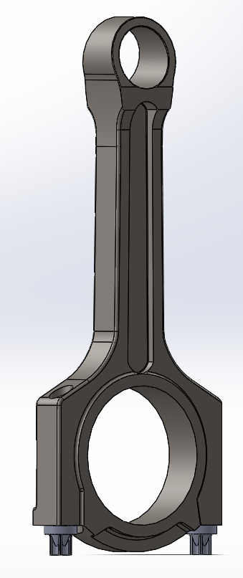

Figure 34: CAD model of the conrod
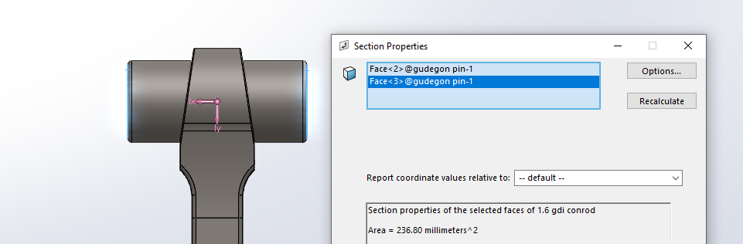

Figure 35: Cross-sectional Area of the CAD model gudgeon pin (mm²)

Forces and stresses acting on the gudgeon pin

Figure 36: Inertia force without the mass of the gudgeon pin (N) vs Crank angle (°)
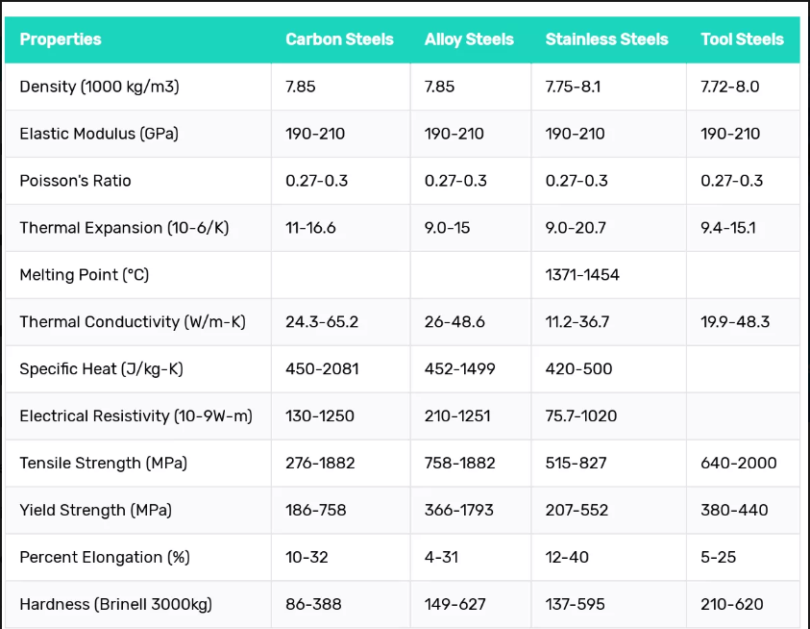

Figure 37: Properties of steel grades (Bell, 2019)

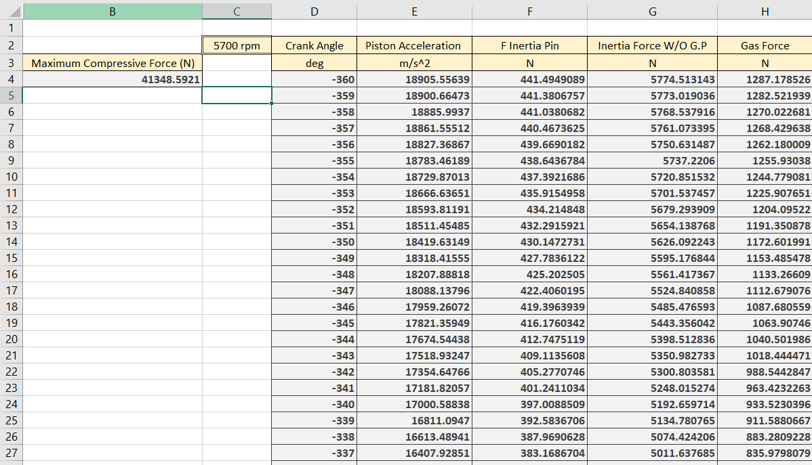

Figure 38: Variable entities acting on the gudgeon pin at 5700rpm

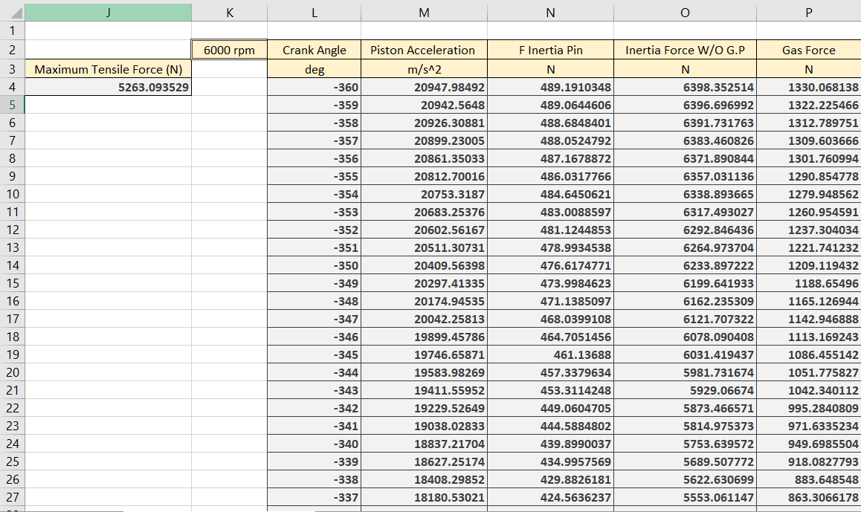

Figure 39: Variable entities acting on the gudgeon pin at 6000rpm

Figure 40: Polytropic equation used for peak gas forces acting on the gudgeon pin (N)

Figure 41: Polytropic equation used for tensile force acting on the gudgeon pin (N)

Three critical rod-sections
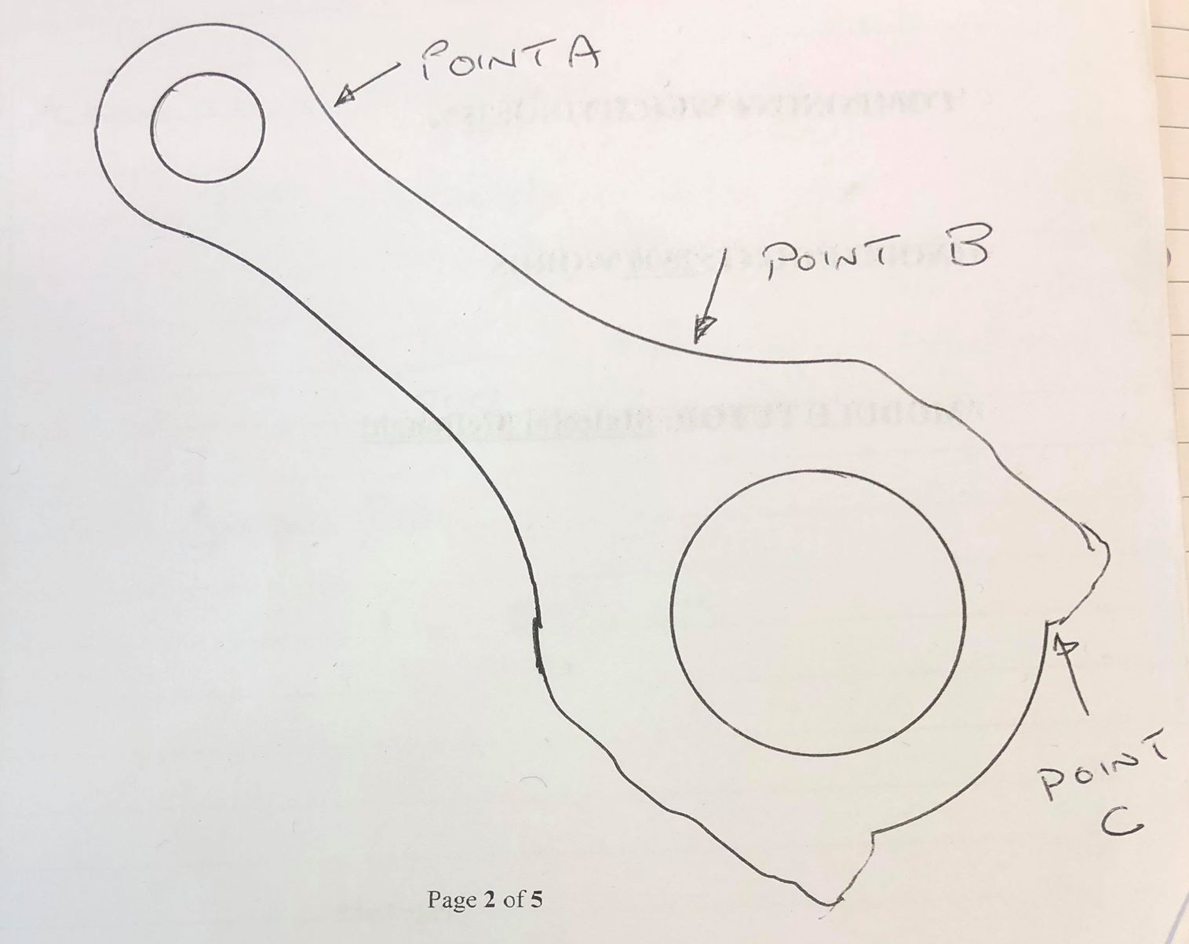

Figure 42: Three critical rod-sections diagram

Forces acting on each point on the three critical rod-sections
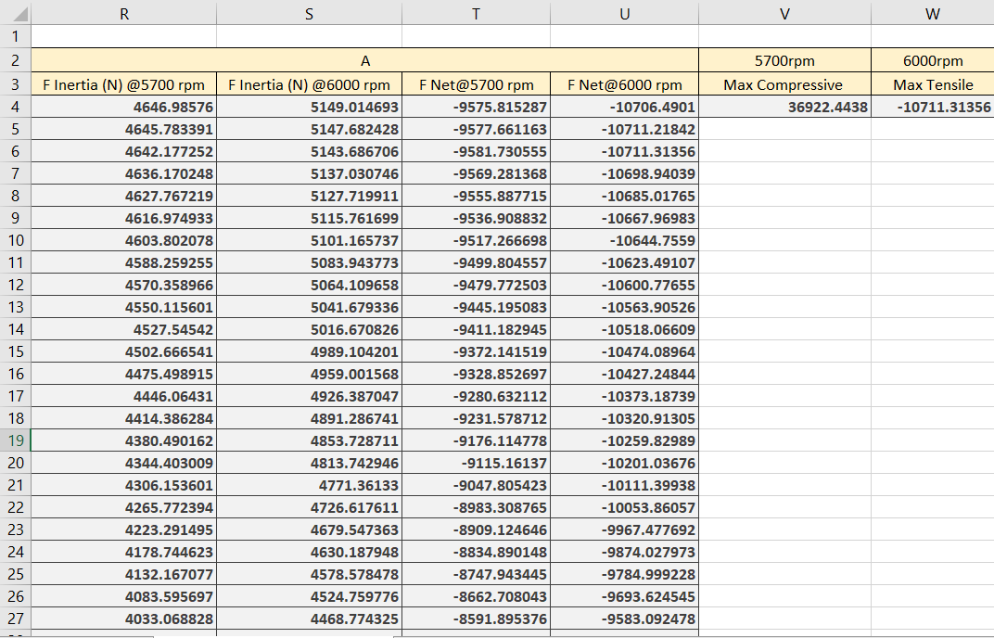

Figure 43: Applied forces acting on point 'A' (N)

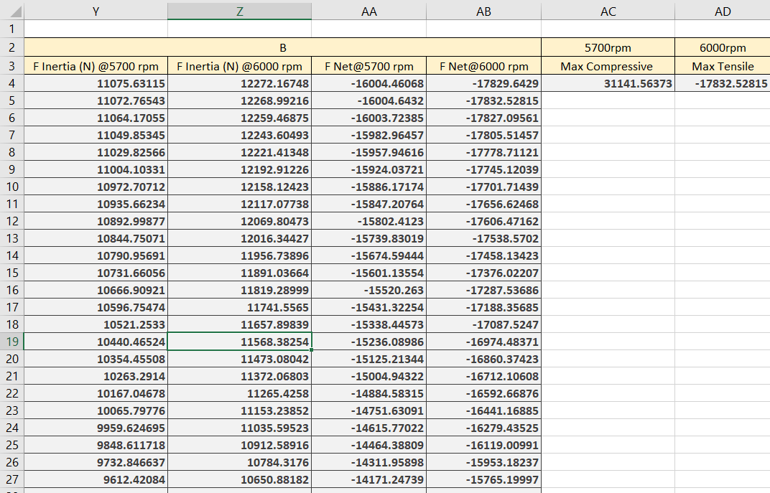

Figure 44: Applied forces acting on point 'B' (N)

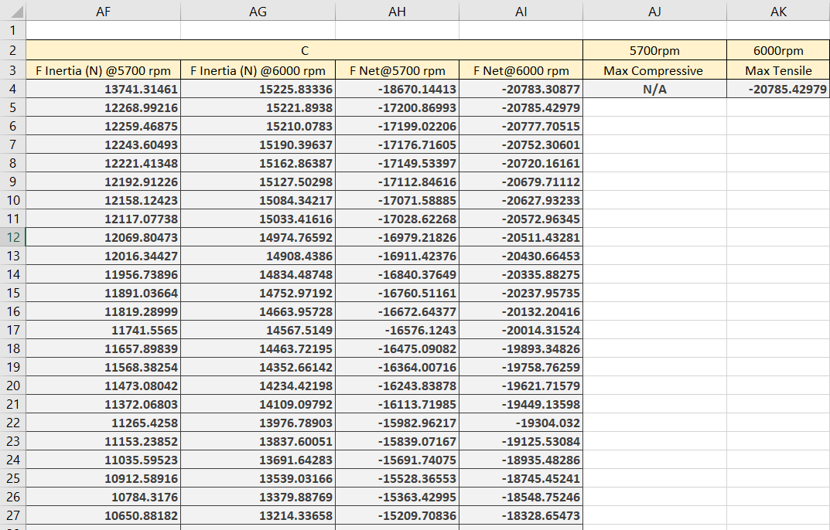

Figure 45: Applied forces acting on point 'C' (N)

