

BSc. Health and Social Care, Level 6 Term 1
Topic
The Impact of loneliness and social isolation on the elderly population: The United Kingdom compared to Ghana

Student name:​ Elizabeth Owusu
Student ID: ​1917244
Module name: Living with Care: The Older Person
Module code: BMHP6009
Lecturer name: Diola Diojlhout ​
Date: 30/ 4/ 2022

Table of Contents
Introduction 3
Definition of the older person………………………………………….………………………….3
Discussion………………………………………………………………….…………………………4
1.1 Classification of the older person in the United Kingdom…...……………………………….5
1.2 Classification of the older person in Ghana…………………………………………………...5
1.3 Definition of Loneliness and Isolations in the United Kingdom…………………………….5
1.4 Definition of Loneliness and isolation in Ghana…………………………………………….5
1.4.1 The impact of loneliness and isolation in the United Kingdom………………………….6
1.4.2 The impact of loneliness and isolation in Ghana…………………………………………6 Future care…………………………………………………………………………………………….6
Relevant Theories of Ageing……………………………………………………………………6- 7
Use of technology for the provision of care to the lonely older person in the UK.…………7- 8
Use of technology for provision of care to the lonely older person in Ghana………………….8
Analysis 8
Current Legislation and Policies In the UK………….…………………………………………8- 9
Current Housing needs in the UK……………….…………………………………………………9
Current Legislation and Policies in Ghana………………………………………………….9- 10
Current housing needs in Ghana……………………………………………………………...10
Interventions, UK…………………………………………………………………………………10
Interventions, Ghana…………………………………………………………………………11
Evaluation……………………………………………………………………………………...11
Recommendation……………………………………………………………………….………….11
Conclusion…………………………………………………………………………………….11
References…………………………………………………………………………………………...A
Appendix………………………………………………………………………………………………B

Introduction
This paper compares the impact of loneliness and social isolation on the older population in the United Kingdom and Ghana as well as the future provision of care using technology, in Health and Social care services.
The World’s aging population is a major global concern in the twenty-first century. Few aspects of life will be unaffected by resulting cultural, economic, and social changes. The report will also look at the demographic changes in high and low-income nations, theories of aging and loneliness, shifting definitions of age, retirement patterns, and family and intergenerational relationships (Phillipson, 2022).
Care workers have authority over the people they look after. They use their behaviors to direct their daily lives. They are bound by informal work environment control, and they have been known to levy informal sanctions on residents who are deemed disruptive.
The report will start with the discussion, followed by using technology in Health and Social Care Services, and the benefits of the use of technology in various health services. Next will be the analysis within the UK and Ghana, followed by relevant theories, legislation, and policies. Then finally, the recommendation and conclusion.

Definition of the older person
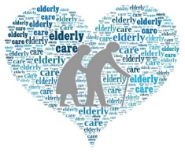
Although there is no universal definition of old age, the WHO defines old age as 60 years. Those above the age of 65 are commonly referred to as such in Western societies.
People age at different speeds biologically, so a 75-year- old may be healthier than a 60-year-old, making it difficult to attach a specific definition to old age, according to the NHS.
The term ‘’aging’’ can be defined in two ways. Individuals and populations are aging, and this study examines how aging affects individuals and how governments can deal with the expanding number, as well as the impact on the elderly in connection with society. (Leukkunen, 2019).
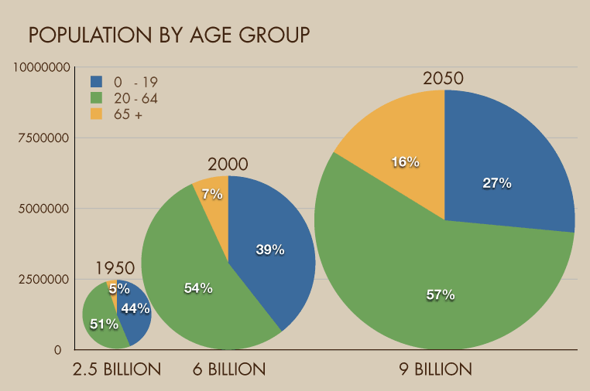
Table 1

Discussions 1
The concept of Ageing has been developed as a global issue and worry (See table 1). The most common discrimination is ageism. (Lait, 2018).
Despite the UK’s expanding senior population, Social Care funding is decreasing. (Haghes, 2020). Loneliness is frequently related to advancing years, the absence of an attachment figure causes emotional loneliness, which is defined as a lack of sentiments of social integration.


(Better, 2020).
2. 7 million persons over the age of 50 were furloughed. Due to the pandemic, everyone was on board
Over 600,000 people aged 50 and older were seeking unemployment benefits as of September 2020.

The state pension age is rising, and a growing proportion of people work over 65. (Evidence in table 2).
Table 2
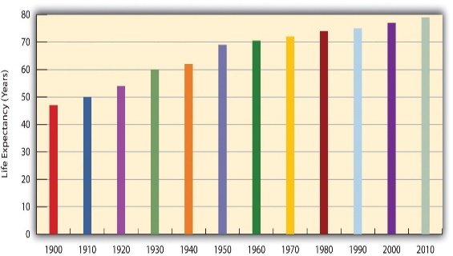
Feeling excessively lonely at a later age is a common occurrence, owing to a perceived absence of personal relationships. Loneliness is becoming more widely recognized as a major public health risk for the elderly, and it has been prominent during the Covid-19.
While estimated reveals that 20-34% of older persons in Europe and 25-29% in the USA are lonely, WHO predicts that 30-40% of adults in Sub-Sahara Africa without the exemption of Ghana are experiencing transient and chronic loneliness (Gyasi, 2022). (Evidence in table 2).
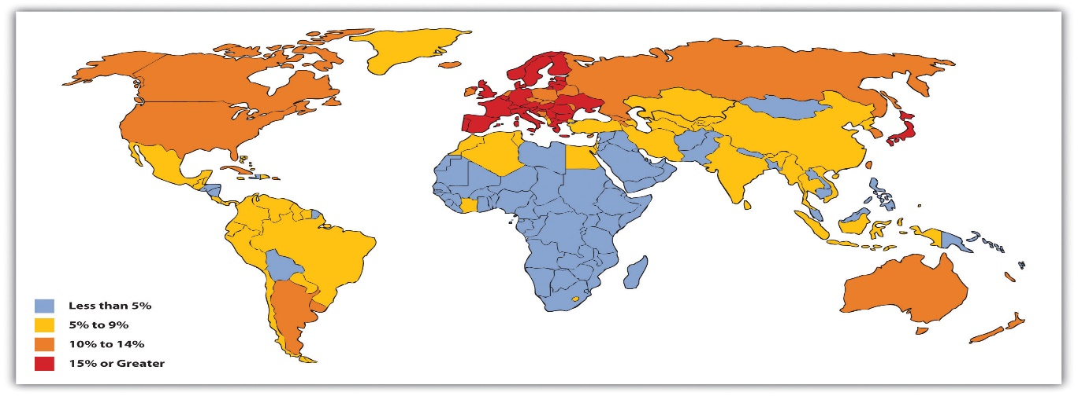
The United Kingdom red coded with 15%
Table 3
Ghana is among the yellow coded with 5-9% aged.

1.1 Classification of an elderly person in the UK
The term ‘’elderly ‘’is referred to a group of adults who have reached the advanced ages of 60 or 65 years or more. In the United Kingdom, the theory of disengagement, which is linked to a shrinking social network in old age and the awareness of approaching death, is more practical, as society creates awareness in all areas of life, including constant advertising and messages.
In the United Kingdom, an older person is someone who has reached retirement age at the age of 65, or when active participation becomes less and most roles are taken away. (Cofterell, 2018).
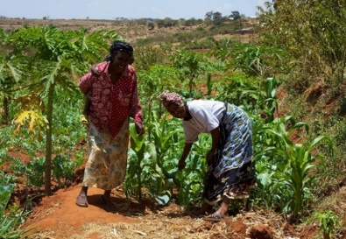
1.2 Classification of the older person in Ghana
The older person is referred to as 60 years old in Ghana. In Ghana 60 years is considered retirement age because life expectancy is lower (Nyarko, 2013). The elderly is defined as people aged 60 and up.
In Ghana, symbolism, resemblance, what you wear and say, as well as behavior are largely used to describe the elderly. Although physical strength may be lacking, in Ghana’s traditional settings, the older person is seen as having greater wisdom and experience. Counseling is one of their social roles. They are expected to have a good impact on their society as stewards of tradition and culture with their chiefs.
1.3 Definition of loneliness and Isolation in the UK
Loneliness in the United Kingdom is defined as an individual’s lack of contacts or links with others, such as family, friends, acquaintances, and neighbors, it can be classified as isolation, which is defined as an absence or limitation in the number of social interactions (Cofterell, 2018).
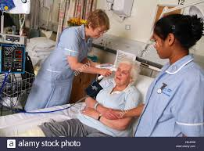
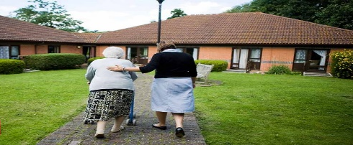
The United Kingdom has an aged care setting that deals with the old’s well-being in terms of housing, everyday care, and health care. Residential Care, Residential Nursing Care, Hospital Care, and Assisted Living are the most common venues (NHS, 2020).
Five million people in the UK, one in every seven adults, are managing caring responsibilities with work, however, because of the tremendous responsibilities of caregiving, 600 people give up their jobs each day to care for an elderly relative (Carers, 2019). In older men and women, social isolation is linked to a greater mortality rate. (Poscia, 2018).
1.4 Definition of loneliness and Isolation in Ghana
According to World Health Organization, 2014, Ghana has one of the highest populations of the elderly in Sub- Sahara Africa, and it is constantly increasing. More than half of the elderly are in some type of marital union, whether they are married or living together. Early studies on aging in Ghana revealed that the protection provided to the old in Ghanaian society has been harmed by modernity, urbanization, and the pursuit of a better life (Kpessa, 2018).

1.4.1The Impact of Loneliness and Isolation in the UK
Loneliness can be a subjective, uncomfortable, and distressing situation that occurs when an individual’s intended, and accomplished levels of social contact are not in sync (Fakoya, 2020). Isolation has been shown to increase the risk of dementia by 40%. Isolation, according to Age UK, is living alone, having little social support, feeling isolated from others, or feeling like an outsider are all symptoms of loneliness. (Griffiths, 2017).
More than 5 million older people claim that television is their primary source of entertainment. Around 10% of over 65s say they are lonely, while another 20% say they are lonely on occasion.
1.4.2 The Impact of loneliness and Isolation in Ghana
According to research conducted by Gyasi et al in 2021, 74% of the lonely in Ghana live alone, whereas 66% of those who explored living with others felt lonely. Living alone and loneliness were both linked to a higher risk of mental health, unlike those living alone, loneliness has a wide range of effects that we’re stronger as people get older.
According to data analysis from the WHO-SAGE survey, the prevalence of depression is highly related to social isolation, financial demands, and physical needs. (Amegbor, 2021).
According to research done by Kpessa-Whyte, social revolution in contemporary life everywhere in Africa and mainly in Ghana is fueled by a slew of different factors. Modernization, urbanization, and globalization all contribute to social transformation, making the older generation isolated and excluded (Kpessa, 2018).
Future care
Excess mortality among the isolated and lonely can be reduced by health initiatives that target risk factors such as socioeconomic situations and unhealthy behaviors

Relevant Theories Aging and Isolation
Humans age from a cultural, biological, and cognitive perspective. Aging is a lifelong process that begins at conception, but its meaning is shaped by the social and cultural discourses to which we were exposed (Avci, 2022).
Theories of Ageing

Table 3

Social Breakdown Reconstruction Theory
- Symbolic Interaction

Disengagement Theory

Activity Theory

Modernization Theory

Gero transcendence

Continuity theory

Theories of Isolation
Theories of loneliness
.

The social control theory internalized, and the overt influence of network members, accordingly, to discourage poor health habits and favor good ones.

The biopsychosocial model is a multidisciplinary approach that examines the relationship between biology, psychology, and socioeconomic issues.

Biopsychosocial model

Physical health, genetic vulnerabilities, pharmacological side effects, social skills, familial relationships, self-esteem, mental health, and environmental factors can make people feel lonely or isolated. People also lose their passion for many things as they become old and lonely, social stigma, discrimination, and workplace culture can cause an emotional drain, and the older person begins to realize he or she is no longer a member of the society. This is linked to the theory of social breakdown where people begin to rewrite the rest of their lives (Bone, 2017)
The negative psychological functioning brought about by society’s attitude towards the old and the inadequate provision of assistance for them is the primary cause of loneliness and isolation (Scheidt, 2020).
The MIND responds to the address of the Secretary of State for Health and Social Care by laying out its long-term vision for NHS reform. (Scheidt, 2020) (NHS, 2018).

In April 2015, the ‘’Raising Standards’’, and the ‘’Putting People First’’ Strategy 2013-2016, measures were established as part of the government’s response to Francis, which aimed to enhance the quality of treatment and make care providers more transparent, and accountable for substandard care (NHS, 2018).
All adult safeguarding work is underpinned by the following six principles (Care Acts, 2015), See Appendix A. (NHS, 2021)

Use of technology for the provision of care to the lonely older person, UK

The introduction of new technology provides chances to modify services so that they are better suited to deal with a variety of situations, (Maguire, 2018).
Technology’s impact on social isolation and loneliness has long been a point of contention. Technology-based interventions of internet access, AI chatbot, and other cognitive technologies in medical settings have all been found to reduce social isolation (Griffiths, 2017).’’ CogniWin’’ is a device that encourages and helps an older person to stay active and productive at work by giving smart assistance and well-being coaching. Personal alarms, wheelchairs, and mobility scooters are all useful.
Artificial intelligence care for the elderly can be good up to a point, thanks to integrated services and hybrid models, but it cannot completely replace human methods because it fails occasionally, and when it does, it can be life-threatening.
Use of technology for the provision of care to the lonely older person in Ghana
Ghana’s technology has advanced to the point where it is now producing more solutions than it is now it was three years ago, and it is constantly learning new things (Atakoro et al, 2021). Devices for medical diagnosis and analysis are being used, and many more, making health care in Ghana much easier than previous.
Analysis
Treatment and care of the elderly are at the heart of how health care is delivered. The rising population of seniors aged 65 and up has posed a significant challenge to health and social care services provision and funding over the previous decade. (Kingston, 2018). Losing social relationships and feeling lonely may be linked to depressed mood and cognitive impairment, as well as a worsening of immunological dysfunction and weight gain.
According to a study published in December 2019 by Suzanne Hughes and Sarah Burch, continuity of formal carers is a challenge, as services are frequently poor and limited, some due to low pay. It is also known that understanding oneself, varied aging experiences, and the importance an older person takes on their living space improve care. (Haghes, 2020).
The modernization theory, analysis the generational differences and the challenges facing the older generation. The senior population is dwindling as society progresses. In the United Kingdom, the government is doing everything possible to encourage the elderly to gain new skills, such as work-related skills, computing skills, social skills, and so on, to assist them to integrate into society.
As a result of urbanization, socioeconomic development, and globalization, traditional institutions of protection and care for the elderly can be challenging in Ghana. This has ramifications for public policy as well as the elderly’s overall well-being (Kpessa, 2018).
Current Legislation and Policies, UK
Beverage 1942 and the upheaval and the new Welfare State was first published in 1939 and adopted after WWII. In 1948. It was supposed to give care from cradle to grave and was the most influential piece of law and social policy in the UK. Poverty and social difficulties in the past were supposed to be a thing of the past.
The goal of Social Security was to eliminate wants and needs. Full employment was ensured to eliminate idleness. Diseases were the reason for the establishment of the National Health Service. Public housing was established for everyone to have a place to live. To deal with ignorance, comprehensive education was created. (Scrimshaw, 2021).
The purpose of Public Health England is to identify health-related risk factors, as well as peoples’ responsibilities, the environment, and the larger social context in which they live. The Public Health England concept provides a good framework for understanding and investigating the causes and consequences of loneliness and social isolation, as well as interventions (Scrimshaw, 2021).
The Social Insurance Program gathers resources and shares the risk of becoming economically reliant because of old age or disability. The elderly are the beneficiaries of social security. The state pension is the administrate pension of the government. It is calculated using the number of qualifying years accrued through National Insurance contributions paid or credited during applicants’ working careers. When you reach the age of retirement, you can apply for a state pension.
The proposed Convention on Human Rights of the Elderly is intended to address discrimination, poverty, the elderly’s welfare, violence and abuse, and lack of measures and services. This was established to reinforce the international protection regime for human rights, particularly for violence against women, health, financial exploitation, long-term care, and participation in policymaking, labor, and political life.
Many possibilities for older individuals to stay engaged and connected have been created by the UK government. There are educational institutions such as colleges and universities, as well as community centers and public libraries that offer educational programs. Intergenerational programs allow older adults to mentor younger students, connect with them, and influenced their skill development. Other organizations, such as Generation Connection, work to close the generational gap.
(Services and support for the elderly/ UK- See Appendix B)
(Services and support for the elderly/ Ghana- See Appendix B)

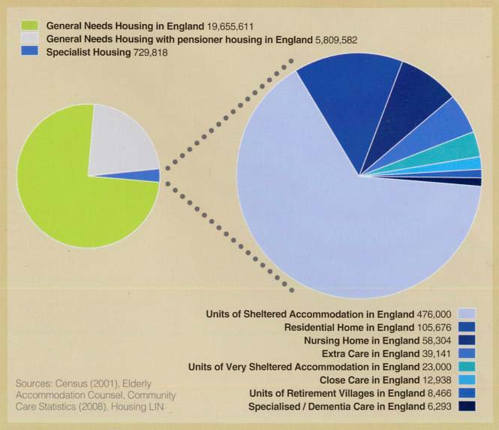
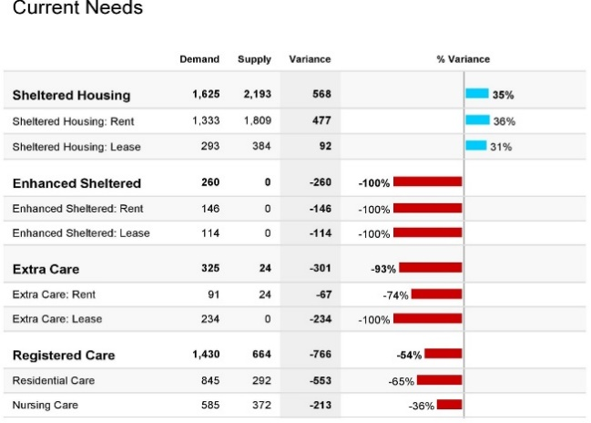
Current housing needs in the UK

90% of adults over the age of 65 live in regular dwellings. Nearly 70% of people own their own homes, while the rest live in social housing, supported housing for the elderly accounts for less than 5% of the market (729,818).
1.5 million people say they have a medical condition or impairment that necessitates special accommodations. By 2033, there will be a shortfall in specialist housing supply with demand for care space, including accommodation for persons with dementia, ranging from 164,000 to 240, 000.
Current legislation and policies in Ghana
The National Health Insurance Scheme (NHIS). This policy covers the age of 70 without charging a charge. This is to ensure that the elderly in Ghana have better access to health care. The most serious problem with the NHIS is that older people aged 65 and up but under 70 join the scheme by payment.
The pension system was created to capture Ghana’s 84% informal sector, which is dominated by the elderly (Srivastava, et al, 2019). The Social Policy Framework for the vulnerable and excluded in human resource development is included in section 4.8 of the Growth and Poverty Reduction Strategy (GPRS II) (2006-2009). It recognizes the vulnerability and exclusion of Ghanaians, particularly the elderly, women, and people with disabilities, in attaining their full human potential or are unable to look after themselves
National Social Protection Strategy (NSPS) helps poor and vulnerable people manage socio-economic challenges like unemployment, sickness, disability, and old age. The strategy also includes recommendations for ensuring a significant role in enhancing health and educational needs.
Livelihood Empowerment Against Poverty (LEAP), was created to reduce extremely impoverished Ghanaians households receiving Bi-Monthly conditional and unconditional cash transfers under this program. The cash transfer is expected to protect beneficiaries from unexpected financial hardships and improve their access to fundamental social services such as health and education. The elderly are the intended beneficiaries of the initiative. Those over the age of 65 who are unable to work are eligible for coverage. (Srivastava, et al, 2019).
In July 2010, Ghana passed an aging policy named the ‘’ National Ageing Policy. The Ageing Policy aims to address poverty, health issues, loneliness, and the living environment for the aged (Gyasi, 2019).
Current housing needs in Ghana
Almost two-thirds of the aged population lives in a house owned by a family member, and nearly a fifth of the elderly population lives in a home owned by a relative. A large percentage of the elderly live in shacks or compound houses with inadequate access to sanitation and utilities according to research done by Nyarko. (Kpessa, 2018).
Interventions /UK
The Care Acts of 2014, outline the main legislative responsibilities and powers that govern the Care and Support System. Section 15 of the Act provides measures to put a cap on the expenses of care. Equality and diversity, Mental Capacity Act 2005, Safeguarding Vulnerable Group Act (2012) (NHS, 2021).

Act also prepared the stage for the planned billing reforms. (Care, 2022). The policies are implemented to promote the human rights of the elderly.
The use of robots like chatbots can help with care plans, social robots personal alarm systems, medication organizer alarmed dispensers, and many more, for the older person’s well-being, as well as the obstacles and the benefit that comes with it, are essential (Griffiths, 2017). Social interactions and relationships can reduce loneliness (Poscia, 2018) (WHO, 2022). Educating young children, about adulthood can help (Avci, 2022).
Communities can assist and deal with the elderly, the lonely, and the isolated, by increasing programs and awareness. Public engagement and health services have been established to support the elderly and lonely. (Griffiths, 2017).

Interventions/ Ghana
According to Gyasi and Ohemeng et al, 2019, older adults who retain touch with family members and receive socioeconomic support, as well as those who actively participate in social events and emotional bonds, are more likely to have greater mental and psychological well-being. (Gyasi, 2019).

Evaluation
Isolation and loneliness can be objective or subjective, external, or internal. It might be determined by a person’s emotional sense of the social connections they require, or by the number of social ties and contact they have. It might be caused by physical factors or loss of society principle of disengagement.
Many older individuals retreat from society due to poor health, reduced mobility, and other life changes, spending most of their time gazing back and reflecting on what they have made of their lives. The older adult increasingly withdraws from society, owing to how society disengages from them, and the adult develops self-preoccupation, decreases emotional bonds with others, and loses interest in social activities utility.
The active aging model is not just for the elderly or the lonely, it is a stairwell that humans are designed to climb from birth to death. It serves as a source of strength for both, young and old, physical, and emotional development.
Due to the possibility of permanently losing employment because of Covid-19, some inequalities have become even more pronounced (Better, 2020).

Recommendation
To be effective, the public health approach to loneliness must ensure that appropriate policy frameworks and regulations are placed in addressing issues such as the built and natural environment, work environment, housing models, transportation, and funding to support community-based programs (Scrimshaw,2021).
Physical activity and social connectedness mitigated the impacts of loneliness and living alone on mental issues, hence physical activity and social cohesiveness interventions should be included in later life mental agendas. (Gyasi, 2019).

Conclusion
A growing number of senior citizens are living alone and at risk of social isolation. (Courtin, 2017). Loneliness affects people of all ages, but it is more commonly associated with the elderly. Loss of social contacts is linked to age-related losses and declining health, which is likely to increase the risk of loneliness (Sagit, 2018).
(CQC, 2018).

References
Abuladze, L. and Perek-Biala, J.(2018). Measures of aging in the labor market- International Social Studies. Ayalon, August, 19(3), pp. 461-491.
Amegbor et al. (2021). Social Frailty and Depression Among Older Adults in Ghana: Insights from the WHO SAGE Surveys, Research on Aging, 43(2), pp. 85-95.
Avci, C. a. Gulseven, E.(2022). Aging versus active aging: how old age is represented in children’s books. Educational Gerontology, 48(4), pp. 145-159.
Better, (2020). The State of Ageing in 2020- The impact of Covid on the elderly, Center for Ageing.
Bone et al. (2017). What is the impact of population aging? Palliative Medicine, 32(2), pp. 329-336.
Cacioppo, T and Casioppo, S. (2018). Loneliness in Modern Age: An Evolutionary Theory of loneliness (ETL). Advances in Experimental Social Psychology, 58(3), pp. 127-197.
Carers, UK (2019) Making life better for carers. [Online]
Available at: https://www.carersuk.org
[Accessed 18 April 2022].
Cotterell, N., Buffel, T. and Phillipson, C. (2018). Preventing Social Isolation in older people. Maturitas, Volume 113, pp. 80-84.
. Social isolation, loneliness, and health in old age: a scoping review. London, Health and Social Care in the Community.
Courtin, E. & Knapp, M., (2017).Social isolation, loneliness, and health in old age: a scoping review. Health & social care in the community, May, 25(3), pp. 799-812.
Courtlin, E., and Knapp, M.,(2017), Social Isolation and Health in old age; a scoping review. Health and Social Care in the Community, 25(3), pp. 799-812.
CQC, (2018). [Online]
Available at: https://www.cqc.org.uk/sites/default/files/20200623_closedcultures_guidance.pdf
[Accessed 24 April 2022].
Fakoya, O. McCorry, N. &. Donnell, M., (2020). Loneliness and social isolation interventions for older adults: a scoping review of reviews. BMC Public Health, 14 Febrruary.2(20).
Fumagalli, E. Shrum, L., and Lowrey.T., (2020), Consuming in response to loneliness; Bright side and dark side effects. Current opinion in psychology, Volume 46.
Griffiths, H., 2017. SOCIAL ISOLATION. IoTUK, April, 29(1), pp. 2-18.
Gyasi et al. (2019) Neighborhood, social isolation and mental health outcome among older people in Ghana. Journal of Affective Disorders, December, Volume 259, pp. 154-163.
Hughes, S. and Burch, S.,(2020)‘I'm not just a number on a sheet, I’m a person: Domiciliary care, self, and getting older. May, 28(3), pp. 903-912.
Haslam, S. and Haslam, C., (2022). Social Identity makes group-based social connection possible: Implications for loneliness and mental health. Current Opinion in Psychology, February, 43(3), pp. 161-165.
Lancet, (2017). Contribution of risk factors to excess mortality in isolated and lonely individuals; an analysis of data from the UK Biobank cohort study. The Lancet Public Health, 2(6), pp. e260-e266.
Heylen, L., (2010), The older, the lonelier?. Risk factors, loneliness in old age. Aging and Society, 30(7), pp. 1179-1196.
Kingston et al. (2018). Projections of multi-morbidity in the older population in England to 2035: estimates from the Population Ageing and Care Simulation (PACSim) model, London: BSG.
Kpessa, W. (2018). Aging and Demographic Transition in Ghana: State of the Elderly and Emerging Issues, The Gerontologist, June, 58(3), pp. 403–408,
Lait, A. and Romer, C., (2018). Contemporary Perspectives on Ageism, s.l.: Springer nature.
Leukkunen, K. (2019). Economic of Ageing. Encyclopedia of Gerontology and Population Aging, 3 May, 185(1), pp. 2-3.
Michelle, A. and Duyndum, J. (2020), Strategies of Socially Isolated older adult; mechanism of emergence and persistence. Journal of Ageing Studies, June.53(2).
Maguire, D., (2018), Digital change in Health and Social Care. s.l.: The King's Fund.
Maksim, R., (2021). The Social Status of the elderly from a comparative perspective: Distinctions of post-communist countries. Sociological Journal, 27(4), p. 8.
NHS, (2018), A practical guide to. [Online]
Available at: https://www.england.nhs.uk/publication/a-practical-guide-to-healt
[Accessed 23 April 2022].
NHS, (2020). A practical guide to. [Online]
Available at: www.nhs.uk/choiceintheNHS/Yourchoices/appointment-booking/Pages/
[Accessed 29 April 2022].
NHS, (2021). Safeguarding Adults Policy and Procedures (. Humber Teaching NHS Foundation Trust, 4(1), pp. 3-28.
Nyarko, P., (2013). The Elderly in Ghana. Ghana Statistical Service, July, 112(2), pp. 4-12.
Proscia, A., Stojanovia J., and Ignazio, D. (2018). Interventions targeting loneliness and social isolation among older people. Experimental Gerontology, February, 102(2018), pp. 133-144.
Sagit, L.Wum, S., and Lait, A., (2018). Contemporary Perspective of Ageism. International Perspective of Ageism, 19(1), p. 51.
Sagit, L.Wum, S., and Lait, A., (2018). International Perspectives on Aging. In: Contemporary Perspective of Ageing. New York: Springer, p. 51.
Santabárbara et al. (2021). Prevalence of anxiety in health care professionals during the COVID-19 pandemic: A rapid systematic review (on published articles in Medline) with meta-analysis, Science Direct, 20 April, Volume 107, pp. 110-244.
Scheidt, R., (2020). An interview with author Victor Regnier. (2020) ‘, FAIA’, (), pp. ., 34(1), p. 86–102.
Scrimshaw, C., Lane, S., (2021). The Scope Handbook of Social studies in Health and Medicine. Social Science, 1 December, Issue 1, p. 704.
WHO, (2022). World Health Organization, News. [Online]
Available at: https://www.who.int
[Accessed 13 April 2022].

Appendix

REFERENCES

Appendix A
All adult safeguarding work is underpinned by the following six principles (Care Acts, 2015), which apply to all sectors and contexts, including care and support services.
Empowerment | People are supported and encouraged to make their judgments and consent based on their knowledge
Prevention | It Is preferable to act before something bad happens
Proportionality | The least intrusive response in light of the danger
Protection | Support and representation for those in greatest need
Partnership | Local solutions are provided by services that collaborate with their communities. Communities must have a role in preventing, identifying, and reporting abuse and neglect.
Accountability | Accountability and transparency in delivering safeguarding.

Appendix B
Services and support for the elderly/ UK-
Adult Day Care Center
Assisted Living | Errands and Shopping
Bill Payer | Financial Management
Case Management- Private | Legal Assistant
Chore Services | Information and referral
Consumer Direct Attendant Care | Home Health Aide
Continuing Care Community | Home Delivered Meals
Counseling/ Emotional Support | Home Maker Services

Medication Aide | Nursing Care Skilled Facility
Nursing Care in Home | Nutrition Counselling
Nursing Skilled facility | Personal Care Services
Personal Emergency Response Device | Remote Electronic Monitory
Respite care | Transportation

