

Assignment Title:
Critical Evaluation of Eden Spa's Website and Digital Presence

Student Name: Ameer Hamza Anayat
Student ID: 2437867
Course: Business Skills for the Workplace
Submission Date: 27.07.2025

Table of Contents
1. Introduction 3
2. Website Overview 3
3. Evaluation Criteria 3
3.1 Navigation and Layout 3
3.2 Visual Design and Branding 4
3.3 Mobile Responsiveness 4
3.4 Content Quality 4
3.5 Accessibility and Inclusivity 5
3.6 Customer Communication and Social Media 5
4. Recommendations for Improvement 5
5. Conclusion 6
6. Reference: 7
Appendix A 10

1. Introduction
Eden Spa Harborne is a local health and beauty company that also provides personalised services to the people of the UK, including massages, facials and holistic treatments. The use of the Wix platform on its site serves as a source of digital touchpoints, facilitating contact with customers, describing the products being offered, outlining the costs of obtaining these products, and allowing for reservations. This report aims to critically analyse the online presence of the Eden Spa website, including its strengths and areas for improvement. Significant points of evaluation include the site's design, navigation structure, mobile friendliness, content quality, accessibility compliance, and communication functionality. All sections will address the concepts of usability and online design paradigms for small wellness companies. Realistic, research-based suggestions will be made to enhance the site's effectiveness in meeting user and business requirements. Their assessment is based on the theory of digital communication and research on web usability. It can be said that the analysis will serve Learning Outcomes 1 and 2 by focusing on the implementation of digital tools and content strategy (Liao et al., 2023; Garrett, 2011).

2. Website Overview
Eden Spa Harborne offers a range of massages, skincare treatments, and holistic therapies. The website targets wellness-focused individuals, especially local women seeking personalised spa experiences. Promoting services, offering deals, and letting customers schedule appointments or inquire are its primary purposes. Wix, a popular no-code platform for small businesses, limits customisation and capability compared to commercial websites. However, platforms like Wix enable microbusinesses to establish an online presence at a low cost (Papadopoulos et al., 2020). This digital environment is crucial to assessing the platform's fit for Eden Spa.

3. Evaluation Criteria

3.1 Navigation and Layout
The single-scroll style, featuring a fixed top navigation bar, simplifies navigation on the Eden Spa Harborne website; however, it limits internal choices. The site gives a basic summary of services, but the lack of internal anchors, filters, and dropdown menus limits user involvement. In service-based websites, better navigation aids job completion and autonomy (Rosen & Purinton, 2004). Without a booking system, users must manually schedule appointments, which reduces the usefulness. Users anticipate simple routes to action; therefore, small firms with low navigational depth may have greater bounce rates (Nielsen, 2020). Although it appears and persists, the menu lacks current UX design structural sophistication.

3.2 Visual Design and Branding
Eden Spa employs a soft, calming colour palette of lavender and cream tones, reflecting its wellness ethos. However, while the colours align with brand expectations, visual inconsistency arises from the use of mixed font types and sizes across pages. Research by Cyr et al. (2009) highlights the psychological significance of design consistency in fostering user trust and emotional engagement on wellness-related websites. Moreover, the site lacks a custom logo and favicon, which weakens brand recall and professional appearance. Branding elements, such as logos, serve as identity anchors and influence perceived credibility (Park et al., 2018). The visual design is aesthetically pleasing but requires refinement to establish a consistent and memorable digital brand identity.

3.3 Mobile Responsiveness
Eden Spa's website is mobile-responsive, automatically resizing elements for different screen sizes. However, it suffers from performance lags on mobile devices due to the heavy use of high-resolution images, resulting in longer loading times. According to Google's research, 53% of users abandon mobile sites that take more than three seconds to load (Google, 2018). Moreover, mobile usability could be enhanced with tap-to-call buttons and collapsible menus, which are absent. As highlighted by Seckler et al. (2015), users tend to engage more with mobile sites that offer tailored interactivity and improved task efficiency. The Eden Spa app conforms to the minimum technical requirements but is being enhanced with features that can result in higher user satisfaction and better business.

3.4 Content Quality
The site features a list of spa services, each accompanied by a brief description and its corresponding price. The site, however, lacks dynamic content, such as a blog or customer updates, and thus, it has a static appeal, as it simply does not hold much interest. Content relevance and freshness play a key role in user retention and SEO rankings (Ramsay, 2010). Additionally, the site contains occasional grammar errors and missing calls-to-action (CTAs), such as "Book Now" or "Get in Touch," which weakens conversion potential. Quality digital content should be persuasive, error-free, and action-oriented (Rowley, 2008). Without regular updates or interactive media, the site fails to fully utilise content as a communication tool, limiting its ability to inform and persuade the target audience effectively.

3.5 Accessibility and Inclusivity
Accessibility is an essential part of inclusive digital design, yet Eden Spa's website lacks key compliance features. Images do not contain descriptive alt text, violating WCAG 2.1 standards for non-text content (W3C, 2018). Although text contrast is adequate, users cannot adjust the font size, and there is no accessibility widget. Inclusive websites allow users with visual or cognitive impairments to access content without barriers (Lazar et al., 2015). The absence of multi-language options further limits inclusivity for diverse local users. Small businesses often overlook accessibility due to budget or platform limitations, but compliance not only improves usability, but it is also a legal and ethical responsibility. Addressing these issues could enhance the site's reach and equity.

3.6 Customer Communication and Social Media
Eden Spa has a simple email and contact form. The Instagram-themed site lacks ratings, interactive maps, and instant chat. These technologies enhance trust and conversions, particularly in service industries (Zhang et al., 2017). Live chat, WhatsApp integration, and Google Maps location embeds might boost consumer engagement. Kumar & Reinartz (2016) state that real-time digital interaction enhances brand loyalty and consumer satisfaction. Without these elements, the website relies on passive contact techniques, which limit its ability to capture spontaneous interest or address user concerns in real-time.

4. Recommendations for Improvement
To achieve the goal of increasing the digital efficacy of Eden Spa Harborne, the following five SMART (Specific, Measurable, Achievable, Relevant, Time-bound) changes are proposed. To start with, the addition of a booking service, such as Wix Bookings or Calendly, would allow scheduling clients transparently in the location. The real-time booking functions enhance operational efficiency and user satisfaction (Verhoef et al., 2021). Second, addressing accessibility issues by applying alt text, ensuring screen reader compatibility, and implementing a toggle for high contrast will align the site with the WCAG 2.1 guidelines, which contribute to digital inclusion (Alajarmeh, 2021). Third, mobile UX would be optimised by compressing images and adding a button to call, achieving shorter loading times and better interaction. Nimble, speedy mobile experiences are the key for service-based SMEs (Grewal et al., 2020). Fourth, the inclusion of certified customer comments via the platform, such as Google Reviews, can promote high levels of trust and online reputation, which are highly valuable for their subsequent impact on purchase intentions (Liu & Park, 2015). And finally, consistency in branding can be achieved by creating a custom logo and favicon, as well as setting font typography uniformly throughout the site. Good branding empowers brand familiarity and career reputation (Kapferer, 2012). All of these alterations are possible to implement in the short term with the help of digital tools, which are either free or have low prices, making them feasible for small businesses.

5. Conclusion
The Eden Spa Harborne website offers a visually calming aesthetic and includes foundational contact features that align with its wellness brand. However, the digital evaluation has revealed several critical limitations, including the lack of a booking system, inadequate accessibility, slow mobile performance, and inconsistent visual branding. These factors reduce both usability and client engagement. Implementing the proposed improvements—ranging from enhanced interactivity to design consistency—would significantly strengthen the site's digital presence and operational efficiency. By addressing these digital shortcomings, Eden Spa can not only meet modern user expectations but also build stronger, long-term customer relationships in an increasingly competitive market.

6. Reference:
Alajarmeh, N. (2021). Evaluating the accessibility of public health websites: An exploratory cross-country study. Universal Access in the Information Society, 21(3). doi: https://doi.org/10.1007/s10209-020-00788-7.
Cyr, D., Head, M., & Larios, H. (2009). Exploring human images in website design: A multi-method approach. MIS Quarterly, 33(3), 539–566. http://sammelpunkt.philo.at/3545/1/cyr.pdf
Garrett, J. J. (2011). The Elements of User Experience: User-Centred Design for the Web and Beyond. New Riders. https://ptgmedia.pearsoncmg.com/images/9780321683687/samplepages/0321683684.pdf
Google (2018). The Need for Mobile Speed. Think with Google. https://www.thinkwithgoogle.com/_qs/documents/2340/bc22e_The_Need_for_Mobile_Speed_-_FINAL_1.pdf
Grewal, D., Roggeveen, A. L., & Nordfält, J. (2020). The Future of Retailing. Journal of Retailing, 96(1), 69–76. https://www.dhruvgrewal.com/wp-content/uploads/2017/05/2017-JR-Future.pdf
Kapferer, J. N. (2012). The New Strategic Brand Management: Advanced Insights and Strategic Thinking. Kogan Page Publishers. https://www.perlego.com/book/1589780/the-new-strategic-brand-management-advanced-insights-and-strategic-thinking-pdf
Kumar, V., & Reinartz, W. (2016). Creating Enduring Customer Value. Journal of Marketing, 80(6), 36–68. https://journals.sagepub.com/doi/10.1509/jm.15.0414
Lazar, J., Goldstein, D. F., & Taylor, A. (2015). Ensuring Digital Accessibility Through Process and Policy. Morgan Kaufmann. https://shop.elsevier.com/books/ensuring-digital-accessibility-through-process-and-policy/lazar/978-0-12-800646-7
Liao, C., Zuo, Y., Xu, S., Law, R. and Zhang, M. (2023). Dimensions of the health benefits of wellness tourism: A review. Frontiers in Psychology, [online] 13. doi: https://doi.org/10.3389/fpsyg.2022.1071578.
Liu, Z., & Park, S. (2015). What makes a helpful online review? Implication for travel product websites. Tourism Management, 47, 140–151. https://ideas.repec.org/a/eee/touman/v47y2015icp140-151.html
Nielsen, J. (2020). Usability Heuristics for User Interface Design. Nielsen Norman Group. https://dl.acm.org/doi/abs/10.1145/3387263.3387267
Papadopoulos, T., Baltas, K. N., & Balta, M. E. (2020). The use of digital technologies by small and medium enterprises during COVID-19: Implications for theory and practice. International Journal of Information Management, 55, 102192. https://www.sciencedirect.com/science/article/pii/S0268401220310549
Park, C. W., Eisingerich, A. B., & Park, J. W. (2018). Brand Attachment and Loyalty: Bridging the Gap. Journal of Marketing, 82(5), 26–40. https://www.scirp.org/reference/referencespapers?referenceid=1949854
Ramsay, M. (2010). Content Strategy for the Web. Rosenfeld Media. https://api.taylorfrancis.com/content/books/mono/download?identifierName=doi&identifierValue=10.4324/9780429259920&type=googlepdf
Rosen, D. E., & Purinton, E. F. (2004). Website design: Viewing the web as a cognitive landscape. Journal of Business Research, 57(7), 787–794. https://ideas.repec.org/a/eee/jbrese/v57y2004i7p787-794.html
Rowley, J. (2008). Understanding digital content marketing. Journal of Marketing Management, 24(5–6), 517–540. https://www.scirp.org/reference/referencespapers?referenceid=2870765
Seckler, M., Heinz, S., Bargas-Avila, J. A., Opwis, K., & Tuch, A. N. (2015). Designing usable web forms: Empirical evaluation of web form improvement guidelines. Human–Computer Interaction, 30(3–4), 198–236. https://research.google.com/pubs/archive/42513.pdf
Verhoef, P. C., Broekhuizen, T., Bart, Y., et al. (2021). Digital transformation: A multidisciplinary reflection and research agenda. Journal of Business Research, 122, 889–901. https://www.sciencedirect.com/science/article/pii/S0148296319305478
W3C (2018). Web Content Accessibility Guidelines (WCAG) 2.1. https://iaccessible.com/wcag2-1/
Zhang, M., Hu, M., Guo, L., & Liu, W. (2017). Understanding relationships among customer experience, engagement, and word-of-mouth intention on online brand communities. Internet Research, 27(4), 839–857. https://primo.wpunj.edu/discovery/fulldisplay/cdi_crossref_primary_10_1108_IntR_06_2016_0148/01WILLIAMPAT_INST:WPUNJ

Appendix A
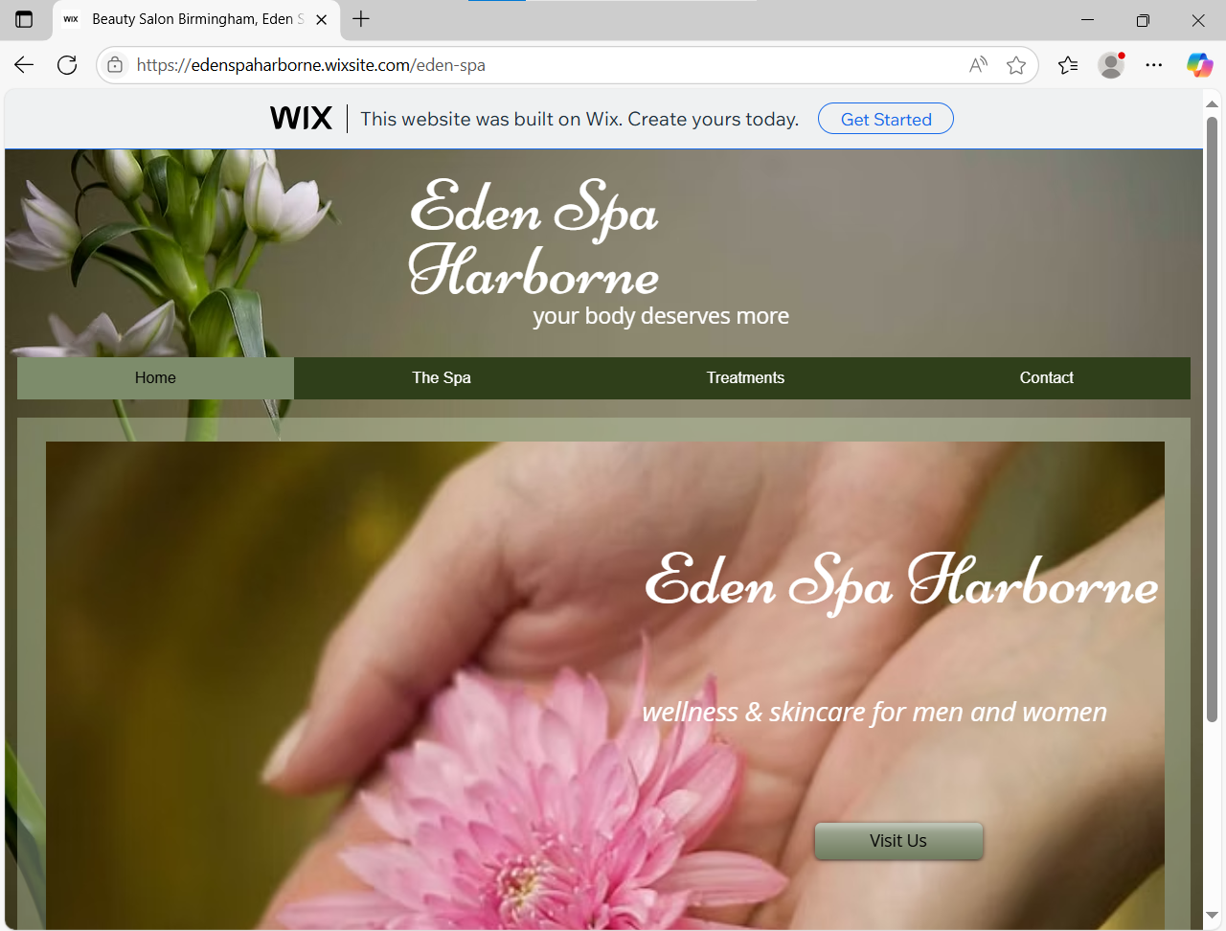
Figure 1 Eden Spa Harborne. (2025). Homepage. https://edenspaharborne.wixsite.com/eden-spa

