CHANGEMAKERS: CREATIVITY AND VALUE CREATION
(E-PORTFOLIO)

Module Code: BMHP5014_LON
Lecturer: ELENI KOUTSOGEORGOU
Student Name: Violeta Cicu
Student Number: 2109660

Table of Contents
Introduction 3
Elevated pitch 5
Flyer 7
Facts 7
Factors 7
Challenges 7
Impacts 7
Benefits of Health Campaigns 8
Steps to Mental Health Care 8
Conclusion: 10
Reference List 12 12

Introduction
Emotional, psychological, and social well-being comprises mental health. It affects thought, feeling, and action. It affects how people face anxiety, reacts to others, and choose. From preadolescence through maturity, mental health is important.
Unfortunate “mental health” affects human beings’ affinity with their children, kinsfolk, friends, and co-workers. Often, the mental health of the UK leads to complications such as social alienation which smash people's communication and fundamental interaction with others. Especially when recurrent and with moderate or saviour health severity, depression can become a serious health condition.
Mental illness is a threat to the world, almost greater than 300 million individuals, 4.4% of the global population, suffer from “depression”. In the UK 4 to 10 per cent of total citizens encountered depression in their lifespan.
According to a survey of “mental Health” in the UK that one in six human beings aged 16 + became used to signs of a typical mental health problem, such as “depression or anxiety”.. Females were more prone to experience general mental disorders than males, all the incidents have piled up since 1993.
Several mental health disorders can be seen in the UK. Several surveys have come to light, that is very inquietude for people. Many of them are Anxiety, Bipolar Disorder, Depression, Dissociative Disorders, Attention Deficit Hyperactivity Disorder (ADHD), Post-Traumatic Stress Disorder, Schizophrenia, and Obsessive-Compulsive Disorder.
Mixed anxiety and depression have been found in about 8 in 100 people, “Generalized anxiety disorder(GAD)” has been found in about 6 in 100 people, and “Post-Traumatic stress disorder(PTSD)” has been found in about 4 people among 100 people in the UK.
Depression has been found in about 3 in 100 people and 2 in 100 people in the UK are suffering from Phobias. Obsessive-compulsive disorder (OCD) is diagnosed in about 1 in 100 people, panic disorder is also found in the UK.
In recent years, "mental health" report results have skyrocketed. Between 1993 and 2014, the number of men and women with mental health disorders rose by 20%. The proportion of people with serious mental illness rose from 7% in 1993 to nearly 9% in 2014. Young women are experiencing more mental health issues (Cheng et al. 2014).
We are part of the Every Mind Matter organization and help people with mental health issues. In this e-portfolio we have chousen to present a pitch and a flyer. The pitch aims to support, help and raise founds in order to help people with mental health issue by offering mental, moral and financial support into a new and frendly environment where they can also socialise.
The flyer is focusing on a mental health awareness and guides the reader through the right help he/she needs, if it is the case, though the above frendly team.

Elevated Pitch
Hello, Good Morning everyone. My name is Violeta, i represent Every Mind Matters Organisation and i`m here today to talk about mental health awareness. In this new project plan we aim to support a prevention mental health campane for young children and old people. It is decided that communication and active participation within society should be promoted to deal with mental health issues. Moreover, young children and old people should be given extra care and attention to meet their emotional requirements. The Every Mind Matters campaign has been more affluent for focussing on self-care while mentally affected or providing support to each other to deal with this situation. According to the reports, money management and unemployment can have big impacts on the minds of the people, and thus, psychological illness can be determined (Nhs. UK, 2021). Parents and other family members should not compare their children or abuse them whereas older people should be involved in society without any discrimination. Thus, proper interactions are considered very important in certain cases.
Good communication with others must be practised so that people can share their problems and tensions to make themselves free from excessive tension and unnecessary worries. Though this healthcare campaign has included all the help from the experts, the peer support that can be provided to the people for maintaining mental conditions which have not been incorporated. According to the statement of Dalton et al. (2020), ineffective communication generally evokes anxiety, uneasiness, stress, and depression since thoughts and personal perspectives cannot be shared. In this regard, overall mental conditions remain poor, and better health conditions become difficult to achieve.
Both old age and young children also undergo psychological problems due to traumatic experiences, abuse, and domestic violence, and thus, their overall conditions also deteriorate.
While being associated with this Every Mind Matters campaign, I have understood that a higher level of patience and positive attitude is needed for handling mentally affected patients because they are very sensitive and overall conditions can be improved. Leaders, there should not be discrimination made because of the mental illness of people, and equal treatment needs to be given to everyone for making them feel valued and respected like any others.
The reason we are here today is that we need financial support for developing a new location in this area. The amount we are looking for is £400.000, this amount will help us to improve our services and to help more people. Thank you for your time and attention. You can send your donation at EMM@yahoo.co.uk

Flyer

Facts
1 in 4 people in the UK is observed with mental health problems whereas 1 in 6 people undergo problems such as anxiety and depression (Mind.org.uk, 2022). 22% of men and 28% of women belonging above 65 years face depression and 85% of the cases fail to receive support from the NHS. As a leader in mental health campaigns, good communication is very important because the problems of the people can be easily shared. As you people know, constant support is needed by mental health patients because they suffer from depression and anxiety. In this way, leaders have to provide constant support to the mentally affected people so that they feel socially accepted and their self-doubts can be eradicated easily (Su et al. 2021).

Factors
- Long-term illness among the older population leads to depression
- Children bothered by social and peer pressure often feel stressed and anxious
- Children with separated or divorced parents also face mental issues
- Older people with no support from their children generally undergo psychological problems
- Poverty and homelessness also can lead to depression, anxiety, and stress among the people

Challenges
- Patients get generally annoyed, impatient, and angry (Greenberg et al. 2020)
- Patients cannot share their feelings and social interactions become difficult eventually
- Complications within their behaviour are also observed
- Patients are also observed harming themselves

Impacts
- People with mental illness fail to judge and make decisions on their own
- Students fail to perform well in academics and sports
- A feeling of social alienation always bothers them
- Older people become more prone to alcohol consumption or drug misuse
- Their normal ability to actively participate in social gatherings and hence, their depression level and anxiety also increase subsequently.

Benefits of Health Campaigns
- Mental health campaigns help in eradicating the social stigmas posed by old people and children
- Better support networks are developed through the health campaigns
- Family members and peers become aware of the effective support that is to be provided to the patients
- Health campaigns also manifest the importance of self-care for both young children and old people

Steps to Mental Health Care
Good communication is needed from the family, friends, and peers for sharing their fears and anxieties. Consumption of healthy food items and an adequate amount of sleep are required for maintaining both good mental and physical well-being (Gupta and Sahoo, 2020). Moreover, proper exercises can also be helpful for the patients for their mental well-being and overall physical development can be improved. In addition to that, the older population should decrease their alcohol consumption and children should not be compared with their friends to avoid judgments and self-doubts to ensure positive mental conditions. Children also should be encouraged to be involved in learning new sets of skills and opportunities which can help them to stay active and their mental conditions also improved (Mind.org.uk, 2022). Moreover, all people with mental issues also have to be treated with respect so that they feel involved within society and good psychological conditions are improved.

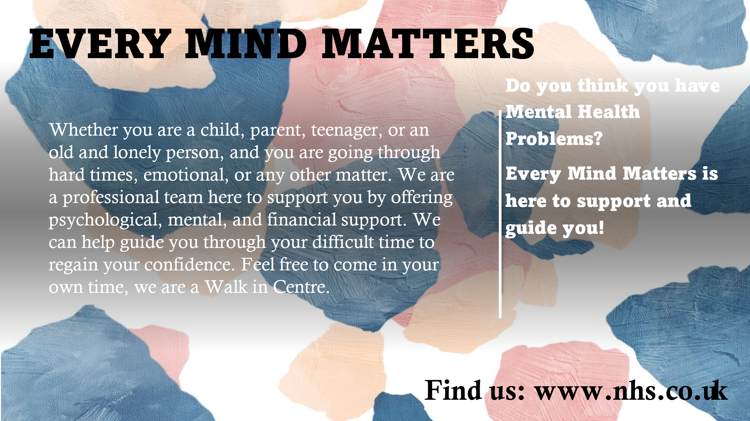
Conclusion:
“Depression” influences more children and immature people nowadays than in the previous few years. children were more likely to encounter “depression” than immature children. Self-damage is a very familiar problem among the UK's young nationals. Separation of relationships due to lack of communication between parents is a very common reason for mental disorders in young people. Moreover, changes such as moving home, or changing school, may act as triggers. due to breaking up their relationship or family turmoil, some young people in the UK experiment with drugs, alcohol, or other substances that can also influence mental health.
Students “mental health” in the UK may affect their education, “social life”, and “emotional well-being”. Pupils who are suffering from their mental illness may encounter more challenges throughout school and adulthood, while those who are not suffering may have greater enthusiasm for education, social experience, and more.
Ageing is a fact of nature, which every human or living being has to deal with. when we grow up both mental and physical strength gradually fades. Though this is a normal process, the speed or intensity of the change varies from person to person. Some people age gracefully and retain their sight, hearing, and cognitive potential until the end. Everyone is not so lucky to get help from family and relatives to support them through the challenges that can also cause emotional problems in old age.
While being associated with this "Every Mind Matters" campaign, I have understood that a higher level of patience and positive attitude is needed for handling mentally affected patients because they are very sensitive and overall conditions can be improved. This should be the duty to look into and not discriminate against them only because of their mental illness of people, and equal treatment needs to be given to everybody for making them feel appreciated and respected like any others. Good communication is highly important because the problems of the people can be easily shared. As constant hand-holding is needed by mental health patients because they suffered from depression and anxiety. In this way, leaders have to provide consistent support to mentally ill people so that they feel socially accepted and their self-doubts can be mitigated easily.
Many challenges occurred too but the campaign leader has to be patient and kind enough to overcome the challenging situation, Patients get generally annoyed, impatient, and angry. Many complications within their behavior are also observed. As people cannot share their feelings, social interactions become more difficult eventually. So, the leader of this type of mental health campaign should get trained well before they start their journey. If they failed to do so they may see patients harming themselves.
It can be concluded that mental health campaigns help in eradicating the social stigmas posed by old people and children. Many challenges can be mitigated by better support networks which can be developed through health campaigns, and aware family members and peers of effective support. Besides that, health campaigns also manifest the significance of self-care for both young and old people.

Reference List
Cheng, Y., Li, X., Lou, C., Sonenstein, F.L., Kalamar, A., Jejeebhoy, S., Delany-Moretlwe, S., Brahmbhatt, H., Olumide, A.O. and Ojengbede, O., 2014. The association between social support and mental health among vulnerable adolescents in five cities: findings from the study of the well-being of adolescents in vulnerable environments. Journal of Adolescent Health, 55(6), pp.S31-S38.
Dalton, L., Rapa, E. and Stein, A., 2020. Protecting the psychological health of children through effective communication about COVID-19. The Lancet Child & Adolescent Health, 4(5), pp.346-347.
Greenberg, N., Docherty, M., Gnanapragasam, S. and Wessely, S., 2020. Managing mental health challenges faced by healthcare workers during covid-19 pandemic. bmj, 368.
Gupta, S. and Sahoo, S., 2020. Pandemic and mental health of the front-line healthcare workers: a review and implications in the Indian context amidst COVID-19. General Psychiatry, 33(5).
Mind.org.uk, 2022. Mental health facts and statistics. Available from https://www.mind.org.uk/information-support/types-of-mental-health-problems/statistics-and-facts-about-mental-health/how-common-are-mental-health-problems/. Accessed on 7/11/2022.
Nhs.uk, 2021. Be kind to your mind. Available from https://www.nhs.uk/every-mind-matters/. Accessed on 7/11/2022.
Su, Z., McDonnell, D., Wen, J., Kozak, M., Abbas, J., Šegalo, S., Li, X., Ahmad, J., Cheshmehzangi, A., Cai, Y. and Yang, L., 2021. Mental health consequences of COVID-19 media coverage: the need for effective crisis communication practices. Globalization and health, 17(1), pp.1-8.

