Regeneration Report of Llanelli

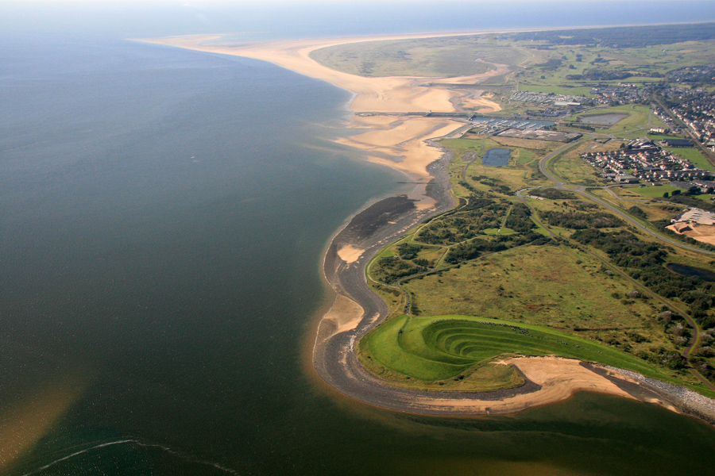(Carmarthenshire County Council, n.d.)

Anne-Marie Thomas 2011226

Executive Summary

Llanelli area has an extensive historic background in industry and other events, it was rich in work and community.
In the 1950, s work declined, and Llanelli became a town that lost jobs, and its society. Due to the depletion of work and the lack of up-keep and repair on many houses and buildings the area now faces many empty and run-down properties, in poor state of repair and are uninhabitable, with waste land in vast amounts. Urban Regeneration will be the only saviour for the area, if the local councils, business, charities, community and building owners worked together to invest in making the historic, rundown buildings and areas ascetically pleasing and habitable again, this will make the town more attractive to visitors and business, boosting the Llanelli area and in turn creating more jobs.

Contents Page

  - Introduction

2.1Part A

2.1.1Historical Development

2.1.2 Changing Fortunes

2.1.3 Existing assets, structures, and economic character

2.1.4 Key Stakeholders and interest groups

2.1. 5 Local/Regional development strategies

2.2 Part B – Regeneration Ideas

2.2.1 Regeneration ideas for Tyisha area
2.2.2 Regeneration ideas for Llanelli Town
2.2.3 Regeneration ideas for The Old Castle Works
3 Conclusion
4 References
5 Appendices

1.1 Introduction

Regeneration involves the public, private and community sectors working together towards a clear single aim. To improve the quality of life for all, to achieve real and lasting change in our towns and cities, make best use of resources we have human and financial. (Matthews, 2012, pp. 1–3) There are many towns and villages in wales which had changing fortunes due to the Industrial Revolution, Llanelli was one of these it was a small town in South Wales, where you could find large estates, family farms and small mines. Llanelli had no real significance that is until the start of the Industrial Revolution in the eighteenth century. The revolution made Llanelli see a rise in many industries in and surrounding the town with a significant rapid growth of population, in 1795 Llanelli had a population of just under 500 people due to the rapid influx of people seeking work by 1801 this had jumped to just under 3000. With the vast amount of coal, limestone and iron ore sourced locally and the costal access English entrepreneurs seen it as an ideal area for relocating and investing in. There are many streets in Llanelli that still have links with the industrial revolution and the well know people of the time, an example of this is the Neville and the Raby families both have left behind a legacy of a street name that can be found in the town. (hassan. d,2019)

2.1Historic Development

Alexander Raby was an English man from London he decided to move himself and his family to Llanelly in around 1796 he was 1 of many English entrepreneurs that seen the wealth and opportunity Llanelly could bring.

He was to be the catalyst that transformed the town from a small fishing village of 56 houses and a parish church into one of the major coal and steel towns of South Wales. (Old Llanelly p75 (1904) J. Innes)

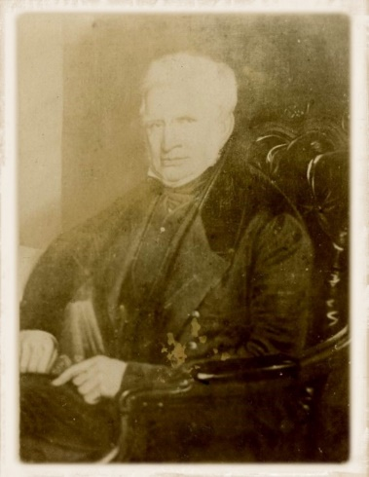
(John, 2018)

Alexander Raby moved to Llanelli around 1796, it is said to gamble his entire families fortune on the coal and iron industry by financing two iron founders who had set up in an iron furnace on the Stradey estate in 1791. The two men Gevers and Ingham were not successful in their iron furnace and were unable to pay back Alexander Raby, who then took the iron works back off the two men and took over it himself in 1796.
By the time Alexander Raby took over the furnace in Stradey estate the town was already known for its coal, it is said this is the reason that Alexander moved to Llanelly.

2.1.2Changing fortunes
At the start of the eighteen hundred many industrialists arrived from England investing huge amounts of money into Llanelly and acquired 1300 acres of land and a large house in the town (Pemberton House) this can still be seen in the town today. Between 1830-1870 Llanelly seen the expansion of their railways and tramway connections to the mines and the coast which made the transportation of produce far easier and more cost effective. Constructed by Llanelly Railway and Dock company as an outlet for the coal from the Llanelly area. In 1834 the docs seen the opening of the First public floating dock in Wales. This created many jobs in the area and making Llanelly a place to want to live and work with many people having accommodation provided by their employer. By 1886 the once small fishing village had grown into one of the major industrial towns of South Wales, boasting seven large tinplate works, a large copper works, four large foundries, a lead and silver works, a ship-building yard, three steam-powered sawmills and half-a-dozen collieries which exported 87,500 tons of coal in that year. (Wilkins, 1888, pp. 42.43)
However, in the early 1900’s the mines started to close the docks gradually decreased in their usage, the affluent areas of Llanelly gradually became very poor, residence were losing their houses as many people were lucky enough to have accommodation that came with their jobs, others losing their jobs had no income coming in. Gradually over the years Llanelli mine and steel communities became poorer due to many businesses either moving on or being closed due to the reduction of need for produce.

2.1.3 Existing assets, structures, and economic character
Tata steel tinplate factory is still trading and boasts a work force of around 700 people, many Llanelli residence have worked here since they were young children.

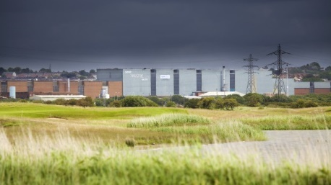(Sustainability at Trostre, n.d.)

On disused tata land that the council now owed was built the new home of the Scarlets rugby team, this has improved the area both economically and visually.
In 1988 Trostre park was built on ground that had been branded as waste land, With some of the biggest high-street names and 2,000 parking spaces all crammed into 450,000 square feet, around 90,000 shoppers were believed to visit the site every week. (Thomas, 2020a)
Llanelli town centre has many structures that date back to the early 18th century, many of which are very rundown and both structural and visually. However, there are historic buildings that have already been regenerate and have created jobs in the area, one of these buildings is Llanelly House it is a grade 1 listed building dating back to approximately 1714, which has had its transformation thanks to the Heritage Lottery Fund back in 2013.
BENEFIT | CARMARTHENSHIRE | WALES
Jobseekers Allowance (only) | 2.8% | 3.6%
Incapacity Benefits (IB or ESA) | 3.5% | 3.3%
Any Benefit (includes in work benefits) | 17.3% | 17.4%
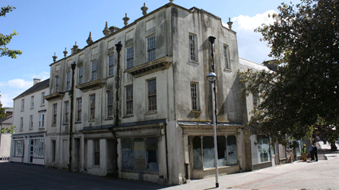(History, 2012)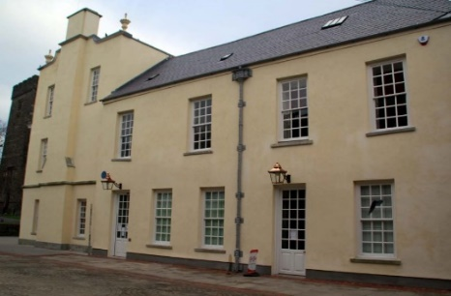 (Stuff, 2013)
Llanelli currently has a high amount of residence that are claiming some sort of benefit by having regeneration plans in place this could reduce the numbers of unemployment and can increase community spirit.
Below is a chart of Llanelli’s Benefit and unemployment status Sources: Office for National Statistics & Department for Work & Pensions. (Llanelli, Carmarthenshire - ILiveHere - Britain's Worst Places to Live, 2012)

2.1.4 Key stake holders and interest groups

The stakeholder concept was originally defined as "those groups without whose support the organization would cease to exist." The list of stakeholders originally included shareowners, employees, customers, suppliers, lenders, and society (Freeman, 2010, p.32). Below is a table of Key stakeholders and interest groups for my regeneration plans in Llanelli. The main stakeholders need to be kept informed and always involved, investors can get disheartened and if not involved at every step could revoke their investment, whereas the public and community can cause problems with the development, but very doubtful if they managed to halt the project.

Keep Satisfied -Meet Their Needs  Local Council | Manage Closely, Key Player  Investors  Project Developers  Contractors
Monitor – Least Important  Media | Keep Informed – Show Consideration  Local Businesses  Neighbours  Public/community
Interest Of Stakeholders

Influence and Power of Stakeholders
2.1.5 Local/Regional development strategies

After researching online about my chosen area, which is Llanelli, I have found that there are various development plans in the process of being put in place or about to be started. The main ones I have found is South Llanelli Strategic Zone this includes Delta Lakes, Machynys Development, The Avenue, North Dock, and the Old Castle Works, all these areas are located along the coast of the town. The area boasts strategic transport networks with the railway and bus station both in walking distance from all the developments mentioned.

Public and private sector investment has been made within the area, including the delivery of a new link road. Largely flat and consisting of the developed land by virtue of the area’s industrial past. (Carmarthenshire County Council, n.d.)

2.2.1 Regeneration Ideas
Regeneration ideas for the Station Road and the Tyisha area of Llanelli.
I spoke to a few Llanelli residence and asked them several questions, these are in the appendices of this report, majority of the answers where the same they all wanted Llanelli to have a better name than it currently has especially the Tyisha area. One of the questions they were asked was what area they would like to see improved and regenerated? Station road and the Tyisha are of Llanelli was discussed. The train station was mentioned and that it is very run down and tired, why would it be left unkept, rundown and dirty being one of the first points visitors will see either passing through or arriving by train, the second point that was raise was that most houses were built to accommodate workers many years ago and have never been improved or updated. This area is one of the most deprived areas in Carmarthenshire. More than a quarter of the houses in the area are rented and there are many properties empty and difficult to rent out, as the area is classed as anti-social. Shops and businesses have closed in the area because of this. Residence are weary and many will go out of their way to shop else were and not shop there as they do not feel safe to do so, some do not even feel safe leaving their own homes due to the rate of crime and antisocial behaviour. A regeneration project to improve the run-down area improve the community’s safety and the feeling of being safe, by helping shops re open by working with the council and premises owners for a reduced rent and rates scheme, possibly give a certain amount of rental and rates time free before the reduction was implicated. Unemployment and antisocial behaviour are a big factor of the area this is due to the fact of the hight number or unemployed in the area which attributes to a high rate of crime and antisocial behaviour, reducing both would be a large factor of the regeneration plan working with the local authorities, community, community groups and charitable organisations and local business to help achieve this.
A community steering group would increase community spirit and community participation creating a sense of place, utilising the unemployed by including them within the project, learning a trade, new skills or being able to improve on existing ones that could help gain future employment. The steering group and the regeneration interested parties work with local charities such as Choose Life, this is a group that provides help with alcohol and substance abuse, assists their members where they can to improve themselves mentally, physical and academically or the local job centre could assist in finding suitable candidates to help with many projects under the regeneration umbrella for instance Building, painting, decorating, or setting up a refreshment centre to cater for all involved.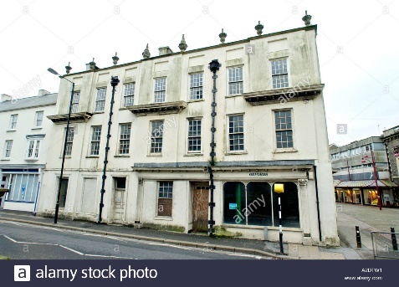 (Waste Land in Llanelli Town Centre Awaiting Redevelopment, Carmarthenshire West Wales UK, n.d.)

2.2.2 Regeneration idea for Llanelli Town.
The main area that has been mentioned when speaking to local residence about regeneration was regeneration of the town itself, regeneration of the high street as most called it. A regeneration project to possibly go niche with the hight street like Narberth, the niche area could be around arts and crafts as there is already a gallery scene in town. The local authority and the Welsh government could help by seeking to subside business rates, provide artists, and crafts people with the opportunity to ‘live above the shop’ so this will also help with housing, take on large empty premises and create affordable smaller units within them so initially the unit holders do not have to come up with large deposits for premises. This would help create a destination and boost employment particularly sole traders and SME’s. These premises could also be open after dark, building on events that are on at the Fwrnes Theatre creating an evening music scene for example jazz, folk and opera nights, as well as perhaps regular dance meets from tea dances to street dance so this will cover all ages. Within the town centre there are various buildings that are historic, Llanelly House, various churches, and The Town Council Buildings along with many more shop fronts. To create more jobs and a sense of history there could be heritage routes created, pre- booked guided tours of the town to include the Industrial Revolution, and the massive sport history of the area. The Heritage Townscape group, tourist board, visit Llanelli and Visit Wales could get involved to promote and possibly seek funding as tourists generate money for the area
The gardens area of town is also a wasted space this could be used in the better weather for an open-air theatre and using the existing graffiti as a platform to make Llanelli a street gallery inviting various groups and schools to participate making every available and suitable wall space to be a canvas, run competitions and possibly have regular spaces that would change frequently by the winning artist, local theatre companies, students studying the arts and school pupils along with the local councils could have involvement.
2.2.3 Regeneration of The Old Castle Works

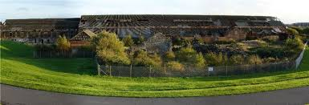(blueshiva, 2005)

Reusing the Old Castle Works to possibly create a West Wales Gallery and Museum, conference, and art centre like Galeri in Caernarfon, or possibly a walking, cycling and hostel hub, both ideas could be utilised as the area is very large and would generate much needed jobs and visitors to the area brining money. The museum and gallery would focus on the history of Llanelli and Llanelli area, there is a tremendous amount of rugby history within Llanelli along with the industrial revolution, being know for the area that a beer can was first made and the first ever spare wheel for a car was made. There are similar Museums in Wales that concentrate on the local history of the area, for instance The Pendine Museum of Speed, the museum is dedicated to Pendine Sands for land speed record attempts, the museum is owned and ran by Carmarthen County Council and has been built on the sea front on waste land. All the suggestions listed could seek funding from various organisations such as the heritage lottery, National heritage fund, and the local council and business investors. This regeneration plans will bring visitors to the area which In turn will create jobs alongside celebrating the history of the area.

Below is a SWOT analysis (Strengths, Weaknesses, Opportunities, and Threats) of the regeneration projects above. This will help with the regeneration and reduce the chance of failure and allow the interested parties to understand the business more.

Strengths | Weakness
- Local authority and councils help  - Community help  - Supportive local businesses  - Local artists on board with the project  - Tourism  - Network of public transport  - Welsh Language | - Government funding issues  - Welsh language  - Residence complaints
Opportunities | Threats
- New jobs and employment  - Tourism  - SME’s social enterprises  - Heritage assets  - Circular economy  - Local sponsorship business opportunities | - Tourism  - Environmental impact  - Competition from other similar projects in local areas

3 Conclusion

As my research demonstrates the potential for Llanelli’s coastline is vast, with many opportunities for business to regenerate and build new enterprises. Llanelli needs to look at re-creating itself and celebrating the history it has, while utilising the waste land that is alongside the breath-taking views of the Carmarthenshire Coast Line, making it a place that people want to visit in Wales or even the United Kingdom. If you create the’ hook and bait ‘and make the projects attractive, to match the surrounding sea and countryside it will lead to more people wanting to visit Llanelli, which in turn will attract more business wanting to invest and be a part of the area. More visitors and new business will be creating more jobs for the area, make the area more financially stable and pick the town back up from the low regard that people hold for it currently.

4 References
blueshiva. (2005, October 19). Display location: Old castle tinplate company - urban exploration resource. Uer. https://www.uer.ca/locations/show.asp?locid=23595
Carmarthenshire County Council. (n.d.). Carmarthenshire council - local development plan. Carmarthenshire Council. Retrieved 13 January 2021, from http://www.cartogold.co.uk/CarmarthenshireLDP/english/text/Appendix-2.htm
Editor. (2017, September 16). Success of asset transfers to Llanelli rural council. Llanelli Online News. https://llanellionline.news/success-asset-transfers-llanelli-rural-council/
hassan, D. (2019, March 1). The rise of Llanelli through the industrial period. West Wales Chronicle. https://www.westwaleschronicle.co.uk/blog/2019/11/01/the-rise-of-llanelli-through-the-industrial-period/
History, B. W. (2012, January 26). BBC - wales history: Inside Llanelly house. BBC Wales History. https://www.bbc.co.uk/blogs/waleshistory/2010/09/llanelly_house_restoration.html
Innes, J. (2012). ‘old Llanelly’.... Ulan Press.
John, L. (2018, July 28). Alexander raby - ironmaster and coalmaster. Llanelli Community Heritage. https://www.llanellich.org.uk/files/395-alexander-raby-ironmaster-coalmaster
Llanelli & the millennium coastal park. (n.d.). Discover Carmarthenshire. Retrieved 13 January 2021, from https://www.discovercarmarthenshire.com/places/llanelli-the-millennium-coastal-park/
Llanelli, Carmarthenshire - iLiveHere - britain's worst places to live. (2012, July 9). ILiveHere - Britain’s Worst Places to Live. https://www.ilivehere.co.uk/statistics-llanelli-carmarthenshire-22912.html
Matthews, R. (2012). Wales, a very peculiar history (2nd ed.). Salariya.
O’Sullivan, C., & Roderick, O. (2018, October 2). The projects coming soon to breathe new life back into llanelli town centre. WalesOnline. https://www.walesonline.co.uk/news/wales-news/projects-coming-soon-breathe-new-15223475
Strategic management: A stakeholder approach by R. edward freeman (2010) paperback. (2021). Cambridge University Press.
Stuff, G. (2013, November 28). Llanelly house, llanelli, carmarthenshire. British Listed Buildings. https://britishlistedbuildings.co.uk/300011892-llanelly-house-llanelli/photos/94124#.X_8R8zr7TIU
Sustainability at Trostre. (n.d.). Tata Steel Construction. Retrieved 11 January 2021, from https://www.tatasteelconstruction.com/en_GB/About-us/sustainability/Trostre#Trostre-6
Targeted regeneration investment programme - thematic funding. (2020, August 20). Carmarthenshire County Council. https://www.carmarthenshire.gov.wales/home/business/funding/targeted-regeneration-investment-programme/#.X_WVofn7TIU
Thomas, B. (2020, July 16). The story of parc trostre in llanelli and the shops that have come and gone. WalesOnline. https://www.walesonline.co.uk/whats-on/shopping/story-parc-trostre-llanelli-shops-18602344
Wilkins, C. (1888). The south wales coal trade and its allied industries, from the earliest days to the present time. Daniel Owen & Co.

5 Appendices
History and Regeneration of Llanelli questions.

What history do you think is important in Llanelli?
What areas do you think need regenerating and why?
What would you like to see in a regeneration plan?
What do you think regenerating areas of Llanelli will gain?

