
University of Wales Trinity Saint David London

Module Title: Professional Career Development
Module No: BMSW4005_LON
Lecturer: Lloyd Beharry
Student Name: Maria Sabrina Belcianu
Student Number: 1914905

Table of Contents
1.Introduction 2
2.The employment relationship 3
2.1 The recruitment process 4
Reflection on the role play 5
3.0 Career development 6
Learning style analysis 7
Personal development plan 8
Conclusion 10
References 10

1.Introduction
Employment refers to the contractual agreement between an employer and an employee where the employee is agreed to provide certain services in return for payment with some other facilities. An employee and an employer have different motives and different expectations from each other (Allen, 2019).
This report will present the employment relationship and how is regulated it as well will show the recruitment process.
In response to different issues and aspects related to employment, I have played a role as an employee and an employer. This reflective report is going to outline the employment relationship along with a personal development plan based on the learning from role-playing during the module.

2.The employment relationship
Employment in the UK is regulated under employment right act 1996 and national minimum wage act 1998 (Ivancevich, 2013). As a result, the relationship between the employees and employers follows a certain standard framework along with the industry norms and culture.
The employment relationship in the UK is regulated by different acts. The most important employment acts are the employment rights act 1996, national minimum wage act 1998, and employment relations act 1999, transfer of undertaking regulations 2006, the equality act 2010, the agency worker regulations 2010, and many more. Different acts have different objectives (Mondy, 2019). The employment right act of 1996 covers different rights of the employee such as dismissal, leave, redundancy, etc. National minimum wage act 1998 keeps the salary of the employees in line with economic indicators and employment relations act 1999 covers the right of trade union recognition, industrial actions, etc. (Torrington, 2019)
Responsibilities of the employers
According to different acts, employers have the following responsibilities:
- Offering regular wage and appraisal
- Job security
- Career growth opportunity
- Management supervision and control
- Training and development
- Safe and hygienic workplace
- Health benefits
- Work-life balance (Cottrell, 2010)
Responsibilities of the employees
- Employees have the following responsibilities to the employers:
- Take reasonable care of the interest of the employers
- Work with passion, loyalty, integrity, honesty, and commitment
- Take responsibility for the tasks
- Maintain workplace ethics and norms
- Ensure the best use of resources (Rue, 2018)

2.1 The recruitment process
Recruitment and selection are a continual process of hiring the best-fit employees (Rue, 2018). Thus, an integrated recruitment and selection process is described below (The Balance Careers. 2020):
Advertisement
There are many media for advertising while recruiting such as websites, newspapers, recruitment agencies, and many for to attract the candidates for hire. Employers need to clearly state the job requirements while advertising.
Job description
It tells details about the job to the candidates. It includes different criteria such as the position, general tasks, roles & responsibilities, and job essentials.
Job specifications
It clearly states the required qualities, experience, qualifications, and abilities for a particular job and satisfactory performance. It informs the candidates about the job itself.
Application forms
Certain format of job application can be provided by the employee otherwise candidates can use the widely accepted framework for application by mentioning the required qualifications.
Shortlisting
Nowadays employers use software for shortlisting based on different criteria. Shortlisted candidates can be asked for an interview.
Interviewing
It is a technique of exploring the relevant characteristics and qualifications of the candidates to explore whether they are fit for the job or not. During the pandemic online interviewing is widely used by employers.
Hiring
After meeting all the requirements, employers send the offer letter to the best-fit candidates. Candidates having the offer letter can join in the new workplace under certain terms and conditions based on the job description and job specifications.

Reflection on the role play
In week 9 I have played the role of both an interviewee and interviewer. As an interviewee, I applied for a restaurant business manager position. My interviewer asked me five questions in the interview. She asked me to talk about myself, my career achievement, my leadership skills, about the desired position, and my desire for working in the company.
As an interviewer, I designed some questionnaires for interviewing an interviewee who is seeking the job of a security operation manager. I told her to ask about the position, about the company, about herself, and her experience. I also tried to explore the reason behind the left of her present job.
I was very excited while the role was assigned to us. However, I was a little bit nervous while I was playing the role of an interviewee. Sometimes, I was jetted while replying to my interviewer. After the session, I felt pressure-free. I think this experience is more or less the same for the majority of the interviewees.
I felt more comfortable while I was acting as an interviewer. I enjoyed asking questions and the nervousness of the interviewee. I think it is easier to act as an interviewer than an interviewee.
Playing roles both as an interviewee and an interviewer were great. Mostly I have a positive experience except for some negatives while playing the roles.
Firstly, I played the role of an interviewee for a restaurant business manager position. I did some homework before participating in the interview session as an interviewee. Positive things were that I had taken notes by analysing different interviewee sessions also, I prepared a draft questionnaire for the session. During the interview, I was well-dressed, focused, attentive, passionate, and tried to be positive. Besides, I tried to listen to questions carefully and answered them politely.
I also had a mixed experience while playing the role of an interviewer but enjoyed the role of the interviewer more than the interviewee.
I enjoyed preparing the questionnaire for the session. I was well prepared, managed, time-bounded focused, and confident in asking questions.
However, I may do better if I could focus more on designing an integrated questionnaire.
Playing roles as an interviewee and an interviewer have enabled me to explore the experience of real-world employment and employability.
When I played the role of an interviewee, I realised the impact of stress and mental pressure during an interview session. It enabled me to prepare appropriate job application by focusing on the job description and job specifications. Then I have learned how to prepare myself for an interview session including gestures, body movement, non-verbal issues like eye contact, voice tone, etc. It also enabled me to collect, analyse, and evaluate data from alternative sources relevant for an interview session. As a result, I have improved my communication skills, time management skills, public speaking skills, stress taking skills, etc.
In summary, the activities during playing role have helped me to improve my employability skills and real-life experience of an interviewee and interviewer. So, it was a great experience for me. However, learning is a continual process. I need to focus on a continual improvement plan to make me competent by eliminating the weaknesses that I have identified while playing the roles.
Based on my career goals and weaknesses I have prepared a personal development plan as the concern of the action plan. The action plan is described in detail in the personal development plan section.

3.0 Career development
Career development is a share responsibility between employee and employer. When organisations take responsibility for the development of their employers, they are more likely to have hight potential employees and discoverer skills within the company that they did not know it existed before. For the employee in order to develop first he needs to identify his strengths and limits, he can do that by identifying his learning style and also by creating a personal development plan.

Learning style analysis
Different person has different learning styles. According to Dessler, (2020), there are mainly three types of learning styles namely visual learning style, auditory learning style, and kinaesthetic learning style. It is also called VAR learning style framework. There are 30 integrated and interactive questionnaires that are used to explore the learning hospital of an individual. I have also analysed to my learning style based on the VAK learning a style framework. The summary of the findings is as follows:
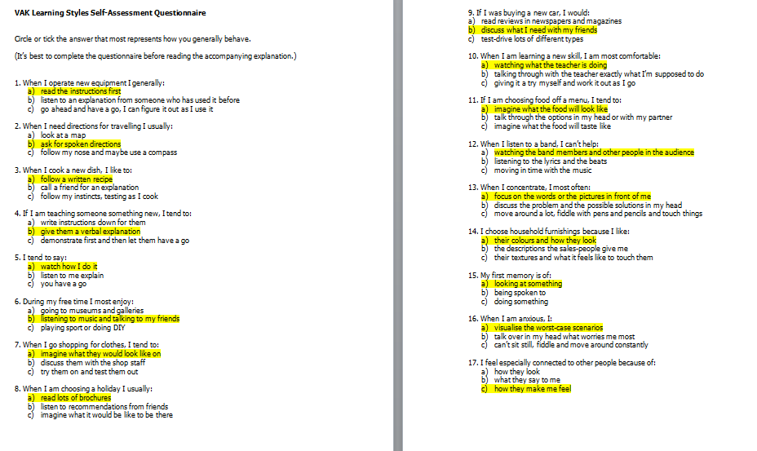
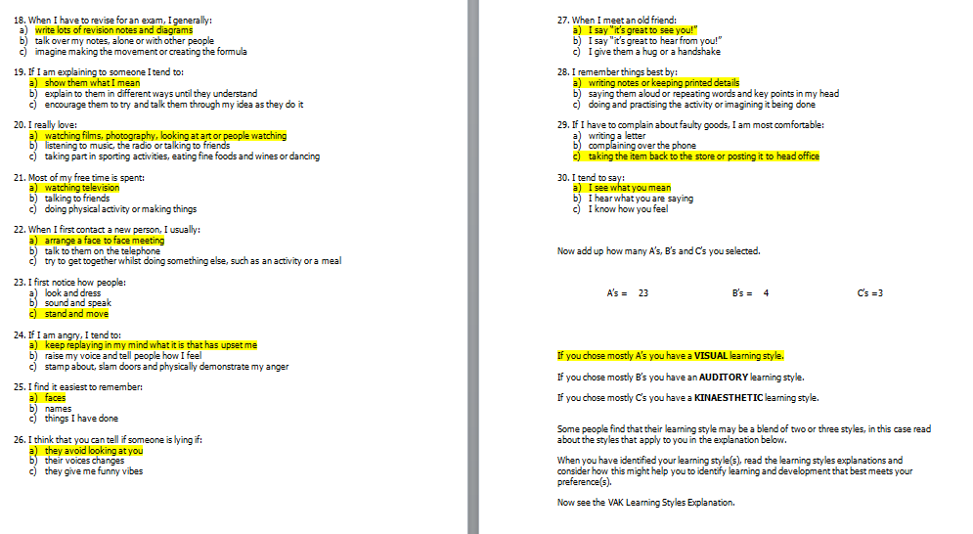
Figure: VAK outcome
I have chosen ‘A’ in 23 times, ‘B’ in 4 times, and ‘C’ 3 times. It represents that I am mostly a visual learner. According to the characteristics of a visual learner, I have a preference for seen and observed things such as pictures, displays, flip chart, diagrams, handout, demonstrations, etc. So, while I am going to design my development plan, I need to focus on including more visual items in my learning methods. The below describes the personal development plan has also included some visual resources for learning.
However, I might need to include auditorial and kinaesthetic approaches of a learner as I also have a footprint in these learning styles.

Personal development plan
I have some short term, midterm, and long-term ambitions. According to Adair, (2013), the design of appropriate personal development plan depends on career objectives and learning requirements. Thus, I have prepared my development plan based on my career objectives and learning requirements as desired below:
Career objectives
- In short term, I want to get my level 4 in CERT HE in skills for the workplace and to start the next term with UWTSD
- To get level 6 in Leadership and Management in 2-year time
- To find a job as a business manager where I can put in practice my experience and all I learned in the university
learning requirements | ways to achieve learning requirements | Resource and support requirements | Success criteria | Target dates for review and completion
Communication skills | I need to improve my communication skills by focusing on my listening skills, non-verbal communication skills, verbal communication skills, and written communication skills. Focusing on picking up the right medium wait effective interpersonal skills and empathy are also required to improve communication skills. | To improve my verbal and non-verbal communication skills I will require the support of books, journals, novels, videos, etc. Besides, I will also require the support of individual for communicating in different circumstances. | For verbal and non-verbal communication, I will use individual feedback and for written communication, I will use Grammarly score as key performance indicators. | I will review my performance after the end of each month and the target date of completion will be six months.
Presentation and public speaking | I can improve my presentation and public speaking skills by improving my Microsoft PowerPoint skills for preparation of slides and then I can improve my public speaking skills by presenting in front of different people. I can watch the video on YouTube for improving my PowerPoint skills and then I can record my presentation for self-evaluation. | I will mostly require the support of my friends and family members for improving public speaking. | Individual rating will also be used for evaluating progress and the desired rating is 9 out of 10.  MS PowerPoint test score of 90% out of 100% will be the desired rating. | monthly review with three-month period to explore the success
Time management skills | According to Adair, (2013), time management skills can be improved by classifying daily task based on emergency and important. A proper balance between urgent and important tasks helps to ensure the best use of time. Besides, urgent but less important tasks are needed to be delegated for effective time management. | I will require the support of a time management framework and daily routine. Time management framework developed by Eisenhower can be helpful. | my objective of time management is to make me 100% accurate in completing the daily task. So, 100% completion of tasks based on the time management framework is the success criteria. | The routine tasks will be review daily and the expected period of exploring the criteria is 6 months.

Conclusion
In this reflective report, I have tried to outline the key issues in the recruitment and selection process along with the legal requirements. Then the report outlined the experience of playing roles as an interviewee and interviewer. I have some scope for improvement, and I designed a personal development plan based on my career objectives. However, the appropriate implementation of the plan is required for future success. I think by applying the PDP I can overcome my weaknesses and make me competent in this field to explore long-run career objectives.

References
Adair, J. and Allen, M., 2013. The Concise Time Management and Personal Development. London: Thorogood.
Allen, A. and Allen, M., 2019. Time Management and Personal Development. London: Thorogood Publishing.
Barcham, L., 2011. Personal Development for Learning Disability Workers. Exeter: Learning Matters.
Cottrell, S., 2010. Skills for Success. Basingstoke: Palgrave Macmillan.
DeCenzo, D., Robbins, S. and Verhulst, S., 2013. Human Resource Management. Hoboken, NJ: Wiley.
Dessler, G., 2020. Human Resource Management. New York: Pearson.
Grit, R., Guit, R. and Side, N., 2016. MANAGING YOUR COMPETENCIES. [Place of publication not identified]: ROUTLEDGE.
Ivancevich, J. and Konopaske, R., 2013. Human Resource Management. New York: McGraw-Hill Irwin.
Mondy, R. and Martocchio, J., 2019. Human Resource Management, Global Edition.
Riessman, C., 2019. Narrative Analysis. Newbury Park, Calif: Sage.
Rue, L., Ibrahim, N. and Byars, L., 2018.d. Human Resource Management.
Stewart, I., 2018. Developing Transactional Analysis Counselling. London: Sage Publications.
Torrington, D., Hall, L., Atkinson, C. and Taylor, S., 2019. Human Resource Management.
Winkelmann, C., 2014. The Language of Battered Women. Albany: State University of New York Press.
The Balance Careers. 2020. Learn All the Steps in The Recruiting and Hiring Process. [online] Available at: <https://www.thebalancecareers.com/recruitment-and-hiring-process-2062875> [Accessed 27 December 2020].

