Student Name: Nia Lloyd-Jones
P Number: 1909499
Programme of Study: Surface Pattern Design
Module: ADAD4018
Ways of Thinking Lecturer’s Name: Julia Lockheart
Portfolio of Writing

Tasks in the order I received them:
Task 1: Manifesto Writing = 586 words
Task 2: Observational Writing = 537 words
Task 3: Practice-based Writing = 494 words

Task 1: Manifesto Writing
- Amsugno’r hiraeth o beth sydd wedi bod a’i ddefnyddio yn holl bwrpasol yn fy ngwaith.
- Darganfod ffyrdd newydd i weithio gyda defnyddiau a brosesau uchelgeisiol
- Gwthio ffiniau dyluniadau i gyrraedd pwynt cyn toriad, dyma lle mae pethau da yn digwydd.
- Ailddefnyddio. Ailddefnyddio.
- Casglu ystyr, syniadau a defnydd a’u gwinio gyda’u gilydd.
- Immerse yourself with creative people.
- Arddangos i fy mhlant mae gwaith caled yn dilyn I bosibiliadau unigryw.
- Mae’r byd gyda cynllun i chi. Embellish it with sequins!

Task 1 – 1. Amsugno’r hiraeth o beth sydd wedi bod a’i ddefnyddio yn holl bwrpasol yn fy ngwaith.

There is a hidden, underlying, current of creativity that runs through my heritage that is a responsibility to pass on to my next generation. It is difficult to know one’s true self when so easily influenced by the world and everything in it. Do I pull on my heritage and let it define me or do I crown myself as my own person and develop my own unique path? So I ask, is creativity learned or inherited? Maslow, a theorist I have come across when studying leadership has also studied creativity, he says “there is some evidence that great musical talent and great mathematical talent are more inherited than acquired”, Maslow (1958 quoted in Covin, 1974, p107). He continues to define creativity in his research in this article.

I believe my heritage gives me purpose, to embrace my talent and continue with my skills and develop them through an educational environment that will lead onto a commercial enterprise.

Task 1 – 6. Immerse yourself with creative people
Where do I fit and who are my people? As I journey through life I come back to creativity following a term of opposing careers. It is my holy place, my peace, my celebration in a world where I can be lost and a potential to make an earning from my craft. I have always felt like a “lone ranger” but I do know I belong to a tribe, not necessarily related. I find comfort in inspiration. I believe this was the aim of the Bauhaus as suggested by Walter Gropius “The Bauhaus strives to bring together all creative effort into one whole” (Gropius, 1919). I am a journeyman he refers to. Fritz says ““There’s nothing like surrounding yourself with people who actually like you just the way you are” and “care about you and your success.” (Fritz, 2017)

Task 1 – 8. Mae’r byd gyda cynllun i chi. Embellish it with sequins!

I am a scrapper, a fighter, a wrestler of life with its twists and turns, I have tried to control it. When there has been a hard path, I have chosen, often through impatience. Whether you believe in a higher power, religion, a divine God, my path is guided by my growing spirituality. What I have lacked is the comfort blanket of support, which leaves me cold and desperate to be swaddled. In these times, my creativity from within has calmed me and assured me there is a future in my work. I should learn to listen to its voice and be confident. What is meant to be is for me. Fritz defines this life battle in his book The Path of Least Resistance,
“You are like a river. You go through life taking the path of least resistance. We all do—all human beings and all of nature. It is important to know that. You may try to change the direction of your own flow in certain areas of your life—your eating habits, the way you work, the way you relate to others, the way you treat yourself, the attitudes you have about life. And you may even succeed for a time. But eventually you will find you return to your original behavior and attitudes. This is because your life is determined, insofar as it is a law of nature for you to take the path of least resistance.”
(Fritz, 1989)
I am always drawn back to creativity.

Bibliography
Covin, Theron M, (1974) ‘Readings in Human Development’ A Humanistic Approach, p.107 available at https://books.google.co.uk/books?hl=en&lr=&id=wmxZIaW03QkC&oi=fnd&pg=PA107&dq=is+creativity+learned+or+inherited&ots=RGVDgaagrX&sig=OuOKtrH6McMkpEd-BEoscftIwD4&redir_esc=y#v=onepage&q&f=false (Accessed 03/01/21).
Fritz, Robert (2017) Your Life is Art, 2nd edn. Newfane Press
Fritz, Robert (1989) The Path of Least Resistance: Learning to Become the Creative Force in Your Own Life, Ballantine Books
Gropius, Walter 1919 Bauhaus Manifesto and Program

Task 2 – Observational writing
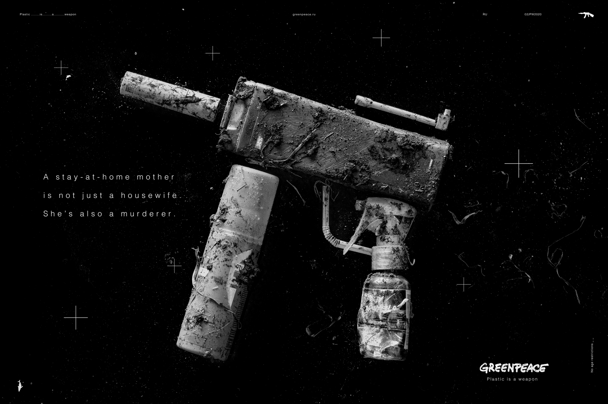
Figure 1.
I have chosen to discuss a Greenpeace advert as I believe the semiotics, (they study of signs and symbols and their use or interpretation) is strong. One image in particular, of a series developed by Russian marketing company called Possible on behalf of Greenpeace. Greenpeace an organisation, known for their controversial, contemporary, thought provoking messages to instil responsibility and powerful action in their audience.

I have enjoyed the study of semiotics and the deconstruction, decoding of purposeful images that have a narrative. However, firstly it’s important that the audience can understand the language of semiotics otherwise the signifiers will go unnoticed. According to Ferdinand De Saussaure, the language of sign has two components, the signifier and signified in his study of linguistics. “The connection between the signifier and the signified is arbitrary” (Saussaure), meaning the sign is relational in the word chain or in its context. Judith Williamson also agrees “A sign is simply a thing – whether object, word, or picture – which has a particular meaning to a person or group of people. It is neither the thing nor the meaning alone, but the two together. A sign consists of the Signifier, the material object, and the signified, which is its meaning. These are only divided for analytical purposes: in practice a sign is always thing-plus-meaning”. I have begun to consider this in my own work adopting subtle signifiers in my design. The Bauhaus manifesto explains “Forms and colors gain meaning only as they are related to our inner selves. Used separately or in relation to one another they are the means of expressing different emotions and movements”.

The denotations of easily recognisable individual plastic bottle objects are identifiable and form a shape of a recognisable fire arm. An iconic sign, a symbol of murder or death. The colour scheme is monochrome, also to signify the lack of colourful nature of what we can assume to be the sea, is dark and colourless. It is opposite to the psychogeography that we would expect from this environment, vibrant natural colours, preservation and nurture of nature. The myth I suppose is that the sea should be vibrant and busy with nature but in reality is dark and full of foreign objects we have imposed on it, damaging, forever changing the environment. Like death, a permanent result.

What is most shocking is the anchoring text, accusing the term of a “mother” to be murderer. Again controversially against the nurture we understand from unconditional love to purposefully encouraging decay. It wasn’t until discussing the encoding with my peer that I realised the connotation (secondary deeper meaning), the consciousness of the mother to potentially continue in this way as a cost to completing chores based on my own values. Which lead me to consider the following quote by Roland Barthes “To see someone who does not see is the best way to be intensely aware of what he does not see.” In this case the signifier was not recognised until analysis and discussion with peers. With the volume of information we are exposed to in today’s environment, do the signals, symbols need to be loud? With social media platforms being a main stream of communication, we have seconds to recognise the signifiers.

Bibliography

Barthes, Roland (1957) Mythologies
Gropius, Walter 1919 Bauhaus Manifesto and Program
Saussaure, Ferdinand de (1959) Course in General Linguistics. The Philosophical Library, New York City.
Williamson, Judith (2010) Decoding Advertisements: Ideology and Meaning in Advertising
List of Figures:
Figure 1: Plastic is a weapon series of images by Possible. Available at https://www.adsoftheworld.com/media/print/greenpeace_a_regular_weapon_0 (Accessed 03/01/21)

Task 3 – Practice based writing
Keyword – Legacy
Object – Scissors
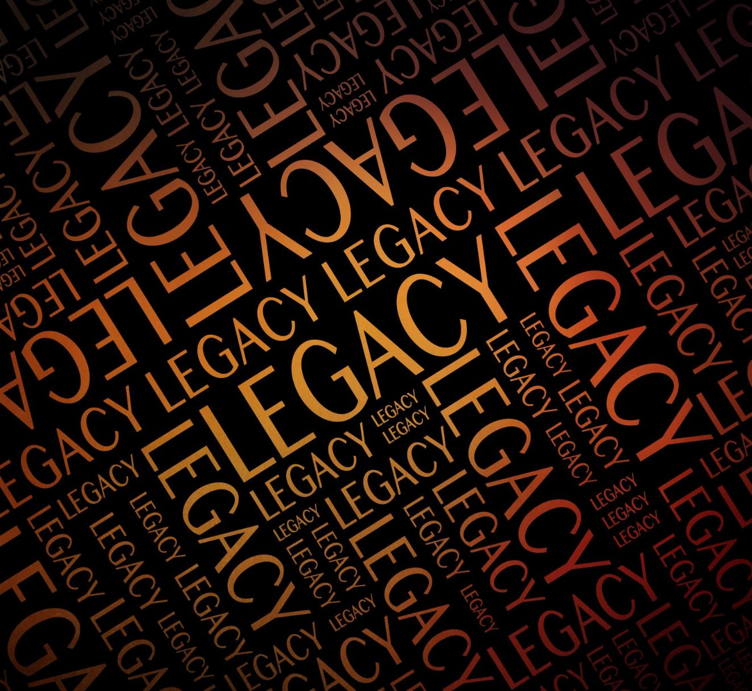
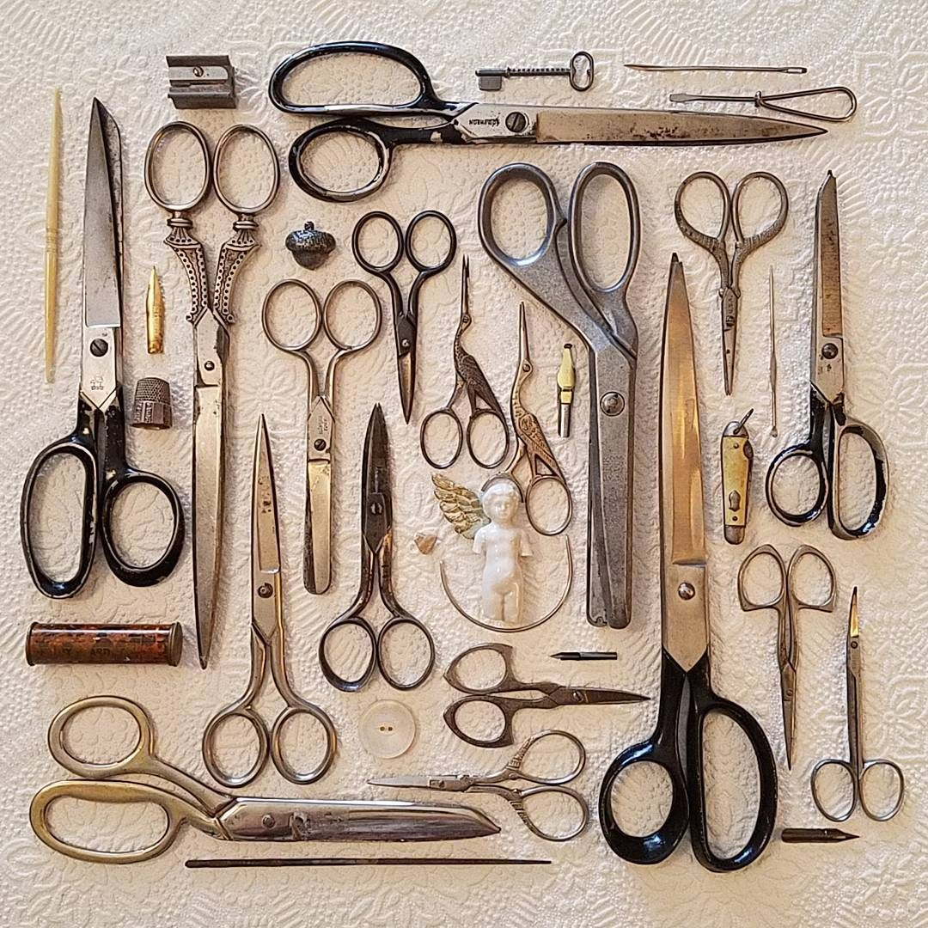

Figure 2. Figure 3.

In the consideration of the importance of a manifesto, should the work be enough to speak for itself? I have decided, following self-reflection is that the manifesto or the design writing is the opportunity to substantiate the work by its owner. It would be impossible to fully convince the audience of the owner’s viewpoint but at least it is placed in its context to be discussed. Marcel Duchamp says “No work of art is finished until completed by the spectator.”

In its simplest form the object is a double blade with handles. The importance of this object doesn’t come from its dormant state but from the endless opportunities where it has shaped my life. The scissors has been poignant in my career. For 10 years, the sharpest of blades have designed my hairdressing career, cutting traditional formational patterns and styles on trend on the most visible of heads. Vidal Sassoon, an iconic figure in the hairdressing world is known to have said inspirationally “For me the working of hair is architecture with a human element” (Hunsley, 2017). The hardest part of this for me was executing the version of the clients brief whilst dealing with a penetrating stare at your every cut until complete. The ratio of perfection had to be its highest continually as they would be your walking advert for the next 6 weeks, that was if you were successful!

Legacy, according to the Collins English Dictionary is “an event or period of history is something which is a direct result of it and which continues to exist after it is over.” With the shears I am creating short term and long term legacies along with embracing the legacy of my heritage. My grandmother was a seamstress and she taught me to sew and I find myself more comfortable with fabric shears than hair cutting tools of late. Following her passing it is her self made clothes that are left behind, as memories and her legacy that all began with the pattern cutting shears.

When I consider my own legacy I agree with Patrick Dobel (2006) “Thinking of a legacy guides leaders to a less controlling style, supporting people and institutions capable of adaptation and growth. While legacy does not capture all aspects of managerial leadership, it maps broad and rich understanding of leadership and responsibility linked to trusteeship.” Which brings me back to the Bauhaus movement, immersion of likeminded creatives, peer inspiration and a legacy of material to be studied and reflected upon when my time has come and gone.

The well-known saying of measure twice and cut once in the carpentry industry also applies to the hair industry and fashion. To avoid mistakes can be costly in reputation or material. My appreciation of the power of the blade has been instilled in these professions but also to honour the legacy of my heritage and to which I will leave behind after my days. To know is enough, I did that.

Bibliography
Collins English Dictionary (2021) Available at: https://www.collinsdictionary.com/dictionary/english/legacy (Accessed: 03/01/21)
Duchamp, Marcel (1957) The Creative Act
Hunsley, Ruth (2017) ‘Vidal Sassoon’s 12 Best Inspirational quotes’ Hairdressers Journal, Available at: https://www.hji.co.uk/top-hairdressers/vidal-sassoon-quotes-to-inspire/ (Accessed: 03/01/21)
Patrick Dobel, J. (2006), "Managerial Leadership and the Ethical Importance of Legacy", Saint-Martin, D. and Thompson, F. (Ed.) Public Ethics and Governance: Standards and Practices in Comparative Perspective (Research in Public Policy Analysis and Management, Vol. 14), Emerald Group Publishing Limited, Bingley

List of Figures
Figure 2: Chris Skinners Blog (2019), Available at: https://thefinanser.com/2019/10/legacy-systems-isnt-legacy-what-you-leave-behind-after-youre-dead.html/legacy-5/ (Accessed 04/01/21)
Figure 3: Little Prairie Sparrow Pinterest (2021), Available at: https://www.pinterest.co.uk/pin/AWLVn-acXhsMpF3ByDGGfaizWMmSUhKHo0UahcV3npA_MfLVPgg-Fnk/ (Accessed 04/01/20)

