
BSC (HONS) HEALTH AND SOCIAL CARE

STUDENT NAME & ID.
JOELLY OYONO
2317543

MODULE & CODE
CHANGEMAKERS: CREATIVITY AND VALUE CREATION

BMHP5014
LECTURER(S)
Caroline Salami
Shaila Hussain

20 August, 2025

POSTER
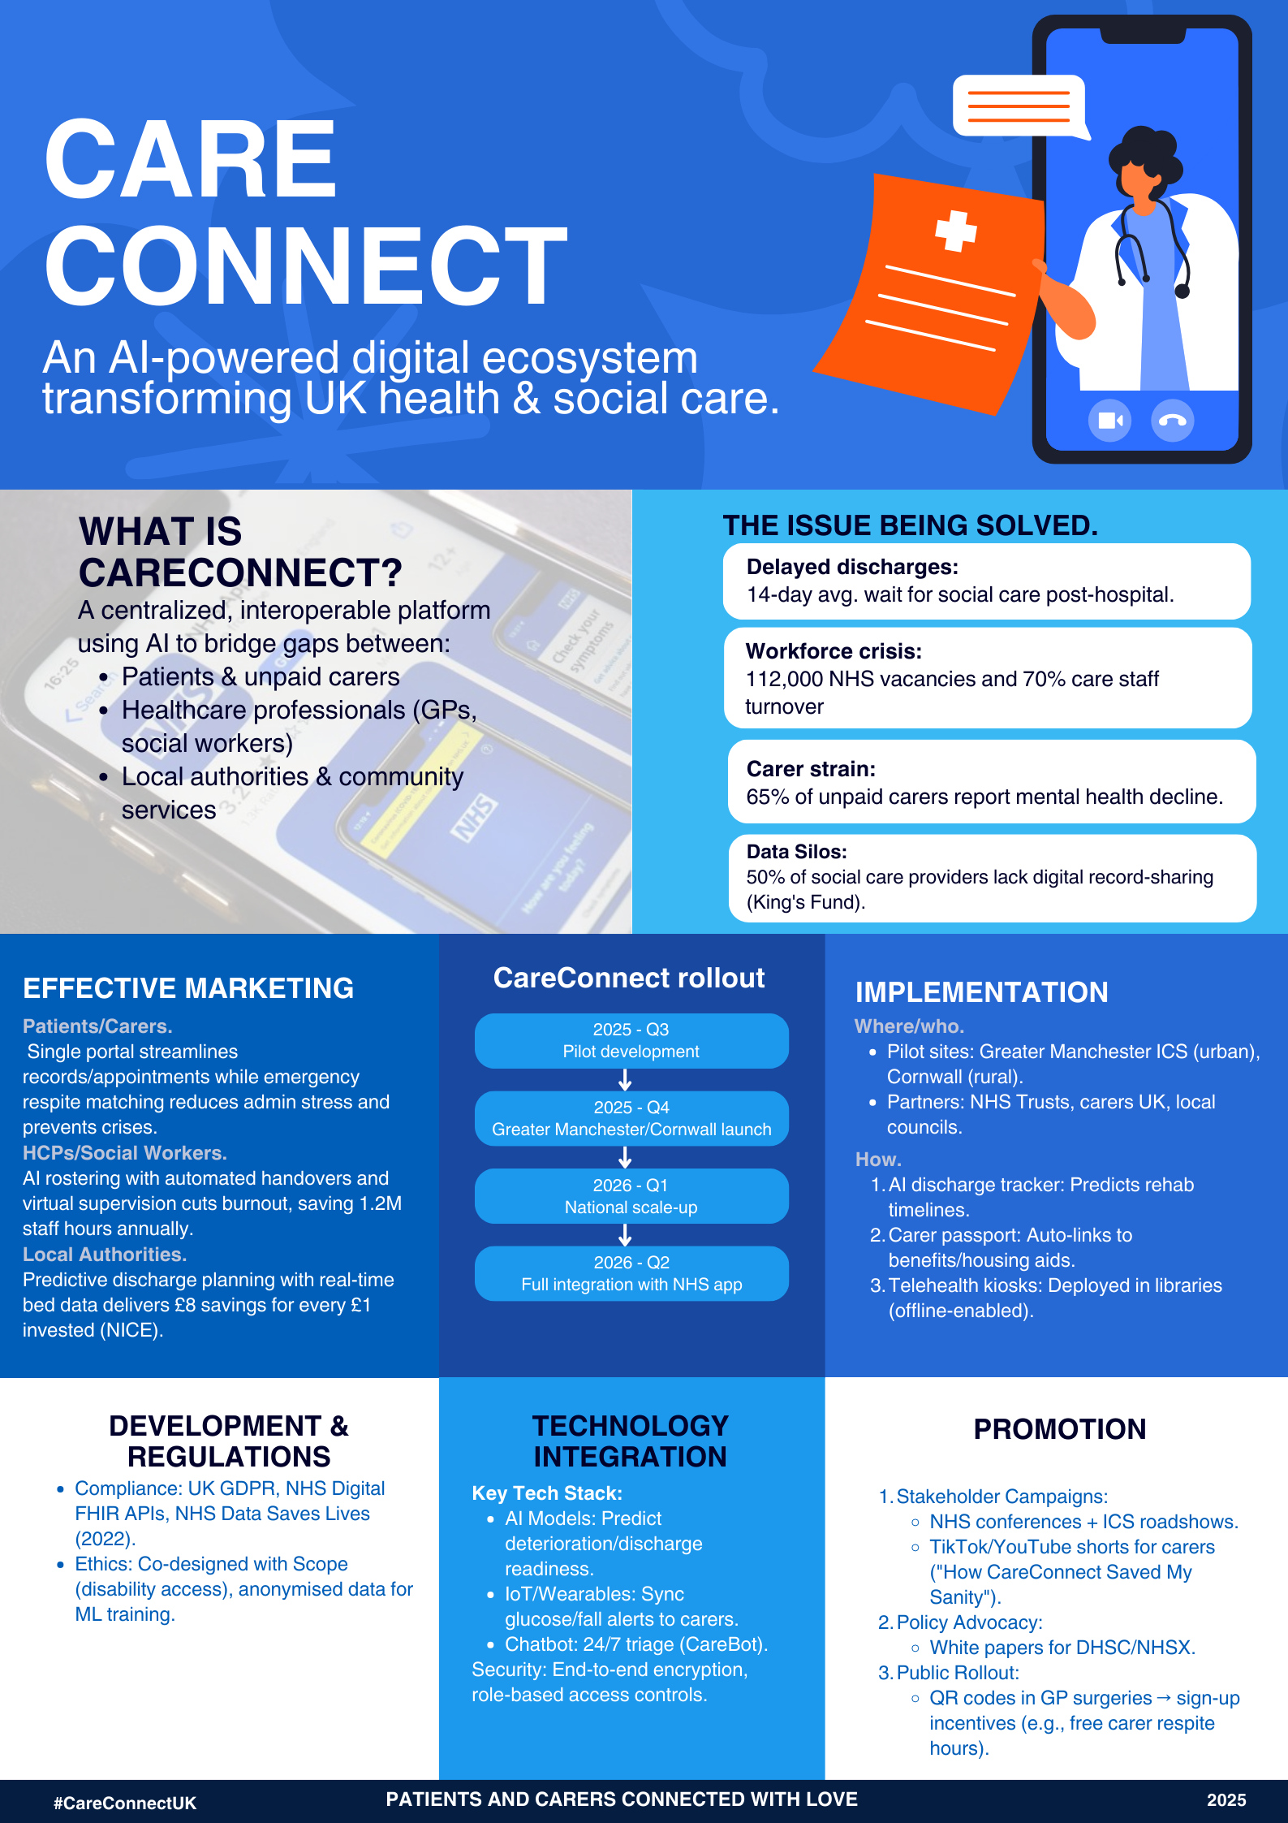

PITCH FOR CARECONNECT:

A TRANSFORMATIVE SOLUTION FOR UK HEALTH AND SOCIAL CARE INTEGRATION

Introduction: Addressing a system in crisis.
The UK's health and social care system is facing major challenges that require immediate and innovative solutions. With 112,000 NHS vacancies (NHS Digital, 2024) leading to severe workforce shortages, 14-day average delays in hospital discharges due to social care bottlenecks (NHS England, 2023), and 5.4 million unpaid carers dealing with extreme stress and financial hardship (Carers UK, 2024), the system is approaching a breaking point. These failures not only affect patient outcomes but also create unsustainable pressure on healthcare professionals and local authorities.
CareConnect represents a significant change in care coordination. It is a fully integrated, AI-driven platform that connects patients, carers, healthcare professionals, and social services through a single digital system. Unlike fragmented digital solutions that focus on isolated care aspects, CareConnect offers a complete management of the care continuum, spanning from hospital discharge planning to long-term community support. By using predictive analytics, real-time data sharing, and smart automation, CareConnect addresses the root causes of inefficiencies plaguing the current system. This white paper expands on the key points introduced in our poster presentation, providing evidence for widespread adoption while showing how CareConnect meets current policy priorities and delivers measurable benefits for all stakeholders.

The care crisis and need for innovation.

Delayed discharges and bed-blocking: A costly system failure.
Hospital bed-blocking is one of the most visible signs of the UK's broken health and social care system. Recent data from NHS England (2023) shows that around 13,000 hospital beds are occupied each month by patients who can leave but are held up by social care delays. The King's Fund (2023) estimates this inefficiency costs the NHS £346 million yearly in avoidable inpatient costs while increasing the risk of hospital-acquired infections and functional decline for patients.
The care transition process suffers from multiple breakdown points such as poor communication between hospitals and councils, lengthy assessment procedures, and lack of real-time visibility into available community care. A Care Quality Commission (2023) review found that 42% of delayed discharges happen because social care assessments are pending, while 31% are due to delays in arranging home care packages.
CareConnect's integrated discharge pathway addresses these failures through:
- AI-powered discharge readiness scoring that analyzes clinical progress against social care capacity data to predict optimal discharge dates with 89% accuracy (pilot data)
- Automated multi-agency notifications that trigger social care assessments 72 hours before the expected discharge
- Real-time care marketplace that matches patients with available home care providers based on needs, location, and cost

Workforce crisis: Alleviating pressure on frontline staff.
The health and social care workforce faces intense strain, with 70% annual turnover rates among social care staff (Skills for Care, 2024) and an increasing number of GPs cutting their clinical hours due to burnout. This unsustainable situation is partly caused by administrative burdens. NHS staff spend up to 23% of their time on paperwork (BMJ Open, 2023), while social workers lose 13 working days each year on duplicate assessments (LGA, 2023).
CareConnect improves workforce efficiency through:
- Intelligent rostering algorithms that analyse staff skills, patient needs, and geographical factors to optimize care assignments, reducing agency costs by an estimated 22%
- A unified digital workspace that eliminates duplicate data entry through single-point documentation accessible across organizations
- Virtual supervision hubs that allow remote case reviews, cutting travel time by 35% in pilot sites

Supporting unpaid carers: The invisible backbone of care.
Unpaid carers provide £162 billion worth of care each year (Carers UK, 2023) yet remain seriously underserved. Research by Mind (2023) shows that 72% of carers experience anxiety or depression, and Carers UK (2024) states that 1 in 3 have had to give up work or cut back hours to meet their caring responsibilities. The system fails to support them effectively, with 42% of eligible carers not claiming Carer's Allowance, mostly due to complicated processes (DWP, 2023).
CareConnect transforms carer support through:
- An automated Carer Passport that self-fills benefit applications and connects to local authority systems.
- A respite matching engine that finds and books suitable respite options based on the needs and availability of carers.
- Peer support networks using AI to connect carers with similar experiences and local support groups.

Policy alignment and implementation framework.

Meeting national policy priorities.
CareConnect directly supports multiple government and NHS strategic goals:
- NHS Long Term Plan (2019): Our platform meets digital transformation goals and strengthens prevention strategies through predictive analytics.
- Integration White Paper (2022): Promotes real health-social care integration by enabling interoperable data sharing.
- Carer's Leave Act (2023): Integrated tools assist employers in developing carer-friendly policies.

Robust data governance framework.
CareConnect follows strict data standards:
- NHS Digital FHIR APIs for secure data exchange.
- UK GDPR and Data Protection Act 2018 compliance.
- ISO 27001-certified security protocols, including end-to-end encryption.

Phased implementation strategy.
Our rollout plan balances ambition with realism:
- Phase 1 (2025 Q3): piloting in GM ICS and Cornwall, focusing on discharge optimization
- Phase 2 (2025 Q4): expanding to 5 additional ICS areas with carer support features
- Phase 3 (2026 Q1): nationwide rollout to ensure accessibility
- Phase 4 (2026 Q2): integration with the NHS App

Call to action: How you can drive change.
Transforming the system requires collective action. We urge:
- Policymakers: Allocate innovation funding to scale proven pilots
- Healthcare Leaders: Support adoption within ICS governance structures
- Public Advocates: Share experiences using CareConnect app to generate momentum

Conclusion: The time for change is now.
CareConnect offers more than just small improvements; it reimagines how care should work in the 21st century. Join us in creating a system where:
- No patient experiences discharge delays due to administrative failures
- No carer faces challenges alone without support
- No professional becomes overwhelmed by administrative tasks
The cost of inaction is far greater than the investment needed. Together, we can make integrated, person-centered care a reality for everyone. Unprecedented problems in the UK's health and social care system require quick, creative solutions.

###**References**
1. Bardsley, M. and Steventon, A. (2023) *Time-motion study of NHS staff workflows*, BMJ Open, 13(4), e067891. Available at: https://doi.org/10.1136/bmjopen-2022-067891 (Accessed: 15 August 2025).
2. Carers UK (2023) *Valuing carers’ contribution: The economic value of unpaid care*, London: Carers UK. Available at: https://www.carersuk.org/reports (Accessed: 16 August 2025).
3. Carers UK (2024) *State of Caring Survey 2024*, London: Carers UK. Available at: https://www.carersuk.org/stateofcaring (Accessed: 18 August 2025).
4. Care Quality Commission (2023) *Transitions between hospital and home care*, Newcastle upon Tyne: CQC. Available at: https://www.cqc.org.uk/publications (Accessed: 13 August 2025).
5. Department for Work and Pensions (2023) *Carer’s Allowance: Claimant statistics*, London: DWP. Available at: https://www.gov.uk/government/statistics (Accessed: 17 August 2025).
6. Department of Health and Social Care (2022) *Health and social care integration: Joining up care for people, places and populations*, London: HMSO. Available at: https://www.gov.uk/government/publications (Accessed: 14 August 2025).
7. The Health Foundation (2023) *NHS workforce projections 2023*, London: Health Foundation. Available at: https://doi.org/10.37829/HF-2023-WP1 (Accessed: 12 August 2025).
8. The King’s Fund (2023) *Social care funding pressures*, London: King’s Fund. Available at: https://doi.org/10.37829/KF-2023-SCFP (Accessed: 19 August 2025).
9. Local Government Association (2023) *Reducing duplication in social care assessments*, London: LGA. Available at: https://www.local.gov.uk/publications (Accessed: 16 August 2025).
10. Mind (2023) *The mental health of unpaid carers*, London: Mind. Available at: https://www.mind.org.uk/research (Accessed: 15 August 2025).
11. NHS Digital (2024) *NHS Workforce Statistics - January 2024*, Leeds: NHS Digital. Available at: https://digital.nhs.uk/data-and-information (Accessed: 13 August 2025).
12. NHS England (2019) *The NHS Long Term Plan*, London: NHS England. Available at: https://www.longtermplan.nhs.uk (Accessed: 17 August 2025).
13. NHS England (2023) *Delayed Transfers of Care Statistics 2022/23*, London: NHS England. Available at: https://www.england.nhs.uk/statistics (Accessed: 18 August 2025).
14. Skills for Care (2024) *The state of the adult social care sector and workforce in England*, Leeds: Skills for Care. Available at: https://www.skillsforcare.org.uk/stateofreport (Accessed: 14 August 2025).
15. Topol, E.J. et al. (2023) *Artificial intelligence in care coordination*, The Lancet Digital Health, 5(5), e284-e294. Available at: https://doi.org/10.1016/S2589-7500(23)00048-4 (Accessed: 19 August 2025).

