Cameron Davies – P150422

Abstract
A report discussing the feasibility of original design, and the potential improvements that can be made to make sure that the component is as efficient as possible
Engineering design project
Drill Press Main Sliding Unit

Table of Contents
Introduction 2
Main Body 3
Current Design 3
Proposed manufacturing method and polymeric material 3
Documented final design for manufacture 5
Conclusion 10
Bibliography 11

Introduction

This report shall analyse the current design of the drill press and look into the advantages and disadvantages of its functionality. Then a potential new design of the drill press main sliding unit, and its manufacturing process will be discussed. The new proposal will explain why the changes have been made so that it can justify the design being manufactured. Different polymeric materials will be analysed to identify a suitable material for the new design. Then a documented account explaining how the final design was produced will be explained. This will finally lead into a conclusion summarising the findings, and justifying why the new design should be manufactured.

Main Body

Current Design

The current design of the drill press main sliding unit has the functional requirements that it must move vertically up and down efficiently without any problem. It also has to have the holes that are currently on it, as they are vital for aligning the sliding unit with the other components of the drill, as they must be able to line up and connect. Finally the most important function of the sliding unit is that the drill clip is aligned correctly as the drill needs to go there, and positioning is vital.
The advantages are as followed;
- Despite the need for re-designing it currently does its job correctly, and can function as it is supposed too
- There is flat surface’s on both the top and bottom of the sliding unit which helps with preventing wear and tear of the part, as after a certain duration of time, any sharp edges or features that are sticking out will get damaged and worn down. This is why it can be argued that flat surfaces are a very efficient feature.
- The radius on the side of the sliding unit, as this will help in strengthening the corners.
The disadvantages are as followed;
- There are sharp edges which increase the potential of shrinkage, weak corners and the possible chance of damaging the part.
- Excessive amount of features, there are some parts for example the hole on one side of the sliding unit which doesn’t have a function, this could increase the tooling cost for no sufficient reason.
- It is a big part with a lot of material which increases the tooling cost as well as the material cost. The sliding unit can be argued to not need all the material the conceptual design has.

Proposed manufacturing method and polymeric material

There are several different types of manufacturing methods that can be used for creating the proposed design; 3D printing and injection moulding are two methods that will be evaluated. The main advantage of using 3D printing for manufacturing (Redwood, 2019) is the fast “speed at which parts can be produced”. 3D printing is also effective as it can create parts with several different materials, including polymeric materials which are vital for this design. The main disadvantage is the price, as a 3D printer is a big investment, which can be argued to not be justifiable for this particular job as not many parts are required. The other manufacturing method, injection moulding (Nano Mould Coating, 2019) has the advantage of creating “detailed features” and using “complex geometry” for the parts, which would be great for the proposed design as it will need these capabilities. The main disadvantage is it does not have the same dimensional accuracy of 3D printing, as a 3D printer is able to create the smallest details while injection moulding can be restricted to the ability of the toolmaker and the equipment. Due to the costing difference between 3D printing and injection moulding, it can be argued that injection moulding would be the more efficient manufacturing method as it would be challenging to justify the investment for a 3D printer.
A polymeric material will be used in the manufacture of the design due to their high “strength” and “resilience” (Woodruff, 2018). There are several different materials that could be used, this report shall evaluate the polymers Polyvinyl Chloride (PVC), Polycarbonate and Polyamide (Nylon).
Polyvinyl Chloride (PVC)
PVC is a “very durable” and “resistant” material according to an article (BPF, 2019). PVC has the following properties.
Tensile Strength 2.60 N/mm²
Notched Impact Strength 2.0 - 45 Kj/m²
Thermal Coefficient of expansion 80 x 10-6
Max Cont Use Temp 60 °C
Density 1.38 g/cm3
Polycarbonate
Polycarbonate is a “very resistant” material according to an article (BPF, 2019). Polycarbonate has the following properties.
Tensile Strength 70 - 80 N/mm²
Notched Impact Strength 60 - 80 Kj/m²
Thermal Coefficient of expansion 65 x 10-6
Max Cont Use Temp 125 °C
Density 1.20 g/cm3
Polyamide (Nylon)
Polyamide is another “resistant” material according to an article (BPF, 2019). Polyamide has the following properties.
Tensile Strength 90 - 185 N/mm²
Notched Impact Strength 5.0 - 13 Kj/m²
Thermal Coefficient of expansion 90 - 20/70 x 10-6
Max Cont Use Temp 150 - 185 oC
Density 1.13 - 1.35/1.41 g/cm3
What makes all of the polymeric materials viable options is there high tensile strength, which will be needed to take up the demands of making several parts a day. After comparing the materials, it can be reasoned that PVC is the best material to use. This is due to its high resistance capabilities and also its high durability, which will be needed for the sliding drill unit. As an essential requirement for the material is to be resistant and durable, to achieve the job of creating a thousand parts a week.

Documented final design for manufacture

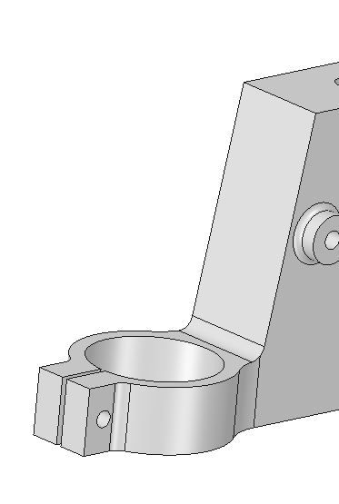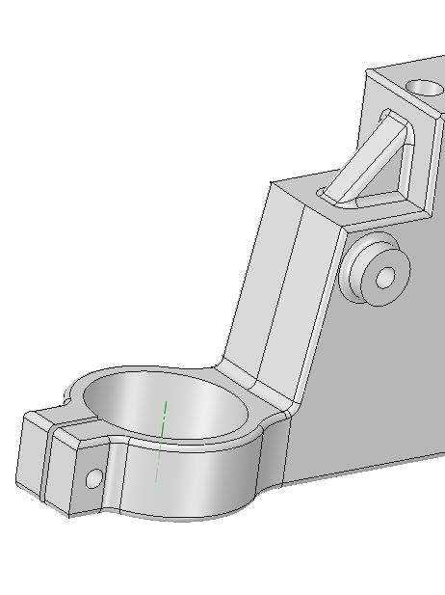
BEFORE AFTER
The first design change as seen above was to remove all sharp edges along the side of the sliding unit and replace them with radiuses, so that it can reduce the potential of defects. Sharp edges can form “unbalanced crystal grains”, which creates a “hot spot” that can induce a “mechanical weakness” at the corners, which interrupts the “free cooling”. This means it’s essential to add these radiuses in, as they will help in preventing these types of defects.
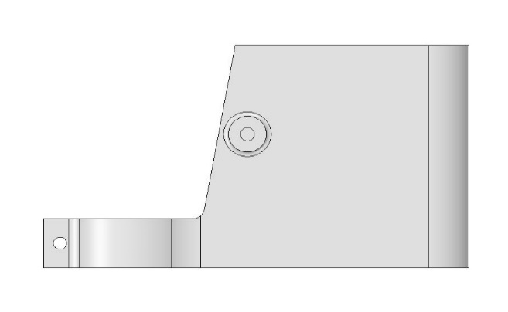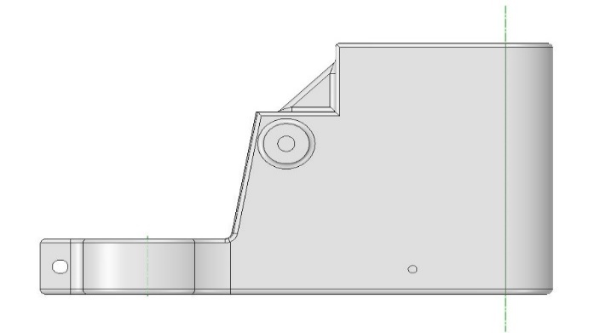
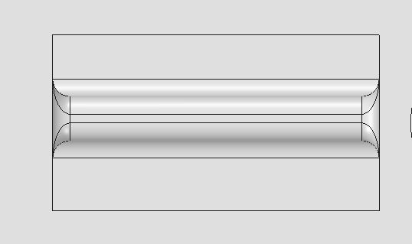
BEFORE AFTER
The changes above are ways of decreasing the mass of the sliding unit. As the bigger the unit the more the tooling and material cost will be. The conceptual design would weigh a mass of 2.4kg, while the redeveloped design weighs 1.8kg. Taking away material from the conceptual design that is not important is what helps bring down the mass. Ribs have been added as a level of support so that the new design is reinforced.

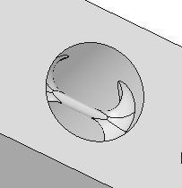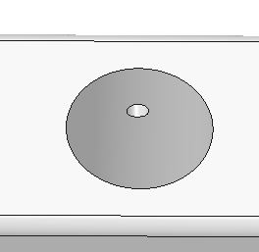
BEFORE AFTER
Rib has been removed as is would be difficult to create due to the small diameter and the large radius on the edges. Making a threaded hole of 3mm diameter a more viable option. As it is easier to add into the tooling, as well as being easier to use. A screw would be able to go through the part, and a bolt would hold it in place.

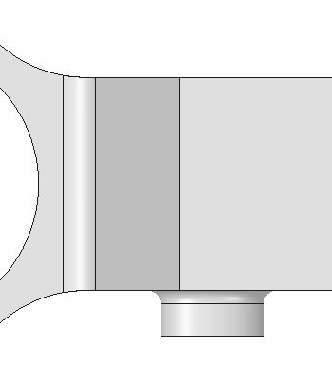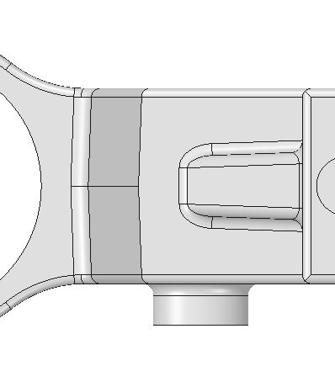
BEFORE AFTER
Added in a 2 degree draft as shown above. This is a way of improving the efficiency of removing the finished part from the tool. According to an article (RevPart, 2019) adding draft to a part has the following advantages;
- Reduces the chance of damage to the part due to friction during release
- Reduces wear and tear and chances of damage to the mold
- Ensures a uniform, smooth, unscratched finish when required
- Ensures the integrity and uniformity of other surface finishes and textures
- Reduces overall cooling time by lessening or eliminating the need for unconventional ejection setups
- Most, if not all, of these benefits offer either direct or indirect overall production cost reductions
These following reasons justify why it is important for an injection moulded tool to have draft in it.

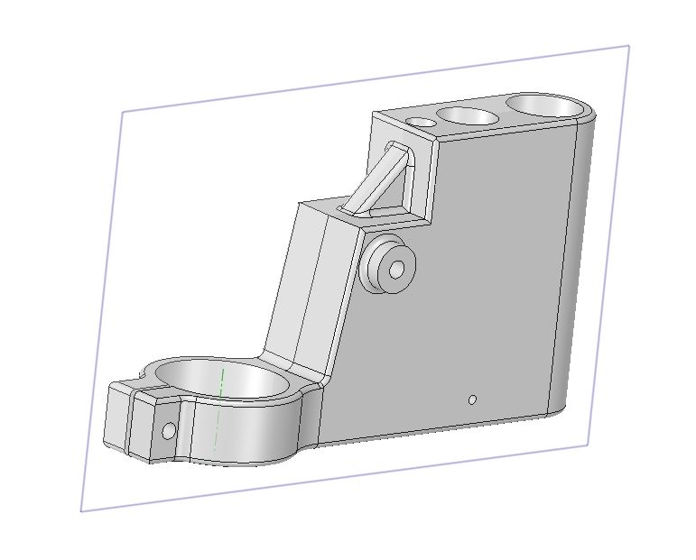
TOOL INTERSECTION POINT
The above image shows a plane going through the centre of the sliding unit, which represents where the tool will intersect.

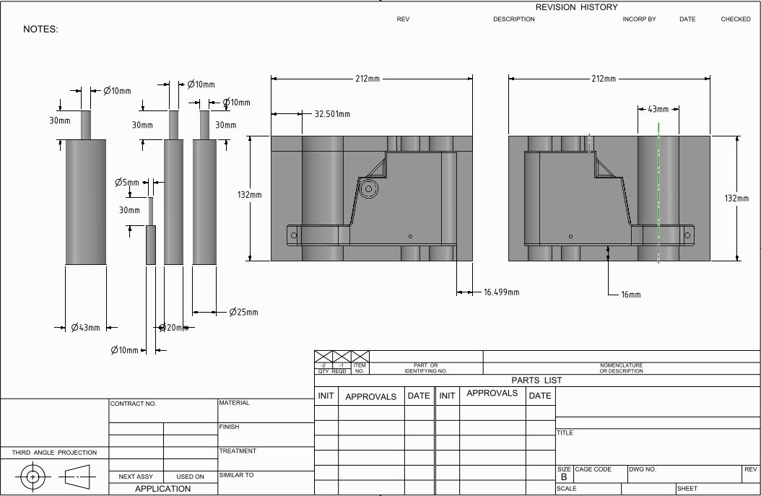
DRILL-PRESS MAIN SLIDING UNIT TOOL DRAWING
Drawing of tool with dimensions, that toolmaker would be given to make. The material used to create the tool will be mild steel, due to its low cost, high durability and resistance.

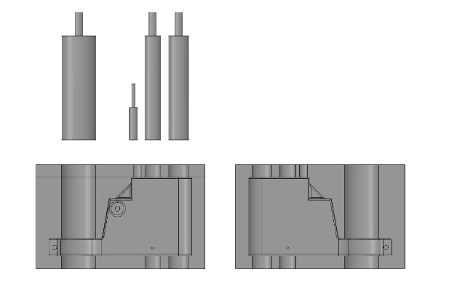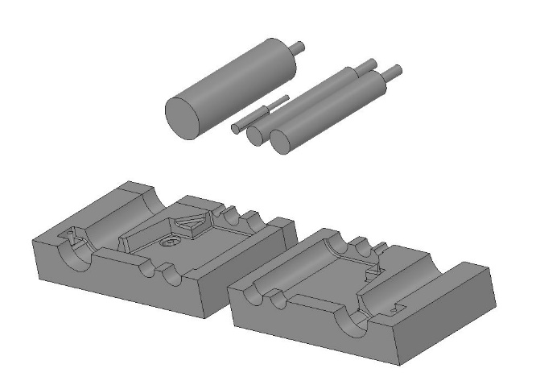

DRILL-PRESS MAIN SLIDING UNIT TOOL
Two images above show what the final tool would look like for the injection moulding process, with the polymeric material PVC filling up through the tool to make the final mould. Sliders will be inserted through the side of the tool, to complete the part.

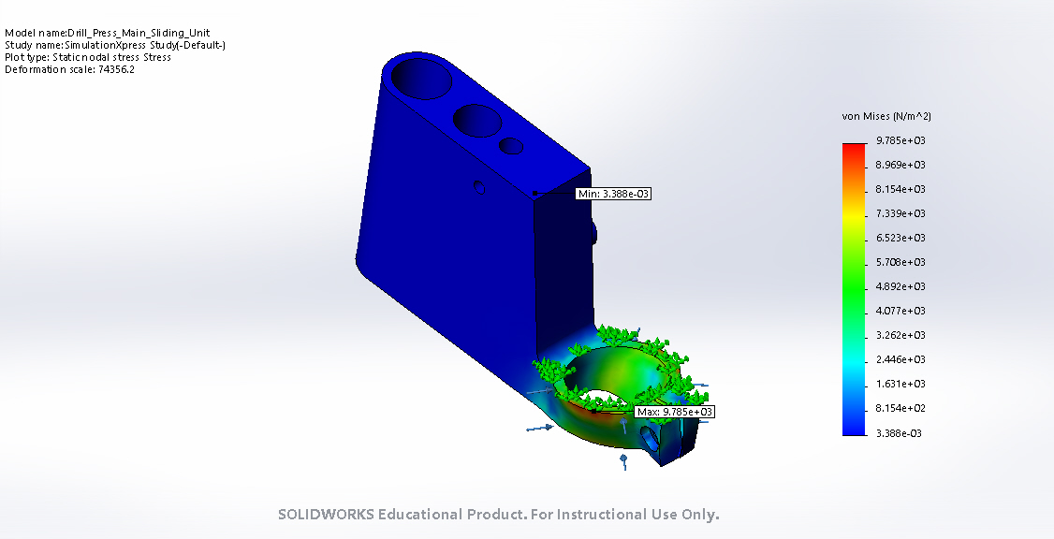
ORIGNAL DESIGN
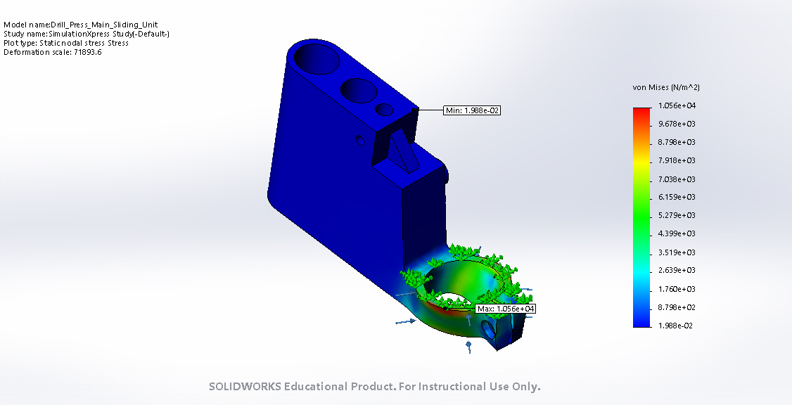
CONCEPTUAL DESIGN
After using the Solidworks simulation analysis to compare both the original and conceptual designs, it shows that the changes that have been made are suitable, without adding anymore stress into the part which may cause defects.

Conclusion

In conclusion the conceptual design for the drill press main sliding unit, has had a few modifications. The original design had positives, but also negatives which have all been stated in this report. These negatives prompted the different design changes to reduce the costing of the tooling and material, as well as any potential defects the part might have. Different polymeric materials where analysed such as Polyvinyl Chloride PVC, Polycarbonate and Polyamide (Nylon). After the analysis of the different materials, due to its strong resistance and durable properties, PVC can be argued to be the best suited material to use. As to make a thousand parts a week, the part must be durable enough to meet these targets and standards. The tooling manufacturing process was considered, looking into why for this particular component, injection moulding would be the most efficient method. This is due to it being cost effective, as only one component needs to be made. The tooling split line would be straight down the middle of the part, as the features would allow them to make it effectively, with only needing to add sliders to the side of the tool. The PVC would go into the tool and form the final mould of the new design.

Bibliography

3D Hubs, 2019, 3D Printing, Viewed 10th February 2019, https://www.3dhubs.com/advantages-3d-printing
Nano Mould Coating, 2019, Injection Moulding, Viewed 10th February 2019, https://www.nanomoldcoating.com/5-major-advantages-to-using-plastic-injection-molding-for-the-manufacturing-of-parts/
Woodruff, Jim. "Advantages & Disadvantages of Polymer Composites." Bizfluent, https://bizfluent.com/info-11370067-advantages-disadvantages-polymer-composites.html. 11 February 2019.
HP Polymers, 2019, Polymers, Viewed 14th February 2019, https://www.hardiepolymers.com/polymers/pmma-or-acrylic/
Atlas Foundry Company, 2019, Avoid Sharp Corners and Angles, Viewed 11th February 2019, http://www.atlasfdry.com/casting-design3.htm
REV Part, 2019, Draft Angles for Every Part, Viewed 14th February 2019, http://www.atlasfdry.com/casting-design3.htm

