Galina Kaeva
2019393
BMSW4005
Husam Alharahsheh
Proffesional Career development
Professional Career development report and role play (interviewee and interviewer)

Table of Contents
Introduction 2
Recruitment and Selection 2
Self-evaluation 6
‘SWOT analysis’ & ‘SMART objectives’ 7
Conclusion 9
References 9
Appendix: 10

Introduction

The career development that every employee strives for is the right direction of development. This is a process that provides the necessary skills through which career goals are easily achieved. The whole process can unite different actions and events from the professional life, such as: acquiring new knowledge, performing spilled actions, changing a job position, starting your own business. Career development is directly related to the goals that each employee sets. The first stage is related to self-assessment of the interests and abilities of the employee and continues with the acquisition of skills that are needed in the career path. Finally, after gaining competitiveness, the employee should effectively apply these skills to achieve his career goals. From this point of view, it is important for me to acquire knowledge over time, and the opportunity to stay relevant. Despite my young age, the training and the opportunities provided for my development in the profession I wanted helped me to acquire useful knowledge and skills. At the beginning of my twenties, a stage of research and self-examination regarding the choice of a position came for me. To a large extent, I formed an attitude towards work by meeting deadlines and commitments. On the other hand, I was still confused about my strengths and weaknesses. At the next stage I started my first job as an assistant in the management of a company for organizing events and celebrations. Undoubtedly, I made mistakes in marketing, but this helped me to be more responsible and start developing my competencies in this area. My ambition is to focus on my achievements so far and to improve my work performance in the future. I strive for creativity and innovation and taking on new work tasks and positions.

Recruitment and Selection

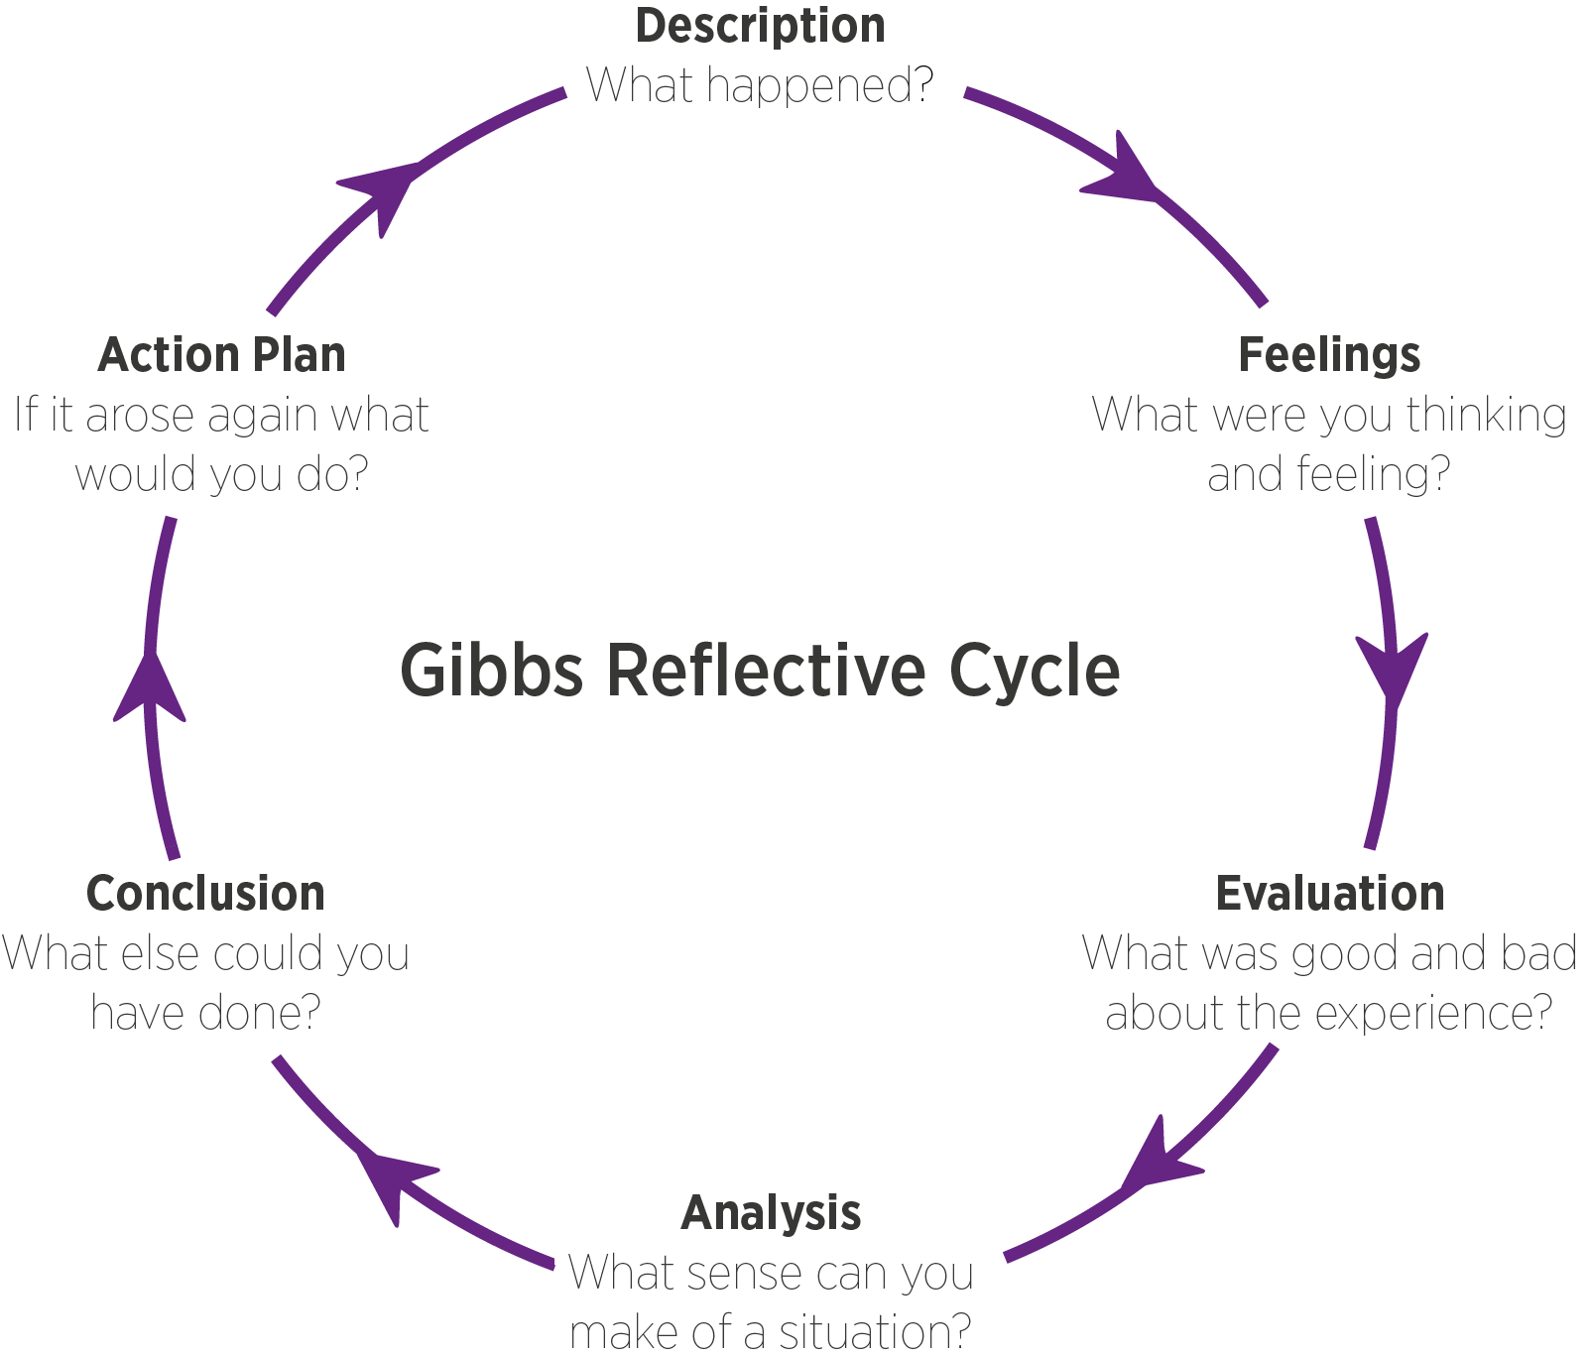
Reflection is a process of exploring and exploring ourselves, our views, attributes, experiences and actions / interactions. It helps us get an idea and see how to move forward. There are many different patterns of reflection. Reflection usually begins with a description of what happened, followed by what you already know about the situation, such as being aware of your own feelings to analyze the situation. Understanding all these factors makes it possible to recognize what has been learned and what changes need to be made for future situations (Brush, 2020). In this case, I used the Gibbs model from 1988 to analyze the situation from the role play and see what I could improve. The Gibbs cycle includes six stages: description, feelings, evaluation, analysis, conclusion, action plan.

Figure 1: Gibbs Reflective Cycle
Source: https://www.leaplikeasalmon.com/reflection-is-it-a-skill/

Role play as an interviewee

Description:
In the game of interviewer and interviewer, I played the role of interviewer as I had applied for the position of Marketing Assistant. In our game, the interviewer asked me five questions that I had to answer, and I was also entitled to one.

Feelings:
From the beginning I felt calm and confident and ready to start the interview, but when the interviewer greeted me and started asking me questions about my skills and previous experience, I felt scared and lost my confidence as this began to show gestures in my body language. and my speaking too.

Evaluation:
I think I was well prepared and confident. I was familiar with the new job, conditions, and culture of the company, but the bad thing about my personality is that I am worried and ashamed when I speak in front of new people or in public. This poor quality of mine can play a bad role for me because it is a sign of insecurity and indecision, which the employer would not like at all. One of the qualities of a Marketing Assistant is to be confident in decision-making, to be confident and to have good communication skills because he must talk to employees and colleagues.

Analysis:
This experience in the role play of the interviewee gave me the opportunity to consider my advantages and disadvantages and to think and decide to improve them. In this case, I need to work on my communication skills, such as meeting and communicating with more people. I think that one of the main factors of my insecurity and fear of new experiences is also due to not talking to new people and meeting. In this case, I need to improve this shortcoming by meeting and talking to them.

Conclusion:
Meeting and communicating with new people and friends would make me more confident and would also improve my communication skills which are a very important aspect of every life (both at work and personally).

Action plan:
Next time I will approach with more confidence because I will have improved my shortcomings. When the interview starts, I will be more confident, and I will be able to answer them calmly and confidently.

Role play as an interviewer

Description:
In the game of interviewer and interviewer, I played the role of interviewer. In our game, I had the right to ask him five questions to find out if the person applying for the position was suitable.

Feelings:
In my position as an interviewer, I felt responsive, open to conversation and answers. I thought that I should keep my composure and predispose the candidate to feel in a calm environment and confident to talk about himself.

Evaluation:
I think that the interview went well, I was able to ask the necessary questions to the candidate about the time we had and I was able to understand everything important for him and his experience in this field.

Analysis:
This experience in the role play of an interviewer helped me to improve my leadership, communication skills, ability to motivate others. I have acquired important qualities of a leader. Which would help me in my future work as a manager.

Conclusion:
Practicing role-playing games or activity manages to help build some personal and professional skills.

Action plan:
I don't think I have anything to change next time, as I think I did well.

Self-evaluation

People often gain a preference for the desired profession through different learning experiences and act using scientific skills (Gikopoulou, 2008). Decisive is the inner motivation, which requires a lot of discipline and determination. Self-motivation is the connection between goals and achievements and enthusiasm to achieve a goal without the influence of others. From this point of view, when I am more motivated, I feel ready to achieve my goals. Motivation is important to me because it leads to improving the quality of life positively (materially), ie achieving a prestigious job. In addition, personal inner motivation in my career is important to me, which is based on personal challenge and interest in achieving goals, because the profession I have chosen is as exciting as it is responsible and satisfying for me. In addition to career motivation, training is also important. All people learn throughout their lives. By learning, we gain experience and build our strengths in our careers. According to David Kolb, the acquisition of new knowledge is acquired through experience. However, everyone learns differently. In this case, the position of Marketing Assistant would help me gain new knowledge by gaining experience in this environment to reach the position of Manager. Training is an important stage in the long-term development of the workplace and is a continuation of the employee's earlier education. Training is a stage in which people express their ideas and thoughts (Neugebauer and Evans-Brain, 2016). There are several personal learning styles published in 1986 and are known as Honey and Mumford learning styles.
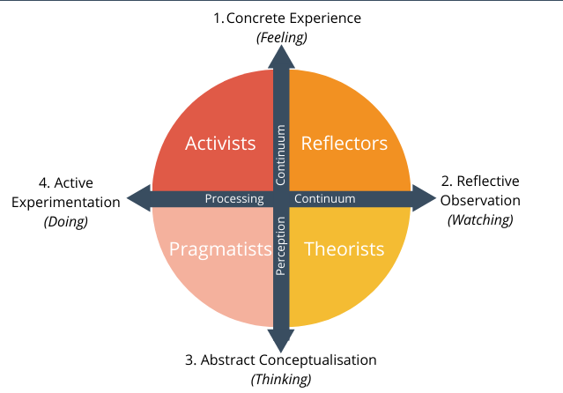

Figure 2: Honey and Mumford Learning Styles
Source: https://expertprogrammanagement.com
Depending on how we want to learn, based on the four learning styles, we create a foundation for our learning skills. Honey and Mumford's teaching styles are based on Kolb's work:
Activists - employees learn through active participation in specific tasks. These tasks are relatively short-term.
Spotlights - employees usually learn by watching, thinking, listening, thinking.
Theorists - employees learn new situations poetically but have to connect them with the theory.
Pragmatists - pragmatists learn by connecting new information and real-life problems. Pragmatists usually like techniques that they can apply immediately (Neugebauer and Evans-Brain, 2016).
It is customary for employees to use one or at most two of these learning styles. In this case, my training style is based on Employee Activists, as I have taken on specific tasks for relatively short lead times. For example, making a poster for an event. On the other hand, I have often used the training of reflectors, listening and watching a task. But in many cases this was not useful for me because the practice is more efficient because I have often received feedback from my employer to eliminate shortcomings in the task.

‘SWOT analysis’ & ‘SMART objectives’

SWOT analysis is an extremely useful tool for any employee to understand different situations and make decisions. The model was created by Albert Humphrey, with the help of which the mistakes and failures in the strategic planning of the business can be better understood. SWOT analysis is also useful for employees in terms of analyzing the personal strengths and weaknesses in the professional skills that employees have. SWOT analysis is a method of strategic planning used to assess strengths and is particularly useful in identifying areas for development. If one of the goals is not achievable, another goal must be chosen (Moniz and Bishop, 2016). In this case, I have analyzed my personal qualities to improve or use to the benefit of my professional career development.

Straights
- Good organizational and time-management skills
- Motivation skills
- Computer and technology skills
- Hard Working
- Creative
- Positive
- Struggle for improvement

Weaknesses
- Professional experience
- Education
- Problem-solving
- Communication
- Team-working

Threats
- Competitions
- New technology
- Consumer preference

Opportunities
- Work experience
- Opportunities for learning in workplace
- Competencies
- Listening and comprehension skills
- Working in team

Based on this SWOT analysis, I was able to extract a list of different ideas to be transformed into specific goals (SMART goals, n.d.). The connection between my strengths and opportunities turns out to be the most beneficial for possible career development. Based on my strengths and existing capabilities, I can plan my actions to get a favorable result. On the other hand, weaknesses set clear ideas on how to neutralize them. Opportunities can eliminate some of the threats. For example, training and development opportunities in my workplace can eliminate the threat of competition I face. On the other hand, due to my strengths, some of the threats may be neutralized. For example, motivation and diligence can eliminate the threat of the introduction of new technologies. Since the combination of my weaknesses and threats leads to a high risk for me, the correct assessment of this risk is crucial. If the risk is low, the threats can be ignored, but if the risk assessment is high, then I should plan actions to neutralize my weaknesses, such as: the need to increase my education.

SMART goals are important for achieving high results in the professional development of the employee. Without clear goals, there is no way to determine future results, and vague goals lead to unclear results. In this case, I have clearly defined the goals through which I can expect concrete results. Goals must be concrete and measurable, accepted, realistic and timely. It is not difficult to set smart goals, but it is a challenge to achieve them. Goals are a part of every person's life and provide a sense of direction, motivation, clear focus. By setting goals, I provide a goal to pursue (Smart Goals, n.d.). Of course, smart targets should not be easy as they will be less effective. Rather, my goals are realistic and achievable, and completely feasible. This will help me develop my potential and skills.

S | M | A | R | T
- Acquisition of knowledge and skills in marketing.  - My goal is to become a Marketing Manager. | - I will know when I have achieved my goal by measuring. | - Once someone else has reached their goal, so can I. | - Step by step, or in other words short-term goals will take me to the main goal. | - I will reach the set goal within a certain period of 4 years.

Conclusion

The doctorate focuses on personal reflection on role play and career planning. The personal reflection from the role play was done with the help of the Gibbs reflection model, going through all the steps of the model. Career development planning was achieved using various activities such as self-assessment, SWOT analysis and Smart objectives.

References

- Brush, K. (2020) Model of reflection. Available at: https://whatis.techtarget.com/definition/model-of-reflection Accessed: 8th of January
- Gikopoulou, N. (2008) Report on Effective Career Guidance. Socrates
- Moniz, K. and Bishop, T. (2016) Principles and Techniques of Marketing Management. United State: College Publishing House
- Neugebauer, J. & Evans-Brain, J. (2016) Employability: making the most of your career development. London;: SAGE.
- Smart Goals (n.d.) Available at: www.oratefinanceinstitute.com Accessed: 21st of November

Appendix:

Job Application Form:
https://d.docs.live.net/b75b595be747b30b/Документи/Proffesioal%20career%20development/PCD%20-%20JOB%20APPLICATION%20FORM.pdf
Answers given to the interview:
https://d.docs.live.net/b75b595be747b30b/Работен%20плот/Answers%20to%20the%20questions.docx

