University of Wales TSD
Collins Festus Anieke
Student ID: 1707647
Lecturer: Gladius Kulothungan
Date: 8/08/21
LCMB7000
MBA Human Resource Management
Assignment 2
Table of Contents:
Introduction…………………… Page 1
HRM strategies for change management:
Strategy …………………………….Page2:1
Structure …………………………….Page 2:2
System ………………………………..Page 2:3
Skills ………………………………………...Page 2:4
Staff ……………………………………….. Page 2:5
Style ……………………………………....... Page 2:6
HRM strategies for Staffing Retention:
Sub Heading: (Engagement Strategy)
Recognition and Reward ………………………. Page 3:1
Recruiting the Right Employees ………….. Page 3:2
Good Employee Touch point ………………..Page 3:3
Continuous Improvement …………………….. Page 3:4
Impressive Workplace Culture …………………… Page 3:5
Attracting incentive …………………………………… Page 3:6

HRM strategies for Leadership Development:
Assessing and identifying talents ……………… Page 4:1
Determine the key Leadership competencies ……………… Page 4:2
Identification of Leadership style……………………. Page 4:3
Leadership Development plan …………………………… Page 4:4

Having defined human resource management in the previous assignment 1, it is pertinent to define it again based on different concept accountable to its empirical diversity of understanding thus: it can be defined as the process through which management builds the employees and tries to generate the human performances that the organisation needs according to (O'RIORDAN, 2017) The assignment will be in report format and it is going to discuss human resource HR strategies for “Change Management, Staffing Retention and Leadership Development” and each of these topics will be discussed in full together with the principles, models, concept, the current human resource management HRM and International human resource management IHRM theories. There will be conceptual framework of human resource management HRM discussed in this report and how a good HR system can make it possible for an organisation to have competitive advantage. Apart from the discussion of the chosen topics as required by the assignment, there will be an extensive research of the subject to expand on hypothetical theories of human resource management HRM such as the goals of HRM, the human resource function in an organisation, the consequence of bad human resource management in an organisation, human resource strategic system, the stages involved in formulating human resource strategy, human resource system and strategies.
HRM Strategies for Change Management
HR system consists of three important elements such as strategies, policies and procedures. Many organisations have numerous discreet human resource practices for example; employee well-being, employee development, pay and reward etc. and these practices have no clear or discernible links which means that they are not generic to all organisations (JOANNA, 2017) however; one thing is generic about human resource management, when an establishment want to improve people’s performance, there will be need to develop HR strategy and set out what the organisation is supposed to do in order to revamp the current human resource policies and revamping the current HR policy enables the organisation achieve the set business objective. Although, human resource strategy may exist in some establishment without deliberate attempt or anything written down, it can just exist in collective mind of relevant people which is very precarious however; in most cases, establishments rise to matters where they have control of their strategy and plan and this is the need for human resource strategy for change management (JOANNA, 2017)
Change management occurs when an organisation want to develop HR strategy in order to improve employees performance. At this point, it is imperative to define change management and align the meaning with HR strategy thus: change management can be defined as a realistic observation in an establishment entity of variations in shape, quality or state over time (Jalagat, 2016) an organisation must be able to identify through the HR system the area of employees performance that needs improvement and doing it requires the ability to differentiate between “Hard and Soft areas of the HR system for example; Strategy, Structure and System are hard areas while Skills, Staff and Style are soft areas.
Strategy | Structure | System== Hard areas
 | Shared Value
Skills | Staff | Style== Soft areas

Strategy:
A developed plan that can sustain competitive advantage for a long period of time reinforced with strong mission, vision, and value and aligned with six other elements of this model (Jalagat, 2016)
Structure:
This reveals the organisational chart of the establishment where it identifies departments with the corresponding assignment. Then accountabilities and hierarchy of the organisation are under the structure that the HR system may need to revamp in order to achieve cohesion and set business objective (Jalagat, 2016)
System:
The method of implementing the work contents as well as the pattern of decision making and decision making requires a lot carefulness and tactful approach to avoid negative discernible outcome. The process and procedure may need re-organisation if the current system is not suitable to the test of time (Jalagat, 2016) for example; in Medway Hospital Kent, it used to be a clinical requirement to record the result of vitae signs manually after checking but the system has been digitalised and now requires the data to be recorded in the computer gadget for easy access.
Skills:
This is about the employees’ abilities to carry out the responsibilities assigned to them. In the process of change management, the human resource manager needs to re-evaluate the workers abilities to determine if there is need to re-skilling and re-training to reinforce the new strategy and in determining the employees’ roles it is important to consider the capability of each person (Jalagat, 2016)
Staffing:
The element of staffing in organisational change defines the issue of workforce in terms of the level of productivity if it can be achieved through recruitment, training, motivation or reward. The issue of workforce is very important because it is one of the pillars of an organisation and motivation can be intrinsic or extrinsic to inspire the employees (Jalagat, 2016)
Style:
In the context of change management style means the approach of leadership adopted by the top level managers that impacts the performance of the entire establishment. However; the approach can be top down but there is need for good communication line that allows flexibility so that there will be no blind spot. In the course of organisational change to boast the employees performance, it is important there is shared values in place which aligns with the models and standard of the organisation that enhance employees good behaviour (Jalagat, 2016)
The purpose of organisational change is to improve the performance of employees for competitive advantage, so there are a number of benefits:
- Managing organisational change ensures quick response to customer’s demand
- It can enhance customer journey and improved customer touch point
- Change can take place without affecting the organisation’s everyday routine unless it is a radical
- Organisational change does not automatically guarantee leverage in competition but it give the firm an opportunity of knowing new competitors and what needs to be revamped.

HRM strategies for Staffing Retention
There is no generic method for employee retention in organisations since there are different organisational and workplace culture and the purpose of employee retention is to effectuate an effective workforce as well as actualising the operational requirement (Ferreira, 2017) Employee retention is a major challenge to firms in this 21st century because of many reasons ranging from the consequence of downsizing, political issues and economic factors however; staff retention is subject to dependent and independent variables which means there are triggering factors for the employee retention so; this aspect of assignment concentrates on investigating and analysing the suitable staffing retention as a HR Manager in an organisation therefore the under stated strategic model can be applies for staffing retention:

Engagement Strategy
Recognition and Reward | Continuous improvement
Recruiting the right employee | Impressive workplace culture
Good employee touch point | Attracting incentive

- Recognition and Reward
Appreciation makes employees work harder and fulfilled to stay longer on the job and not doing so demoralises the employee for example; in the context of US employment sector, over 80% employees feel not recognised and rewarded (Achievers, 2021) Lack of recognition or reward is detrimental to collective and single productive output. According to Brando Hall Group, the companies that recognise employees multiple times a month are 41% more likely to experience increased staff retention and 34% more likely to enjoy employees engagement on the job (Achievers, 2021) Comparing this assertion with personal experience with National Health Service NHS there is no contention to believe that a lot NHS staff switch over to Agency because of the Government inability to recognise and reward primary health care workers.
- Recruiting the Right Employee
Recruitment needs to be thorough in order to select those who really desire and want to be inspirational to others for example; the employee selling themselves must merit to be sold to your company. There is need to position a company work environment in a way to attract the best for example; intrinsic or extrinsic leave policies or onsite fitness centres, though this has to be within the financial capacity of the company. In some cases the best candidates do not come automatically from the so called Ivy League of school if there is no tacit or embedded experience therefore; there is need to engagement professional groups or community career offices to help and select the candidates with suitable and practical experience for the job role.

- Impressive workplace culture:
Workplace culture plays an important role to attract and retain workers and as an instrument of retention, every HR manager needs to consider improving it from time to time for example; workplace culture can be the condition for permanent contract, maternity and paternity leave or sick leave etc. It is been revealed according to “Glassdoor” that 77% workers consider a company’s culture before applying and neatly half workers can swap to other organisation because of amazing workplace culture therefore, with good workplace there is likely to be a cordial relationship that can pave way for the attraction and retention of best talents (Achievers, 2021)

- A good employee touch point
Employees feel comfortable and willing to stay longer than expected at a company if there is good on boarding experience from the beginning (Achievers, 2021) for example; helping new employees shift from outsider to an insider from the first day is an everlasting positive employee journey capable of conducive atmosphere. Being concise in explaining the step by step job roles is better than inundating new employees with too much information that can cause anxiety from the beginning and it is necessary to ask the new employees for feedback as this would help the HRM assess the on boarding experience that can re-shape employee touch point.

- Continuous improvement:
An employee is part and parcel of an organisation in terms of understanding and implementing policies that enable the achievement of the business set objective. This measure is to protect the organisation against the changing world that necessitates the need for continuous improvement. The purpose of continuous improvement is to increase productivity which can increase or stabilize the financial capacity of the organisation to retain employees. One of the several causes of labour productivity slowdown has been mentioned and pin pointed to lack of continuous improvement of employees for example; not knowing how to use the latest technology etc. (Kollenburg, 2019)
Attracting incentive:
Incentives are means of acknowledging employees’ impressive work. Generally, greater percentages of workers are motivated when incentive is offered so it is a strategy of retention and motivation that can result in stable or increased output. However; there is need to make sure that the compensation is appropriate for example; gym membership, referral programs or tuition reimbursement and lack of incentive demoralises workers while the revise is capable of making workers stay longer at a company (Achievers, 2021)

HRM strategies for Leadership Development:
Human resources management for leadership development and people resourcing aims at the plan of employment, retention, and professional development practices of employees and the effective execution of the strategic organization process (Dimitrios, 2017) Considering the exigency and the dynamics of human resources management, it cannot be separated from leadership development especially for people resourcing for example; during the Greek economic meltdown, there was a shift within the tourism industry that demanded change management strategy for high quality service in order to gain competitive customer service advantage over the high ranking positions globally. In order to achieve competitive advantage over the high ranking positions and improvement of performance which is the tenet of HR, a number of hypothetical strategies stated underneath can be implemented.

- Assessing and identifying talents
Since the core mandate of HR managers is to assess, identify, select and develop employees who have the potentials of contributing to the achievement of organisational set of business objective, making use of talent pool through assessment and identification can be of help in people resourcing for example; National Health Service NHS has graduate management scheme conducted annually and continuous improvement programme to identify potential graduates for management positions and using the latter to develop employees for organic growth. This strategic leadership development gives the human resources team members the opportunity to identify potentials and be able to manage the business strategies.

- Determine the key leadership competencies

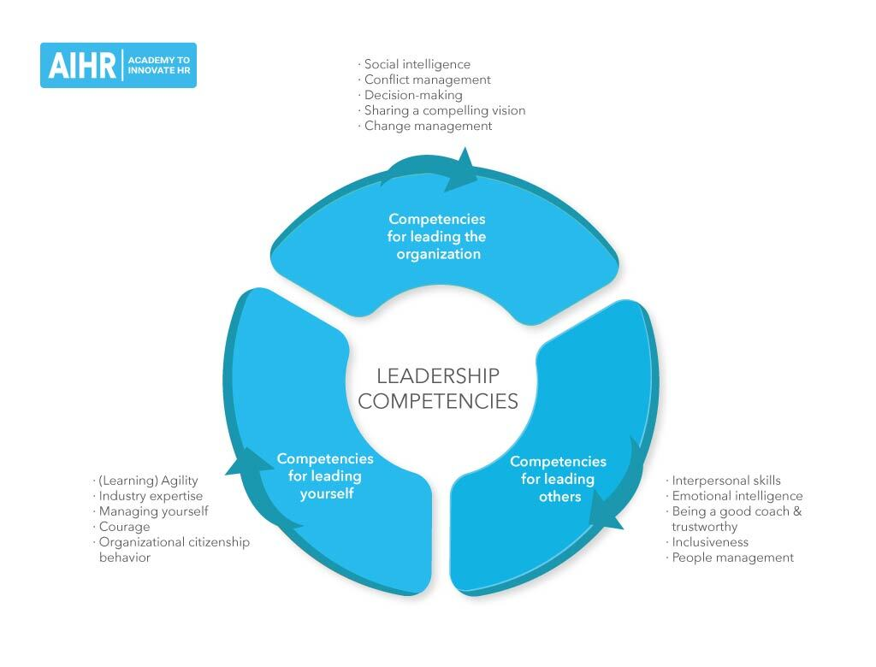
Source of this diagram(AIHR DIGITAL)

It lacks no credence to believe that identifying the key leadership competencies required for an organisation’s immediate and long term success is essential to embark on feassible leadership development strategy and these competencies are the panacea for the preparation of next generation to tackle future challenges. Determining the key leadership competencies will always help the HR team manage different individual skill proposition and valuable to ths organisation in terms of remodelling the current set of business objectives.

- Identification of Leadership style:
It is unequivocal that an organisation’s vision and mission form the basis of the leadership sytle and any establishment without leadership syle is sitting on the cliff eadge. Identifying the leadership syle of an organisation helps to build capacity and decide who fit into the perking order. However; the leadership syle of an organisation must not be the opposite direction in terms of the firm’s workplace culture for example; there are many leadership sytle ranging from Autocratic, Democratic, Coaching, Laissez Faire, Authoritative, Pacesetting, Affliative or Transformational however; any chosen sytle must conform to the workplace culture and it is capable of making an organisation determine the external organisational culture to expunge (Gardner, n.d.)

Leadership Development Plan: 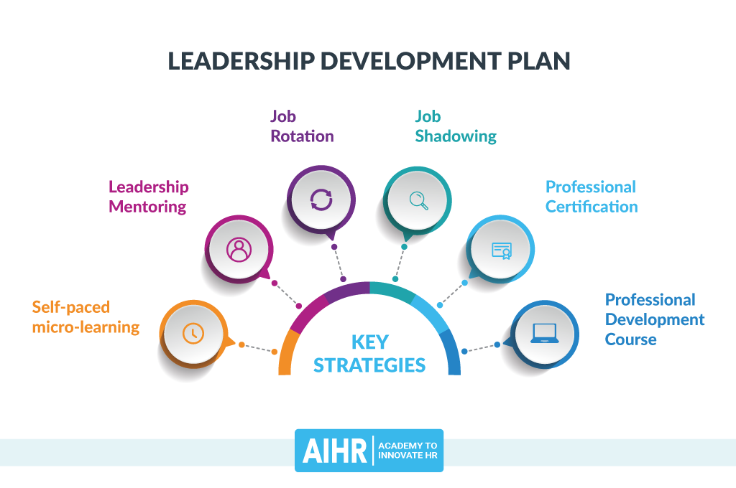

Source of this diagram (AIHR DIGITAL)

It is worth while as a strategy for leadership development to consult the learning and development of an organisation because it helps to develop appropriate learning and development opportunities for the staff however; there are a number of learning and development that can be incorporated for example;

- Self-paced Micro-Learning: With the self-paced-micro learning, an individual can learn using internet provision for example; linkedIn or Google Search engine.

- Leadership Mentoring: This is complementary leadership that is required in terms shared value of the strong leaders where the potentuial leaders are weak for example; a Mentor who is strong and competent in the areas of the Mentee weakness.

- Job Rotation: The employee assumes new role after a short period of time in order to have embedded knowledge of different activities.

- Job Shadowing: This is to enable the employee get realist view of the activity is conducted through watching those who are mastery on the job.

- Professional certification: The employee may need to get personal training in order to have a lead to the job.

- Professional Development course: This is all about training the employee to get the skills for a particular job role (Gardner, n.d.)

Tasks facing the design of leadership development strategy:
- Insifficient resources and allocated time
- Lack of commitment or learning culture in an organisation
- Inability to make skills development early enough to satisfy the prevailing skill need
- Lack of change management solution that result in bad leadership (Gardner, n.d.)

Conclusion:

Though, HRM requires change management as an emergent strategy to solve future work related issues, such management method should bring postive changes. Furtghermore, it is imperative for HRM not to concentrate only re-skilling as a means of deciding staff rention so there is need to considering different individual proposition and leadership development is very essential to enhance transferable skill.

Reference Lists
Achievers, 2021. 9 Employees Retention Strategies for Keeping Best Talent. Employee Retention, 30 March.
Dimitrios, B., 2017. Human Resource Management, Strategic Leadership Development and the Greek Tourism Sector. Researchgate, February.pp. 189-205.
Ferreira, N., 2017. Career Meta- Capacities and retention factors of recruiting advertising agencies: An exploratory Study. Journal of Psychology in Africa, 27(5), pp. 405-411.
Gardner, R., n.d. 7 Steps to create Leadership Development, s.l.: AIHR DIGITAL.
Jalagat, R., 2016. The impact of change and change management in Achieving Corporate Goals and Objectives: Organisational Perceptive. International Journal of Science and Research, 5(11), pp. 1233-1239.
JOANNA, O., 2017. The practice of human resource management, s.l.: IPA.
Kollenburg, T. V., 2019. The future of contiuous improvement. European Lean Educators Conference;, 9 May.
O'RIORDAN, J., 2017. The practice of human resource management, s.l.: IPA.
Zahoor, A., 2015. Impact of Human Resource Management Practices on Employee Retention in Telecom Sector of Pakiatan. Journal of Resources Development and Management, Volume 12, pp. 2422-8397.

