

How do high profile policing incidents impact on the public’s trust and confidence in the police service?

Name of student: Lauren Richards

Student number: 2222319

Degree title: BSc (Hons) Professional Policing Practice.

Word Count: 8,260

Acknowledgements
I want to sincerely thank UWTSD for offering a stimulating environment that supported my academic development. My sincere gratitude goes to my tutor Deepak Patel, whose guidance was highly appreciated during this process.
I want to thank my wonderful friends Ffion, Sophie and Kira, for helping me along the way. My motivation has been your faith in my abilities and unwavering support. Finally, I want to thank my family for always supporting and encouraging me to work hard, and this is demonstrated in this dissertation.

Declaration

This work has not previously been accepted in substance for any degree and is not being concurrently submitted in candidature for any degree.
Signed: L.Richards
Date: 02/06/25

STATEMENT 1
This dissertation is being submitted in partial fulfilment of the requirements for the degree of BA.
Signed: L.Richards
Date: 02/06/25

STATEMENT 2
This dissertation is the result of my own independent work/investigation, except where otherwise stated.
Other sources are acknowledged by footnotes giving explicit references. A bibliography is appended.
Signed: L.Richards
Date: 02/06/25

STATEMENT 3
I hereby give consent for my dissertation, if accepted, to be available for photocopying and for interlibrary loan, and for the title and summary to be made available to outside organisations.
Signed: L.Richards
Date: 02/06/25

STATEMENT 4
I hereby give consent for my dissertation, if accepted, to be available on the university’s IT system to those who have consent to use the system.
Signed: L.Richards
Date: 02/06/25
Abstract
This dissertation explores the relationship between high-profile incidents and public perception. A thorough critical evaluation of the literature revealed evidence of the detrimental effects of media attention, the dissemination of false information, and the way emergency services particularly the police service – respond to high profile incidents, and the public’s perception following such incidents. This study will focus on the media’s portrayal of police actions, public’s perception on the police service from a variety of demographic factors, social movements, and whether changes in policy and reform impact public perception.
A self-report survey was used to identify whether members of the public’s perception alter as a result of high-profile incidents in their communities, or as a result of witnessing such events through media outlets. The aim is to understand not only the immediate impact of such incidents, but also the long-term consequences on police legitimacy and community relations. This work will contribute to the wider discourse on policing accountability and transparency, offering recommendations for how the police service can effectively rebuild trust following public controversies.

Table of Contents
Chapter 1 - Introduction .7
1.0 Introduction………………………………………………………………………………………………………..7
1.1 Background……………………………………………………………………………………………………..…7
1.2 Rationale……………………………………………………………………………………………………………8
1.3 Aims and Objectives…………………………………………………………………………………………….9
1.4 Research Structure………………………………………………………………………………………………9
1.5 Conclusion 10
Chapter 2 - Literature Review 11
2.0 Introduction 11
2.1 How does the media’s potrayal of police actions influence public perception, trust and confidence? 11
2.2 Do public perceptions vary based on demographic factors? 13
2.3 How has social movements and high-profile incidents shaped public discourse on policing? 15
2.4 Is changes in policy and reform important, and does it impact on public perception? 16
2.5 Conclusion 17
Chapter 3 - Methodology 19
3.0 Introduction 19
3.1 Purpose of the study 19
3.2 Research design (Qualitative vs Quantitative) 20
3.3 Data collection methods 20
3.4 Ethics 21
3.5 Limitations 21
3.6 Conclusion 22
Chapter 4 - Data Analysis and Findings 23
4.0 Introduction 23
4.1 Data Analysis 23
4.2 Findings from research questionnaire 24
4.2.1 Participant Demographics 24
4.2.2 Impact of high-profile incidents 24
4.2.3 Media Influence 26
4.2.4 Perceptions of accountability and reform 27
4.2.5 Qualitative responses and Thematic insights…………………………….…………………………28
4.3 Conclusion 29
Chapter 5 - Conclusion and Recommendations 30
5.0 Introduction 30
5.1 Achievement of Objectives 30
5.2 Main Findings 31
5.3 Recommendations 33
5.4 Future research and limitations 34
5.5 Conclusion 35
Bibliography 37
Appendices 41
Appendix A – Participants information sheet regarding the study 41
Appendix B – Notice board message 42
Appendix C - Consent form 43
Appendix D – Copy of questionnaire and results 44
Appendix E – Application for ethical approval 52
Appendix F – Research proposal form………………………………………………………………………...65

Chapter 1 – Introduction
1.0 Introduction
The purpose of this chapter of the dissertation is to investigate the extent to which public trust and confidence are impacted by high-profile incidents. It will examine how the police are viewed by the public in the South Wales area. It will focus on how perceptions are influenced by a variety of factors, such as media coverage, the significance of policy changes and misconduct hearings and how they affect public opinion and whether perceptions differ depending on demographic and socioeconomical characteristics. This chapter will also summarise the goals and objectives of the dissertation and provide background information and justification for the investigation.

1.1 Background
In recent years, high-profile incidents involving the police have garnered widespread media attention and prompted critical public discussion surrounding police conduct. These incidents, widely disseminated through traditional news outlets and social media platforms, have the potential to significantly influence how the public perceives the police, both in terms of legitimacy and trustworthiness. Studies conducted have found that media coverage of police misconduct could be a key driver of negative sentiment of the public towards the police, whereby increased media coverage affects the volume of public discourse. (Succar et al.,2024)
Events such as the deaths of George Floyd in the United States and more local controversies involving UK police forces have intensified scrutiny towards the police. An example of this is the murder of Sarah Everard by serving Metropolitan Police Officer Wayne Couzens. This case raised substantial concerns regarding police recruitment, resulting in reviews of the police vetting process which highlighted significant issues regarding institutional misconduct among police officers. (hmicfrs, 2022)
Recent high-profile cases as forementioned, have led to a significant loss of trust among certain communities in the UK towards the police. This decrease in trust has extensive implications for public safety, police effectiveness and social justice (Helpline, 2023). The institute for government suggests that a deterioration in attitudes towards policing is likely to be linked to highly publicised cases of misconduct among police officers. Recent news stories were also likely to have impacted public opinion regarding policing and police accountability. (Tudor, 2023)
Trust and confidence from the public is fundamental. Trust improves the moral connection between the public and the police, which encourages greater participation and a more active public engagement. Studies show that if the police demonstrate effectiveness, fairness and alignment with local interests it makes them more accountable. (Jackson and Bradford, 2010). National and international incidents involving police has shown to cause reputational damage, it is therefore important to understand how such high-profile incidents affect local perceptions in the UK, specifically of South Wales Police.
This research explores the connection between policing incidents and public perception at local levels across South Wales. By delving into how media coverage of high-profile incidents affects public perceptions, it aims to comprehend not just the degree of trust but also the underlying attitudes, and awareness of high-profile incidents that occur involving the police. It also highlights the implications such incidents have on members of the public regarding topics such as violence against women, racism and misconduct among police officers.

  - Rationale
While many studies have focused on public trust in the police, only few have delved into how certain high-profile incidents, especially ones unrelated to their local area, affect public perceptions. Given the distinct blend of South Wales’s urban and rural areas, socioeconomic diversity, and wide range of demographic characteristics. South Wales offers an appropriate case study this investigation.
This study is significant for several reasons. Firstly, it provides information about the indirect effects of highly publicised incidents on areas of South Wales that might not be directly impacted but have reputational consequences. Secondly, it adds to current studies regarding trust and confidence in the police, police misconduct and media influences. Thirdly, the study provides recommendations based on the views of South Wales residents, amplifying public perceptions at a local level. Lastly, the findings hope to contribute to both academic understanding and policymaking developments.

  - Aims and Objectives
The aims and objectives of this dissertation are intended to guide the study into how public trust and confidence in the police force are impacted by highly publicised policing incidents. The goal of the study is to comprehend how these incidents affect perceptions, particularly within the South Wales area.
This will be achieved by completing the following objectives:
- To determine levels of trust and confidence South Wales residents have in the police.
- To assess if high-profile incidents have an impact on the public’s perceptions towards their local police.
- To examine how media coverage shapes opinions and perceptions of the police.
- To investigate public perceptions of police accountability and the necessity of policy reforms.
- To determine recommendations for improving policing’s transparency and sense of confidence.

  - Research structure
This dissertation is organised into five chapters. The chapters help readers fully comprehend the dissertation’s question:
Chapter 1 – Introduction: Provides background, rationale, research aims and structure.
Chapter 2 – Literature Review: Reviews the literature on the effects of misconduct on public opinion, media influence, police legitimacy and trust.
Chapter 3 – Methodology: Outlines the research design, including sampling methods, ethical considerations and data collection tools.
Chapter 4 – Data Analysis and Findings: Presents quantitative and qualitative results from the survey, including statistical trends and patterns.
Chapter 5 – Discussion and Conclusion: Highlights findings in relation to the literature, identifies limitations, and suggests recommendations for policy and further research.

1.5 Conclusion
This chapter provided an overview of the study’s background and importance, the chapter highlighted the necessity and rationale of researching how public trust is affected by high-profile police incidents, specifically in the South Wales area. It lays the foundation for the subsequent chapters by describing the aims and objectives, and organisation of the dissertation. The following chapter will examine the research, critically analysing the main theories and arguments related to the public’s trust in the police force, police legitimacy as a whole and the media’s influence on public perceptions.

Chapter 2 – Literature Review
2.0 - Introduction
The aim of this literature review is to examine how high-profile incidents can affect the public's trust and confidence in the police force. A literature review is crucial for displaying the expertise and comprehension of the literature on a particular subject, it displays a demonstration of knowledge and understanding of specific topics. (University of Edinburgh, 2024). This literature review will be conducted using a variety of research methods, such as the Google scholar search engine, and the UWTSD Library database.
The review explores media coverage, and the disparate effects on demographic groups. It will also delve into the tactics used by the police force to lessen reputational harm and restore trust. The review aims to give a thorough grasp of the methods used when high-profile incidents undermine public trust in policing, and how policy and reform influences public perception. The literature in this review also aims to cover the impact that social movements have on shaping public discourse on policing, focusing on Black Lives Matter, the murder of Sarah Everard and the Manchester arena bombings.

2.1 - How does the media's portrayal of police actions influence public perception, trust, and confidence?
The public’s perception is influenced by how police actions are portrayed in the media, which frequently magnifies stories that either foster trust or increase mistrust of law enforcement. Although media coverage of the Police is important to form public perception, the media may negatively affect the reputation of the police force as it is often the job of the media to sensationalise events to draw an audience. (Succar et al, 2024)
Yonder (IOPC,2023) discuss how the public views policing and how the media affects public perception. Since 2017, Yonder has regularly surveyed individuals in England and Wales. The purpose of this research is to monitor and investigate public opinions regarding the IOPC and the police complaints system considering current events and news coverage. The survey finds that there is a decrease in confidence towards the IOPC and an increase in negative sentiment towards the police which are likely to be linked to high profile cases of police misconduct. According to Yonder, 73% of women feel more negative towards the police, due to news stories being published regarding abuse of power for sexual purposes and offensive social media usage.
Sim Gill on Finding Sarah Everard, (2024) analysed the first two weeks of news media coverage following the disappearance and murder of Sarah Everard by ex-Met Police officer Wayne Couzens. This analysis found that the media coverage surrounding Everards murder emphasised a symbolic representation of violence against women and girls in the UK at the hands of male perpetrators. At first, the media presented Everard as the perfect victim, subsequently she came to represent the rise in violence against women and girls. Everards wildly reported disappearance had a significant impact on police officers carrying out their responsibilities. At the Everard vigil, anger towards the male offender and, more specifically towards the systemic failures in protecting women were at an all-time high. During this time, the police were scrutinised on social media platforms in a negative light resulting in a decrease in public trust and confidence towards the police. With many women resorting to downloading apps such as “Walksafe” which contains detailed official police crime statistics, and community-reported data that women felt empowered them and raised their personal safety awareness.
A successful working relationship between the police and the media is essential according to Alford and Battle (2024), who highlight the strained relationships in the following article. In addition to aiding in crime solving, media coverage also helps bring criminals to justice, maintains community safety, and fosters confidence in the legal system. Following critical incidents, there is immediate pressure on the police and media to ensure that the public is informed in an accurate and timely manner. However, the use of social media platforms such as Twitter/X can allow false narratives to spread causing confusion.
Following this, it is important to explore how the media report information to receive a greater audience and a specific reaction from the public and how this enables negative portrayals of the police. Mullis (2009) asserts that news reports of police events can significantly affect viewers or readers, particularly if they are biassed. Media bias is apparent when there is a preference toward one point of view or ideological perspective, to the extent that there is no longer a neutral presentation of facts. For most members of the public the media is the main source of their crime and justice knowledge, with the media presenting stories to gain an audience the knowledge behind the criminal justice system leans more towards criminal justice entertainment. With many news outlets portraying a stereotypical “good cop” and “bad cop” narrative to gain an interested audience. An example of negative use of media coverage is the reporting of use of force by police officers during arrests. Officers often deal with allegations of excessive force described as “police brutality.” Consequently, using this term overly dramatizes the events causing a negative connotation of the police officers involved. However, although there are issues with equal exposure and over reporting on negative incidents regarding police officers. Studies have demonstrated that popular crime-related television promotes the police, portraying them as heroes whilst the news portray them as incompetent. It is known that crime dramas frequently borrow and sensationalise story lines from actual headlines across the country. Alternatively, (Mullis, 2009) argue that if the police are portrayed too positively through crime dramas, real life interactions might disappoint leading to poor public perceptions. On the other hand, if police are portrayed too negatively, then the public are led to believe that the average police officer is corrupt and unethical.
In conclusion, a fair and balanced relationship between the police and the media is vital, it’s clear that public confidence and trust are greatly influenced by how the police are portrayed within the media. Additionally, factors such as the spreading of false information, sensationalised reporting and biassed news coverage mislead the public causing further negative perceptions and mistrust.

2.2 - Do public perceptions vary based on demographic factors?
Demographic factors are important when discussing public perception, demographic factors determine an upper boundary to the level of cultural complexity that form a population. (Derex and Mesoudi, 2020). Demographics are statistics that describe the populations characteristics based on factors such as, age, race, sex, and socioeconomic backgrounds. (Hayes, 2024)
The Ipsos (2022) conducted research surrounding public perceptions of local policing and the police force focusing on a variety of demographic groups. Research shows that 36% of members of the public view local police as most effective at protecting those at risk of harm. Ethnic minority groups and their perception of the police is significantly lower, three in ten ethnic minorities think that police officers are racist in comparison to just 11% of white people, highlighting the negative perceptions of local police services from different ethnicities. Studies show that white people hold more positive views of police officers, with half or more thinking they are trustworthy and honest.
Myhill and Beak., (2008) – conducted thorough research that has shown that people are more likely to express confidence towards the police if, during specific encounters the police acted fairly. Specifically, within ethnic minority groups which is often associated with lack of trust towards the police. Currently, research has found that Black members of the public were less likely than white persons to say that police paid attention to what they had to say. A UK study showed that a proportion of respondents felt that the police were less willing to deal with crimes against minority citizens, specifically involving disproportionate use of stop and search, and a perceived lack of police accountability leading to negative perceptions from Black and minority ethnic groups.
According to West et al., (2024) victims’ satisfaction with the police is also declining in England and Wales. Negative reports of police conduct have been highly publicised in the media highlighting institutional failures, specifically in the Met Police. Previous studies have focused on perceptions of the police among sexual offences victims, and ethnic minority groups. However, there is limited research focussing on older victims, The Mayor of London’s office for Policing and Crime conducted a survey which showed a significant decline in satisfaction towards the police between 2021-2022. The percentage of adults ages 65-74 who initially perceived the police as good, fell from 62% to 47%. Overall, confidence in local policing also declined from 79% to 67%. On the other hand, Norman’s (2023) studies have captured young people’s judgement of police legitimacy and indicated that when young people experience fair treatment from the police, they form more positive attitudes. Studies have captured the views of young men from ethnic minority groups, these studies suggest that majority of young men have experienced mistreatment by the police. They felt that the elevated level of suspicion formed by police was not justified, and they were being targeted as permanent suspects. Young people felt the police instantly saw them as a problem for gathering in groups as small as three persons, regardless of their actual behaviour at that time.
Pickering et al., (2024) found that trust in the police varies significantly throughout parts of the country, and in demographic factors such as age and gender. According to this study, respondents who are older have higher level of trust in the police. It also found that, in general being a woman meant a more positive relationship with the police. However, this relationship breaks down significantly in London and the study suggests that the high-profile Sarah Everard case had a profound effect on the relationship between the Met Police and women. The trust in police among women is lower than anywhere else in the country and is notably lower than among men. A survey conducted from July 2022 – September 2023 found that in parts of England only 44% of women trust the police, in comparison to London where the figure drops to 34%. The study suggests that the drop in London is linked to officers breaking the law and engaging in heinous crimes. With the disappearance of Sarah Everard causing scepticism and distrust among the public, it created a general problem for the police force who depend on trust to perform duties equally across all demographic groups.

2.3 - How has social movements and high-profile incidents shaped public discourse on policing?
Social movement has a substantial impact on public perception and the conversation surrounding police and impartiality. Most of the incidents that police deal with receive no media attention, however the minority of incidents that get coverage led to accusations that the police are not acting impartially, specifically when dealing with public order incidents. (HMICFRS, 2019). Police communications and news stories can go viral and potentially have a negative effect on public perception. Currently all 43 Home Office forces have policies on how to communicate with the public, however these communication policies do not give guidance on communicating during contested issues such as social movements, protests, and political parties, which may be the cause of negativity between the police and protestors. (HMICFRS, 2019)
Wright et al., (2022) argues that a protest can undermine government and civilians’ interaction, which may diminish public expectation and have negative effects on public perception. A social movement that has influenced public perception is the Black Lives Matter movement. A study conducted after a BLM movement took place, shows that only white respondents’ levels of trust and confidence in the police altered by a BLM movement. Black participants sense of safety and trust in the police were already substantially lower than those of white participants, indicating that there may not be space for Black participants perception to decline any further. Notably, Black participants in the BLM movement continued to have a negative opinion on the police and stated the movement did not shape their perception in a positive way.
High-profile police related incidents frequently function as flashpoints, influencing public opinion by encouraging widespread conversations calling upon changes to policies and procedures, and igniting discussions about accountability. The following article discusses the inquiry following the Manchester Arena bombings. The inquiry found that the impact of a terrorist attack, caused a lack of trust in government and private bodies due to feeling that they had personally failed in protecting the public. The research offers a personal perception of the psychological effects that the attack had on participants. There’s suggestion there was a delay in support to the victim’s post attack due to lack of government funding. To create a positive direction in policy, a recommendation is that psychological support plans are in place even if the risk of an attack is not likely, as a result public perception has increased, and confidence and trust in the police has improved. After assaults like the Manchester Arena bombing, the government abandoned its current counterterrorism plan CONTEST (Home Office, 2023). The critical incident and the publics negative perception of the strategy put pressure on them to adapt, update and fortify the plan. Causing the government to seek a more integrated partnerships with the business sector to enhance security at UK sites meaning persons attending arenas felt safe. Enhancing security at crowded areas by collaborating with partners are some of the new features of CONTEST (Home Office, 2023), and studies have shown that this has improved public perception. (Atkins, 2022)

2.4 - Is changes in policy and reform important, and does it impact on public perception?
The following article highlights the changes for police officers following the murder of Sarah Everard. The public’s trust in the police has declined because of their performance in combating violence against women and girls. The police have been criticised for their lack of compassion and empathy towards victims, potentially due to lack of training. HMICFRS have reported on the number of cases closed by police, most commonly using the home office defined outcome fifteen whereby the victim wishes to proceed, but the police deemed there were insufficient evidence. The report concludes that the police have made improvements in recent years, and by prioritising Violence Against Women and Girls public confidence has increased. (Farrow, 2023)
The Met Police’s response in relation to the decrease of public confidence in police, after the murder of Sarah Everard was highly publicised. With the Met making the following changes to how they police their community. The appointment of Baroness Casey of Blackstock conducting a review of the Met culture to rebuild trust, as a result a new action plan for tackling violence against women and girls was announced. The action plan highlights a focus on increasing women’s trust in the met, and to increase confidence when reporting crimes that disproportionately affect women and girls in London. By collaboratively working with the inclusion boards, public protection boards and HeorShe forums the Met hopes public confidence will increase, and changes in their policies will allow for a safer space for women and girls reporting crimes. (Met Police, 2020)
The Angiolini Inquiry also encouraged vital changes within UK police forces. The report offers 16 recommendations designed to ensure that action is taken to prevent those entrusted with policing powers, from abusing that power (Angiolini, 2024). The recommendations highlight the significance of offences committed by police officers towards women and girls, a campaign launch to raise awareness of sexual offences such as indecent exposure and the sharing of unsolicited images was recommended to boost victims’ confidence to report such crimes. NPCC along with the College of policing has committed to addressing all recommendations in the Angiolini report regarding current police culture and increasing the robustness of police vetting. Several changes have already been implemented across UK Policing including changes to disciplinary systems, integrity screening and funding towards new WAWG’s programmes. The UK Government have since classified violence against women and girls a national threat, as a result changes have also been made within the Crown Prosecution Service and how they investigate rape cases. The CPS has now received a 30% higher charge in their cases in the same period than the previous years, resulting in further support and confidence for victims of sexual offences in the UK. (Home Office, “Government Accepts All Recommendations Made by Angiolini Inquiry”, 2025)
Research conducted by End Violence Against Women shows that 47% of women and 40% of men reported declining trust in the police following the media coverage of Sarah Everard’s murder. As a result, Home Secretary Priti Patel announced £5 million in funding for measures to keep women safe. This includes CCTV and street lighting. However, the public still addressed concerns as these new measures failed to address the causes of VAWG and police-perpetrated abuse. In addition to this, many felt that the added measures will harm already over-policed Black and ethnic minority communities and instead of increasing public confidence. They felt that increased police presence and surveillance, would enhance risks of criminalisation and affect public confidence in the police. (Geoghegan, 2021)

2.5 - Conclusion
To conclude, this literature review highlights the factors influencing public perception of policing. The general public's perspective varies depending on demographic characteristics. Additionally, the media is crucial in how police incidents are illustrated, frequently police headlines are dramatized resulting in negative perceptions, but receiving greater audiences for news outlets.
Another aspect that has been highly discussed, is police misconduct and their behaviour and attitudes towards a range of demographic groups. Lack of training in how police communicate with the public during social movements, and lack of empathy towards victims is also a cause for negative perceptions. When taken as a whole, these components highlight the dynamics of public opinion and the necessity of changing policies to rectify inequalities, promote trust, and strengthen links between the public, police, and media.
The next chapter will focus on the methodology of the study. The methodology chapter outlines the research approach and methods used to explore public perceptions of the police force in South Wales.

Chapter 3 – Methodology
3.0 Introduction
This chapter of the dissertation aims to achieve objective three of the dissertation:
To determine a suitable research strategy to identify how high-profile cases have influenced public conversation regarding accountability within the police, from members of the public in the South Wales Police area.
This chapter will outline the research design and methods used to investigate how high-profile incidents impact public trust and confidence in the police service. A research methodology provides a framework and guidelines for research to clearly define research questions, hypotheses and objectives. (Sreekumar, 2023) The methodology ensures that the data collection and analysis align with the key themes of the dissertation. Through utilising the survey method, this chapter will explain how reliable and ethical data will be gathered and analysed to answer the research questions effectively. The survey method will provide rapid and real-time data collection, whilst gathering detailed responses from all participants. (Naser, 2024)

  - Purpose of study
The purpose of this study is to investigate the implications high-profile policing incidents have on the public’s trust and confidence in local communities across South Wales. While National and International cases have been thoroughly researched, there is limited research on how such incidents resonate locally, especially in the distinct social and cultural setting of South Wales.
While incidents such as the death of George Floyd in the US or high-profile cases in the UK like that of Sarah Everard have attracted widespread media attention and public reaction. Little research shows how incidents of such magnitude affect local communities that were not directly involved. By analysing local perceptions focusing on the South Wales area, and considering how media coverage, demographics, and current social movements affect public opinion on the police, this study seeks to close this gap by exploring whether public perception of the police in local communities are shaped by more visible, publicised cases of police misconduct. The results will offer valuable insights to enhance local policing strategies and community engagement.

3.2 Research design (Quantitative V Qualitative)
The survey was designed using a mixed-methods approach. In order to establish patterns and general opinions towards the police. Most survey questions were quantitative such as multiple-choice and likert-scale questions. The likert-scale questions were used in order to effectively quantify and capture the complexity of individual opinions and attitudes. (SurveyMonkey, 2025). The process of gathering and evaluating numerical data is known as quantitative research. It can be applied to forecast outcomes, identify trends and averages, and conclude findings to larger populations (Bhandari., 2022). Qualitative research gathers participants experiences, perceptions and behaviour. (Tenny et al., 2022). Qualitative, open-ended questions were added to these to gather deeper, more personal views and opinions regarding policing incidents. This design was selected to portray both quantifiable public perception and the complex way people react to such incidents.

3.3 Data Collection Methods
An online survey was created using Microsoft forms and ran from April 23rd to May 1st, this survey was used to gather data anonymously. There were 23 questions in the survey, divided into sections relevant to the research topic.
1) Demographic information (age, gender, ethnicity, location within South Wales)
2) General perceptions of the police
3) Awareness of High-profile incidents and media coverage
4) Trust, confidence and community relations
5) Personal reflections and suggestions for improving police-public relations

To make sure the survey reached a variety of respondents throughout South Wales. The survey was disseminated through community forums Via WhatsApp and word of mouth.

3.4 Ethics
Prior to data collection, the UWTSD research ethics committee provided the study’s ethical approach. The participants received a participant information sheet explaining the study’s objectives, requirements for participation, and the participants rights – including the ability to withdraw. Before completing the survey, a consent form was also obtained from the participants. A copy of the consent form and ethics form can be found under the Appendices chapter.
All data was collected anonymously, and no identifiable information such as names and addresses were recorded. In compliance with data protection laws, the data was safely stored and will be destroyed on completion of this project.

3.5 Limitations
There are limitations to this methodology. Firstly, I utilised community forums on WhatsApp including local gym groups, community hubs, and workplace groups to reach residents across South Wales. However, convenience sampling might have produced a non-representative sample that was biased towards people with stronger views on policing or those who are more active on community forums.
Secondly, it’s important to consider national or international incidents occurring at the time of completing the survey, participants perceptions may have been influenced depending on what policing incidents were occurring, if any. Biases such as social desirability or emotional influence at the time of completing the survey can affect results.
Furthermore, the data was gathered using an online platform, which the access link was disseminated mainly through WhatsApp which creates difficulties in reaching residents that do not have access to the internet or use WhatsApp as a form of communication. This may result in an under-representation of certain community members, particularly those with lack of digital confidence or internet access.
Lastly, although South Wales is the geographical focus of the study, Community-police relationships vary across the UK and the results may not be applicable to other areas. With South Wales consisting of a variety of urban and rural areas, the survey data was shared mainly within the Bridgend area meaning the results may not provide an accurate reflection of perceptions across the whole of South Wales.

3.6 Conclusion
This chapter outlines the methodological framework used for this study. Along with the mixed-methods design, data collection procedures, and ethical issues. This approach was selected to document both general patterns and more in-depth understanding of how public trust in South Wales is influenced by high-profile police incidents. The results of this study are presented in the upcoming chapter.

Chapter 4 – Data Analysis and Findings
4.0 Introduction
This chapter presents data gathered from an online survey examining the effect of high-profile policing incidents on public trust and confidence. The data collected includes both qualitative and quantitative information, which was analysed and presented into graph’s and detailed statistics. The aim of this chapter is to examine participant perceptions, assess patterns and trends in confidence and trust levels, and delve into how the media’s portrayal of policing incidents affects public perception.
Based on the design of the survey, the chapter is divided into sections. Before presenting the quantitative findings on perceptions of media influence, awareness of high-profile incidents and overall opinions towards the police. A summary of the participant’s demographics is provided. The qualitative themes from the open-ended responses are then analysed, highlighting common opinions that participants raised on police accountability, misconduct and trust. The analysis provides a well-rounded perspective of the public’s opinions which combines both personal insights, and statistics using quotes and charts to explain how the results should be interpreted.

4.1 Data Analysis
The data for this study was collected using Microsoft Forms, a platform that made it possible to develop and automatically collect responses. The survey results are shown in Appendix D.
The survey was disseminated and received responses from 17 members of the public. The survey was sent out via WhatsApp community forums for people residing in South Wales. Real-time, automated responses were compiled and safely saved in a Microsoft Excel spreadsheet. All participants received the consent form, and participant information sheet before completing the survey which included the aims and objectives of the study, the terms of their participation, and the intended use of the data collected.

4.2 Findings from research questionnaire
4.2.1 Participant Demographics
Among the 17 respondents, majority were in the 25-34 age range, followed by those in the 45-54 and 35-44 age ranges. Both male and female respondents were included in the sample, although the proportion of the male respondents were slightly higher. While some participants were from mixed ethnic groups, most participants identified as white. Swansea in South Wales accounted for majority of the responders. Other respondents resided in Barry, Neath Port Talbot, Bridgend and Cardiff.

4.2.2 Impact of High-profile incidents
Considering the residential status of the respondents, and their participation on a more local level all of them were aware of high-profile incidents that had occurred nationally. This demonstrates how awareness of these incidents can spread, even at a local level. Most people who were asked how these incidents affected their trust stated that it “decreased their trust”. With 94.1% of participants reporting a decrease in trust, which highlights the significant detrimental impact on the public’s perception.
Fewer respondents thought the incidents had boosted their trust in police, and a considerably smaller number said high-profile incidents have “no impact” on them. The majority of participants stated that their trust in their local police was influenced by national and international incidents involving the police. This implies that public confidence towards the police at a local level, is negatively impacted even if the incident hasn’t occurred within their local area, there is little evidence that these incidents lead to improvement in perception, and that perception is heavily impacted by media scrutiny surrounding these incidents.
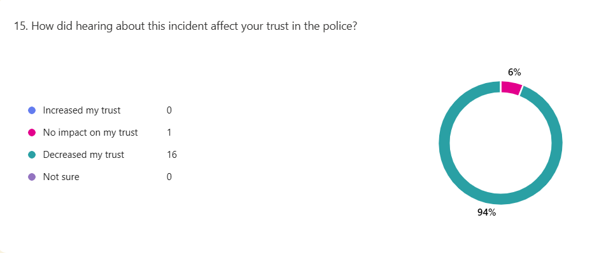
(Graph showing results of question 15)

4.2.3 Media Influence
While over 75% of respondents had at least a ‘fair amount’ of trust, 17% of respondents said they had ‘little to no trust’ towards the police. When asked how they felt about the media’s representation of the police and its fairness, 47% of respondents said it was ‘sometimes biased’, and 35% said it was ‘often exaggerated’. Few people thought that media coverage of police actions was ‘fair and balanced’. Most respondents believed that the public’s perception of the police is ‘greatly influenced’ by the media. On examining the results, there is a broad consensus that the public’s perception of the police is greatly influenced by the media. There is scepticism over how such incidents are portrayed in the media, as the majority of respondents think that media coverage is biased or exaggerated. These results demonstrate how even people who are critical of the police have reservations surrounding media narratives and how police incidents are reported. It seems that participants can differentiate between their response to the actual incident and the way the media presents it. The media might be seen with distrust due to its tendency to exaggerate information for a better story line.

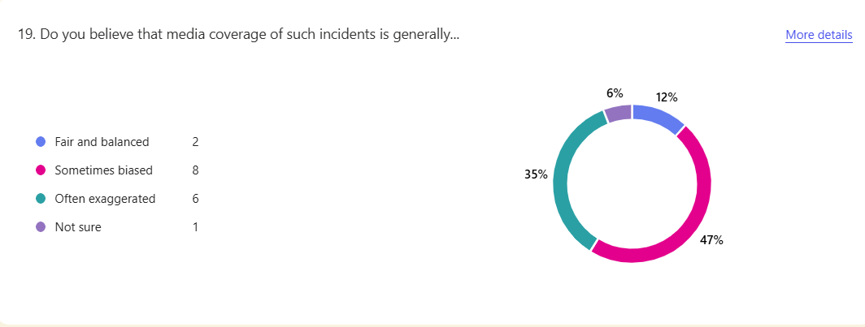
(Graph showing results from question 19)

4.2.4 Perceptions of Accountability and Reform
Opinions on police accountability were inconsistent, some claimed that police officers are ‘sometimes’ or ‘often’ held accountable. Other participants, however, said that police officers were ‘never’ held responsible for their actions. 9 out of 10 participants agreed that misconduct undermines public trust, indicating that this is a widespread and core public perception rather than a minor one. Additionally, participants expressed their belief that the police force requires change as a result of previous high-profile incidents. Although some respondents think that officers are held responsible, the data reveals uncertainty and inconsistency, suggesting that the public does not fully understand or trust the disciplinary procedure.

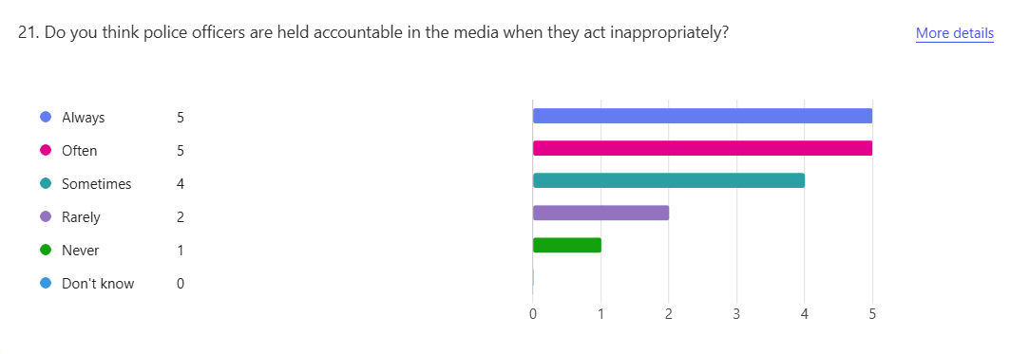
(Graph showing results to question 21)

4.2.5 Qualitative Responses and Thematic Insights
From the open-ended question “what changes, if any, would improve your current level of trust in the UK Police service?”, common themes included:
Theme 1: Accountability and Transparency
Participants called for stricter consequences for misconduct and more transparency in investigations.
“Police should be held more accountable”.
Theme 2: Surveillance and Oversight
Some called for more CCTV or body-worn cameras to ensure transparency and discourage misconduct.
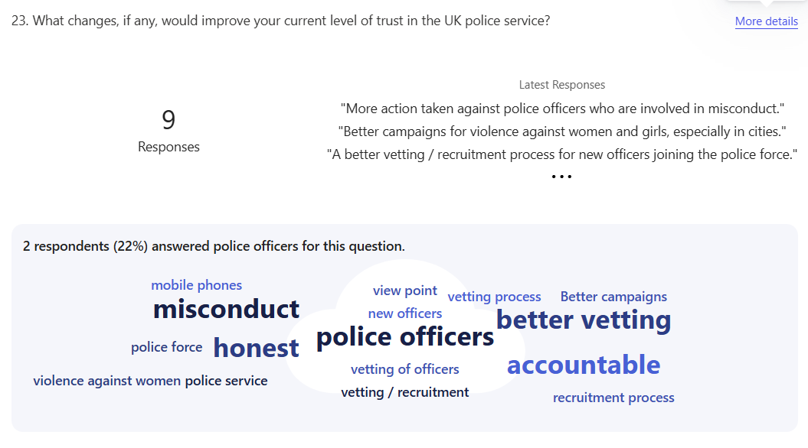
“More control cameras everywhere to record their actions”.
(Graph showing results from question 23, including qualitative responses from participants)

4.3 Conclusion
This chapter provides a thorough examination of the survey data that assesses public perception towards the police in relation to high-profile incidents. According to the findings, the majority of respondents reported a loss in confidence after highly publicised incidents involving the police were reported, demonstrating the significant and negative impact such incidents have on public trust.
Many respondents indicated moderate faith in their local police, however concerns were raised surrounding institutional accountability and behaviour among police officers. Public opinion was shown to be significantly influenced by media coverage, however respondents also voiced doubts about the reliability and impartiality among the media. With themes throughout the results, suggesting that the information shared online and via news outlets were exaggerated or often biased. Participants overwhelmingly agreed that misconduct undermines trust and that reforming the police force may be the answer to restoring public trust and confidence.
The results also indicate that although many participants found their local police officers to be trustworthy, their perceptions were altered as a result of negative policing incidents publicised in the media. The complexity of these views emphasises the necessity of clear accountability procedures, more consistent disciplinary actions, and significant community involvement in order to reduce long-term consequences of high-profile policing incidents.
The next chapter will discuss the findings along with their implications for future policing policies in South Wales, as well as how they support or contradict earlier research.

Chapter 5 – Conclusion and Recommendations
5.0 Introduction
This chapter concludes and summaries the main findings of the study and provides an analysis of how high-profile policing incidents, particularly those that are highly publicised in the media, affect public trust and confidence. This section presents the key findings in light of the initial aims and objectives of the dissertation, considering the data and the themes found in the earlier chapters. Finally, the chapter offers several achievable recommendations aimed to build rapport with the public and increase public confidence towards the police. The study’s limitations are also acknowledged, and recommendations for additional research are made to promote ongoing research into the topic of public perception of UK police forces.

5.1 Achievement of Objectives
The study’s objectives were to study how high-profile policing incidents impact the public’s trust and confidence towards the police. This was effectively achieved, and the research successfully measured public trust levels through the dissemination of an online survey. The results of the survey provided evidence that such incidents, particularly those that receive extensive media coverage, can have a detrimental impact on public opinion. The study also achieved its goal of assessing the role of the media, finding that although it is generally deemed influential, many participants also believe that it is biased.
The study also examined perceptions on police accountability, the survey discovered that the public are generally open to change and strongly believe that police misconduct decreases public trust. With many participants highlighting the need for a better vetting and recruitment process, and more action to be taken against officers involved in misconduct hearings. By receiving both quantitative and qualitative data a more in-depth opinion was gathered from members of the public in South Wales, it also ensured that all the studies aims and objectives were fully addressed and backed by data.

5.2 Main Findings
Focusing on the South Wales area, this study investigated the impact of high-profile policing incidents on public trust and confidence in local policing across South Wales. The findings show various themes and trends, which have been categorised into 8 headings, listed below:

- High awareness of Incidents
100% of the participants were aware of recent high-profile incidents involving the police service. This demonstrates the impact the media, including social media has on the dissemination of information surrounding police activity and how it influences the public’s trust and confidence in their local police force.

- Negative Impact on Trust
Regarding the decline in trust, 94.1% of participants agreed that such incidents impact their trust. None of the participants stated their trust in the police had increased as a result of high-profile incidents. These statistics support the idea that negative police involvement in high-profile incidents may damage public perception towards the police as a whole, regardless of whether the incident occurred locally or nationally.

- Divided Levels of Trust in Local Police
Despite the impact of high-profile incidents, many participants still expressed their trust in their local policing teams.
- 44.4% reported a “great deal” of trust.
- 33.3% had a “fair amount”
- While 16.7% reported little to no trust in their local police.
This points to a complicated view on policing, where confidence in local police officers may be high, however when considering the overall image of the police force regarding national and international incidents the confidence decreases. This also supports the idea, that participants are referring to incidents that occur outside of their local area whereby they receive their information from the news, or social media meaning they have not been directly impacted by the incidents but are being influenced by third parties, resulting in temporary loss of trust towards the police. Not necessarily a lack of trust in their local police officers.

- Strong Belief that Misconduct Damages Trust
Participants generally agreed that police misconduct reduces public confidence. This result highlights the high expectations the public have towards professionalism among police officers and demonstrates concerning perceptions regarding accountability within the police.

- Media Plays a Major Role in Public Perceptions
The results found that majority of participants agreed that the media has a great deal of influence on public perceptions, 82% of participants also expressed concerns that the media can be exaggerated. Suggesting that although people depend on the media for information, they frequently doubt it’s credibility, creating a complex perception among the public, whereby the media is both influential but also widely distrusted. However, these statistics show that whether the media is balanced or sensationalised, it still has a big impact on public perception.

- Inconsistent views on police accountability
The results for police being held accountable show differing opinions. Some participants believed that officers are scrutinised, while others said that accountability is irregular. The difference in opinions surrounding accountability, implies a lack of education and knowledge towards police misconduct hearings and IOPC processes. As well as lack of information being shared from the police regarding misconduct within their forces, which also highlights the issues surrounding transparency and accountability from the Police. Information from the participants sources, including the news, and social media is also a factor.

- Widespread need for reform
While only 12% responding with a firm “yes” for the need for police reform, 59% said “possibly” suggesting that the public is open to change but may lack clarity on what reform should entail. This suggests that there is need for greater engagements with the way the police are held accountable, and how the police service functions for the public to gain better understanding of misconduct hearings and disciplinaries. By establishing better community – police relationships, and following the police are the public and the public are the police vision. (Munro)

- Qualitative and Quantitative trends
Responses in open text were consistent with the quantitative results. There were calls for more accountability and transparency in regard to misconduct, there were recommendations for additional surveillance such as the deployment of body worn camera and more CCTV cameras in local areas, and a focus on community-based programmes to restore confidence. These themes and patterns expand our awareness of public concerns and imply that there is a need for institutional changes, specifically involving better rapport and transparency between the police and the public.

5.3 Recommendations
The study’s research findings allow for the formulation of several important recommendations aimed at enhancing public confidence in the police force.
Firstly, increased accountability and transparency are crucial, especially when it comes to handling instances of police misconduct. In order to guarantee that investigations are seen as fair and comprehensive, South Wales Police should invest in independent monitoring systems and improve public reporting on disciplinary decisions. There is also call for a better vetting system, to avoid future misconducts with individuals not suitable to work within the police.
Secondly, the study emphasises the need for improved community involvement, To achieve this the recommendations, involve, regular forums, public consultations, and collaboration programs and projects targeted at mending local perceptions and building rapport between the police and the public. Increased funding towards departments such as neighbourhood policing will enhance South Wales Police’s ability to better engage with the communities they serve. The implementation of this by SWP has encouraged a community-led policing approach, which is set to improve police relations with the community they serve. (Editor., 2024)
Thirdly, the police should actively oversee its communications strategy, making sure that timely, accurate and balanced information is provided to dispute sensationalised narratives or false information, given the impact the media has on public perception. By enhancing the police’s platform on social media, it will build rapport with a newer generation of individuals who rely heavily on information shared across the platforms, by doing so it aims to dispute any false narratives of ongoing incidents and share information.
Despite being based on a small sample from South Wales, these recommendations are applicable to police departments around the United Kingdom, that are facing difficulties in a time of intense public and media scrutiny, specifically the Metropolitan Police. Although there are several highlighted issues within the South Wales area involving, use of force, misconduct and lack of trust. These recommendations would benefit South Wales cities with a larger multi-cultural population, as well as other forces across the UK with similar demographics.

5.4 Future research and Limitations
This study offers valuable insights on the influence that high-profile policing incidents have on public perceptions of the police in South Wales. However, there are also several limitations to be considered.
Firstly, in terms of age, ethnicity and socioeconomic position, the sample size was limited and not entirely representative of the larger South Wales community. Regarding socioeconomic positions of the participants, this was not clearly highlighted and information regarding socio status was not well gathered, meaning that the results did not accurately reflect participants backgrounds, or detailed geographical area. Many of the participants responded that they lived in “Cardiff” or “Swansea”, these responses are vague and therefore do not provide accurate representation of a particular area. For future research, I aim to ensure that the question is more detailed to achieve a greater understanding of the participants socio-economic status. This will include a person’s living situation, for example if they are privately renting, homeowners or renting from a housing association. I will also consider a person’s employment status, occupation, and education status. By doing so, I hope to gather more detailed results, and achieve the study’s objective of investigating perceptions towards the police from a variety of socio-economic backgrounds to a greater level.
Participation may have been biased towards participants with access to the internet, and social media platforms such as WhatsApp. The study may also have had a more favourable interest from persons with an interest in the discussion surrounding policing as a topic. Furthermore, the study’s design limited the ability to evaluate how trust evolves over time or in reaction to changing circumstances because it only records perceptions at that time, rather than shortly after a high-profile incident has occurred. The study’s questions were also vague in terms of what high-profile incidents entailed. For future research, I would use examples of high-profile incidents such as the murder of Sarah Everard, The Manchester Bombings and the Black Lives Matter movements as discussion points before participants consider their answer to the study’s questions. By doing so, the participants would gain a better understanding of the impact of high-profile incidents and their influence on perceptions across the Nation or Internationally.
For future research, a longitudinal study could be useful to monitor changing opinions both before and after high-profile incidents. Longitudinal studies employ continuous or repeated measures to follow individuals over prolonged periods of time. (Caruana et al. 2015). This study design would allow for better results and gather more detailed qualitative data which would be beneficial for this research topic. Furthermore, using focus groups or qualitative interviews would provide a more in-depth insight and understanding of the environmental and emotional factors influencing public perception. It may also become clear if these patterns are local opinions or indicative of larger national trends surrounding public perception if the geographic area is extended to include comparisons between South Wales and other UK regions.

5.5 Conclusion
This dissertation has highlighted even at a local level, the profound impact that high-profile police incidents have on public perceptions. These perceptions are often heightened by media attention, and the spreading of information via online platforms. Although, the study has shown there is still some degree of public trust in the police in South Wales, it is evident that misbehaviour and a lack of obvious accountability can seriously undermine that trust. However, the need for a more in-depth study is also clear, with obvious gaps in the studies results regarding participants trust towards the police differing throughout the study.
Furthermore, the results highlight the significance of open communication, the importance of community involvement, and institutional changes to restore public confidence. The police service’s tactics for accountability, communication, and ethical behaviour must change. The study also highlights considerations towards the development of more body worn footage, and CCTV operations within local areas to restore confidence in policing and increase transparency. There is also a need for the public’s perception to develop in terms of how they receive information surrounding police activity. With many receiving information from online sources, and social media this can lead to dissemination of the wrong information. Changes to policies surrounding the police sharing first hand information from reliable sources and remaining transparent throughout officers’ misconduct hearings should also be encouraged. The study’s results suggests that this can be achieved by sharing officers body worn footage when necessary, and further developments into vetting and recruitment processes which will assist with increased public perceptions.

Chapter 6 - Bibliography
Alford, Dawn, and John Battle. THE POLICE and the MEDIA REPAIRING the RELATIONSHIP 2.
Angiolini, Elish. “Reports – the Angiolini Inquiry.” Www.angiolini.independent-Inquiry.uk, Feb. 2024, www.angiolini.independent-inquiry.uk/reports/.
Atkins, Tia. “The Impact of the Manchester Arena Terror Attack: Next Steps for Public Safety and Policy.” Journal of Policing, Intelligence and Counter Terrorism, vol. 18, no. 1, 13 Jan. 2022, pp. 1–10, https://doi.org/10.1080/18335330.2021.2022183.
Bhandari, Pritha. “An Introduction to Quantitative Research.” Scribbr, 10 Oct. 2022, www.scribbr.co.uk/research-methods/introduction-to-quantitative-research/.
Caruana, Edward, et al. “Longitudinal Studies.” Journal of Thoracic Disease, vol. 7, no. 11, 2015, pp. 537–540, pmc.ncbi.nlm.nih.gov/articles/PMC4669300/, https://doi.org/10.3978/j.issn.2072-1439.2015.10.63.
College Of Policing. “Guidance for Ethical and Professional Behaviour in Policing.” College of Policing, 24 Jan. 2024, www.college.police.uk/ethics/code-of-ethics/guidance.
Derex, Maxime, and Alex Mesoudi. “Cumulative Cultural Evolution within Evolving Population Structures.” Trends in Cognitive Sciences, vol. 24, no. 8, 1 Aug. 2020, pp. 654–667, www.cell.com/trends/cognitive-sciences/fulltext/S1364-6613(20)30107-8?_returnURL=https%3A%2F%2Flinkinghub.elsevier.com%2Fretrieve%2Fpii%2FS1364661320301078%3Fshowall%3Dtrue, https://doi.org/10.1016/j.tics.2020.04.005.
Editor. “Neighbourhood Policing Set for Boost in South Wales.” Swansea Bay News, 24 June 2025, swanseabaynews.com/2025/06/24/neighbourhood-policing-set-for-boost-in-south-wales/. Accessed 26 June 2025.
Farrow, Kathryn. Legitimacy & Confidence in Policing. 2023.
Geoghegan, Sinead. “Almost Half of Women Have Less Trust in Police Following Sarah Everard Murder.” END VIOLENCE against WOMEN, 18 Nov. 2021, www.endviolenceagainstwomen.org.uk/almost-half-of-women-have-less-trust-in-police-following-sarah-everard-murder/.
Gill, Sim. “Finding Sarah Everard: A Critical Discourse Analysis Exploring the First Two Weeks of News Media Coverage Following Her Disappearance and Murder.” International Journal of Communication, vol. 18, no. 0, 14 Jan. 2024, p. 20, ijoc.org/index.php/ijoc/article/view/21612/4477.
Hanway, Pamela , and Olivia Hambly. “Public Perceptions of Policing: A Review of Research and Literature.” GOV.UK, Mar. 2023, www.gov.uk/government/publications/public-perceptions-of-policing-a-review-of-research-and-literature/public-perceptions-of-policing-a-review-of-research-and-literature.
---. “Public Perceptions of Policing: A Review of Research and Literature.” GOV.UK, Mar. 2023, www.gov.uk/government/publications/public-perceptions-of-policing-a-review-of-research-and-literature/public-perceptions-of-policing-a-review-of-research-and-literature.
Hayes, Adam. “Demographics: How to Collect, Analyze, and Use Demographic Data.” Investopedia, 18 June 2024, www.investopedia.com/terms/d/demographics.asp.
Helpline, Criminal Injuries. “The Trust Gap: Examining Public Perception of the Police | CIH.” Criminal Injuries Helpline, 28 Mar. 2023, criminalinjurieshelpline.co.uk/blog/the-trust-gap-examining-public-perception-of-the-police/.
hmicfrs. “An Inspection of Vetting, Misconduct, and Misogyny in the Police Service.” His Majesty’s Inspectorate of Constabulary and Fire & Rescue Services, 2 Nov. 2022, hmicfrs.justiceinspectorates.gov.uk/publication-html/an-inspection-of-vetting-misconduct-and-misogyny-in-the-police-service/.
Hohl, Katrin. “The Role of Mass Media and Police Communication in Trust in the Police: New Approaches to the Analysis of Survey and Media Data.” Google.co.uk, 2025, www.google.co.uk/url?sa=t&rct=j&q=&esrc=s&source=web&cd=&ved=2ahUKEwiK78i1wc2MAxXiUUEAHRIMIPQQFnoECCMQAQ&url=https%3A%2F%2Fcore.ac.uk%2Fdownload%2Fpdf%2F4187655.pdf&usg=AOvVaw1_uCTPFeSOxrG_Jr66g8iS&opi=89978449. Accessed 10 Apr. 2025.
Home Office. “CONTEST 2023 Factsheet - Home Office in the Media.” Homeofficemedia.blog.gov.uk, 18 July 2023, homeofficemedia.blog.gov.uk/2023/07/18/contest-2023-factsheet/.
---. “Government Accepts All Recommendations Made by Angiolini Inquiry.” GOV.UK, 25 Mar. 2024, www.gov.uk/government/news/government-accepts-all-recommendations-made-by-angiolini-inquiry.
IOPC. “Public Perceptions Tracker Summary Report - 2022/23 | Independent Office for Police Conduct (IOPC).” Www.policeconduct.gov.uk, 26 July 2023, www.policeconduct.gov.uk/publications/public-perceptions-tracker-summary-report-202223.
Ipsos. Public Perceptions of Local Policing and the Police. 2022.
Jackson, Jonathan, and Ben Bradford. “What Is Trust and Confidence in the Police?” Policing: A Journal of Policy and Practice, vol. 4, no. 3, 1 Aug. 2010, pp. 241–248, academic.oup.com/policing/article-abstract/4/3/241/1467577, https://doi.org/10.1093/police/paq020.
Low, Natalie, and Rebecca Owen-Evans. “Public Trust and Confidence in the Police.” UK Parliament , 2024, post.parliament.uk/public-trust-and-confidence-in-the-police/.
Met Police. Metropolitan Police Service Violence against Women and Girls Action Plan. 2020.
Mullis, Joseph. “The Impact of the Media on Public Opinion of the Police - ProQuest.” Www.proquest.com, 2009, www.proquest.com/openview/d00e6fb464c246ee3cf6ae09f0901c4e/1?pq-origsite=gscholar&cbl=18750.
Munro, Tina Orr. “Why It Is Important We Have a Diverse Police Service.” Allpolicejobs.co.uk, allpolicejobs.co.uk/blog/why-it-is-important-we-have-a-diverse-police-service.
Myhill, Andy, and Kristi Beak. Public Confidence in the Police. Nov. 2008.
Naser, Mo. “Why Are Surveys Good for Research?Turn Survey Data into Actionable Insights with Dashboards and Sentiment Analysis.” SmartSurvey, 19 Aug. 2024, www.smartsurvey.co.uk/blog/why-are-surveys-good-for-research.
Norman, J. “Seen and Not Heard: Young People’s Perceptions of the Police.” Policing, vol. 3, no. 4, 1 Jan. 2009, pp. 364–372, https://doi.org/10.1093/police/pap044. Accessed 13 Jan. 2020.
Pickering, Steve, et al. “London, You Have a Problem with Women: Trust towards the Police in England.” Policing & Society, vol. 34, no. 8, 17 Apr. 2024, pp. 747–762, www.tandfonline.com/doi/full/10.1080/10439463.2024.2334009, https://doi.org/10.1080/10439463.2024.2334009.
Solace. “Sarah Everard - Three Years on - Solace Womens Aid.” Solace Womens Aid, 3 Mar. 2024, www.solacewomensaid.org/news/item/sarah-everard-three-years-on/.
Sreekumar, Divya. “What Is Research Methodology? Definition, Types, and Examples | Paperpal.” Paperpal, 28 Aug. 2023, paperpal.com/blog/academic-writing-guides/what-is-research-methodology.
Succar, Rayan, et al. “Understanding the Role of Media in the Formation of Public Sentiment towards the Police.” Communications Psychology, vol. 2, no. 1, 7 Feb. 2024, pp. 1–17, www.nature.com/articles/s44271-024-00059-8#:~:text=Through%20positive%20police-community%20relationships%2C%20the%20police%20could%20disseminate, https://doi.org/10.1038/s44271-024-00059-8.
---. “Understanding the Role of Media in the Formation of Public Sentiment towards the Police.” Communications Psychology, vol. 2, no. 1, 7 Feb. 2024, pp. 1–17, www.nature.com/articles/s44271-024-00059-8#:~:text=Through%20positive%20police-community%20relationships%2C%20the%20police%20could%20disseminate, https://doi.org/10.1038/s44271-024-00059-8.
SurveyMonkey. “Likert Scale: Examples and How to Use It.” SurveyMonkey, 2025, uk.surveymonkey.com/mp/likert-scale/.
Tenny, Steven, et al. “Qualitative Study.” National Library of Medicine, StatPearls Publishing, 18 Sept. 2022, www.ncbi.nlm.nih.gov/books/NBK470395/.
Tudor, Sarah. “Police Standards and Culture: Restoring Public Trust.” House of Lords Library, UK Parliament, 27 Apr. 2023, lordslibrary.parliament.uk/police-standards-and-culture-restoring-public-trust/.
University of Edinburgh. “Literature Review.” The University of Edinburgh, 26 Feb. 2024, institute-academic-development.ed.ac.uk/study-hub/learning-resources/literature-review.
West, Georgia, et al. ““It’s Not like You’re Delivering Amazon Packages”: A Qualitative Study and Thematic Analysis Exploring Older Victims’ Perspectives on How the Police Responded to Their Crime Report.” Policing a Journal of Policy and Practice, vol. 18, 1 Jan. 2024, https://doi.org/10.1093/police/paae042.
Wright, James E., et al. “The Power of Protest on Policing: Black Lives Matter Protest and Civilians Evaluation of the Police.” Public Administration Review, vol. 83, no. 1, 18 May 2022, https://doi.org/10.1111/puar.13498.
Zoe. “30 Years after Stephen Lawrence – Spark.” Sparkandco.co.uk, 10 Apr. 2025, sparkandco.co.uk/30-years-after-stephen-lawrence/. Accessed 10 Apr. 2025
Chapter 7 – Appendices
Appendix A – Participant Information sheet regarding the study.
Study Title: How do high-profile policing incidents impact on the public’s trust and confidence in the police service?
Researcher: Lauren Richards
University of Wales Trinity Saint David.
Email: 2222319@uwtsd.ac.uk

Supervisor: Depak Patel
Email: d.patel@uwtsd.ac.uk

The purpose of this study is to investigate how high-profile incidents involving the police impact the public’s trust and confidence in the South Wales area. Focusing specifically on high-profile incidents involving use of force cases, misconduct claims, and media-covered incidents.
Please consider the following information before providing consent to take part in the survey:
You have been requested to take part in this survey as your thoughts and experiences as a member of the public can offer important insight into how the general South Wales public view policing.
You are free to stop participating at any moment before sending in your answers; participation is completely voluntary. Responses will be anonymous after they are submitted.
If you consent to participate, you will complete a short survey that should take approximately 5-10 minutes. The survey asks about your trust and confidence in the police service, and how certain high-profile incidents may have affected your views.
There are no known dangers related to this research. However, some subjects may be sensitive regarding violence against women and girls, misconduct claims and use of force cases. You can pause at any moment or skip any question. Your involvement will support academic research and help gain a better understanding of public attitudes in the South Wales area towards the police.
There will be no collection of personally identifiable information. Data will be safely kept, utilised exclusively for academic research, and deleted at the end of this study.
If you have any concerns to raise regarding this study, please contact the researcher or the dissertation supervisor mentioned above. If you chose to take part, please read and fill out the consent form below before completing the survey.

Appendix B – noticeboard message
CALLING SOUTH WALES RESIDENTS:
I am PC Lauren Richards a serving police officer on response carrying out a study for my university dissertation. In order to complete this study, I am looking for volunteers to complete a short survey investigating the impact high-profile policing incidents have on public perception. Specifically aiming to better understand perceptions on a local level across communities within South Wales.
If you are interested in completing the survey, the only criteria is that you reside within a community in South Wales. Please contact myself via Whatsapp (07726410403) or drop me an email to 2222319@uwtsd.ac.uk
Thank-you, I look forward to hearing from you!

Appendix C – Consent form
PARTICIPATION CONSENT FORM:
Please tick each box to indicate your agreement:
- I confirm that I have read and understood the study’s participant information sheet.
- I am aware that my participation in this study is entirely voluntary, and that I have the option to opt out at any moment prior to completing the survey.
- I am aware that the details I submit will be kept private and anonymous.
- I understand that the researcher’s dissertation and other academic work may make use of this’s study’s data.
I agree to participate in this research:

Full name (optional):………………………
Date:……………………………………………
Signature:……………………………………..

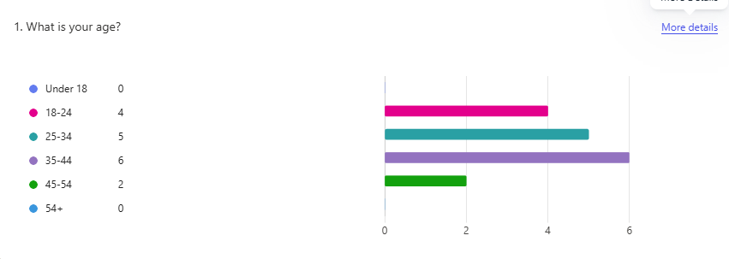
Appendix D – Copy of the survey and results

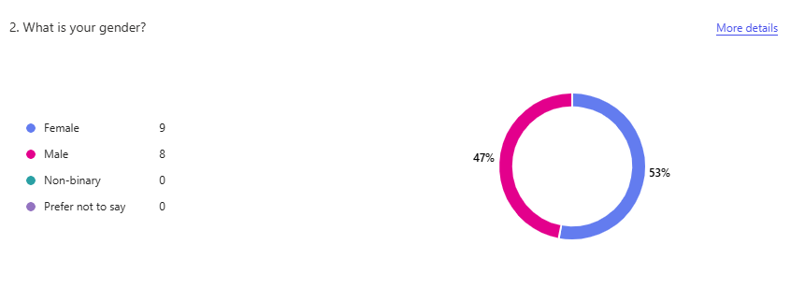
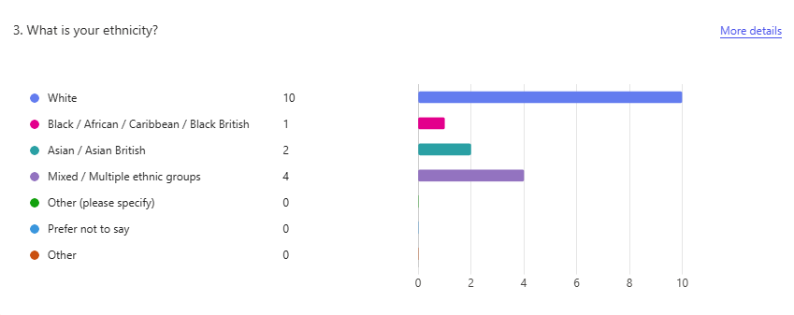

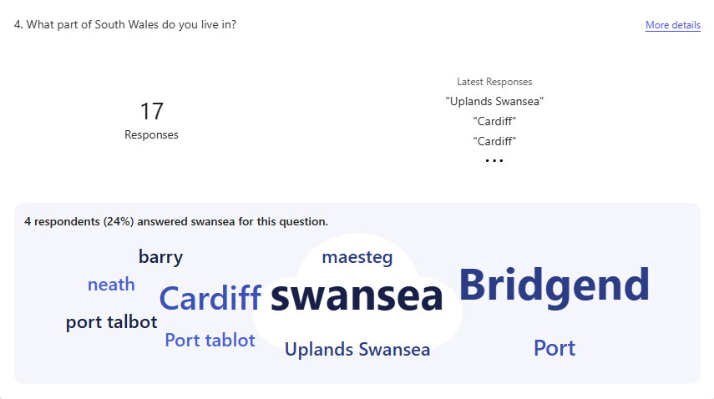
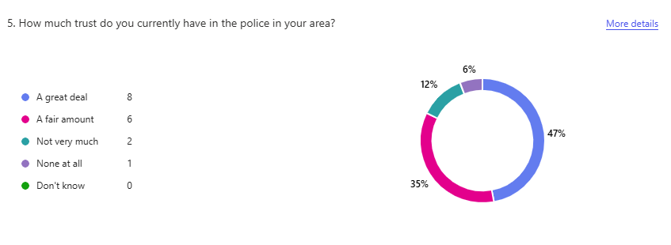
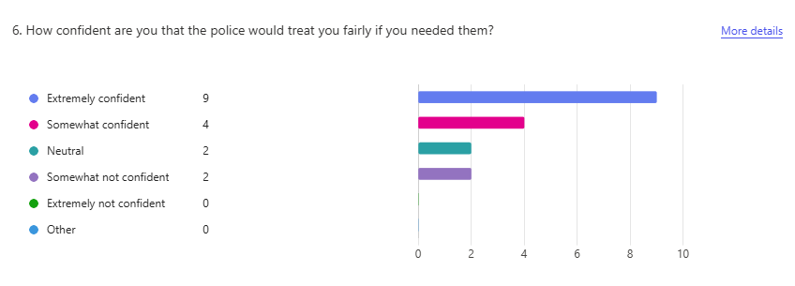

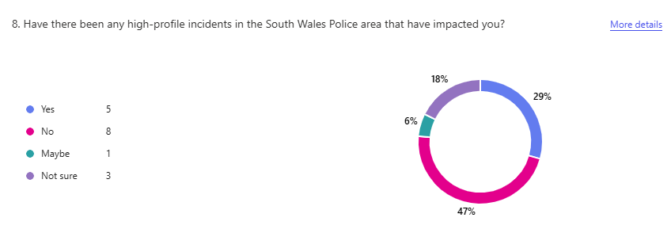
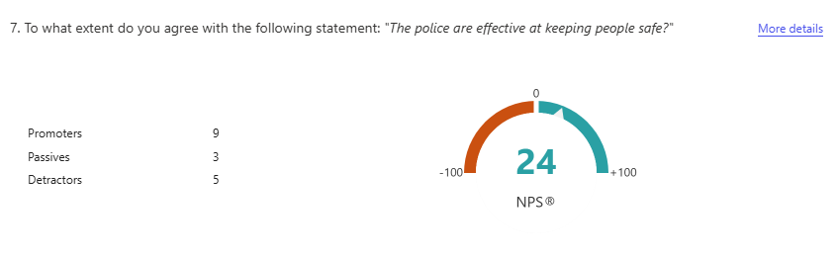

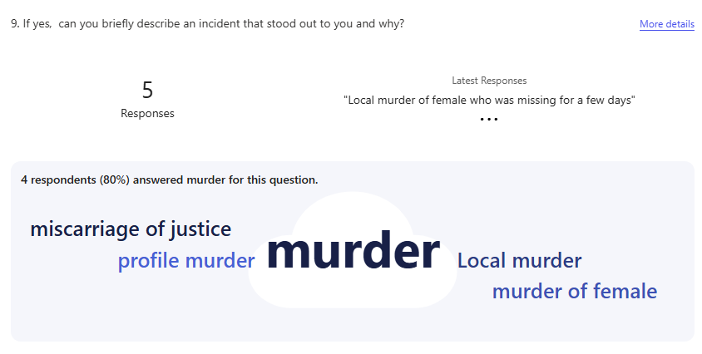

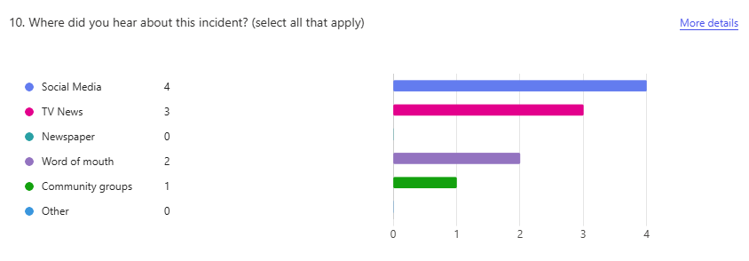
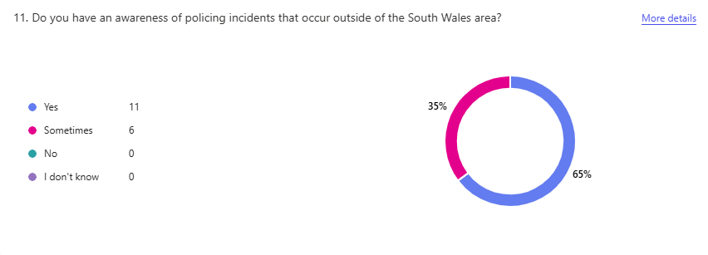
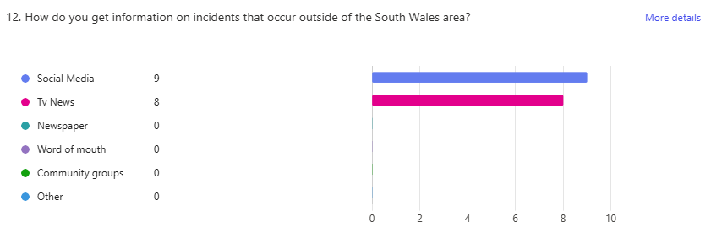

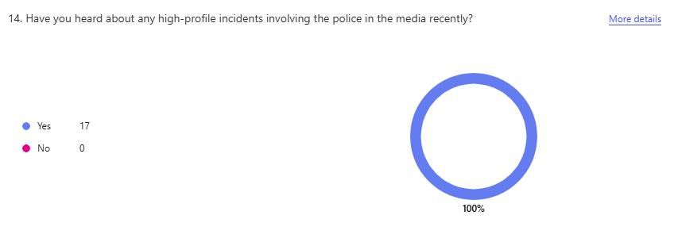
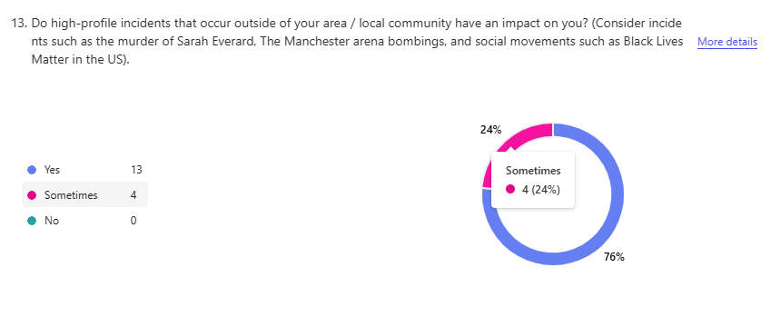

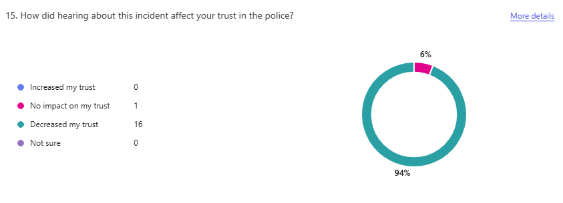

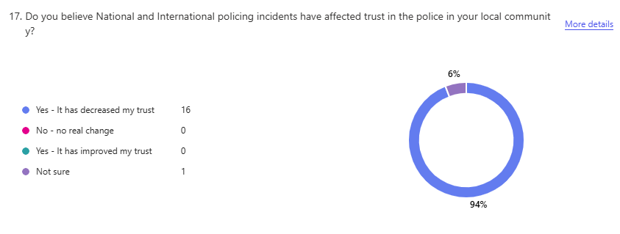
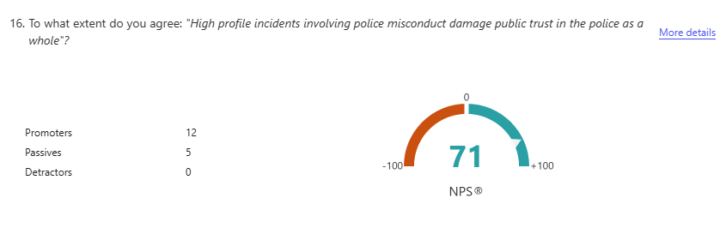

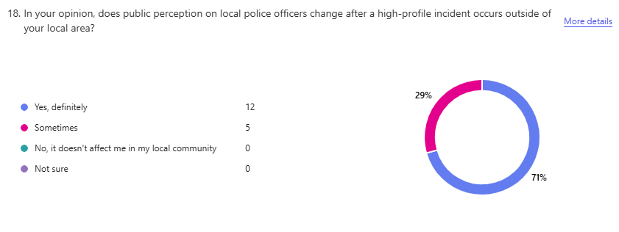

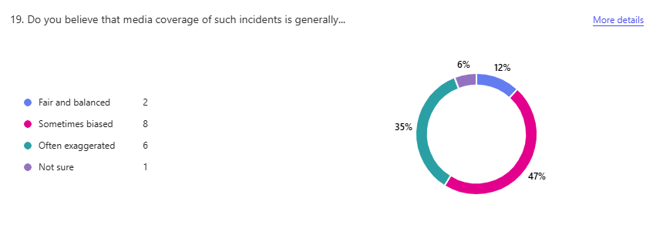

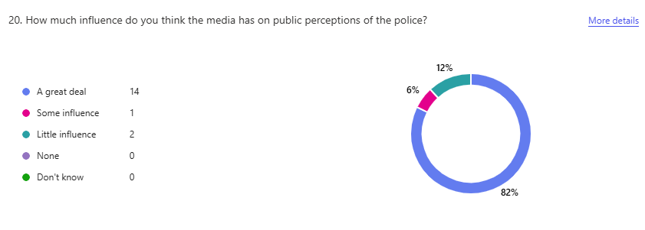
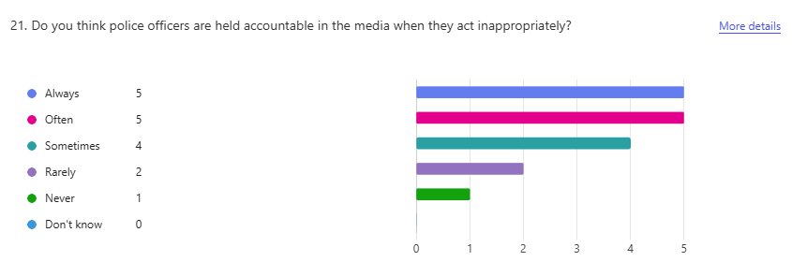

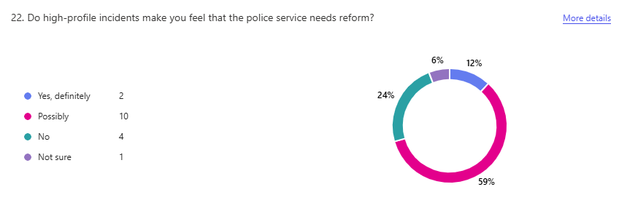
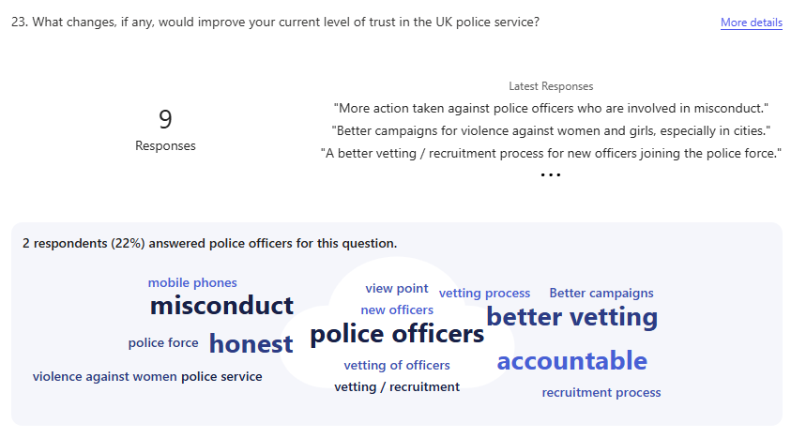

Appendix E – Application for ethical approval
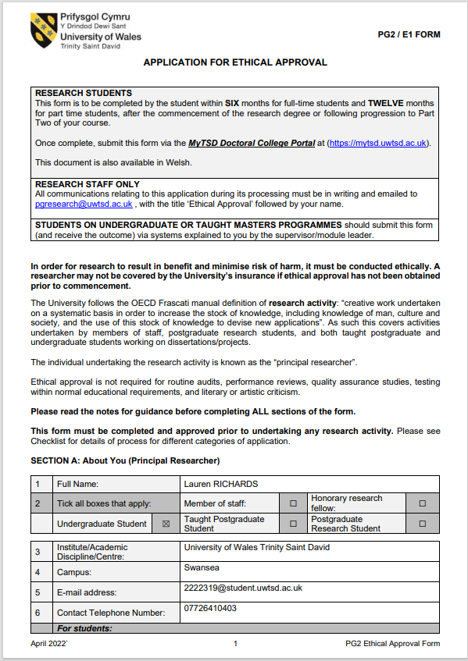
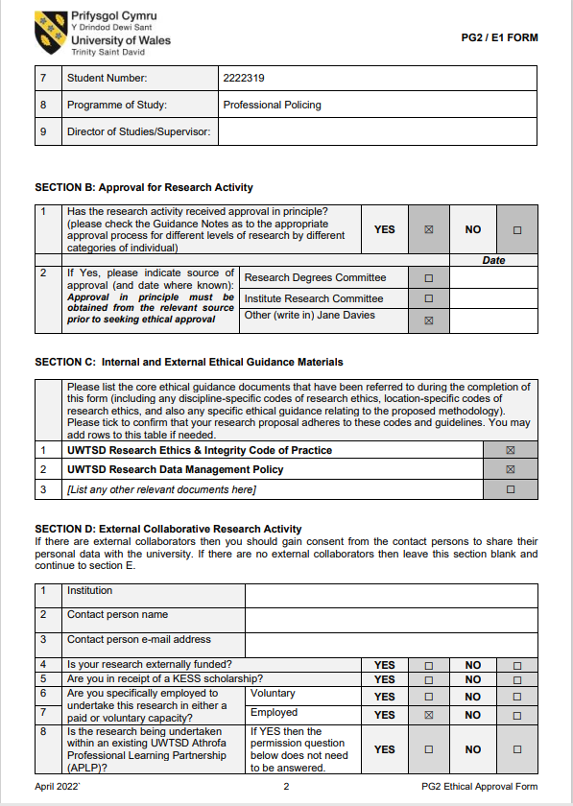

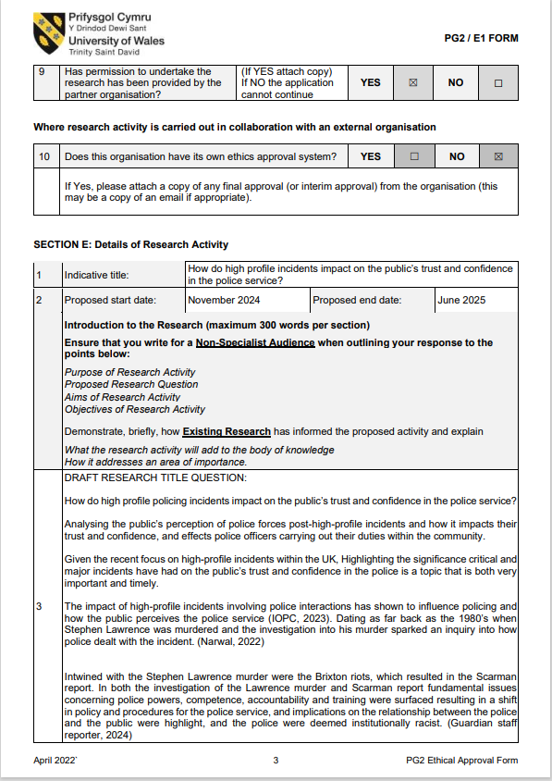

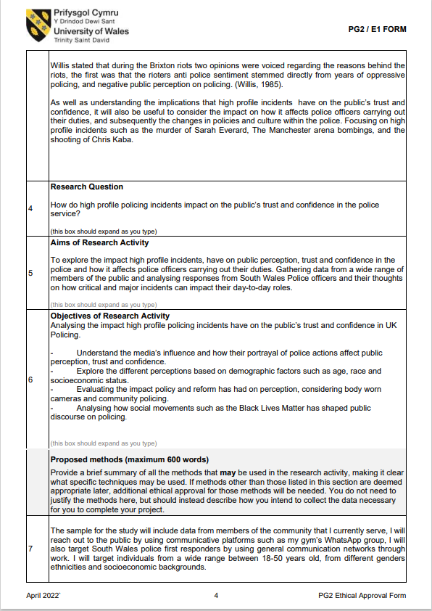

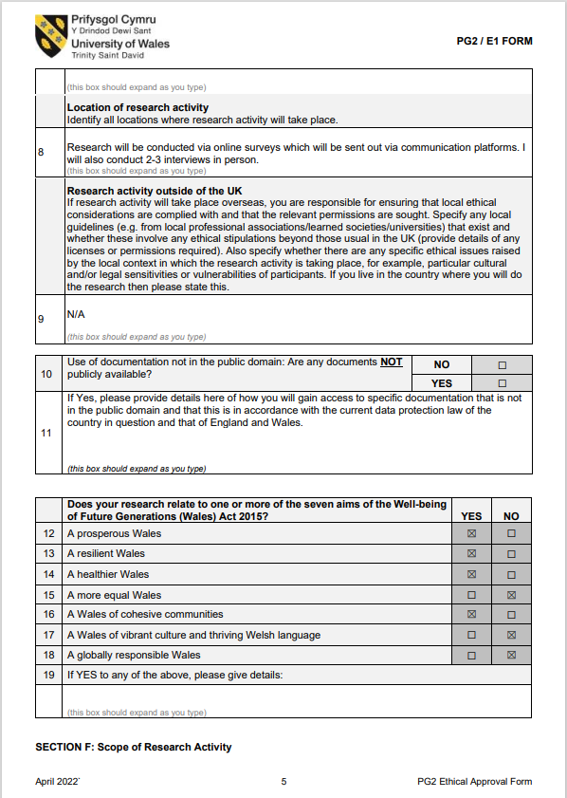

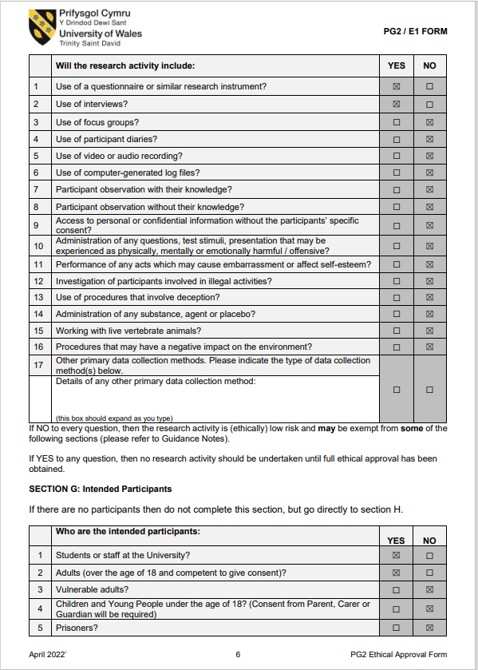

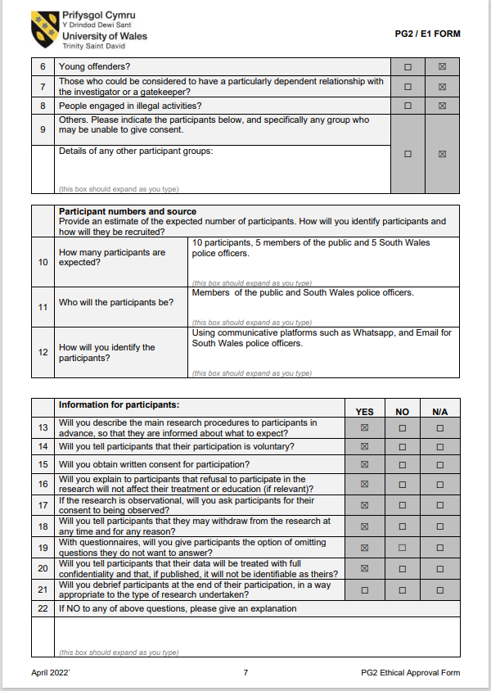

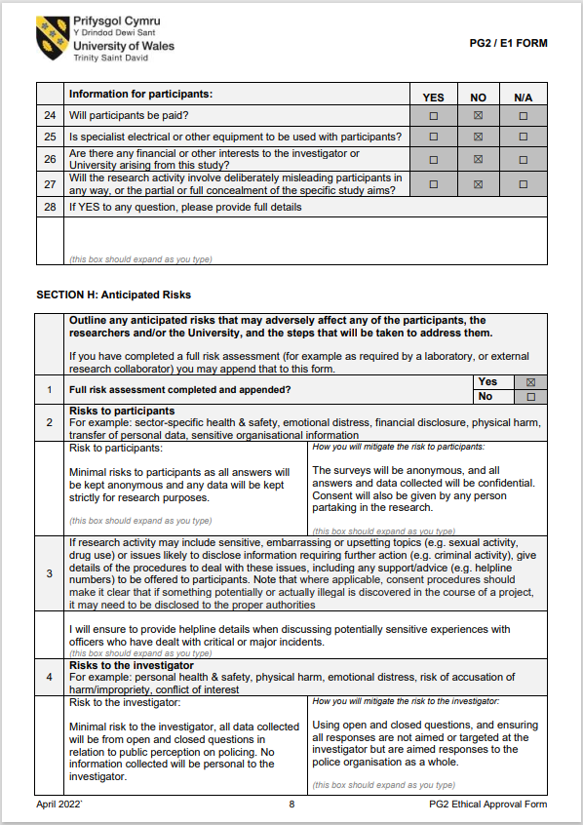

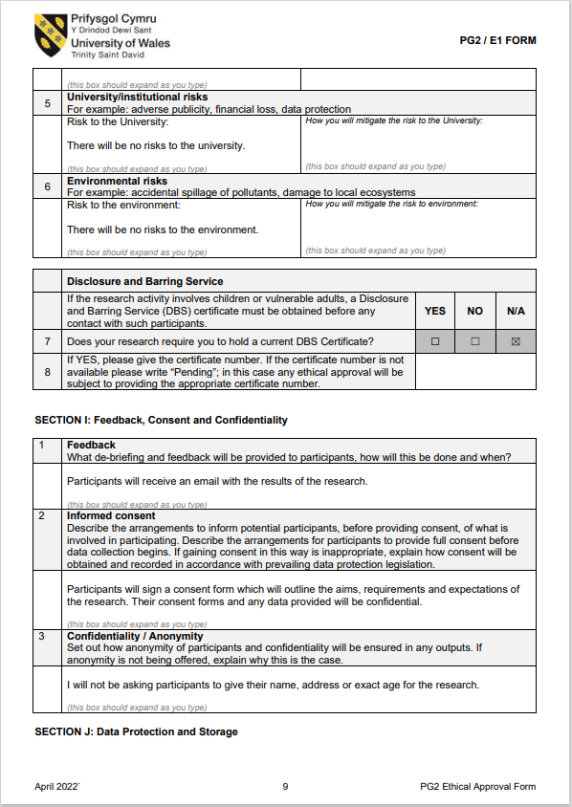

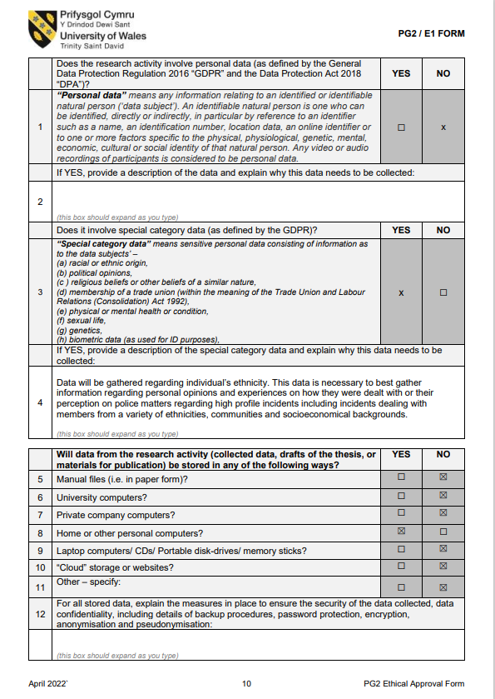

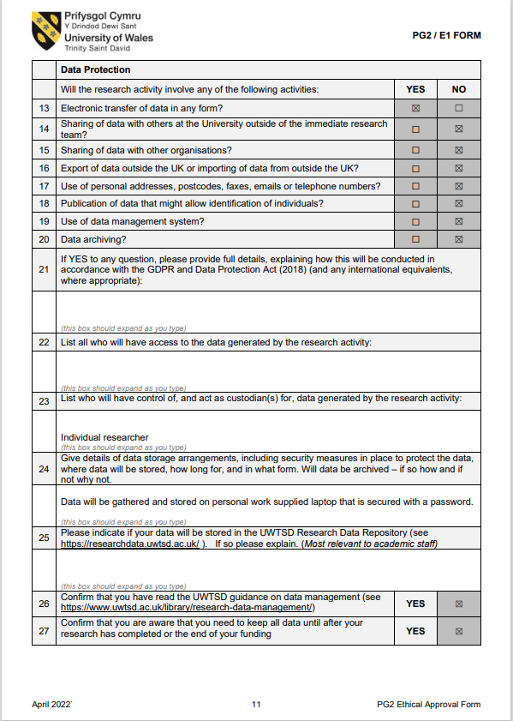

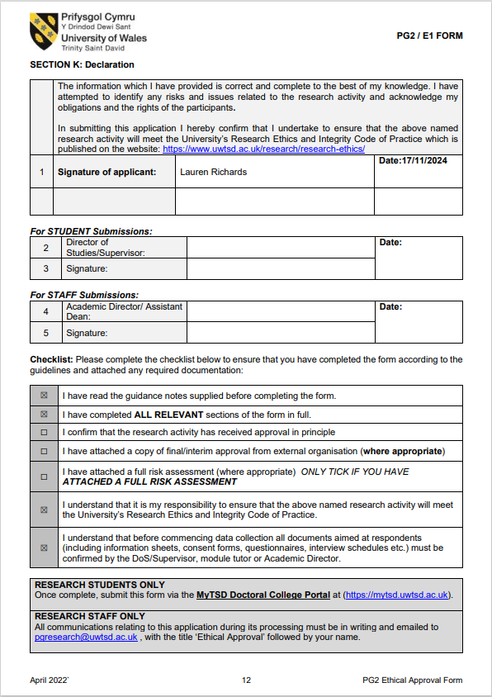

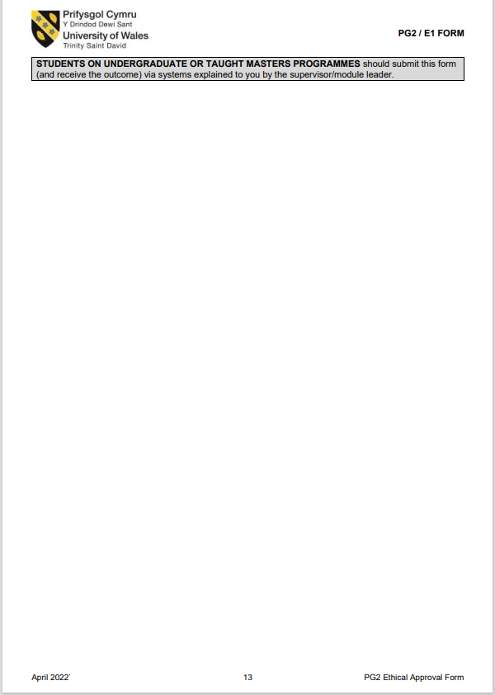

Appendix F – Research proposal form



UNDERGRADUATE DISSERTATION
RESEARCH PROPOSAL FORM

Please complete the following research proposal and submit it to Turnitin.

Which project option are you taking? Please tick:

8,000 word project:
OR
4,000 word project and presentation:

NAME:  Lauren RICHARDS | STUDENT ID No.: 2222319
DRAFT RESEARCH TITLE QUESTION:
INTRODUCTION:
How do high profile policing incidents impact on the public’s trust and confidence in the police service?
Analysing the public’s perception of police forces post-high-profile incidents and how it impacts their trust and confidence, and effects police officers carrying out their duties within the community.
Given the recent focus on high-profile incidents within the UK, Highlighting the significance these incidents have had on the public’s trust and confidence in the police is a topic that is both very important and timely.
The impact of high-profile incidents involving police interactions has shown to influence policing and how the public perceives the police service (IOPC, 2023). Dating as far back as the 1980’s when Stephen Lawrence was murdered and the investigation into his murder sparked an inquiry into how police dealt with the incident. (Narwal, 2022)

Intwined with the Stephen Lawrence murder were the Brixton riots, which resulted in the Scarman report. In both the investigation of the Lawrence murder and Scarman report fundamental issues concerning police powers, competence, accountability and training were surfaced resulting in a shift in policy and procedures for the police service, and implications on the relationship between the police and the public were highlight, and the police were deemed institutionally racist. (Guardian staff reporter, 2024)

Willis stated that during the Brixton riots two opinions were voiced regarding the reasons behind the riots, the first was that the rioters anti police sentiment stemmed directly from years of oppressive policing, and negative public perception on policing. (Willis, 1985).

As well as understanding the implications that high profile incidents have on the public’s trust and confidence, it will also be beneficial to consider the impact on how it affects police officers carrying out their duties, and subsequently the changes in policies and culture within the police. Focusing on high profile incidents such as the murder of Sarah Everard, The Manchester arena bombings, and the shooting of Chris Kaba.

SUMMARY OF RESEARCH OBJECTIVES:
Analysing the impact high profile policing incidents have on the publics trust and confidence in UK Policing.

- Understand the media’s influence and how their portrayal of police actions affect public perception, trust and confidence.
- Explore the different perceptions based on demographic factors such as age, race and socioeconomic status.
- Evaluating the impact policy and reform has had on perception, considering body worn cameras and community policing.
- Analysing how social movements such as the Black Lives Matter has shaped public discourse on policing.

LITERATURE REVIEW:

The following report discusses the public’s perception on policing, and the influence the media has on the decrease of confidence in the police and towards the IOPC.

IOPC-public-perceptions-tracker-report-2022-23.pdf

The following article discuss the inquiry following the Manchester Arena bombings and the effect it had on emergency services, and public perception.
Full article: The impact of the Manchester Arena terror attack: next steps for public safety and policy

The following article follows the first two weeks of the news media coverage following the murder of Sarah Everard.
Finding Sarah Everard: A Critical Discourse Analysis Exploring the First Two Weeks of News Media Coverage Following Her Disappearance and Murder | Gill | International Journal of Communication
The following article highlights the change in policies for police officers following the murder of Sarah Everard.
Legitimacy-and-Confidence-in-Policing-SCREEN.pdf
The following article highlights the UK’s perception on the Police Constabulary and explores the levels of satisfaction between Black and Minority Ethnicities and non BME communities towards UK Police.
Full article: Understanding the public perception and satisfaction of a UK police constabulary

The following article explores how trust levels are held by police officers towards community members when dealing with critical incidents:
Officer Trust Towards Community Members and Critical Incidents: a Comparison of Factors | Journal of Police and Criminal Psychology

The following article highlights how police feel they are perceived by the public and how it affects them carrying out their duties, as well as their job satisfaction:
Full article: Police and their perceived image: how community influence officers’ job satisfaction

SUMMARY OF RESEARCH –SURVEY METHOD:

Surveys – In order to gather both quantitative and qualitative data I will be using a survey asking both members of the public and South Wales police offers what their views are on policing in the UK in relation to major and critical incidents. I will use open and closed questions to gain a better understanding of individuals views.

Interviews – I will also conduct interviews with South Wales police officers to gather further information. By conducting interviews I’m hoping to gather real life experiences and emotions and getting a more in depth understanding of how negative public perception post high-profile incidents can impact officers in the South Wales area.

SUMMARY OF SAMPLING FRAMEWORK:

The sample for the study will include data from members of the community that I currently serve, I will reach out to the public by using communicative platforms such as my gym’s WhatsApp group, I will also target South Wales police first responders by using general communication networks through work.

The target sample will have a wide range, using people from ages 18-50 years old, I will also be targeting a wide range of genders, ethnicity and socioeconomic backgrounds. I will also target members of the public that work in the emergency services such as paramedics, nurses, fire service to gain an understanding from their perspective of how high profile incidents affect them in South Wales.

ETHICAL ISSUES:

To ensure there are no ethical issues during my research, participants will get a description of the study’s objective before any data is collected. The participation in the study will be entirely voluntary, and participants won’t face any dangers whilst participating in the study. I will also be asking for the participants consent before they partake in the study, they will also be made aware that the study and their information will be kept confidential.

I will be discussing and asking South Wales police officers to potentially disclose personal experiences when dealing with high profile incidents, or how the incidents have impacted them later. This may cause ethical issues, but I will ensure to explain that the information provided is strictly for the study and any information provided will be kept anonymous.

TIME SCALE:
Research proposal and ethical form is completed (Nov 2024)
Literature review is ongoing and will continue up until confirmation of dissertation in December 2024.
Survey and data gathering, as well as full literature review will be completed by the end of Jan 2025.

Surveys and data gathering will be conducted in the New Year and completed by March 2025.

Data findings will be completed by April 2025.

Overall findings will be completed by Summer 2025.

Final Dissertation will be completed by June 2025.
REFERENCE LIST:

Atkins, Tia. “The Impact of the Manchester Arena Terror Attack: Next Steps for Public Safety and Policy.” Journal of Policing, Intelligence and Counter Terrorism, vol. 18, no. 1, 13 Jan. 2022, pp. 1–10, https://doi.org/10.1080/18335330.2021.2022183.

Awan, Imran, et al. “Understanding the Public Perception and Satisfaction of a UK Police Constabulary.” Police Practice and Research, vol. 20, no. 2, 17 Jan. 2018, pp. 172–184, www.tandfonline.com/doi/full/10.1080/15614263.2018.1428098, https://doi.org/10.1080/15614263.2018.1428098.

Bonnan-White, Jess, et al. “Officer Trust towards Community Members and Critical Incidents: A Comparison of Factors.” Journal of Police and Criminal Psychology, vol. 37, no. 3, 5 May 2022, https://doi.org/10.1007/s11896-022-09515-9.

Farrow, Kathryn. Legitimacy & Confidence in Policing. 2023.

Gill, Sim. “Finding Sarah Everard: A Critical Discourse Analysis Exploring the First Two Weeks of News Media Coverage Following Her Disappearance and Murder.” International Journal of Communication, vol. 18, no. 0, 14 Jan. 2024, p. 20,
ijoc.org/index.php/ijoc/article/view/21612/4477.

Guardian staff reporter. “Facing the Ugly Facts.” The Guardian, The Guardian, 17 Feb. 1999.
www.theguardian.com/uk/1999/feb/17/lawrence.ukcrime1. Accessed 11 Nov. 2024.

IOPC. IOPC Public Perceptions Tracker Summary Report, Waves 6.1 -6.3 MAY 2023 INDEPENDENT OFFICE for POLICE CONDUCT (IOPC). May 2023.

“Public Perceptions Tracker Summary Report - 2022/23 | Independent Office for Police Conduct (IOPC).” Www.policeconduct.gov.uk, 26 July 2023,
www.policeconduct.gov.uk/publications/public-perceptions-tracker-summary-report-202223.

Narwal, Jaswant. “Remembering Stephen Lawrence 30 Years On.” Www.cps.gov.uk, 2022, www.cps.gov.uk/stories/remembering-stephen-lawrence.

Willis, Carole F. “The Police and Race Relations in England.” Police Studies: The International Review of Police Development, vol. 8, 1985, p. 227,
heinonline.org/HOL/LandingPage?handle=hein.journals/polic8&div=38&id=&page=.

Yim, Youngyol, and Bryan D. Schafer. “Police and Their Perceived Image: How Community Influence Officers’ Job Satisfaction.” Police Practice and Research, vol. 10, no. 1, Feb. 2009, pp. 17–29, https://doi.org/10.1080/15614260802128658.

