

Module:
Professional Carer Development

Lecturer:
Charles Oham

Andrei’s reflective Personal Development Plan

Created by:
Andrei Razvan Nistor
1818628

Introduction
My name is Andrei and in the following essay I will guide you through my personal development plan. I am currently about to finish a Certificate of Higher Education and I intend to go all the way to a Honours Degree in Management and Leadership. I always wanted to be a manager and now is my opportunity to get a qualified to do so. During this year of study for the certificate, I started a Personal Development Plan (PDP) to help me track my progress and to see what I need to work on to achieve my preferred job. You will be able to find it as an appendix at the end of this paper.
In my first week of study we had a in-class exercise named ‘’lifeline’’ which helped me to understand that putting your ideas on paper makes it easier for you to understand them. In this exercise we made a graph of our top achievements and big mistakes in a chronological order. After this exercise I realised that all my problems and mistakes during my life was influenced by my lack of studies.
Based on that exercise and using the SMART technique I started my PDP and I am pleased to say that I even put things in action in my day to day life , not just on paper.
The SMART technique is a technique that helps you to create your goals. SMART is a acronym that comes from Specific, Measurable, Achievable, Realistic and Timely. So a SMART goal gathers all these facts to help you reach your goals. (Institur, 2020)
Reflection
Reflection is an activity that is based on past experiences that are analysed and helps you to improve or learn new skills and practices (University of Birmingham, 2015). There are many reflective modules, but I will be using Gibbs’ Reflective module.
This module was created by Graham Gibbs in 1988 and it is used to learn from experience. This module is based on six stages:
- Description of the encounter problem
- Feelings and thoughts about the problem
- Evaluation of the problem (good and bad facts)
- Analysis of the problem
- Conclusion about how you could’ve deal with the problem differently
- Action plan how you would deal with future similar problem. (Edinburgh, 2020)

Gibb’s reflective module, Source Google
Having in mind Gibbs’ Reflective module I have analysed my PDP and the following is my reflection about my past experiences and encounter problems.
When I first arrived in UK, I was nervous when I needed to speak. I am from Romania and my English was not very good and my expression was very poor. Slowly I started to gain confidence and I made friends from all around the world. Then I realised that this country gives lots of possibilities when it comes to carer development. After gaining my confidence I have applied for a Team Leader position. I failed. I did not have the experience or qualification for this job. I felt very disappointed. I had leading experience from back home, but I was unable to demonstrate it. I did nor know what to do.
After a amount of time I started to think about my options. I then realised that I need this qualification to get my dream job. I was not sure how to get it, but I knew that I need it. No one gives you a leadership position if you are not experience or qualified. When I analysed the problem from the organisation pot of view, I understand that if I would have been the hiring manager, I would deny this application. Even more, I realised how dumb I was to think that I can get this position. So, I started to build my confidence towards this mater. After more than three years of thoughts and considerations I enrolled myself into a Collage program to gain my qualification.
Going back and thinking about this mater, I realised that you should never apply for a job that you are not experienced or have a qualification for. At the same time, I got to the conclusion that is for the best not to take rushed decision and to always analyse and think things through all the aspects of the task, job or decision. In my opinion a good skill to have is analytical thinking.
Analytical Thinking is about researching and observing the problem, dividing it into small facts. By doing that you identify easily the cause and it helps you to get a solution (IQDOODLE, 2020).

Career plans
I never had a chance to go for my dream job. I realised that my desired job is a leadership/managing position. I like working with people and being surrounded by people that is why my dream job is to become a manager. In the past years I worked around different industries and different types of jobs. From being a simple salesman in a shop to become a supervisor on a production line is a big chad. So, my career took me around different types of jobs, but I never went for my desired one. I did not actually had a desired job until a few years ago. I was happy with whatever job I would find to keep some food on the table and pay the bills. Now I know what I want to do and how to help my dream job become true. For that I started a Personal Development Plan (PDP).
“A goal without a plan is just a wish.” (Saint-Exupéry, 1935) that is why I started this plan. It is a long way to go but here I am starting it and fighting for it to become reality. To achieve this, I will need to get some experience or some studies in this matter. Anywhere in this type of work it is required to have experience. Having this in mind I will first go for the qualification and the studies. It is a big challenge to study in a foreign language, but I am very optimistic and starting to become confident that I will be successful.
To be a successful manager you will need some certain type of skills. One of the most important one is a good Communication Skill both writing and speaking. It is crucial to understand all the facts and to able to be understood for a effective communication. Another important skill is Problem Solving and Decision Making as well as a good Time Management and Interpersonal Skills (good emotions control, team-working, self-confidence, body language and so on.) (Wikijob, 2020).
My first goal is to finish the Honours Degree in leadership and management, followed by getting a manager position preferably in my current workplace.
Learning styles
In the second week of my first academic year we had a course about leaning stiles. There are different leaning styles. One of the most common one is VARK.
VARK is an acronym who refers to four types of leaning (Teach, 2020):
- Visual, where learners prefer to learn from graphics, pictures, maps and videos.
- Auditory, where learners understand and learn easier by hearing and speaking
- Read & Write, student finds easy to learn by writing and reading.
- Kinesthetic, students rely on their hand to understand and learn better.
Having this in mind, I believe to a Visual learner. I found everything easier to understand a situation, problem or fact by seeing it. I never knew this VARK style existed, but now that I know about it, it makes it easier for me to understand and learn. At the same time, I identify myself a write learner as well. Recently discovered that whatever I write I memorise. When I read sometimes is hard to keep focus and after a few minutes I do not remember anything that I read. When hearing new things, I usually get tired of listening and stop paying attention. I will not remember what I just heard if you are to ask me a few minutes after.
In conclusion my leaning technique is visual and writing. I believe it is because of my subconscious because everything we see remains stored in our brain and with the writing is the same.
A different technique is “Study Without Tears” (SWOT). “Study Without Tears” is easy to be applied on any student at any level (Board, 2020). It is commonly used by teachers or lecturers in classrooms to help student understanding the mater.
A different style is Kolb’s learning theory. In his theory he puts out four styles that are based on a cycle. (see graph below):
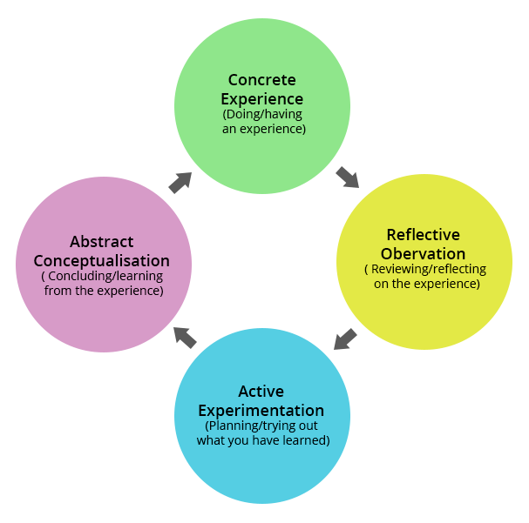
Kolb’s learning style. Source Google
In his style the four stages are:
- Concrete experience (new experiences or reinterpretation of a old experience)
- Reflective observation (reflect the new experience and fully understanding it)
- Active experimentation (applying what you have learned)
- Abstract conceptualisation (learning from the experience). (Psychology, 2017)
What employers want
All employers want a perfect employee. But what makes a perfect employee? I would say there are some skills one must have to be a perfect employee or to fill out the position required. For every job you need a certain type of skill but there are some essential skills that all employers are looking for. Some of them are (STEMNET, 2019):
- Communication skills to be able to understand and make yourself understood.
- Problem solving skills is the ability of breaking a problem in small pieces to find the key problems to find the best solution.
- Working under pressure to always be calm and efficient even when you are working under deadline and to be able to think rational when press by time
- Team working to work well with others and to be easily adaptive when it comes to new team members
- Organizational skill to be organised and to be able to plan work or duties to meet the deadline.
- Ability to learn and adapt to be open minded and to be able to learn from your mistakes.
Before everything it is for the best to have a good CV and Cover Letter. Having those will make it easy for the employer to see if you are the person they are looking for. Before he can meet you and see your visible skills, you must past the writing part(CV & Cover Letter). Having a good CV followed by a Cover Letter is the halfway between you and the job. The first part of a selection, before the interview is going through the application form and the CV’s attached. When applying for a job keep in mind what the job requires and complete the application form as needed for the job you applied. For example, if you apply for a manager position, make sure you have the correct spelling, be short in your expressions but at the same time highlight your ability to communicate effectively. Make sure your CV and Cover Letter is built effectively for the job you apply for.
This are some of the skills I gain and learn aver the years. A good communication is main skill everyone is looking for. At the beginning of my first academic year I was very shy and reserved. My communication was a nightmare. I was afraid to speak in public and even in front of my friends. Was afraid I would say something wrong and they start to laugh at me. Then I began to gain confidants in my abilities, and I started slowly to speak in front of others. Now even at work my colleagues and my bosses keep telling me to be quit. I cannot seem to stop speaking. When you enter the building at my workplace, if I am there, you will hear me from the entrance. Now I can proudly say I started to face my fears and start speaking in from of new people.
One of the key points all employers are after I believe it to be Self-motivation. At the same time self-motivation is an important skill you need to achieve your goals. What is self-motivation?
Self-motivation is according to Cambridge dictionary (Dictionary, 2020) : ability to work without being forced or told to do so. ‘’ Self-motivation is, in its simplest form, the force that drives you to do things.’’ (need, 2020). Self-motivation has some key elements:
- Personal push to achieve (can be defined by ambition)
- Commitment to goals (stay focused on your goals)
- Initiative (start going towards your goal and find ways to achieve it)
- Optimism or resilience (think positive about your achievements) (need, 2020).
Keep in mind that self-motivation is they key factor on personal development. I used to lack this skill and was easily disappointed when things did not go as planned. In this academic year I realised that the first person who needs to help you in order to achieve success is yourself. Being motivated and going towards your goal no matter how far you are is very important. At work I keep applying for a leading position, but I was denied every time. This motivated me to start my studies, and now that I almost finished my first year of university, the senior managers from my workplace change their opinion about me. I was given the opportunity to apply for this position (Team Manager) and I am waiting for my interview in the following weeks. I am optimistic about my chances to be successful.
Personal Development
Personal development is a long-time process. it is a way for individuals to have a clear vision over their skills and qualifications in order to complete their goals (need, 2020). Reflecting on your skills and qualifications can do can bring you the ideas and facts you need to do in order to achieve your goals. You need to be self-aware of your skills and options. Self-awareness is based on the theory that you are not your ideas, you are an observant of your ideas; you are the person who thinks outside and apart form your thoughts (Duval & Wicklund, 1973). When understanding the self-aware theory, it will be easy to make a SWOT Analyses of yourself.
A SWOT Analyse is form of analyse commonly used when evaluating a company position or a person’s development to make strategic plans. It is based on internal and externals factor(see graph below) (Investopedia, 2020).
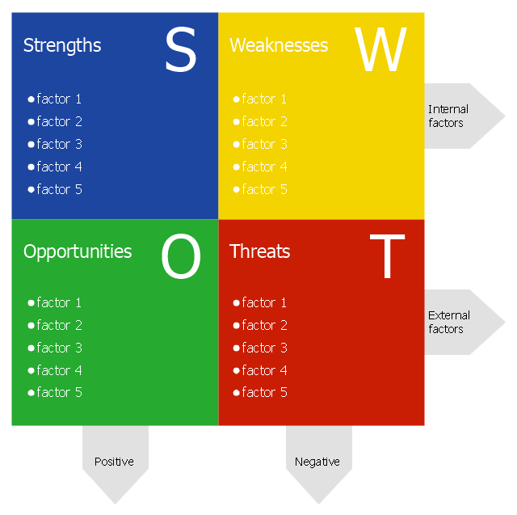
SWOT Analyses graphic. Source Google
I will use myself as an example to make you clearly understand the subject.
Strengths:
- Knowledge of a foreign language
- Open minded and easy to adapt person
- Quick learner with good self-motivation
- Good team worker and understand of teamwork meaning
- Owner of a certificate of higher education
Weaknesses:
- Losing focus when it comes to reading
- Shy when needed to speak with new people
- Small mistakes when it comes to correct grammar
- Being far distance from my family
- Do not have a driving licence
Opportunities:
- Finishing a degree in Leadership and Management
- Applying for a team manager position
- Offered support from work to finish my studies
- Chance of making new friends and acquaintances on a weekly basis
- Starting to learn for a driving licence
Threats:
- Not being accepted a student finance
- More experienced person applying for the same team manager position as me
- Being denied the support from work to finish my studies
- Cannot afford to gain my driving licence
- Covid19 the pandemic virus that keeps killing people
These are most important facts I can think of. After a short analyse of them I realised that some changes must come in place to get the desired outcome. I will start working on my weaknesses first and try to lose them. After successful with my weaknesses I will start to improve my strengths and at the same time I will try to eliminate some of the threats. As time goes by I am aware that new opportunities might become available so I am very optimistic about personal development and my career goals.
Employment Goals
As employment goals it is very simple: less physical work more money. Having this in my mind my first targeted job will be a Team Leader or a Team manager. Off course there is a difference between this two but it not so big. Both are based on team working but there are differences when it comes to act. For example a manager will work to get the job done, while a leader will work to change , develop and implement every possible way to get the job done easily. (Qusus, 2017)
The next step would be a Shift Manager position, where your duties are to coordinate and plan activities having in mind the price, time and labour requirements. At the same time, you must assist in hiring new staff, make sure all shift are covered, lead a team , delegate task and monitor team performance at all times. (seek, 2019)
The next goal is to become a Operational Manager. To do so you must be very experienced in administration-related fields and in business, all this being backed up by a bachelor’s degree or a similar level qualification in business and management. Your experience should include:
- Production manager where you need to identify the processes and the feedback to improve them, ensuring that the work is done smoothly
- Financial Manager where you are to see overall the financial management and to organise financial document with chief operations officer (COO)
- Resource Management where your duties are to increase the efficiency of the HR, IT and finance department as well as communication and coordination. (getsmarter, 2020)
You might think that the chief operations officer is the next stop, but no. Being CEO of a company requires to have a great vision of the company and it is the highest-ranking individual in an organisation. As a CEO you are responsible for the wellbeing of the company and it is required to make important decision to develop or to maintain your business flow. (Inc., 2020)
Conclusion
You must always be aware of your goals and to do everything possible in order to obtain them. No mater what goal you have, you must fight for them. One of the easier ways to keep a clear vision over your goals and to check your progress is a personal development plan (PDP). Using a SWOT analyse makes it easy to complete your PDP. By analysing your Strengths, Weaknesses, Opportunities and Threats you can learn what you need to improve and how to improve it.
My PDP has two main goals: to finish a degree in Leadership and Management and to obtain a job as Operations Manager. I put in my PDP what I need to improve, how to improve it and what I need to fulfil my goals.
I have a long way till success, but I am optimistic that I will be successful. I will keep track of my development and as I go through my achievements, I will update my PDP with more goals. I am aware that new possibilities and opportunities might appear, so I will take time to analyse all of them and see witch one suits me the most. I will use SWOT analyse before making any decision and I will always keep an analytic perception about all the events that are to come my way.
You will find my PDP attached as an appendix on this esay.

References
Board, P. L., 2020. How can you use the Study Without Tears Method in Your Classroom?. [Online]
Available at: https://k12teacherstaffdevelopment.com/tlb/how-can-you-use-the-study-without-tears-method-in-your-classroom/
[Accessed 30 04 2020].
Dictionary, C., 2020. Self-motivation. [Online]
Available at: https://dictionary.cambridge.org/dictionary/english/self-motivated
[Accessed 01 05 2020].
Duval, S. & Wicklund, R. A., 1973. A theory of objective self-awareness. 1st ed. Cambridge: Academic Press Inc.
Edinburgh, T. U. o., 2020. Gibbs' reflective cycle. [Online]
Available at: https://www.ed.ac.uk/reflection/reflectors-toolkit/reflecting-on-experience/gibbs-reflective-cycle
[Accessed 28 04 2020].
getsmarter, 2020. How to Become an Operations Manager. [Online]
Available at: https://www.getsmarter.com/blog/career-advice/become-operations-manager/
[Accessed 06 05 2020].
Institur, C. F., 2020. What is a SMART Goal?. [Online]
Available at: https://corporatefinanceinstitute.com/resources/knowledge/other/smart-goal/
[Accessed 27 04 2020].
Investopedia, 2020. Strength, Weakness, Opportunity, and Threat (SWOT) Analysis. [Online]
Available at: https://www.investopedia.com/terms/s/swot.asp
[Accessed 02 05 2020].
IQDOODLE, 2020. Analytical Think. [Online]
Available at: https://school.iqdoodle.com/framework/competencies/analytical-think/
[Accessed 28 04 2020].
need, S. y., 2020. self-motivation. [Online]
Available at: https://www.skillsyouneed.com/ps/self-motivation.html
[Accessed 01 05 2020].
need, S. y., 2020. What is a personal development?. [Online]
Available at: https://www.skillsyouneed.com/ps/personal-development.html
[Accessed 02 05 2020].
Psychology, S., 2017. Kolb's Learning Styles and Experiential Learning Cycle. [Online]
Available at: https://www.simplypsychology.org/learning-kolb.html
[Accessed 01 05 2020].
Qusus, O. A., 2017. What's the difference between team manager and team leader?. [Online]
Available at: https://specialties.bayt.com/en/specialties/q/337768/what-s-the-difference-between-team-manager-and-team-leader/
[Accessed 05 05 2020].
Saint-Exupéry, A. d., 1935. Quote. [Art] (poet).
seek, 2019. Shift manager. [Online]
Available at: https://www.seek.com.au/career-advice/role/shift-manager
[Accessed 05 05 2020].
STEMNET, 2019. Employability Skills. [Online]
Available at: https://www.exeter.ac.uk/ambassadors/HESTEM/resources/General/STEMNET%20Employability%20skills%20guide.pdf
[Accessed 01 05 2020].
Teach, 2020. Learning Styles. [Online]
Available at: https://teach.com/what/teachers-know/learning-styles/
[Accessed 30 04 2020].
University of Birmingham, 2015. A short guide to reflective writing, Birmingham: University of Birmingham.
Wikijob, 2020. Interpersonal Skills. [Online]
Available at: https://www.wikijob.co.uk/content/interview-advice/competencies/interpersonal-skills
[Accessed 30 04 2020].

Appendix



