Josh Jones (2501946)

Operating systems assignment
Computer Architecture & Operating Systems – Computing Portfolio
Table of Contents
Introduction 4
Key functions of general Operating Systems 4
Process Management 4
Memory Management 4
File System Management 5
Device Management 5
Security and Access Control 5
User Interface 5
References 5
Use of Windows OS CLI commands 6
Process Management 7
Tasklist 7
Taskkill 7
Get-Process 8
File & Directory Management 9
DIR 9
MD 9
Network Testing / Monitoring 10
Ping 10
Ipconfig 10
Netstat 11
User Management 11
Net user 11
Net localgroup administrators 12
Task Scheduling 13
schtasks 13
Schtasks /create 13
References 14
Use of Linux OS CLI commands 15
Process Management 15
PS aux 15
Kill 16
File & Directory Management 16
mkdir 16
ls 16
cp 17
rm 17
chmod 17
Network Testing / Monitoring 17
ping 17
cat 18
User Management 18
whoami 18
useradd 18
id root 19
Task Scheduling 19
crontab -e 19
crontab -l 19
References 20
Use of Windows OS scripts 20
@Echo off & Basic Output (Bat 0 & 1) 20
Variables (Bat 2) 21
Numbers & Operators (Bat 3) 22
Goto (Bat 4) 23
Input, If & Goto (Bat 5) 24
Arrays (Bat 6) 24
Functions (Bat 7) 25
Text Adventure Game (Bat 8) 26
References 28
Use of Linux OS scripts 29
Bat 1 29
Bat 2 29
Bat 3 29
Bat 4 30
Bat 5 30
Bat 6 31
Bat 7 31
Bat 8 32
References 32
Conclusion 33
Reference list 34
Key functions of general Operating Systems 34
Use of Windows OS CLI commands 34
Use of Linux OS CLI commands 35
Use of Windows OS scripts 35
Use of Linux OS scripts 35
Appendices 36
Tutorial Activities 36
Lecture Log 36
Evidence of engagement 37

Introduction
The report highlights the noticeable features of operating systems (OS), both from a theoretical point of view as well as practical implementation. After a brief description of what is an OS and its basic functionalities, the report proceeds to practical demonstration of various command line utilities on both Windows and Linux platforms. This involves Batch and PowerShell commands, Windows Batch scripting, Bash commands and Linux Bash scripting, each backed up by code snippets and screenshots.

Key functions of general Operating Systems
An operating system is a type of system software that manages and controls the resources and computing capability of a computer and provides users a logical interface for accessing the physical computer to execute applications. As covered in your lecture notes, it acts as an intermediary between the hardware and the user, managing the CPU, memory, storage, and handling tasks like file management, input/output control, and security. The five most commonly used general-purpose OSs are Windows, macOS, Linux, Android, and iOS.

Process Management
Operating systems handle the creation and deletion of processes, allocate processing power and other resources, schedule their execution, manage process communication and synchronisation, and handle deadlocks. Time-sharing systems allocate only a small amount of CPU time to each process in turn to ensure the system remains responsive. This is especially important in desktop OSs like Windows and macOS, which your tutorials note are designed to support multitasking.

Memory Management
Memory management handles primary memory, keeping track of each memory location regardless of whether it is allocated to a process or free, and deciding which process will get memory and at what time. When RAM becomes full, the OS uses a portion of the hard disk as virtual memory, temporarily moving data from RAM to disk so other processes can use physical memory

File System Management
Your tutorials note that file management is one of the core features of desktop operating systems like Windows, macOS, and Linux. Programs need to read and write files and directories, create and delete them, search them, and list file information which are all governed by permission management handled by the OS file system.

Device Management
Device management controls peripheral devices by sending them commands in their proprietary machine language. The software routine that deals with each device is called a driver, and the OS requires drivers for each peripheral attached to the computer.

Security and Access Control
Operating systems provide password protection to keep unauthorised users out of the system, and activity logs are maintained. They generally also provide backup and recovery routines for starting over in the event of a system failure. Your tutorials also highlight that server OSs such as Windows Server and Red Hat Enterprise Linux place a particular emphasis on security and stability given they serve multiple users simultaneously.

User Interface
Operating systems provide either a graphical user interface (GUI) or a command-line interface (CLI). GUIs provide a visual interface with windows, icons, buttons, and menus, making them more intuitive and accessible to users with varying levels of technical expertise. As your tutorials note, user-friendliness is a primary design goal of desktop OSs like Windows and macOS

References
[1] A. Silberschatz, P. B. Galvin, and G. Gagne, Operating System Concepts, 10th ed. Hoboken, NJ: Wiley, 2018.
[2] GeeksforGeeks, "Introduction to Operating System," 2024. [Online]. Available: https://www.geeksforgeeks.org/operating-systems/introduction-of-operating-system-set-1/
[3] TutorialsPoint, "Operating System: Memory Management," 2024. [Online]. Available: https://www.tutorialspoint.com/operating_system/os_memory_management.htm
[4] HostingAdvice, "What Is an Operating System?" 2024. [Online]. Available: https://www.hostingadvice.com/how-to/what-is-an-operating-system/
[5] The Free Dictionary / FOLDOC, "General-purpose operating system," 2024. [Online]. Available: https://encyclopedia2.thefreedictionary.com/General-purpose+operating+system
[6] Unstop, "15 Functions of Operating Systems Explained," 2024. [Online]. Available: https://unstop.com/blog/functions-of-operating-system

Use of Windows OS CLI commands

Process Management

Tasklist
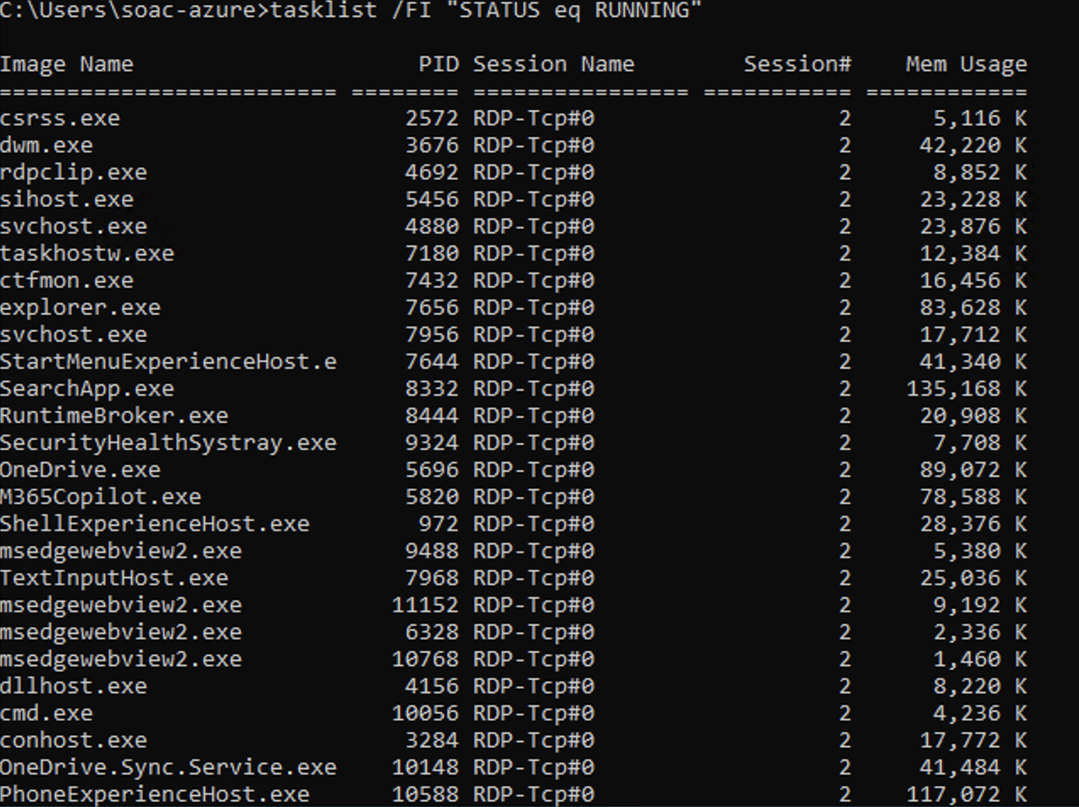
This lists all currently running processes by using the /FI switch to filter by status which will be useful for monitoring active processes without scrolling through everything on the system.

Taskkill
This force terminates a process by its image name using /IM and /F. The /F switch makes sure the process is killed even if it isn't responding.

Get-Process
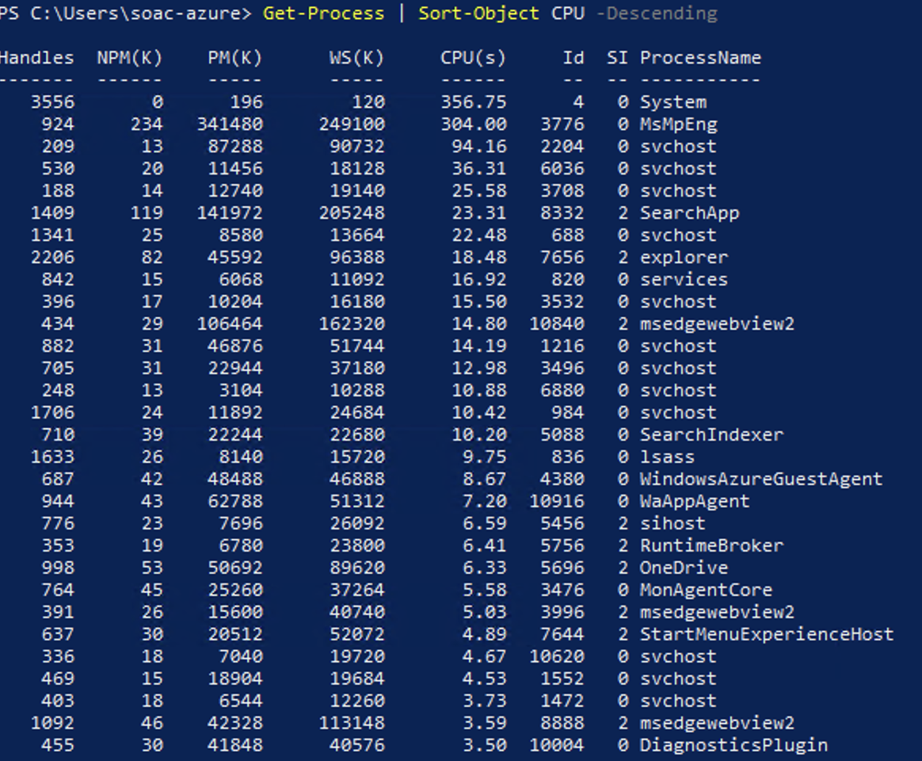
This is a PowerShell command that grabs all running processes and sorts them by CPU usage in descending order which makes it easy to find resource-heavy applications.

File & Directory Management

DIR
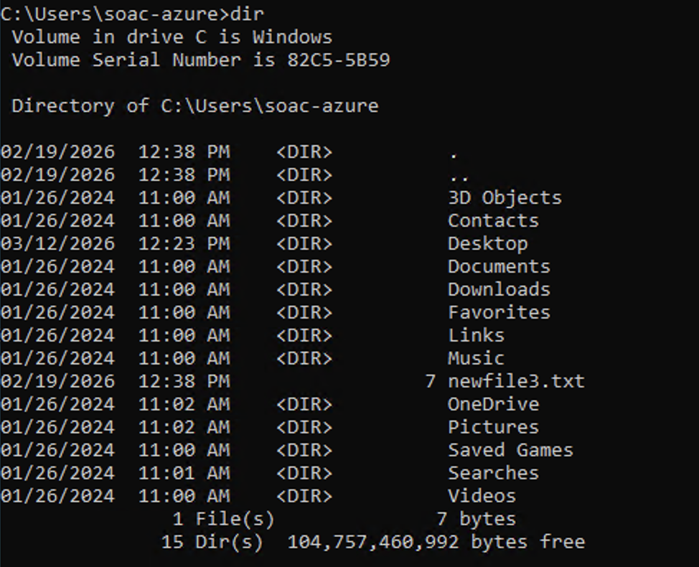
This shows a list of all files and directories within the current working directory. The output includes each item's name, file size and even the date and time it was last modified as well as a summary at the bottom showing the total number of files and the remaining disk space.

MD
This creates a new directory called "TestFolder" in the current working location.

Network Testing / Monitoring

Ping
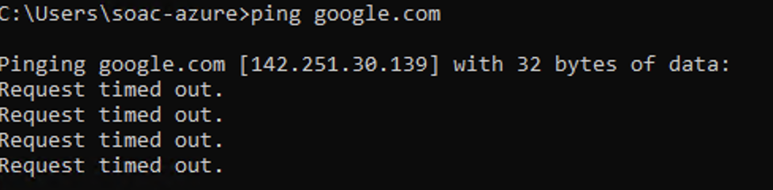
This sends a continuous stream of requests to google.com with no limit on the number of packets. It will send 4 pings and then at the end, it will show a summary of packets sent, received and lost.

Ipconfig
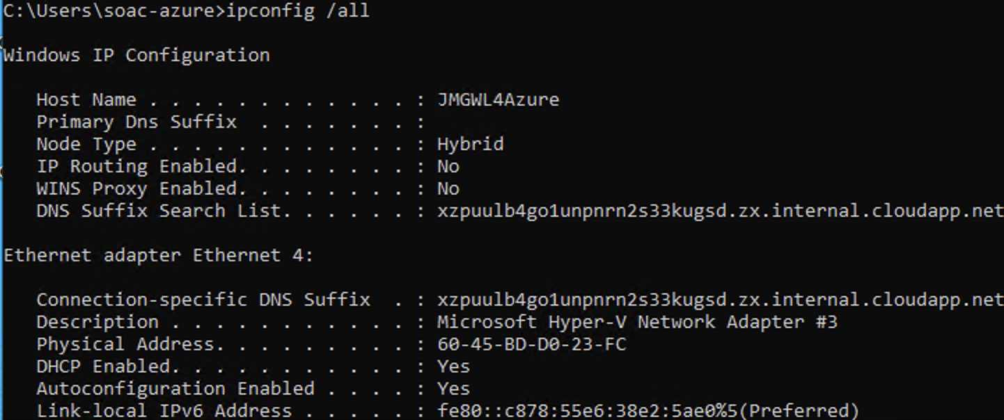
This shows full network adapter configuration including the IP address, subnet mask, default gateway and MAC address. The /all switch reveals details hidden in the basic ipconfig output.

Netstat
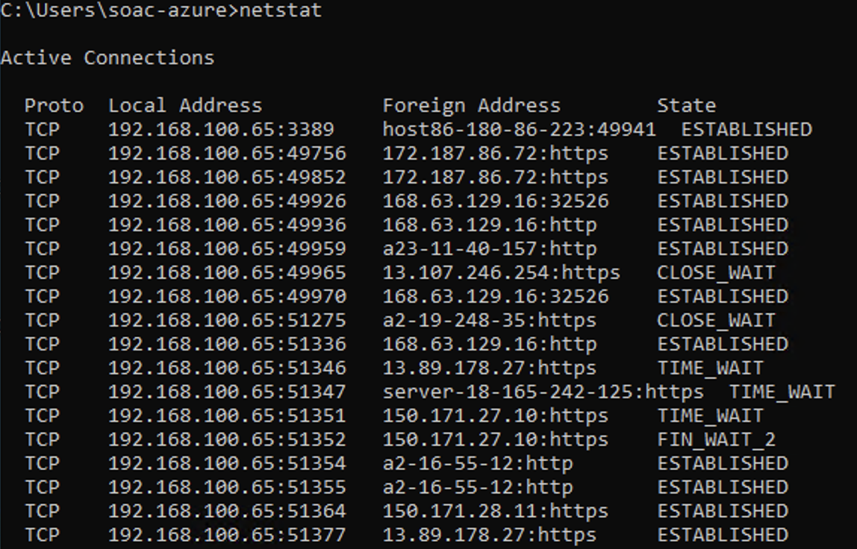
This shows all active network connections and listening ports.

User Management

Net user
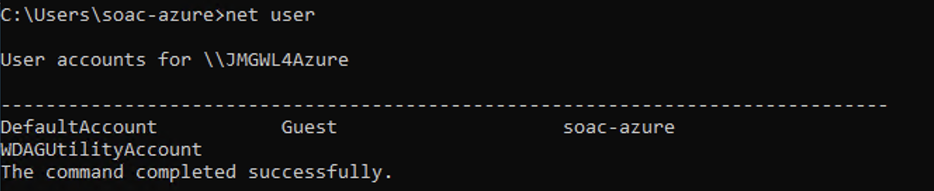
This lists all local user accounts on the machine. This is a simple but important command for seeing who has access to the system.

Net localgroup administrators
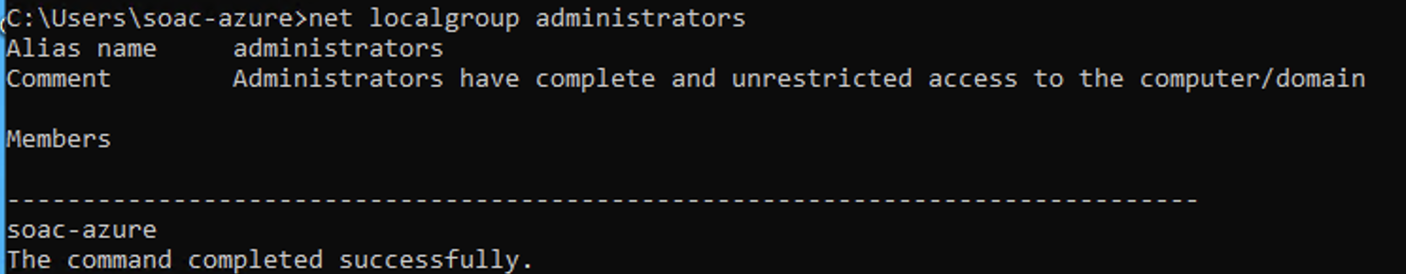
This shows all members of the local Administrators group.

Task Scheduling

schtasks
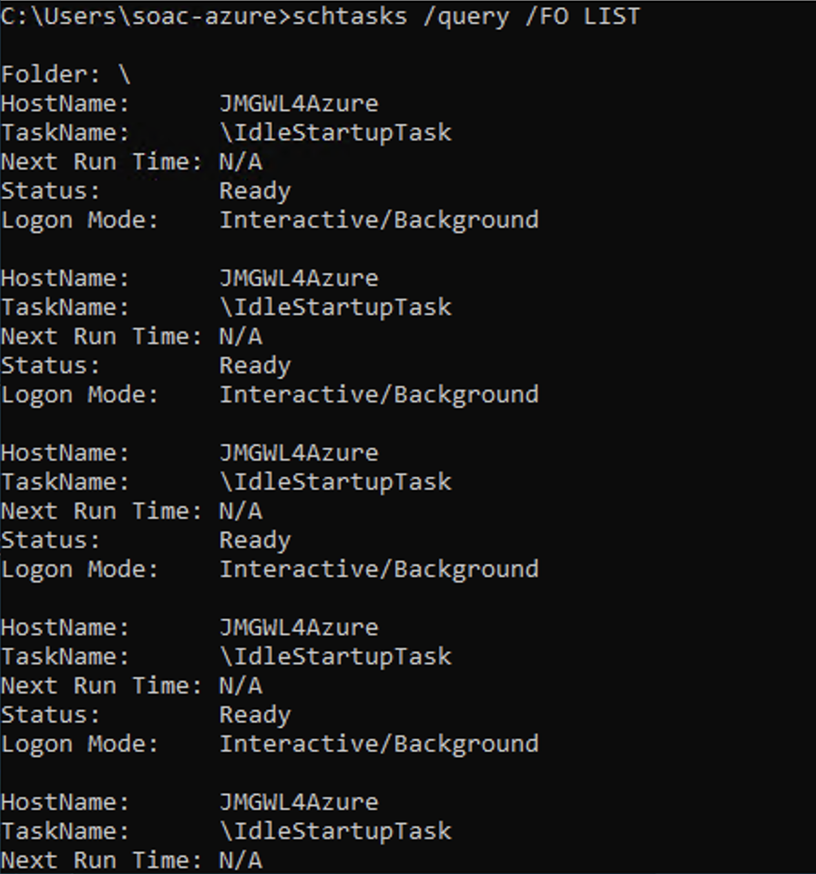
This finds all scheduled tasks on the system and shows them in list format using /FO LIST. This gives a breakdown that’s easy to read of every task, its status and its next run time.

Schtasks /create
This creates a new scheduled task called "MyBackup" that runs a batch file daily at 10pm. /SC sets the schedule frequency where /TN names the task and where /TR points to the file to run, and /ST sets the start time.

References
[1] Microsoft, "Windows Commands," 2024. [Online]. Available: https://learn.microsoft.com/en-us/windows-server/administration/windows-commands
[2] Microsoft, "PowerShell Documentation," 2024. [Online]. Available: https://learn.microsoft.com/en-us/powershell
[3] SS64, "Windows CMD Reference," 2024. [Online]. Available: https://ss64.com/nt

Use of Linux OS CLI commands

Process Management

PS aux
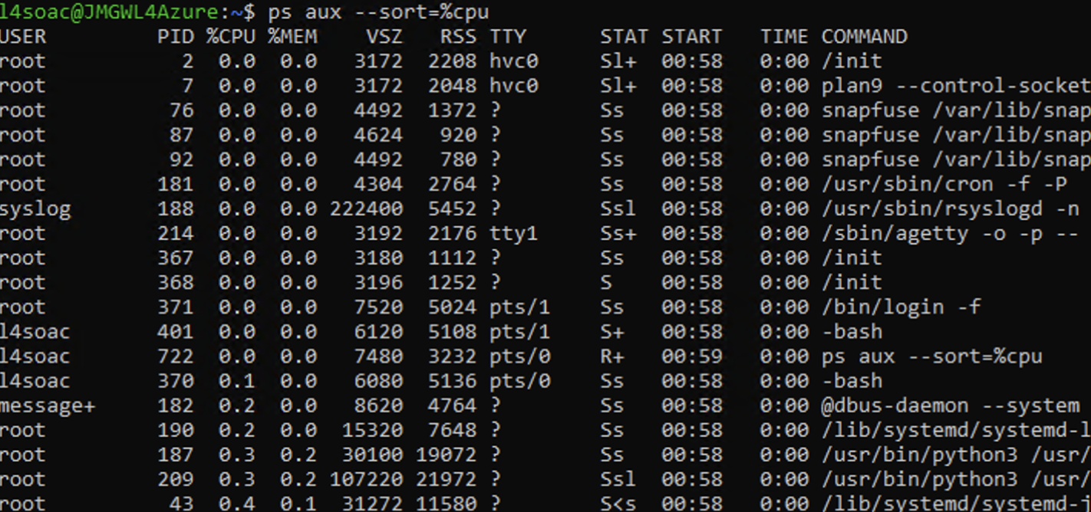
This lists all running processes for all users (a = all users, u = user-oriented format, x = includes processes not attached to a terminal). The –sort=%cpu flag orders them by CPU usage highest first which makes it easier to spot which processes are consuming the most resources.

Kill
This terminates a process by its Process ID using signal 9 (SIGKILL), which forces an immediate stop with no cleanup.

File & Directory Management

mkdir
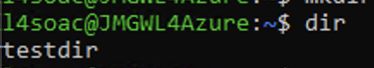
This creates a directory and any necessary parent directories in one command using the -p flag. Without -p, the command would fail if the parent directory didn't already exist.

ls
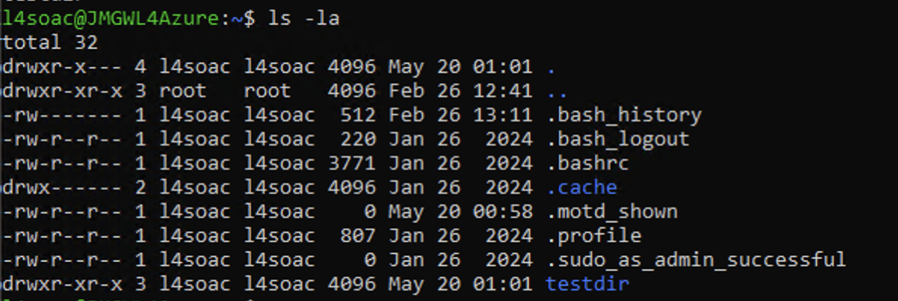
This lists all files and directories including hidden ones (those beginning with .) in long format and shows permissions, owner, file size, and last modified date for each item.

cp
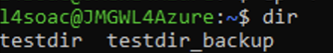
This copies an entire directory and its contents recursively using the -r flag. Without this flag, the cp command would only copy individual files and would fail on directories.

rm
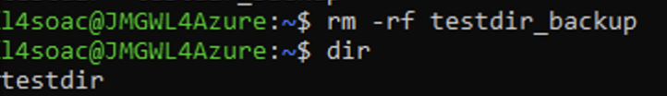
This deletes a directory and all its contents recursively and forcefully. The -r flag handles directories and -f suppresses any confirmation prompts.

chmod
This changes the permissions of a file or directory. 755 grants the owner full read/write/execute permissions while group and other users get read and execute only.

Network Testing / Monitoring

ping
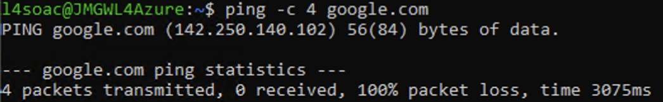
This sends exactly 4 request packets to google.com using the -c flag to limit the count and tests basic network connectivity and shows round-trip latency for each packet, finishing with a summary of packets sent, received, and lost.

cat
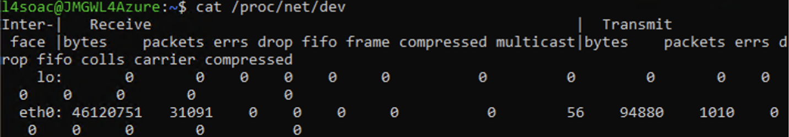
This reads the Linux kernel's network statistics file directly and shows the bytes and packets transmitted and received on each network interface.

User Management

whoami
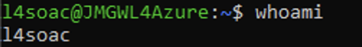
This shows the username of the currently logged-in user. It’s a simple but useful command to confirm which account is active and especially when switching between users or working with elevated privileges.

useradd
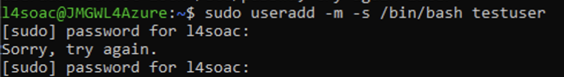
This makes a new user account called "testuser". The -m flag automatically creates a home directory for them and -s sets their default shell to Bash.

id root
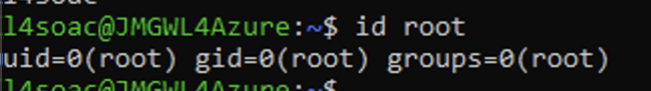
This shows the user ID (UID), group ID (GID) and all group memberships for a specified user.

Task Scheduling

crontab -e
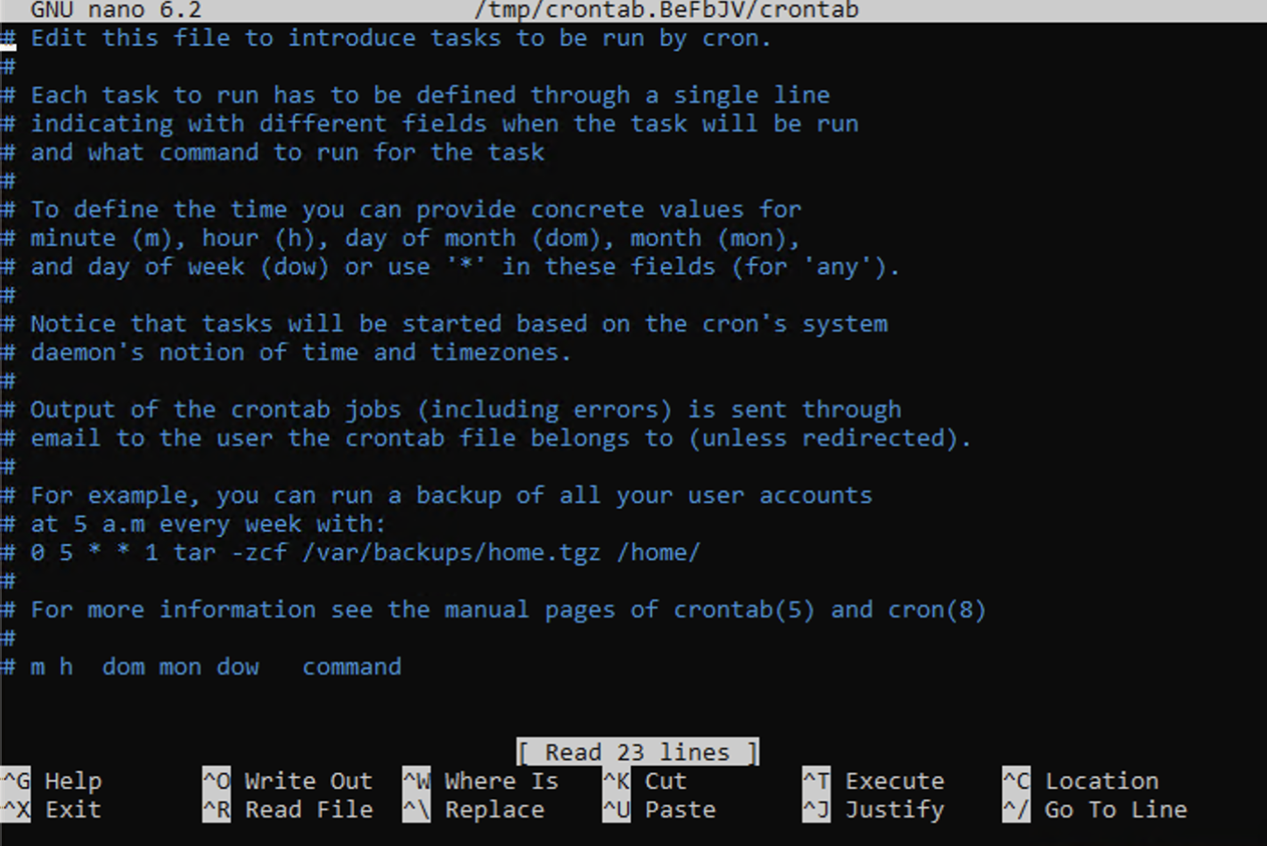
This opens the cron table for the current user which allows you to create, edit or remove scheduled tasks.

crontab -l
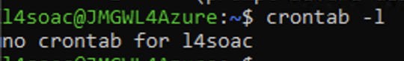
This lists all currently scheduled cron jobs for the active user without opening the editor.

References
[1] The Linux Documentation Project, "Bash Guide for Beginners," 2024. [Online]. Available: https://tldp.org/LDP/Bash-Beginners-Guide/html
[2] Microsoft, "Windows Subsystem for Linux Documentation," 2024. [Online]. Available: https://learn.microsoft.com/en-us/windows/wsl
[3] A. Silberschatz, P. B. Galvin, and G. Gagne, Operating System Concepts, 10th ed. Hoboken, NJ: Wiley, 2018.
[4] SS64, "Bash Command Reference," 2024. [Online]. Available: https://ss64.com/bash

Use of Windows OS scripts

@Echo off & Basic Output (Bat 0 & 1)
@Echo off is placed at the top of every script to stop the command prompt from printing each line of code as it runs which keeps the output clean. Echo is then used to print text to the screen. Bat 1 also uses Title to set the window title and :: to add a comment, which is a line the script ignores entirely.

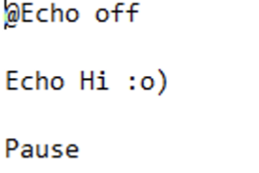
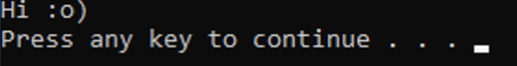

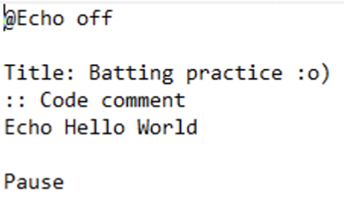
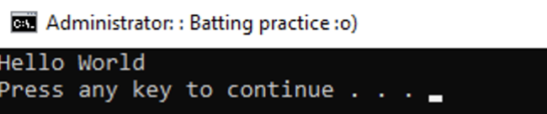

Variables (Bat 2)
Variables are declared using set. Plain set name=Stephen stores a string where set /A age=21 uses the /a flag to store a numeric value. Variables are then accessed by wrapping the name in percentage signs: %name%. It also shows a string chain by building a full sentence from multiple variables into a single %info% variable.

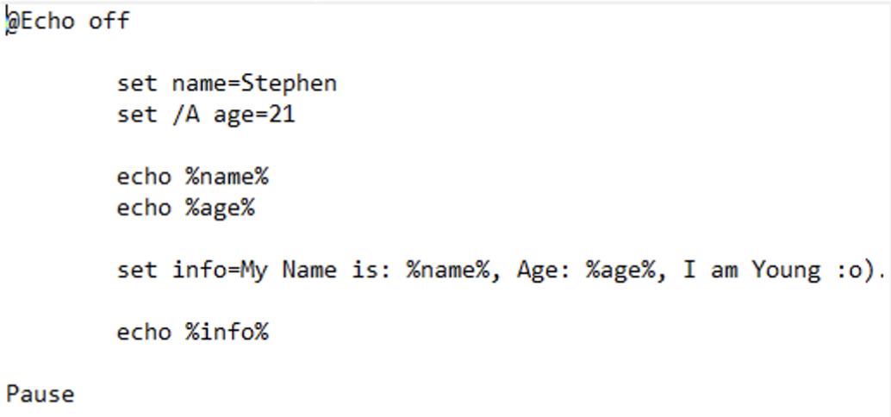
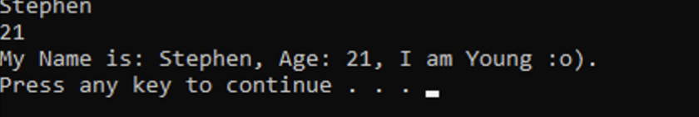\

Numbers & Operators (Bat 3)
Arithmetic is handled using set /a with standard operators and this command states two variables and then calculates their sum with set /a sum = a + b and shows the result with echo.

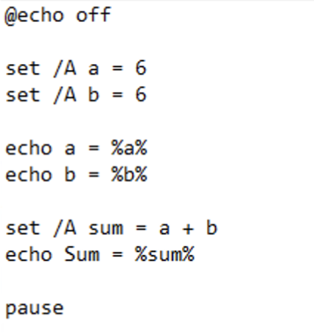
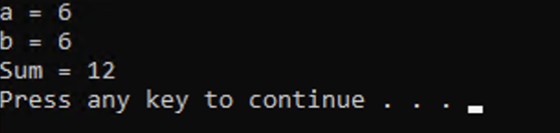

Goto (Bat 4)
Goto redirects execution to a labelled section of the script which is defined with a colon prefix like :CodeJump. Any code between the Goto and the label is skipped entirely & this is Batch's primary flow control mechanism.

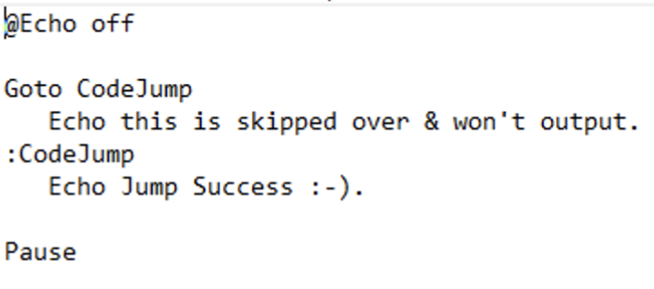
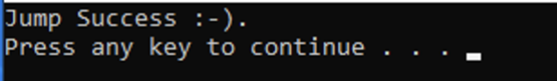

Input, If & Goto (Bat 5)
Set /p pauses execution and waits for user input to store it in a variable. It also uses this alongside an if statement to branch based on the answer where if the user types Y it thanks them, otherwise goto Name loops the script back to the start.

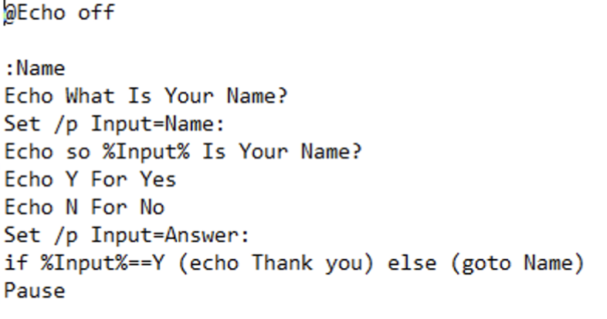
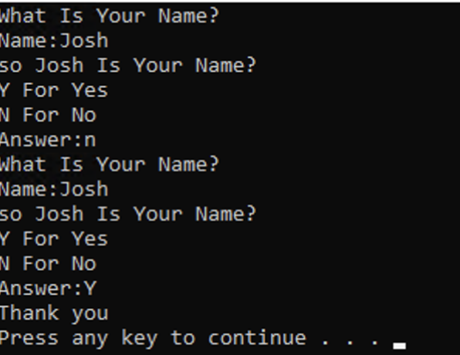

Arrays (Bat 6)
Batch has no native array type so arrays are replicated using indexed variable names like NameArray[0], NameArray[1] and so on. Each index is a separate variable and this bat command also shows declaring, reading and reassigning array values as well as using @Rem as an alternative comment syntax.

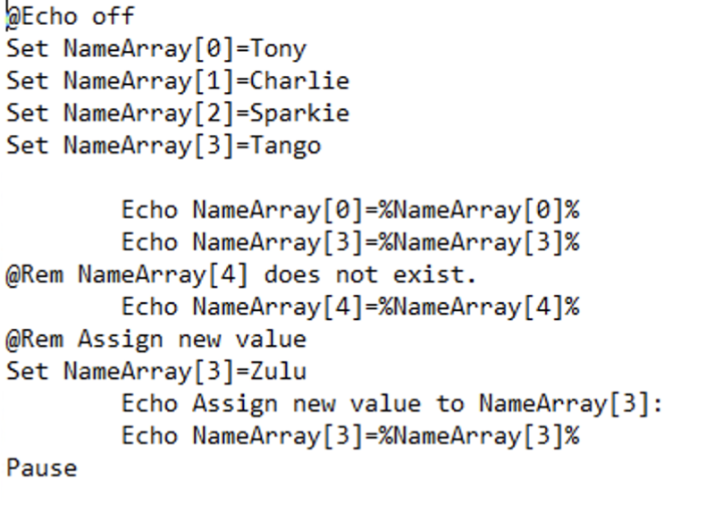
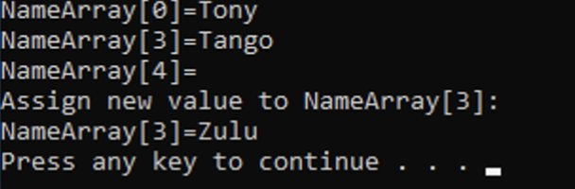

Functions (Bat 7)
Functions are created using labels and called with Call :function_echo. Exit /B is used to return from the function back to the main script without closing the window entirely, it specifically exits only the current subroutine rather than the whole script.
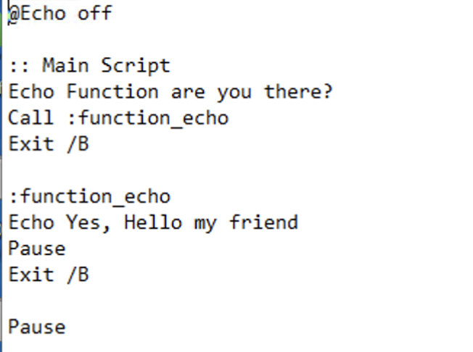
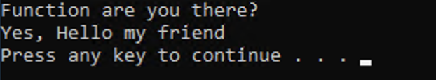

Text Adventure Game (Bat 8)
This bat command brings all the above features together like Color 4e sets the console colour, Set /p captures user input, multiple if statements that branch to labelled sections using goto, Cls clears the screen between scenes and Pause >nul suppresses the "press any key" message.
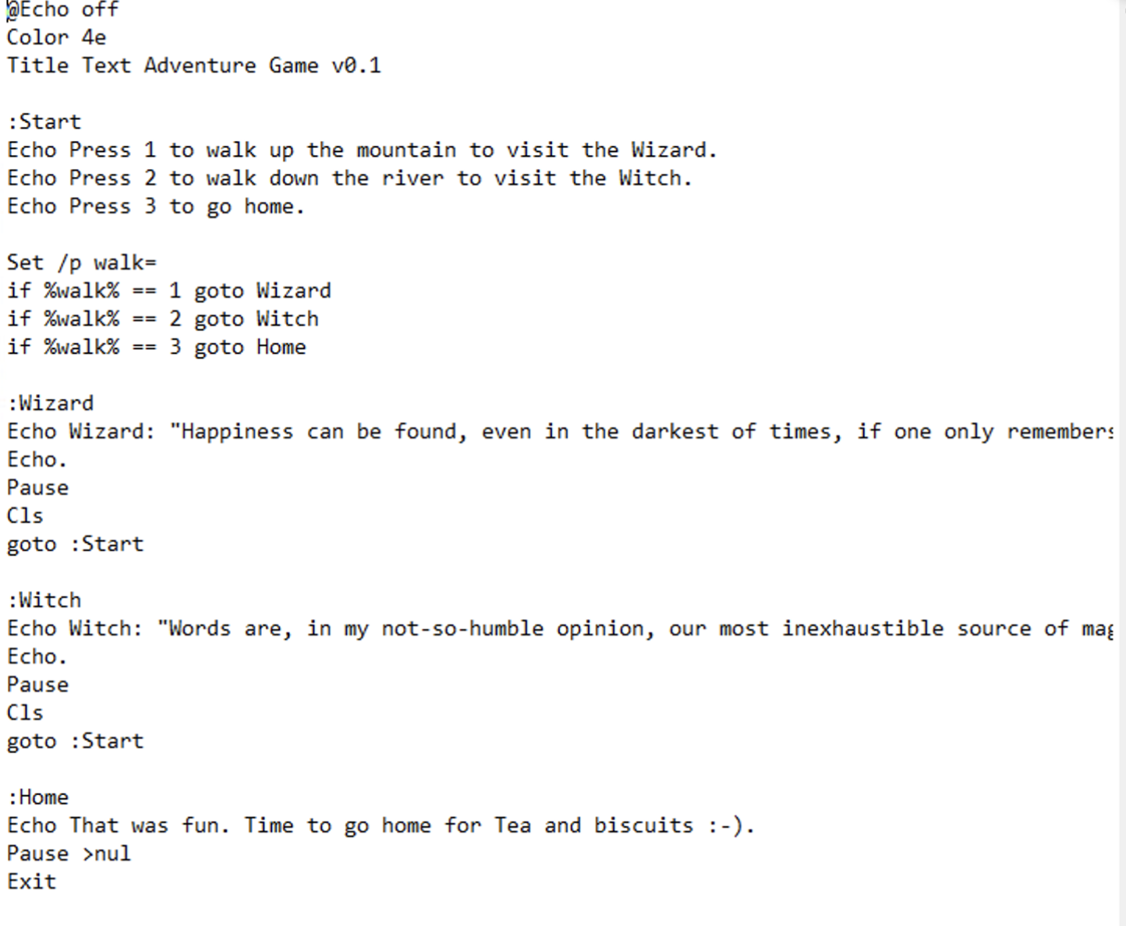
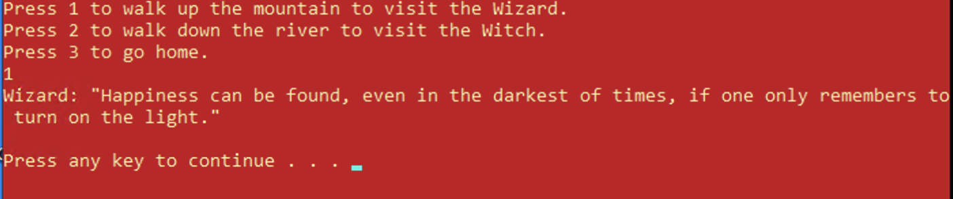
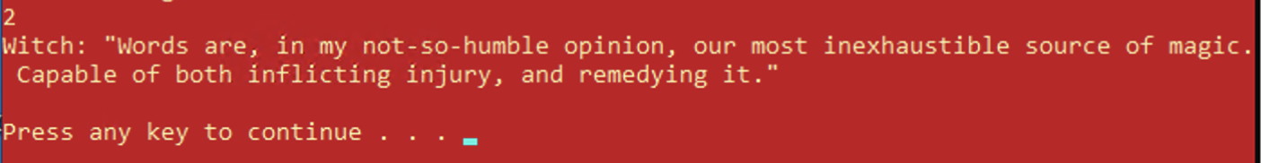

References
[1] Microsoft, "Windows Commands," 2024. [Online]. Available: https://learn.microsoft.com/en-us/windows-server/administration/windows-commands/windows-commands
[2] SS64, "Batch File Commands A-Z," 2024. [Online]. Available: https://ss64.com/nt
[14] W3Schools, "Batch Scripting," 2024. [Online]. Available: https://www.w3schools.com/bash/bash_script.php

Use of Linux OS scripts

Bat 1
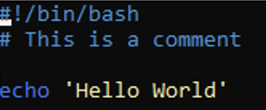
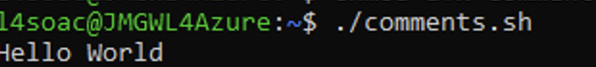
Every Bash script begins with #!/bin/bash on the first line — known as the sha-bang. This tells the OS the location of the Bash interpreter that will run the script. The # symbol is used to write single-line comments, which are ignored during execution.

Bat 2
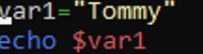
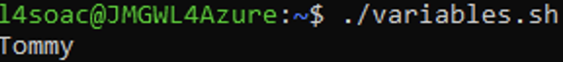
Variables are declared by assigning a value using = with no spaces either side. To access a variable's value, the $ dollar symbol is placed before the variable name. Bash variables are not strongly typed — everything is treated as a string by default.

Bat 3
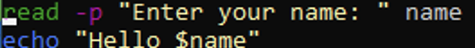
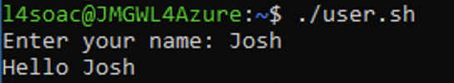
The read command pauses the script and waits for keyboard input, storing it in a named variable. The -p option allows the prompt text to appear on the same line as the input cursor.

Bat 4
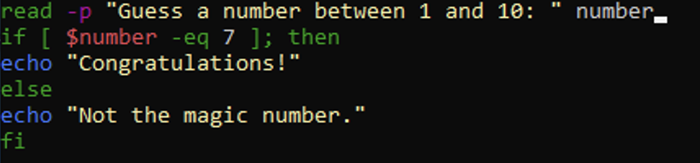
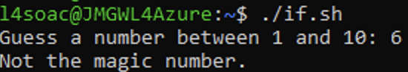
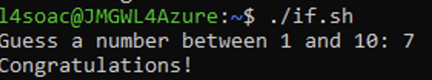
if statements execute code based on whether a condition is true. The condition is placed inside square brackets [ ] with a space either side. The block ends with fi (if backwards), and an else branch handles the false case.

Bat 5
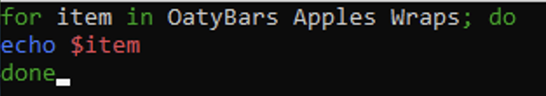
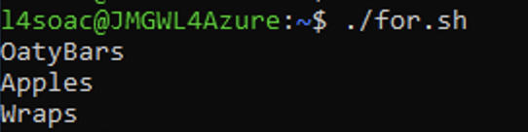
For loops iterate through a list of items and then perform code on each one. The do keyword starts the code block and done ends it.

Bat 6
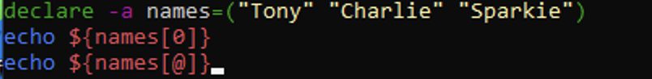
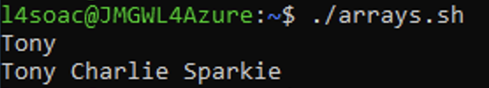
Arrays are declared using the declare keyword. Individual elements are accessed using ${ArrayName[index]} and the @ symbol can be used to print all elements at once.

Bat 7
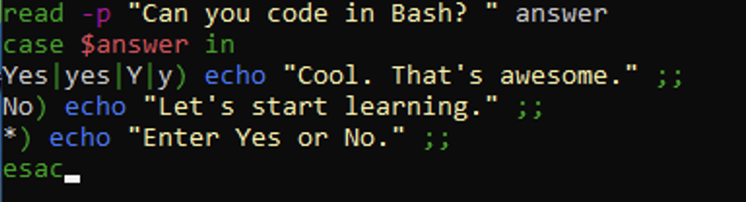
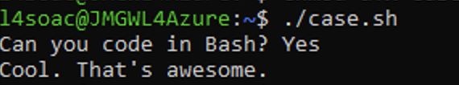
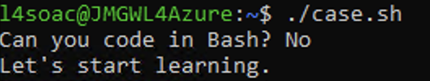
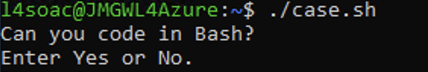
A case statement matches a variable's value against multiple patterns and then performs the matching block. The | pipe separates alternative patterns, ;; ends each case, * acts as a default catch-all, and esac closes the statement.

Bat 8
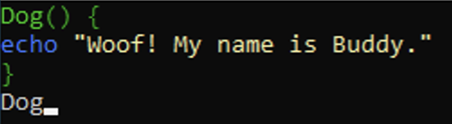
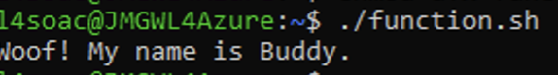
Functions are declared with a name followed by () and curly braces {} containing the code. They are called simply by typing the function name. Values can be passed to functions and accessed inside using $1, $2 etc.

References
[1] TutorialsPoint, "Unix / Linux — What is Shell?" 2024. [Online]. Available: https://www.tutorialspoint.com/unix/unix-what-is-shell.htm
[2] The Linux Documentation Project, "Bash Guide for Beginners," 2024. [Online]. Available: https://tldp.org/LDP/Bash-Beginners-Guide/html
[3] Guru99, "Introduction to Shell Scripting," 2024. [Online]. Available: https://www.guru99.com/introduction-to-shell-scripting.html

Conclusion

This has discussed various important aspects of the operation of systems ranging from basic functionalities to command line and script programming under both Windows and Linux systems.
It was recognized that an OS serves as a very important interface between hardware and the user, performing critical operations like process management, memory management, file management, device management, and security, which are important for ensuring the smooth functioning of any computer system. This was further illustrated using command line techniques under Windows Batch and PowerShell programming, including functionalities like process management, file management, networking, user management, and task scheduling.
The scripting part discussed the use of Batch and Bash languages for developing various applications and automating processes. Important concepts covered in this section included variables, user input, conditionals, loops, arrays, case statement, and function. While Batch language is suitable for Windows automation purposes, Bash language has proved to be much more flexible, and executing Bash scripts on a Windows machine using WSL on an Azure VM was quite easy.

Reference list

Key functions of general Operating Systems
[1] A. Silberschatz, P. B. Galvin, and G. Gagne, Operating System Concepts, 10th ed. Hoboken, NJ: Wiley, 2018.
[2] GeeksforGeeks, "Introduction to Operating System," 2024. [Online]. Available: https://www.geeksforgeeks.org/operating-systems/introduction-of-operating-system-set-1/
[3] TutorialsPoint, "Operating System: Memory Management," 2024. [Online]. Available: https://www.tutorialspoint.com/operating_system/os_memory_management.htm
[4] HostingAdvice, "What Is an Operating System?" 2024. [Online]. Available: https://www.hostingadvice.com/how-to/what-is-an-operating-system/
[5] The Free Dictionary / FOLDOC, "General-purpose operating system," 2024. [Online]. Available: https://encyclopedia2.thefreedictionary.com/General-purpose+operating+system
[6] Unstop, "15 Functions of Operating Systems Explained," 2024. [Online]. Available: https://unstop.com/blog/functions-of-operating-system

Use of Windows OS CLI commands
[1] Microsoft, "Windows Commands," 2024. [Online]. Available: https://learn.microsoft.com/en-us/windows-server/administration/windows-commands
[2] Microsoft, "PowerShell Documentation," 2024. [Online]. Available: https://learn.microsoft.com/en-us/powershell
[3] SS64, "Windows CMD Reference," 2024. [Online]. Available: https://ss64.com/nt

Use of Linux OS CLI commands
[1] The Linux Documentation Project, "Bash Guide for Beginners," 2024. [Online]. Available: https://tldp.org/LDP/Bash-Beginners-Guide/html
[2] Microsoft, "Windows Subsystem for Linux Documentation," 2024. [Online]. Available: https://learn.microsoft.com/en-us/windows/wsl
[3] A. Silberschatz, P. B. Galvin, and G. Gagne, Operating System Concepts, 10th ed. Hoboken, NJ: Wiley, 2018.
[4] SS64, "Bash Command Reference," 2024. [Online]. Available: https://ss64.com/bash

Use of Windows OS scripts
[1] Microsoft, "Windows Commands," 2024. [Online]. Available: https://learn.microsoft.com/en-us/windows-server/administration/windows-commands/windows-commands
[2] SS64, "Batch File Commands A-Z," 2024. [Online]. Available: https://ss64.com/nt
[14] W3Schools, "Batch Scripting," 2024. [Online]. Available: https://www.w3schools.com/bash/bash_script.php

Use of Linux OS scripts
[1] TutorialsPoint, "Unix / Linux — What is Shell?" 2024. [Online]. Available: https://www.tutorialspoint.com/unix/unix-what-is-shell.htm
[2] The Linux Documentation Project, "Bash Guide for Beginners," 2024. [Online]. Available: https://tldp.org/LDP/Bash-Beginners-Guide/html
[3] Guru99, "Introduction to Shell Scripting," 2024. [Online]. Available: https://www.guru99.com/introduction-to-shell-scripting.html

Appendices

Tutorial Activities
https://uowtsd-my.sharepoint.com/:w:/g/personal/2501946_student_uwtsd_ac_uk/IQCp6nBMMiOcT5O78HL7eqvcARErSLfn-kTuzegFsHF_FE4?e=ellDcy

Lecture Log
https://uowtsd-my.sharepoint.com/:w:/g/personal/2501946_student_uwtsd_ac_uk/IQALn6xYo8OdR64UMajzP8ulAcF1toi71mTmN7LmBl29xPU?e=OdhLNQ

Evidence of engagement


