Introduction
The world is now a global village, thanks to technology. “We live in a global world where technology, especially information and communication technology, is changing the manner in which businesses create and capture value, how and where we work, and how we interact and communicate” (https://www.researchgate.net/publication/299400943_How_Technology_Is_Changing_Work_and_Organizations [accessed Jan 11 2019]). Technology is changing the world and the way people do things. It is very easy to work in any part of the world now because of technology. Meetings can be held all over the world with people in different locations because of the use of technology. The emergence of Skype, Whatsapp, emails, text messages, phone calls even conference calls now make it easy for business owners to carry on work without missing out on any aspect of work.
The technology world has been growing and flourishing the interest in designing technologies that mediate and create a feeling of relatedness within interpersonal relationships beyond the explicit verbal communication (Hassenzahl, Heidecker, Eckoldt, Diefenbach, & Hillman, 2002)
Modern technology have changed things in the world to make it easier for people to carry out daily tasks, for example, the e messaging, e procurement, check out services in shops, cloud storage facilities, etc. This can be argued by some scholars as something good but also, it can also be argued by others as not such a good thing.
Effectiveness of modern technology
In today’s organizations one of the things that make organizations unique is the use of modern technological gadgets. Both internal and external forces such as market competition, consumer behaviour, technology and quality management are the drivers of organizational change In today’s business world, every office requires facts and accurate information for quick decision making (Akpomi and Ordu, 2009). This has made technology effective and yielding results overtime in the recent business world. Companies are increasing sales because robots and automated machines are now taking over the role of humans in rendering services. Examples are the use of check out services in shops, the use of automated phone calls to handle customer queries.
For community organisations, technology is seen as a means to contribute to organisational efficiency and effectiveness, in addition to contributing to social capital and community building. Modern community organisations are characterised by virtual relationships and distributed professional communities. (https://www.aracy.org.au/publications-resources/command/download_file/id/159/filename/Using_information_and_communication_technology_in_the_workplace.pdf>). It has been proven to increase profitability as more companies have access to more information than ever. The world being a global village aids this as it breaks unseen barriers and information is being passed on as quickly as possible if needed. Though technology in the workplace can be seen from the positive light, it has also been the problems that some organisations face. Listed below are some of the pros and cons of modern technology.
Pros and cons of Modern technology
Advantages of technology in the workplace
- With the modern use of cell phone and laptops, people can work anywhere virtually. They can always be reached if need be by their bosses or work colleagues. Employees can easily interact and exchange any needed information between each other at any given time. Example will be the use of conference phone calls for meetings. Everyone can have their input even when they are not physically available for the meetings. It also aids doing
- With the easy access to modern technology, people have become very creative with building aps that make work easier for them to carry out. They Workers can use different business technologies to create innovative business ideas which can be used in business growth and expansion. Many companies create technological challenges and reward employees who come up with creative ideas using technology. Employees can use internet technology to innovate ways of promoting a business online. Social enterprise networks like Yammer.com can be used by employees to socialize and interact with other creative employees from different organizations, this interaction will result into information exchange and it also encourages brain storming on various work related issues.
- Technology in the workplace can change the way human resource managers do their job. It improves on the process of screening, recruiting and hiring new employees. Many human resource managers are using internet to advertise job openings. Targeted candidates will be in position to apply for these positions online by submitting their resumes to the human resource manager. The all process saves time and it makes the human resource managers work easier. Technology can also be used to track performance and productivity of each employee at work. Once employees are aware that they are being monitored, their productivity will increase.
- Technology can be used to automate various tasks at work; this automation will guarantee efficiency and will also increase on production at work. The use of computers to accomplish specific tasks at work creates room of making corrections on instant and it also reduces on human errors. Using databases to capture and store information can facilitate quick decision making at work. Employees can easily access business information via one single database; this information can be edited and saved for later use. Use of internal networks at the workplace can help in sharing of gadgets like printers and scanners, so employees do not have to move to different departments to share technological tools.
- The use of internet and computers to work has eliminated space and time boundaries. Employees can work from anywhere at any time, this mobility makes employees stay in control of their jobs. Technological tools like virtual meeting applications save us time, we don’t have to be in meetings physically yet information and data will be shared in real-time. For example, mobile workforce management software allows field workers to access real-time work order information when they’re on the job.

Disadvantages of Technology in the Workplace:
- People are constantly looking at their phones and hence this distracts people from carrying out their work. Also, they are days where the conference calls are so loud and this distracts other colleagues when they are doing their work. The use of social media at work also is a major distraction and hence, employers have blocked out the use of social media from work computers.
- Modern technology is expensive, it is expensive to buy technology, it expensive to set it up and it is also expensive to keep it running and maintaining it. For best performances of technology, it has to be maintained so that it can produce accurate results.
- Work environment should also be sociable, but this is lost by the use of modern day technology. Social and interpersonal skills which should be important skills for employment are now missing because face to face meetings and communication have become a thing of the past. Interactions have been killed because of modern technology tools. People are now more into themselves rather than knowing about the other person ad striking conversations.
- There are high risks associated with the use of modern technology. The main risk being with data security and issue with viruses and spam messages. Hackers are always looking for ways to hold companies to ransom so that they get paid money. Monitoring usage is very difficult and trusting information with people is also very difficult with the use of modern technology.
For everything with advantages, there are also disadvantages but the advantages supersede the disadvantages which makes technology here to stay.
Social media as a tool for marketing, information gathering and communication within the workplace
Social media, created with Web 2.0 technology, is a means of personal and public communication through the use of various networking software and websites. However there have been disagreements over the scope and meaning of the term social media (Power and Phillips-Wren, 2011). Kaplan and Haenlein’s definition of social media fits best in post Internet 2.0 era. They define social media as “a group of Internet-based applications that build on the ideological and technological foundations of Web 2.0, and that allow the creation and exchange of User Generated Content,” (Kaplan and Haenlein, 2010), and which can be divided into six different categories: Collaborative projects, Blogs and micro-blogs, Content communities, Social networking sites, Virtual game worlds, Virtual social worlds (Kaplan and Haenlein, 2010). These categories of social media are what have helped a lot of companies build their marketing, gather information and communicate to their customers/clients.
Social media has become an important tool for marketing, information gathering and communication on many organisations in present times. This is because every individual and companies now have accounts on Facebook, LinkedIn, Twitter, Instagram, etc. these various social media tools are now what most organisations rely on for communication to the public and it also makes it easy for companies to reach wider audience in terms of information gathering and make sales of their goods and services if need be.
After the deadly hurricane Sandy that engulfed America in 2012, social media was widely used for information gathering and passing information to those affected by the hurricane. Digital broadcasts took precedence over the traditional means of broadcast such as print, television and radio. The Federal Emergency Management Agency (FEMA) not only published a Sandy-specific webpage to update live information but also used Facebook and Twitter to provide information to the public before, during, and after Sandy made landfall (Cohen, 2013). The example of the hurricane shows how effectively social media can help in passing on information to the correct crowd.
Taking this specifically to the workplace, employers can now decide to recruit employees just by looking at their linked in profile which is more professional. The use of linked in is now gradually taking over employment agencies, as organisations will prefer to go on there to recruit and also gather information on any employee they are interested in, to work for them.
Social media is also an avenue that many organisations use to market their goods and services to the wider public. They are able to advertise their goods and services and services to the wider population in the community they are based and the world at large. It is used to publicise events that ar upcoming to the people so they know what is available and signup for more information as well as taking part in the events virtually.
Conclusion
Technology is a one stop tool that makes businesses easy to carry out and also building the empire of the business. It has come to stay and also have become an important tool for any business to succeed. Small scale and large scale business thrive because of technology. Just as humans need air to live, companies that are in business, need technology to thrive and become successful because, building information and marketing to the right crowd builds the empire of any organisation.
Online presence
See below links and screen shots to my online presence on facebook, twitter and linkedin.
Facebook
https://www.facebook.com/home.php?ref=wizard>
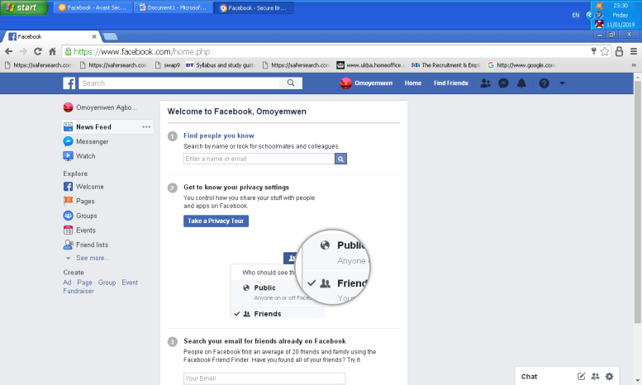

Linkedin
https://www.linkedin.com/feed/>
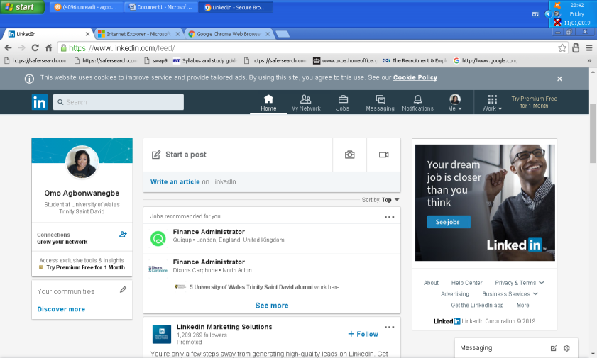

Twitter
https://twitter.com/>
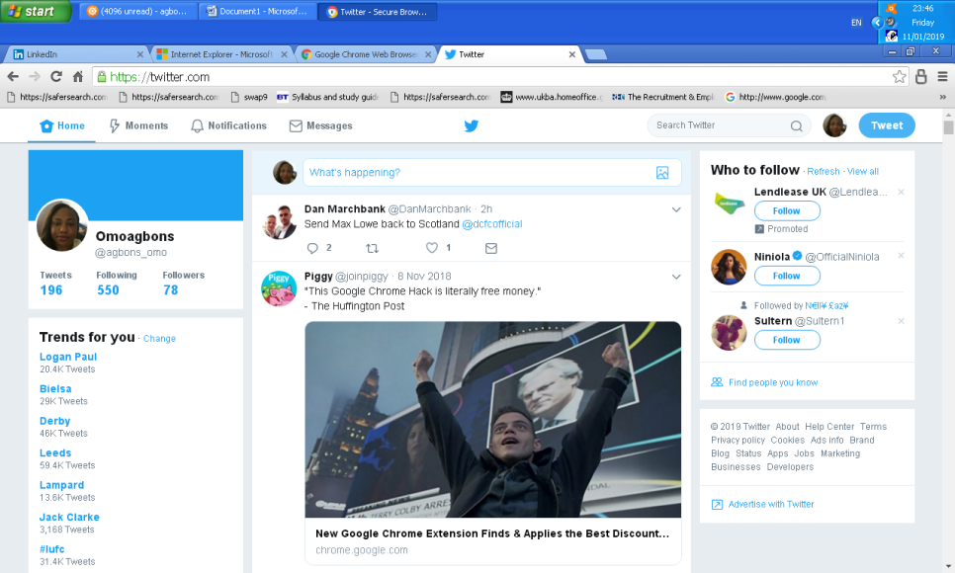

Reference
Akpomi, M. and Ordu, P. (2009). Modern office technology and the secretary’s productivity in private business organizations. African Journal of Business Management. Vol. 3 (8), pp. 333-339.
Cohen , S. (2013). Sandy marked a shift for social media use in disasters. Emergency Management, Retrieved July 30, 2013 from http://www.emergencymgmt.com/disaster/Sandy-Social-Media-Use-in-Disasters.html
Hassenzahl, M., Heidecker, S., Eckoldt, K., Diefenbach, S., & Hillmann, U. (2012). All you need is love: Current strategies of mediating intimate relationships through technology. ACM Transactions on C
Kaplan, A. M., &Haenlein, M. (2010). Users of the world, unite! The challenges and opportunities of Social Media. Business horizons, 53(1), 59-68.
Power, D. J., & Phillips-Wren, G. (2011).Impact of Social Media and Web 2.0 on Decision-Making. Journal of Decision Systems, 20(3), 249-261.
(PDF) How Technology Is Changing Work and Organizations. Available from: https://www.researchgate.net/publication/299400943_How_Technology_Is_Changing_Work_and_Organizations [accessed Jan 11 2019].
https://www.aracy.org.au/publications-resources/command/download_file/id/159/filename/Using_information_and_communication_technology_in_the_workplace.pdf>

