Marketing Plan for Travelodge Hotels

Name: Alina Adriana Badea
Student ID: 2234830
Module title: Marketing Essentials BMIH4005
Lecturer: Luciana Suardi

The marketing plan is an advertisement strategy of an organisation, which supports customer attraction for the products and service (Jarek and Mazurek, 2019). The purpose of a marketing plan is to define strategies for attracting customers for achieving business objectives. The marketing department of organisations prepares a marketing plan for providing benefits to businesses, setting goals and understanding the market audience (Elsayed Fayed, 2021). In addition, the goals of the marketing plan for Travelodge Hotel are to ensure marketing activities are timely, relevant and structured to achieve organisational objectives. By using the SOSTAC marketing strategy, this assignment will explain the 4Ps marketing mix and Bowman's strategy clock for the Travelodge Hotel.
SWOT Analysis of Travelodge Hotel
Strengths | Weaknesses
- A good brand image in the business market increases customer attraction.  - Travelodge Hotel provides better quality service to its customers (Travelodge, 2023a). | - The market share of this hotel is limited.  - This hotel did not adopt modern technology in their business which is affecting the business (Travelodge, 2023b).
Opportunities | Threats
- Travelodge Hotel has an opportunity of expanding business in other countries.  - They can adapt modern technology for providing better service to customers. | - High competition in the hotel industry creates threats to the business.  - High taxes in the UK is also another threat to Travelodge Hotel.
Table 1: SWOT Analysis of Travelodge Hotel
(Source: Created by Alina-Adriana Badea)

The Travelodge Hotel segments the market demographically and this segments according to the level of income of people for increasing sales. In addition, they are committed to providing the best service at a lower price.
The main target of this hotel in the hospitality industry is lower-income people who are casual travellers.

In Bowman’s strategy clock, there are eight types of positions of organisations in the business market such as low value-added, lower price, low price, differentiation, hybrid, risky high margins, focused differentiation, loss of market share and monopoly pricing (Villagrasa et al., 2022). The loss of market share is appropriate for the Travelodge Hotel and they use a lower pricing strategy in the business for business development (Travelodge, 2023b).
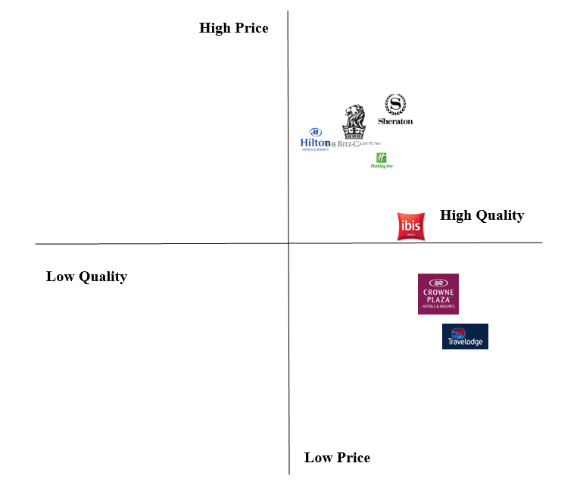
Figure 1: Perceptual Map for Travelodge Hotel
(Source: Created by Alina-Adriana Badea)
From the perceptual map of Travelodge, it can be stated that this organisation provides high-quality service to their customers at a lower price than their competitors do.

The collaborator of Travelodge Hotel in terms of B2B relationship is Holiday Inn (Travelodge, 2017). Holiday Extras are a partner of the business, which spreads awareness of the business in the global market (Travelodge, 2023g). In addition, an entrepreneur can take a franchise of Travelodge for increasing brand recognised throughout the world.

PESTLE Analysis
- Political
The latest value of the UK in the Political stability index is 0.54, which shows that the UK is stable politically (The Global Economy, 2021). Hence, the Travelodge Hotel can run the business without any impact of politics.
- Economical
The rate of inflation of the UK in January 2023 was 10.1%, which is very high (TRADING ECONOMICS, 2023). This will affect the operating cost of the hotel and Travelodge have to reduce unnecessary cost or business operation.
- Social
The population growth rate of the UK is increasing and in 2023, it has increased by 0.34% (Macrotrends, 2023). Then, it can be mentioned that Travelodge will get potential customers in future.
- Technological
The UK government has started investing in science and technology and already invested $30 billion annually (INSIDER, 2023). Then Travelodge can implement technology in their business easier for business development.
- Environmental
Environmental acts like the Control of Pollution Act 1974, and the Environmental Protection Act 1974 must be obeyed by Travelodge for operating the business smoothly (FIELD.ORG.UK, 2023).
- Legal
Travelodge have to obey the Equality Act 2010 of the UK to run the business without facing any legal issue (GOV.UK, 2023).

Aim: The marketing plan of Travelodge Hotel aims to decrease competition, increase sales and enhance the brand image within 12 months.
Specific | Measurable | Achievable | Relevant | Time- Bound
To decrease market competition | 6% | By finding pain-point of customers and solving their issues. | This is relevant for the betterment of the business. | 8 months
To increase the number of sales | 9% | Providing a large range of services to customers. | After increasing sales, the revenue of the business will be larger. | 12 months
To enhance the brand image of the business | 3% | By unlocking the power of digital marketing, the brand image can be enhanced | Enhanced brand image with enhanced credibility and support in getting a competitive market advantage. | 6 months
Figure 2: SMART Analysis for Travelodge
(Source: Created by Alina-Adriana Badea)

The value proposition of Travelodge Hotel is to provide better quality service to their customers at a lower price. In addition, this is a low-cost choice for business and leisure travel for people (Travelodge, 2023c). The 200 hotels of Travelodge have on-site Bar Café restaurant and are located in other coffee shops which makes Travelodge's ideas base of travelling. This process of Travelodge differentiates itself from other competitors of the organisation. From the traditional marketing theory, the uniqueness of Travelodge can be promoted through billboards, newspapers and printed copy. In addition, by using social media and television for digital marketing, the business can be promoted towards customers. It will be delivered through modern technology like social media marketing. As Travelodge segments its customers demographically and targets casual travellers from lower-income people, this will increase customer attraction as people use Travelodge for leisure travel. Moreover, the targeting and positioning of Travelodge will help to increase customer attraction through social media and newspaper marketing.

Marketing mix
- Product
The main product of Travelodge Hotel is restaurant service and accommodation service. This organisation provides rooms to travellers with internet facilities. In addition, video conferencing facilities and meeting rooms are available at this hotel (Travelodge, 2023d). Customers also get television, internet service, and lower disturbance, which can increase customer attraction towards Travelodge Hotel.
- Place
This hotel is serving its customers in a large area and the number of hotels is 590 with 40000 guest bedrooms throughout Spain, Ireland, and the UK (Travelodge, 2023e). In the major city centres, towns and vital road side stop, people will find the hotels of Travelodge, which helps the business to increase revenue of business as they serve a huge area.
- Price
The Travelodge Hotel maintain an average pricing strategy so that middle and lower-income people can also purchase the service and help the company to generate revenue (Travelodge, 2023f). As the targeted customers are lower-income people, then the pricing strategy of Travelodge is average. In addition, they have also various price points for their customers to make them effective.
- Promotion
The hotel will be advertised through social media marketing strategy, television, newspaper, and billboards for increasing customer attraction. By using Communication, mixed strategy promotion of business can be explained.
- Advertising through social media like Facebook and Instagram
- Personal selling of service by door-to-door
- By making public relations at a long-term awareness
- Direct marketing through social media
- Sales promotions by demonstrating and contests

Action
Activities | Start Date | Duration | End Date
Advertising through social media like Facebook and Instagram | 06-03-2023 | 2 | 08-03-2023
Personal selling of service by door-to-door | 08-03-2023 | 9 | 17-03-2023
Making public relations at a long-term awareness | 17-03-2023 | 10 | 27-03-2023
Direct marketing through social media | 27-03-2023 | 18 | 14-04-2023
Sales promotions by demonstrating and contests | 14-04-2023 | 23 | 07-05-2023
Table 2: Marketing Channel Schedule
(Source: Created by Alina-Adriana Badea)

Figure 3: GANTT Chart
(Source: Created by Alina-Adriana Badea)

The traditional method of marketing leaves a longer impression on the audience, which helps to increase customer attraction. In addition, this also provides high local coverage and quick delivery of a message, which is effective for business development (Indeed, 2022). On the other hand, social media and television making increase traffic to the organisation’s website, which is beneficial for Travelodge Hotel.

By utilising the below-mentioned KPIs, the success of Travelodge can be evaluated.
Sales revenue: By comparing the present income of the company with after 5Year sales of the business, the sales revenue can be measured. If it increases, then this will be a success for the business.
Market Share: After comparing today's market share and after a 5-year market share of Travelodge, if the share increases, then it will be mentioned that the marketing plan becomes successful.
Customer satisfaction: Measuring customer satisfaction from today to after 5 years, if the market share is boosted, then it can be explained that the marketing plan has become effective.
Brand Loyalty: By measuring brand loyalty from today and a day after 5 years, if increased, then it will be mentioned that the marketing plan, become successful.

In preparing a marketing plan, there are several challenges, such as KPI selection, financial, promotional and strategy selection. There are varied KPIs which are not selected in this study and choosing the appropriate KPI for the Travelodge is a challenge. Selecting an appropriate promotional strategy is another complication for a business. After discussing the challenges of a marketing plan, a recommendation to Travelodge can be provided. The selected KPIs are Sales revenue, Market Share, Customer satisfaction and Brand Loyalty. There are more KPIs like client retention rate, revenue per client and Travelodge may use such KPIs for measuring the business development of their brand.

References
Elsayed Fayed, A., 2021. Artificial Intelligence for marketing plan: the case for e-marketing companies. Marketing i menedžment innovacij.
FIELD.ORG.UK, 2023. List Of Environmental Laws [Online] Available at: http://www.field.org.uk/list-of-environmental-laws/ [Accessed 06 March 2023]
GOV.UK, 2023. Equality Act 2010: guidance [Online] Available at: https://www.gov.uk/guidance/equality-act-2010-guidance [Accessed 06 March 2023]
Indeed, 2022. Traditional Marketing: Types, Advantages and Disadvantages [Online] Available at: https://www.indeed.com/career-advice/career-development/traditional-marketing [Accessed 06 March 2023]
INSIDER, 2023. From Nobel Prizes to vaccine development, the UK is ahead of the pack in science and technology [Online] Available at: https://www.businessinsider.com/sc/uk-science-tech-investment-boost-2022-2?IR=T#:~:text=The%20UK%20government%20is%20boosting,economy%20of%20the%20entire%20nation. [Accessed 06 March 2023]
Jarek, K. and Mazurek, G., 2019. Marketing and Artificial Intelligence. Central European Business Review, 8(2).
Macrotrends, 2023. U.K. Population Growth Rate 1950-2023 [Online] Available at: https://www.macrotrends.net/countries/GBR/united-kingdom/population-growth-rate [Accessed 06 March 2023]
The Global Economy, 2021. United Kingdom: Political stability [Online] Available at: https://www.theglobaleconomy.com/United-Kingdom/wb_political_stability/ [Accessed 06 March 2023]
TRADING ECONOMICS, 2023. United Kingdom Inflation Rate [Online] Available at: https://tradingeconomics.com/united-kingdom/inflation-cpi [Accessed 06 March 2023]
Travelodge, 2017. Travelodge acquires the Holiday Inn Express hotel at Liverpool John Lennon Airport [Online] Available at: https://www.travelodge.co.uk/press-centre/press-releases/Travelodge-acquires-Holiday-Inn-Express-hotel-Liverpool-John-Lennon [Accessed 06 March 2023]
Travelodge, 2023a. Home [Online] Available at: https://www.travelodge.co.uk/ [Accessed 06 March 2023]
Travelodge, 2023b. Our Company [Online] Available at: https://travelodge.wpengine.com/about/our-company/ [Accessed 06 March 2023]
Travelodge, 2023c. About Us [Online] Available at: https://www.travelodge.co.uk/about/our-company/#:~:text=We%20are%20the%20low%20cost%20choice%20for%20leisure%20and%20business%20travel.&text=Travelodge%20is%20the%20ideal%20choice,your%20travel%20needs%20and%20budget. [Accessed 06 March 2023]
Travelodge, 2023d. Introducing the new look Travelodge [Online] Available at: https://www.travelodge.co.uk/about/refitted-hotels/ [Accessed 06 March 2023]
Travelodge, 2023e. Our company [Online] Available at: https://www.travelodge.co.uk/about/our-company/#:~:text=With%20more%20than%20590%20hotels,locations%20and%20vital%20roadside%20stops. [Accessed 06 March 2023]
Travelodge, 2023f. Amazing value prices [Online] Available at: https://www.travelodge.co.uk/about/amazing-value-prices/ [Accessed 06 March 2023]
Travelodge, 2023g. Holiday Extras [Online] Available at: https://www.travelodge.co.uk/partners/holidayextras [Accessed 06 March 2023]
Villagrasa, J., Sánchez, F. and Donaldson, C., 2022. HOW TO TEACH THE STRATEGIC CLOCK WITH A NUMERICAL METHODOLOGY: MAKE IT REAL, MAKE IT HAPPEN. In INTED2022 Proceedings (pp. 35-44). IATED.

Appendices
Appendix 1: Inflation Rate in the UK
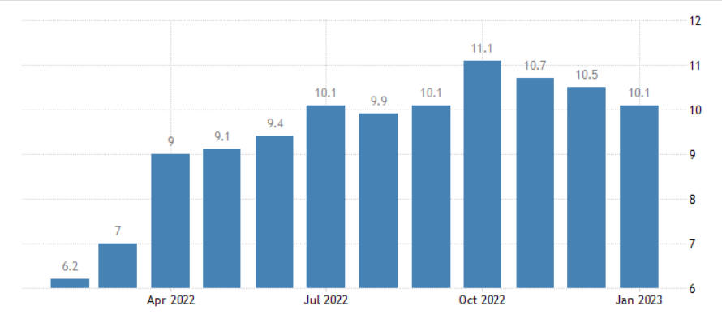
Figure 4: Inflation Rate in the UK
(Source: TRADING ECONOMICS, 2023)
Appendix 2: Population Growth Rate of the UK
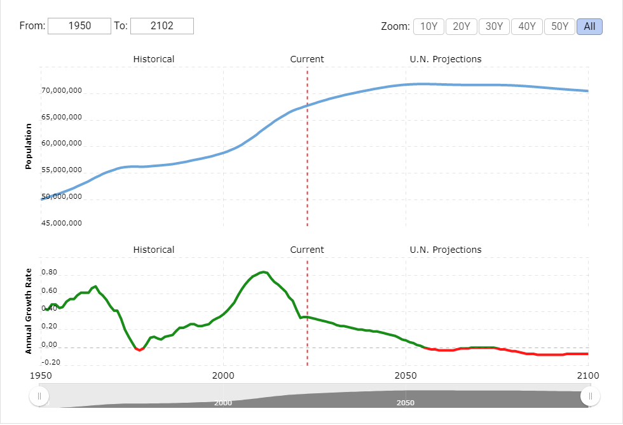
Figure 5: Population Growth Rate of the UK
(Source: Macrotrends, 2023)




