Food Menu

Student Name:
ID:
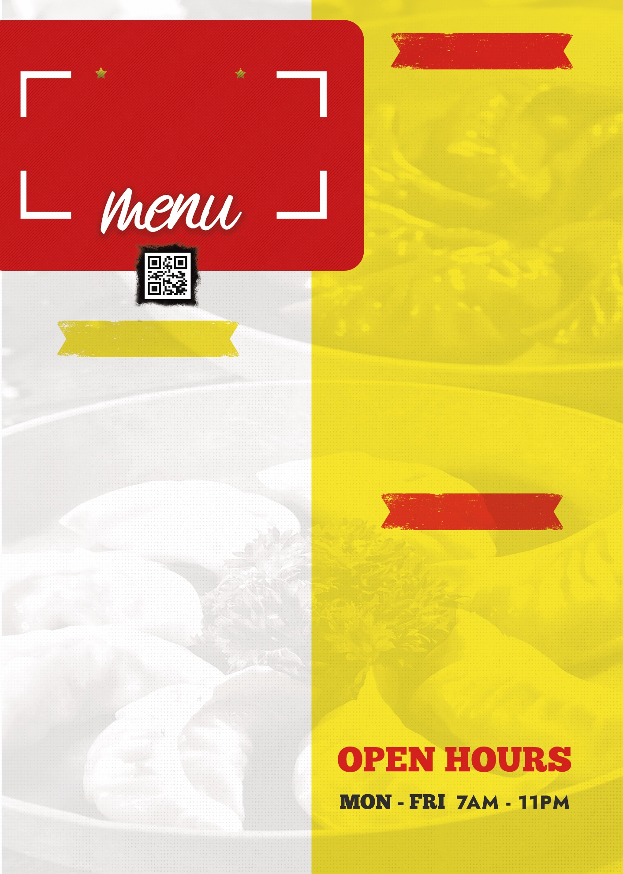
£12
£8.5
£7

Baked Tortoise
Mouth watering recipe with full of spicy that contains high energy, vitamin and nutrients. Allergic to some patients.

Vinho Verde 90 ml
Only item imported from Portugal. Scallops with grapefruit and alcohol mix wine.

Verdejo 85 ml
Spanish red wine with low sugar goes with tart and sea foods items. Contains 25% alcohol per serving.

Seafood Dishes
£10
£9.5
£8


Malbec 120 ml
Highly farmented alcoholic drink imported from greece. Contains high level of sugar and flavour. 25% alcohol per serving.

Cotes-du-Rhone 80 ml
Bold drink imported from Italy. Contains 45 ml sugar and alcohol with grape flavour.

Drumstick Spice
Soft and juicy chicken drumstick with spiced BBQ sauce and chilli paste. Contains high calorie and protien. As served with crispy shrimp fry, it may be aallergic to some persons

£6

£8

Chocolate Mousses
Creampie cakes with gratterd chocolate crunchies. High fat item.
Orange Fanta
Orange flavored beverage

Dessert and Beverages
Note: Only Dine in option is available. For placing order please call at +44 2938 3224322. Credit card payment is available.

Beet Risotto
High flavoured beet recipe that kids love most. High sugar and yummy food.

Duck Cracklings
Spiced duck specially made in winter season. (120 mg protien, 230 gm calorie, fat 40 gm and vitamin a)

£7

£5

£9
£8.5
£11

www.trinity.com
123, Swansea, South Wales

Kids Menu
Seafood Tamind (For Vegans)
Sizzling sea fishes with tomato sauce and crispy potato fries. (Contains caloruie 210 mg, protien 360 gm, fat 19 gm, sugar 20 gm)

Pinot Grigio 70 ml
Delicated white wine. Imported from Italy. Best suited with flavoured seafood dishes. Contains 10 ml alcohol and rose flavour, mild sugar

Chablis 50 ml
Excellent white wine directly imported from france. Grape berryu flavour toned with sugar and ice. 35% alcohol included per bottle.

Chicken Dishes
Fish Dishes
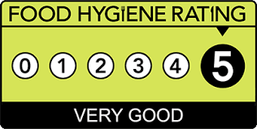
Trinity Special
References
Ferreira, S.L. and Muller, R., 2019. Innovating the wine tourism product: Food-and-wine pairing in Stellenbosch wine routes. African Journal for Physical Health Education, Recreation and Dance, 19(sup-3), pp.72-85.
Gagić, S. and Ivkov, M., 2019. FOOD AND WINE PAIRING–SIX COURSE MENU EXAMPLE.
Galmarini, M.V., 2020. The role of sensory science in the evaluation of food pairing. Current Opinion in Food Science, 33, pp.149-155.
Harrington, R.J., 2017. Food and wine pairing: A sensory experience. John Wiley & Sons.
Terrier, L. and Jaquinet, A.L., 2018. Food–wine pairing suggestions as a risk reduction strategy: reducing risk and increasing wine by the glass sales in the context of a Swiss restaurant. Psychological Reports, 119(1), pp.174-180.

