University of Trinity St David

Lyndsey Copp: Student number: 2118579
Evidence of E-Learning Portfolio

Contents
Lyndsey Copps blog page3-5
Time Management page 6-8
Critical Thinking Poster page 9
Reference list page 10

Lyndsey Copps blog:

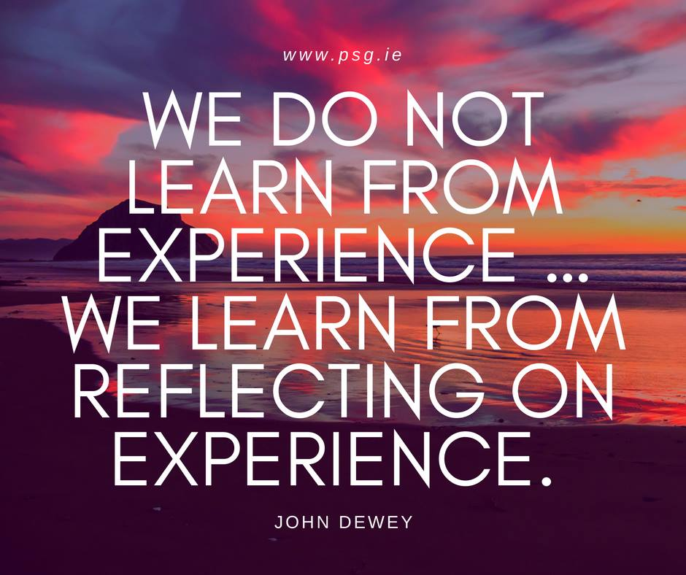

Reflection and why we use it.
I am so excited to be writing this first post in my very own blog!
I am sure that this will be a perfect way to share my research and thoughts.
This blog is about reflection and why we use it.
Have you ever thought back on a situation or a time and discovered something new, had a lightbulb moment, or realised something? I know that I have! Especially in my role as a social communication champion, working with children with severe and complex needs gives me many opportunities to reflect and learn from my experiences. No day is ever the same in my job, nevertheless, reflecting upon these daily experiences helps me to develop my own skillset and helps me to reflect upon what worked and what I could have done better in order for me to move forward.
What is reflection, and what lessons can we draw from it? It involves investigating and analysing oneself, as well as one's viewpoints, characteristics, encounters, behaviours, and interactions. This is how reflection works. It aids in understanding concepts and guiding our decision-making. Writing about reflections is a common practice, probably because it enables us to investigate them further and develop them more wisely. (Anon, 2022)
Every day, my job requires me to think on my feet. For example, today I blew bubbles for two of my ALN pupils who needed sensory stimulation to pop. The two pupils were eagerly awaiting as I pursed my lips to blow the bubbles, when to my horror only one bubble came floating before us. Eek! I instantly knew that this would cause a meltdown (which it did) as one child would not be able to pop a bubble. Reflecting upon this situation is very important for me as it made me re-think my sensory sessions and make me reconsider using this technique for these particular children again, I would definitely need to adapt it in some way as they find bubbles such a stimulating activity.
Reflection is the process of analysing your own experiences to enhance how you operate or learn. It is a useful ability that can assist students and professionals in gaining knowledge, self-assurance, and experience.
Every single one of us experiences unique events and moments throughout the course of a typical day.
John Dewey, a well-known figure in education, held that reflection was a crucial step before taking action. Dewey promoted the idea that students should reflect on what they read and experience so that, once they have done so, they may apply their knowledge more effectively. (Anon, 2022)
John Dewey stated that:
“We do not learn from experience. We learn from reflecting on experience.” – John Dewey (Dewey, 2002)
As I have stated, reflection is extremely important for us all. It helps us in not just in our jobs but also in our everyday lives.
Thanks for listening folks!
Catch up on my blog again soon!
Always remember that reflecting helps you to learn from your experiences.

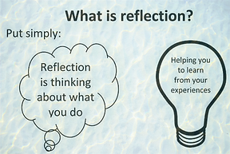
(www.fons.org, n.d.)

Essay – Time Management.

By Lyndsey Copp

UWTSD Student number: 2115879

Time is constant and equal for everyone. There really are twenty-four hours in a day for everyone, but some people are better at managing their time than others. Time management is so crucial in both personal and professional lives. Time management is an act of planning and managing our time effectively. Time is limited, hence why it is crucial that we plan the restricted hours of the day efficiently, we cannot retrieve back any lost/wasted hours.
Time management is essentially an intentional effort to set aside a certain amount of time to carry out a task efficiently. Furthermore, it is believed that making a productive effort is required if one wishes to get better results. Thus, productivity is the top priority in this situation. Striking a proper balance between your work, social life and any other hobbies or activities you may have been another excellent example of efficient time management.
Time management is an essential ability for employment chances because employers seek out candidates with this effective competence when employing new employees. Therefore, it is advised to begin teaching this essential skill as soon as is practical. In the academic setting, time management is essential for completing tasks successfully and quickly. (2022, Leverage Edu)
Time is your most valuable resource. It is precious to us all and irreplaceable. Working people have so much to do and subsequently have so little time for their personal lives. This can make us become very overwhelmed with our day-to-day responsibilities that they start to feel like they are falling behind and lose all sense of control.
It is very important to take a moment out of your time each day to think about how you intend to spend your time before you spend it as this will improve your personal and professional time management. Time management is a core skill upon which everything in life depends upon. Throughout your life there are so many demands on our time from family, friends, colleagues etc. that very little amount of time is your own, however, at home, you have far more control over your time and how you choose to spend it. (www.youtube.com, the importance of time management 2019)
Time management helps to increase the effectiveness and the efficiency of the time well uterlised. It helps us to work smarter instead of harder whilst also enabling us to get more work done in a lesser amount of time.
Time management techniques can help us greatly; these techniques include deciding on your priorities. Know everything that must be done immediately. Make a "TO DO" list or a "Task Plan" to record the things you need to finish in relation to the allotted amount of time for each activity. Extreme priority tasks should be listed first, followed by those that may wait until a later time. Be careful to complete the tasks on your list. Ensure that you complete your tasks by the deadline and check off the items you have previously completed. It is fundamental to recognise the distinction between significant and urgent jobs. You should manage your work effectively. Start your day with something significant rather than something that can be done later.
It is important to always stay focused and in control, set goals for yourself that are both attainable and reasonable. Understand what you must never burden yourself with too much, thus taking on tasks that you are confident of achieving. (Managementstudyguide.com, 2015)
The ability to manage your time well is essential. By boosting productivity and efficiency, effective time management reduces stress and enhances success in life. Here are some advantages of time management. It relieves the pressure of worrying about whether you are accomplishing your goals which helps you avoid feeling stressed and anxious. You must make sure that you are taking breaks during tasks too as this is also so important for your health and well-being. Positive time management gives you more time to spend with your family/friends whilst also allowing you to take part in more hobbies or interests, which is excellent for your health and well-being. It also gives you more opportunities in the employment market as employers are more likely to employ an individual who shows effective time management skills. Eliminating unneeded tasks or activities is crucial. Choose what deserves your attention and what is significant. You can spend more time on critical tasks by quitting time-wasting hobbies and obligations.
Let us also consider the consequences of poor time management. Poor planning and goal-setting lead to ineffective efficiency. For instance, if there were a lot of urgent jobs that needed to be finished, it would be advantageous to accomplish related work concurrently or sequentially. However, if you do not prepare in advance, you can find yourself needing to go back and forth or backtrack while working. That results in decreased production and efficiency. Time is lost because of poor time management. You could be spending time and becoming distracted by conversing with friends on social media while working on an assignment, for instance. The quality of your job often suffers when you do not manage your time well. For instance, rushing to do work at the last minute frequently results in quality being compromised. (CFI Team, 2022)
To summarise, planning and regulating how much time is spent on various tasks is done through time management. One may accomplish more in less time with effective time management, which also reduces stress and promotes success at work.

Critical Thinking Poster

Reference list
CFI Team (2022). Time management. [online] Corporate Finance Institute. Available at: https://corporatefinanceinstitute.com/resources/management/time-management-list-tips/.
COMSTOCK, L.G. and MOFF, T.E. (1991). Cost-effective, Time-efficient Charting. Nursing Management (Springhouse), 22(7), pp.44–45. doi:10.1097/00006247-199107000-00013.
Dewey, J. (2002). Why Reflection Is Important. [online] www.linkedin.com. Available at: https://www.linkedin.com/pulse/why-reflection-important-mark-milotich.
Gray, L. (2019). Reflective Learning: Definition, Style & Theory - Video & Lesson Transcript | Study.com. [online] Study.com. Available at: https://study.com/academy/lesson/reflective-learning-definition-style-theory.html.
Leverage Edu. (2022). Essay on Time Management. [online] Available at: https://leverageedu.com/blog/essay-on-time-management/.
Managementstudyguide.com. (2015). Time Management Skills. [online] Available at: https://www.managementstudyguide.com/time-management-skills.htm.
P, A. and P, B.N. (2019). Make them think in the Digitalized Era: Developing Critical Thinking Skills Using Technology. International Journal of Psychosocial Rehabilitation, 23(4), pp.500–509. doi:10.37200/ijpr/v23i4/pr190383.
Reimagining Education (2022). Why is reflection important in education? - Reimagining Education. [online] Available at: https://reimaginingeducation.org/why-is-reflection-important-in-education/.
www.fons.org. (n.d.). Teaching Care Homes - Resources. [online] Available at: https://www.fons.org/programmes/teaching-care-homes/resources [Accessed 6 Jan. 2023].
www.youtube.com. (2019). The Importance of Time Management | Brian Tracy. [online] Available at: https://www.youtube.com/watch?v=Z6kAEQJhSoU&t=121s [Accessed 8 Jan. 2023].

