EFFECTIVE TEAMWORKING FOR TEAM SUCCESS
Univercity of Wales Trinity Saint David
Module: Effective Teamworking and Communication
BMSW4002
Lecturer: Dale Clarke
Student: Zhasmina Krumova Georgieva (2026746)

Summary

Team building and cohesion in a business or organizational setting are vital for effective development and overall performance among team members and the organization. With the changing organizational dynamics and managerial projections in the modern environment marred with consistent changes in organizational needs and demands, these organizations must create an enabling environment for individuals and groups within various departments. In this regard, most firms are shifting to effective and holistic grouping and team development to speed up the execution of critical tasks within the business environment. With cohesive teams and effective management, an organization can witness effective leadership and smooth running of various activities within the scope of service or product delivery to the target market. In this regard, team development, assessment, and cohesion are vital aspects of modern organizational models towards achieving intensive goals and objectives. This report explores the development and effectiveness of work-based teams in organizational management and sustainability, focusing comprehensively on Trinity Social care Home Birmingham.

Table of Contents
1.Introduction 3
1.1Team and effective teamwork 3
2.How the Management at Trinity Care Home Can Develop an Effective Team 4
2.1 The Tuckman’s Model for Group Development 4
2.2 The Wheelan’s model 6
3.Roles Needed To Create An Effective Team 6
4.Impact Of Effective Teamwork In Health and Social Care Sector 7
5.Barriers To Effective Team Working 8
6.Conclusion 9
7.Reference List 10

1.Introduction
The challenge of creating an effective care home team depends on how the management can
develop an effective team; how inefficient teamwork can affect health and social care;
detecting and removing barriers to effective teamwork; the types of roles that are needed to create a cohesive and effective team.
Within the report will identified problems, present key points, and theories to achieve effective teamwork and resolving the conflicts due to the diverse nature at Trinity Social care Home Birmingham. This report will aim to minimize the prevalence of conflicts among the employees in recent instance and possibly foster positive inter - personal relationships among them and educate them for grouping and group cohesiveness. Theories will be presented with examples from professional experience and correctly included references.

1.1Team and effective teamwork
A Team is a group of people who have a collective responsibility and use additional skills to achieve a common goal. The benefit of working as a team, not as a group of individuals, is that the products are greater than sum of individual contributions. Teams amplify the benefits produced by all. Teamwork occurs when team members respect their collective responsibility to achieve goals. The effectiveness of any company or organization depends on both the ability of employees to work in a team and ability of leaders to forms appropriate work teams.
It is extremely important to know the prerequisites for building an effective team, the psychological compliance of people and the perception of the values of the team not only for internal satisfaction, but also to achieve the goals of the organization. When working in a team, the efforts are the same, but the result is many greater. When everyone in the team has directed their efforts in the same direction, it facilitates the work process.
Teamwork in health and social care facilities has an impact on individuals and groups involved. Ideally, team member satisfaction, dedication, performance, and wellness are examples of individual – level outcomes ( Guraya and Barr, 2018).

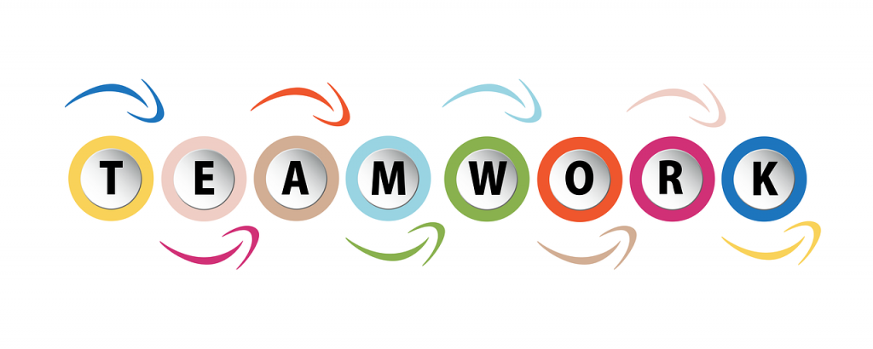
This Photo by Unknown Author is licensed under CC BY-SA

2.How the Management at Trinity Care Home Can Develop an Effective Team
The facility has a diverse but incoherent workforce within its departments. Although workforce diversity has several advantages, it can be hazardous to business development and progression without proper cohesive integration. The challenge in organizational scope and the need for effective teamwork is the major concern for Trinity Social Care Home as the teams need to be cohesive and bond together to execute the organizational roles and needs sufficiently without inhibiting failures.

2.1 The Tuckman’s Model for Group Development
The facility can utilize Tuckman’s model to aid efficient group formation and development to enhance organizational service delivery. The model focuses exclusively on the major steps that teams or groups go through, informing and completing assigned tasks. The model has five major stages of team development that the Trinity Care home can use to develop effective teams and groups.
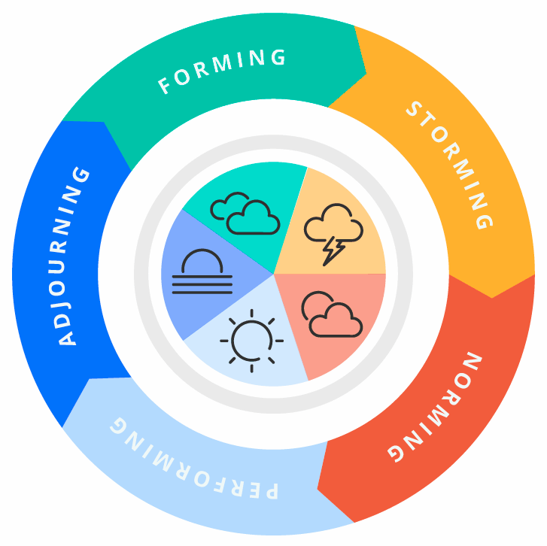Tuckman’s model

The first step is Forming: During this phase, employees at the facility attempt to construct their workgroups by selecting five individuals for each group. The varies depending on the overall size of the participating group and the number of individuals in each group ( Bonebright, 2010, 4). At this stage, employees now have more options. Getting to know each other and introducing oneself to new colleagues is also a benefit of this step.
Ideally, during this stage, personal relationships are defined by reliance. Members of a group rely on safe, predictable behaviour and seek direction from the group leader (Bonebright, 2010, 6). Members of a group want to be accepted by the group and feel comfortable in the group.
The second step that the facility can employ based on Tuckman's model is Storming, where participants will be exposed to the change agent that is trying something new during this phase (Tudor, 2013, 4). Storming occurs during this stage and is linked to emotions and behaviour, with the potential for conflict arising as a result. At initially, group members or employees merely attempt to get to know one another (Tudor, 2013, 4). The second step is for participants to think out how to collaborate and with the case at hand. Third, employees may reach an agreement, but they may also come to many differences of opinion (Chou and Garcia, 2011, 3). For Tuckman, "group members grow antagonistic towards one another and the therapist or trainer to express their uniqueness and fight the creation of a group structure" (Tudor, 2013, 2). The facility should counter the challenges in this section with a comprehensive and holistic intervention.
With Norming stage members are open to changing their previous notions or viewpoints in light of new information offered by other colleagues, and they actively seek to learn more from one another by asking questions. By getting to know one another, group members establish confidence in their relationships, which aids in the formation of cohesiveness. Because of the resolution of interpersonal problems, people start feeling like they belong in the group at this point in growth (Jones, 2019, 4). During this third stage of the development, group members exchange information about their thoughts, request input from one another, and consider possible solutions to the problem. As soon as the group reaches this stage, their interactions will be more honest and open, both on an interpersonal and task level (Tudor, 2013, 5). They enjoy the feeling of belonging to a productive team.
The fourth stage in this model is the Performing stage. At this point, individuals can work independently, in smaller groups, or as part of a larger team, all with the same level of comfort. Fourth-stage interdependence is seen in human relationships and task-related problem resolution (Jones, 2019, 4). The team should be working at peak efficiency by this stage. At this stage, it's no longer necessary for the organization to provide its consent to the individual members. Members have a strong focus on getting things done and caring about the people around them (Zoltan et al., 2016, 4). Problem-solving experiments are encouraged, and success is prioritized (Jones, 2019, 4).
The last stage, according to Tuckman, is the Adjourning stage. A planned end usually involves the celebration and the chance for members to say their goodbyes personally. At this stage, it is important to recognize and celebrate the accomplishments of individuals and groups for their dedication, tenacity, and hard work (Jones, 2019, 5). There, the facility can instil a sense of accomplishment in the group.

2.2 The Wheelan’s model
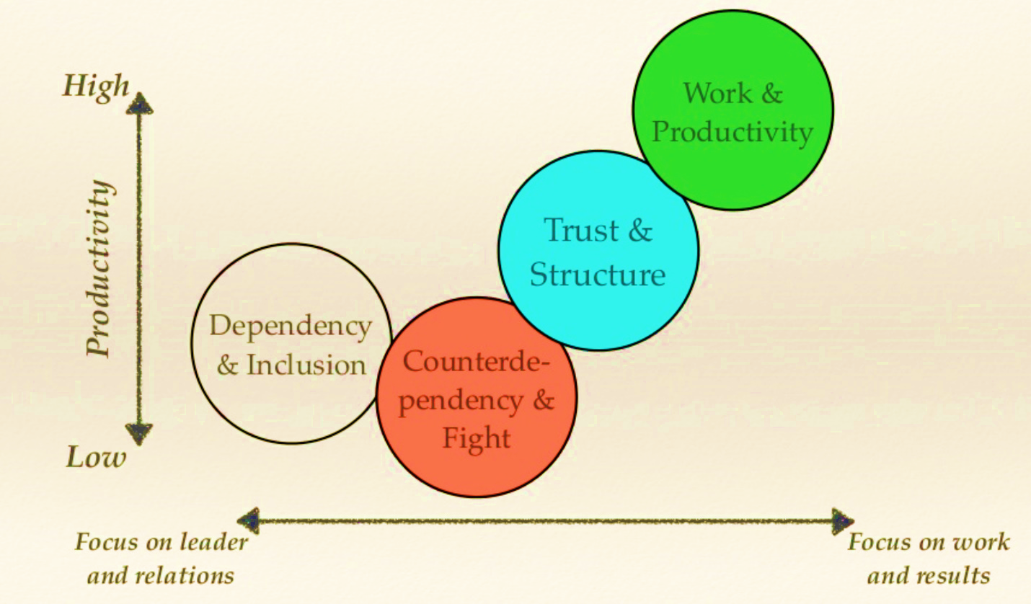
Susan Wheelan introduced a four-stage integrated model for group development. The first stage of the model is dependency and inclusion, a stage marred with high uncertainty, politeness, and anxiety among group leads (Raes et al., 2014, 7). The members are concerned with issues evolving around acceptance. The second stage is counter dependency and fighting, where the group experiences a lot of conflicts attributed to power and identity struggles (Raes et al., 2014, 7). The third phase is trust and structure. At this phase, the group members agree to execute a particular task and are exposed to various opportunities. The last stage of the model is work, where team members are comfortable with each other and have a mutual feeling of togetherness while doing the assigned task (Raes et al., 2014, 8).

3.Roles Needed To Create An Effective Team
Team building can only be successful if the goals are clear, measurable, doable, relevant, and time bound. It's critical to incorporate feedback from all team members into the goal-setting process (Fapohunda, 2013, 4). There must be no ambiguity about what is expected of team members, and team members must be aware of why the team was formed in the first place. The team's ongoing efficacy must be measured and documented for eventual sharing and discussion with the entire team (Fapohunda, 2013, 4). Team members must believe that members are appropriate and that the concerns for which those teams were formed necessitate the possession of requisite knowledge, skills, and capacities on the part of the team members (Fapohunda, 2013, 5). For example, conflict resolution, effective communication, and problem-solving are just a few of the abilities that team members will need to develop to operate well together.

4.Impact Of Effective Teamwork In Health and Social Care Sector
Poor teamwork has been linked to medical errors, while effective teamwork reduces or eliminates these errors (Guraya and Chen, 2019, 4). Poor collaboration and status hierarchies have been linked to several medical mishaps. As a result of these hierarchies, members of lower-level teams are less likely to question the decisions of their superiors, even if they believe such judgments are incorrect.
Teamwork in health and social care facilities has an impact on individuals and groups involved. Ideally, team member satisfaction, dedication, performance, commitment, and wellness are examples of individual-level outcomes (Guraya and Barr, 2018, 2). Providing health care is inherently stressful for the people involved and can be dangerous as well. Errors can cause illness and injury to both patients and employees (Guraya and Chen, 2019, 5). The more successful, upbeat, and supportive your group is, the more content your team members will be (Guraya and Chen, 2019, 3). This is especially true if team members work in an environment that is full of pain and misery. Health care research shows that a high workload and a hostile work environment are linked to lower levels of job satisfaction and greater intentions to leave the job.
The quality of care provided by teams and the satisfaction of patients are among the team's accomplishments. Patient satisfaction is a key factor in determining the quality of a health care system. If an intervention effectively cures, manages disease, recovering, or provides appropriate assistance in non-pathological conditions like childbirth, it is considered effective health care (Guraya and Barr, 2018, 5). Health care teams have a responsibility to prioritize the needs of patients, and patient satisfaction is critical to meeting those expectations. Patient satisfaction is influenced by various factors, including how well they are informed about their treatments, how active they are in making decisions about their care, and whether or not they are given alternative treatments over which they have some control.

5.Barriers To Effective Team Working
The main barrier to effective teamwork is a lack of trust and respect among team members, leading to constant conflicts and misunderstandings. Despite this, people occasionally lack regard for those unique from themselves, whether in gender, age, or race and ethnicity (Weller et al., 2014, 3). Unfortunately, ageism, sexism, and racism are pervasive in the tech industry, possibly even more so on certain teams. There may be cultural gaps between people from diverse backgrounds who operate in different professions to imply variations in the group models and nature (Weller et al., 2014, 5). Besides, having members with divergent perspectives might complicate things for a group. Attitudes, power bases, and stress quotients are all factors that might lead to misunderstandings when dealing with people from different backgrounds. Disagreements in teammates' attitudes may appear dangerous and cause resistance, anxiety, and even rage (Weller et al., 2014, 3). People who are anti-creative, for example, may exhibit contempt or denigrate the ideas of others because they threaten them.
Barriers for effective teamwork

6.Conclusion
Trinity Social care Home should consider the enlisted steps to develop the diverse groups into productive units and teams to improve its efficiency and overall productivity and service delivery to patients across different care groups. For example, in a healthcare setting, a specific group can be assigned to the paediatric department while another is assigned to the cancer care and treatment department to take care of cancer patients in the care centre. On the other hand, the facility should approach the barriers to effective team development with vigour to minimize interruptions in delivering quality services and formulating competent groups and teams.

7.Reference List
Bonebright, D.A., (2010). Forty years of storming: a historical review of Tuckman's model of small group development. Human Resource Development International, 13(1), pp.111-120.
Coyle, D. (2018), The Culture Code, London, Random House Business.
Fapohunda, T.M., (2013). Towards effective team building in the workplace. International journal of education and research, 1(4), pp.1-12.
Guraya, S.Y. and Barr, H., (2018). The effectiveness of interprofessional education in healthcare: A systematic review and meta-analysis. The Kaohsiung journal of medical sciences, 34(3), pp.160-165.
Guraya, S.Y. and Chen, S., (2019). The impact and effectiveness of faculty development program in fostering the faculty's knowledge, skills, and professional competence: a systematic review and meta-analysis. Saudi journal of biological sciences, 26(4), pp.688-697.
Jones, D., (2019). The Tuckman's Model Implementation, Effect, and Analysis & the New Development of Jones LSI Model on a Small Group. Journal of Management, 6(4).
Kaba, A, et al. (2016) “Are we at risk of groupthink in our approach to teamwork interventions in helath care?”, Medical education, 50(4), pp 400 – 408.
Persilv, C. A. (2013), Team leadership and Partnering in Nursing and Health Care. New York: Springer Publishing Company.
Raes, E., Kyndt, E., Decuyper, S., Van den Bossche23, P. and Dochy, F.,(2014). Group development and team learning: How development stages relate to team-level learning behaviour. Human Resource Development Quarterly, 26(1), pp.5-30.
Tudor, K., (2013). Group imago and group development: Two theoretical additions and some ensuing adjustments. Transactional Analysis Journal, 43(4), pp.321-333.
Weller, J., Boyd, M., and Cumin, D., (2014). Teams, tribes, and patient safety: overcoming barriers to effective teamwork in healthcare. The postgraduate medical journal, 90(1061), pp.149-154.
Wheelan, S. A., (2016), Creating Effective Teams, 5th edn, London: SAGE.
Zoltan, Raluca, and Romulus Vancea. "Workgroup development models–the evolution from simple group to an effective team." Ecoforum Journal 5, no. 1 (2016).

