- Define projects and project management
- Give brief about your specific project and why is it a project
- Briefly discuss what analysing tools used in the report.

‘A project is a sequence of unique, complex, and connected activities that have one goal or purpose and that must be completed by a specific time, within budget, and according to specification’ (Wysocki, 2013, p. 4).

A project is a brief endeavour undertaken to produce a special good, service, or outcome. Every project produces a distinctive product, service, or outcome. The end is reached when goals have been attained, when goals will not or cannot be attained, or when the necessity for the project is no longer there. The result could be physical or intangible. A project may involve one or more individuals, one or more organisational units, or organisational units from different organisations (Project Management Institute, 2012).

’Project management is the application of knowledge, skills, tools, and techniques to project activities to meet the project requirements’ (APMBok, 2019).

- Initializing
- Planning
- Project execution
- Closing
Achieving the organization's goals by maintaining balance among the various tasks involved in producing this output, delivering the desired effects, and accomplishing the organization's objectives (Badewi, 2016).

PROJECT LIFE CYCLE
The life cycle of a project is crucial to its management: Various deployment strategies can be used, depending on the desired outputs, benefits, and results as well as the anticipated unpredictability, novelty, and life cycle serves as a key management tool, concentrating on the distribution of resources, the blending of activities, the accessibility of key individuals, the support of prompt decision-making, the reduction of risk, that are in line with the life cycle structure. As a result, it's critical that sponsors and executives are aware of the qualities and unique elements of the chosen strategy (APMBok, 2019).

Initiating phase created a team of five people possess different skills and being committed to a clear goal.
Leighton really proved his Belbin role as Shaper and Resource Investigator. His strong leadership skills and excellent communication skills did coordinate our team to successfully complete the quad chart.
Valentin ‘passion and dedication scrutinised our work for any errors and encouraged us to respect the plan for successful result.
Kitty’ professional experience brought confidence to our team and lot of energy. Her problem-solving skills broke-down any barriers and created the way to reach team ‘objectives.
Ben is an Implementer and a Specialist. He turned team’s ideas efficiently and systematically into a plan. The teamwork did bring stress and challenges where Ben as a psychotherapist was involved. A team ‘act as one’ and perform well when is cohesion.
The team created a quad chart which aim is to identify needs of new asylum seekers in the area. It's a one-page document with a simple yet effective four-quadrant layout for presenting information quickly. The four quadrants are the same size, and the goal is to stimulate conversation about the strategic direction to make better project decisions.
Violeta role in the team is Resource Investigator.
Resource Investigator explore options, develop contacts, and negotiate for resources. Is optimistic and motivated to finish the project and to achieve all the objectives.
To determine the resources requires planning skills.
Communication skills are required to write, listen, speak, and present information to members of the team and stakeholders.
Conflict management skills is the ability to mediate conflict between my team or between team and stakeholder to move forward for achieving goals.
Having integrity means to recognise mistakes, being accountable for errors and downfalls.
Motivation for project: nurse’ knowledge suitable on health issues such long-term illnesses or emotional and mental health problems like depression or stress. It is knowing that adult asylum seekers may be experiencing anxiety, poor health.
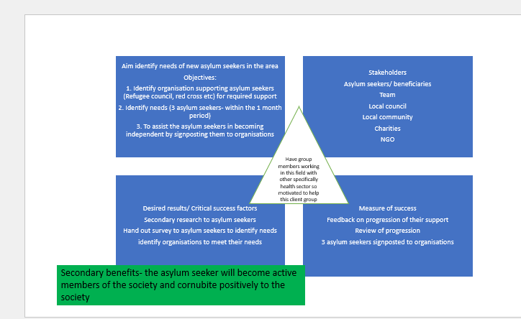
Gantt charts have been demonstrated to be a simple and successful way of task planning. A method of presenting data in such a way that they can be easily comprehended. As a technique of reducing waste and inefficiency for completing tasks on time (Weaver, 2012a).
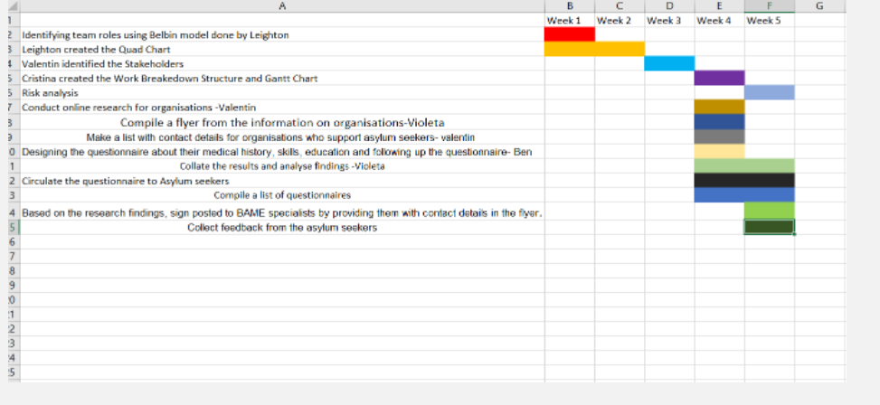
A work breakdown structure (WBS) is the first step in creating a project schedule. It is a visible, hierarchical, and deliverable-focused decomposition of a project. It's a helpful diagram for project managers since it helps them break down the scope of their projects and visualise all the tasks required to complete them. Make us understand our project scope and allocate resources for all project tasks (ProjectManager, 2022).
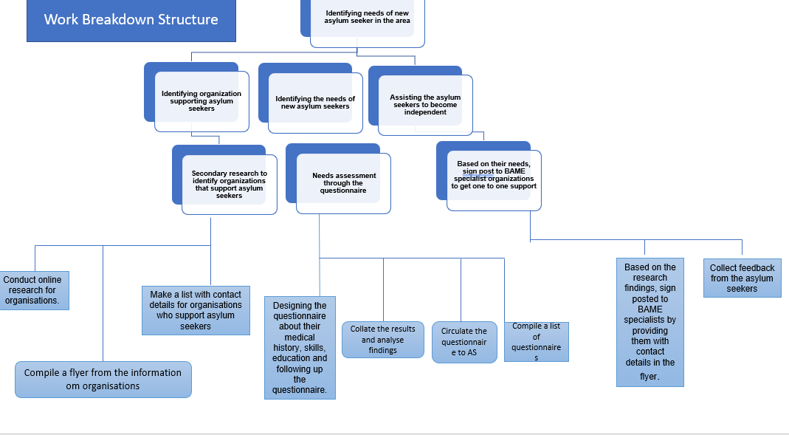

In project management, the Work Breakdown Structure (WBS) has become a core idea and technique. It's a key enabler that ensures a clear definition and communication of project scope while also serving as a vital monitoring and control tool (Norman, et al., 2008)

Planning includes:
-defining all project work
-estimating duration to complete the work
-estimating resources required
-estimating the cost of the work
-sequencing the work
-building the initial project schedule
-analysing and adjusting the project schedule
-writing a risk management plan
-documenting the project plan
-gaining senior management approval to launch it.
A stakeholder includes anyone who has a “stake” in the success of the project: sponsors, customers, clients, and users (Cooke, 2022).
Paying attention to stakeholder relationships is strategic for successful companies in actual hypercompetitive environment (Alexander, et al., 2005).
According to Ackerman& Eden the Top Management Team creates an organization's strategy, it must also pay attention to stakeholder strategic management if the strategy is to be successful. Actions can be taken to either capitalise on anticipated positive reactions or decrease or eliminate negative responses by anticipating and managing stakeholder responses to organisational strategy (Ackermann & Eden, 2011). There are essentially two categories of stakeholder: internal stakeholders, who are those actively involved in project execution; and external stakeholders, who are those affected by the project (Olander, 2007).

The team identified and structured stakeholder: high power /high interest, and perspective and action for each stakeholder.
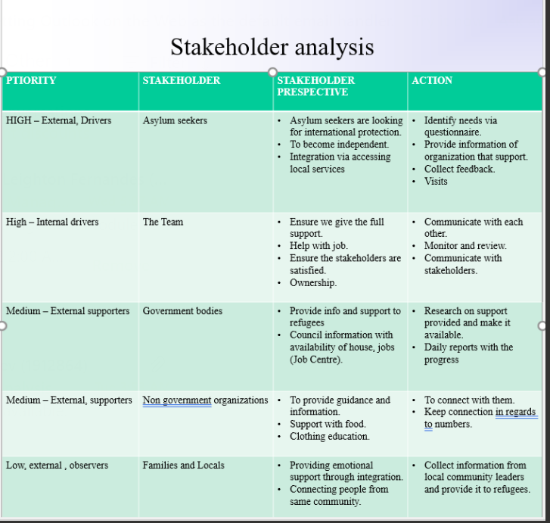

PROJECT EXECUTION PHASE
Project launching requires energy and enthusiasm. Main elements: building a team, understanding the scope, developing the execution strategy, developing the project plan, establishing the project infrastructure, facilities, and administration (Ward, 2018).
Monitoring and controlling includes:
- establish the project performance and reporting system
- monitoring project performance
- monitoring risk
- reporting project status
- processing scope change requests
- discovering and solving problems (Wysocki, 2013)

REFERENCES
Ackermann, F. & Eden, C., 2011. Strategic management of stakeholders: theory and practice. Long Range Planning, , 44(3), pp. 179-196.
Alexander, C. S., Miesing, P. & Parsons, A. L., 2005. How Important Are Stakeholder Relationships. Academy of Strategic Management Journal, , 4(), p. 1.
Anon., . What is project management?. [Online]
Available at: https://www.apm.org.uk/WhatIsPM
[Accessed 15 6 2022].
APMBok, 2019. APM BODY OF KNOWLEDGE 7th edition. 7th ed. BUCKINGHAMSHIRE: Association for Project Management.
Badewi, A., 2016. The impact of project management (PM) and benefits management (BM) practices on project success: Towards developing a project benefits governance framework. International Journal of Project Management, 34(4), pp. 761-778.
Cooke, H. S., 2022. INFOWORKS. [Online]
Available at: https://infoworks.com/five-strategies-successful-stakeholder-management/
[Accessed 20 May 2022].
Institute, P. M., 2017. The Standard for Program Management Four edition, Newton Square: Project Management Institute.
Olander, S., 2007. Stakeholder impact analysis in construction project management. Construction Management and Economics, , 25(3), pp. 277-287.
Project Management Institute, a. M. I. P., 2012. A Guide to the Project Managemnt Body of Knowledge(PMBOK R Guide), Newton,Square,Pennsylvania: Project Mnagement Institute.
ProjectManager, 2022. Work breakdown structure. [Online]
Available at: https://www.projectmanager.com/guides/work-breakdown-structure.
[Accessed 25 May 2022].
Ward, G. G. F., 2018. Effective Project Management: Guidance and Checklists for Engineering and Construction 1st edition, Oxford: Willey-Blackwell.
Wysocki, R. K., 2013. Effective project management:traditional,,agile,extreme seventh edition, Indianapolis: Wiley-Blackwell.

