Group Project.
ACMA5009 – Reflective project report.

University of Wales. Trinity Saint David
Barry Phillips Student ID:2014949

Contents

Contents 1
Introduction 2
Aims and objectives of this report 3
Project Plan 4
The Project. 5
Step 1. 5
Step 2. 6
Step 3. 7
Step 4. 8
Step 5. 9
Conclusion 9
Reflections 10
References 11

Introduction
This report will give an insight into a project that I created in LSN Diffusion in 2021. A project can be described as full of risk or full of surprises as nobody knows how the outcome will unfold. Project management covers all aspects from the start of the project up till the end of it. The project needs to consider all variables from cost to finishing late or even deciding to cancel the project altogether before the completion date (Lock, 2013).
To understand what needs to be achieved we need to understand what a project is. One definition of a project is a group of activities that have one specific purpose and that must be completed within its financial restraints, be done within a specific time frame and finally be done according to its plan (O’Reilly, 2022). Every project is different even the same project run repeatedly would be different due to learning from the first time, a delay in shipping or even sickness of an employee. so, we can say each project is unique. A typical project is not described as a simple task, it would normally involve some form of a complex activity. Within the project most aspects are connected, this is normally due to the nature of the tasks, an example of this could be as simple as you can’t train a person in the project until the project is designed, or you can’t make something until a relevant part has arrived for production. The project has can be split up and given to different departments within the company or different contractors however they will always have one goal and every department or aspect of the project is to achieve this goal. The goal is to achieve the final result within its specified time, all projects need to have a start date. Without a start date, a project manager can only give a duration, such as this will take 3 months from the start date, however, most people want deadlines and demand to know when it will be ready. Therefore, they must also have an end date, the time frame is normally set by the management or even the customer. The timeframe will rely heavily on the costs involved; most projects will have a resource limit. Even though the project can be completed within three months with 20 people working on the budget might only allow enough money for 10 people, which needs to be factored into the time frame (Wysocki, 2019).
At the beginning of 2021, a new management structure was created in LSN Diffusion. From its date of creation in 2010 –until 2021 the management team had remained the same. The change was implemented with the creation of a new manager for each of the three departments, and the existing department leaders as they were known, were moved to different roles. The creation of the three new managers was implemented to offer a more streamlined structure and to reduce the workload of the current production manager who was overseeing all three of the current departments.
The result of this did not go as anticipated. What was discovered was that due to the department leaders controlling the departments for several years they did everything their way. This resulted in no appropriate training or paperwork set in place for their replacements. Some of the department leaders were unwilling to pass on their knowledge. In the workplace when an employee refuses to share their knowledge this can have a detrimental effect on the company and is often referred to as “knowledge hiding” (He Peixu et al., 2021).
The knowledge hiding needed to be addressed as a matter of urgency mostly in the screening department. The new manager subsequently tasked the assistant manager with designing and executing a project using management strategies, covering any time and budgeting constraints and the sustainability of the project. The information needed to be researched and documented and a transparent way of sharing the information with all the employees and managers onsite was needed to be found.

Aims and objectives of this report
LSN Diffusion is a manufacturing site in South Wales, they currently manufacture Nickel, cobalt and Iron-based metal alloys. They achieve this by using gas and water atomising. The metal powders will then be separated into different particle sizes using a method called screening (LSN Diffusion, 2020).
The customer will provide LSN Diffusion with a particle size distribution (PSD) Specification of their requirements and a product will be made that adheres to this. (Image 1)
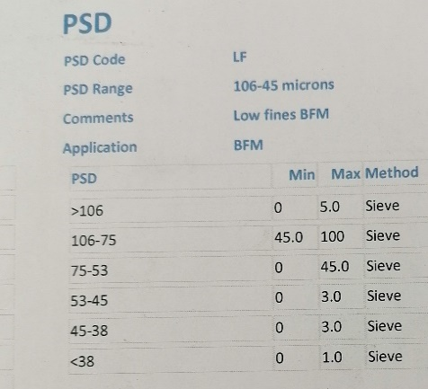
(Image 1) Example of PSD
As of January 2021, LSN Diffusion had over 10,000 products in its database, each with its unique PSD and chemistry make-up. The project needed to identify how many of these products were indeed still active, and how they are to be processed.
Although there are over 10,000 products in the database, many of these belonged to companies that we no longer supplied. The products that LSN supply can be filtered down into subcategories. An example of this is a product called N-500-PL2, the N denotes Nickel, the 500 dictates the chemistry makeup and the PL2 classifies the PSD range. Although there are 1000s of products all PL2 products are screened in the same way as they have the same customer range. The PL2 has a range of 53-150 Microns. As can be seen in image 2.
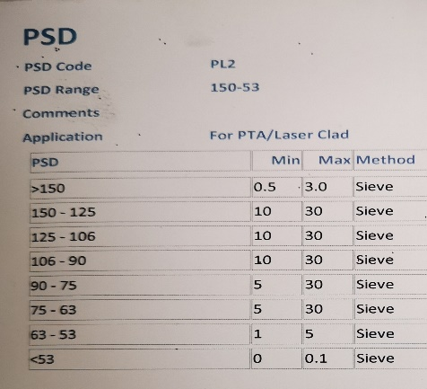
(Image 2) Example of PL2 PSD
The plan is to create a new database using only products that have been manufactured within the last 3 years. To filter them into the PSD range and to make it searchable and user-friendly for anyone to access whilst having the facility to add new products and to amend should they be needed. To record the effectiveness of the chosen method and to monitor the yield achieved with selected parameters.

Project Plan
The project of making a spreadsheet and database may seem simple however due to its urgent need and its uniqueness to the company it was decided that it must be done 1st time, therefore it had to be done efficiently and more importantly effectively. A team meeting was called upon and the agenda was the discussion and plans of the project, to identify the tasks and realistic time frames.
In the meeting, a pert chart often referred to as a pert diagram which is mainly designed to identify, organise and coordinate specific tasks within a project (Chai, 2021) was discussed and so was a Gantt chart. The participants of the meeting decided upon the use of Gantt to be used in the project.
The meeting was needed so we could schedule a timeline for when the assistant manager needed to be away from the production line to ensure the completion of the project. To ensure the objectives were identified to all shareholders and all parties involved to ensure clarity throughout.
The purpose therefore of the meeting was as follows, Identify the steps needed to complete the task, identify any costs involved and provide management with a realistic time frame of when the system will be operational.
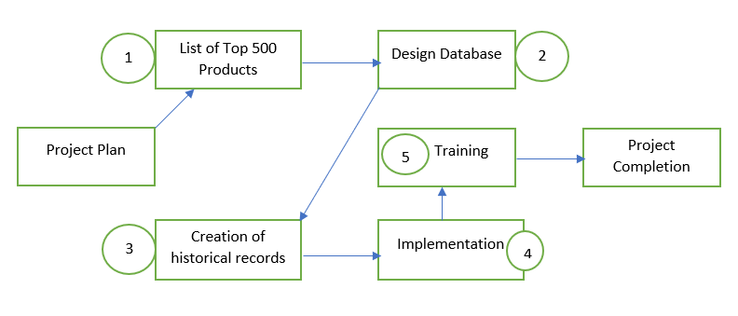
Tasks identified in the meeting.

The project was split into various sections each with its time frame. To start it was needed to determine what tasks and timeframes were needed to undertake this project. They were as follows.
- Find and identify the top 500 Products. LSN can run four atomising towers at the same time. Each tower can melt and atomise 12 products in 24 hours. In theory, LSN can therefore run 48 different products a day. So, 500 products would give 10 days’ worth of planning ability, although this is rarely the case as the majority of the time one tower will run the same product for one day. This task should take around 10 days to organise so it was decided that two weeks should be enough time for this task.
- Designing the database is the second task on the agenda. This needs to be researched and the simplest solution needs to be found. It was agreed that this task should take again two weeks to design.
- The 3rd task is to determine which screens are required for each of the 500 products in task one. This task is most likely the most troublesome as this is the reason this database is required. Although difficult it was decided this can take no longer than three weeks due to the urgency needed.
- The 4th task is the actual implementation of the database and to ensure it works and is efficient. This task is the longest as needs constant monitoring to ensure that all the parameters in task 3 are correct. However, it is requested that the implementation starts in one week and be monitored for 32 weeks.
- The last and final task is the training, this task needs to be completed immediately after the implementation and is required to be done with all operators in just one week.
Since all the tasks and timeframes had been agreed upon a system was needed to ensure our goals and targets were met. The Gantt chart was decided to be used for this project; this is likely the most commonly used tool for planning a project. The Gantt chart is a bar graph, with the bars representing how long the project should take to complete (Cobb, 2012). Named after its creator Henry Laurence Gantt who was born in 1861, this type of visual tool has been used since the 1920s and was made well known for being used in the construction project of the hoover dam in 1931, so it has proven itself to be an innovative tool of the 20th and 21st century (Clark, 2022).

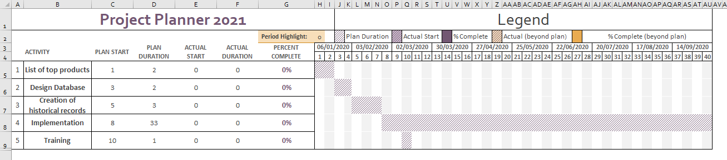
Image 3 - Gantt Chart

Using the Gantt chart as shown in image 3 there is an expected deadline of just eight weeks for the database to be operational and for training to commence. After the eight weeks, there is a further 33 weeks allocated for the collection of the data and adding new products. By week 40 this is expected to be a complete and comprehensive list of all products that LSN supplies. The project is to be completed in five steps which are detailed below.

The Project.

Step 1.
To achieve the list of the top products we needed to understand what has been atomised over the last 48 months. Until recently LSN Diffusion did not store all records in a central database so for us to find a list of all atomised products several databases had to be consulted. All the digital records were then combined into 1 excel sheet to have a historical list of all products melted between 2019 and 2020. Once this task was achieved, we then selected all products and made a pivot table in excel. A Pivot table is a tool built into Excel that allows you to organise and summarise specific rows and columns of data (Thakur, 2022a).
The pivot table feature made it extremely easy to view and manage all the Products, and to be sorted by name and the count of the number of times this product was made (Image 4). This then sorted data became the start of our spreadsheet with the top 500 products. Although relatively straight forwards this still took 8 days to complete, so was done within the two-week timeframe and was completed on the 18th of January 2021.
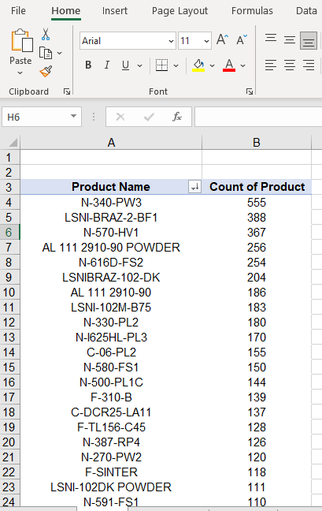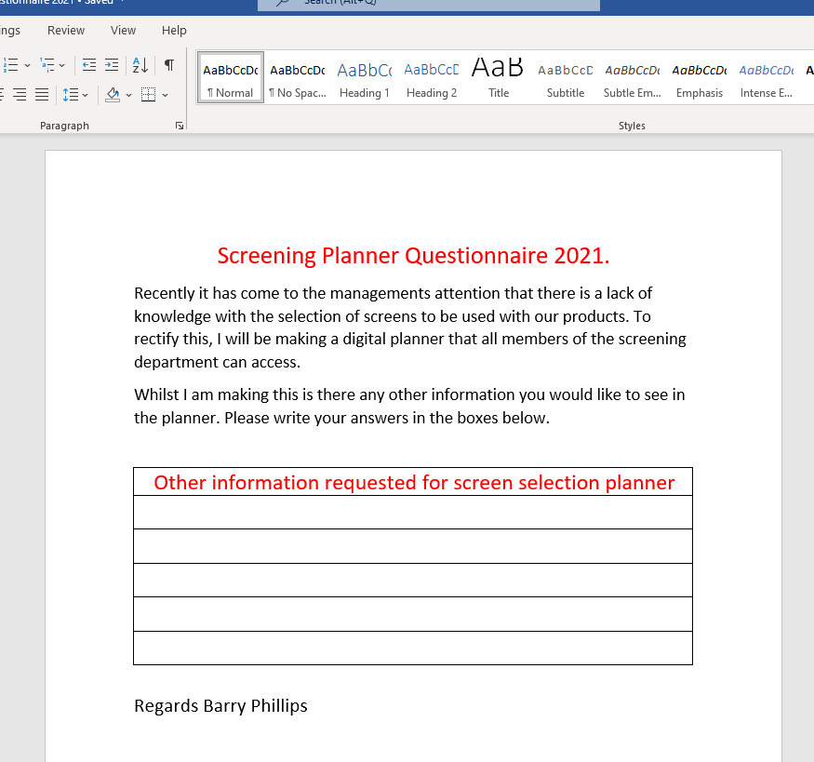
Image 4- Pivot Table Image 5 – Simple questionnaire to department

Step 2.
The next step of the project is the design of the database, as there has never been this kind of knowledge sharing available to the employees before, it was decided to ask them if they would like any further information added to the database. This was actioned in the form of a simple questionnaire (Image 5), it was agreed that employees who are involved in the project from the start are most likely to be more engaged and offer support, and they will be more productive as they feel involved and they will have a positive approach to the new change (Lauby, 2022). The questionnaire was given to all 12 employees and several of the management staff and after compiling all the answers and opinions the extra information most requested was, what alloy family do the products belong to, and if any special instructions or any common issues were associated with the selected products for example if a product required the oversize to be rescreened or a second pass with different screens.
The design of the database was the next step in the project. The design had to be simple and easy to use, but also be able to share the information with everyone in the company without confusion. The average worker is not expected to be an expert on computer software or be proficient in excel. LSN has four towers that atomise the powder which is to be screened by the screening department. So, the ability to modify and change the parameters at very short notice is needed with the database.
The platform chosen to be used for the project is Google Documents. Google was chosen over Microsoft Excel due to the reasons that Google has a better collaboration, all LSN employees have a google account given to them, so no further accounts are needed unlike using Microsoft 365. Google offers a revision history so if a product is changed, we can always go back and see what it was changed from and even who changed it, so we can efficiently record all changes.
Google sheets are easy to share because they are already online, you can simply share the link with any employee that wishes to view the file (Benigni, 2016).
For the design of the database, there were many options available. To make it easy to read and use it was decided that there would be 13 columns (image 6), but an employee would only need to change two columns and the rest would self-populate from a historical database stored on another page.
It was decided that the historical database and every column except the two that can be changed would be locked to the document creator only to ensure nobody accidentally wiped any data. This task was implemented on schedule and started on the 20th of January and run for two weeks up to the 2nd of February 2021.
Image 6 - 13 Columns of database – Green columns are the only cells that can be changed.

Step 3.
The historical database from step 1 now needs instructions added to them. Using any available data and my knowledge of the department every product in the top 500 was looked at. The product was labelled under its official name using the product specification available. The top screen and bottom screen were then entered into separate columns. The speed at which the machines operate was selected along with the classification requirements, how many times the product needs to be processed and finally any instruction or special requirements that were needed to be followed.
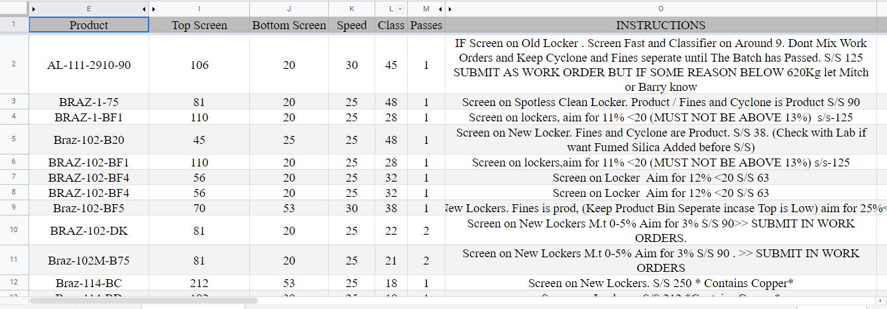
Image 7 – Historical database of sizes and instructions.
The historical database page is the most crucial stage of the project. Should the sizes or parameters be incorrect then the product would fail. When a product fails it would need to be reworked, slowing production time and increasing production costs mostly due to extra staffing levels.
This page was designed to be able to add to it daily, each time that we atomise a new product or from products not in the top 500. The timeframe of this step, unfortunately, went over the planned expectations mostly due to trying to locate any historic records or trying to identify the settings of the machines that were to be used. The Gantt chart was forecast for 3 weeks unfortunately this task lasted 5 weeks and ended on the 9th of March 2021.
The second part was the alloy family each product has a specific family that they belong. They are listed in the following categories.
• Cobalt hard facing. • Dental (Cobalt). • Inconel. • Nickel Aluminium.
• Phosphorus brazing. • Phosphorus hard facing. • Cobalt Soft Facing. •Nickel standard.
• Tungsten containing. • Iron • Others.
Each product can be grouped under one of these categories based on its product name, for example, a product called N-500 will be listed under Nickel standard and C-06 will be listed under Cobalt hard facing. A separate page was assigned for this to reduce the visual impact of the historical database (Image 8)
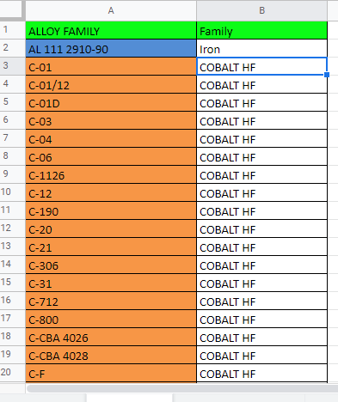
Image 8 – Alloy family.

Step 4.
Slightly behind the schedule the time for implementation had arrived. We had the design, and we had the historical database and alloy family set up so now what was left was to combine all the data and implement.
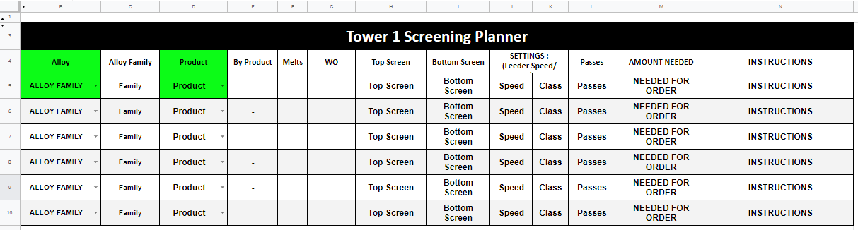
Image 9 - Finished design database.
The interface we decided upon is to minimise mistakes and to allow an easy sheet for everyone to be able to follow. Column B was based on a drop-down from the list of all the products in Image 8. Column D was also a drop-down based on all the products listed in Image 7. This meant there was no typing the incorrect product in that would result in no product found.
Columns C, and E through to N were then set up using V-lookup. V-lookup is a function that uses four arguments on Microsoft excel and Google documents. Using this function, we can look up any value from another table or even page. So, we looked up the products against historical data, then we could choose which information was to be copied over such as screen sizes or notes. Then at the end of the argument, we can choose a similar match or an identical match, by using the identical match we can ensure any given information is what the operator is looking for (Thakur, 2022b).
At this time, it was also decided to allocate different colours to each product based on the alloy family. This was decided to minimise contamination risk, If the colour changed between products, then a clean down or change in operation was needed. A completed row can be seen in the image below (Image 10)
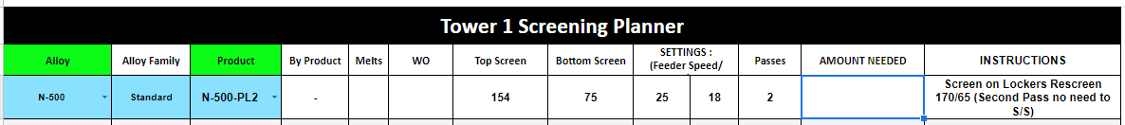
Image 10 - Completed row from the database.
The completed database was implemented to all employees on the 9th of March 2021 only two weeks behind schedule.

Step 5.
The final step was the training. All operators were called in to have a toolbox talk. A Toolbox Talk is normally used to discuss safety aspects between supervisors and their employees; however, studies have shown that it can be a valuable tool for sharing face to face information with all employees (Olson et al., 2016). The toolbox talk was well communicated, and all staff were very interested in the project and understood the importance of adhering to the plan.

Conclusion
The project started on its planned date of the 6th of January 2021 and run smoothly up to the date of implementation which was the 9th of March 2021. After this date, the implementation and monitoring of the project were put in place. This was to be monitored, corrected, and allow new products to be added to the system, 33 weeks were allocated for this to ensure enough time was allocated. The project run very well with only a two-week delay which was due to the creation of the 500 products taking longer than anticipated. As can be seen in the completed Gantt chart (Image 11).
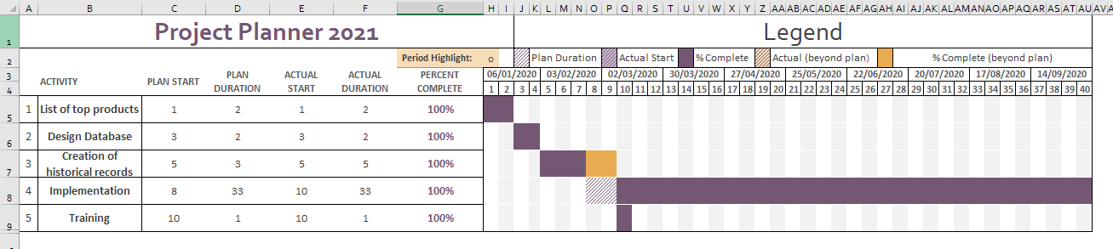
Image 11 – Completed Gantt chart.
All the operators in the screening department were trained via a toolbox talk and were implemented with no issues all within the one-week window.
This project has allowed all managers and operators to run the screening department without any in-depth knowledge requirement. It has allowed production to run efficiently and effectively without the reliance on one single person. The knowledge is no longer hidden and can be viewed by any LSN employee.
Since the creation of this database and the concept of knowledge sharing being made readily available there have been several manager meetings where this kind of database has been requested in various other departments and many other aspects of the screening department.

Reflections
For this project, I was tasked with creating a database to allow the smooth operations of the screening department within my company. The database was required due to a lack of knowledge of the products we atomise, with just one or two people holding the knowledge. The project was classed as finished once it was implemented, however, we needed to maintain and monitor the database for a further 33 weeks to make sure we included all products and not just the top 500.
The project offered some enjoyable experiences for me, up until this project I had never really used google documents and had to search and learn a lot of codes and formulas that I had never seen or used before. The fact that this project will be running long after I have left the company also offers me a sense of achievement knowing that my mark is left on the company and that without this the department would suffer. The most difficult aspect of this project was the actual learning of the top 500 products. As nobody was willing to share the information they had learned in the past. For most of the products, I had to use trial and error to make sure I had chosen the best available parameters for the company.
In the project, I learned various aspects of project management. I developed new skills and learned that working as a team is vitally important to achieving your end goals. Without my colleagues’ input and feedback, this project would not have been achieved. I found many of the employees were willing to share what little they did know to aid me in my task, unfortunately, was just a shame that previous management was not as open. This project was hailed as a success and as it was the first of its kind in the company, was more than suitable for the job at hand, however, this project did not reach its full potential. Since there was no system in place things that were also needed were not implemented at the time. What I found with the project was how easy it was to use, whereas before the operator had to look at the tower plan to see what was melting that day, then go to the department leader and ask him what screen selection he would like and if any special instructions were available. If the department leader was off-site or on holiday, then there was no option except to ring him and ask him for the information. Now anyone with an internet connection can find out instantly. Which led to a lot more productive department and a department with staff who were able to run it without needing management support.
There was no form or system in place that recorded the results of the designated screens. An example of this would be the N-500-PL2 that you can see in Image 10, when this product was screened with the desired screens it failed in the production testing. Without any way of recording passes or failures, this was doomed to repeat the same mistake every time this product was run.
The screening method involves removing any oversize metal particles that the customer does not require from the atomised product and also removing any undersize or fines from the product.
As you can see in image 2 the PL2 product can pass if there is 5% on the 63 - 75 Microns band or if there is 30%. This kind of scope on the product specification can have a detrimental effect on the company. When we have an order for 10,000Kg of N-500-PL2 we can make the powder at a loss by achieving a pass but not maximising the yield. Another method of checking to see the effectiveness of the desired screen selection would be to continuously monitor the yield achieved from the selected screen. This again could be done on another spreadsheet to form a more comprehensive database, and due to the success of this database, this was indeed to be my next project.

References
Benigni, M. (2016) 6 Reasons You Should Be Using Google Sheets Instead Of Excel | TLT HD. Available at: http://tlt.cofc.edu/2016/10/28/6-reasons-you-should-be-using-google-sheets-instead-of-excel/ (Accessed: 8 May 2022).
Chai, W. (2021) What is a PERT Chart and How to Use it, With Examples. Available at: https://www.techtarget.com/searchsoftwarequality/definition/PERT-chart (Accessed: 15 May 2022).
Clark, W. (2022) History of the Gantt Chart – Gantt Charts. Available at: https://ganttchart.com/history_of_the_gantt_chart/ (Accessed: 7 May 2022).
Cobb, A. (2012) “Project Scheduling.” in Leading Project Teams: The Basics of Project Management and Team Leadership. 2455 Teller Road, Thousand Oaks California 91320 United States : SAGE Publications, Inc., pp. 61–84. DOI: 10.4135/9781483349169.n4.
He Peixu, Jiang Cuiling, Xu Zhixing and Shen Chuangang (2021) “Knowledge Hiding: Current Research Status and Future Research Directions.” Frontiers in Psychology 12, pp. 1–1.
Lauby, S. (2022) How to Inspire Employees to Get Involved in Company Events. Available at: https://www.adp.com/spark/articles/2017/11/how-to-inspire-employees-to-get-involved-in-company-events.aspx (Accessed: 8 May 2022).
Lock, D. (2013) Project Management. 10th edn. Gower. DOI: 10.4324/9781315245911.
LSN Diffusion (2020) ADDITIVE MANUFACTURING – LSN Diffusion. Available at: http://lsndiffusion.com/products/additive-manufacturing/ (Accessed: 2 May 2022).
Olson, R., Varga, A., Cannon, A., Jones, J., Gilbert-Jones, I. and Zoller, E. (2016) “Toolbox talks to prevent construction fatalities: Empirical development and evaluation.” Safety Science 86, pp. 122–131. DOI: 10.1016/J.SSCI.2016.02.009.
O’Reilly (2022) 1. What Is a Project? - Effective Project Management: Traditional, Agile, Extreme [Book]. Available at: https://www.oreilly.com/library/view/effective-project-management/9780470423677/ch01.html (Accessed: 1 May 2022).
Thakur, M. (2022a) Pivot Table in Excel (Examples) | How to Create Pivot Table? Available at: https://www.educba.com/pivot-table-in-excel/ (Accessed: 8 May 2022).
Thakur, M. (2022b) VLOOKUP in Excel (Formula, Examples) | How to Use? Available at: https://www.educba.com/vlookup-function-in-excel/ (Accessed: 10 May 2022).
Wysocki, R. (2019) “What is a Project?” in Effective Project Management - Traditional, Agile, Extreme, Hybrid. 8th edn. John Wiley & Sons, pp. 3–4.

