

Name: SAQIB AHMED
Student ID: 2527092
Module Code: DS1 LCLM4002-A1P1
Module: Digital Skills

Submitted on: 04/10/2026

DS 1 Template

My Screenshots/Photos
- Please add 4–6 screenshots or photos of your digital life.
- You can use your phone or laptop.
- For each screenshot, write one or two sentences explaining what it shows.

Screenshot/Photo 1
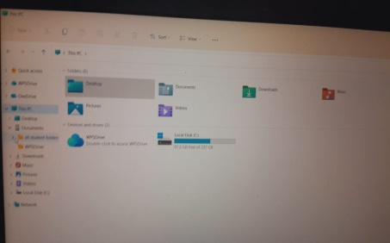
This is a screenshot of my PC's File Explorer, which I use to organize my academic folders, documents and local storage. It helps me keep my digital workspace structured and easily accessible for my studies.

Screenshot/Photo 2
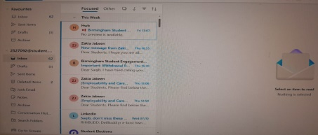
This is my email inbox in Outlook, with some announcements from University departments and staff. I check my email every day to receive important student information and academic correspondence.

Screenshot/Photo 3
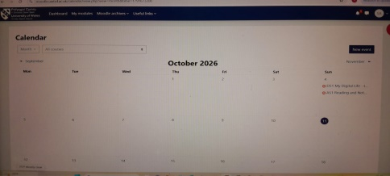
This is a screenshot of my University Moodle calendar with upcoming assignment deadlines and course events. It makes managing time and keeping track of submission dates easier for me.

Screenshot/Photo 4
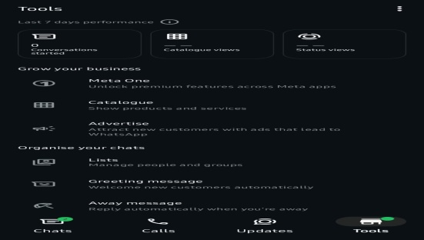
This screenshot highlights the business and chat tools I use on WhatsApp to manage conversations and group communications. It is how I interact with peers, groups and contacts in the digital world every day.

Screenshot/Photo 5
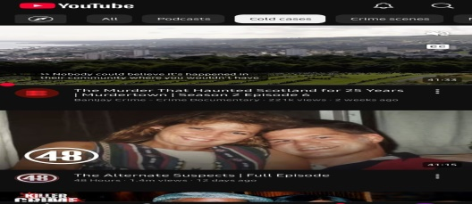
This screenshot shows my YouTube homepage where I watch documentaries and educational videos. During my down time, I watch videos for fun and for learning.

Screenshot/Photo 6
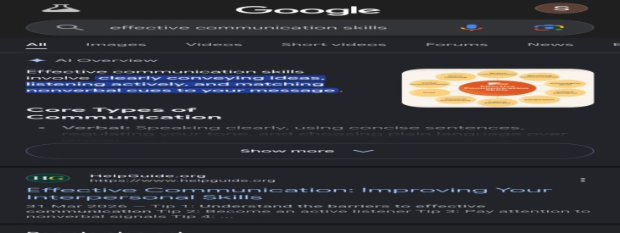
This image shows a Google search for effective communication skills, along with AI overview summaries. I rely heavily on web searches to quickly research topics and build my understanding.

My Short Reflection
- Write 5–8 simple sentences about your digital life.
- You can use the sentence starters below if helpful.
I use digital tools for studying, communicating with University staff and managing my daily routine. I feel good when I maintain my files and I go to my email regularly. I wish to increase my digital research capabilities and to know about new features of software. I use them frequently: Outlook, Moodle, Google Search and WhatsApp. I am sometimes anxious about meeting the deadlines of assignments and technical glitches. I hope that in this module I will develop my digital communication and productivity skills more. Digital skills are relevant to me as they help me to be successful in my studies and in my future career.

Sentence starters
- I use digital tools to …
- I feel confident when I …
- I want to improve …
- I often use these tools: …
- I sometimes feel nervous about …
- I hope this module will help me …
- Digital skills are important for me because …
You can write more if you want.

Submission Checklist
Before you submit, please check:
​​​ ☐ I added 4–6 screenshots
☐ I wrote short sentences for each screenshot
☐ I wrote my short reflection
☐ My work is my own
☐ My file opens correctly
​​☐ My file opens correctly

