Component 1: BMHP5014
Student number: 2437844
Student name: Whitney Brito Moreno
Lecturer: Alice Clayton
Word count: 2000

Table of Contents

Table of Contents 2
Task 1 3
Concept map 3
Task 2 6
Gibbs Reflective model 6
Task 3 8
Case Study 8
Task 4 10
Current issue – mental health 10
Task 5 11
Podcast 11
Task 6 12
NHS Leadership Framework 12
Task 7 14
Self-reflection 14
Reference list 15

Task 1

Concept map
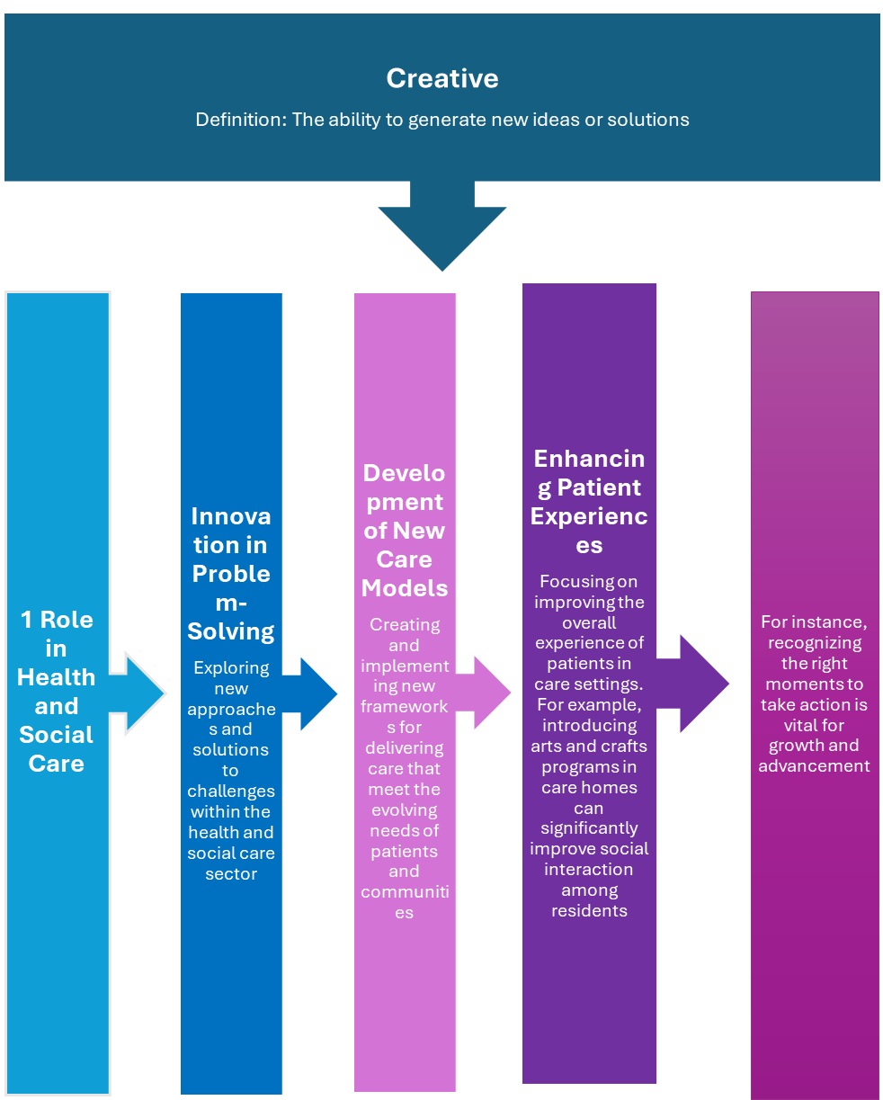

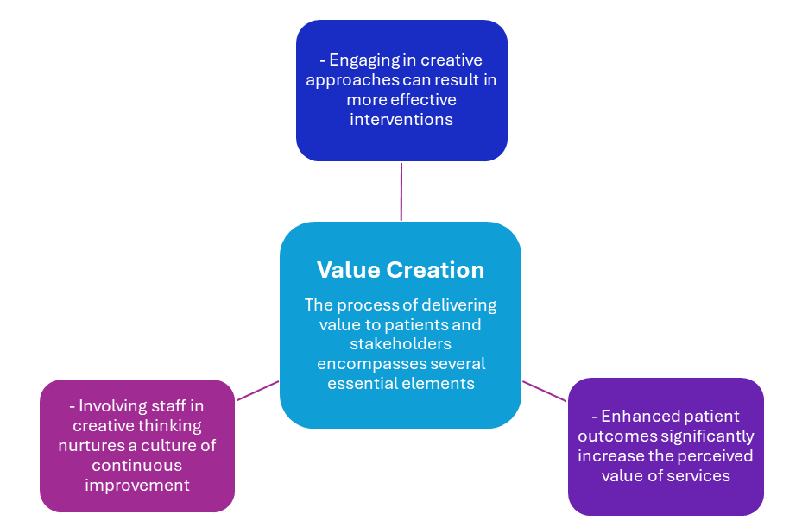

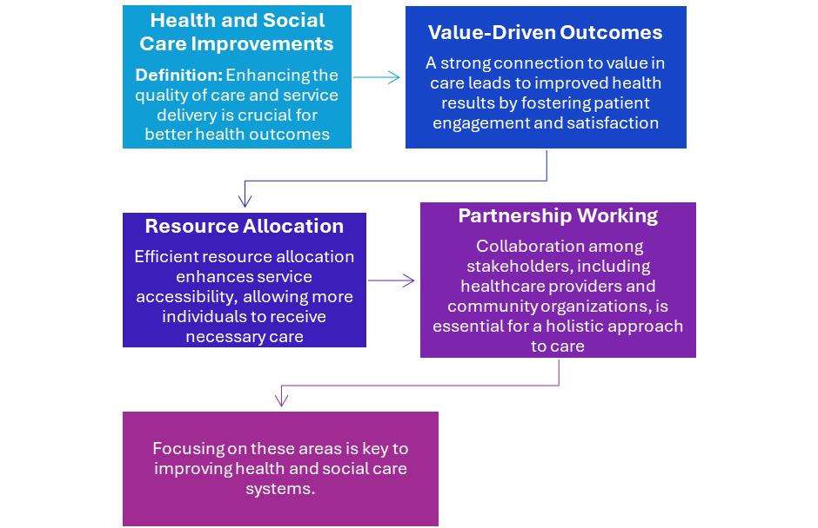

Task 2

Gibbs Reflective model

According to Potthoff, Mishek and Hart (2019) convergent and divergent thinking are two critical cognitive strategies. Convergent thinking seeks a single correct solution to a problem, while divergent thinking generates multiple, creative ideas. Both processes are essential for effective problem-solving and innovation.

Description
In this case study, we analysed a real-world problem using convergent and divergent thinking techniques. We began by brainstorming numerous solutions, then systematically narrowed our focus to the most viable options. This approach balanced creativity with practicality in our final recommendations.

Feelings
At first, I felt overwhelmed by the open-ended nature of divergent thinking, but as we generated ideas, my anxiety turned into excitement. The collaborative environment fostered creativity and allowed me to appreciate my peers' unique perspectives.

Evaluation
The case study effectively illustrated the strengths of both thinking styles. Divergent thinking fostered innovation and exploration, while convergent thinking offered clarity and direction. The transition between the two concepts can be challenging, hindering creative flow, and may require careful navigation to maintain innovation and avoid stifling ideas.

Analysis
This experience underscored the importance of balancing both creative and analytical thinking styles in problem-solving. The integration of these two approaches yields more effective solutions.
Conclusion
I have come to recognise the significance of integrating both methodologies in future projects. This experience underscored how collaborative efforts can significantly improve the problem-solving process, leading to more innovative and effective outcomes.

Action Plan
In our upcoming group work, I intend to promote a structured approach that emphasises divergent thinking before transitioning to convergent analysis. This strategy will enable us to generate innovative ideas while keeping our focus on our objectives. By dedicating time to brainstorming and considering multiple perspectives, we can foster creativity and subsequently evaluate our best solutions systematically. This balanced approach will ultimately enhance the quality of our outcomes.

Task 3

Case Study

Innovation is the implementation of novel ideas in health and social care, ultimately supporting improved health outcomes and enhancing the overall service experience. The integration of technology into care delivery is transforming service models and fostering creative problem-solving. The importance of innovation in healthcare cannot be overstated, as it alleviates the financial burdens associated with traditional models that have proven less successful in today’s challenging environment. Innovation helps address issues related to providing high-quality care and improving patient outcomes, ensuring that resources are utilised effectively.
The "NHS at Home" initiative primarily aims to alleviate the pressure on hospital admissions by enabling patients to monitor their health from the comfort of their own homes. This approach not only enhances patient independence but also reduces overall demand for hospital resources. Considering the growing pressures on acute services, an ageing population, and the rise of chronic conditions, the NHS has adeptly incorporated technology and clinical pathways to deliver care in patients' homes.
This analysis suggested that Shepherd et al. (2009) underscored how innovative strategies prompted a shift from reactive, hospital-centred care to proactive, patient-focused management, ultimately creating considerable value for both patients and the healthcare system.
Remote monitoring allows patients to manage their health from home, effectively tracking symptoms and signs. This access fosters greater engagement in personal health management, leading to improved health outcomes through technology-enabled support and timely interventions. Ultimately, it empowers individuals to take an active role in their wellness (Kelly and Young, 2017).
Medical devices such as Pulse oximeters, blood pressure monitors, thermometers, and weighing scales. Digital platforms, smartphone applications, specialised tablets, or web portals that allow patients to input data and respond to symptom-related questions. A dedicated team of healthcare professionals, including nurses, doctors, and therapists, remotely reviews the submitted data. They can identify emerging trends and intervene early, providing virtual consultations, adjusting medications, coordinating necessary in-person visits, and escalating care as needed.

Providing healthcare at home enhances patients' quality of life by allowing them to receive care in familiar surroundings. This approach reduces the stress associated with hospital stays and contributes to overall well-being by maintaining a sense of normalcy and comfort during treatment. According to Alpay, van der Boog and Dumaij (2011), increased empowerment and continuous monitoring by the clinical team reassures patients. Additionally, they are encouraged to manage their own health actively, fostering a sense of control and boosting their self-efficacy.
In conclusion, the incorporation of innovation and technology in healthcare, as demonstrated by initiatives such as "NHS at Home," greatly enhances service delivery. By enabling patients to monitor their health from the comfort of their homes, we not only improve their quality of life but also alleviate pressure on hospital resources. This proactive, patient-centred approach encourages greater engagement and empowerment, ultimately resulting in better health outcomes and more efficient use of resources. As we confront the challenges posed by an ageing population and the increasing prevalence of chronic conditions, it is essential to embrace such innovations to sustain high-quality care and promote overall patient wellness.

Task 4

Current issue – mental health

Evans et al. (2023) highlight that the mental health and well-being of children and young people aged 5 to 25 years is a pressing public health concern. The ongoing crisis has contributed to a deficiency in integrated, age-appropriate, and person-centred interventions, resulting in considerable distress and neglecting to prioritise the optimal care experiences for young individuals. The findings indicate that the absence of multi-agency collaboration has resulted in insufficient support from various services. This inadequacy is characterised by a lack of resources, insufficiently trained professionals, and inadequate crisis resolution protocols. The youth demographic often relies heavily on emergency departments for their healthcare needs. While this dependence can provide immediate support, it often leads to prolonged wait times and inadequate follow-up care. Consequently, these factors often overlook the underlying issues that contribute to recurring crises, thereby hindering the effectiveness of long-term solutions. Addressing these systemic challenges is essential for preventing future health emergencies among young individuals.

The research conducted by Delan Devakumar, Jennifer Hall, Joy Lawn, and Zeshan Qureshi in (2019) highlights significant global health challenges faced by women, newborns, children, and adolescents. They argue that disparities in public health interventions have notably contributed to increased morbidity and mortality rates, particularly in low- and middle-income countries. This highlights the pressing need for targeted health policies and interventions to address these disparities and enhance health outcomes in vulnerable populations. The primary factors contributing to this issue include inadequate access to health services, primarily driven by poverty. This lack of resources results in hindered access to healthcare, leading to adverse outcomes for affected populations. Addressing these root causes is essential for improving overall health and well-being.

In conclusion, both analyses highlight the significance of progress in health on both global and local scales. A comprehensive understanding and investment are crucial to address the system effectively. Furthermore, financial investment and dedicated workforce development are crucial for establishing integrated, population-centred care models that can play a significant role in early intervention. Each pathway has demonstrated clear evidence of complex health challenges, highlighting the necessity for systemic improvements to prioritise enhanced support.

Task 5

Podcast

Task 6

NHS Leadership Framework

According to the National Health Service (Leadership Academy 2011), it has implemented a comprehensive framework designed to enhance leadership across all levels of the organisation, from staff members to the Chief Executive Officer (CEO). This strategic approach aims to improve treatment quality, optimise health outcomes, and elevate the overall standard of services provided to patients. By fostering a culture of effective leadership, the NHS seeks to create an environment that encourages collaboration, innovation, and continuous improvement, ultimately benefiting both healthcare professionals and the communities they serve.

The seven domains of self-awareness involve being adaptable and open to learning new skills, such as partnering with others to build strong, mutually beneficial relationships. Effective planning requires collaboration, which includes managing people and resources and taking actions to hold individuals accountable. A key focus is on improving services that encourage transformation. Conversely, setting a clear direction requires a deep understanding and the ability to make informed decisions. The values of the NHS should be embraced with pride and respect, ensuring alignment with the organisation. This can be achieved by implementing a strategy that transforms both actions and vision into reality, Alderwick et al (2015).

Effectively managing services within the NHS is a fundamental responsibility that requires proactive leadership, comprehensive planning, and strategic management of resources, personnel, and performance. One of the primary goals of effective planning is to enhance patient services by integrating feedback mechanisms that allow for continuous improvement and the development of better health outcomes (NHS Digital, 2024). It is essential to utilise available resources not only efficiently but also with careful consideration, ensuring that the right amount of services is allocated to those in need. This approach contributes to sustainability and cost-effectiveness, which are critical in today’s healthcare environment (NICE, 2021) .
In terms of managing people, the focus should be on fostering a culture of motivation and support. This involves establishing a skilled and well-reviewed workforce that is trained to assist colleagues and contribute positively to the organisational environment. Creating opportunities for professional development and encouraging teamwork can significantly enhance employee engagement and performance (NHS employers, 2021).

Performance management is another vital aspect, encompassing a broad range of services that may necessitate improvement. Identifying these areas for enhancement involves a systematic process of evaluation, which the development and implementation of detailed action plans should complement. As a leader, it is your responsibility to ensure that these plans are executed effectively, driving accountability and continuous progress within the organisation. By addressing these key areas, the NHS can work towards achieving its mission of delivering high-quality patient care (NHS England, 2018).

Task 7

Self-reflection

What I have learned in this module is that creativity plays a crucial role in problem-solving to find solutions in health and social care. The connection between creativity and innovation lies in its ability to challenge new ideas; creativity, in turn, facilitates the implementation of these concepts. An example of this is the transition from paper documents to electronic health records.

The Gibbs Reflective Cycle emphasises the value of reflecting on one’s learning experiences. By actively engaging in reflection, I have learned to assess my strengths and weaknesses throughout various situations. Developing a personal journal has been particularly beneficial, as it allows me to document my thoughts and insights. This practice not only enhances my understanding of specific experiences but also contributes to my overall personal and professional growth. Through regular reflection, I can identify areas for improvement and celebrate my achievements, ultimately fostering a more mindful approach to my learning journey.

Reference list

Kelly, C.J. and Young, A.J. (2017) ‘Promoting innovation in healthcare’, Future Hospital Journal, 4(2), pp.121–125. doi:https://doi.org/10.7861/futurehosp.4-2-121.

NHS Digital (2024) NHS Outcomes Framework Indicators, April 2024 release. [online] Available at: https://www.gov.uk/government/statistics/nhs-outcomes-framework-indicators-april-2024-release. (Accessed: 04 November 2025).

NHS employers (2021) TEAM Toolkit. [online] Available at: https://www.nhsemployers.org/system/files/media/Do-OD-Team-Toolkit_0.pdf. (Accessed: 31 October 2025).

NHS England (2018) Patient experience improvement framework. [online] Available at: https://www.england.nhs.uk/wp-content/uploads/2021/04/nhsi-patient-experience-improvement-framework.pdf. (Accessed: 30 October 2025).

NHS Leadership Academy (2011) Leadership framework. Coventry: NHS Institute For Innovation And Improvement.

NICE (2021) Patient Experience in Adult NHS services: Improving the Experience of Care for People Using Adult NHS Services. [online] www.nice.org.uk. Available at: https://www.nice.org.uk/guidance/cg138/chapter/Recommendations. (Accessed: 04 November 2025).

Ocampo, F.A., McIntyre, B.G., Massey, D. and Saunders, R. (2025) ‘Nursing Student Reflections on a Research internship: a Reflective Discussion following the Gibbs’ Reflective Cycle’, Nurse Education Today, [online] 145(1), p.106481. doi:https://doi.org/10.1016/j.nedt.2024.106481. (Accessed: 30 October 2025).

Saeed, H., Md Som, H. and Mahmood, R. (2022) ‘Leadership Styles, Organizational Culture, and Innovation in Healthcare: A Conceptual Framework’, International Journal of Academic Research in Business and Social Sciences, 12(8). doi:https://doi.org/10.6007/ijarbss/v12-i8/14551.

Potthoff, S., Mishek, J. and Hart, G.W. (2019) Applied problem solving in healthcare [online] Google.co.uk. Available at: https://www.google.co.uk/books/edition/Applied_Problem_Solving_in_Healthcare_Ma/SwbcDwAAQBAJ?hl=en&gbpv=0 (Accessed: 24 October 2025).

Shepperd, S., Doll, H., Angus, R.M., Clarke, M.J., Iliffe, S., Kalra, L., Ricauda, N.A., Tibaldi, V. and Wilson, A.D. (2009) ‘Avoiding hospital admission through provision of hospital care at home: a systematic review and meta-analysis of individual patient data’, Canadian Medical Association Journal, 180(2), pp.175–182. doi:https://doi.org/10.1503/cmaj.081491.

