

International Market Entry Strategy and Marketing Mix of IKEA in Germany and India
Programme | Master of Business Administration
Module | International Marketing: Principles and Practices
Module code | LCMB7026
Lecturer | Dian Mayasari
Student name | Asif Mahmud Emon
Student ID | 2439438
Word count | 5657
Submission date

Table of Contents
1. Introduction 3
2. Comparative market analysis: PESTEL 4
3. Comparative STP analysis 9
4. Comparative international marketing mix (7Ps) 10
4.1 Product 10
4.2 Price 11
4.3 Place 11
4.4 Promotion 12
4.5 People, Process and Physical evidence 12
5. Directional development strategy in India 14
6. Ethical issues in the marketing mix 15
7. Recommendations 16
8. Conclusion 17
Section 2: Reflective account using Gibbs’ reflective cycle 18
9. Reflection 18
References 21

1. Introduction
In this report, the international market entry strategy and marketing mix of IKEA in Germany and India are evaluated. The two have been chosen due to the contrast being strategically appropriate and materially diversifying compared to a mere developed/ developing country comparison. Germany is a highly developed, high-income, digitally developed European economy with high concentration in the furniture and home-improvement sector in which IKEA competes. India is a growing and low-income and very heterogeneous market with a growing home furnishing demand, although infrastructure, housing types, service needs and affordability pressures are much different. It is the contrast that enables a better evaluation of the extent to which a global retailer can standardise its proposition and the areas that it has to customise.
The brief has task requirements that are used to structure the report. It then contrasts the macro-environment in Germany and India based on PESTEL with specific consideration on consumer behaviour and culture. It then assesses the segmentation, targeting and positioning of IKEA, and then compares the 7Ps, particularly the product, price, place and promotion. The next evaluation of the report measures the directional development strategy of IKEA in India, evaluates ethical concerns associated with the marketing mix, and offers recommendations. Section 2 puts the reflective cycle of Gibbs to the research and writing process.
The main thesis is that IKEA defends a greatly standardised brand core in both markets, which revolves around democratic design, self-service retail logic, flat-pack efficiency and coordinated omnichannel experience, but it is far more profoundly adapting the commercial system in India than in Germany. Germany Adaptation is comparatively small since the market already qualifies IKEA in terms of scale, assortment logic and culture of home-improvement. In India, IKEA has been forced to moderate the expectations of the conventional big-box model by scaling the geographic expansion, stretching the service provision, small customer meeting spaces, and moderating cost and local living standards. This indicates that the international strategy of the company can not be seen as mere standardization or adaption but rather as selective modular adaption in a highly controlled global format.

2. Comparative market analysis: PESTEL
The most strategically relevant PESTEL contrasts are summarised in table 1. This is not to enumerate all the macro factors, but to determine the factors that significantly influence the path of market, consumer experience and resource allocation of IKEA between the two countries.
Factor | Germany | India | Strategic implication for IKEA
Political / regulatory | Stable policy environment; predictable consumer regulation; advanced competition and product-safety rules. | Stable democratic setting but more layered regulation, infrastructure approvals and state-level complexity; foreign retail expansion remains operationally more demanding. | Germany supports scale efficiency; India requires phased expansion, careful compliance and longer planning cycles.
Economic | High GDP per capita, mature demand, slower market growth, stronger labour costs. | Lower GDP per capita but stronger medium-term growth and a rising urban middle class. | Germany rewards efficiency and brand consistency; India requires sharper affordability architecture and gradual market development.
Social / cultural | High acceptance of functional self-service retail; smaller households and urban apartments support storage solutions and convenience. | Family-centric households, multi-generational living, aspirational consumption and stronger need for service reassurance. | The same IKEA proposition must be framed differently: convenience and style in Germany, accessible aspiration and guided solutions in India.
Technological | Very high internet penetration and stable omnichannel habits. | Large digital audience but uneven physical access and significant regional variation. | Germany can assume frictionless omnichannel usage; India must use digital as a scaling tool while recognising uneven fulfilment reach.
Environmental | High expectations around circularity, energy efficiency and responsible consumption. | Environmental concern is rising, but affordability and access remain immediate priorities for many buyers. | Sustainability messaging is important in both markets, but the balance between affordability and environmental claims must be managed carefully.
Legal | Well-established standards for delivery, returns, data protection and consumer rights. | Growing consumer protection and e-commerce regulation, but execution conditions differ by location and logistics capability. | Germany allows standardised policy communication; India requires clearer service communication and operational flexibility.
The most apparent structural divergence is the economic one between Germany and India. World Bank statistics reveal that the GDP per capita of Germany is about US $56,103.7 in 2024 as compared to that of India of 2,694.9. This gap is important as IKEA is competing based on an affordability promise, which is never absolute, but relative. A sofa or modular Kitchen that would seem to be attainable in Germany, may become aspirational in India when the question of delivery, assembly and room-size is put into consideration. Thus, the price architecture used in one market cannot just be replicated in another one.
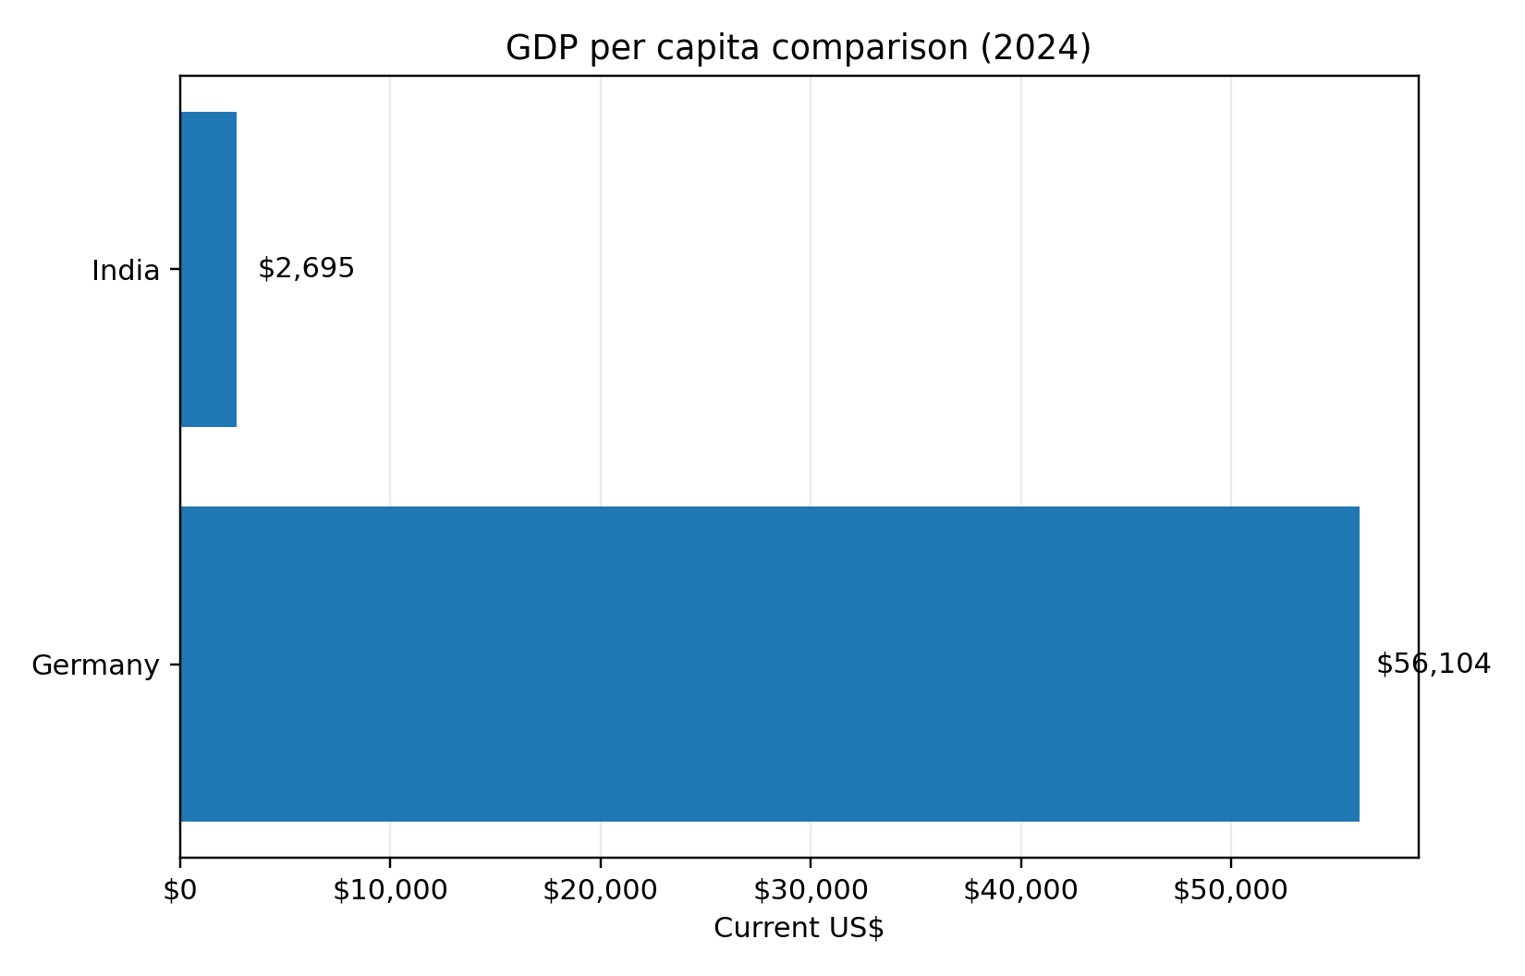
Figure 1. GDP per capita comparison between Germany and India, 2024. Source: author-created chart based on World Bank country data.
Figure 1 supports the reason why the value proposition of IKEA needs to be viewed differently across the two nations. In Germany, the concept of affordable design is functioning within a developed consumer economy whereby discretionary income and housing infrastructure is fairly stable. In India, the same idea has to deal with stronger price sensitivity, larger range of variations in the housing size and more urgency to focus on more entry-level and space-saving solutions. This leads to the second strategic implication, which is that affordability in India cannot be substantially based on nominally low prices only, but need to be reinforced by assortment discipline, access point that is of smaller sizes, and the design of selective service.
The social and cultural aspect is even of more significance than the macroeconomic gap since this brief requires a greater comparison of consumer behaviour and culture. Germany is less distant to the assumptions of the traditional IKEA model: a high culture of home improvement planned, comparatively large acceptability of self-service retail and a consumer population accustomed to researching products online and then going to the stores or placing an order to pick up and deliver. The self-selection logic, the flat-pack transport and modular furnishing consequently become behaviourally congruent with the market. The Click and Collect service by IKEA in Germany represents a mature omnichannel rationale since pickup can be made in stores or pickup points and a collection-based pricing incentive is offered on the basis of a membership.
India is not just different in terms of income. The household setup is more varied, the intergenerational co-residence is more widespread, the choices of the housewife are more frequently negotiated within the family, and the purchases of home furnishing might be placed between the necessity, the desire and social mobility. This is not to say that IKEA global proposition is not appropriate, but only that the company needs to minimise decision friction. India thus needs more support, planning, room inspiring and trust forming as compared to Germany. The increase of online delivery by IKEA India in North India and the first Bengaluru Plan and Order Point demonstrate that the company has realised that planning and approach to customers must be brought closer to the customers instead of depending on destination megastores.
Both the countries are digitally important technologically, although the trend is different. According to DataReportal, in 2025 the internet penetration in Germany (93.5) and India (55.3) is 93.5% and 55.3% respectively. The omnichannel customer experience in Germany is low-friction and stable due to the digital environment. India, in its turn, is an amalgamation of huge digital coverage and imbalanced physical servicing. IKEA has reacted to this by leveraging online growth as a market-entry mechanism, but with clearly limited delivery areas and pin code serviceable zones. The implication is important: in India digital is not only a marketing channel, but it is also a tool of disciplined market geographical development.
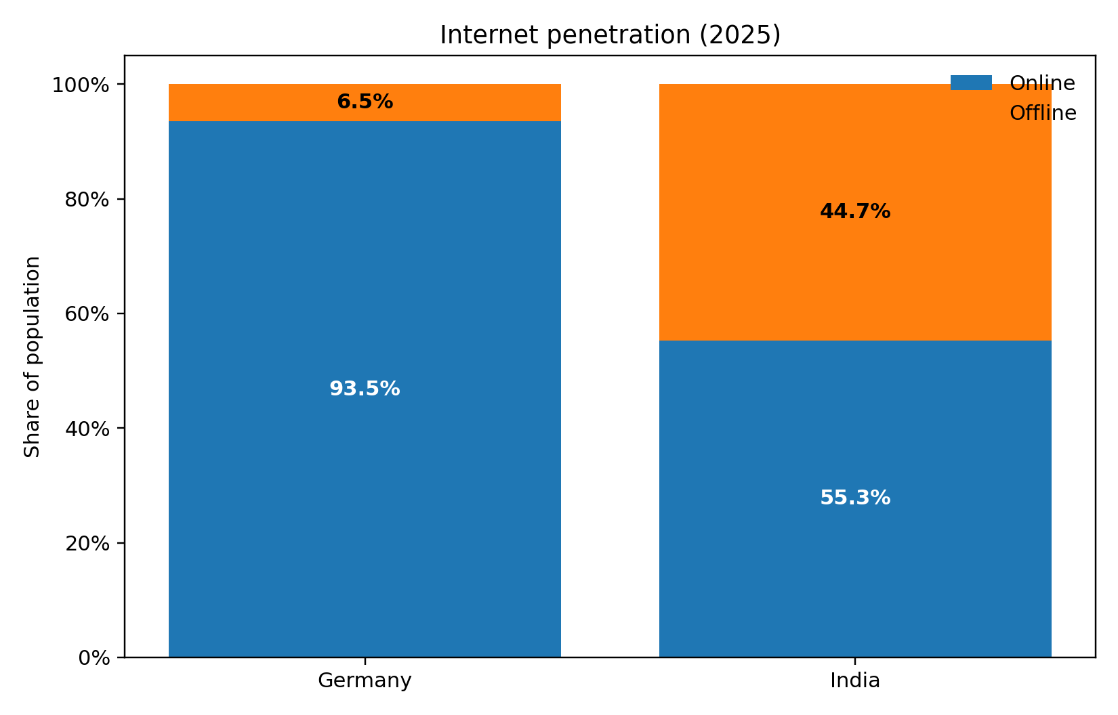
Figure 2. Internet penetration in Germany and India, 2025. Source: author-created chart based on DataReportal country reports.
The reason why omnichannel cannot be considered the same capability in the two countries is illustrated in Figure 2. Online research, pick up and parcel or truck delivery can be integrated into a developed retail system in Germany. In India, the level of digital penetration is high in absolute terms, but omnichannel remains more reliant on the areas where IKEA can provide, assemble and support the customer experience. Thus, the technology strategy adopted by the company in India is not merely a marketing communication strategy; it is a strategy of reaching more people without straining the fixed assets.
Both nations exert significant, yet varying, pressure in the environment and the law. The German consumers and regulators work in an environment where sustainability, product durability, energy efficiency and circularity are high expectations. Environmental agenda of India is also growing at a high rate, but many customers still focus on affordability, durability and accessibility of the services. The strategic dilemma IKEA is thus presented with is the classical one: it has to maintain its sustainability credibility, and at the same time, it should not allow the expense of sustainability efforts to alienate the brand to cost-conscious families. This is its tension at the core of its international marketing challenge.

3. Comparative STP analysis
The segmentation of IKEA in the two markets is multi-layered and not demographic. The best segmentation logic would be a mix of life stage, home formation, home-space restriction, budget sensitivity, and desire to take part in the IKEA shopping model. In Germany, IKEA will be able to address a comparatively wide range of urban and suburban customers, such as young adults who furnish first apartments, families who need functional value, and design-sensitive customers who want cheap fancies. In India, the market that can be effectively addressed is smaller due to physical access, delivery coverage, size of the home, and purchasing power of those who can practically purchase the brand.
Focusing on targeting is thus different. In Germany, IKEA has the opportunity to continue with the broad-market approach since the category is mature and the shopping model is not novel. In India, the logic of targeting is more discriminating. The key focus is on urban middle-income and upper-middle-income households in large urban and neighbouring metropolitan areas that are digitally accessible and receptive to organised home retail and open to planned purchases. That is why the recent actions of IKEA India were based on online launch in Delhi-NCR, the development of city stores and plan-and-order points instead of the immediate nation-wide launch. The company is also doing the right thing of targeting accessible areas of demand instead of nationwide coverage that is undifferentiated.
The global brand coherence of IKEA is the strongest in positioning. In both markets, the brand is offering high quality, functional, and affordable home furnishing solutions. But, it is the positioning in each market that is different. In Germany, IKEA can afford to pay more attention to convenience, design efficiency, family membership benefits and self-directed shopping. The positioning requires another level of instructed access in India. IKEA continues to sell democratic design, yet it needs to lessen the path along that design as something less fearful by inspiring rooms, planning services, simplified delivery communications and more localised digital entry-points.
Another interpretation that would be useful is that IKEA standardises meaning of the brand but customise the access path to the brand. This difference is important as a lot of discussions over adaptation and standardisation prove to be too dichotomous. Germany and India demonstrate that a company can maintain a consistent position statement and still localise the commercial and service system that will render such a positioning statement plausible in practise.
STP element | Germany | India | Critical evaluation
Segmentation | Broad life-stage and household segmentation in a mature category. | Urban, digitally reachable, middle-income and aspirational family households. | India uses narrower effective segmentation because geography and service access materially shape demand.
Targeting | Mass-premium value targeting across a wide addressable market. | Selective urban market development focused on metros and adjacent high-potential cities. | India’s targeting is more disciplined and operationally constrained, not merely marketing-led.
Positioning | Affordable, functional design with convenient omnichannel fulfilment. | Affordable aspiration with more support, planning and trust-building. | The brand promise stays global, but the path to conversion is adapted locally.

4. Comparative international marketing mix (7Ps)

4.1 Product
The product strategy of IKEA is internationally identifiable: Scandinavo design hints, modularity, flat-pack engineering, room-based merchandising and extensive good-better-best assortment. But there is still need of product adaptation. In Germany, the product system will not need to be so far apart in relation to the global standard since the market is already preconditioned to self-assembly, standard dimensions of rooms, and functional storage systems. The product challenge in India is more complicated. Homes differ drastically depending on city, budget and family size, whereas heat, humidity, space and use intensity may alter the value of customers. This does not necessitate an entirely different collection, however it does necessitate tighter curation, greater focus on entry products, and solutions that the household furnishing small or multi-purpose spaces can read.
It is not just local products but local relevance of range curation that is of the utmost importance as far as product adaptation in India is concerned. IKEA is capable of maintaining the global design identity but choosing and selling products based on small living, family usage and simpler planning. This is enabled by the Plan and Order Point format in Bengaluru where the brand would shift to design-support and solution selling rather than displaying the pure product, which is especially necessary in the markets where the customer might require more assurances before they make bigger purchases.

4.2 Price
The most obvious reason as to why international standardisation has boundaries is price. IKEA has a price philosophy that is worldwide based on the democratic design and cost effectiveness, but the perceived sense of affordability in Germany and India is vastly different. The context of higher income in Germany permits IKEA to brand itself as a cheaper-but-fashionable middle-end product. India needs more emphasis on entry barriers, package economics, delivery price and service fees. Total acquisition cost can also emerge as an obstacle even in those places where the price can be considered as competitive on the sticker price.
A more developed utilisation of membership-based price incentives in services is also seen in Germany, including discounted or free Click & Collect over some thresholds of IKEA Family members. Delivery-service pricing and geographic availability are more selectively used in India, which is indicative of the fact that fulfilment economics remain a greater constraint. The strategic lesson is that a global low-price storey can only work in cases where the entire purchase experience, as opposed to the shelf price, is plausible.

4.3 Place
The most noticeable point of divergence between the two markets is place strategy. Germany is an advocate of the mature omnichannel model of IKEA: the stores, Click and Collect, pickup points, parcel delivery, and truck delivery. The place system is convenient, routinised and dense. It is indicative of the reality that Germany is a highly developed market in which customers are able to move freely between internet shopping, store shopping, and hassle-free picking up of orders.
The place strategy used by India is overtly staged. IKEA has integrated the growth of large-format stores with online delivery, presence in the city stores in Delhi, and Plan and Order Point in Bengaluru. It is an advanced market growth since it does not demand the capital cost of immediate national big-box imitation. Rather, IKEA is establishing a network of customer meeting points, which together increase accessibility. Strategically, India shows that place adaptation does not merely entail where to put up stores rather it is a portfolio of access formats that is best suited to the infrastructural and behavioural conditions of the market.

4.4 Promotion
The promotional strategies in both countries are based on the worldwide IKEA storey of improved everyday living, democratic design and room inspiration. This however, alters the emphasis of the message. In Germany, one can be more confident in self-directed promotion communication due to a higher brand familiarity and awareness of the category. India needs to be communicated about the anxiety of the way to shop, the way delivery is organised, the presence of the brand officially, and the possibility of the support of design planning. The official communications and customer-information pages of IKEA India themselves demonstrate that the basic access and trust is still a part of the promotional work. That is, promotion in India also has an educative role.
This is an important observation since it demonstrates that promotion is place and process oriented. Promotion can be narrowed in a more mature market, brand, products and offers. Promotion has also to frequently include extra explanatory labour in an emerging omnichannel market, as the customers need to comprehend the service structure underlying the purchasing of the product.

4.5 People, Process and Physical evidence
The other three Ps only enhance the contrast. In India, people are more important since direction, strategizing and encouragement may be more decisive in conversion. The process is also different as the checkout, delivery and installation expectations tend to be more fluctuating. In both countries, physical evidence continues to be the core of the IKEA experiential model, albeit with smaller, edited formats being increasingly used as an extension of destination stores in India. This indicates that the delivery architecture can be highly localised around even in case of standardisation of core experiential DNA.
7P | Germany | India | Judgement
Product | Global range with limited adaptation; strong fit with self-service culture. | Curated range, compact-living relevance and stronger planning support. | Moderate adaptation in India improves relevance without eroding brand identity.
Price | Affordable mainstream positioning; service incentives via membership. | Higher sensitivity to total cost, delivery and assembly charges. | Affordability in India must be managed systemically, not just through ticket price.
Place | Mature omnichannel ecosystem with stores, pickup and delivery options. | Phased network using big-box stores, online delivery, city stores and planning points. | Place is the most strategically adapted element in India.
Promotion | Brand and offer-led communication. | Brand plus education, reassurance and service explanation. | Promotional content in India carries more informational labour.
People | Lower dependency on intensive support. | Higher value of co-worker guidance and planning support. | Human support is more commercially significant in India.
Process | Standardised and low-friction. | More carefully managed due to delivery scope and service variability. | Process adaptation protects conversion in India.
Physical evidence | Large-format experiential retail remains effective. | Mix of destination and smaller-format meeting points. | India shows more format innovation within the global IKEA system.

5. Directional development strategy in India
The matrix created by Ansoff can be applied, in this case, since the current direction of IKEA in India can be best described as market development with selective format innovation. The company does not entirely alter the product-market logic of IKEA; it is just expanding the same logic to new geographies, points of entry and demand clusters of customers and serviceable within India. It is supported by the North India online rollout, the first Delhi city store, the Bengaluru Plan and Order Point. Such actions increase market penetration without the company having to imitate the entire big-box approach everywhere simultaneously.
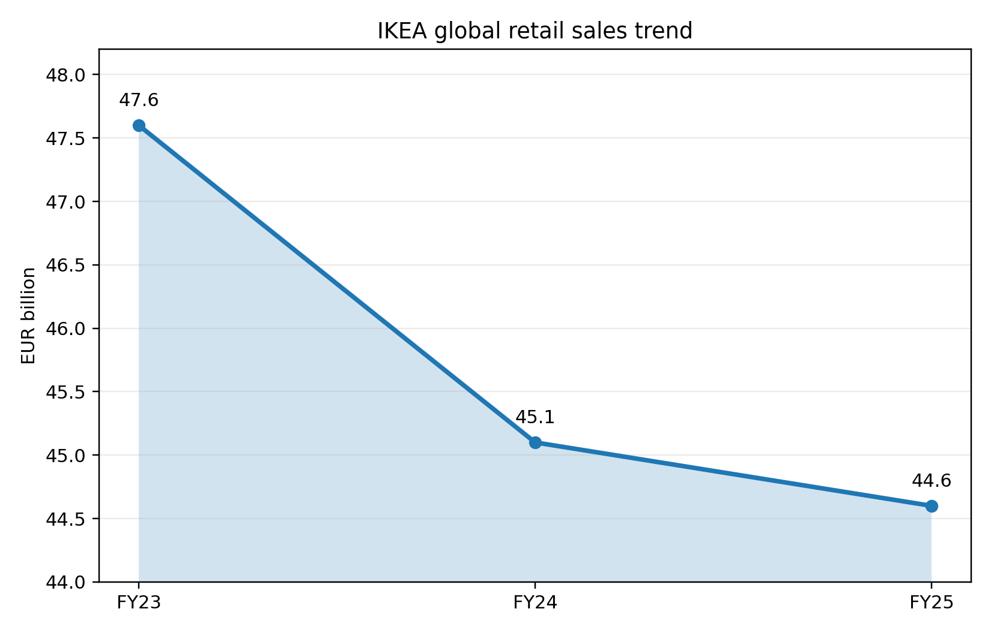
Figure 3. IKEA global retail sales trend, FY23 to FY25. Source: author-created chart based on IKEA year-in-review disclosures.
This strategic assessment can be well put in context by figure 3. International sales have also been consistent but moderately reduced in the past three financial years since IKEA has been focusing on low prices and wider accessibility. The above situation makes it more significant to have restrained growth decisions in markets like India. Instead of pursuing the scale by prematurely rolling out into physical locations, IKEA seems to be developing a more capital-aware omnichannel presence. This is a strategically good move since it fits in the uneven geography in India, price sensitivity and urban concentration.
There are four reasons why the strategy is attractive. First, it minimizes the capital risk due to the increased access on digital and smaller formats. Second, it enhances learning, which enables IKEA to monitor response by city and service area prior to higher commitments. Third, it defends the brand in that the delivery, planning and customer care remain as it expands. Fourth, it establishes a channel between awareness and trial to increased household expenditure. The market development in India is thus not merely opening more stores but sequencing access in such a manner that it maintains the brand promise to be believable.
Nonetheless, there exist limits too. A gradual approach can reduce market share uptake in case local or digital-native rivals are more aggressive. It can also make the brand appear urban-elite in case the expansion continues to be concentrated in more high-income metros. The dilemma to IKEA is thus to keep expanding without jeopardising service quality and making the business model overly complex.

6. Ethical issues in the marketing mix
Ethical evaluation must not look at a single controversy as an independent entity but should look at how the marketing mix itself presents tensions. The first conflict is that of affordability and sustainability. The climate action, circularity and lower emissions are publicly stated by IKEA, and the sustainability and climate FY 24 reports indicate definite progress, including a decrease in both overall climate footprint by 5 and decarbonisation of transport efforts by FY23. However, even the prospect of low-cost bulk retailing can drive up levels of consumption. The ethical dilemma then arises as to whether the business can stimulate a frequent refresh behaviour of homes and at the same time promote sustainability at a credible level. It is not exclusive to IKEA, but this is particularly applicable since the mission of accessibility of the brand can be easily misinterpreted as promoting more buying cycles.
The second problem is that of service fairness and transparency. In Germany, developed logistics and more defined service criteria facilitate the buying process and make it a relative transparent one. The moral imperative to set boundaries is higher in India where zones of service, eligibility of delivery, and availability of products is more visibly dependent on pin code and reach of a store. IKEA India customer-information pages demonstrate that this problem is not ignored as there are specific serviceable areas, official channels, and delivery terms, mentioned explicitly. This makes commercial sense as well as ethical imperative since vague promises of fulfilment would overburden first time customers.
The third problem is connected with environmental footprint of growth logistics. The introduction of the first heavy-duty electric trucks in India by IKEA is a good sign, yet it also brings a more underlying message, namely, the development of rising markets necessitates physical transportation of large-sized products, which may escalate the emission of transport unless the logistics change. In this regard, ethical marketing implies that the sustainability communication should be supported by the operational change and not symbolic marketing. In general IKEA does better than many retailers in the world in terms of transparency and climate ambition, however its ethical reputation relies on its ability to keep the triple bottom line of affordability, circularity and veridical service delivery.

7. Recommendations
- Ethical assessment cannot examine one controversy in isolation but should examine how the marketing mix itself is problematic. The former struggle is the struggle of affordability and sustainability. IKEA publicly states the climate action, circularity and lower emissions, and the sustainability and climate FY 24 reports show certain progress, such as a reduction in the overall climate footprint by 5 and decarbonisation of the transportation activities by FY23. Nevertheless, consumption levels can be increased even by the threat of low-end bulk retailing. The ethical question then emerges as to whether the business will be in a position to trigger a high frequency of refresh behaviour of homes and at the same time maintain sustainability at a plausible level. This does not only apply to IKEA, but this is especially true because the mission of accessibility of the brand can be easily misinterpreted as the promotion of more buying cycles.
- The second issue is the service fairness and transparency. In Germany, the purchases process is a relatively transparent and simplified one because of the developed logistics and a more specific service criterion. The ethical need to establish limits is stronger in India where areas of service, eligibility of delivery, and products availability is more conspicuous in relation to pin code and accessibility of a store. The customer-information pages of IKEA India prove that this issue is not overlooked as there are certain serviceable areas, official channels, and delivery terms, which are stated clearly. This is both commercially wise and ethical because empty threats of fulfilment would overwhelm first time customers.
- The third issue is related to environmental footprint of growth logistics. The fact that IKEA has introduced the first heavy-duty electric trucks in India is a positive indicator, but it also carries a deeper meaning, that is, the emergence of the growing markets requires the actual transportation of the large-size products, which can increase the emission of transport unless the logistics is changed. Concerning this, ethical marketing means that the sustainability communications must be backed by the change of operations rather than symbolic marketing. Generally speaking, IKEA is more transparent and climate ambitious than most retailers in the globe but its ethical image depends on its capacity to maintain the triple bottom line of affordability, circularity and veridical service provision.

8. Conclusion
The case of IKEA operation in Germany and India shows that there is no need to select between complete standardisation and complete adaptation when it comes to successful international marketing. Rather, the company defends a closely guarded global centre and localises the route by buying, service system and rollout sequence to the local market realities. Germany is one of the markets where the classical IKEA model can be operated with comparably little adjustment. India needs greater commercialization, particularly in place, process, price structure and directed entry. This does not undermine the brand. Quite on the contrary, it demonstrates that the best global strategy is a strategy that homogenises the meaning of the brand but localises the mechanisms through which customers can realistically experience it.

Section 2: Reflective account using Gibbs’ reflective cycle

9. Reflection
Description. My research process started with a clearer definition of the problem of analysis than the brief itself. Rather than viewing the task as a mere comparison between two country reports, I redefined it as an inquiry on how a global retailer could strike a balance between standardisation and adaptation in situations whereby the two markets are not just different in terms of wealth, but also in terms of infrastructure, household structure and service expectations. This ruling formed the whole report. The first step I took was to collect company and country data, and then I picked academic literature that would assist me in interpreting data instead of describing it. I applied this evidence in organising the report according to macro-environment, STP, 7ps, directional strategy, ethics and recommendations.
Feelings. Initially, I feared that IKEA would be a brand that is too well-known and hence tough to critically analyse. Brands known can also lure writers into description since the brand storey seems self-evident. Another danger that I foresaw was overgeneralizing cultural difference in a naive manner. As I proceeded with the research process, I felt more confident when I realised that there were even stronger differences that were not necessarily cultural, but operational as well. The delivery geography, city-store development and planning-point approach of India allowed a more detailed analysis than general statements of East versus West or developed versus emerging market.
Evaluation. One of my greatest strengths in the process was the integration of existing official information and fundamental academic theory. The official sources also assisted me in avoiding outdated claims, particularly in the case of the recent market expansion of India and the existing omnichannel formats. The scholarly materials came in handy in another manner; they offered conceptual aids to assessing when standardisation can still be possible and when adaptation is commercially needed. One of the weaknesses of my process was that some useful market data, particularly category-level data on home-furnishing, was more difficult to obtain out of entirely open sources than macroeconomic data. Due to this, I was forced to depend more on the disclosures of the company and country indicators than on the sector-specific syndicated reports.
Analysis. The model by Gibbs promotes a more in-depth explanation of the reasons the process was undertaken in the way it was. The greatest lesson to me was the fact that present day corporate information should be critically used. Authoritative sources are useful as they are up-to-date and narrow, but not apolitical. They are meant in part to project the company positively. This implied that I could not copy the language of the company blindly, particularly sustainability and accessibility. I thus applied academic theory as a test of the assertions. Citing an example, when they said that affordable to a large number, I did not simply assume the words but I questioned them on whether the affordability was still viable when delivery, access to the service and housing conditions in India were factored into it. This enhanced the quality of decision in the report.
The second analytical lesson was a lesson on methodology. The short demands comparison, which is all too readily turned into the juxtaposition of two distinct descriptions. To prevent that, I employed a comparative logic in the process. All the sections were composed on contrast, implication and judgement. This has compelled me to enquire not only what IKEA is doing in Germany and India, but why the difference is strategically important. That helped to enhance the coherence and make the recommendations more convincing since they were based on cross-market analysis, not on individual observations.
Conclusion. Generally, the process enhanced my knowledge of how the strategy of international marketing must be assessed at post graduate level. I was made to understand that good analysis goes beyond mechanic application of frameworks. PESTEL, STP and 7Ps are practical but they can only be good when applied to create argument. I also came to the conclusion that the most persuasive piece of work in such an assignment hinge on the ability to choose sources wisely, compare them thoroughly, and be ready to analyse tension and contradiction, particularly when the company narratives seem to be too polished.
Action plan. There are three ways in which I would enhance the process in future assignments. On the one hand, I would create such a source matrix earlier, dividing theoretical, macro, company and ethical evidence in order to balance it with ease. Second, I would seek additional independent industry information at an earlier stage so that the sources of the companies are not as predominant. Third, I would write the recommendations after the completion of all the sections of the analysis, as this order generated further evidence-based recommendations in this report. Such measures would help my future research process be more effective and my arguments even stronger.

References
Ansoff, H.I. (1957) ‘Strategies for diversification’, Harvard Business Review, 35(5), pp. 113-124.
DataReportal (2025a) Digital 2025: Germany. Available at: https://datareportal.com/reports/digital-2025-germany (Accessed: 10 March 2026).
DataReportal (2025b) Digital 2025: India. Available at: https://datareportal.com/reports/digital-2025-india (Accessed: 10 March 2026).
De Mooij, M. and Hofstede, G. (2010) ‘The Hofstede model: Applications to global branding and advertising strategy and research’, International Journal of Advertising, 29(1), pp. 85-110.
Douglas, S.P. and Wind, Y. (1987) ‘The myth of globalization’, Columbia Journal of World Business, 22(4), pp. 19-29.
Gibbs, G. (1988) Learning by Doing: A Guide to Teaching and Learning Methods. Oxford: Oxford Polytechnic.
Hollensen, S. (2020) Global Marketing. 8th edn. Harlow: Pearson.
IKEA (2024a) IKEA continues to lower prices for customers. Available at: https://www.ikea.com/global/en/newsroom/corporate/ikea-retail-sales-fy24-241010/ (Accessed: 10 March 2026).
IKEA (2025a) The year in review FY25. Available at: https://www.ikea.com/global/en/our-business/how-we-work/year-in-review-fy25/ (Accessed: 10 March 2026).
IKEA (2025b) IKEA answers the call to ‘When is IKEA coming to North India’ with the launch of online deliveries. Available at: https://www.ikea.com/in/en/newsroom/corporate-news/ikea-answers-the-call-to-when-is-ikea-coming-to-north-india-with-the-launch-of-online-deliveries-pub889756b0/ (Accessed: 10 March 2026).
IKEA (2025c) IKEA moves in to a new home in Delhi. Available at: https://www.ikea.com/in/en/newsroom/corporate-news/ikea-moves-in-to-a-new-home-in-delhi-pub38418e20/ (Accessed: 10 March 2026).
IKEA (2025d) IKEA India taps into the need for home design planning with its very first ‘Plan and Order Point’ in Bengaluru. Available at: https://www.ikea.com/in/en/newsroom/corporate-news/ikea-india-taps-into-the-need-for-home-design-planning-with-its-very-first-plan-and-order-point-in-bengaluru-pube8fe1460/ (Accessed: 10 March 2026).
IKEA (2025e) IKEA deploys first heavy-duty electric truck in India. Available at: https://www.ikea.com/in/en/newsroom/corporate-news/ikea-deploys-first-heavy-duty-electric-truck-in-india-pub419a9980/ (Accessed: 10 March 2026).
IKEA (2025f) Click & Collect: Order online and collect later. Available at: https://www.ikea.com/de/en/customer-service/services/click-collect/ (Accessed: 10 March 2026).
IKEA (2025g) Delivery service: options and prices. Available at: https://www.ikea.com/de/en/customer-service/services/delivery/ (Accessed: 10 March 2026).
IKEA (2025h) Delivery service. Available at: https://www.ikea.com/in/en/customer-service/delivery-service-pubd5889e60 (Accessed: 10 March 2026).
IKEA (2025i) Caution against fake IKEA website and social media channels. Available at: https://www.ikea.com/in/en/customer-service/knowledge/articles/2b7504dc-f069-40f1-97e1-gfd1f67f3760.html (Accessed: 10 March 2026).
IKEA (2025j) IKEA Sustainability and Climate Reports FY24: making progress towards climate goals and investing in the future. Available at: https://www.ikea.com/global/en/newsroom/sustainability/ikea-sustainability-and-climate-reports-fy24-250130/ (Accessed: 10 March 2026).
Jain, S.C. (1989) ‘Standardization of international marketing strategy: Some research hypotheses’, Journal of Marketing, 53(1), pp. 70-79.
Kotler, P. and Keller, K.L. (2016) Marketing Management. 15th edn. Harlow: Pearson.
Levitt, T. (1983) ‘The globalization of markets’, Harvard Business Review, 61(3), pp. 92-102.
Vrontis, D. and Thrassou, A. (2007) ‘Adaptation vs. standardization in international marketing: the country-of-origin effect’, Innovative Marketing, 3(4), pp. 7-21.
World Bank (2025a) Germany. Available at: https://data.worldbank.org/country/DE (Accessed: 10 March 2026).
World Bank (2025b) India. Available at: https://data.worldbank.org/country/india (Accessed: 10 March 2026).
World Bank (2025c) Data for Germany and India. Available at: https://data.worldbank.org/?locations=DE-IN (Accessed: 10 March 2026).

