To what extent does destruction encourage change through two approaches to societal change in contemporary art addressing postcolonialism?

Abstract

This essay will look to compare the work of two contemporary practitioners in an associated filed to glean insight into their conceptual and practical methods. The two practitioners in particular are Otobong Nkanga and Zarina Hashmi. This essay will look to explore the manner they represent the ‘scar’, in both a literal and non-literal sense, the concepts of ‘Survival’, the role of destruction as a key proponent in the course of one’s own survival, looking at the effects of human interaction with the environment, and how both a female artist, and artists of different ethnicity have reclaimed and portrayed their own messages and self-representation within a post-colonial world.

Essay

“There is a crack, there is a line, and eventually there will be a scar. It will remain as a memory of the work and also as a memorial to the issues” (Alberge, 2007). The scar as a symbol both on a literary and visual representation can be seen to appear through both the works of Otobong Nkanga and Zarina Hashmi, a reference to the actions of others. Within this essay, it will look to explore the effect of mankind’s actions on the environment, through the removal of minerals and elements, to allow for progress of civilisations. Otobong Nkanga was born in Kano, Nigeria, in 1974. Her practice explores “the extraction of natural resources from the earth, connecting threads that reveal complex and fraught histories around land acquisition, capitalism and consumption across the globe" (Barlow and Jackson, 2019). Zarina Hashmi was born in Aligarh, India, in 1937. “While her work tends towards minimalism, its starkness is tempered by its texture and materiality. Her art poignantly chronicles her life and features recurring themes of home, displacement, borders, journey, and memory.” (Hashmi, n.d.) The theories of Manuel Alvarado in regard to portrayal of ethnicity through stereotypes within the media (CBAC, 2017), with ethnicity being broken down into four key categories, pitied, exotic, dangerous, and humorous. Aspects of these categories will be used to explore how Nkanga, and Hashmi refer and or subvert them within their work on a compositional facet. With regards to the concept of survival within this essay, it is of a societal transposition to an advancement of the protection and recovery of the environment; and it is the survival of those who have experienced war and tragedy.
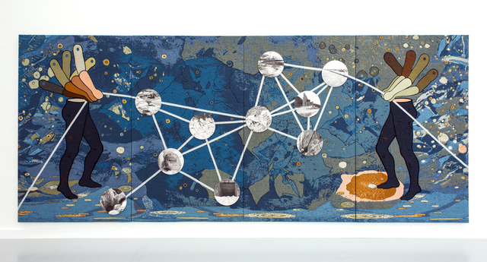
Figure 1 - Otobong Nkanga, The Weight of Scars, 2019/20
Otobong Nkanga’s work looks to explore the effects of destruction on the environment, the removal of material. This removal of minerals and other materials leaves in its wake, a husk of what once was.
The conjoining of material can be viewed as the tethering of two meanings, her use of diagonal lines transcending the four-panel tapestry draws links between imagery of mines, this combination of both the artists hand, and eye, through her photography envelops the composition, with figures in a stance of movement, a kinetic energy, the repetition of arms, in a constant state of engaged exertion of strength and control. One reference that can be seen to reinforce this point, “Their arms are shown in multiple positions suggesting the ‘push and pull’ of shifting relationships as land is consumed and changed. The ‘scars’ in the title suggest damaged and vulnerable bodies within a landscape devastated by the extraction of knowledge, people and resources.” (Nkanga, 2019).

The figures are transplanted across a discord of blues and earth tones, a symbol of the traversing of distance, akin to that of a global map, an echo to the actions of the colonial powers which tore apart pre-existing civilisations with the aim to develop their own capitalist gains, through the abduction and enslavement of the natives under the guise that they are less superior. The weight of their actions is held apparent with each space left abandoned, these mines filled those who surrounded them with false hopes of providing support to many, but in reality, are removed for the gain of a greater organisation not intent on supporting others.

The work can be seen to provide an insight into a world often summarised to simple stereotypes, but Nkanga as highlighted in this source can be seen to oppose this, "That is one of the things that I became quite concerned about, especially at a time when people talked a lot about 'the exotic'. I was looking for ways to make work that could have the layers that it needed, without it becoming something that you gawk at." (Barlow and Jackson, 2019). When taking in consideration the theories of Alvarado it can be seen that Nkanga aims to subvert the norm or stereotype typically placed over those of ethnic origins as highlighted with this extract, “The 'exotic' stereotype presents the individual in terms of how they look, what they wear, what they eat and their 'different' customs.” (Alvarado, 2017).

The language of the materials, the use of weaving and tapestries, a possible return to the methods of recording history and holding a fabric back together, this bringing together of two materials, the stich pulls together two lost connections or create new ones. As an observer of Nkanga’s work, the notion of the weave, the structure of the weft, bring on a level of intimacy as evidenced further with this quote by Nkanga; "The se materials have to be embedded in each other to become what they are. So at different levels, you start thinking about connectedness and understanding the world through that way of looking." (Barlow, Jackson and Nkanga, 2019).
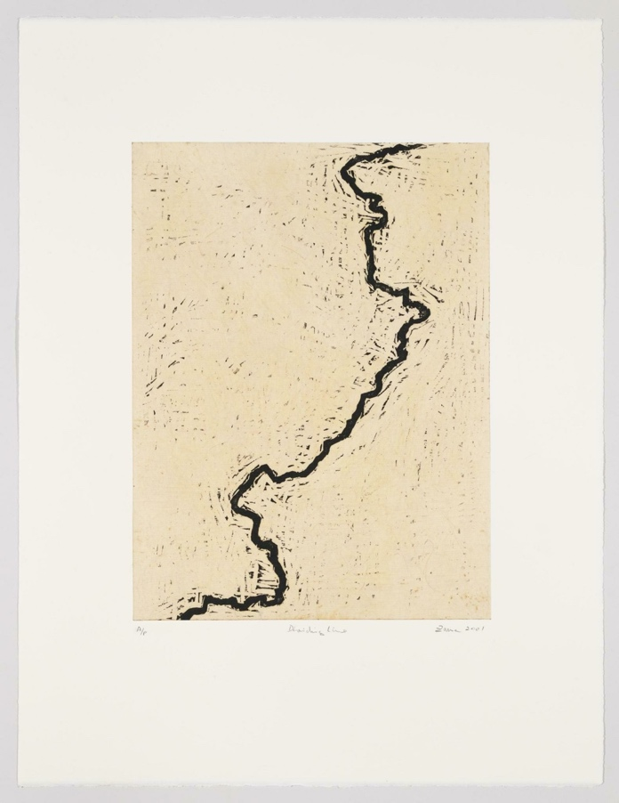
Figure 2 - Zarina Hashmi, Dividing Line, 2001
The evidence of her marks enforces both the artists presence, whilst linking to the mark made within the ground, to remove material, to create a mark which creates the message.

This contrast of her living in the city, New York, “Zarina moved back to New York permanently in 1999. She has lived and worked in the same studio since 1976. Back in New York, she started thinking about maps again and began creating works based on maps.” (Hashmi, 2019). These hectic locations far from any greater source of nature, can be seen to have the effect of creating this structural quality closer akin to that of a vast metropolitan, the lines are stark and distinct, the artists can be seen to reference the borders which now separate her from her family as a whole, and further the rift between the two predominant religions, Islam and Hinduism which were divided between Pakistan and India. “Millions of Muslims moved to West and East Pakistan (now Bangladesh). Millions of Hindus and Sikhs travelled to be within India's new borders.” (Puri, 2017).

This mark, a reflection of the India Partition, a division between the two countries that came with the ‘end’ of colonialism between Pakistan and India, “I was ten years old when the partition of India happened. My family was moved from our home in Aligarh to a refugee camp in Delhi for our safety.” (Naeem, 2017). A form of scarification, similar to the line made between the unseen countries, their borders separating many from friends and families. A quote which can be seen to emphasis this “Dividing Line, explore geographical borders and contested terrains, particularly those areas which are scarred from political conflict.” (Hashmi, 2019)

“When I’m carving I use ply wood and it’s very soft to cut. I just like the texture of wood, I like you know the way you dig in.” (Hashmi, 2013). Bold abstract form of the scar, both in the material and of the continental divide which changes the perspective of the viewer, not seeing a distinct place or names but just a line, this removal of the meaning, when context in not applied, push these lines to a quality akin to that of a scar.

An aspect which transcends both artists, the scar as a metaphor of destruction, a moment ingrained into a simple mark, this can further be read as a mark of change, a message of hope, that this scar is not of pain. This separation within the composition, this opposition between the black and white, a shift in tones, this will not heal, this damage of the surface, to carve into wood, the line which makes up the entirety of the composition.

Her work takes on a pluralism which conveys both the tragedies of the partition and the effect this had on many millions of people caught within this rift, but instead her work can be seen to take on a voice of hope, which can be seen to contrast the media’s stereotype of these people as ‘the pitied’ as denoted in the theories of Alvarado, “In certain texts ethnic minorities are stereotyped as vulnerable and as victims.” (Alvarado, 2017).

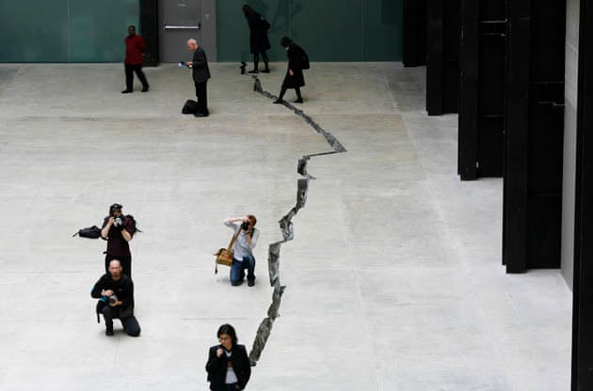
Figure 3 - (The Guardian, 2007)
There is not one story presented within this mark, but the artist could have indented a story of millions, a story which converses time, a work which draw similarities, and as noted at the start of this essay, ‘Shibboleth’ by Doris Salcedo. The work of Doris Salcedo can be seen to underpin aspects of both artists, one reference which can be seen to draw comparison to “‘The history of racism’, Salcedo writes, ‘runs parallel to the history of modernity, and is its untold dark side’. For hundreds of years, western ideas of progress and prosperity have been underpinned by colonial exploitation and the withdrawal of basic rights from others. (Salcedo, 2007)

To note, ‘Shibboleth’, was a word used to define one group from another through the mispronunciation of that word, Salcedo work spoke of the divide and journey of many, “the crack in the floor in the Shibboleth photographs and installation could be seen as a symbol of the damage caused by cultural and geographical exclusion.” (White and Salcedo, 2007), The crack then becomes a symbol for both the journey of many immigrants throughout time, but also the personal journey one makes within a lifetime.

Not able to verbalise truly the extent of one’s experience, the mark becomes the strongest of metaphor; with this removal of humans control of space, natures transcend borders, but are still affected by them, “It hit me much later, it’s almost like your writing your life story, and it’s not just my story, it’s the story of all immigrants,” (Hashmi, 2013). To replicate an image, a homage or a symbol of change, linked the scar of both the city with the mental scar of her separation of her family, and of the families and others, a story is never a story of one, but of many, you are not born alone, you do not exist on your own, thus the stories of many are intertwined.

Bibliography

Alberge, D., 2007. "Welcome to Tate Modern’s floor show it’s 167m long and is called Shibboleth." The Times, [online] p.1. Available at: <https://www.thetimes.co.uk/article/welcome-to-tate-moderns-floor-show-its-167m-long-and-is-called-shibboleth-mwktzwgwbdb> [Accessed 5 March 2021].

Alvarado, M., 2017. Representation. [online] Resource.download.wjec.co.uk.s3.amazonaws.com. Available at: <http://resource.download.wjec.co.uk.s3.amazonaws.com/vtc/2015-16/15-16_int_04/website/eng/9%20-%20Useful%20Theories%20and%20their%20application%20to%20media%20texts/the-exotic.html> [Accessed 19 March 2021].

Alvarado, M., 2017. Representation - The Pitied. [online] Resource.download.wjec.co.uk.s3.amazonaws.com. Available at: <http://resource.download.wjec.co.uk.s3.amazonaws.com/vtc/2015-16/15-16_int_04/website/eng/9%20-%20Useful%20Theories%20and%20their%20application%20to%20media%20texts/the-pitied.html> [Accessed 17 March 2021].

Barlow, A., Jackson, G. and Nkanga, O., 2019. Otobong Nkanga - From Where I Stand. 1st ed. London: Tate Publishing, p.53.

Barlow, A. and Jackson, G., 2019. Otobong Nkanga - From Where I Stand. 1st ed. London: Tate Publishing, p.55.

Barlow, A. and Jackson, G., 2019. Otobong Nkanga - From Where I Stand. 1st ed. London: Tate Publishing, p.6.

CBAC, W., 2017. Representation. [online] Resource.download.wjec.co.uk.s3.amazonaws.com. Available at: <http://resource.download.wjec.co.uk.s3.amazonaws.com/vtc/2015-16/15-16_int_04/website/eng/9%20-%20Useful%20Theories%20and%20their%20application%20to%20media%20texts/index.html> [Accessed 15 March 2021].

Hashmi, Z., n.d. Life. [online] Zarina.work. Available at: <https://www.zarina.work/life> [Accessed 16 March 2021].

Whitney Museum of American Art, 2001. Dividing Line. [image] Available at: <https://whitney.org/collection/works/46388> [Accessed 8 March 2021].

Hashmi, Z., 2019. Cities I Called Home. [online] Zarina.work. Available at: <https://www.zarina.work/cities-i-called-home> [Accessed 16 March 2021].

Hashmi, Z., 2013. Zarina Hashmi Studio Visit – TateShots | Tate. [online] Tate. Available at: <https://www.tate.org.uk/art/artists/zarina-hashmi-17194/zarina-hashmi-studio-visit> [Accessed 17 March 2021].

Hashmi, Z., 2019. Art. [online] Zarina.work. Available at: <https://www.zarina.work/art> [Accessed 17 March 2021].

Hashmi, Z., 2013. Zarina Hashmi Studio Visit – TateShots | Tate. [online] Tate. Available at: <https://www.tate.org.uk/art/artists/zarina-hashmi-17194/zarina-hashmi-studio-visit> [Accessed 17 March 2021].

Naeem, A., 2017. Zarina Hashmi: Refugee Camps, Temporary Homes. Asian Diasporic Visual Cultures and the Americas, [online] 3(3), pp.345-353. Available at: <https://brill.com/view/journals/adva/3/3/article-p345_345.xml> [Accessed 15 March 2021].

Nkanga, O., 2019. Otobong Nkanga: From Where I Stand – Exhibition Guide | Tate. [online] Tate. Available at: <https://www.tate.org.uk/whats-on/tate-st-ives/exhibition/otobong-nkanga/otobong-nkanga-where-i-stand> [Accessed 19 March 2021].

Puri, K., 2017. A Country Divided. [online] Bbc.co.uk. Available at: <https://www.bbc.co.uk/news/resources/idt-sh/partition_how_it_affected_me> [Accessed 16 March 2021].

Salcedo, D., 2007. The Unilever Series: Doris Salcedo: Shibboleth – Exhibition at Tate Modern | Tate. [online] Tate. Available at: <https://www.tate.org.uk/whats-on/tate-modern/exhibition/unilever-series/unilever-series-doris-salcedo-shibboleth> [Accessed 18 March 2021].

Tate, 2019. The Weight of Scars. [image] Available at: <https://www.tate.org.uk/whats-on/tate-st-ives/exhibition/otobong-nkanga/otobong-nkanga-where-i-stand> [Accessed 9 March 2021].

The Guardian, 2007. The work, entitled Shibboleth 2007, took over a year to construct and five weeks to install. The artist remained enigmatic about how it was made. [image] Available at: <https://www.theguardian.com/arts/gallery/2007/oct/08/1#img-1> [Accessed 16 March 2021].

White, C. and Salcedo, D., 2007. ‘Shibboleth I’, Doris Salcedo, 2007 | Tate. [online] Tate. Available at: <https://www.tate.org.uk/art/artworks/salcedo-shibboleth-i-p20334#:~:text=The%20photographs%20were%20made%20as,a%20concrete%20cast%20of%20a> [Accessed 18 March 2021].

