

Marketing Management

Assessment 1

Student Name: Leanne Lawrence
Student ID: 1711795
Module Name: Marketing Management
Moudle Code: LCMB7001
Moudule Sub-Topic: MBA-Master of Business Administration
Tutor: Tushara Balendran
Assignment Title: Assessment 1

Table of Contents
Introduction 3
Organization Profile 4
Understanding Marketing 4
Customer Oriented Innovative Marketing Strategy of Adidas 5
Negative Aspects of Too Much Customization 8
Innovation Marketing Strategies to Address Core-marketing Challenges 9
Innovative Marketing Strategy for Awareness 12
Innovative Marketing Strategy for Brand Management 12
Innovative Marketing Strategy & Communication Channel 13
Communication Channel to Meet the Expectation of Stakeholders 15
Conclusion 16
References 17

Introduction
Innovative marketing strategy is becoming most popular to overcome the marketing challenges, brand awareness, and meet the expectation of the stakeholders within this intense market competition. However, putting too much emphasis on customer satisfaction only. May divert the organisations from focusing on the other important aspects. This writes up discusses the concept of marketing strategy and innovation, address how innovative marketing helps business to overcome the globalisation, changing business environment, digitalisation, information management, CRM and other challenges successfully. Moreover, based on Adidas a world-class brand, it has tried to analyse the marketing channel mix and address how the marketing channel sorts out the problems, such as raising brand awareness, brand management, and meeting the expectations of their customers to ensure sustainability, brand awareness, and reputation by ensuring quality to lead the market.

Organisation Profile
Adidas is a multinational German footwear and Sportswear Company that has been established from 1949 (Hermanns & Riedmüller, 2020). It is the largest sportswear manufacturer within Europe and one of the biggest stores within the world. And it is the second-largest sports and Footwear Company within the world. It offers footwear, classic styles & modern designs sportswear, denim, a wide range of different brands, different clothing, apparel, etc. However, it is well recognise because of its sportswear line (Laluyan et al., 2017).

Figure-1: Logo of Adidas, Source: (Yoga et al., 2019)
A giant football club within Europe and other parts of the world uses sportswear from Adidas. It has achieved the honor within being able to supply sportswear within the Olympics and Asian games. Innovation, marketing strategy, quality, sustainability, and best experience within enabling this giant organisation to lead the market (Fokina et al., 2015). Customer concern and no compromise within the quality by continual innovation, creativity, decision-making has made an unparalleled position and branding for Adidas. It has operations within more than 189 countries worldwide. The annual turnover for Adidas in 2020 was £ 22.926 billion (Yoga et al., 2019; Mahdi et al., 2017).

Understanding Marketing
Marketing is an integrated approach within referring to the functions and actions for designing, developing, promoting, pricing, and placement of products and services for the motive of profits, wealth maximisation, brand, customer loyalty, and reputation. The consumer and customer always compare what they get and what they spend for a particular product and service. Customers are satisfied when they get maximum benefits from lower costs and efforts. Customers may get dissatisfied when the costs overleapt the utilities and benefits (Jain et al., 2020).
Customer satisfaction= Products utilities & benefits>Products cost & efforts.
Putting too much concentration on customer satisfaction often displace the organisation and decision-maker to focus on the core and most important aspects such as own identity of the organisation, self-decision, and efficacy, autonomy, quality, pricing strategy, etc. The concern to satisfy the customer always drives the decision-maker and marketer to analyze the data and information of the customer rather than focus on the business itself (Jain et al., 2020). Therefore, the marker cannot able to make a good decision for the betterment of the organisation rather are too busy to satisfy the needs and expectations of the customer and end-users (Hsu, 2017; Yoga et al., 2019). For example, in 2010, to satisfy the customer and capture the market, the price of Adidas shoes has to reduce significantly, which drastically reduce the price and net profit for the organisation.

Customer Oriented Innovative Marketing Strategy of Adidas
Marketing refers to the actions and activities that the organisation adapts to promote its products and services for selling to current and potential customers. The core functions of marketing are the pricing, advertising and personal selling, delivering, and placement of products and services.
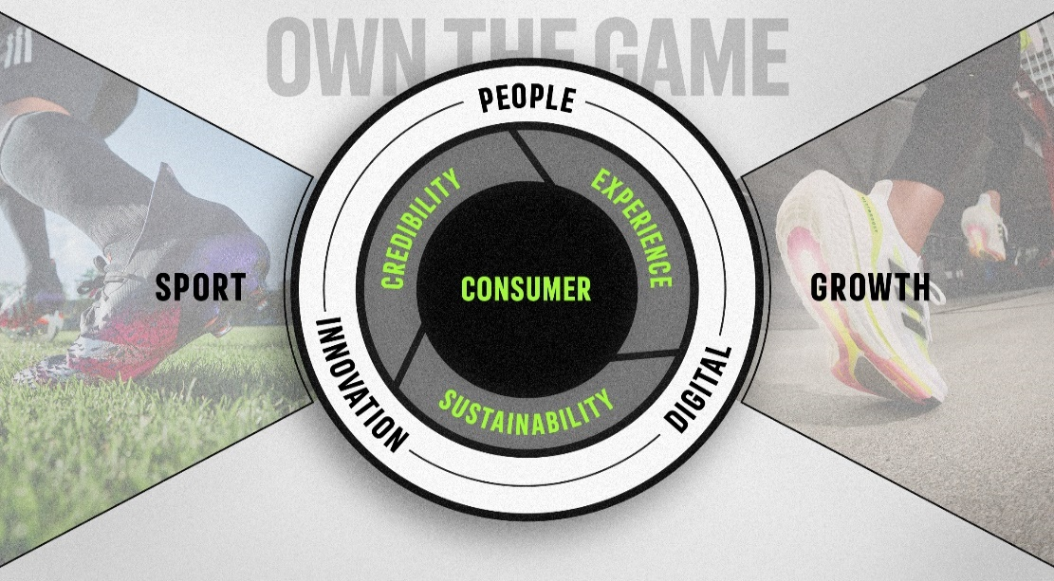
Figure-2: Adidas Marketing Strategy, source: ((Laluyan et al., 2017; Grainger et al., 2015)
On the other hand, marketing strategy is the overall action plan of creating the consumer into the customer of the products and service. It involves understanding the market, analysing the competitors, design the marketing mix, market positioning, and executing an action plan. For example, the guerrilla marketing strategy by Adidas (Yoga et al., 2019).
Adidas offers two types of shoes, sports shoes, and exercise shoes. The branding and marketing strategy of Adidas solely concentrating on the consumer. Moreover, the company has prime concern within the people, digitalisation of marketing process, innovation, and creativity continually (Finney, 2019). To win the customer Adidas believes in credibility by offering what customer want with quality and sustainability and best experience. Thus, all the aspects of strategic marketing help Adidas to win the customer create a loyal customer base to lead the market. Within this process, creativity and innovation have given an edge to understand and design the best marketing action for the products and services (Grainger et al., 2015).
The innovative marketing strategy concentrates on the creative and innovative process to render the marketing endeavor. To develop an innovative and creative marketing strategy organisation should focus on the following. Innovative and creative marketing that involves the following aspects-

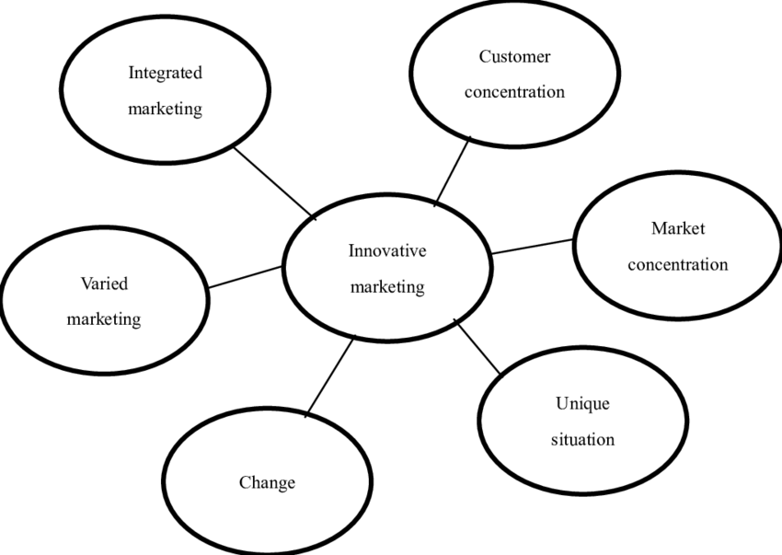
Figure-3: Aspects of Innovative Marketing, source: (Fokina et al., 2015; Mahdi et al., 2017).
- Customer Orientation: Today business organisations are more customer-oriented than a traditional business. Now, customers are the prime focus, and products and services are designed to satisfy the needs and expectations of the customer. For that, the marketing manager must be strategic and tactical to formulate the marketing policy and activities. The marketer needs to collect a wide array of customer information and build up a database to trace the changing trends and fashion of the customer. Hence, the behavior, expectation, and needs of the customer and end-user get the most priority for designing and placing products and services in the market (Gurău, 2018). For example, Adidas collect customer information by marketing intelligence within building a strong database to address and trace customer expectation within maximum the quality to survive within the competition.
- Market Concentration: It refers to the distribution of market among the competitors such as the market share that an individual company poses by offering particular products and services targeting a segment of customer. When competitors are within similar condition and pose the same market share then the products and quality improvement is the only way to survive such competition. Hence, research and development are the prime tool for marketers to serve this purpose ((Yoga et al., 2019; Finney, 2019). For example, the quality and designs of Adidas is the result of intense R & D to market concentration to be a market leader within a sports shoe. Doing so, Adidas ignores important aspects of price, which is comparatively high to the low and middle-income segment (Deepak et al., 2019).
- Change and Unique Situation: Another aspect that encourages innovative and creative marketing is the unique and changing situation of the business. Business is always unpredictable and challenging. Therefore, to cope with the changing situation and market demand businesses must render R & D continually (Jain et al., 2020).
- Varied Marketing: It refers wide array of marketing activities targeting different segments of the customer. For designing such different activities, the marketers must focus and depend on marketing innovation and creativity. For example, Adidas spends most of its budget on varied marketing endeavors and a customised variety of sports shoes based on the requirements of an athlete from different countries. As woolen shoes are very popular within the western sporting club.
- Integrated Marketing: Another creative and innovative marketing endeavor is integrated marketing where two or more marketing attempts are occurred simultaneously such as promotion, personal selling, advertisement, designing products, pricing strategy, communication, customer database, etc. For example, within this marketing process, Adidas uses different popular social platforms and place the products within an eye-catchy and attractive manner. Such as the way the model will display the products, colour, price tag concession, and waiver, etc. to draw the attention of the customer. This type of marketing often breaches legal and ethical considerations such as environmental issues, fraudulence with the customer, etc.

Negative Aspects of Too Much Customisation
The sole attention on customer satisfaction may drive an organisation away from focusing on other most crucial and important aspects such as develop a budget, formulating production and operation plans, organisation environment management, employee relations, procurements, etc. In most cases, customer focus has a tremendous impact on customised product design according to market demand ((Fokina et al., 2015; Patra & Datta, 2012). Which highly discourages the creativity and autonomy of the organisation. The research and development team are always busy with analysing their customer behavior and making different offering according to their expectation. This daunts and discourages them in design and developing any unique products with a feature that can serve better, efficient, and effective way. Another issue is that Adidas is trying to make the customer happy, the organisation sets the price to satisfy the customer. Hence, it also reduces the number of profits. Sometimes, an organisations has to sell the products at a lower price to survive the intense within the marketing competitions (Gurău, 2018).
The behavior, expectation, and demand vary according to the nature of each customer because people are different from each other and their perception, satisfaction level, the expectation is different. Thus, focusing on customer satisfaction may reach a certain segment but unable to satisfy all of them. Hence, only customer focus may not bring success to the organisation and long-term survival within intense market competition (Hsu, 2017).
To overcome such dilemmas, Adidas maintains a balance between the two. It has a well-established customer orientation, as well as this their emphasis on innovation and creativity. Equal emphasis on innovation and creativity that helps with designing and developing unique and quality products to compete with the most popular competitors like Nike with leading the market (Fokina et al., 2015).

Innovation Marketing Strategies to Address Core-marketing Challenges
By using an innovative marketing strategy, Adidas can overcome the following marketing challenges and create strong brand awareness among the customers and end-user.
- Changing Business and Globalization: Business is always unpredictable and challenging. Hence, to cope with the changing situation and market demand businesses must render R & D continually. In the evolving situation, the marketer identifies new features, ideas, and customised products to meet the need and expectations of the customers and survive within the intense competition (Deepak et al., 2019).
- Digitalization: Digital marketing platform provides a global platform to promote and place products and services to the customers. However, it also associated its challenges and risks. For example, within the digital platform, there is a lot of scope for fake product promotion where customers can be cheated and other fraudulent activities can occur within the ordering processing and payment system (Mahdi et al., 2017). Ensuring quality as per the customer expectation is another challenge pose by digital marketing platforms. For instance, Adidas ensure two-stage of authentication and high security within the ordering processing and payment system (Gurău, 2018).
- Information Management: The data and information of the end-user and the customers are very sensitive. Any breach of privacy can bring a bad reputation to the company. Hence, innovative and strategic marketing management is required to collect, sort, arrange, store and process such sensitive data and information effectively and efficiently (Grainger et al., 2015). For example, to get the complete insight of customer, Adidas use database management system package (Hsu, 2017).
- Brand Creation: This involves the process of creating, promoting, and positioning the brand within the market by continuous innovation, creativity, research, and development. Too much concentration on this often dispatches and forces the marketers to adapt fabrication and fake declaration of utilities that the products are not providing (Hermanns & Riedmüller, 2020).
For example, the logo of Adidas represents a unique message to its customers and has immense popularity and acceptance. As part of the marketing endeavor, it is the prime concern of the marketer to establish the brand within the market and ensure the acceptability among the customer (Patra & Datta, 2012).
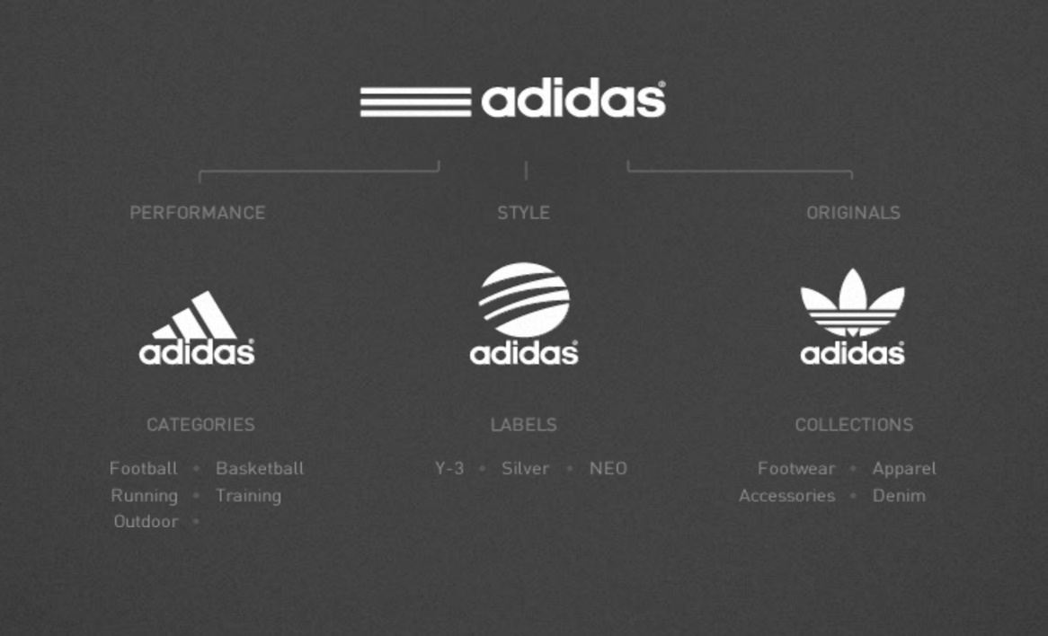
Figure-4: Adidas Brand Design, source: ((Laluyan et al., 2017; Dharmender, 2015).
- Communication Channel: Another challenge of current business organisations is to keep the business on track with regular communication with its customer. The pattern of communication can be one-to-one communication, one-to-many, and many-to-many communication. The positioning of the brand, customer loyalty, and total satisfaction depend on regular communication and exchanging of information to its customer. By this channel, information is passed and delivered to the customer, the marketing is able to know market offerings, products, price, and special offer by this process (Finney, 2019). Too much concentration on communication channels may drive the organisations away from focusing on other core aspects ((Varadarajan, 2018; Laluyan et al., 2017).
Any mismatch and displacement of such communication may create grievance and dissatisfaction among the users. Hence, marketers of Adidas it needs to understand the marketer within design the most effective and efficient pattern to handle and manage information and deliver them using the right path by continual innovation, creativity, research, and development which can be done by direct marketing, personal selling, public relations, and marketing intelligence, advertising and sales promotion, etc. (Hsu, 2017).
- Competitive Business Market: Creativity and innovation keep ahead of the competitors providing a competitive edge within the market. The creative marketing strategy allows the marketer to trace the core needs, expectations, and trends within the market and be able when design the most appropriate products and strategies within variety and greater acceptability among their customers (Oestreicher, 2019). For example, the design, color, and quality of Adidas enable it to win the customer and create a competitive position within the market so far.
- Managing Reputation: The establishment of a good brand is not enough but the marketer needs to take action for well preserve such reputation. Hence, the innovative and creative team of Adidas identifies the area to get social acceptance and recognition the among for the customer. Hence, special sponsors and athlete demonstration of shoes from Adidas Company within the different sporting event this also helps to spread the message and reputation among the customers and the potential users (Varadarajan, 2018). The fan of representing athlete also act to spread the reputation. Thus, creative and innovative strategies make Adidas able to have remarkable footprints on managing reputation (Fokina et al., 2015).
- Customer Orientation: The customers are always the prime concern and focus area of Adidas. Adidas believes in quality and its research also within its development team designs within the marketing strategy so that the customer can easily accept the products. For example, Adidas wants to give its user the best experience and as a part of marketing, most of the promotional activities is a performance by a celebrity such as Leonel Messi, Cristiano Ronaldo, etc. Thus, their mentors and celebrity inspire the user. Besides, Adidas prefers to learn from their mistake, and it encourages feedback and suggestions from customers and applies them within the next decision formulation to offer the best experience (Laluyan et al., 2017).

Innovative Marketing Strategy for Awareness
The marketing strategy is the tactics to perform the marketing activities by value proposition, customer data, and information, client demographics, marketing intelligence, and networking, etc. The innovative marketing strategy is the application of creative and innovative thoughts and ideas to promote, deliver pricing, and placement of products and services to current and potential customers (Grainger et al., 2015). It involves understanding the customer needs, expectations, behavior, fashion, and trends, etc. designing products and services, promoting and launching new products and services in the most innovative and customised way ((Patra & Datta, 2012; Manu & Sriram, 2016).

Figure-5: Event marketing for mass Awareness, source: ((Yoga et al., 2019; Dharmender, 2015).
For example, designing and placing products with benefits and features. Within this process, Adidas renders personal promotion within various important points to inform the community and spread the message regarding price, offer, quality, new products with proven experience (Gurău, 2018). Using billboard, bulletin board, headline, sponsorship of different sporting events, sponsorship will help with the favorite athlete, personal promotions, within using the digital platform, etc. This is what the commonly used to get the customers accounted with their products and services for Adidas, using special offer within different occasions, quality, durability, and utility, etc. Thus, a creative and innovative marketing strategy will help to create mass awareness among the current and potential customers and attract them into purchasing the products from the company (Oestreicher, 2019).

Innovative Marketing Strategy for Brand Management
Brand management is the process of creating, promoting, and positioning the brand within the market by continuous innovation, creativity, research, and development. Branding is setting the message within the mind of the customer regarding the company, its products, services, value, and utilities. Too much concentration on this often dispatches and forces the marketers to adapt fabrication and fake declaration of utilities that the products are not providing. In this case, Adidas is different. It also ensures quality and sustainability besides customer focus since it has to compete with another excellent brand like Nike ((Laluyan et al., 2017; Mahdi et al., 2017). In most of the cases the organisations will use Bulk marketing, event marketing, personal selling, advertisement, and other promotional activities both within online and offline using different digital means and platform (Fokina et al., 2015).
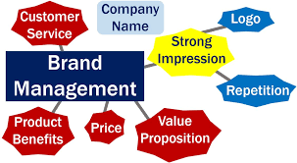
Figure-6: Adidas Brand Management, source: (Manu & Sriram, 2016).
Branding creates an image within the mind of customer regarding the company, products, and services.The brand management strategy of Adidas includes positioning the name, logo, reputation, and other information within the mind of their customer and helps to attract them to purchase the products and service. It also includes a value proposition, which refers to the utilities and benefits the users against the money they invest. Another strategy to lead the market of Adidas is that it never compromises the quality and sustainability of its products within offering the best experience to its customers and end-users (Yoga et al., 2019). Thus, Adidas creates a good brand impression among their customer. A bad side of this brand management is that the products are out of reach to the lower end of the market often this is the middle income-earning segment because the price is comparatively high. Besides this there is too much attention on customisation and branding, make a way for the decision-maker to design their budget, production and operation plan, organisation environment management, employee relations, procurements, etc. In most cases, customer focuses have had a tremendous impact on customise product designs according to market demand. Which highly discourages the creativity and autonomy within the organisations (Deepak et al., 2019).

Innovative Marketing Strategy & Communication Channel
For evaluating customer journey and keeping them in touch with the organisation, there is no alternative to marketing communication. The main purpose of such communication is to create a bridge and connection between the customer and the business organisations (Laluyan et al., 2017). When using marketing and communication tools they are used to build a stronger connection and communication channel with the customers (Hsu, 2017; Varadarajan, 2018).
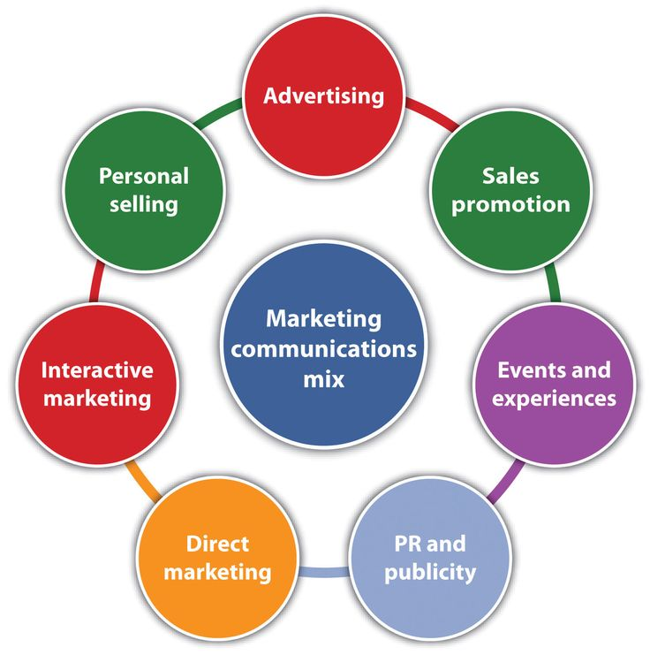
Figure-7: Marketing Communication mix, source: ((Finney, 2019; Grainger et al., 2015)
- Advertisement: it refers to informing the market about the offers such as products, services, features, utility, sustainability, etc.
- Sales Promotion: It refers to the promotion of products by selling larger quantity or amount with less cost. For example, the bulk selling strategy of Adidas is part of a promotion (Patra & Datta, 2012).
- Personal Selling: It involves selling with direct interaction with the customer. In most cases, Adidas uses the most popular actor, athlete, singer, etc. to promote its products as part of personal selling (Hermanns & Riedmüller, 2020).
- Events and Experiences: During different occasions and events organisation, arrange to sell with special offers, lucky coupons, concessions, etc. Thus, they inform the market and conduct branding activity.
- Public Relation & Publicity: Publicity is the non-paid form of promotion, which refers to demonstration or encouragement using by a most popular figure or celebrity. Those who follow such individuals are prone to buy those products by influencing by the persons who is promoting them (Finney, 2019).
- Interactive Marketing: This refers to passing the information by direct and one-to-one interaction with the customers and end-users. This is the most effective mode for marketing since the marketers can collect customer insights, suggestions, feedback, input, concerns and customer satisfaction which later can be used to improve the process (Manu & Sriram, 2016).
- Direct Marketing: it is an important process within selling the product directly to the customer by creating instant demand within the marketing effort. Direct marketing is mostly effective because of direct customer insights, opinion, feedback, suggestions, and customer relationship management (CRM).

Communication Channel to Meet the Expectation of Stakeholders
To build trust, develop long-term customer relationship management (CRM), public relations, etc. there is an alternative for marketing communication with the customers. Effective communication channel facilitates direct interaction, will always help within obtaining the customers insight, and being able in understanding their needs and expectations, the changing trends, and behavior, seek opinion suggestions, feedback, management grievance, instant feedback, and after-sale service, etc. (Finney, 2019).
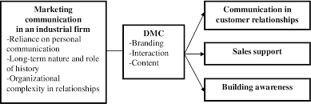
Figure-8: Marketing communication channel are used to meet expectations, sources: (Oestreicher, 2019)
The better the understanding is within the organisations will allow them to meet the demand and expectations. Hence, the right communication channel and CRM can provide the necessary information regarding the changing trends, and expectations of the customers and it will help within the marketers when design, promoting and different offer with products and services addressing such expectations for the stakeholders. To do so, marketers build a CRM, create brand and sales support within brand awareness via the direct interaction and using other marketing tools (Manu & Sriram, 2016). The marketing communication channel also helps with redesign the products and services with desired features and qualities, set affordable pricing strategy, after-sales services where required, suitable to meet the need and expectations of the customers (Gurău, 2018).

Conclusion
Innovation marketing strategy helps with overcome within marketing and business challenges within a competitive market and changing business environment. Marketers all need to have a very tactical within market analysis, understanding customers within design appropriate marketing policy. For that innovation and creativity this is very necessary to have. The right balance between innovation and creativity within strategic marketing management increases the rate of success for the organisations to meet the stakeholders' expectations.

References
Deepak, R.K.A. and Jeyakumar, S., 2019. Marketing management. Educreation Publishing.
Dharmender, S., 2015. Brand 2.0: what could this mean for Adidas, Nike, Puma and Levi’s? Brand value and young consumers in 2015.
Finney, S., 2019. Stakeholder perspective on internal marketing communication. Business Process Management Journal.
Grainger, A.D., Newman, J.I. and Andrews, D.L., 2015. Global adidas: sport, celebrity and the marketing of difference. Global sport sponsorship, pp.89-105.
Gurău, C., 2018. Integrated online marketing communication: implementation and management. Journal of communication management.
Hermanns, A. and Riedmüller, F. eds., 2020. Management-Handbuch Sport-Marketing. Vahlen.
Hollensen, S., 2018. Marketing management: A relationship approach. Pearson Education.
Hsu, Y., 2017. Design innovation and marketing strategy within a successful product competition. Journal of Business & Industrial Marketing.
Jain, S.C., Haley, G.T., Voola, R. and Wickham, M., 2020. Marketing planning & strategy. South-Western College Pub..
Laluyan, W.N., Pangemanan, S.S. and Worang, F.G., 2017. The effect of advertising, perceived quality and brand awareness on consumer purchase intention (Case study: Adidas sport shoes). Jurnal EMBA: Jurnal Riset Ekonomi, Manajemen, Bisnis dan Akuntansi, 5(2).
Mahdi, H.A.A., Abbas, M., Mazar, T.I. and George, S., 2017. A Comparative Analysis of Strategies and Business Models of Nike, Inc. and Adidas Group with special reference to Competitive Advantage in the context of a Dynamic and Competitive Environment. International Journal of Business Management and Economic Research, 6(3), pp.167-177.
Manu, F.A. and Sriram, V., 2016. Innovation, marketing strategy, environment, and performance. Journal of business Research, 35(1), pp.79-91.
Oestreicher, K., 2019. Strategic communication and the stakeholder concept: Merging marketing communication and PR.
Patra, S. and Datta, S.K., 2012. Celebrity Selection & Role of Celebrities in creating Brand Awareness and Brand Preference-A Literature Review. Journal of Marketing & Communication, 8(2).
Sozinova, A.A. and Fokina, O.V., 2015. Special aspects of studying the internet as a marketing communication channel within the service industry. Mediterranean Journal of Social Sciences, 6(4), p.139.
Varadarajan, P.R. and Jayachandran, S., 2019. Marketing strategy: an assessment of the state of the field and outlook. Journal of the academy of marketing science, 27(2), pp.120-143.
Weerawardena, J., 2013. The role of marketing capability is innovation-based competitive strategy. Journal of strategic marketing, 11(1), pp.15-35.
Yoga, I.M.S., Korry, N.P.D.P. and Yulianti, N.M.D.R., 2019. Information technology adoption on digital marketing communication channel. International journal of social sciences and humanities, 3(2), pp.95-104.

