Project Title:
Streamlining Data Retention Auditing and File Management
Chris Powell (2508868)

2508868@student.uwtsd.ac.uk
APPLIED COMPUTING
(DATA & INFORMATION SYSTEMS):
Creativity and value creation
Assignment 2: Practical & professional development
July 27, 2026
Table of Contents
Project Title: Streamlining Data Retention Auditing and File Management 0
Introduction 3
1. Practical Development / Implementation 3
Initial Feedback 3
Data Collection 3
Summary and Analysis of Feedback 3
Resulting Changes 5
Implementation 5
Practical Work 5
Problem Solving 7
2. Enterprise & Innovation: Innovation 8
Background 8
Implementation in a Large Organisation 8
PEST Analysis 8
P – Political Factors 9
E – Economic Factors 9
S – Social Factors 9
T – Technological Factors 9
L – Legal Considerations 9
E – Ethical Considerations 9
3. Project Reflection 10
Practical Feedback 10
Summary & Analysis of Feedback 10
Resulting Changes 11
Project Progress Diary 11
Skills Development 12
Positive Social Impact 12
4. Conclusion 13
References 14
Appendices 15
Progress Sheets 15
CPD Evidence 17
Project Feedback Data Collection 18
Initial Feedback Questions 18
Practical Feedback Questions 19
Tool Screenshot 19

Introduction
As organisations move deeper into a digital revolution [1], increasing amount of thought should go into the digital infrastructure that underpins key processes in the modern workplace.
Over time we see increasing quantities of what’s known as ‘dark data’ being stored indefinitely. Dark data refers to information that hasn’t had appropriate processing practises in place, so has gone unused, forgotten about, and unclassified [2].
Dark data can fast become an operational burden, consuming costly storage & network infrastructure, driving up energy costs, causing excessive manual work to review & address, and even posing regulatory risks under data privacy laws therefore opening companies up to the risk of fines. This report will demonstrate the important role that adequate project planning can have in the journey towards producing a value-adding, innovative solution to this real-world problem.

1. Practical Development / Implementation

Initial Feedback
Evaluating the project idea early on can often be key to determining whether it’s something that will lead to successful outcomes [3]. Successfully gathering feedback can also inform the project roadmap, highlight weaker design elements and suggest improvements before development commences, potentially saving re-work.

Data Collection
Ordinarily feedback would be gathered from a meaningful population for varied opinions across different demographics [4]. In this case, a data collection survey incorporating both quantitative and qualitative questions was administered to peers, with results anonymised to prevent bias. It was developed using Microsoft Forms due to ease of use and access, with 4 responses logged. See appendix for full questions.

Summary and Analysis of Feedback

Purpose & Value
The intended purpose of my project makes sense to 100% of respondents as shown below:
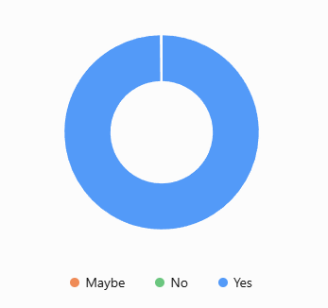
[Fig1 – Pie Chart showing spread of responses when survey participants were asked if the project idea made sense]

The below chart shows respondent likelihood of using the application. Demonstrating very high potential adoption rate of 9.5/10.

[Fig2 – Bar Chart showing likelihood of participants to use the proposed product]

Product Utility
Respondents consistently highlighted key features, like automated directory scanning, were likely to be useful. This highlights which features should take priority over others during development.

Key Product Benefits
This question highlighted where the most value will be drawn for potential users. In this case the time saving was overwhelmingly the feature that would give the most benefit.
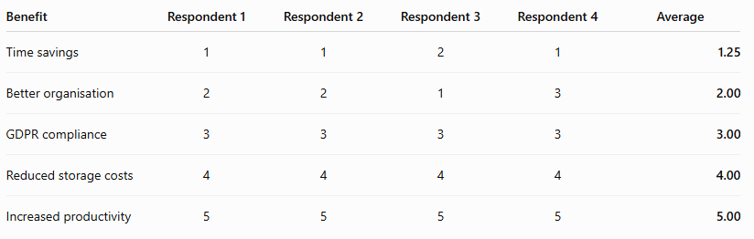
[Fig3 – Respondent ranking results of potential product benefits]

Concerns
Some key concerns were stability of the tool during use, and the risk of deleting required files by accident or though misuse.

Resulting Changes
In response to the feedback, the following changes were made to the tools design. These should add guardrails for data safety and improve performance:
- Add a standard protection from deletion for more recent files (with them being more likely to still be necessary), preventing deletion if a file was last modified within the last 2 years
- Force logging of deletion activity, keeping an audit trail of what was deleted, by who, and when, creating transparency and accountability.
- UI & UX design was adjusted to ensure progress reporting is visible to users, giving confidence in its activity during large directory scans.

Implementation
The tool was built using Python, a multi-purpose programming language that’s one of the most widely used globally. This meant that an abundance of resources and training material was available to support the knowledge needed to implement the required features [5].
Only built-in code libraries were used, such as pathlib for parsing directories, to minimise external dependencies and therefore any potential licensing issues. It also kept the project lightweight, which is important for desktop applications [6]

Practical Work
The initial focus was on the basic functionality, namely: parsing directories, collecting metadata, deleting files, and saving results for review. Functions were defined as shown below to meet these requirements:
- Looping directory and collecting metadata
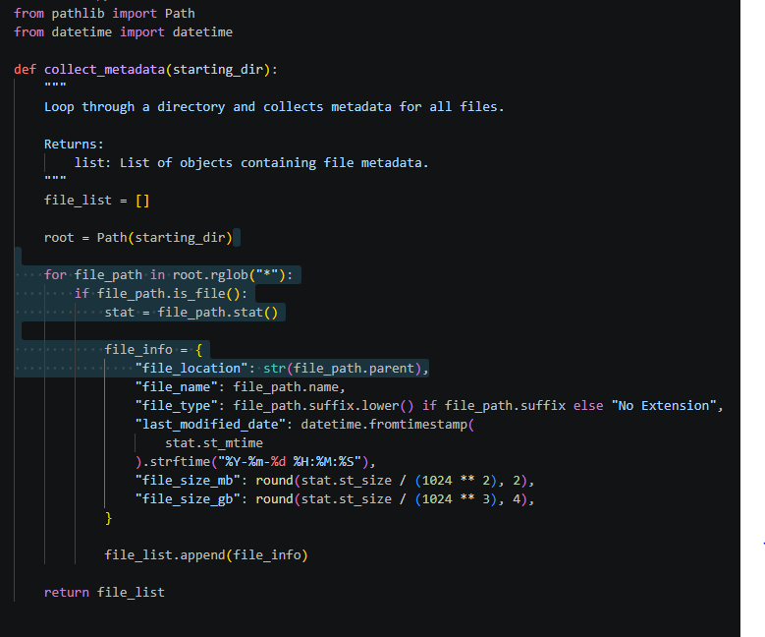
[Fig4 – Python code showing directory scan function]

- Saving results to csv with user interface elements
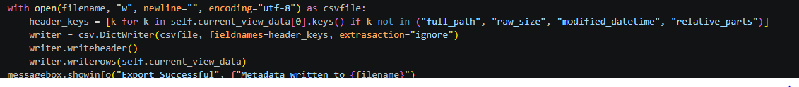
[Fig5 – Python code that writes a list of data to a csv file]

- Showing progress to user
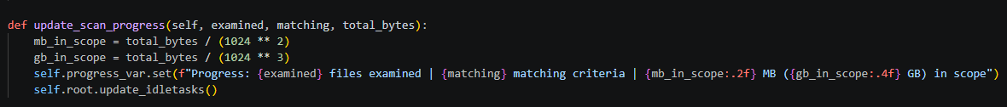
[Fig6 – Python code generating a progress update for users during tool operation]

- Deletion of in-scope files
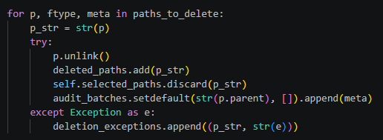
[Fig7 – Python code that deletes files based on a list of filepaths]

- Implementing guardrail preventing deletion of recently modified files
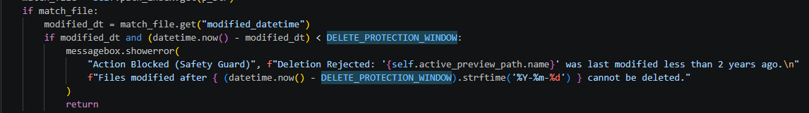
[Fig8 – Python conditional logic that prevents the deletion of files with recent ‘last modified dates’]

- Progress update visible to users during operation
[Fig9 – Progress output visible to users of the tool]

Problem Solving
During development, many different types of issues were encountered and overcome. Some key hurdles included:
- Fatal errors causing crashes during scanning: During operation, non-standard characters could cause a read error, crashing the programme. Error handling was included to prevent fatal crashes.
- Unreadable progress updates:The data size progress update could become unreadable if the units weren’t suitable for the total size discovered. A dynamically adjusting data unit function was created to address this.
- Date format issues: As with many coding projects [7], correct treatment of ‘date’ datatypes proved tricky to implement correctly during testing of the deletion protection function. Conversion functions were sourced to rectify.

2. Enterprise & Innovation: Innovation

Background
To develop and implement this tool in a large organisation, such as a financial services provider, a robust and structured development lifecycle would need to be followed to ensure requirements, testing, and security are to a standard required in such a heavily regulated industry. This would involve an agile software development lifecycle, intense quality assurance (QA) and user testing, strict governance, and consistent deployment methods.

Implementation in a Large Organisation
- Development methodology
  - As outlined in the project plan, a feature driven software development lifecycle methodology should be followed, with feature iterative development being tracked consistently with a project management tool such as Jira.
  - Testing should be done on a per feature basis (unit testing) as well as on a whole product level to ensure all the individual features work correctly while maintaining consistent results.
  - Security and traceability is paramount, so versioning should be handled using Git/GitHub, and automated code analysis should be performed by tools like SonarQube.
  - The tool should have a low architectural footprint to minimize external dependencies and IT/server resources, so should be developed in a lightweight manner using only built-in code libraries.
- Deployment practices
  - The tool should be packaged and distributed in a manner that requires the least set-up and maintenance for users. This can be achieved by packaging the code in a standalone executable to prevent the need for a separate Python installation.
  - Rollout would be handled by central IT teams who have standard deployment practices to ensure software is documented and audited regularly. They would need to be engaged only when the tool is packaged and ready to deploy to the internal software catalogue.
- Iterative review and updates
  - The internal landscape in regulated companies change frequently, and so can risk appetites, external regulations, and internal policies. This necessitates continual bugs fixes and functionality updates to match the pace of change. An internal reporting method using a tool like Service Now could be linked to the deployed app to collect requirements as needed.

PEST Analysis
A PEST analysis, sometimes extended to PESTLE/PESTEL, is a business tool that can assess the impacts that external macro-environmental factors can have on operations [8]. It’s useful to perform on the hypothetical financial services organisation as results could inform the direction of product development e.g. if cloud hosting was being considered, sensitive data security risks [9] could impact whether it would introduce regulatory concerns. See below PESTLE analysis for this company.

P – Political Factors
- International relations: Where geopolitical concerns such as war are a concern, they could introduce cross-border sanctions affecting an international organisation’s ability to operate in certain markets.
- Government interventions: If a company operates in multiple countries, they are likely to be subject to entirely different policies and regulations [10]. For example, GDPR is a European regulation that doesn’t appear in other markets.

E – Economic Factors
- Economic volatility: Metrics like inflation and changing interest rates can markedly impact borrowing and therefore cashflow
- Global Markets: Constantly fluctuating foreign exchange rates can impact earnings, particularly where it negatively affects the companies home market.

S – Social Factors
- Digitisation of services: Increasing demand for instant access to online services combined with reduced cash use both reduces physical presence and increases the need for investment in digital products.
- Changing public priorities: There is an increased push for ethical & ‘Green’ services to be offered [11], drastically changing the kind of investments and considerations of companies.

T – Technological Factors
- Rapidly accelerating technology: Proliferation of AI, automated decisioning, and cloud technology has forced rapid digital growth and employee training [12] in established companies to keep up with ‘Fintech’ competition
- Cybersecurity concerns: Heavily increased investment in cybersecurity is a must-have when trying to stay ahead of a constant flow of attacks aimed at financial institutions.

L – Legal Considerations
- Regulatory compliance: Mentioned heavily throughout this report, financial regulations are stringent and punished harshly when not met. Investment in appropriate controls and compliance measures with robust audit trails are essential.

E – Ethical Considerations
- Responsible & fair practises: Outside of the legal and financial ramifications of not adhering to regulation, the court of public opinion can quickly turn on any organisation if they have been deemed to not be acting in a manner that is considered ethical to its consumers.

3. Project Reflection

Practical Feedback

Summary & Analysis of Feedback
The questions focussed on concerns raised during initial feedback as well as key features. See appendix for full questions. Quantitative metrics scored well, with qualitative responses providing insight into innovative features, as well as the reasons for lower scores.

Intuitiveness
An average score of 4.5/5 demonstrates the app is intuitive and simple to use, with coinciding remarks stating documentation would be useful.
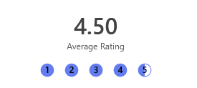
[Fig10 – Average Intuitiveness score from project feedback]

Visual Layout and Duplicate Detection Feature Clarity
Both questions received a 100% positive response, indicating these aspects of the tool have been implemented successfully.
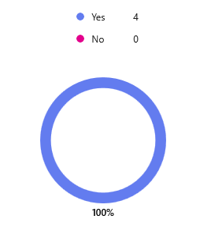
[Fig11 – Pie chart demonstrating a 100% positive response to survey questions]

Deletion Feature Safety Measure Clarity
This feature had the lowest average rating, despite being positive overall. Again, this could be improved by adding documentation.
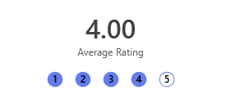
[Fig12 – Average rating received from respondents when asked about the tool safety features]

App Responsiveness
100% of respondents felt that responsiveness was not a concern, addressing concerns raised during initial feedback.

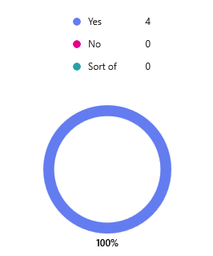
[Fig13 – Pie chart demonstrating a 100% positive response to survey questions]

Resulting Changes
In response to the feedback, several items have been added to the feature backlog for future development:
- A bug fix to the ‘empty folder’ search feature.
- Incorporate in-built documentation to explain features clearly.
- Add contextual hover tool-tips next to certain UI elements.

Project Progress Diary

What went well?
Consistently completing weekly progress sheets allowed for greater discipline around meeting milestones, keeping the overall delivery on track. The often-neglected time spent upfront to document ideation, project methodology, and scope was critical in determining structure and preventing scope creep.

What challenges were faced?
Due to short timescales between project start and delivery, issues encountered during the practical development put the timeline at risk. There was also little time available to test each feature, leading to one of the feedback points raised.

What would be done differently next time?
In future projects, additional development buffer would be added to allow for more robust testing and to reduce the risk of project delays should issues be encountered. Additional rounds of feedback would also be included to allow for more feature iterations.

Skills Development
Hard skills
- Python programming – Enhanced knowledge of some advanced concepts, including functions, classes, and UI design
- Coding technologies – Setting-up and managing a programming environment
- Coding version control – Using Git/GitHub to ensure projects progress is protected while forcing proper code review before publishing of a new version.

Soft skills
- Communication – Presenting the tool to a group of people when seeking feedback
- Planning – Using the different development methodologies to effectively narrow down project scope, requirements, and development steps
- Time management – Effectively adhering to the plan to keep on-track
- Design thinking – Factoring in usability when designing layout, messaging, and aesthetics of the UI

Positive Social Impact
The outcome of this project will directly contribute to improved governance around data, and to ‘green-computing’ – After internal research in a large financial services company I have discovered that there is an estimated £5million annual cost for storage used by ‘dark data’, so the financial impact of such a tool can’t be understated.
Furthermore, enabling companies to more easily audit their non-structured data will result in better overall data hygiene, reducing the risk of sensitive customer data being mis-managed to their detriment.
Personally, considerable new skills in programming/app development have been gained. Combined with a deeper understanding of the wider data landscape and the associated risks/regulations, I will be able to be a digitally focused advocate for the importance of robust data governance. The new skills and knowledge can also help others save time on what is objectively a time-consuming process with little immediate return on that investment.

4. Conclusion
This project aimed to expose students to the skills of project management while teaching the importance of creativity for societal benefit. An innovative idea to solve a real-world problem was developed and taken through a structured development lifecycle. Applying the different project management stages helped to crystallise the goals clearly, plan milestones, and kept development on track within the planned timescales.
Importantly, the innovative idea has the potential to lead to positive impacts on society. The growing issue of ‘dark data’ in an increasingly digital world can lead to negative economical and environmental impacts if it isn’t mitigated. The project output aims to help to address this issue while supporting adherence to data privacy regulations. It also supports green computing initiatives, as less data lowers storage needs, energy consumption, and carbon footprint.
Practical insight was gained into issues that can be encountered in the workplace if proper risk management practises aren’t followed, which showing that individuals can create societal change at pace.

References

[1] | U. Schmuntzsch, A. Shajek and E. A. Hartmann, New Digital Work II : Digital Sovereignty of Companies and Organizations, Springer Nature Switzerland, 2025.
[2] | L. Marumolwa and C. Marnewick, “Unveiling Dark Data in Organisations,” International Journal of Service Science, Management, Engineering, and Technology, vol. 16, no. 1, 2025.
[3] | M. Birulya, “Feedback as a Tool for Effective Project Management: Significance, Methods of Utilization, and Practical Examples,” Russian Journal of Project Management, vol. 13, no. 2, pp. 14-22, 2024.
[4] | S. Littler, “The Importance and Effect of Sample Size,” Select Statistical Services, [Online]. Available: https://select-statistics.co.uk/blog/importance-effect-sample-size/. [Accessed 23 Jul 2026].
[5] | F. Company, “The Benefits of Using Python for Desktop Applications,” Medium, 18 Aug 2023. [Online]. Available: https://medium.com/@finoitcompany/the-benefits-of-using-python-for-desktop-applications-8916a8962316. [Accessed 26 Jul 2026].
[6] | Mike, “How Lightweight Apps Are Winning in a Cluttered Tech Space,” Turbo IRC, 12 Feb 2026. [Online]. Available: https://www.turboirc.com/how-lightweight-apps-are-winning-in-a-cluttered-tech-space/. [Accessed 23 Jul 2026].
[7] | Z. Liang, “Automating Date Format Detection for Data Visualization,” in International Conference on Advanced Machine Learning and Data Science (AMLDS), 2025.
[8] | H. V. Belsare, “PESTLE ANALYSIS,” International Journal of Advanced Research, vol. 13, no. 02, pp. 608-612, 2025.
[9] | M. B. Soewito, F. L. Gaol and E. Abdurachman, “A systematic literature Review: Risk analysis in cloud migration,” Journal of King Saud University - Computer and Information Sciences, vol. 34, no. 6, pp. 3111-3120, 2022.
[10] | E. Jones, The political economy of bank regulation in developing countries : risk and reputation, Oxford: Oxford University Press, 2020.
[11] | A. Oyegunle, DEVELOPMENT OF SUSTAINABILITY AND GREEN BANKING REGULATIONS — EXISTING CODES AND PRACTICES, C. Hurst and Company, 2015.
[12] | A. Mazurchenko, M. Zelenka and K. Maršíková, “DEMAND FOR EMPLOYEES’ DIGITAL SKILLS IN THE CONTEXT OF BANKING 4.0,” E+M ekonomie a management, vol. 25, no. 2, pp. 41-58, 2022.

Appendices

Progress Sheets
Name: Chris L Powell (2508868)
Programme: Applied Computing (Data & Information Systems)

Project Aim: Develop a tool that will heavily reduce effort needed to audit and manage file/data retention.
Project Objectives:
- Programme will scan all directories & sub-directories from a starting location chosen by a user, returning a single output summarising 100% of accessible files, file locations, file sizes, and last modified dates. Metadata returned should have 100% accuracy.
- Programme should have the ability to only target files according to specific criteria set by the user. e.g. files last modified before a certain date. File targeting should have 100% accuracy demonstrated during testing.
- Programme should have the ability to delete files, also utilising the user defined criteria. 100% of eligible files should be deleted during testing, with all information recorded in a log file.
- Programme should be easy enough to use so that non-technical colleagues are able to use it with no/minimal instruction. e.g. requires less than 10 minutes to begin use. 80% of users should be able to complete core functionality without additional instruction.
<< WEEKLY UPDATE: NEW FORM EACH WEEK >>
Weekly Project progress forms:

Date: 30/06/2026

Progress:
- Designed data collection method and questions for the proposed project idea. Gathered feedback from a selection of peers and began reflecting on how the feedback should affect development

Actions:
State priority actions to undertake over the next week below.
- Collate, digest, and summarise feedback received.
- Progress with practical implementation of project idea, documenting development steps along the way
- Ensure initial feedback was acted upon in development
- Document any errors/issues encountered

Next review date: 07/07/2026.

Date: 07/07/2026

Progress:
- Completed first version of the tool and documented the progress through screenshots. Covered the direct link between how this project has been structured and how projects are executed in the external industry, covering the lifecycles through tools, practises, deployment, and iteration

Actions:
State priority actions to undertake over the next week below.
- Decide on most appropriate Task 2 question to incorporate into my Assignment 2 report.
- Complete Task 2 Question 1, relating my project idea to either an established company or to a fictional tech start
- Create a PESTLE analysis for the company in question
- Build reference list to support claims and conclusions made throughout the body of my assignment

Next review date: 14/07/2026.

Date: 14/07/2026

Progress:
- Went with ‘Innovation’ as it most closely related to the intended use of my project output. Completed both Q1 and Q2 in relation to a large financial institution

Actions:
State priority actions to undertake over the next week below.
- Review of work completed thus far
- Finalise practical development so that it’s ready for a demonstration to peers
- Begin collating references/citations that support claims made to justify certain development decisions.

Next review date: 21/07/2026.

Date: 21/07/2026

Progress:
- Reflection on practical implementation done to help inform feedback that would be most useful to enhance the project. Feedback questions were designed and a form was created. Demo of build was done with test group and feedback was requested

Actions:
State priority actions to undertake over the next week below.
- Reflect on skills learned and analyse then document
- Assess project for positive social impact and potential contributions to society
- Write overall project conclusion
- Build reference list to support claims and conclusions made throughout the body of my assignment

Next review date: 27/07/2026.

CPD Evidence
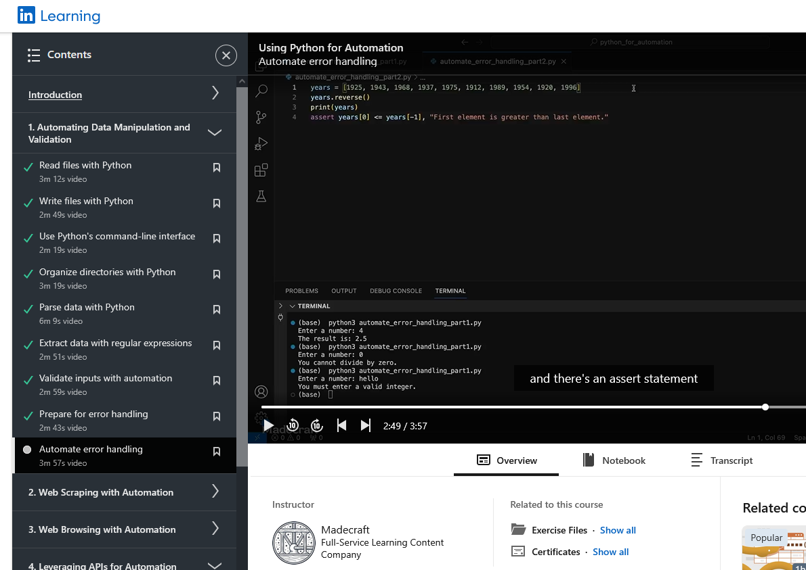
[Fig14 – Image of LinkedIn learning course with content relevant to manipulating data in Python]

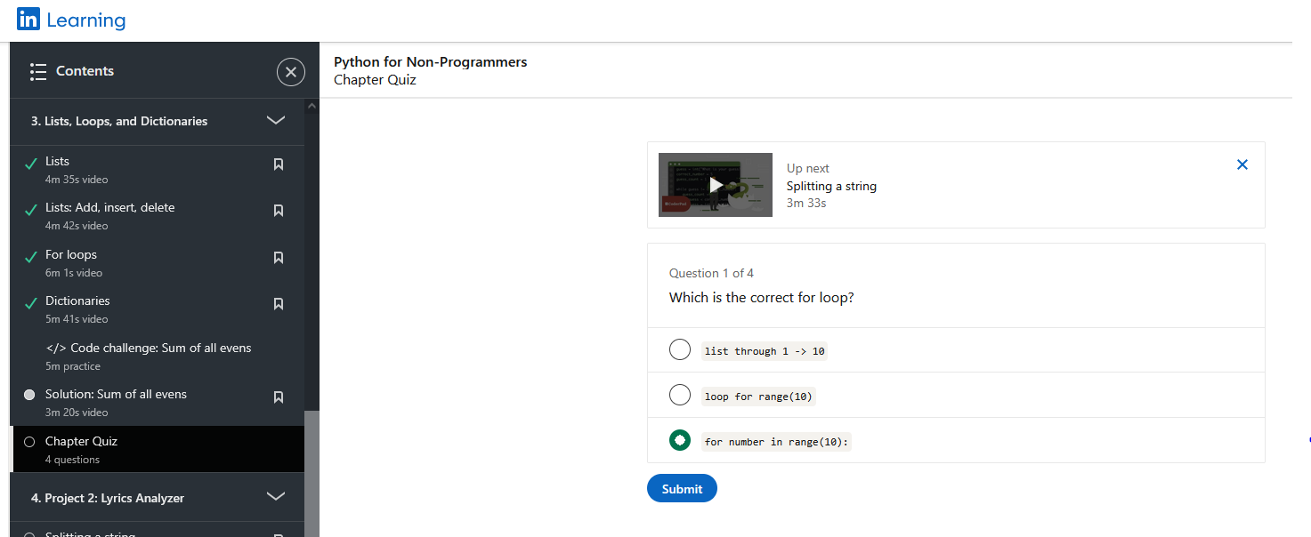
[Fig15 – Image of LinkedIn learning course with content related to handling lists and loops in python]

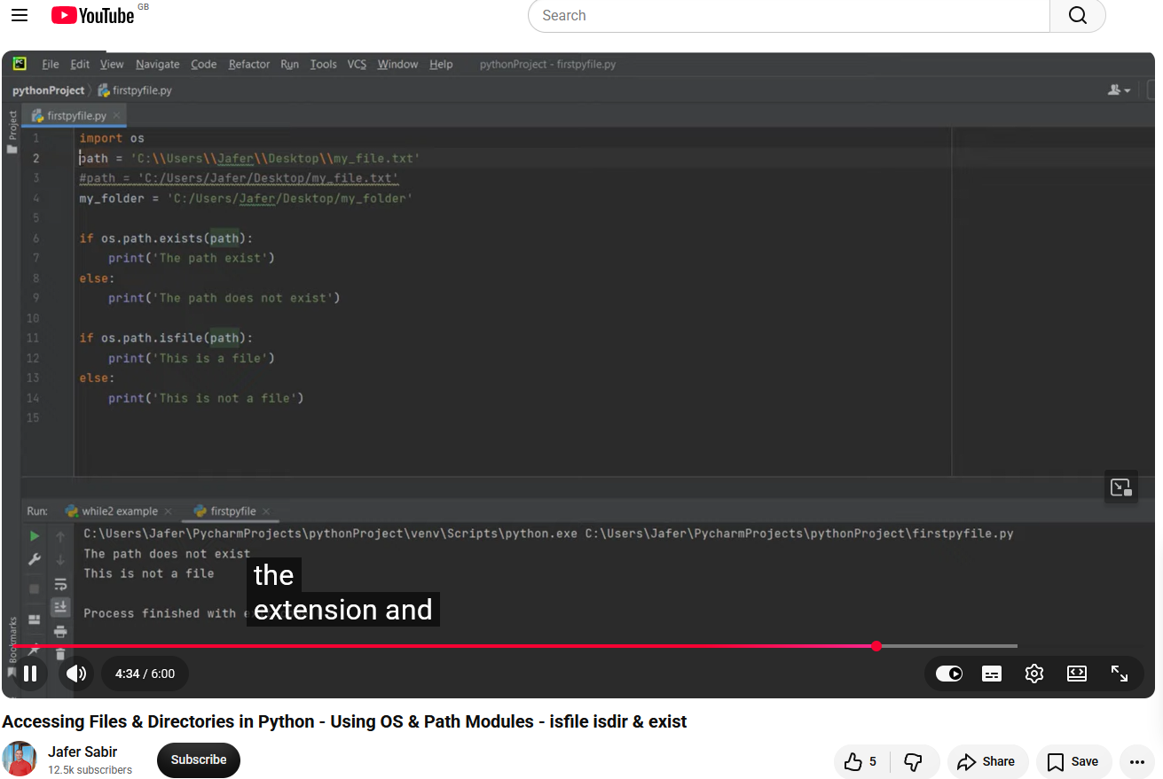
[Fig16 – Image of a YouTube video with relevant content to my project complete]

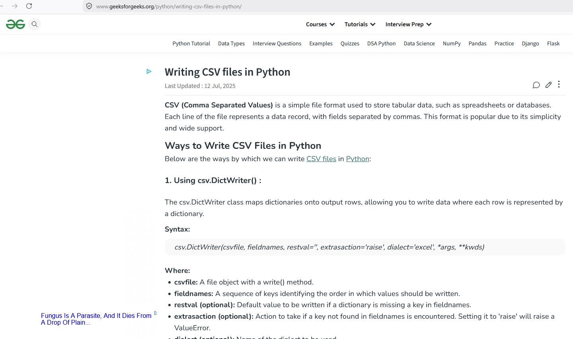
[Fig17 – Image of website documentation on relevant information for my project]

Project Feedback Data Collection

Initial Feedback Questions
- Does the application's intended purpose make sense? (Yes/No/Maybe)
- Which features do you think are the most useful? (Free format text)
- Are there any features missing from this application? (Free format text)
- On a scale of 1 to 10, how likely would you be to use this application? (Rating scale)
- Please rank the potential benefits of this application. (Ordered list)
- What concerns could you have that would prevent you from using this application? (Free format text)
- Do you have any suggestions on how to maximise the application User Experience? (Free format text)

Practical Feedback Questions
- On a scale of 1–5, how intuitive was it to navigate the main layout (filtering, grid, and preview panel)? (Rating scale)
- Visual Layout: Did the live charts and sidebar metrics make it easier to understand storage distribution? (Yes/No/Maybe)
- Duplicate Detection: Was the multi-stage duplicate scan process easy to understand? (Yes/No)
- How clearly did the app communicate safety measures (e.g. preventing deletion of files modified within the last 2 years? (Rating scale)
- Did the app feel responsive during use? (Yes/No/Sort of)
- What feature did you find the most innovative or useful? (Free format text)
- What did you find, confusing, unintuitive, or missing from your experience? (Free format text)

Tool Screenshot
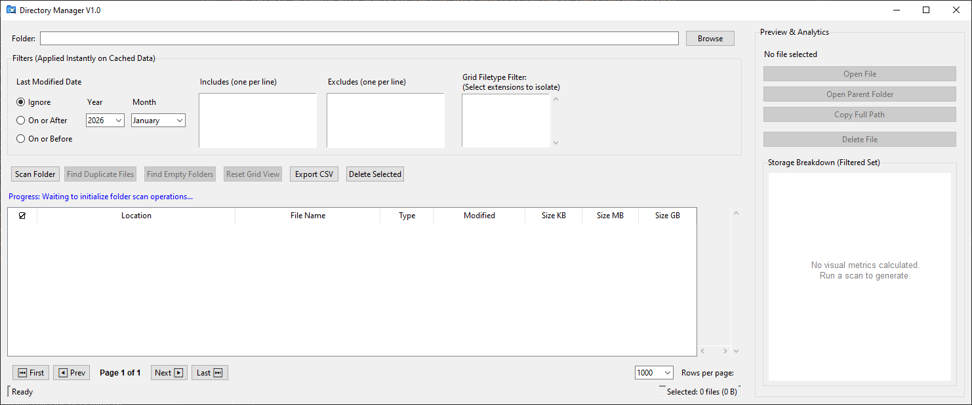
[Fig18 – Image of the app screen on initial opening]

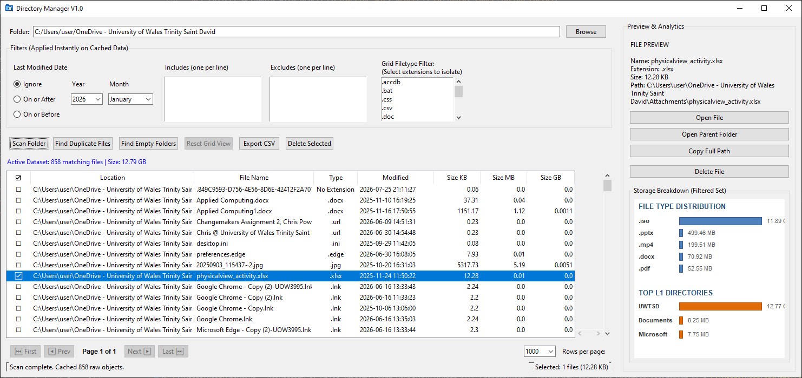
[Fig19 – Image of the apps screen after a directory has been scanned for its contents]

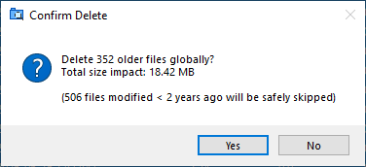
[Fig20 – Image of app deletion confirmation window highlighting that the safety guardrail will prtect recently modified files]

