
^{LEVEL 4 ASSIGNMENTS}

Programme:

Name:

Student ID:

Module:

Module Code:

Lecturer’s Name:

Assignment Title:

Submission Deadline:

University Name: | UWTSD – Birmingham Campus

Contents
❖ Task 1.1 - Solution) Describe the rules of Scrabble? 3
❖ Task 1.2 - Solution) Create a requirement features list for a possible computer-based solution for the game using the MoSCoW requirements prioritisation technique. 4
❖ Task - 2 - Solution) Identify the variables you need to use in your solution, indicating if any are constants. 6
❖ Task - 2.1 – Solution) Create flowcharts of a scrabble game using a computer programme and provide an algorithm for your proposed solution and their implementation. 7
❖ Task - 2.2 – Solution) Using flowcharts in Visio of a scrabble game and provide an algorithm for your proposed solution and their implementation. 8
❖ Task – 2.3 – Solution) Using flowcharts in Visio of two sub processing and provided details of their pseudocodes. 9
❖ Bibliography 12

Task 1.1 - Solution) Describe the rules of Scrabble?
Scrabble is a popular word game in which players use letter tiles to create words on a game board. The game is designed for two to four players and combines elements of strategy, vocabulary, and luck. The goal is to accumulate the highest score by forming words on the board using your tiles. Each word's score is determined by the sum of the values of its letters, adjusted by any special squares it covers. Playing this game, there are various rules, which are explained below [1].
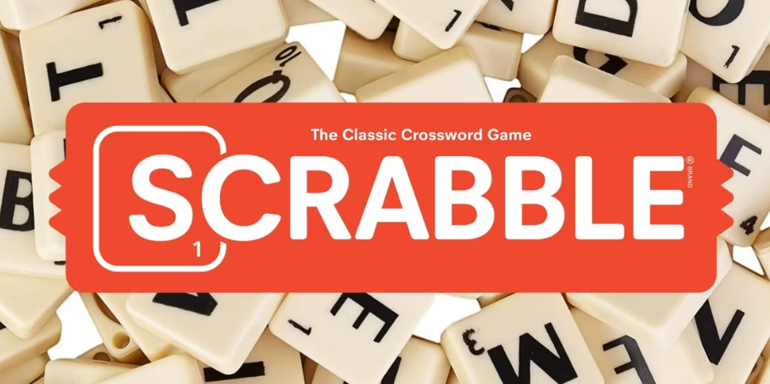
Figure 1: Rules and requirements of Scrabble Game.
- Objective: The objective of Scrabble game is to score the highest points by forming words on the game board using letter tiles.
- Beginning the Game: To decide who goes first, players draw tiles. Starting from the beginning is the player which letter is closest to 'A'. From that, each player draws seven tiles.
- Creating Words: Before a player's turn, they may arrange tiles from their rack to create a word on the board. The centre star square must be covered by the first word.
- Points: Letter values and any board squares used will be considered when assigning points to words. A player receives a 50-point bonus, if they use all seven tiles in a single turn [2].
- Replacing Tiles: The player replenishes their rack by drawing fresh tiles from the bag after creating a word.
- Exchanging Tiles: A player can skip their turn to exchange some or all of their tiles with new ones from the bag (only if there are at least seven tiles remaining in the bag).
- Questioning the Player if you think their word is invalid: Other players could question a word that a player forms that is incorrect. The player losses their turn and must remove the tiles if the term is invalid.
- Closing the Round: When every tile has been drawn, when a player uses their final tile, or when there are no more moves possible, the game is over. Points from unused tiles on racks are added to the player who utilised all their tiles and are deducted from the scores of all other players.

Task 1.2 - Solution) Create a requirement features list for a possible computer-based solution for the game using the MoSCoW requirements prioritisation technique.
To design a Scrabble game using the MoSCoW method, which helps prioritize features, I will categorize the features into must have, should have, could have, and won't have.
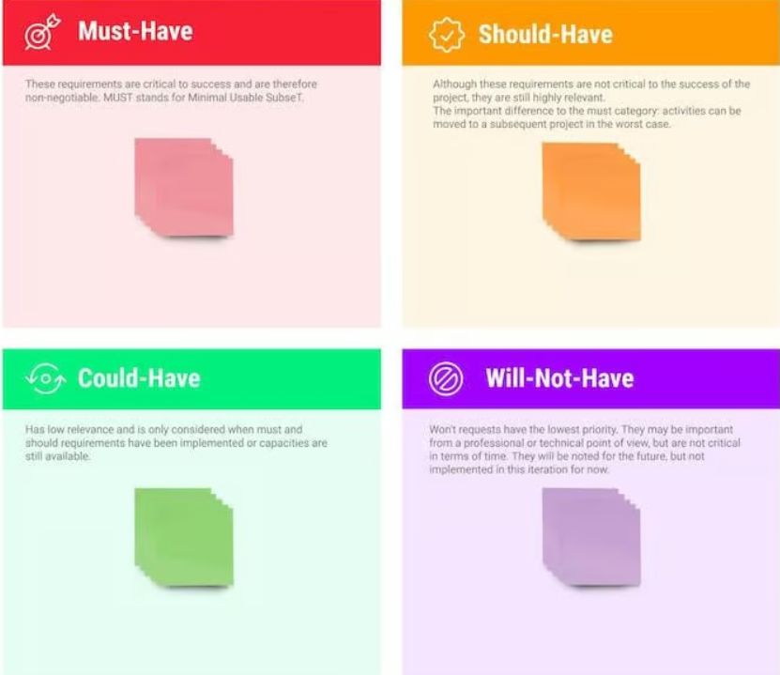
Figure 2: To design a Scrabble game using the MosCow method.
Must-Have Features:
Interface Each Player: Game board with different squares and tiles must clearly displayed for all players and each player's tile rack can carry seven tiles and a scoreboard that displays each player's current score.
Player Registration or login details: Each player must have registered and login details for the game.
Scoreboard and Timer: Scoreboard instruction must give to each player and to set the time for turns to keep the game moving.
Conditions for the game's end: When the player uses all the tiles in their tile bag or when there are no more moves left, the game automatically ends and the computation and presentation of the final scores, with the leftover tiles subtracted.
Enforcing Rules: The first word must start from centre of the scrabble board, and it connect to the other words of the boards and every word must have a meaning.
Word Validation: Each player must have connections with a standard dictionary for verifying word validity [3].
Should-Have Features:
Opinion for the Player’s: The player can advise and tips for inexperienced players.
This game allow players to repeat the last move selection and
highlight possible word locations.
Social Engagement Qualities: The player should be able to engage online for multiple players and should have system of awards achievements to high-ranking leaderboards.
Improvements to the Audio and Visual Area: The players should have the option animate for scoring and moving tiles and to play the background music and to change the theme selection for various tile and board designs.
Keyboard Navigation: The players should have full support for navigating and playing the game.
Tile Exchange Option: Each player should have the opportunity to exchange the tile or skip their turn in the game.
Could-Have Features:
Cross-Platform to Play: Players could have the support for playing game across different devices and operating systems.
Replay and Analysis: Each player could have this option to review the completed games and analyse moves.
Timer: This game could have this option to keep the time of the game and keep moving turns for the players.

Will-Not-Have Features:
Non-standard tile sets or board sizes: The normal 100 tile set and the conventional 15x15 board will be the only ones utilised.
Custom dictionaries or word lists outside of the default ones: In order to preserve a typical competitive environment, it will not be supported for players to make extensive modifications to the dictionary or to make their own word lists.
Large-scale offline tournaments: The game's features will not promptly help to organise and control of large-scale offline events.
Cross-platform game integration with non-word games: Scrabble gameplay cannot be integrated with other unrelated game categories, such as an action or strategy game.

Task - 2 - Solution) Identify the variables you need to use in your solution, indicating if any are constants.
To represent the scenario, using their structures and rules of the Scrabble game, I must consider several variables and constants from the Scrabble game features. Here is a summary of some of the variables and constants and their descriptions.
Definitions of variables in the Scrabble game:
A storage location paired with an associated symbolic name, which contains some known or unknown quantity of information referred to as a value [4].
- currentPlayerIndex: Indicates who is taking the turn.
- playerRegistration: Before beginning a game of Scrabble, a player must register.
- playerLogin: To play Scrabble, a player must have their login information.
- playerTileDictionary: Player names are mapped to their tiles using the player tiles dictionary.
- scoresBoard: The record of scores for all players.
- playedWords: A list of words that have been played is called played words.
- tileBag: The collection of all letter tiles available to draw from.
- tilePoints: The point values associated with each letter tile.
- gameOver: A Boolean indicating whether the game has ended.
- turnCount: The number of turns that have been taken in the game.
- exchangeTiles: A function allowing a player to exchange tiles from their rack.
- validateWord: A function to check if a played word is valid.
- calculateScore: A function to compute the score for a played word.
- remainingTiles: The number of tiles left in the tile bag.

Definition of constants variables in the Scrabble game:
A value that cannot be altered during the execution of a program. Constants are used to store values that are meant to remain the same throughout the program [5].
- boardSize: Specifies the game board's fixed size.
- tileSet: Specifies the point values and fixed distribution of tiles.
- maximumTiles: Specifies the most tiles that a player is allowed to hold.
- totalTileCount: The total number of tiles in the game (usually 100).
- bonusBingoPoints: The extra points awarded for using all seven tiles in one turn. Which are usually in total 50.
- maxPlayers: The maximum number of players in a game (usually 4).
- minPlayers: The minimum number of players in a game (usually 2).
- timeoutDuration: The maximum time allowed for a player's turn (e.g., 5 minutes).
- blankTileCount: The number of blank tiles in the game (usually 2).
- maxPasses: The maximum number of consecutive passes before the game ends (usually 6).
- initialTileDraw: The number of tiles drawn by each player at the start of the game (usually 7).
- firstMoveBonus: A boolean indicating whether the first move has an additional bonus, which is false.

Task - 2.1 – Solution) Create flowcharts of a scrabble game using a computer programme and provide an algorithm for your proposed solution and their implementation.
Using a computer program, this is a high-level Scrabble game algorithm that can be represented using hierarchy feature a flowchart, which includes the main programme and their sub-parts [6].

Figure 3: Using flowchart of a scrabble game.

Task - 2.2 – Solution) Using flowcharts in Visio of a scrabble game and provide an algorithm for your proposed solution and their implementation.

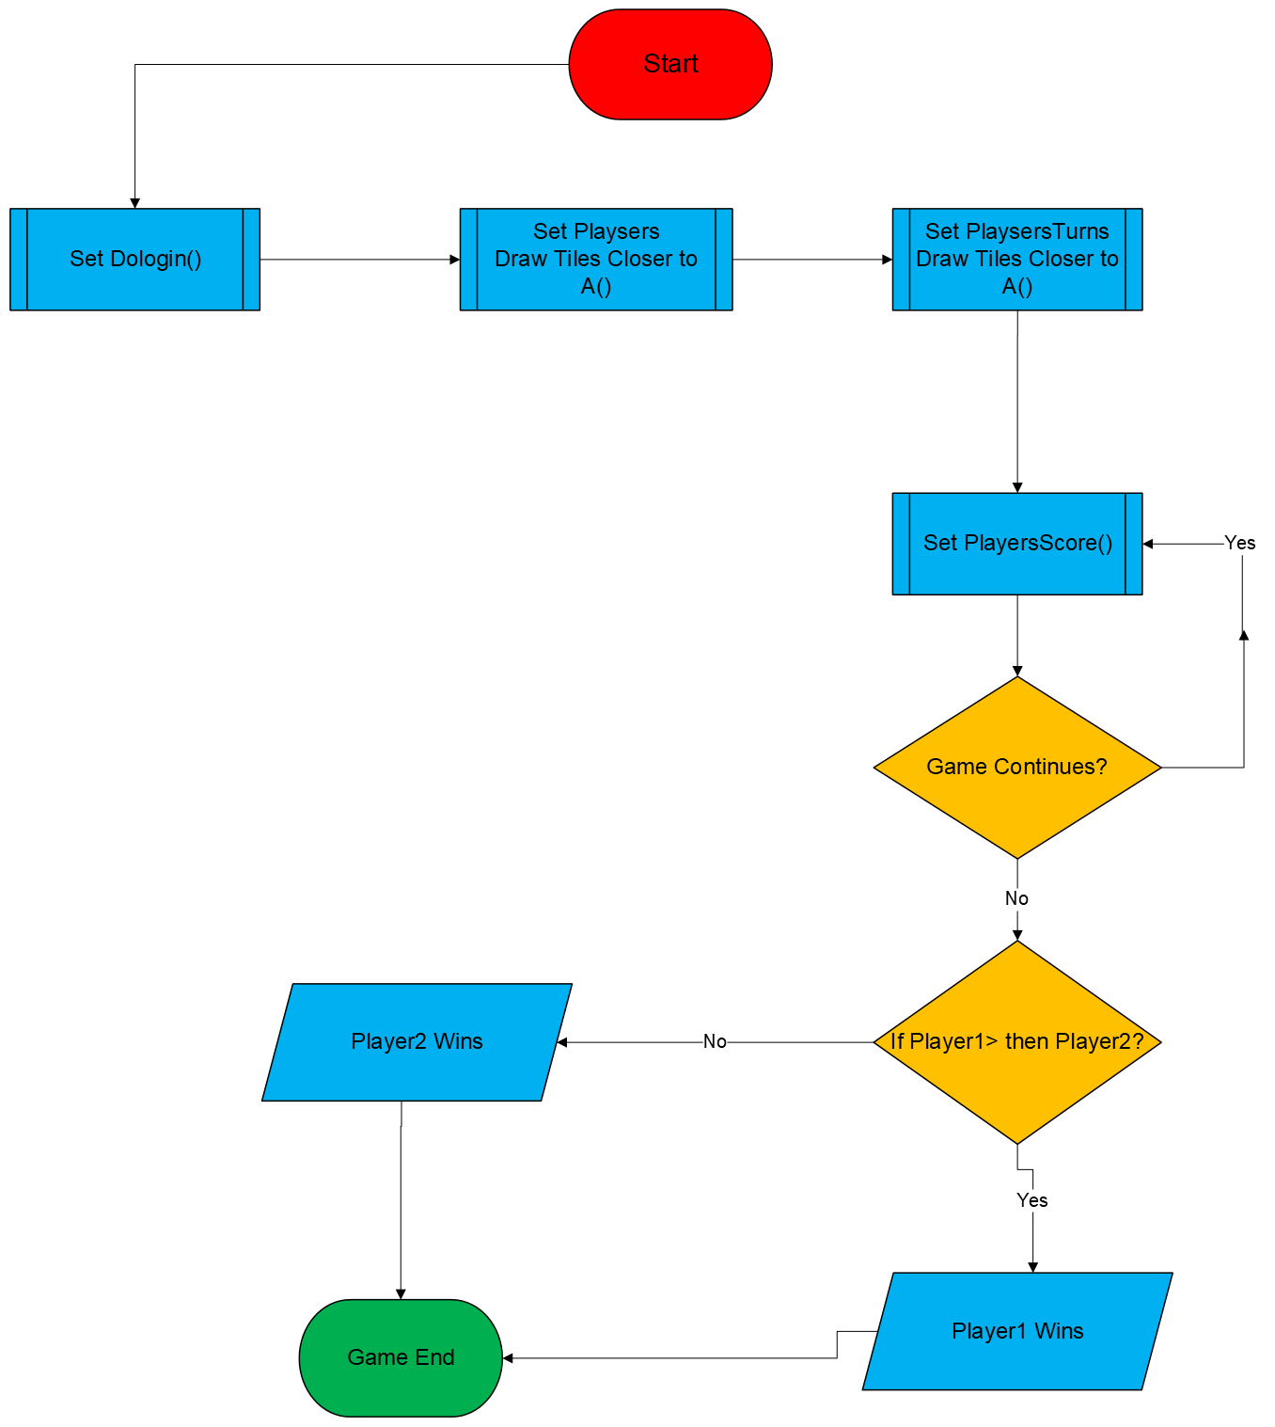
Figure 4: Using flowcharts in Visio of a scrabble game and provided their algorithm.

Task – 2.3 – Solution) Using flowcharts in Visio of two sub processing and provided details of their pseudocodes.
The logic of a program can be expressed more simply and casually using pseudocode rather than the language of a particular programming language. It uses programming techniques and aspects of natural language to describe the organisation and flow of an algorithm or program. Pseudocode is mostly used to design and visualise a program's stages prior to writing them in a specific language [7].

- Sub process and pseudocodes of Dologin:
Sub-processing in flowcharts for Dologin:
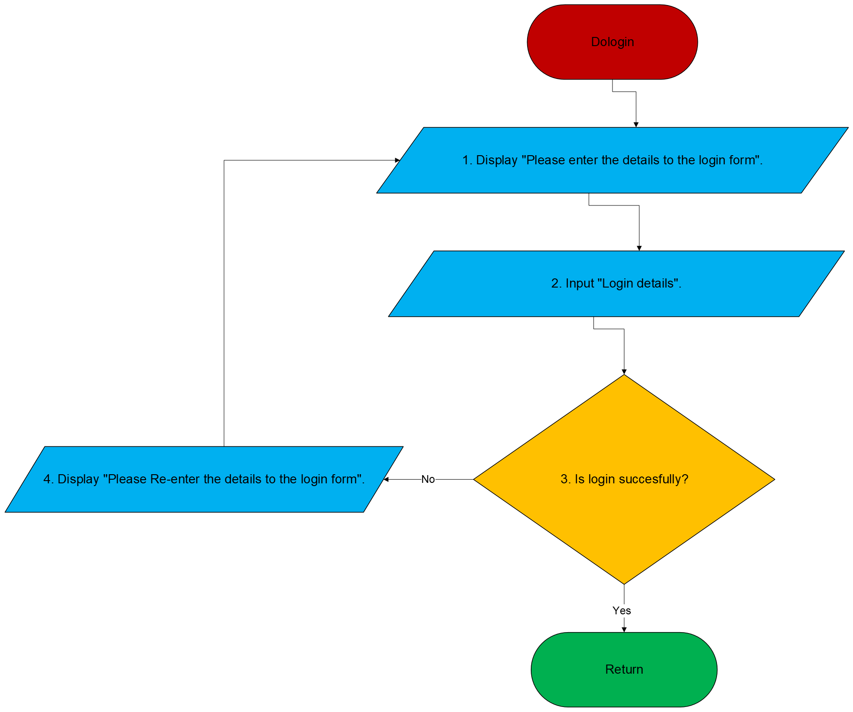
Figure 5: Using flowcharts in Visio for "dologin" sub processing.
Pseudocode for Dologin:
1. Display “Please enter the login form”.
2. Input “login details”.
3. If login successfully.
Display to “Return”.
4. Else
Display “please Re-enter the login form”.
Details of pseudocode for Dologin: I have created a sub process for “Dologin” from the main flowchart. I have broken down the sub process into few steps. Basically for “Dologin” I needed first to enter the login form, then I needed to check the details and if the login successfully, then go to “Return”, if else, then I need to re-enter the details in login form until I get the successful login.
- Sub process and pseudocodes of “Select Players”:
Sub-processing in flowcharts for “Select Players:
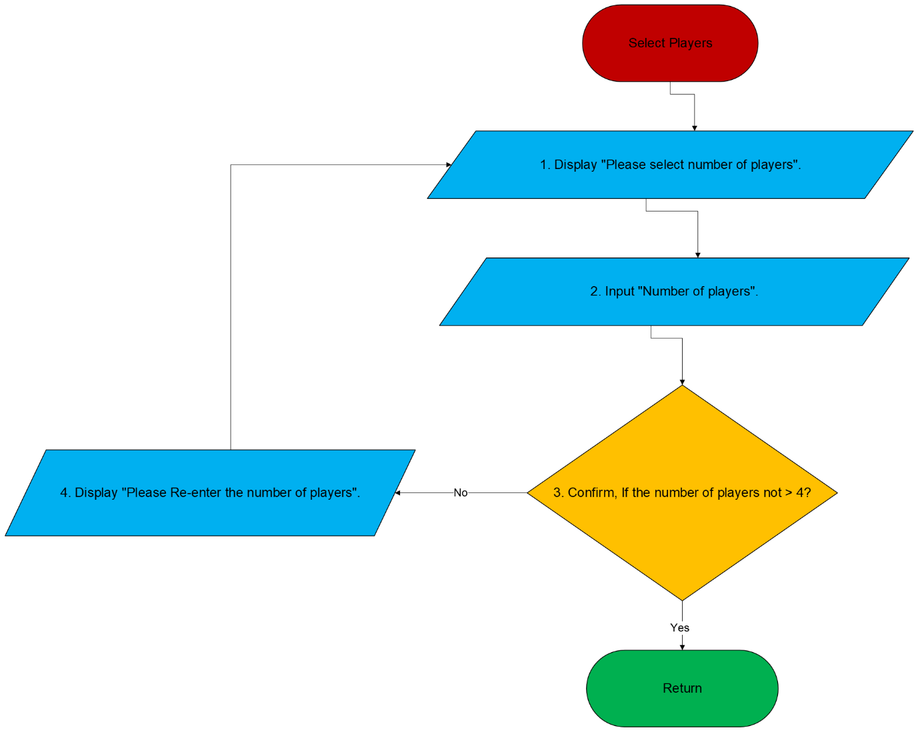
Figure 6: Using flowchart in Visio for "Select Players" sub-processing.

Pseudocode for select players:
1. Display “Please select the numbers of players”.
2. Input “Number of players”.
3. Confirm the number of players, if not greater than 4.
Display to “Return”.
4. Else
Display “please Re-enter the number of players”.
Details of pseudocode for select players: I have created a sub process for “Select Players” from the main flowchart. I have broken down the sub process into few steps. Basically for “Select Players” I needed first to select the number of players, then I needed to check that the numbers of players are not greater than 4 and then I have to confirm if the player are four and ready to play, in this case then can go to “Return”, if else, then I needed to re-enter the number of players in the same way process until I get four players in game.

Bibliography

[1] | N. Smith, “Mattel v. Zynga - Court of Appeal rules in SCRABBLE dispute,” Intellectual property & technology law journal, vol. 27, no. Clifton: Aspen Publishers, Inc, pp. no. 7, pp. 22-, 2015., June. 2024.
[2] | T. O. R. o. S. -. H. t. P. S. -. L. S. Rules, “https://www.scrabblepages.com/scrabble/rules/,” [Online]. Available: https://www.scrabblepages.com/scrabble/rules/. [Accessed 30 june 2024].
[3] | B. Harrison and D. L. Roberts, “Analytics-driven dynamic game adaption for player retention in Scrabble,”,” in Conference on Computational Inteligence in Games (CIG), 2013.
[4] | K. Gröchenig and A. Klotz, What Is Variable?,” Communications on pure and applied mathematics, , vol. 70, no. New York: John Wiley and Sons, Limited, pp. no. 11, pp. 2039–2083, 2017, doi: 10.1002/cpa.21694., 2022-2013.
[5] | I. T. Monitoring, “https://www.ibm.com/docs/en/tcamfma/6.3.0?topic=tesl-constants-variables,” IBM Documentation. [Online]. [Accessed 11 07 2024].
[6] | C. C. S. Helmers, “Creating Flowcharts for Beginners,” linkedin.com, 2020.
[7] | W. G. W. N. M. A. a. A.-B. S. A. Alokla, Retrieval-Based Transformer Pseudocode Generation,” Mathematics (Basel, vol. 10, no. DOAJ Directory of Open Access Journals, pp. No. 4, pp. 604-, 2022, doi: 10.3390/math10040604., 2024.

